SUPPLEMENTARY FIGURES AND TABLES

Supplementary figure 1 Flowchart of study population
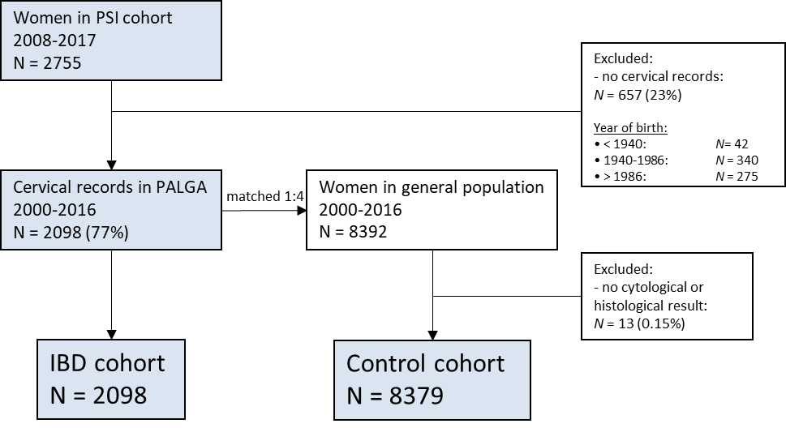

Abbreviations: PSI: Parelsnoer Institute; N: number; PALGA: Dutch nationwide network and registry of histology and cytopathology; IBD: Inflammatory bowel disease;

Supplementary Figure 2A-C. Kaplan Meier estimates for a CIN1 or CIN2+ lesion as worst diagnosis for IBD cohort and matched cohort by years of follow-up attained age in total study population.
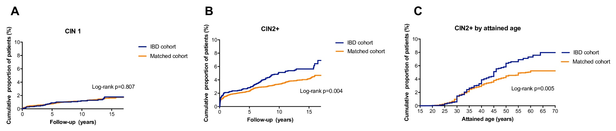

A: Proportion of women with CIN1 as highest grade of dysplasia during follow-up. B: Proportion of women with CIN2+ as highest grade of dysplasia during follow-up. C: Proportion of women with CIN2+ as highest grade of dysplasia by attained age. Attained age is defined as the age at diagnosis of CIN2+ or age at end of follow-up.

Abbreviations: CIN = cervical intraepithelial neoplasia. CIN2+ = CIN2, CIN3 or cervical cancer; IBD = inflammatory bowel disease; OR: Odds ratio. Attained age = age at diagnosis of CIN2+ or age at end of follow-up.

 |  | CD  N (%) | UC, IBD-U/I  N (%) | P value
Total number of women |  | 1382 (65.9) | 716 (34.1)
Age at IBD diagnosis | <25 years | 586 (42.4) | 186 (26.1) | <0.001^
N/A for 5 (0.2%) | ≥25 years | 795 (57.6) | 526 (73.9)
Montreal L | L1 | 256 (21.0)
N/A for 164 (11.9%) | L2 | 277 (22.7)
 | L3 | 530 (43.5)
 | L4 | 6 (0.5)
 | L1+L4 | 28 (2.3)
 | L2+L4 | 30 (2.5)
 | L3+L4 | 91 (7.5)
Montreal B | B1 | 495 (40.4)
N/A for 157 (11.4%) | B2 | 191 (15.6)
 | B3 | 192 (15.7)
 | B1p | 123 (10.0)
 | B2p | 60 (4.8)
 | B3p | 164 (13.4)
Montreal E | E1 |  | 56 (8.8)
N/A for 76 (10.6%) | E2 |  | 238 (37.2)
 | E3 |  | 346 (54.1)
Smoking status | Never | 882 (66.2) | 584 (85.0) | <0.001^
N/A for 78 (3.7%) | Current/<6 months | 451 (33.8) | 103 (15.0)
Education level
N/A for 46 (2.2%) | Low | 911 (65.4) | 472 (66.4) | 0.777^
 | High | 461 (34.6) | 239 (33.6)
Medication exposure
N/A for 33 (1.6%)
Immunomodulator | No | 650 (47.0) | 418 (58.4)
 | <1 year | 170 (12.3) | 67 (9.4)
 | >1 year | 562 (40.7) | 231 (32.3) | <0.001^
Biological | No | 796 (57.6) | 595 (83.1)
 | <1 year | 174 (12.6) | 53 (7.4)
 | >1 year | 412 (29.8) | 68 (9.5) | <0.001^
Number of screening episodes in a 5 year period
N/A for 38 (1.8%) | 1 | 956 (69.2) | 495 (69.1) | 0.413^
 | 2 | 375 (27.2) | 191 (26.7)
 | >2 | 50 (3.6) | 30 (4.2)
Supplementary Table 1 Patient demographics of women with Crohn’s disease and ulcerative colitis

Abbreviations: IBD: inflammatory bowel disease, PSI: Parelsnoer Institute, N: number; yrs: years; IQR interquartile range, CD: Crohn’s disease, UC: ulcerative colitis, IBD-U: IBD-unclassified, IBD-I: IBD-indeterminate, N/A: not applicable, L: location, B: behavior, E: extent, 5-ASA, 5-aminosalicylic acid
* Mann-Whitney U test ^ Chi square test ** independent samples T-test
Supplementary Table 2 Standardized detection ratios of CIN2, CIN3 and cervical cancer for IBD women by age, time period and urbanization, follow-up period 2000-2016 as compared to matched cohort
 |  | CIN2 ª |  |  |  |  | CIN3 ª |  |  |  | Cervical cancer ª
 | No. prim. tests^{b} | Obs^{b} | Exp^{b} | SDR^{b} | 95% CI^{c} |  | Obs^{b} | Exp^{b} | SDR^{b} | 95% CI^{c} | Obs ^{b} | Exp^{b} | SDR^{b} | 95% CI^{c}
Overall detection rate^{b} | 6,654 | 52 | 34 | 1.53 | 1.14-2.01 |  | 64 | 52.7 | 1.21 | 0.94-1.55 | 2 | 6.7 | 0.30 | 0.03-1.08
Screening age
<29 | 348 | 7 | 8.3 | 0.84 | 0.34-1.74 |  | 5 | 8.0 | 0.63 | 0.20-1.46 | 0 | 0.3
29-34 | 1,457 | 15 | 11.7 | 1.28 | 0.71-2.12 |  | 25 | 21.7 | 1.15 | 0.75-1.70 | 0 | 1.5
35-39 | 1,068 | 11 | 4.2 | 2.62 | 1.31-4.69 |  | 11 | 7.9 | 1.39 | 0.69-2.49 | 1 | 1.1 | 0.91 | 0.01-5.06
40-44 | 1,136 | 10 | 4.3 | 2.33 | 1.11-4.28 |  | 7 | 5.7 | 1.23 | 0.49-2.53 | 0 | 0
45-49 | 1,060 | 5 | 2.4 | 2.08 | 0.67-4.86 |  | 8 | 4.2 | 1.91 | 0.82-3.75 | 1 | 1.1 | 0.91 | 0.01-5.06
50-54 | 706 | 1 | 1.5 | 0.67 | 0.02-3.72 |  | 5 | 2.1 | 1.91 | 0.51-4.88 | 0 | 0.7
55-59 | 594 | 3 | 0.9 | 3.33 | 0.67-9.74 |  | 2 | 1.2 | 1.67 | 0.20-6.02 | 0 | 0.6
≥60 | 285 | 0 | 0 |  |  |  | 1 | 0.6 | 1.67 | 0.02-9.27 | 0 | 0.3
Total | 6,654 | 52 | 33 | 1.57 | 1.17-2.05 |  | 64 | 51.4 | 1.25 | 0.96-1.59 | 2 | 5.5 | 0.36 | 0.04-1.31
Time period
2000-2005 | 2,157 | 12 | 7.9 | 1.52 | 0.78-2.65 |  | 19 | 17.3 | 1.10 | 0.66-1.72 | 0 | 2.2
2006-2010 | 2,006 | 19 | 8.7 | 2.18 | 1.31-3.41 |  | 19 | 16.0 | 1.19 | 0.71-1.85 | 0 | 2.0
2011-2016 | 2,491 | 21 | 17.7 | 1.19 | 0.73-1.81 |  | 26 | 17.4 | 1.49 | 0.98-2.19 | 2 | 2.5 | 0.80 | 0.10-2.89
Total | 6,654 | 52 | 34.3 | 1.51 | 1.13-1.98 |  | 64 | 50.7 | 1.26 | 0.97-1.61 | 2 | 6.6 | 0.30 | 0.03-1.10
Urbanization
High level | 1,962 | 17 | 15.4 | 1.10 | 0.64-1.77 |  | 24 | 17.2 | 1.40 | 0.89-2.08 | 2 | 0.6
Low level | 4,692 | 35 | 23.0 | 1.52 | 1.06-2.12 |  | 40 | 31.7 | 1.26 | 0.90-1.72 | 0 | 4.7
Total | 6,654 | 52 | 38.4 | 1.35 | 1.01-1.78 |  | 64 | 48.9 | 1.31 | 1.01-1.67 | 2 | 5.3 | 0.38 | 0.04-1.37

ª CIN: Cervical intraepithelial neoplasia; CIN1: mild dysplasia; CIN2: moderate dysplasia; CIN3: severe dysplasia or carcinoma in situ; cervical cancer: invasive cervical squamous cell carcinoma and non-clear cell adenocarcinoma; CIN2+: CIN2 or worse
^{b} No. of prim tests: number of primary screening tests; Detection rate is the percentage of episodes starting with a primary cytology or histology screen test resulting in a histological diagnosis of CIN or cervical cancer. Obs: detection rate in the IBD cohort. Exp: detection rate in the age and year of screening matched cohort. SDR Standardized detection ratio: defined as observed detection rate in IBD cohort compared to the expected detection rate.
^{c} 95% CI: 95% confidence interval based on a Poisson distribution. Bold numbers: statistically different.
Supplementary Table 3 Observed number of CIN and cervical cancer cases, person-years, incidence rates per 1,000 person-years and incidence rate ratios for women with IBD compared to matched women from general population in total study population
 | Person-years | Obs-No | IR (95% CI) | IRR (95% CI)
CIN1
IBD women | 24,737 | 31 | 1.25 (0.85-1.80) | 1.09 (0.73-1.61)
Matched women | 98,730 | 114 | 1.16 (0.95-1.39)
CIN2
IBD women | 24,624 | 46 | 1.87 (1.37-2.49) | 1.58 (1.12-2.22)
Matched women | 98,821 | 117 | 1.18 (0.98-1.42)
CIN3
IBD women | 24,482 | 61 | 2.49 (1.91-3.20) | 1.34 (1.00-1.78)
Matched women | 98,083 | 183 | 1.86 (1.60-2.16)
Cervical cancer
IBD women | 24,936 | 2 | 0.08 (0.01-0.27) | 0.40 (0.06-1.47)
Matched women | 99,406 | 20 | 0.20 (0.13-0.31)
CIN2+
IBD women | 24,159 | 109 | 4.51 (3.71-5.44) | 1.37 (1.10-1.70)
Matched women | 97,163 | 320 | 3.29 (2.94-3.68)

Abbreviations: CI: confidence interval; CIN, cervical intraepithelial neoplasia; CIN2+, CIN2, 3 or cervical cancer; IBD: inflammatory bowel disease. No. number; IR incidence rate; IRR incidence rate ratio
 | CIN2+
 | Univariable |  | Multivariable
 | HR | 95%CI | HR | 95%CI
Case
No IBD | 1.00 | Reference | 1.00 | Reference
IBD | 1.37 | 1.10-1.70 | 1.28 | 1.03-1.60
Urbanization
Low level | 1.00 | Reference | 1.00 | Reference
High level | 1.31 | 1.07-1.60 | 1.33 | 1.09-1.62
Screening episodes in a 5 year period
1 episode | 1.00 | Reference | 1.00 | Reference
1-2 episodes | 1.31 | 1.05-1.63 | 1.28 | 1.03-1.60
>2 episodes | 3.42 | 2.31-5.07 | 3.31 | 2.22-4.92
Supplementary Table 4 Univariable and multivariable Hazard ratios for different risk factors for CIN2+ over time in total study population

Abbreviations: CIN: Cervical intraepithelial neoplasia. CIN2+: CIN2, CIN 3 or cervical cancer; IBD: inflammatory bowel disease. HR: Hazard ratio, CI: confidence interval

