APPENDIX, supplementary materials.

Table A. Risk of bias according to Jadad Scale.
Study | Randomization | Blinding | Withdrawals and dropout | Total score
STOPDAPT-2,  JAMA 2019 | 2 | 0 | 1 | 3
SMART-CHOICE,  JAMA 2019 | 2 | 0 | 1 | 3
GLOBAL LEADERS,  LANCET 2018 | 2 | 0 | 1 | 3
TWILIGHT, NEJM 2019 | 2 | 2 | 1 | 5

Figure A. Rates of myocardial infarction during one year follow-up.
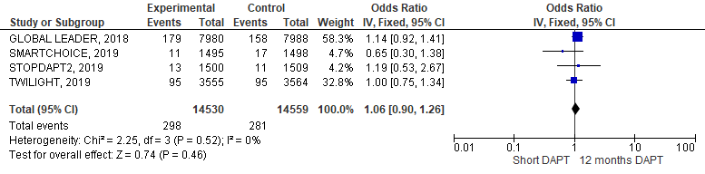

Figure B. Rates of stroke during one year follow-up.
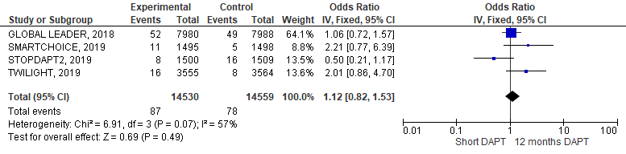

Figure C. Risk of bias.
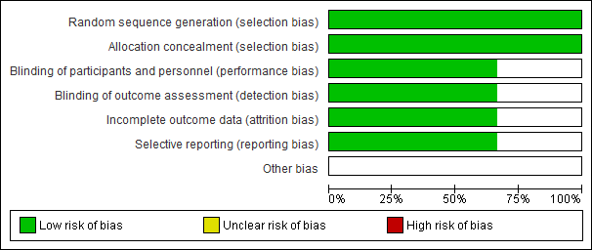
Figures D: Funnel plots.

Figure D1. Funnel plots for MACCE.

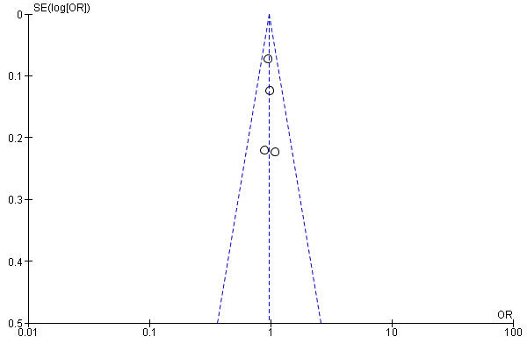
Figure D2. Funnel plots for all cause of death.

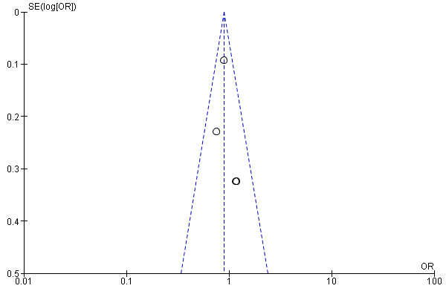

Figure D3. Funnel plots for definite or probable stent thrombosis.

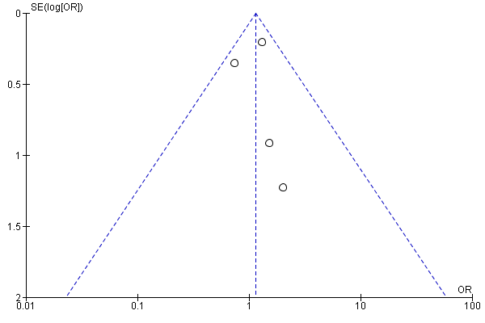
Figure D4. Funnel plots for BARC 3-5.

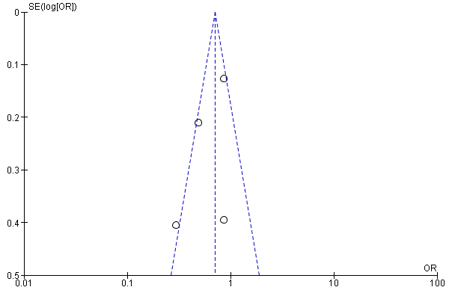

Figure D5. Funnel plots for myocardial infarction.

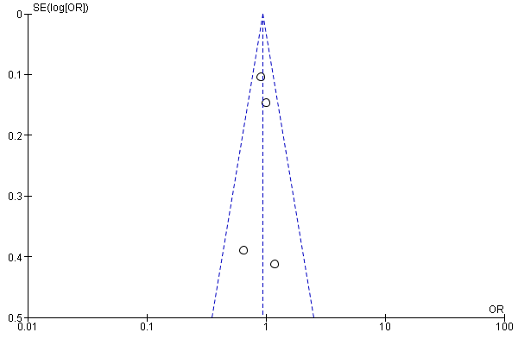

Figure D6. Funnel plots for stroke.

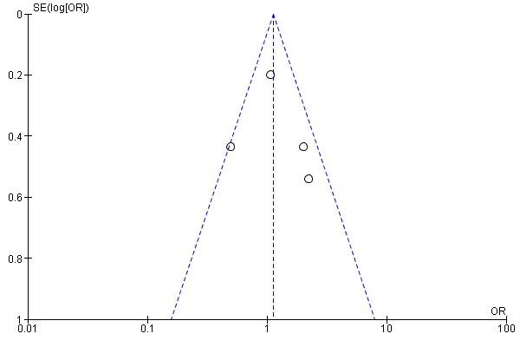

Figures E: Random-effect model analysis.

Figure E1. Random-effect model analysis. Rates of MACCE (major adverse cardiac and cerebrovascular events) a composite of all-cause mortality, myocardial infarction, or stroke during one year follow-up.
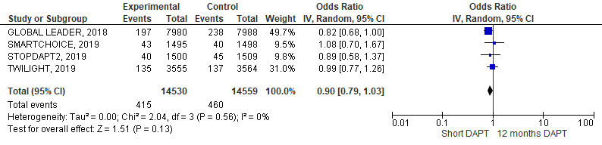

Figure E2. Random-effect model analysis. Rates of all cause of death during one year follow-up.
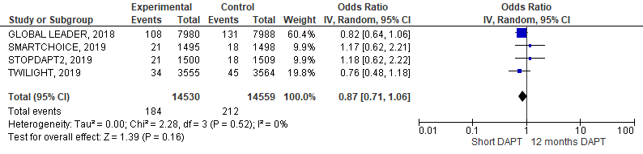

Figure E3. Random-effect model analysis. Rates of definite or probable stent thrombosis during one year follow-up.
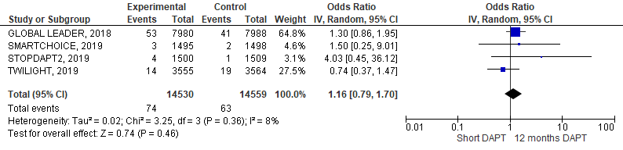

Figure E4. Random-effect model analysis. Rates of BARC 3-5 bleeding during one year follow-up.
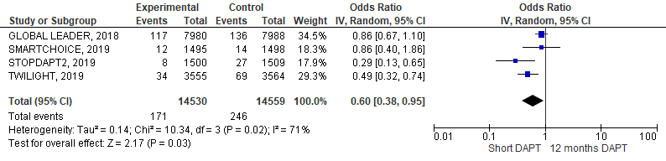

Figure E5. Random-effect model analysis. Rates of myocardial infarction during one year follow-up.
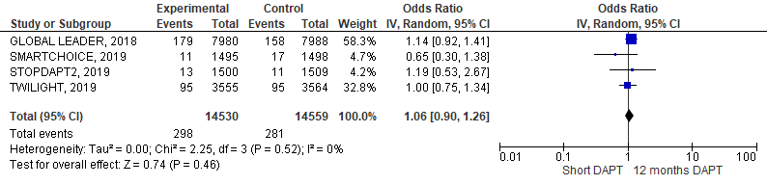

Figure E6. Random-effect model analysis. Rates of stroke during one year follow-up.
