Supplemental Data
EXTENDED METHODS
INCLUSION & EXCLUSION CRITERIA
PET Imaging of Giant Cell and Takayasu Arteritis (PITA):
ClinicalTrials.gov Identifier: NCT04071691
Inclusion Criteria:
- Male or female participants >18 years old
- Able to give written, informed consent and to lie flat
- Either:
- New clinical diagnosis or acute flare of large vessel vasculitis (Giant-cell arteritis or Takayasu's arteritis) within ~1 week of treatment initiation, and
- Clinical indication for ¹⁸F-FDG positron emission tomography (PET) imaging determined by the referring physician, or
- Undergoing surgery for large vessel vasculitis, or
- Diagnosis of large vessel vasculitis in remission
Exclusion Criteria:
- Women of childbearing potential not using adequate contraception
- Contra-indication to magnetic resonance imaging
- Contrast allergy or contrast-nephropathy
- Chronic kidney disease (eGFR <30 mL/min/1.73 m2)
- Any medical condition, in the opinion of the investigator, that prevents the participant from lying flat during scanning, or from participating in the study
- History of recent malignancy deemed relevant to the study by the investigator

Vascular Inflammation Imaging Using Somatostatin Receptor Positron Emission Tomography (VISION):
ClinicalTrials.gov Identifier: NCT02021188
Inclusion Criteria:
- Age ≥40 years of age
- Can provide written, fully informed consent
- Have had a transient ischemic attack or stroke within the preceding four weeks due to carotid artery atherosclerosis; or have ≥30% carotid artery or epicardial coronary artery stenosis
Exclusion Criteria:
- Renal impairment (eGFR<30mL/min)
- History of contrast nephropathy
- Atrial fibrillation
- Any condition, in the opinion of the investigator, which prevents the participant from lying flat during scanning
- Women of childbearing potential
- Inability to provide written informed consent
- Hemorrhagic stroke within 3 months of study entry
- Total occlusion of a culprit carotid artery
- Any medical condition, vital sign or laboratory value that, in the opinion of the investigator, makes the subject ineligible for inclusion

Residual Inflammation and Plaque Progression Long-term Evaluation (RIPPLE):
ClinicalTrials.gov Identifier: NCT04073810
Inclusion Criteria:
- Male or female participants >18 years old
- Able to give written, informed consent and to lie flat
- First-presentation of myocardial infarction within ~2 weeks
- At least mild non-culprit coronary artery disease on angiography, managed medically
Exclusion Criteria:
- Women of child-bearing potential not using adequate contraception
- Contrast allergy or contrast-nephropathy
- Uncontrolled atrial fibrillation
- Chronic kidney disease (eGFR <30 mL/min/1.73 m2)
- Any medical condition, in the opinion of the investigator, that prevents the participant from lying flat during scanning, or from participating in the study
- Uncontrolled chronic inflammatory disorder
- History of recent malignancy deemed relevant to the study by the investigator
- Current use of systemic corticosteroids
- Previous coronary artery bypass grafting surgery (CABG) or percutaneous coronary intervention (PCI) before the index event
- Contraindication to coronary angiography
- Requires CABG or staged non-culprit artery PCI
ADDITIONAL FIGURES

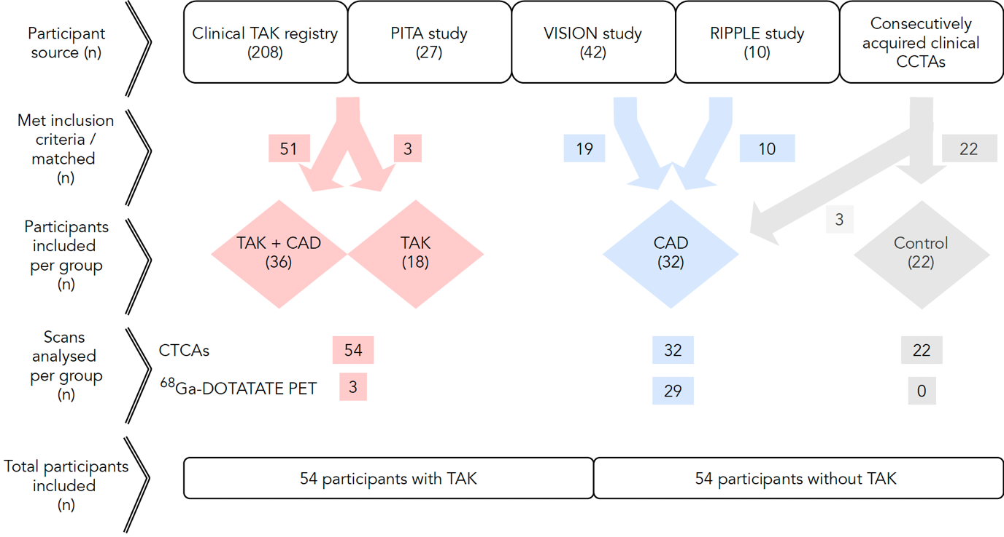
Figure S1. Study flow chart
Red: Takayasu arteritis (TAK); Blue: atherosclerotic coronary artery disease (CAD); Gray: Controls; CCTA: Coronary computed tomography angiography; FDG: Fluorodeoxyglucose; PET: Positron Emission Tomography

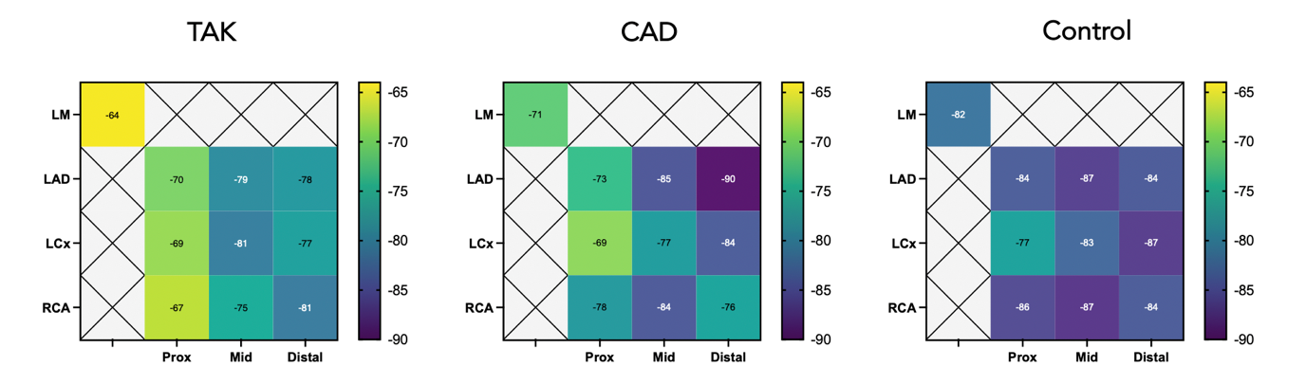

Figure S2. Distribution of PCAT density within the coronary tree
Color heatmap displaying median PCAT values (HU) around individual coronary segments from all subjects in each group.

ADDITIONAL TABLES

Table S1. PCAT & PAAT values by group

 | CAD+TAK | TAK | CAD | Control | p value
mPCAT_{total} (IQR), HU | -72.93 (-79.40, -67.46) | -73.31 (-76.62, -69.95) | -77.42 (-84.86, -73.09) | -82.99 (-86.96, -77.97) | p<0.0001
mPCAT_{prox} (IQR), HU | -68.91 (-75.38, -61.37) | -66.19 (-70.98, -60.36) | -72.08 (-78.37, -60.36) | -80.65 (-86.02, -74.35) | p<0.0001
mPCAT_{pRCA} (IQR), HU | -70.05 (-77.30, -63.81) | -65.79 (-71.53, -61.53) | -77.57 (-82.74, -66.09) | -85.65 (-90.01, -72.43) | p<0.0001
PAAT (IQR), HU | -65.55 (-71.35, -60.29) | -71.29 (-74.44, -63.16) | -74.30 (-79.85, -64.62) | -75.15 (-83.52, -70.27) | p=0.0001

Table S2. PCAT & PAAT ROC analyses

 | TAK+CAD vs  Stable CAD | TAK vs  Controls | Active vs  Inactive TAK | Active TAK vs Controls | Recent MI vs  Stable CAD | TAK vs Non-TAK
mPCAT_{total}
Lower threshold (HU) | -77.4 | -76.2 | -71.8 | -74.1 | -77.4 | -76.2
Sensitivity (%) | 72 | 78 | 73 | 1 | 79 | 0.70
Specificity (%) | 72 | 86 | 74 | 0.95 | 72 | 0.67
AUC (95% CI) | 0.76 (0.60-0.88) | 0.86 (0.72-0.97) | 0.82 (0.7-0.92) | 0.99 (0.97-1) | 0.77 (0.58-0.92) | 0.73 (0.63-0.82)
mPCAT_{prox}
Lower threshold (HU) | -72.7 | -72.2 | -66.9 | -72.1 | -69.8 | -71.5
Sensitivity (%) | 61 | 0.83 | 73 | 0.95 | 78 | 0.67
Specificity (%) | 61 | 0.95 | 66 | 1 | 64 | 0.70
AUC (95% CI) | 0.69 (0.54-0.82) | 0.88 (0.76-0.98) | 0.74 (0.59-0.86) | 0.97 (0.90-1) | 0.72 (0.52-0.89) | 0.72 (0.63-0.81)
mPCAT_{pRCA}
Lower threshold (HU) | -77.1 | -74.9 | -65.5 | -71.3 | -76.6 | -71.5
Sensitivity (%) | 67 | 0.83 | 67 | 0.93 | 64 | 0.67
Specificity (%) | 75 | 0.77 | 79 | 0.86 | 67 | 0.74
AUC (95% CI) | 0.7 (0.55-0.83) | 0.91 (0.81-0.98) | 0.76 (0.62-0.88) | 0.96 (0.89-1) | 0.69 (0.49-0.87) | 0.73 (0.63-0.82)
PAAT
Lower threshold (HU) | -71.9 | -72.9 | -65.1 | -69.9 | -75.1 | -71.2
Sensitivity (%) | 72 | 0.64 | 60 | 0.8 | 57 | 0.67
Specificity (%) | 78 | 0.61 | 63 | 0.82 | 50 | 0.67
AUC (95% CI) | 0.75 (0.61-0.88) | 0.73 (0.57-0.87) | 0.63 (0.45-0.79) | 0.86 (0.72-0.98) | 0.58 (0.37-0.77) | 0.73 (0.64-0.82)
Table S3. Spearman’s correlations for PCAT density vs clinical data

 | ITAS-CRP | CRP | ESR | WCC | Neut | Total Chol | LDL | BMI | % TPB | % CV risk
mPCAT_{total}
r value  (95% CI) | 0.43  (0.17-0.64) | 0.41  (0.22-0.57) | 0.41  (0.16-0.61) | 0.19  (-0.01-0.37) | 0.21  (0.01-0.40) | 0.05  (-0.16-0.26) | 0.02  (-0.18-0.22) | 0.11  (-0.10-0.32) | 0.04  (-0.20-0.28) | 0.08  (-0.11-0.28)
p value | 0.001 | <0.0001 | 0.002 | 0.05 | 0.03 | 0.61 | 0.84 | 0.29 | 0.72 | 0.38
mPCAT_{prox}
r value  (95% CI) | 0.39  (0.12-0.60) | 0.39  (0.20-0.56) | 0.38  (0.12-0.59) | 0.24 (0.04-0.42) | 0.24  (0.04-0.42) | 0.005  (-0.21-0.22) | -0.05  (-0.25-0.16) | 0.08  (-0.14-0.29) | 0.005  (-0.24-0.25 | 0.07  (-0.13-0.26)
p value | 0.004 | <0.0001 | 0.004 | 0.02 | 0.02 | 0.96 | 0.65 | 0.45 | 0.97 | 0.46
mPCAT_{pRCA}
r value  (95% CI) | 0.39  (0.12-0.60) | 0.35  (0.15-0.52) | 0.31  (0.04-0.53) | 0.22 (0.02-0.41) | 0.26  (0.06-0.44) | 0.09  (-0.12-0.30) | 0.003  (-0.19-0.21) | 0.11  (-0.11-0.31) | 0.04  (-0.21-0.28) | -0.03  (-0.22-0.16)
p value | 0.004 | 0.0006 | 0.02 | 0.03 | 0.009 | 0.38 | 0.97 | 0.31 | 0.75 | 0.76
PAAT
r value  (95% CI) | 0.04  (-0.24-0.34) | 0.16  (-0.05-0.36) | 0.05  (-0.22-0.31) | 0.25 (0.06-0.43) | 0.29 (0.10-0.47) | 0.18  (-0.12-0.30) | 0.17  (-0.03-0.36) | 0.09  (-0.13-0.29) | -0.04  (-0.28-0.21) | -0.03  (-0.23-0.16)
p value | 0.78 | 0.12 | 0.72 | 0.01 | 0.003 | 0.38 | 0.08 | 0.42 | 0.75 | 0.71

Table S4. PCAT values for active vs inactive/stable disease
 | Active TAK | Inactive TAK | p value | Recent MI | Stable CAD | p value
mPCAT_{total} (HU) | -68.24 (-73.52, -66.16) | -75.44 (-80.43, -70.90) | 0.0002 | -73.82 (-77.76, -69.80) | -81.49 (-86.37, -75.37) | 0.008
mPCAT_{prox} (HU) | -64.20 (-68.79, -58.21) | -71.05 (-76.13, -62.99) | 0.004 | -73.65 (-84.52, -62.95) | -86.37 (-91.86, -81.49) | 0.0002
mPCAT_{pRCA} (HU) | -63.99 (-66.17, - 61.20) | -70.29 (-77.59, -65.76) | 0.0002 | -76.68 (-80.57, -61.15) | -83.15 (-92.18, -80.97) | 0.24
PAAT (HU) | -64.07 (-69.71, -60.18) | -68.72 (-74.34, -62.41) | 0.15 | -74.30 (-79.17, -64.39) | -74.50 (-82.56, -67.91) | 0.46

Table S5. Associations between PCAT density and potential confounding factors

Potential confounder | Fixed effects
Coronary artery¹ | ANOVA p<0.0001
Proximal, mid or distal segment¹ | ANOVA p<0.0001
Gender | p=0.18
Age² | -0.13 ± SEM 0.05 HU, p=0.008
Body mass index | p=0.51
Current statin use | p=0.42
Current steroid use³ | 3.19 ± SEM 1.43 HU, p=0.03
Total cholesterol | p=0.58
LDL cholesterol | p=0.95
HDL cholesterol | p=0.33
Hypertension | p=0.46
Diabetes mellitus | p=0.48
Current or ex smoking habit | p=0.86
Angina | p=0.19
Previous myocardial infarction | p=0.51
Recent myocardial infarction³ | 3.86 ± SEM 2.02 HU, p=0.06
Culprit vessel | p=0.91
% 10-year cardiovascular risk score | p=0.78
% total plaque burden | p=0.93
kV² | 0.26 ± SEM 0.04 HU, p<0.0001

Fixed effects are reported as estimate ± SEM where p<0.1
¹For categorical variables with multiple stems, the ANOVA p-value is reported
²Reported as the difference in PCAT density per unit of change
³Reported as the difference of PCAT density in samples with the condition versus those without

