Supplementary Online Content

Late Thrombotic Events after Bioresorbable Scaffold Implantation: A Systematic Review and Meta-analysis of Randomized Clinical Trials

Carlos Collet¹ MD*; Taku Asano¹ MD*; Yosuke Miyazaki² MD, PhD; Yuki Kataguiri MD¹; Yohei Sotomi¹ MD; *; Erhan Tecknecioglu², MD; Rafael Cavalcante² MD*, PhD; Robbert de Winter¹ MD, PhD; Takeshi Kimura³ MD, PhD; Runlin Gao⁴ MD, PhD; Serban Puricel⁵ MD; Stéphane Cook⁵ MD; Davide Capodanno⁶ MD, PhD; Yoshinobu Onuma² MD, PhD; Patrick W. Serruys⁷ MD, PhD.

- Department of Cardiology, Academic Medical Center, University of Amsterdam, The Netherlands;
- Department of Interventional Cardiology, Erasmus Medical Center, Rotterdam, The Netherlands;
- Kyoto University Hospital, Kyoto, Japan;
- Fu Wai Hospital, National Center for Cardiovascular Diseases, Chinese Academy of Medical Sciences, Beijing, China
- Department of Cardiology, Fribourg University and Hospital, Fribourg, Switzerland.
- Cardio-Thoracic-Vascular Department, Ferrarotto Hospital, University of Catania, Catania, Italy
- Imperial College of London, United Kingdom.

Table of contents:

- PRISMA checklist (Table 1)………………………………………………………….. 3
- Risk of bias assessment (Table 2)……………………………………………………...5
- Characteristics of device thrombosis cases (Table 3)………………………………….7
- References……………………………………………………………………………...8

Table 1. Preferred reporting items for systematic reviews and meta-analysis checklist. ¹
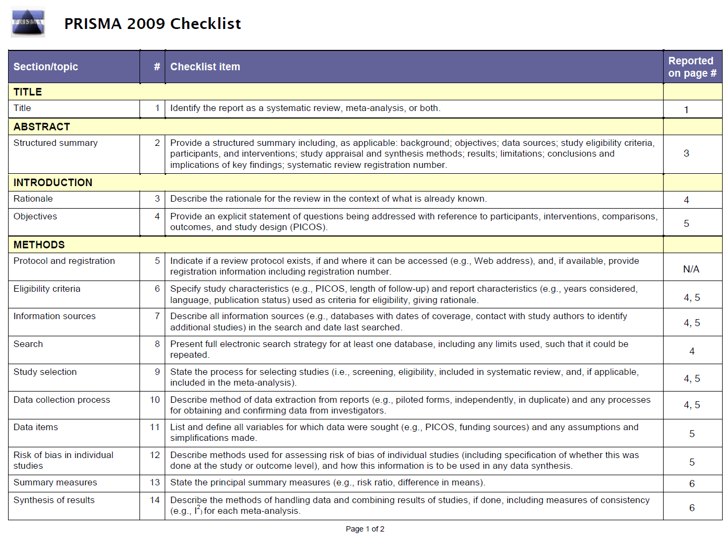

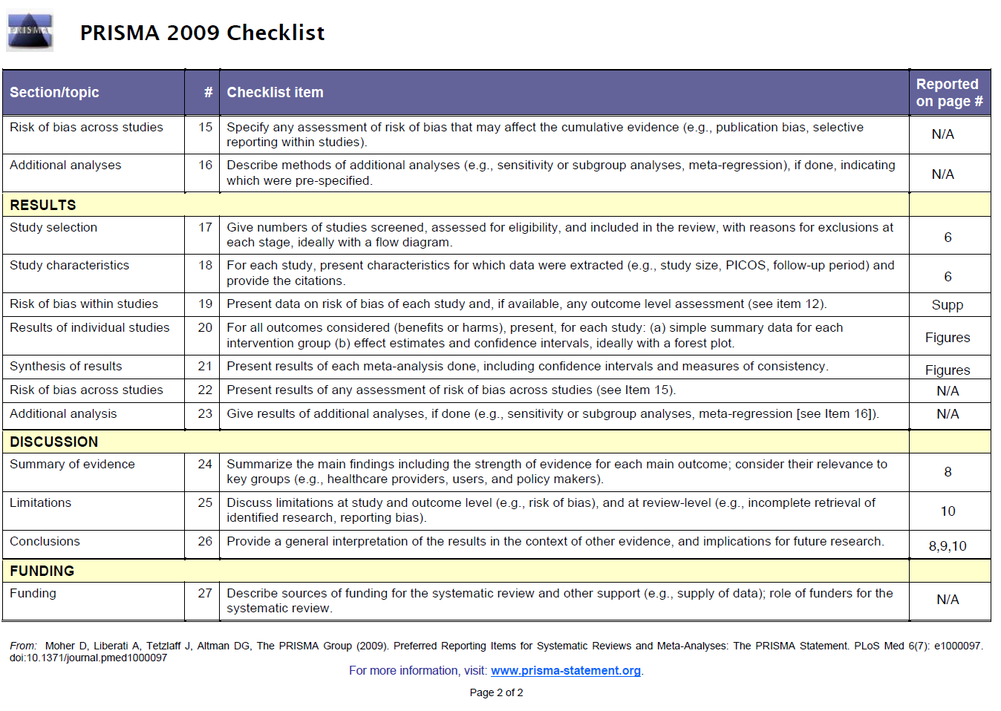

Table 2. Risk of bias assessments for randomized clinical trials. ²

 | Random sequence generation (selection bias) | Allocation concealment (selection bias) | Blinding of participants and researchers (performance bias) | Blinding of outcome assessment (detection bias) | Incomplete outcome data (attrition bias) | Selective reporting (reporting bias) | Other bias | Overall
ABSORB II³ | LOW | LOW | HIGH | LOW | LOW | LOW | LOW | LOW
ABSORB Japan^{4, 5} | LOW | LOW | HIGH | LOW | LOW | LOW | LOW | LOW
ABSORB China^{6, 7} | LOW | LOW | HIGH | LOW | LOW | HIGH | LOW | LOW
TROFI II^{8, 9} | LOW | LOW | HIGH | LOW | LOW | HIGH | LOW | LOW
EVERBIO II^{10, 11} | LOW | LOW | HIGH | LOW | LOW | HIGH | LOW | LOW

The risk of bias was assessed according to Cochrane Collaboration’s handbook. For the assessment of selection bias, assessing the random sequence generation, the method used to generate the allocation sequence was assessed. It was described in detail in all publications, and it produced comparable groups. Therefore, low risk of bias was ascribed in all RCTs. For the allocation sequence concealment, studies protocols prevented foreknowledge of the forthcoming allocations. Therefore, all trials included in this meta-analysis showed low risk of selection bias. Regarding the performance bias, where measures used to blind study participants and personnel from knowledge of which intervention a participant received are assessed. A high risk of bias was ascribed, due to the fact that all studies were designed as open-label trials. Concerning the blinding of outcome assessment, it was graded as low since the outcomes of interest were clinical events (i.e., myocardial infarction, new percutaneous coronary intervention, cardiac death, etc.) which are objectives and well-defined end-points. The attrition bias also was low given that clinical follow-up data at two years was available in 95% (n=1642) of the population (94% [950/1015] Absorb BVS vs. 97% [692/715] EES). Also, the total the number of interventions was the same of the total number of participant included. Regarding the selective reporting of outcomes, all trials were consistent in reporting the primary and secondary end-point according to the Academic Research Consortium. ¹²Nevertheless, due to the fact that the long-term outcomes of three studies were assessed in a abstracts format a high risk of bias was attributed to these studies.

Table 3. Clinical, device, procedural and outcomes of patients presenting with scaffold thrombosis.

Days after implantation | Gender | Age | Target vessel | Scaffold size diameter-length (mm) | Post dilatation | Post procedural MLD in scaffold (mm) | Post procedural %DS | Clinical presentation at the time of thrombosis | Antiplatelet therapy at the time of thrombosis | Death after thrombotic event
0 | M | 53 | Diagonal | 2.5-18 | Yes | 1.94 | 19% | STEMI | DAPT | No
2 | M | 46 | LAD | 3-18*2 | Yes | 2.19 | 19% | STEMI | DAPT | No
4 | M | 64 | RCA | 2.5-18 | Yes | 2.27 | 11.50% | NSTEMI | DAPT | No
4 | M | 55 | LAD | 3.0-18 | Yes | 2.4 | 9.90% | STEMI | DAPT | No
5 | M | 64 | LCX | 2.5-18 | No | 1.69 | 19.80% | STEMI | DAPT | No
6 | M | 70 | LAD | 3.0-N/A | Yes | 2.04 | 14.0% | STEMI | DAPT | No
139 | F | 75 | LAD | 2.5-28 | No | 1.84 | 6.80% | STEMI | None | No
335 | M | 75 | LAD | 3.0-18 | No | 2.36 | 14% | STEMI | None | No
400 | M | 56 | RCA | 3.5-12/3.5-18 | Yes | 3.14 | 13.5% | STEMI | SAPT | No
447 | M | 44 | LAD | 3.0-18 | Yes | 2.24 | 21% | STEMI | SAPT | No
494 | M | 79 | LAD | 3.5-28 | Yes | 2.57 | 18% | STEMI | None | No
536 | M | 44 | RCA | 3.5-18 | No | 2.79 | 16.20% | STEMI | SAPT | No
595 | M | 72 | RCA | 3.0-18 | Yes | 2.19 | 20.5 | STEMI | DAPT | No
602 | M | 54 | RCA | 3.0-18 | No | 2.16 | 21% | STEMI | SAPT | No
679 | M | 59 | RCA | 3.5-18 | No | 3.12 | 7.60% | STEMI | SAPT | No
967 | M | 58 | LAD | 3.0-18 | Yes | 2.38 | 24% | STEMI | SAPT | No
981 | M | 76 | OM2 | 3.0-18 | No | 2.28 | 28% | STEMI | SAPT | No
1022 | M | 65 | LAD | 3.0-18 | No | 2.43 | 13% | STEMI | SAPT | No
1082 | M | 63 | OM1 | 3.0-18 | Yes | 2.29 | 17% | STEMI | SAPT | Yes

M = Male. F = Female. LAD = Left Anterior Descending Artery. RCA: Right Coronary Artery. LCX = Left Circunflex Artery. N/A = Not Available. STEMI = ST- elevation Myocardial Infarction. NSTEMI = Non-ST-elevation Myocardial Infarction. DAPT = Dual Antiplatelet Therapy. SAPT = Single Antiplatelet Therapy.

References

1. Preferred reporting items for systematic review and meta-analysis protocols (PRISMA-P) 2015: elaboration and explanation. BMJ (Clinical research ed) 2016;354:i4086.
2. Higgins JP, Altman DG, Gotzsche PC, Juni P, Moher D, Oxman AD, Savovic J, Schulz KF, Weeks L, Sterne JA. The Cochrane Collaboration's tool for assessing risk of bias in randomised trials. BMJ (Clinical research ed) 2011;343:d5928.
3. Serruys PW, Chevalier B, Sotomi Y, Cequier A, Carrie D, Piek JJ, Van Boven AJ, Dominici M, Dudek D, McClean D, Helqvist S, Haude M, Reith S, de Sousa Almeida M, Campo G, Iniguez A, Sabate M, Windecker S, Onuma Y. Comparison of an everolimus-eluting bioresorbable scaffold with an everolimus-eluting metallic stent for the treatment of coronary artery stenosis (ABSORB II): a 3 year, randomised, controlled, single-blind, multicentre clinical trial. Lancet 2016.
4. Kimura T, Kozuma K, Tanabe K, Nakamura S, Yamane M, Muramatsu T, Saito S, Yajima J, Hagiwara N, Mitsudo K, Popma JJ, Serruys PW, Onuma Y, Ying S, Cao S, Staehr P, Cheong WF, Kusano H, Stone GW. A randomized trial evaluating everolimus-eluting Absorb bioresorbable scaffolds vs. everolimus-eluting metallic stents in patients with coronary artery disease: ABSORB Japan. European heart journal 2015;36(47):3332-42.
5. Onuma Y, Sotomi Y, Shiomi H, Ozaki Y, Namiki A, Yasuda S, Ueno T, Ando K, Furuya J, Igarashi K, Kozuma K, Tanabe K, Kusano H, Rapoza R, Popma JJ, Stone GW, Simonton C, Serruys PW, Kimura T. Two-year clinical, angiographic, and serial optical coherence tomographic follow-up after implantation of an everolimus-eluting bioresorbable scaffold and an everolimus-eluting metallic stent: insights from the randomised ABSORB Japan trial. EuroIntervention 2016;12(7).
6. Gao R, Yang Y, Han Y, Huo Y, Chen J, Yu B, Su X, Li L, Kuo HC, Ying SW, Cheong WF, Zhang Y, Su X, Xu B, Popma JJ, Stone GW. Bioresorbable Vascular Scaffolds Versus Metallic Stents in Patients With Coronary Artery Disease: ABSORB China Trial. J Am Coll Cardiol 2015;66(21):2298-309.
7. Gao R. ABSORB China: Two-Year Clinical Results in Patients with Coronary Artery Disease Randomized to the Absorb Bioresorbable Vascular Scaffold Versus Metallic Drug-Eluting Stents. In: Transcatheter Cardiovascular Therapeutics Congress 2016. Washington DC, USA., 2016.
8. Sabate M, Windecker S, Iniguez A, Okkels-Jensen L, Cequier A, Brugaletta S, Hofma SH, Raber L, Christiansen EH, Suttorp M, Pilgrim T, Anne van Es G, Sotomi Y, Garcia-Garcia HM, Onuma Y, Serruys PW. Everolimus-eluting bioresorbable stent vs. durable polymer everolimus-eluting metallic stent in patients with ST-segment elevation myocardial infarction: results of the randomized ABSORB ST-segment elevation myocardial infarction-TROFI II trial. European heart journal 2016;37(3):229-40.
9. Windecker S, Asano T, Raber L, Brugaletta S, Sabate M, Onuma Y, Serruys P. TCT-49 Two-year clinical outcome of Everolimus-eluting bioresorbable scaffold vs. durable polymer everolimus-eluting metallic stent in patients with ST-segment elevation myocardial infarction: results of the randomized ABSORB ST-segment elevation myocardial infarction—TROFI II trial. Journal of the American College of Cardiology 2016;68(18, Supplement):B20.
10. Puricel S, Arroyo D, Corpataux N, Baeriswyl G, Lehmann S, Kallinikou Z, Muller O, Allard L, Stauffer JC, Togni M, Goy JJ, Cook S. Comparison of everolimus- and biolimus-eluting coronary stents with everolimus-eluting bioresorbable vascular scaffolds. J Am Coll Cardiol 2015;65(8):791-801.
11. Puricel S. Comarison of Everolimus- and Biolimus-Eluting Coronry Stents with Everolimus-Eluting Bioresorbable Scaffold:2-year Ooutcomes of the EVERBIO II Trial. In. Transcatheter Cardiovascular Therapeutics Congress 2015. Washinfton DC, USA; 2015.
12. Cutlip DE, Windecker S, Mehran R, Boam A, Cohen DJ, van Es GA, Steg PG, Morel MA, Mauri L, Vranckx P, McFadden E, Lansky A, Hamon M, Krucoff MW, Serruys PW. Clinical end points in coronary stent trials: a case for standardized definitions. Circulation 2007;115(17):2344-51.

