Appendix 2: Statistical appendix
Impact of design of coronary stents and length of dual antiplatelet therap on ischemic and bleeding events a network meta-analysis of 64 randomized controlled trials and 102,735 patients.

All endpoints are binary endpoints, and the differences between the groups are measured in terms of Odds-Ratios (OR).
First, for each direct pairwise comparison between two groups and for each endpoint, the direct estimates were obtained using frequentist standard pairwise meta-analyses from all trials comparing directly the two interventions, or from a single trial if only one compared directly the two groups. Standard pairwise meta-analyses were conducted in a frequentist framework using a random effect model. The between-study heterogeneity was assessed using a visual inspection of the caterpillar plots with their 95% Confidence Intervals (CI), the I² statistic and Cochrane’s Q tests.
Second, network meta-analyses were performed in a Bayesian framework, using a random-effect model accounting for correlations induced by multi-arm trials and with the assumption of homogeneous between-study variance [1,2]. All the parameters were given minimally informative priors. The posterior distributions of the parameters were obtained with Markov Chain Monte Carlo methods, using two chains. The chains were thinned to reduce autocorrelations, discarding all but every k^{th} sampled value. For each chain, the first 10,000 Monte-Carlo iterations (500,000 in total for death and CV death with a thin of k=50, and 100,000 in total for the other endpoints with a thin of k=10) were run to reach convergence and disregarded, then 10,000 further simulations per chain (thinned as before) were run to estimate the parameters.
The autocorrelation of the chains was checked through inspection of autocorrelation plots. The Brooks-Gelman-Rubin diagnostic tool [2] and a visual inspection of the history plots were used to check the convergence of the chains. The goodness-of-fit of the models was first assessed by comparing the posterior mean of the residual deviance to the number of unconstrained data points. Then, the contributions of individual observations to the fit and complexity are assessed using leverage plots, i.e. diagnostic plots of deviance residuals against leverages. These plots give information on whether poorly fitting data points are having a material effect on the model parameters. The between-study variance τ² was checked and the between-study heterogeneity was assessed using a visual inspection of the caterpillar plots with their 95% Credibility Intervals (CrI). For each endpoint, the global consistency of the network was assessed by comparing the standard consistency model used for the main analysis with an inconsistency model in which the constraints forced by the consistency equations are removed. An omnibus test of consistency is obtained by comparing the deviance statistics of the consistency and inconsistency models. In order to further explore the consistency of the model, a node-splitting analysis [3] was performed, i.e. to assess whether direct and indirect evidence on a specific comparison were in agreement. For each edge of the network where a direct comparison and at least one indirect comparison was available, an inconsistency factor was calculated as the difference between the direct and the indirect estimate, and the amount of agreement between the direct and indirect evidence is formally measured by the so-called Bayesian p-value [3]. Since inconsistency tests are known to be underpowered, the Bayesian p-values were compared to 10% to detect inconsistencies. It should be noted however that, due to the multiplicity of tests for inconsistency, adjustment of significance levels would need to be considered, but knowing the correct level of adjustment is difficult because the tests are not independent. Therefore, no adjustment for multiplicity has been applied, and the findings of the node-splitting analysis should be considered as exploratory since the presence of inconsistency may have been overestimated, leading to too pessimistic conclusions. Comparisons for the primary outcome were evaluated according to the GRADE scale [4].
The presence of small study effects was assessed through inspection of comparison-adjusted funnel plots where the interventions are ordered from less experimental to more experimental.
For each endpoint, the groups were ranked and the posterior distributions of the ranks were examined. The surfaces under the cumulative ranking curve (SUCRA) were calculated, accounting both for the location and the variance of the relative intervention effects. The larger the SUCRA value, the best the rank of an intervention, and it can be interpreted as the average proportion of other interventions worse than it.
A risk of bias assessment was performed using the Cochrane risk of bias tool, evaluating the quality of allocation concealment (selection bias), blinding of participants and personnel (performance bias), blinding of outcome assessment (detection bias), incomplete outcome data (attrition bias) and selective outcome reporting (reporting bias). Sensitivity analyses were performed by (1) excluding studies with high risk of bias and (2) restricting the network to trials at low risk of bias (excluding high, medium and unclear risk of bias). The performance bias was disregarded in the sensitivity analyses since the blinding of the personnel was not possible for such interventions (stents).
Other sensitivity analyses were conducted (1) analyzing EES and ZES separately, by length of DAPT (other groups are unchanged) and (2) analyzing EES, ZES Resolute and ZES Endeavour separately (excluding mixed or unclear ZES groups), by length of DAPT (other groups are unchanged).

- Endpoints and groups
The endpoints are:
- MACE (primary endpoint)
- All cause death
- Cardiovascular death (CV death)
- Myocardial infarction (MI)
- Target vessel revascularization (TVR)
- Target lesion revascularization (TLR)
- Definite Stent Thrombosis (ST)
- Major Bleeding

For MACE, All cause death, CV death, MI, TVR and ST, the following interventions were compared:
- Bioreasorbable stent with DAPT = 12 months
- Polymer biodegradable stent with DAPT = 12 months
- Everolimus/Zotarolimus Eluting Stent (EES/ZES) with DAPT = 12 months
- EES/ZES with DAPT < 12 months
- EES/ZES with DAPT > 12 months
- Paclitaxel Eluting Stent (PES) with DAPT <= 12 months
- Sirolimus Eluting Stent (SES) with DAPT <= 12 months
- Bare-Metal Stents (BMS)

For TLR, the groups were the same with the exception of EES/ZES with DAPT > 12 months for which no data were available.

For Major Bleeding, the following interventions were compared:
- Stents with DAPT < 12 months
- Stents with DAPT = 12 months
- Stents with DAPT > 12 months

- Measure of intervention effect
All endpoints are binary endpoints. For each pairwise comparison, the odds-ratio (OR) was calculated and the results are presented on the OR scale (in the main manuscript and the clinical appendix) or on the log odds-ratio (LOR) scale (in the statistical appendix) along with their 95% Confidence Interval (CI) for frequentist analyses, or with their 95% Credibility Interval (CrI) for Bayesian analyses. Details are provided below.

- Direct comparisons
For each direct pairwise comparison between two groups and for each endpoint, the direct estimates of the LOR were obtained using standard pairwise meta-analyses from all trials comparing directly the two interventions, or from a single trial if only one compared directly the two groups.

Standard pairwise meta-analyses were conducted in a frequentist framework with the meta package from R, using a random effect model. For studies with a zero cell count, by default, a continuity correction is applied and 0.5 is added to all cell frequencies of these studies.

Caterpillar plots of the direct comparisons, from single trials or from pairwise meta-analyses, when applicable, are presented on the LOR scale in Figures 1-8 of this appendix, along with results of the network meta-analysis.

For each endpoint and for each pairwise meta-analysis, the between-study heterogeneity was assessed: the number of studies comparing directly the two interventions, the I² statistic (percentage of variability due to heterogeneity rather than to sampling error) and the p-value of the Cochrane’s Q test are provided in Table 1 of this appendix. Nodes not presented in the table were not compared directly (they may differ from one endpoint to another since not all the endpoints were reported for all the studies).

Overall, 39 direct comparisons were assessed from one single trial and 74 from several trials using pairwise meta-analyses. In the meta-analyses, the between-study heterogeneity is important, with a 33 out of 74 comparisons with a p-value > 10% for the Cochrane’s Q test.

- Network meta-analysis
  - Model and programs
Network meta-analyses (NMA) synthesize direct and indirect comparisons in a connected network of trials involving different interventions. NMA were conducted for each endpoint in a Bayesian framework, using a random-effect model accounting for correlations induced by multi-arm trials and with the assumption of homogeneous variance (i.e. that all comparisons in the network share a common variance τ²) ([5], [6]).

The trial baseline log odds and the basic parameters for LOR relative to the reference group (Bioreasorbable stent with DAPT = 12 months (BRS)) are all given unrelated, minimally informative priors Normal (0, 10,000), while the remaining LOR (functional parameters) are defined in terms of the basic parameters. The between-study variance parameter τ² was also given a vague prior Inverse.Gamma (0.001, 0.001). The choice of the reference group has no implication for the comparisons.

The model was fitted in Winbugs using the code developed by the National Institute for health and Care Excellence (NICE) Decision Support Unit. Its final version is provided in supplemental material. It was run routinely in ‘batch-mode’ from R using the package R2Winbugs, and the data manipulations and the results output were performed in R.

The analyses were conducted using WinBUGS 1.4.3 and R version 3.2.1.

  - Autocorrelations and convergence
The autocorrelation of the chains was checked through inspection of autocorrelation plots. Since they initially indicate that the autocorrelation was high for most of the parameters, the chains were thinned to reduce autocorrelations, discarding all but every k^{th} sampled value. For each chain, the first 10,000 Monte-Carlo iterations (500,000 in total for death and CV death with a thin of k=50, and 100,000 in total for the other endpoints with a thin of k=10) were run to reach convergence and disregarded, then 10,000 further simulations per chain (thinned as before) were run to estimate the parameters.

After thinning, the autocorrelations were satisfactory (lag < 10).

The convergence was checked through inspection of the history plots and according to the Brooks-Gelman-Rubin diagnostic tool [6]. The convergence seems satisfactory: for each endpoint, no structure was observed in the history plots, the between- and within-chain variability have settled together to stability and the ratio between the two has converged to 1.

  - Goodness-of-fit
First, the goodness-of-fit of the models is assessed by comparing the posterior mean of the residual deviance to the number of unconstrained data points [7]. A model is considered to appropriately fit the data is they are close. They are provided for each endpoint in Table 2 of this appendix.
Then, the contributions of individual observations to the fit and complexity are assessed using “leverage plots”, i.e. diagnostic plots of deviance residuals against leverages ([8], [9], [10]). These plots give information on whether poorly fitting data points are having a material effect on the model parameters. The leverage for each data point is calculated as the posterior mean of the residual deviance minus the deviance at the posterior mean of the fitted values. The curves marked on each plot are of the form x² + y = c (c=1, 2, 3, 4) and points lying along such a parabola will each contribute an amount c to the DIC for the model. Points which lie outside the lines with c=3 can generally be identified as contributing to the model’s poor fit. Leverage plots are provided for each endpoint in Figure 33-40.

The residual deviances of the models suggest that the quality of fit is questionable for MI and death. Moreover, for each endpoint, a certain number of points are identified as contributing to the models’ poor fit, with by decreasing proportion: ST (5/84, i.e. 6% of the data points), Death (7/121, 5.8%), MI (6/123, 4.9%), Major bleeding (1/22, 4.5%), CV death (5/114, 4.4%), TLR (3/98, 3.1%), TVR (3/110, 2.7%) and MACE (2/110, 1.8%). Therefore, the results should be interpreted with caution. The quality of fit for MACE, the primary endpoint, seems however acceptable.

  - Heterogeneity assessment
For each endpoint, the estimation of the common between-study variance τ² and its 95% CrI is provided in Table 2 of this appendix. According to Spiegelhalter et al ([5]), values of τ from 0.1 to 0.5 (i.e. τ² from 0.01 to 0.25) may appear reasonable in many contexts, from 0.5 to 1.0 (i.e. τ² from 0.25 to 1) might be considered as fairly high, and above 1.0 would represent fairly extreme heterogeneity. The results therefore suggest that heterogeneity is reasonable for death, CV death, MI and major bleeding, and is fairly high for MACE, TVR, TLR and ST.

  - Probabilities to perform best and SUCRA
For each endpoint, the groups were ranked and the posterior distributions of the ranks were examined. Rankograms are presented in Figures 1, 3, 5, 7, 9, 11, 13 and 15 of the Appendix 1 (web only).

Ranking of groups based on the probability for each group to perform best does not account for the uncertainty in the relative group effect. Instead, the surfaces under the cumulative ranking curve (SUCRA) were calculated ([10], [11]). The SUCRA values account both for the location and the variance of the relative intervention effects. The larger the SUCRA value, the best the rank of an intervention, and it can be interpreted as the average proportion of other interventions worse than it. The ranking plots according to the SUCRA are presented in Figures 2, 4, 6, 8, 10, 12, 14 and 16 of the Appendix 1 (web only).

  - Inconsistency
First, the results of the direct comparisons and of the NMA were compared using the caterpillar plots (Figures 1-8). Some differences are noticeable and usually occur when the result from the direct comparison is highly variable, due to the low number of events reported for the considered endpoint and the considered direct comparison. In general, confidence intervals of the direct comparisons and credibility intervals of the NMA overlap largely, suggesting that their results are not conflicting.

For each endpoint, the global consistency of the network was assessed by comparing the standard consistency model used for the main analysis with an “inconsistency model” (or Unrelated Mean Effect model) in which the constraints forced by the consistency equations are removed ([12], [13]). An omnibus test of consistency is obtained by comparing the deviance statistics of the consistency and inconsistency models. The results are presented in Table 3. None of the omnibus tests are significant, and p-values are large, suggesting that inconsistency models do not fit better than the standard consistency model. Therefore, the global consistency of the models seems satisfying. We can note moreover that, according to the DIC criterion, the standard consistency models are actually slightly better for all endpoints except ST. It should be noted that the inferences are sensitive to the parameterization of multi-arm studies in the inconsistency model ([12], [13]).

In order to further explore the consistency of the model, a node-splitting analysis [3] was performed to detect inconsistencies at the node level, i.e. to assess whether direct and indirect evidence on a specific comparison were in agreement. For each endpoint, and for each edge of the network where a direct comparison and at least one indirect comparison was available, two posterior distributions of the LOR were obtained: one based on studies comparing the two groups directly, and the other using an NMA of all the remaining studies, i.e. using only indirect evidence for this edge. An inconsistency factor was calculated as the difference between the direct and the indirect estimate, and the amount of agreement between the direct and indirect evidence is formally measured by the so-called Bayesian p-value [3]. Since inconsistency tests are known to be underpowered, the Bayesian p-values were compared to 10% to detect inconsistencies. It should be noted however that, due to the multiplicity of tests for inconsistency, adjustment of significance levels would need to be considered, but knowing the correct level of adjustment is difficult because the tests are not independent ([12], [13]). Therefore, no adjustment for multiplicity has been applied, and the findings should be considered as exploratory since the presence of inconsistency may have been overestimated, leading to too pessimistic conclusions.

The inconsistency plots are provided in Figures 9-16 of this appendix and the Bayesian p-value are provided in the figures, in parenthesis near to the label of each comparison. They are ordered according to the magnitude of the medians of the inconsistency factor posterior distribution. The results were interpreted in light of the results of the direct comparisons and of the NMA presented in the caterpillar plots (Figures 1-8).
In few cases, the amount of data was insufficient to estimate the inconsistency factor:
- Bioreabsorbable with DAPT=12m. vs Polymer biodegradable with DAPT<=12m for death, CV death, MI and ST. The only direct comparison between these two groups came from one small study (EVERBIO II) with very few or no events in each arm. Given this, the amount of direct evidence is close to zero and the indirect evidence was the most precise source of information to compare these groups.
- Polymer biodegradable with DAPT<=12m. vs PES with DAPT<=12m for ST. The only direct comparison between these two groups came from one study of moderate size (NOBORI I) with very few or no events in each arm. As before, the amount of direct evidence is close to zero and the indirect evidence was the most precise source of information to compare these groups.
- EES/ZES with DAPT=12m. vs PES with DAPT<=12m for ST. The only indirect comparison between these two groups is made through Polymer biodegradable with DAPT<=12m., using therefore the previous comparison which was not estimable. The direct comparison mostly impacted the NMA result for this comparison (cf. Figure 7), which is considered reasonable.
- Finally, PES with DAPT<=12m. vs SES with DAPT<=12m. for ST. As before the only direct comparison between these two groups came from one study (ZEST) with very few events. The amount of direct evidence is close to zero and the indirect evidence was the most precise source of information to compare these groups.

No inconsistency was detected for MACE, death, ST and Major bleeding.
Three inconsistencies were detected for MI:
- Polymer biodegradable with DAPT<=12m. vs EES/ZES with DAPT<12m (p=0.06). For this comparison, the precision of the direct comparison is low (cf. Figure 4), so the result of the NMA is driven by indirect comparisons. The corresponding result should be interpreted with caution.
- EES/ZES with DAPT=12m. vs Bare−Metal (p=0.06). The caterpillar plot shows that the result of the NMA is slightly more favorable to EES/ZES with DAPT=12m. than the direct comparison, however they are both in the same direction and statistically significant, so the result of the NMA seems acceptable.
- EES/ZES with DAPT=12m. vs EES/ZES with DAPT<12m (p=0.02). The caterpillar plot indicates that the LOR from the direct comparison and from the NMA are in opposed directions, however they are both closed to zero and not statistically significant, so no claim is made from this result.
One inconsistency was detected for CV death: Polymer biodegradable with DAPT<=12m. vs EES/ZES with DAPT<12m (p=0.04). The caterpillar plot (Figure 3) indicates a large difference between the LOR from the NMA and from the direct comparison. However, the direct comparison has a very low precision so the result of the NMA, mainly driven by indirect comparisons, is considered acceptable but should be interpreted with caution.
Two inconsistencies were detected for TVR:
- EES/ZES with DAPT<12m. vs PES with DAPT<=12m. (p=0.06). The only direct comparison between these two groups came from one study of moderate size (RESOLUTE-China) with a low precision (Figure 5).
- PES with DAPT<=12m. vs SES with DAPT<=12m. (p=0.08). The direct comparison between these two groups came from a meta-analysis of two studies (NAPLES and ZEST) with a high heterogeneity, and therefore a low precision (Table 1 and Figure 5).
Finally, one inconsistency was detected for TLR: PES with DAPT<=12m. vs SES with DAPT<=12m (p<0.0001). This inconsistency had a notable impact on the result of the NMA for this comparison (Figure 6), and its reliability is doubtful.
No interpretation or claims are made for these comparisons, and we believe that the few inconsistencies detected among the large amount of results do not invalidate the conclusions of this publication, even though the results should be interpreted with caution.

  - Comparison-adjusted funnel plots
The presence of small study effects was checked through inspection of comparison-adjusted funnel plots [11], provided in Figures 17-24 of this appendix. The interventions are ordered from less experimental to more experimental as: BMS, SES with DAPT <= 12 months, PES with DAPT <= 12 months, polymer biodegradable stent with DAPT <= 12 months, EES/ZES with DAPT < 12 months, EES/ZES with DAPT = 12 months, EES/ZES with DAPT > 12 months, and finally Bioabsorbable with DAPT = 12 months. Then, all LORs are presented as ‘more experimental versus less experimental intervention’. The comparison-adjusted funnel plots present the difference between each study-specific LOR from the corresponding direct comparison-specific summary LOR. A funnel plot which is asymmetrical with respect to the line of the summary effect implies that there are differences between the estimates derived from small and large studies. A linear regression line of the comparison-adjusted LORs on the standard error is added to the plot.
Small study effects are detected for ST (p-value = 0.01 for the slope of regression line), suggesting that less experimental interventions are favoured in small trials for this endpoint. The slope of the regression line appears quite important for major bleeding, but is driven by few data points and is not significant (p=0.14). No small study effects are detected for the other endpoints.

  - Sensitivity analyses
A risk of bias assessment (Table 4 of this appendix) was performed using the Cochrane risk of bias tool, evaluating the quality of allocation concealment (selection bias), blinding of participants and personnel (performance bias), blinding of outcome assessment (detection bias), incomplete outcome data (attrition bias) and selective outcome reporting (reporting bias).
Two sensitivity analyses were performed:
- Excluding studies with at least one high risk of bias,
- Restricting the network to trials at low risk of bias (excluding high, medium and unclear risk of bias).
The performance bias was disregarded in the sensitivity analyses since the blinding of the personnel was not possible for such interventions (stents).
The caterpillar plots of the LOR obtained from the main analysis and the two sensitivity analyses are presented in Figures 25-32 of this appendix.
Six studies out of 64 (9%) had at least one high risk of bias and were excluded from the first sensitivity analysis. They had a minimal impact on the results of the NMA, and the results of the sensitivity analysis and of the main analysis are consistent.
Thirty-one studies out of 64 (48%) had at least one high, medium or unclear risk of bias and were excluded from the second sensitivity analysis. For some comparisons, the sizes of the effects obtained with this sensitivity analysis differ noticeably from those of the main analysis. However, they are not conflicting (all the differences are in the same direction) and the precision of the sensitivity analysis is much lower.

Other sensitivity analyses were conducted:
- Analyzing EES and ZES separately by length of DAPT (other groups are unchanged)
- Analyzing EES, ZES Resolute and ZES Endeavour separately (excluding mixed or unclear ZES groups) by length of DAPT (other groups are unchanged).
Their results are commented in the main publication.

References

[1]. Lu G, Ades AE. Combination of direct and indirect evidence in mixed treatment comparisons. Statistics in Medicine 2004; 23:3105--3124.
[2]. Welton NJ, Sutton AJ, Cooper NJ, Abrams KR, Ades AE. Evidence Synthesis for Decision Making in Healthcare. 2012; John Wiley & Sons, Ltd
[3] Dias S, Welton NJ, Caldwell DM and Ades AE. Checking consistency in mixed treatment comparison meta-analysis. Statistics in Medicine 2010; 29: 932-944. doi: 10.1002/sim.3767.

[4] Puhan MA, Schünemann HJ, Murad MH, Li T, Brignardello-Petersen R, Singh JA, et al. A GRADE Working Group approach for rating the quality of treatment effect estimates from network meta-analysis. BMJ. 2014 Sep 24;349:g5630.

[5] Spiegelhalter DJ, Abrams KR, Myles JP. Bayesian Approaches to Clinical Trials and Health-Care Evaluation. John Wiley & Sons; 2004.

[6] Lu G, Ades AE. Combination of direct and indirect evidence in mixed treatment comparisons. Statistics in Medicine 2004; 23:3105--3124.

[7] Salanti G, Ades AE, Ioannidis JP. Graphical methods and numerical summaries for presenting results from multiple-treatment meta-analysis: an overview and tutorial. J Clin Epidemiol. 2011; 64(2):163–71. doi:10.1016/j.jclinepi.2010.03.016.

[8] Dias S, Welton NJ, Sutton AJ, Ades AE. NICE DSU technical support document 2: A generalized linear modeling framework for pairwise and network meta-analysis of Randomised Clinical Trials. Available from http://www.nicedsu.org.uk (April 2014). National Institute for Health and Clinical Excellence (NICE) Decision Support Unit (DSU).

[9] Dias S, Sutton AJ, Ades AE, Welton NJ. Evidence Synthesis for Decision Making 2: A Generalized Linear Modeling Framework for Pairwise and Network Meta-analysis of Randomized Controlled Trials. Medical Decision Making. 2013; 33 (5): 607-617. doi:10.1177/0272989X12458724.

[10] Spiegelhalter DJ, Best NG, Carlin BP, van der Linde A. Bayesian measures of model complexity and fit. J Roy Stat Soc B. 2002; 64 (4): 583–616.

[11] Chaimani A, Higgins JPT, Mavridis D, Spyridonos P, Salanti G. Graphical Tools for Network Meta-Analysis in STATA. PLoS ONE 2013; 8(10): e76654. doi:10.1371/journal.pone.0076654.

[12] Dias S, Welton NJ, Sutton AJ, Caldwell D, Lu G, Ades AE. NICE DSU technical support document 4: Inconsistency in Networks of Evidence Based on Randomised Controlled Trials. Available from http://www.nicedsu.org.uk (April 2014). National Institute for Health and Clinical Excellence (NICE) Decision Support Unit (DSU).

[13] Dias S, Welton NJ, Sutton AJ, Caldwell DM, Lu G, Ades AE. Evidence Synthesis for Decision Making 4: Inconsistency in Networks of Evidence Based on Randomized Controlled Trials. Medical Decision Making. 2013; 33 (5): 641-656. doi:10.1177/0272989X12455847

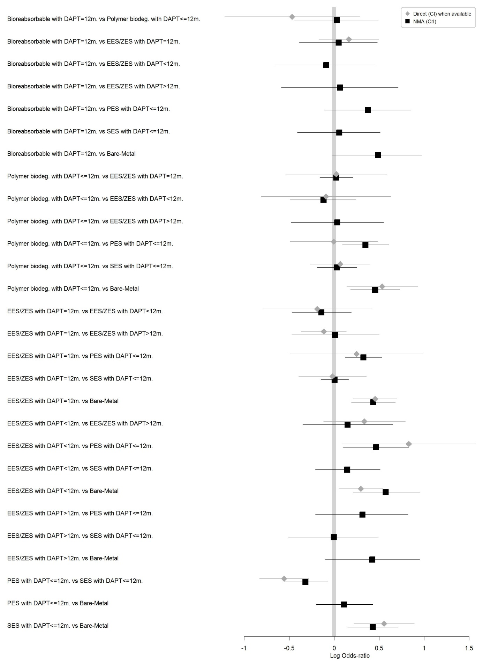
Figure 1: MACE. Caterpillar plot of the LOR estimated using 1) direct comparisons with 95% CI (when available, grey line); and 2) NMA with 95% CrI (black line).

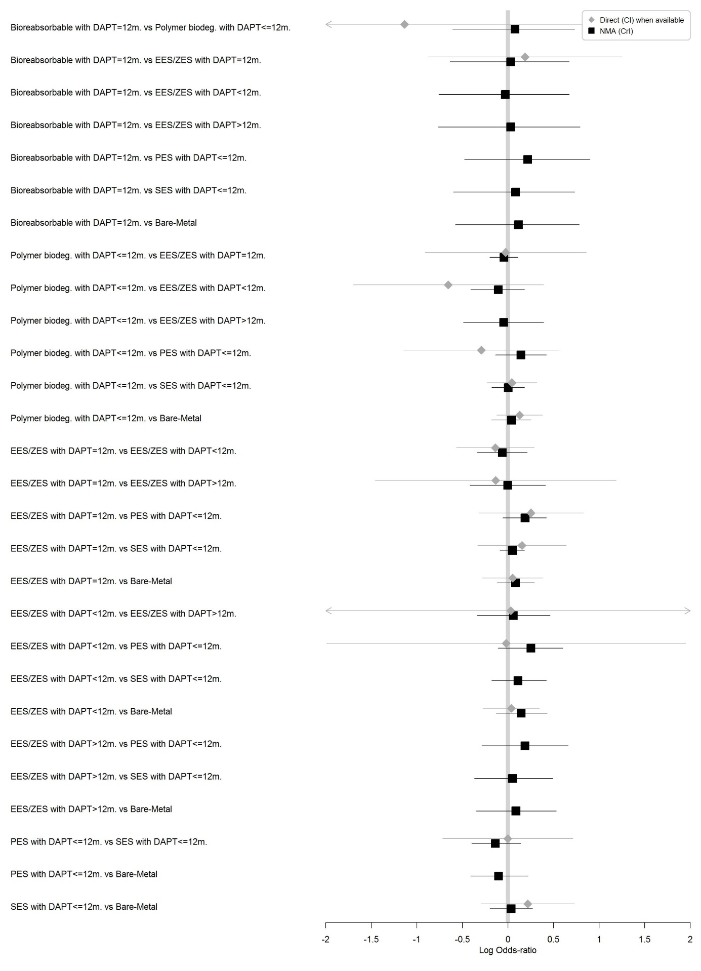
Figure 2: All cause death. Caterpillar plot of the LOR estimated using 1) direct comparisons with 95% CI (when available, grey line); and 2) NMA with 95% CrI (black line).

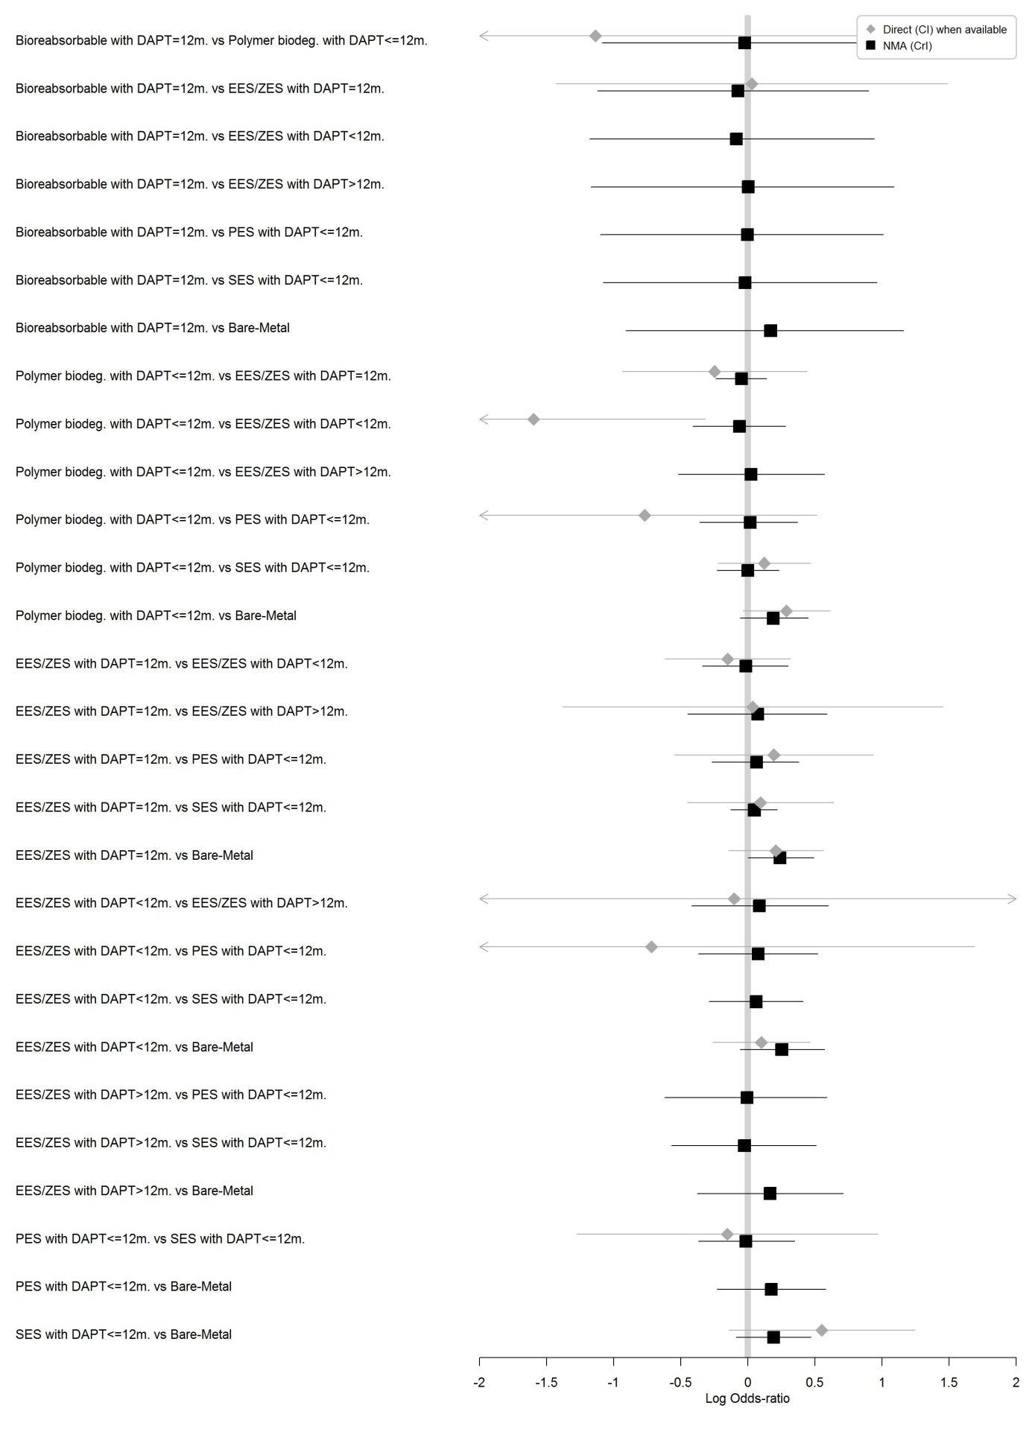
Figure 3: CV death. Caterpillar plot of the LOR estimated using 1) direct comparisons with 95% CI (when available, grey line); and 2) NMA with 95% CrI (black line).

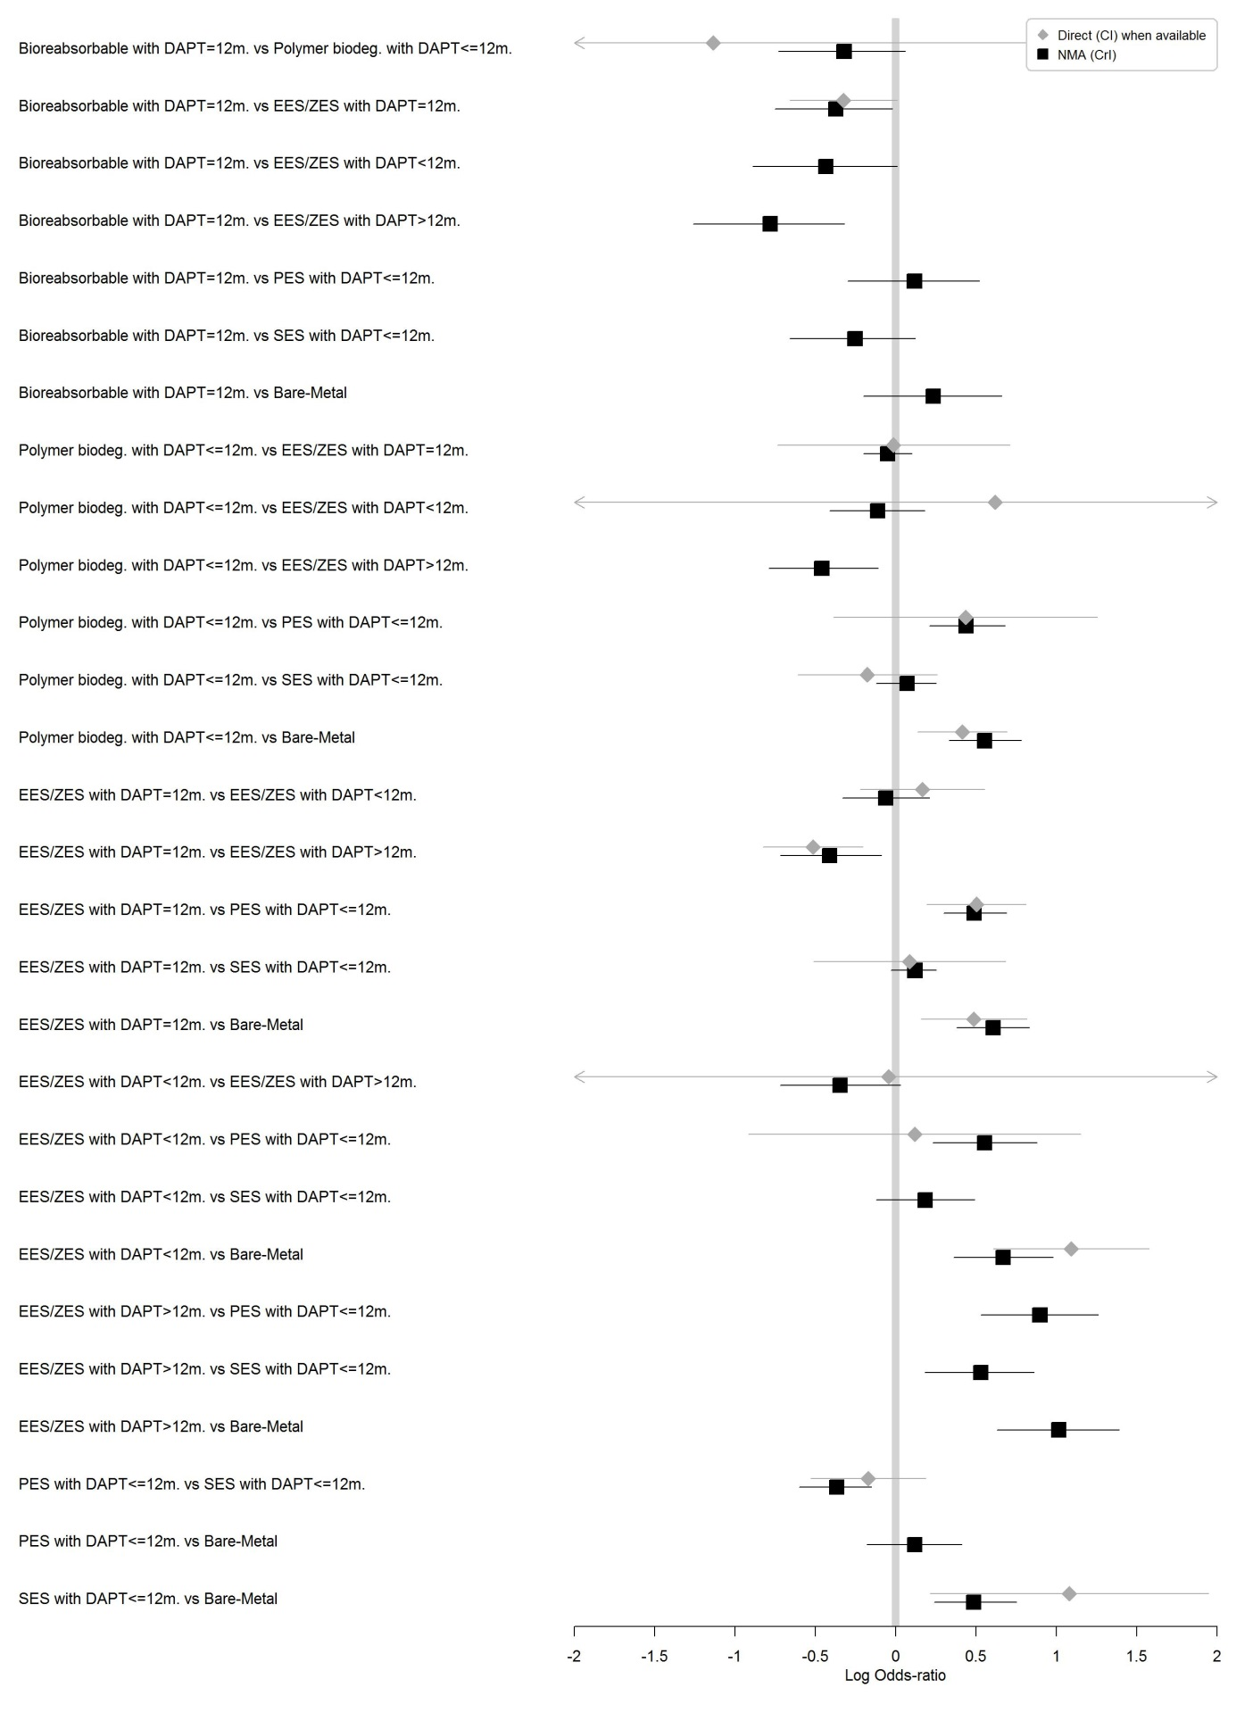
Figure 4: MI. Caterpillar plot of the LOR estimated using 1) direct comparisons with 95% CI (when available, grey line); and 2) NMA with 95% CrI (black line).

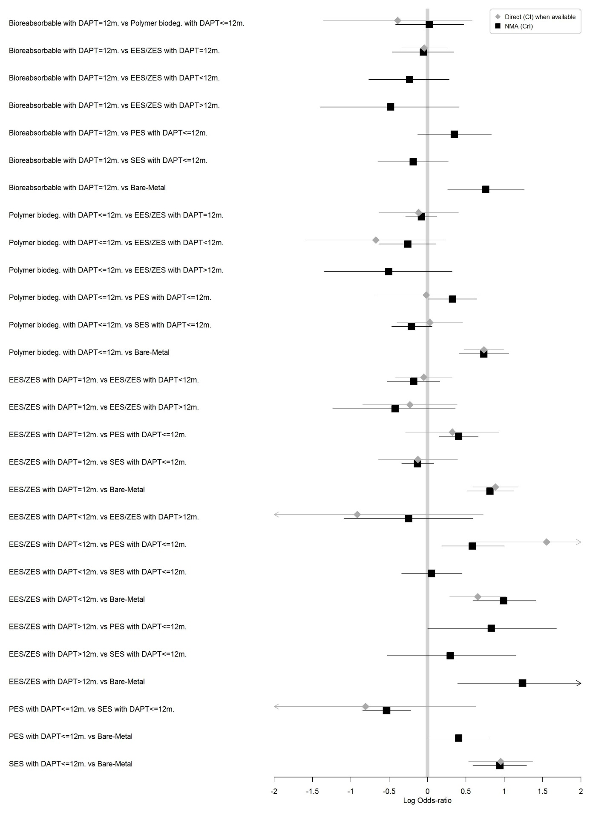
Figure 5: TVR. Caterpillar plot of the LOR estimated using 1) direct comparisons with 95% CI (when available, grey line); and 2) NMA with 95% CrI (black line).

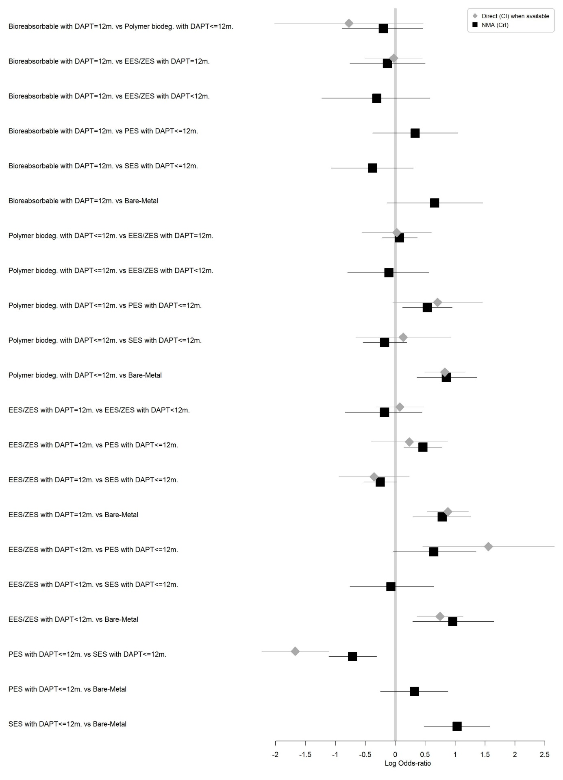
Figure 6: TLR. Caterpillar plot of the LOR estimated using 1) direct comparisons with 95% CI (when available, grey line); and 2) NMA with 95% CrI (black line).

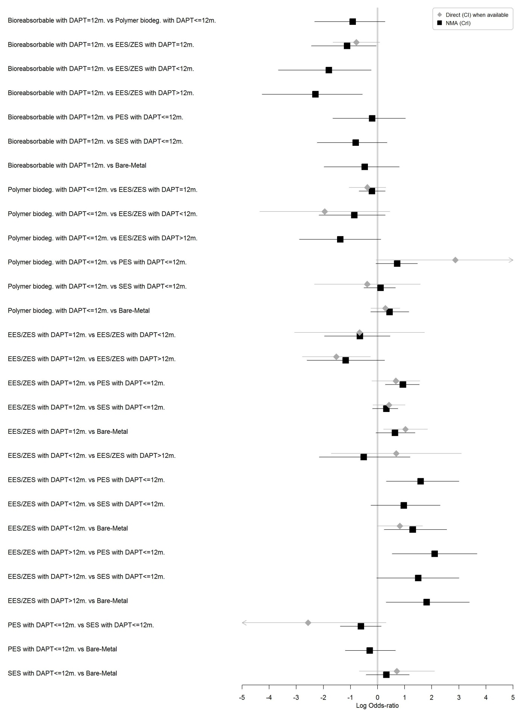
Figure 7: ST definite. Caterpillar plot of the LOR estimated using 1) direct comparisons with 95% CI (when available, grey line); and 2) NMA with 95% CrI (black line).

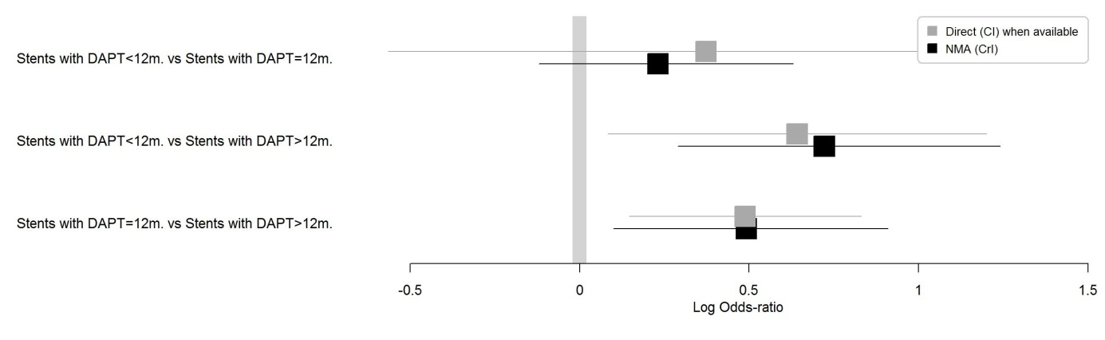
Figure 8: Major bleeding. Caterpillar plot of the LOR estimated using 1) direct comparisons with 95% CI (when available, grey line); and 2) NMA with 95% CrI (black line).

Direct Comparison | MACE |  |  | All cause death |  |  | CV death |  |  | MI
 | NbS | I² | p-value | NbS | I² | p-value | NbS | I² | p-value | NbS | I² | p-value
Bioreabsorbable with DAPT=12m. vs Polymer biodeg. with DAPT<=12m. | 1 | −− | −− | 1 | −− | −− | 1 | −− | −− | 1 | −− | −−
Bioreabsorbable with DAPT=12m. vs EES/ZES with DAPT=12m. | 5 | 0 | 0.99 | 6 | 0.41 | 0.15 | 6 | 0.36 | 0.19 | 6 | 0 | 0.82
Polymer biodeg. with DAPT<=12m. vs EES/ZES with DAPT=12m. | 10 | 0.94 | p<0.0001 | 12 | 0.86 | p<0.0001 | 12 | 0.63 | p<0.0001 | 12 | 0.87 | p<0.0001
Polymer biodeg. with DAPT<=12m. vs EES/ZES with DAPT<12m. | 1 | −− | −− | 2 | 0 | 0.62 | 2 | 0 | 0.32 | 2 | 0.7 | 0.07
Polymer biodeg. with DAPT<=12m. vs PES with DAPT<=12m. | 1 | −− | −− | 1 | −− | −− | 1 | −− | −− | 1 | −− | −−
Polymer biodeg. with DAPT<=12m. vs SES with DAPT<=12m. | 3 | 0.49 | 0.14 | 3 | 0 | 0.54 | 3 | 0 | 0.87 | 3 | 0.25 | 0.26
Polymer biodeg. with DAPT<=12m. vs Bare−Metal | 2 | 0.61 | 0.11 | 2 | 0 | 1 | 2 | 0 | 0.72 | 2 | 0 | 0.9
EES/ZES with DAPT=12m. vs EES/ZES with DAPT<12m. | 2 | 0.78 | 0.03 | 3 | 0.11 | 0.32 | 3 | 0 | 0.42 | 3 | 0.19 | 0.29
EES/ZES with DAPT=12m. vs EES/ZES with DAPT>12m. | 1 | −− | −− | 2 | 0.8 | 0.02 | 2 | 0.71 | 0.06 | 3 | 0 | 0.71
EES/ZES with DAPT=12m. vs PES with DAPT<=12m. | 11 | 0.95 | p<0.0001 | 11 | 0.66 | p<0.0001 | 10 | 0.63 | p<0.0001 | 11 | 0.26 | 0.2
EES/ZES with DAPT=12m. vs SES with DAPT<=12m. | 16 | 0.92 | p<0.0001 | 16 | 0.84 | p<0.0001 | 13 | 0.79 | p<0.0001 | 16 | 0.87 | p<0.0001
EES/ZES with DAPT=12m. vs Bare−Metal | 4 | 0.51 | 0.1 | 4 | 0.2 | 0.29 | 4 | 0 | 0.44 | 4 | 0 | 0.72
EES/ZES with DAPT<12m. vs EES/ZES with DAPT>12m. | 1 | −− | −− | 2 | 0.98 | p<0.0001 | 2 | 0.96 | p<0.0001 | 2 | 0.95 | p<0.0001
EES/ZES with DAPT<12m. vs PES with DAPT<=12m. | 1 | −− | −− | 1 | −− | −− | 1 | −− | −− | 1 | −− | −−
EES/ZES with DAPT<12m. vs Bare−Metal | 1 | −− | −− | 1 | −− | −− | 1 | −− | −− | 1 | −− | −−
PES with DAPT<=12m. vs SES with DAPT<=12m. | 3 | 0 | 0.82 | 3 | 0 | 0.57 | 2 | 0 | 0.44 | 3 | 0 | 0.66
SES with DAPT<=12m. vs Bare−Metal | 1 | −− | −− | 1 | −− | −− | 1 | −− | −− | 1 | −− | −−

Table 1: Direct comparisons: number of studies and heterogeneity assessment of pairwise meta-analyses. NbS = number of studies. I² = percentage of variability due to heterogeneity rather than to sampling error. p-value= p-value of the Cochrane’s Q test.

Table 1 (cont’d):
Direct Comparison | TVR |  |  | TLR |  |  | ST
 | NbS | I² | p-value | NbS | I² | p-value | NbS | I² | p-value
Bioreabsorbable with DAPT=12m. vs Polymer biodeg. with DAPT<=12m. | 1 | −− | −− | 1 | −− | −− | 1 | −− | −−
Bioreabsorbable with DAPT=12m. vs EES/ZES with DAPT=12m. | 6 | 0 | 0.69 | 5 | 0 | 0.71 | 5 | 0 | 0.61
Polymer biodeg. with DAPT<=12m. vs EES/ZES with DAPT=12m. | 12 | 0.9 | p<0.0001 | 10 | 0.86 | p<0.0001 | 10 | 0.23 | 0.24
Polymer biodeg. with DAPT<=12m. vs EES/ZES with DAPT<12m. | 2 | 0.76 | 0.04 | 0 | −− | −− | 1 | −− | −−
Polymer biodeg. with DAPT<=12m. vs PES with DAPT<=12m. | 1 | −− | −− | 1 | −− | −− | 1 | −− | −−
Polymer biodeg. with DAPT<=12m. vs SES with DAPT<=12m. | 3 | 0.54 | 0.11 | 3 | 0.78 | 0.01 | 3 | 0.83 | 0.02
Polymer biodeg. with DAPT<=12m. vs Bare−Metal | 2 | 0 | 0.57 | 2 | 0.24 | 0.25 | 2 | 0 | 0.32
EES/ZES with DAPT=12m. vs EES/ZES with DAPT<12m. | 3 | 0.63 | 0.07 | 1 | −− | −− | 1 | −− | −−
EES/ZES with DAPT=12m. vs EES/ZES with DAPT>12m. | 1 | −− | −− | 0 | −− | −− | 1 | −− | −−
EES/ZES with DAPT=12m. vs PES with DAPT<=12m. | 10 | 0.89 | p<0.0001 | 11 | 0.89 | p<0.0001 | 7 | 0.46 | 0.09
EES/ZES with DAPT=12m. vs SES with DAPT<=12m. | 13 | 0.91 | p<0.0001 | 14 | 0.92 | p<0.0001 | 10 | 0.46 | 0.06
EES/ZES with DAPT=12m. vs Bare−Metal | 4 | 0.32 | 0.22 | 2 | 0 | 0.33 | 2 | 0 | 0.9
EES/ZES with DAPT<12m. vs EES/ZES with DAPT>12m. | 1 | −− | −− | 0 | −− | −− | 1 | −− | −−
EES/ZES with DAPT<12m. vs PES with DAPT<=12m. | 1 | −− | −− | 1 | −− | −− | 0 | −− | −−
EES/ZES with DAPT<12m. vs Bare−Metal | 1 | −− | −− | 1 | −− | −− | 1 | −− | −−
PES with DAPT<=12m. vs SES with DAPT<=12m. | 2 | 0.85 | 0.01 | 3 | 0 | 0.79 | 1 | −− | −−
SES with DAPT<=12m. vs Bare−Metal | 1 | −− | −− | 0 | −− | −− | 1 | −− | −−

Table 1 (cont’d):
Direct Comparison | Major bleeding
 | NbS | I² | p-value
Stents with DAPT<12m. vs Stents with DAPT=12m. | 6 | 0.81 | p<0.0001
Stents with DAPT<12m. vs Stents with DAPT>12m. | 2 | 0 | 0.38
Stents with DAPT=12m. vs Stents with DAPT>12m. | 3 | 0 | 0.99

Table 2: Goodness of fit and heterogeneity of the NMA.
Endpoint | Posterior mean  Residual deviance | Number of data points | Common between-study variance τ²
MACE | 114.2 | 110 | 0.27 [0.18;0.38]
Death | 131.3 | 121 | 0.09 [0.02;0.24]
CV death | 108.4 | 114 | 0.07 [0.02;0.20]
MI | 134.8 | 123 | 0.08 [0.02;0.21]
TVR | 111.0 | 110 | 0.32 [0.21;0.44]
TLR | 103.3 | 98 | 0.43 [0.29;0.62]
ST | 86.32 | 84 | 0.48 [0.06;0.96]
Major bleeding | 20.73 | 22 | 0.12 [0.03;0.56]
DIC = Deviance Information Criterion.

Table 3: Network inconsistency assessment. Comparison between the standard consistency NMA models and the inconsistency model.

Endpoint | Network meta-analysis model  (Consistency model) |  | Inconsistency model |  | Omnibus test of consistency
 | DIC | Posterior mean  Residual deviance | DIC | Posterior mean  Residual deviance | ICDF | p-value
MACE | 805.7 | 114.2 | 810.8 | 115.9 | 10 | 0.99819
Death | 694.9 | 131.3 | 701.8 | 128.7 | 10 | 0.98994
CV death | 564.7 | 108.4 | 571.8 | 109.1 | 10 | 0.99996
MI | 733.3 | 134.8 | 733.8 | 129.8 | 10 | 0.89018
TVR | 755.7 | 111.0 | 757.9 | 101.0 | 10 | 0.99982
TLR | 645.7 | 103.3 | 647.4 | 102.7 | 7 | 0.99897
ST | 387.2 | 86.32 | 383.6 | 78.6 | 9 | 0.56218
Major bleeding | 122.9 | 20.73 | 123.3 | 20.4 | 1 | 0.57744
ICDF = Inconsistency Degrees of Freedom.

Table 4: Risk of bias assessment using the Cochrane risk of bias tool

Study | Selection bias | Performance bias (MACE) | Detection bias | Attrition bias | Reporting bias
SPIRIT II | low | high | low | low | low
SPIRIT III | low | high | low | low | low
SPIRIT IV | low | high | low | low | low
COMPARE | low | high | low | low | low
SPIRIT V Diabetes | low | high | low | low | low
RESET | medium | high | unclear | low | low
SORT OUT IV | low | high | low | low | low
EXCELLENT | low | high | low | low | low
LONG DES III | low | high | low | medium | low
ESSENCE DIABETES | low | high | low | unclear | low
RESOLUTE | low | high | low | low | low
TWENTE | low | high | high | low | low
EXAMITION | medium | high | unclear | low | low
BASKETPROVE | medium | high | low | medium | low
ZEST | medium | high | unclear | medium | low
KOMER | high | high | unclear | medium | low
NAPLES | high | high | low | low | low
ENDEAVOR III | low | high | low | low | low
SORT OUT III | low | high | low | medium | low
ISAR TEST IV | low | high | low | medium | low
ISAR TEST II | low | high | low | low | low
ENDEAVOR IV | low | high | low | low | low
ENDEAVOR II | low | high | low | low | low
PLATINUM | low | high | low | low | low
RESOLUTE-China | high | high | low | low | low
TROFI II | low | high | low | low | low
EVERBIO II | medium | high | low | low | low
AbsorB-III | low | high | low | low | low
AbsorB-II | low | high | low | low | low
AbsorB-Japan | medium | high | low | low | low
AbsorB-China | medium | high | low | low | low
OPTIMIZE | medium | high | low | medium | low
PRODIGY(DES) | low | high | low | low | low
ITALIC | low | high | low | low | low
TUXEDO-India | medium | medium | medium | medium | low
LEADERS FREE | low | low | low | low | low
NEXT | low | high | medium | low | low
EVOLVE II | low | high | low | low | low
BIO FLOW II | low | medium | low | low | low
CENTURY II | low | medium | low | low | low
DES LATE (EES_ZES) | low | medium | low | low | low
SECURITY | medium | medium | low | low | low
DAPT | medium | medium | low | low | low
OPTIDUAL | low | high | low | low | low
XIMA | medium | medium | low | low | low
CTO-IVUS | medium | high | low | low | low
PLATINUM-China | medium | medium | low | low | low
SORT OUT VI | low | high | low | low | low
ZEUS | medium | medium | low | low | low
LEADERS 4Y | low | high | low | low | low
NOBORI-Japan | medium | medium | low | low | medium
PROTECT | medium | medium | low | low | low
APPENDIX-AMI | medium | medium | low | low | medium
ISAR SAFE | low | low | low | low | low
SORT OUT V | low | low | medium | medium | low
ISAR-LEFT-MAIN 2 | low | high | low | low | low
DUTCH PEERS | low | medium | low | low | low
RACE-MI | low | medium | medium | high | low
HOST-ASSURE | low | medium | low | low | low
COMPARE II | low | medium | low | low | low
NOBORI I | low | medium | medium | low | low
BIOSCIENCE | low | medium | low | low | low
LONG DES V | low | medium | medium | low | low
COMFORTABLE AMI | low | medium | low | low | low

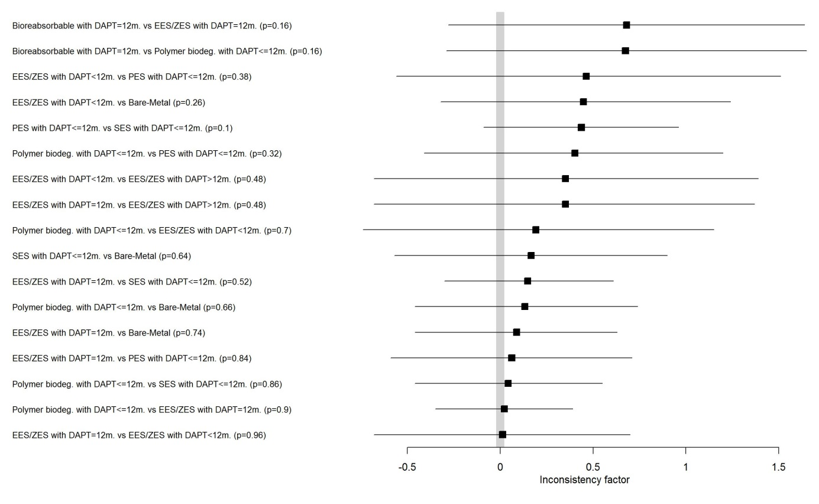
Figure 9: MACE. Inconsistency plot. Inconsistency factors obtained from node-splitting analysis, p = Bayesian p-value.

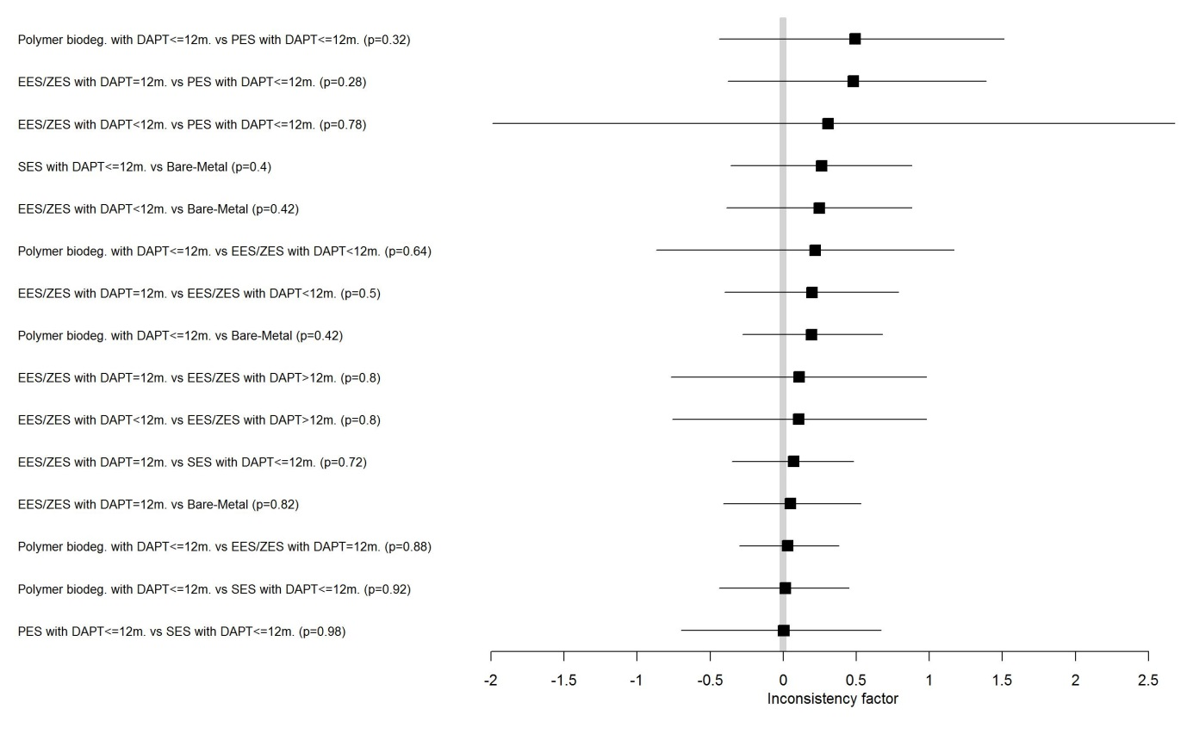
Figure 10: All cause death. Inconsistency plot. Inconsistency factors obtained from node-splitting analysis, p = Bayesian p-value.

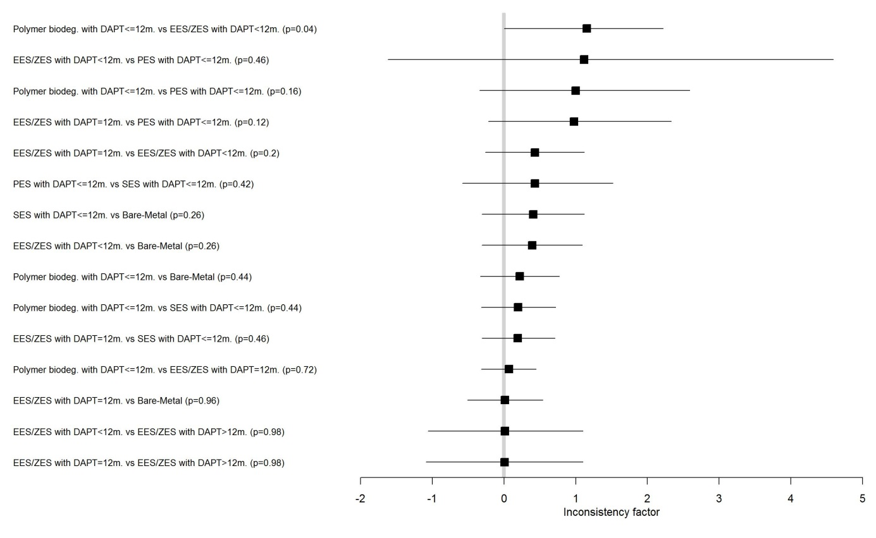
Figure 11: CV death. Inconsistency plot. Inconsistency factors obtained from node-splitting analysis, p = Bayesian p-value.

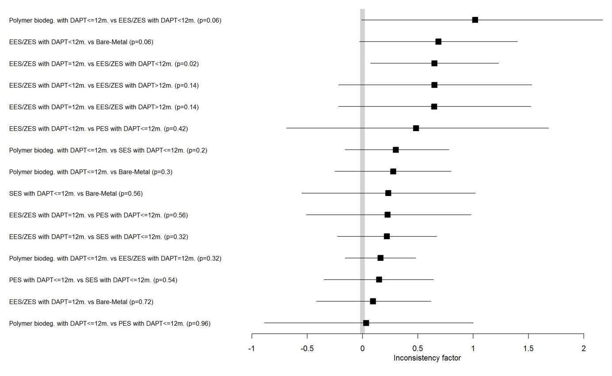
Figure 12: MI. Inconsistency plot. Inconsistency factors obtained from node-splitting analysis, p = Bayesian p-value.

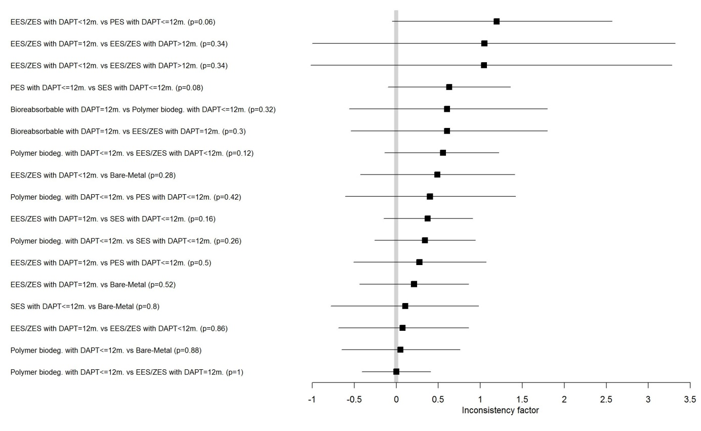Figure 13: TVR. Inconsistency plot. Inconsistency factors obtained from node-splitting analysis, p = Bayesian p-value.

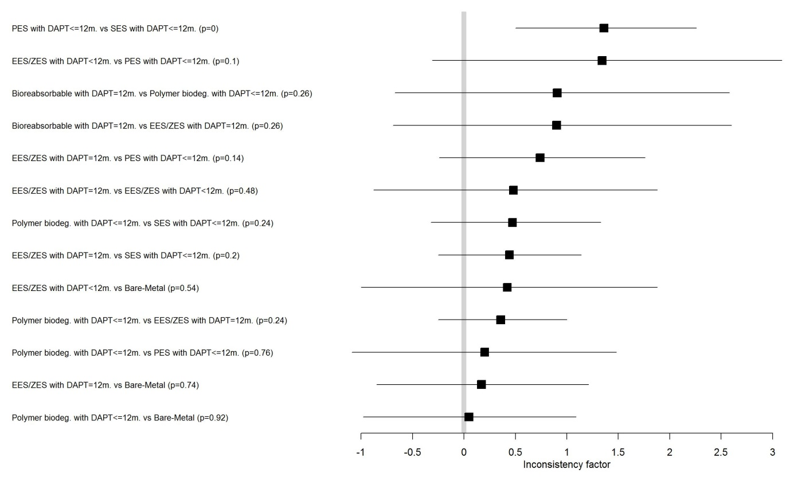
Figure 14: TLR. Inconsistency plot. Inconsistency factors obtained from node-splitting analysis, p = Bayesian p-value.

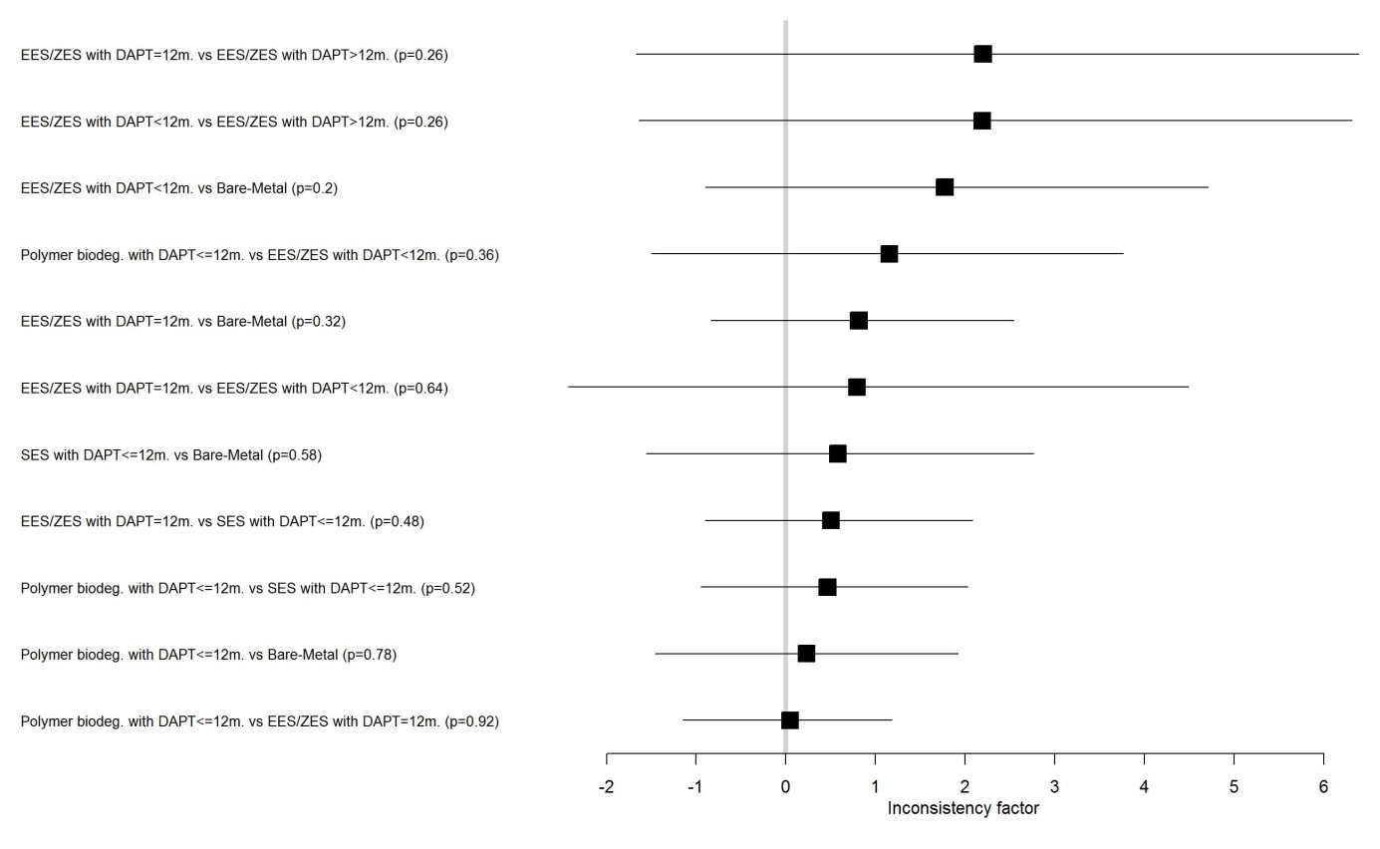
Figure 15: ST definite. Inconsistency plot. Inconsistency factors obtained from node-splitting analysis, p = Bayesian p-value.

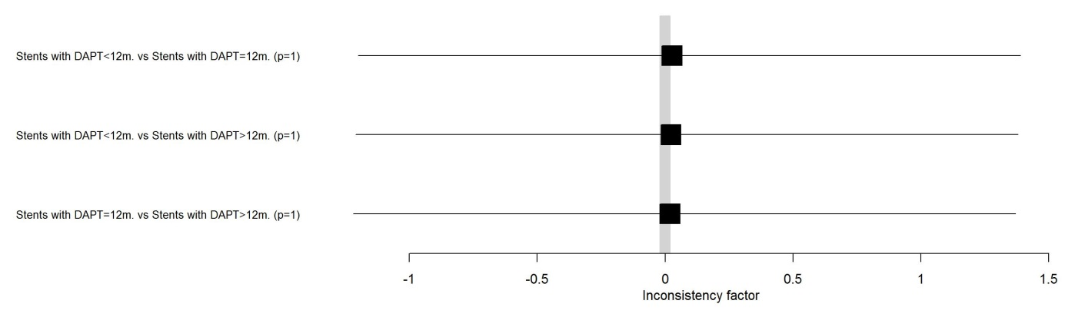
Figure 16: Major bleeding. Inconsistency plot. Inconsistency factors obtained from node-splitting analysis, p = Bayesian p-value.

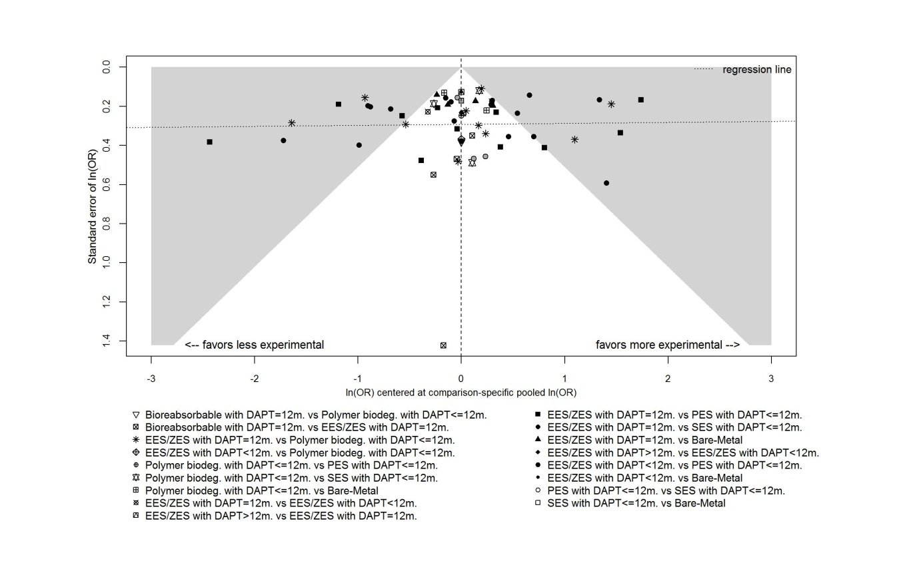
Figure 17: MACE. Comparison-adjusted funnel plot.

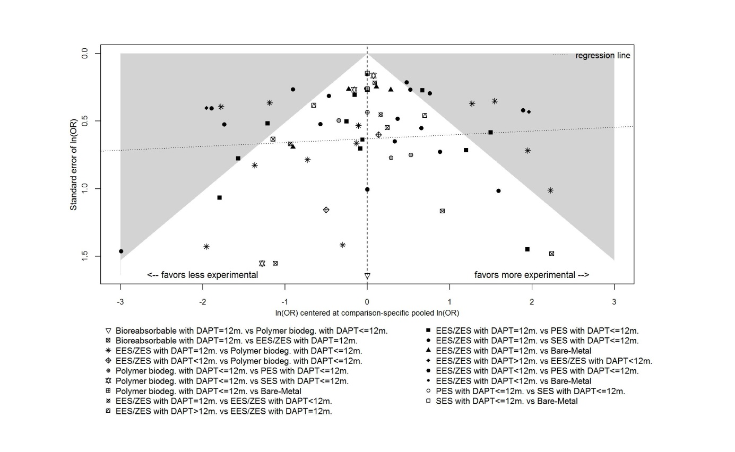
Figure 18: All cause death. Comparison-adjusted funnel plot.

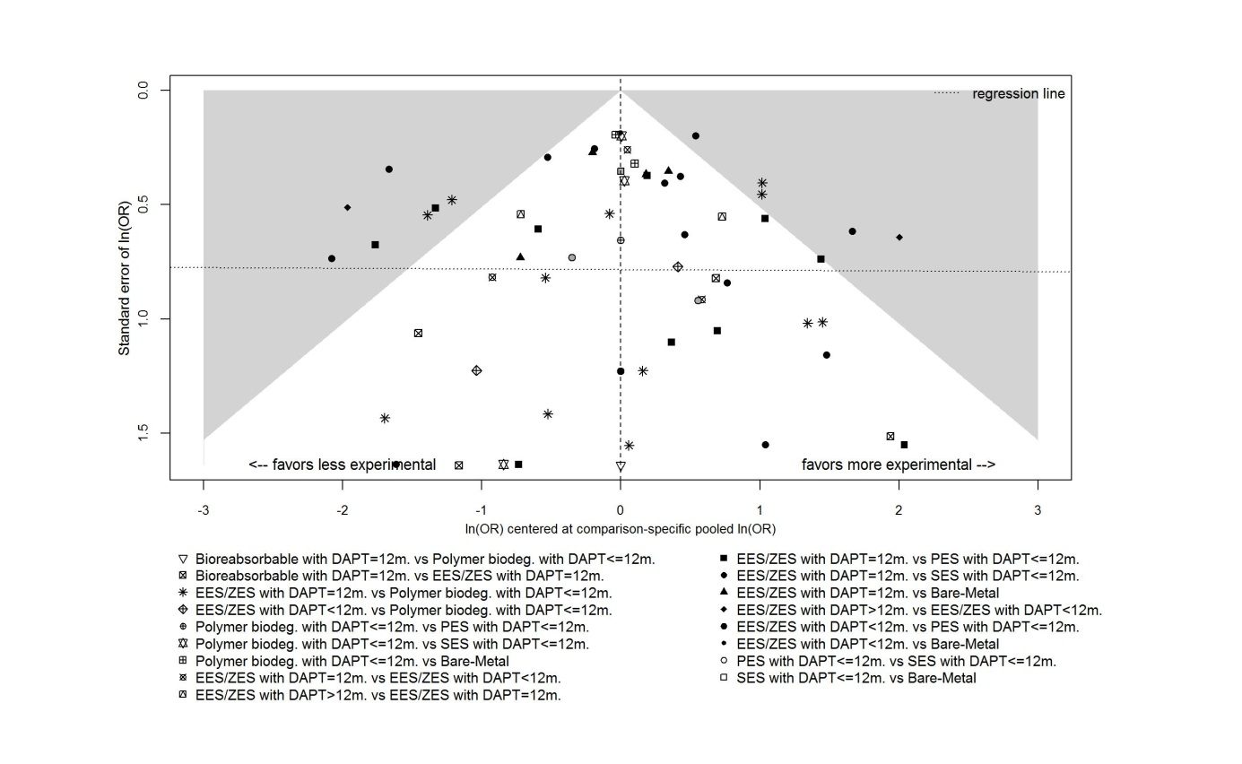
Figure 19: CV death. Comparison-adjusted funnel plot.

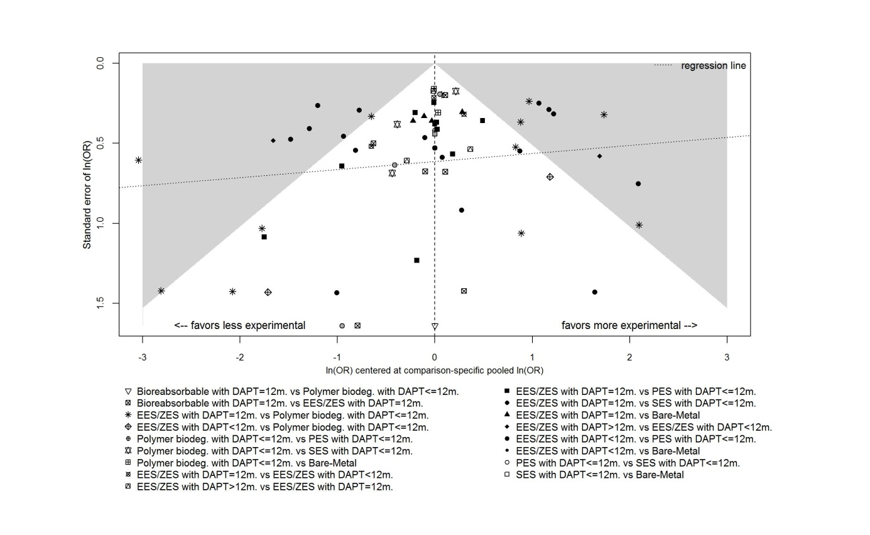
Figure 20: MI. Comparison-adjusted funnel plot.

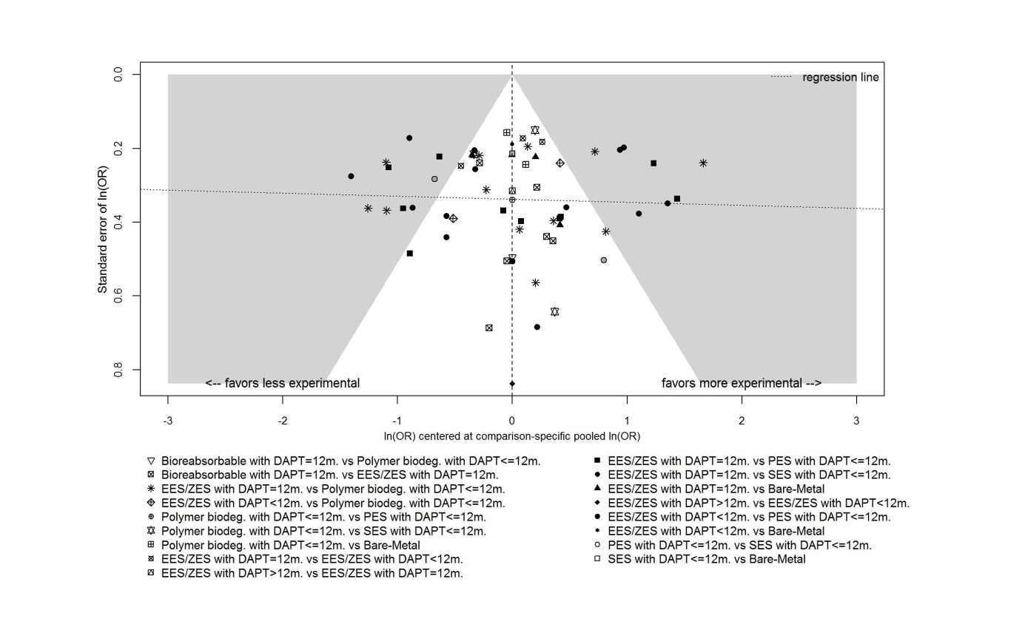
Figure 21: TVR. Comparison-adjusted funnel plot.

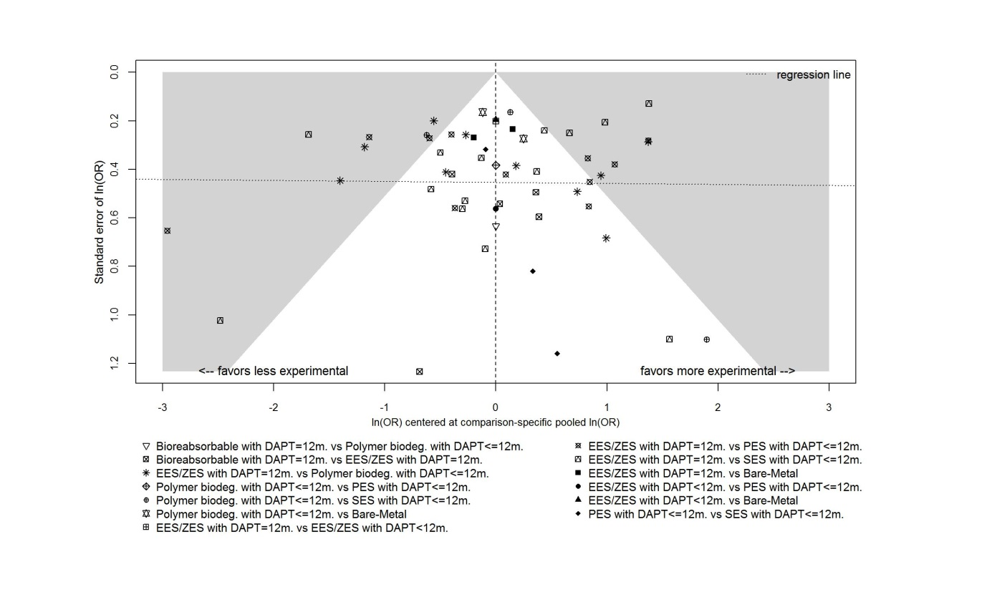
Figure 22: TLR. Comparison-adjusted funnel plot.

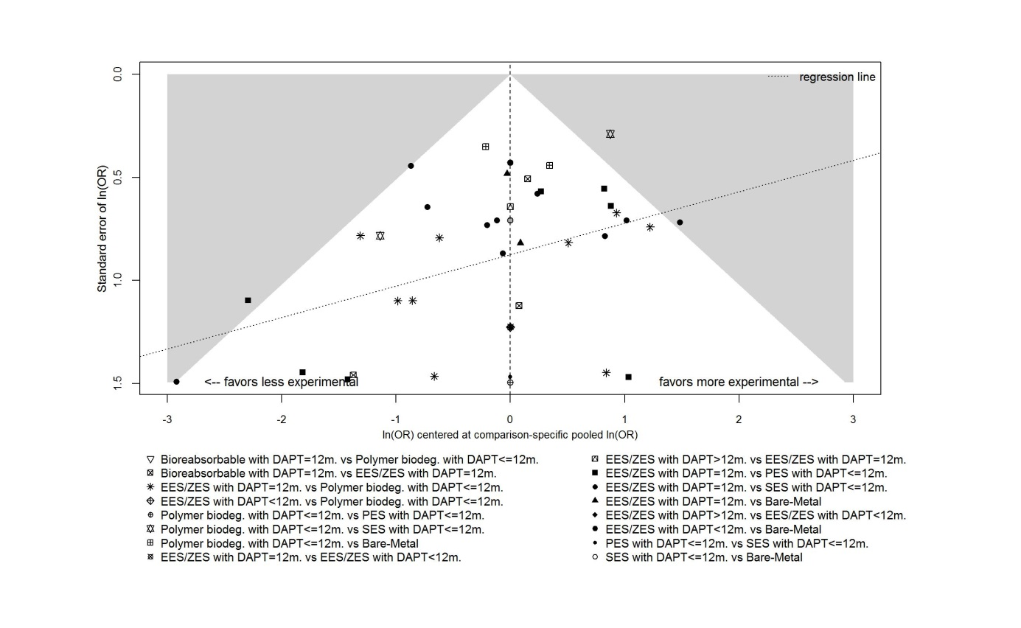
Figure 23: ST definite. Comparison-adjusted funnel plot.

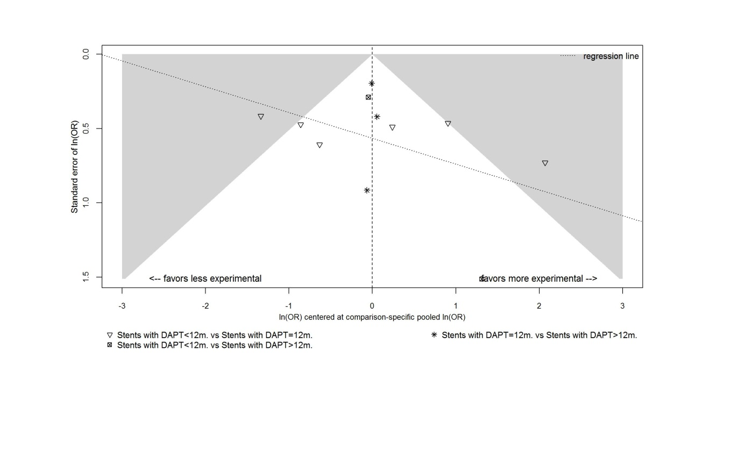
Figure 24: Major bleeding. Comparison-adjusted funnel plot.

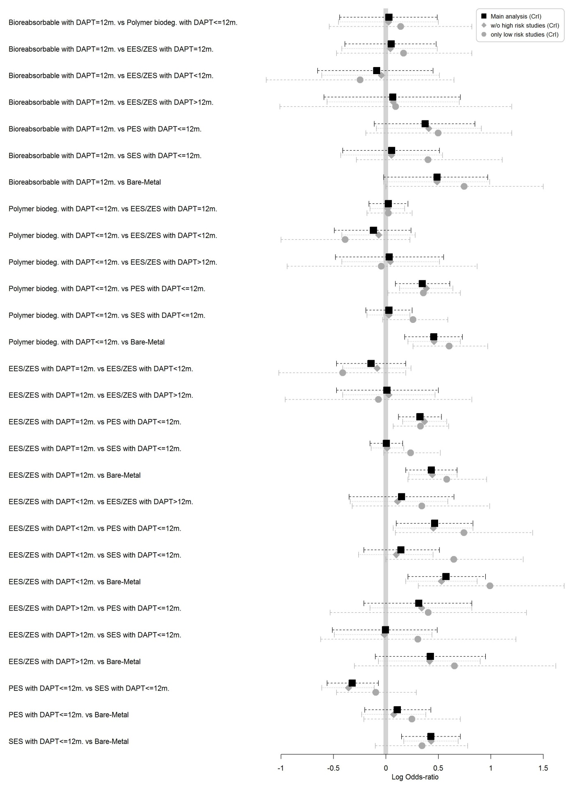
Figure 25: MACE. Caterpillar plot of the LOR with 95% CrI for 1) main analysis (square, black solid line); 2) sensitivity analysis excluding studies with high risk of bias (diamond, grey dotted line) and 3) sensitivity analysis including only studies with low risk of bias (circle, grey dashed line).

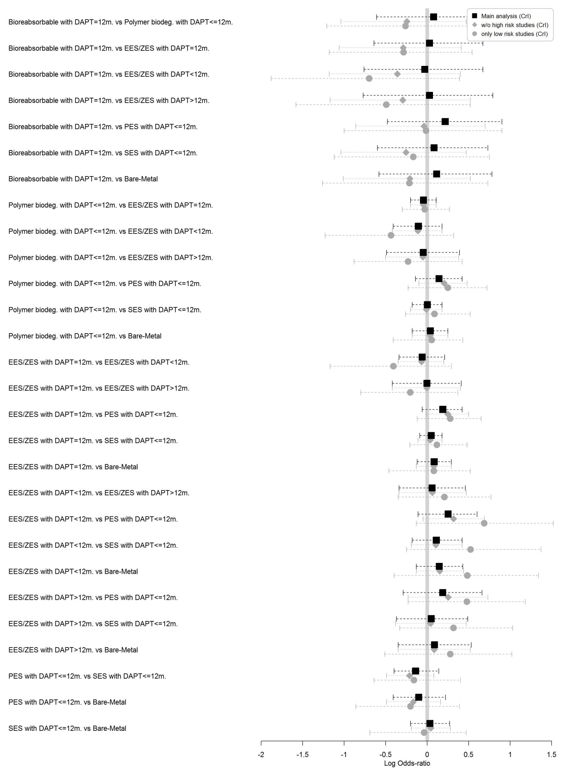
Figure 26: All cause death. Caterpillar plot of the LOR with 95% CrI for 1) main analysis (square, black solid line); 2) sensitivity analysis excluding studies with high risk of bias (diamond, grey dotted line) and 3) sensitivity analysis including only studies with low risk of bias (circle, grey dashed line).
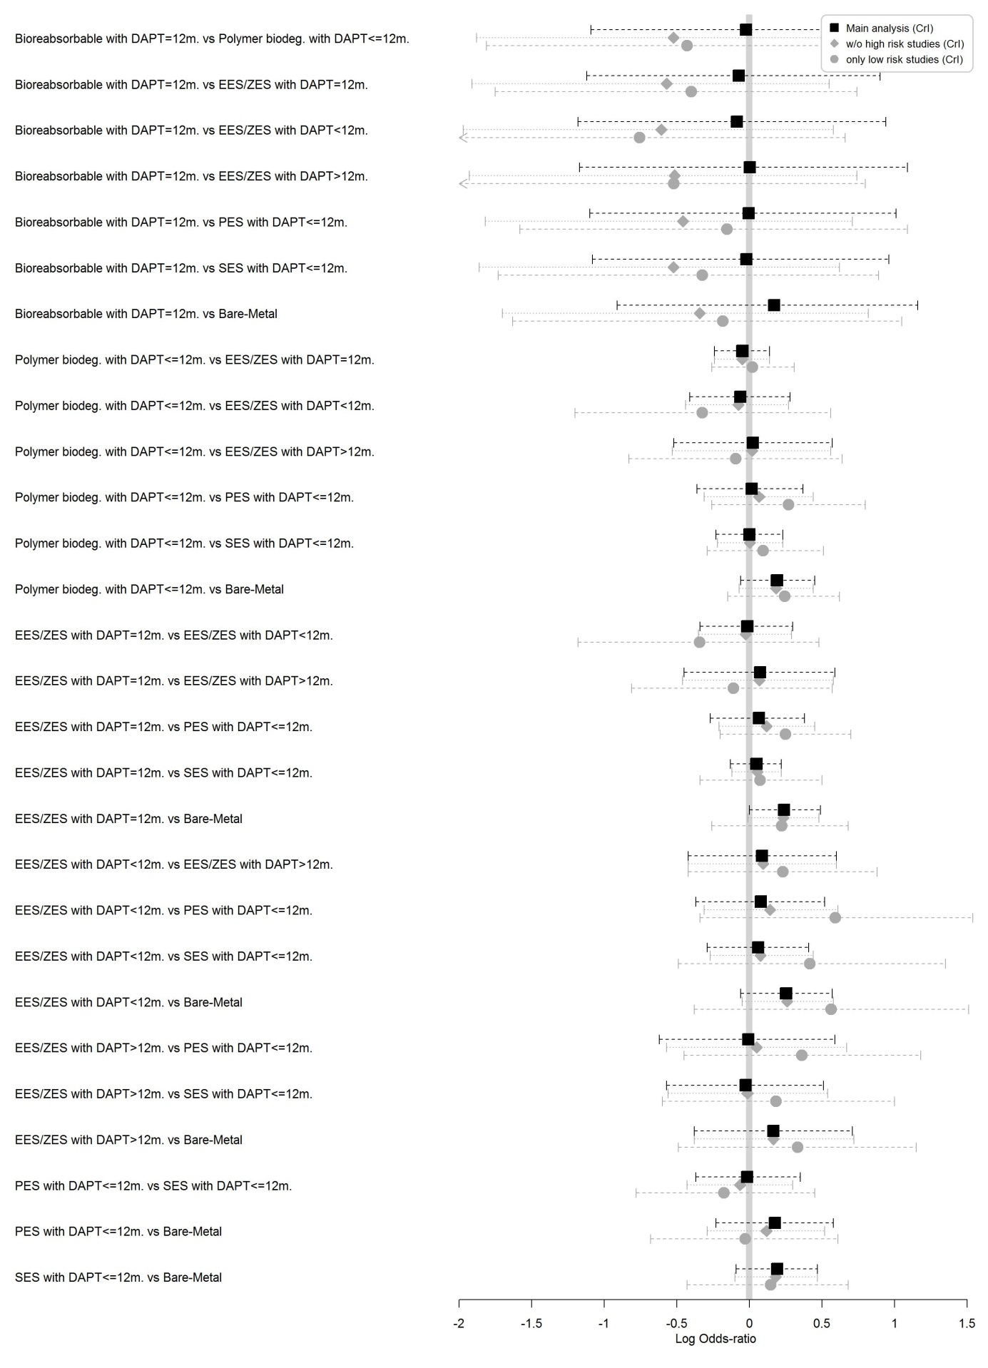
Figure 27: CV death. Caterpillar plot of the LOR with 95% CrI for 1) main analysis (square, black solid line); 2) sensitivity analysis excluding studies with high risk of bias (diamond, grey dotted line) and 3) sensitivity analysis including only studies with low risk of bias (circle, grey dashed line).

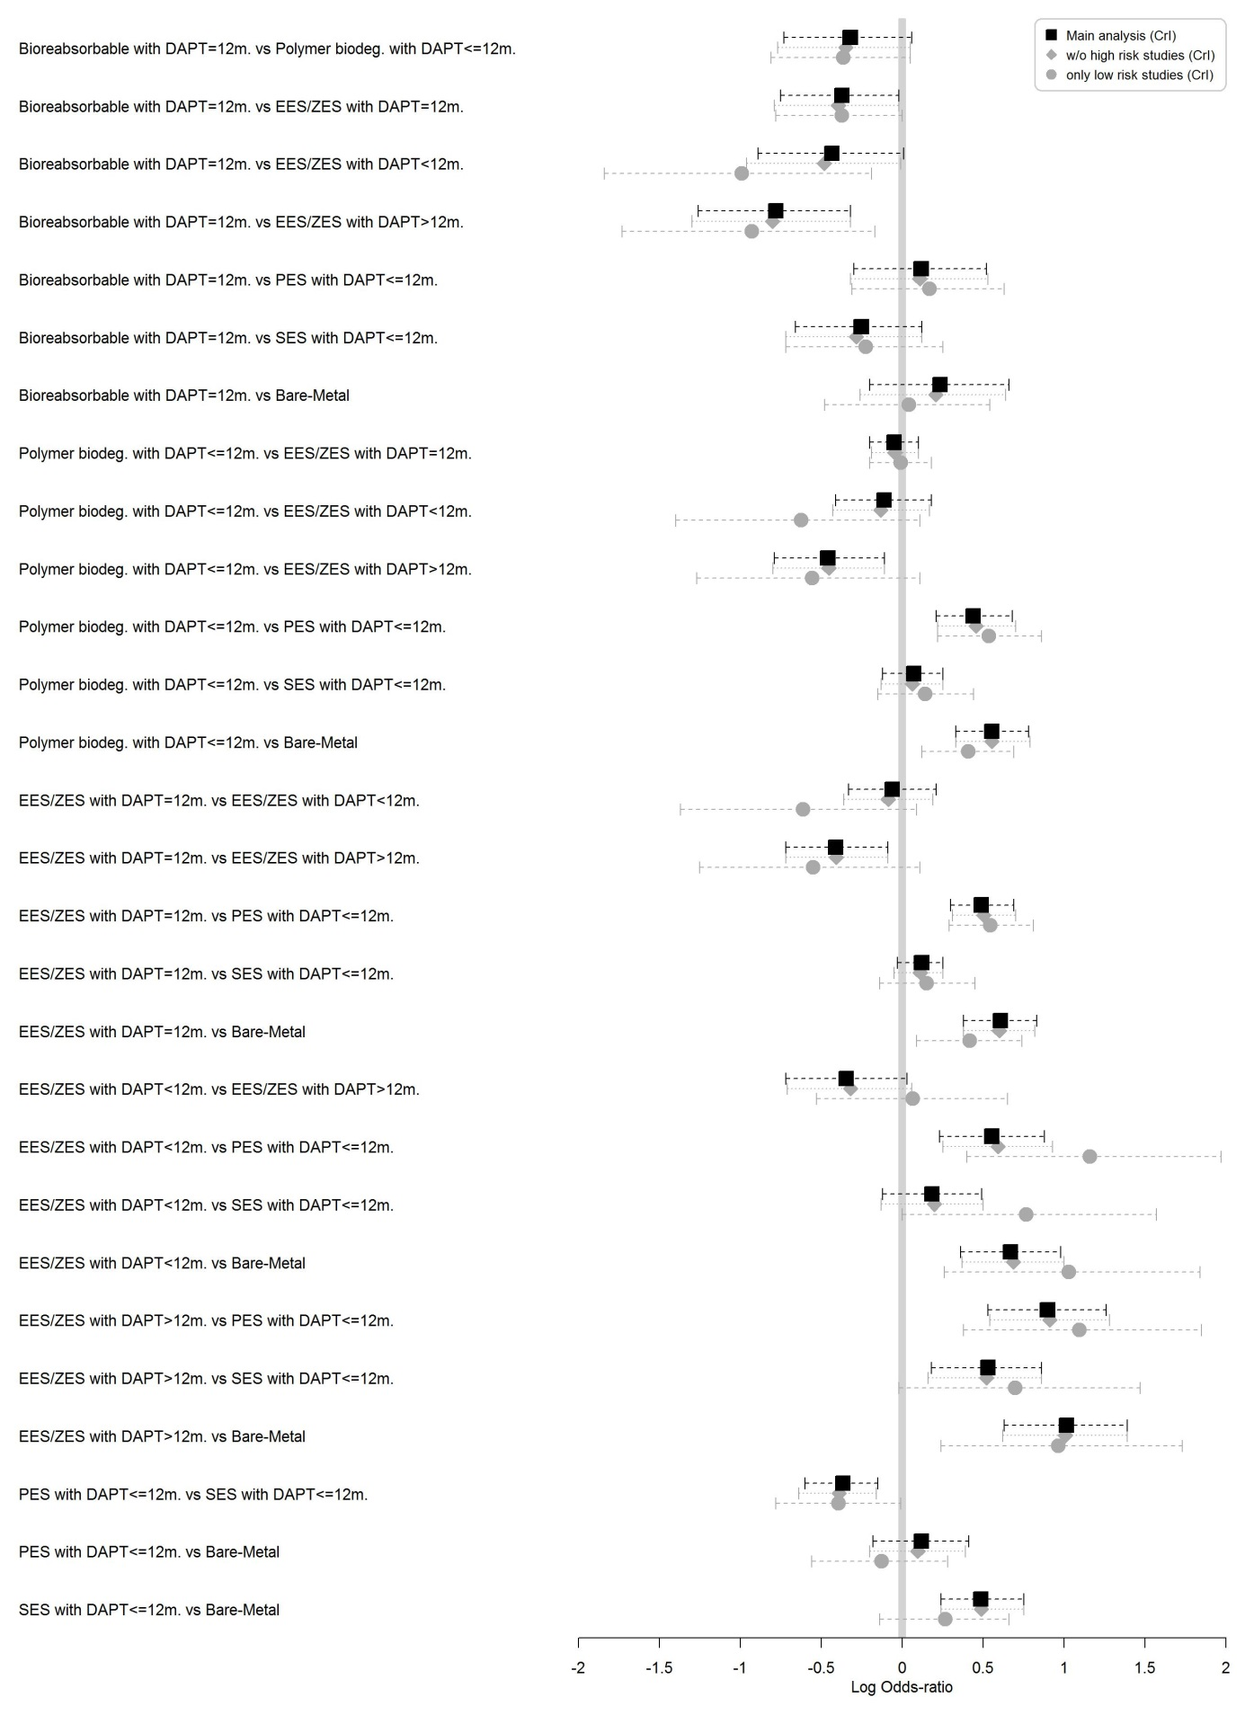
Figure 28: MI. Caterpillar plot of the LOR with 95% CrI for 1) main analysis (square, black solid line); 2) sensitivity analysis excluding studies with high risk of bias (diamond, grey dotted line) and 3) sensitivity analysis including only studies with low risk of bias (circle, grey dashed line).

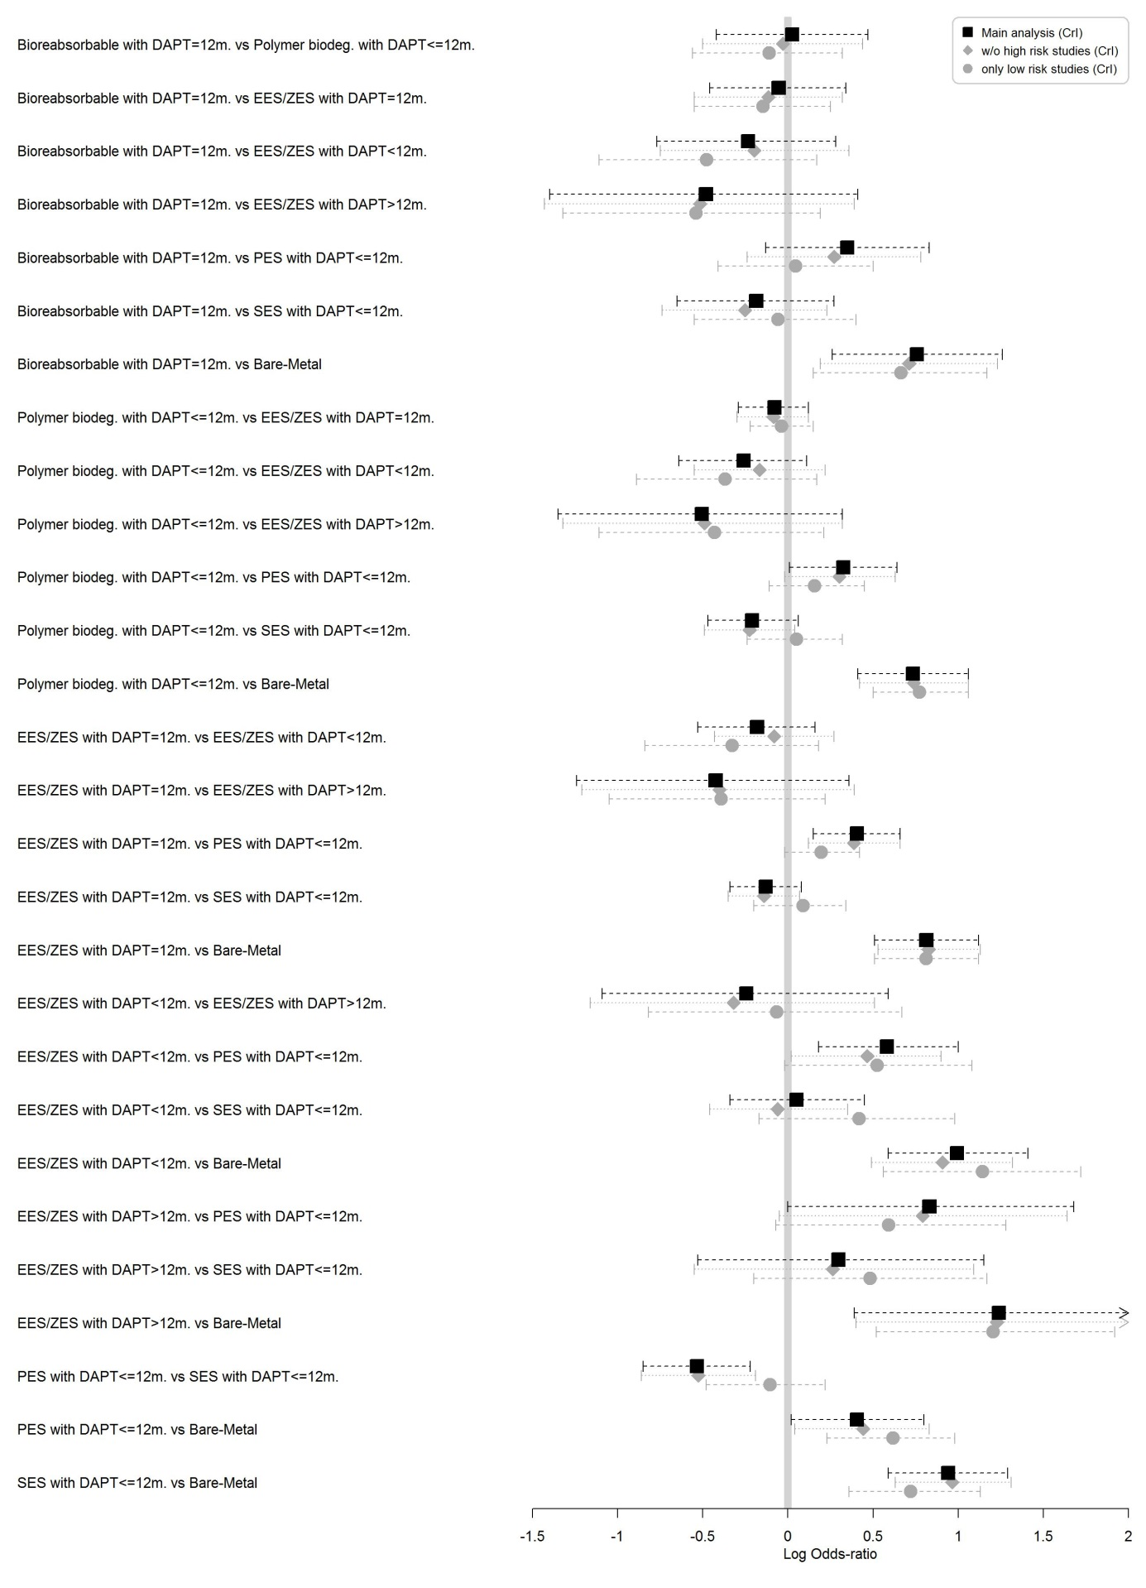
Figure 29: TVR. Caterpillar plot of the LOR with 95% CrI for 1) main analysis (square, black solid line); 2) sensitivity analysis excluding studies with high risk of bias (diamond, grey dotted line) and 3) sensitivity analysis including only studies with low risk of bias (circle, grey dashed line).

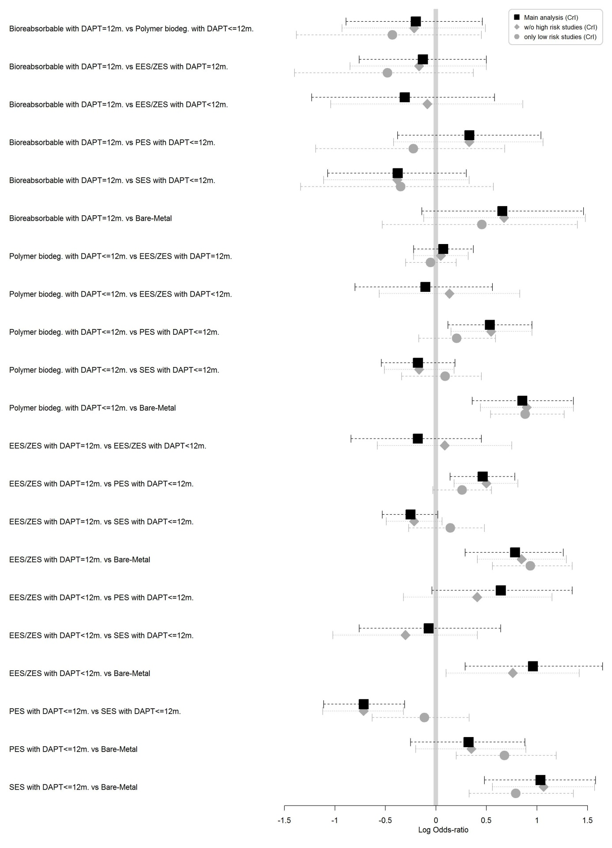
Figure 30: TLR. Caterpillar plot of the LOR with 95% CrI for 1) main analysis (square, black solid line); 2) sensitivity analysis excluding studies with high risk of bias (diamond, grey dotted line) and 3) sensitivity analysis including only studies with low risk of bias (circle, grey dashed line).

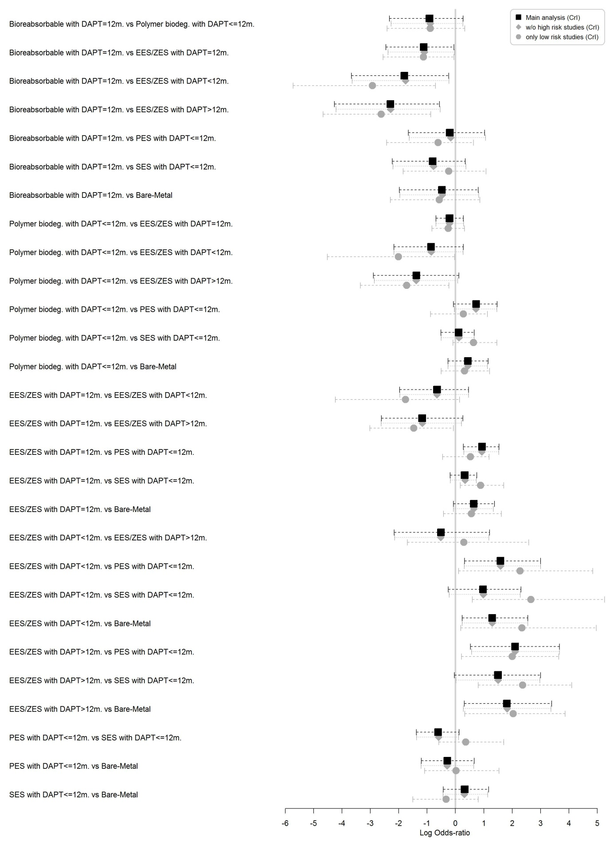
Figure 31: ST. Caterpillar plot of the LOR with 95% CrI for 1) main analysis (square, black solid line); 2) sensitivity analysis excluding studies with high risk of bias (diamond, grey dotted line) and 3) sensitivity analysis including only studies with low risk of bias (circle, grey dashed line).

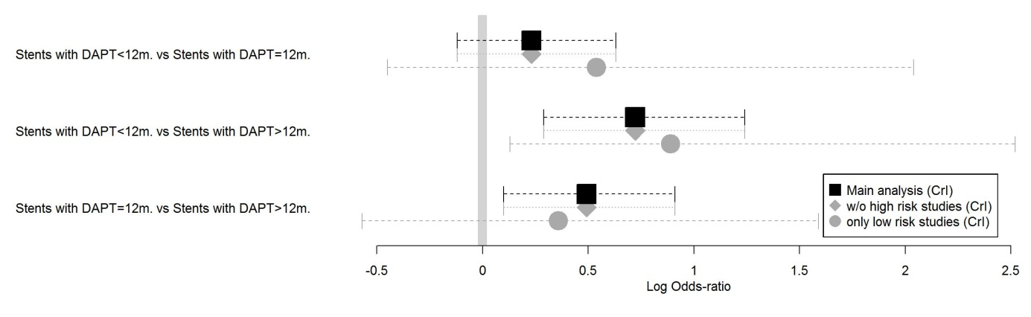
Figure 32: Major bleeding. Caterpillar plot of the LOR with 95% CrI for 1) main analysis (square, black solid line); 2) sensitivity analysis excluding studies with high risk of bias (diamond, grey dotted line) and 3) sensitivity analysis including only studies with low risk of bias (circle, grey dashed line).

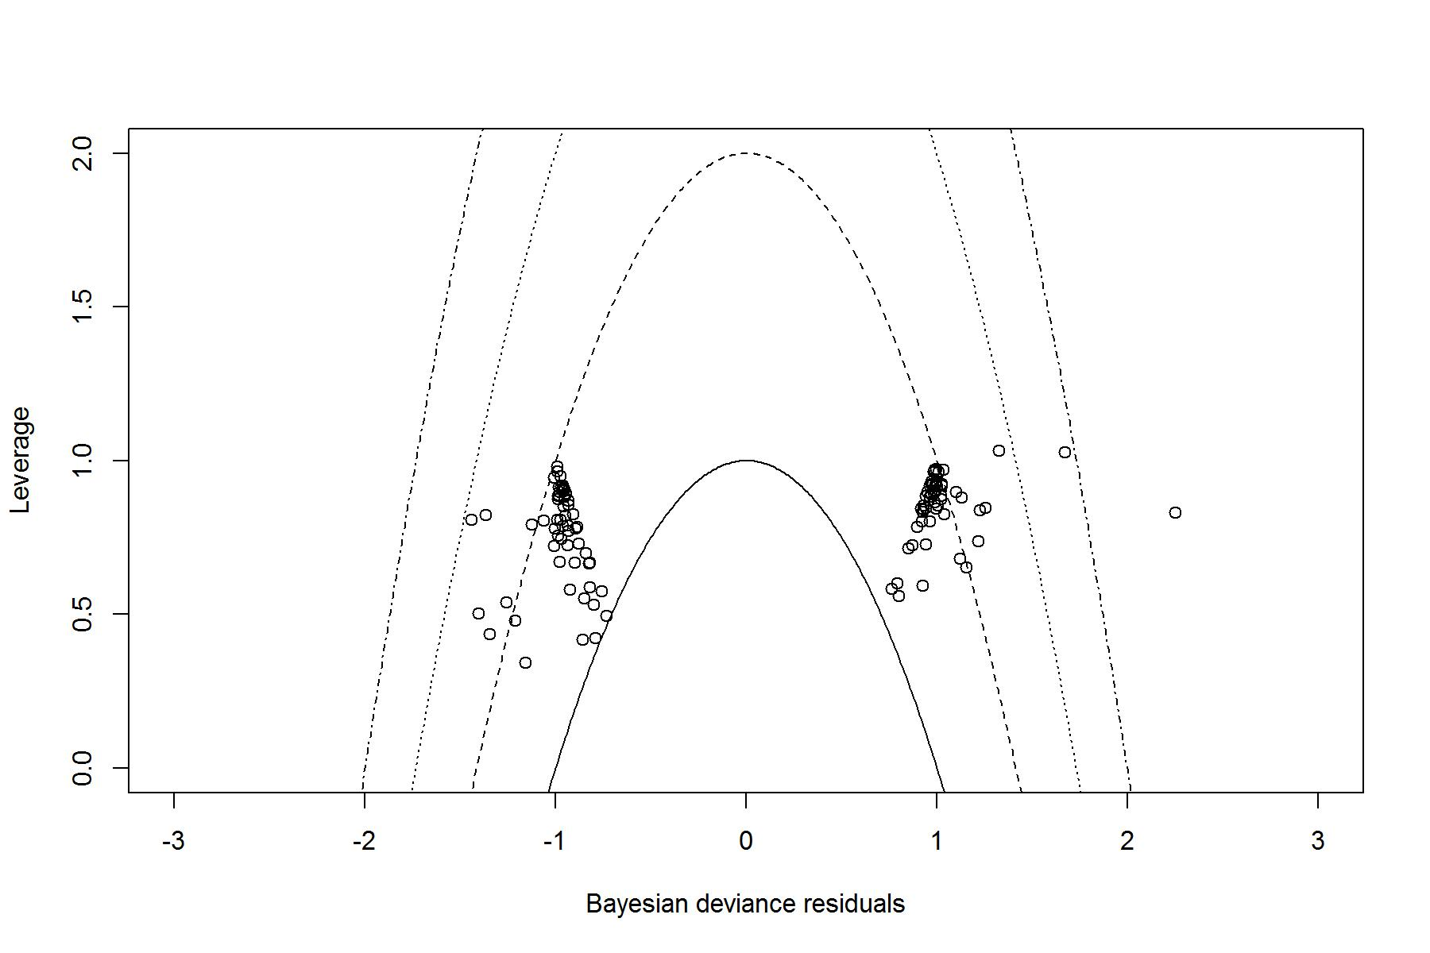
Figure 33: MACE. Plot of leverage vs Bayesian deviance residual, with curves of the form x²+y=c, with c=1,2,3 and 4.

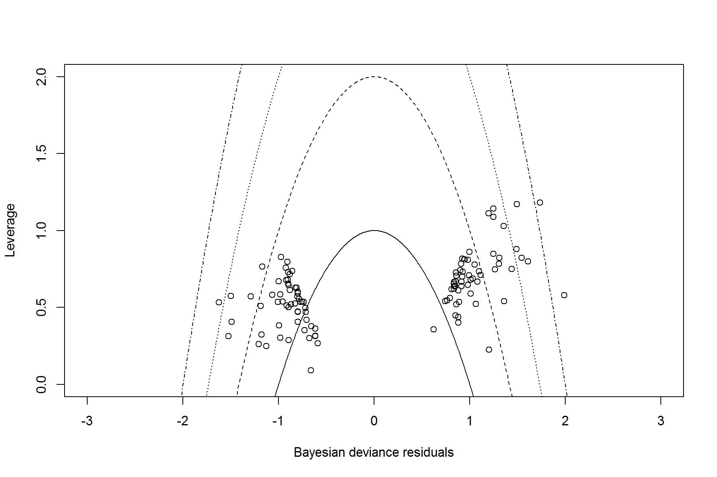
Figure 34: All cause deaths. Plot of leverage vs Bayesian deviance residual, with curves of the form x²+y=c, with c=1,2,3 and 4.

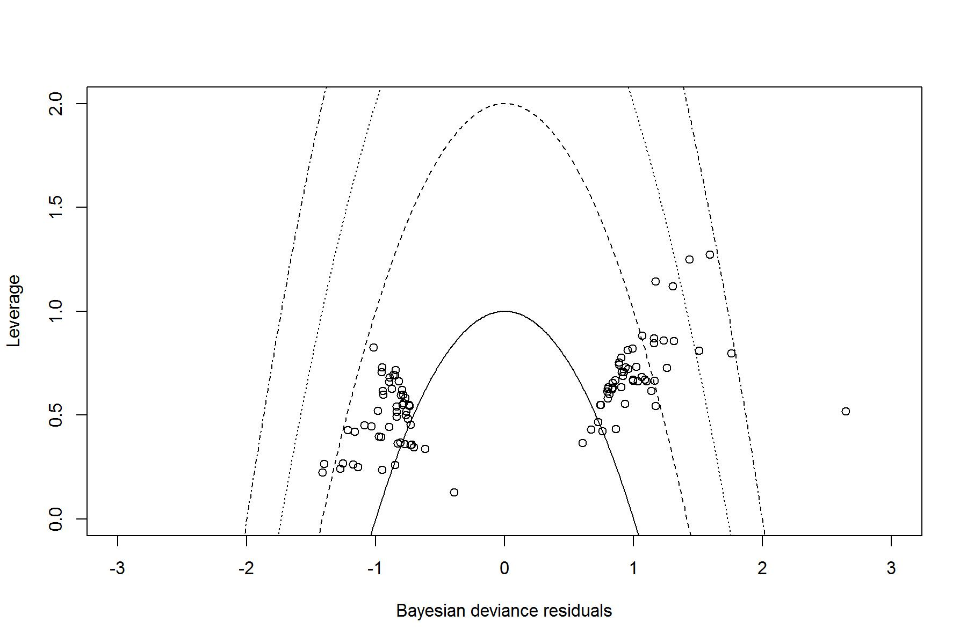
Figure 35: CV deaths. Plot of leverage vs Bayesian deviance residual, with curves of the form x²+y=c, with c=1,2,3 and 4.

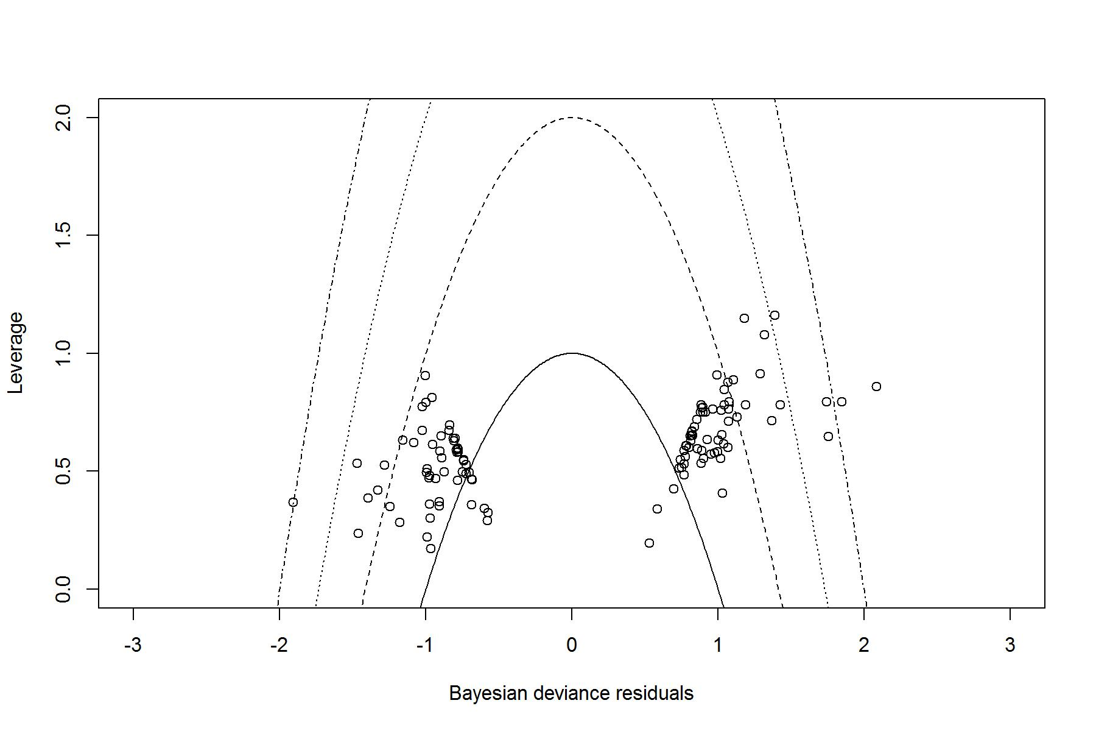
Figure 36: MI. Plot of leverage vs Bayesian deviance residual, with curves of the form x²+y=c, with c=1,2,3 and 4.

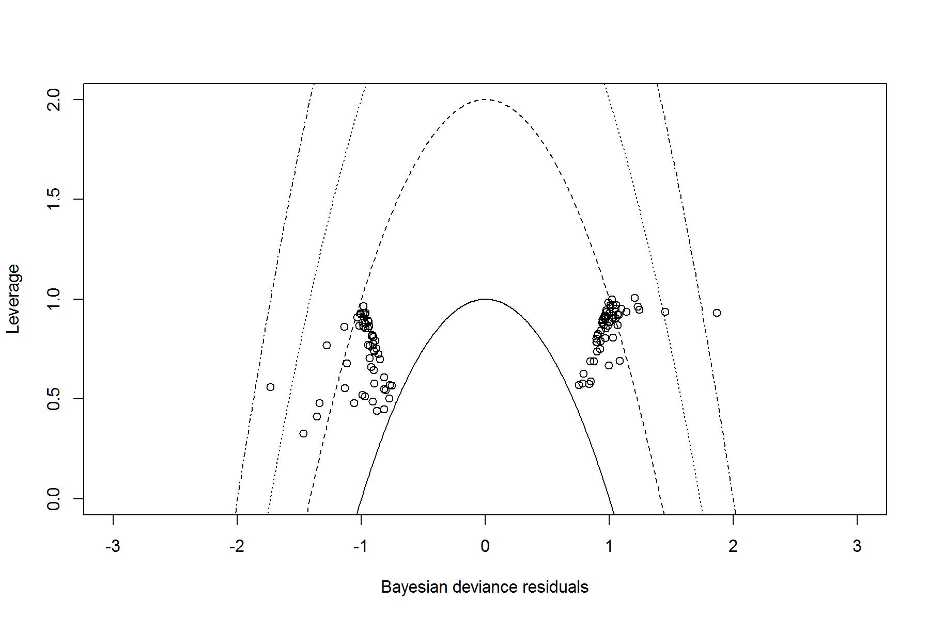
Figure 37: TVR. Plot of leverage vs Bayesian deviance residual, with curves of the form x²+y=c, with c=1,2,3 and 4.

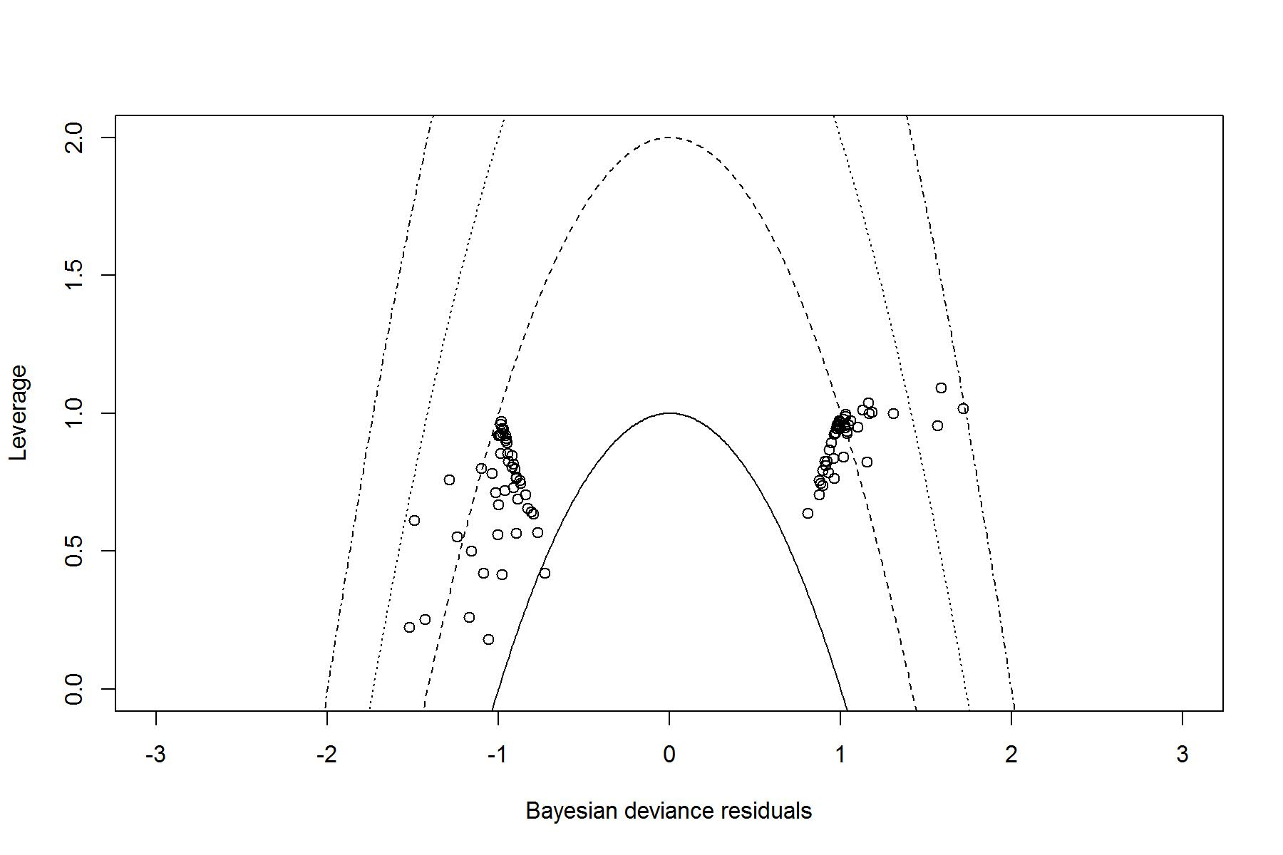
Figure 38: TLR. Plot of leverage vs Bayesian deviance residual, with curves of the form x²+y=c, with c=1,2,3 and 4.

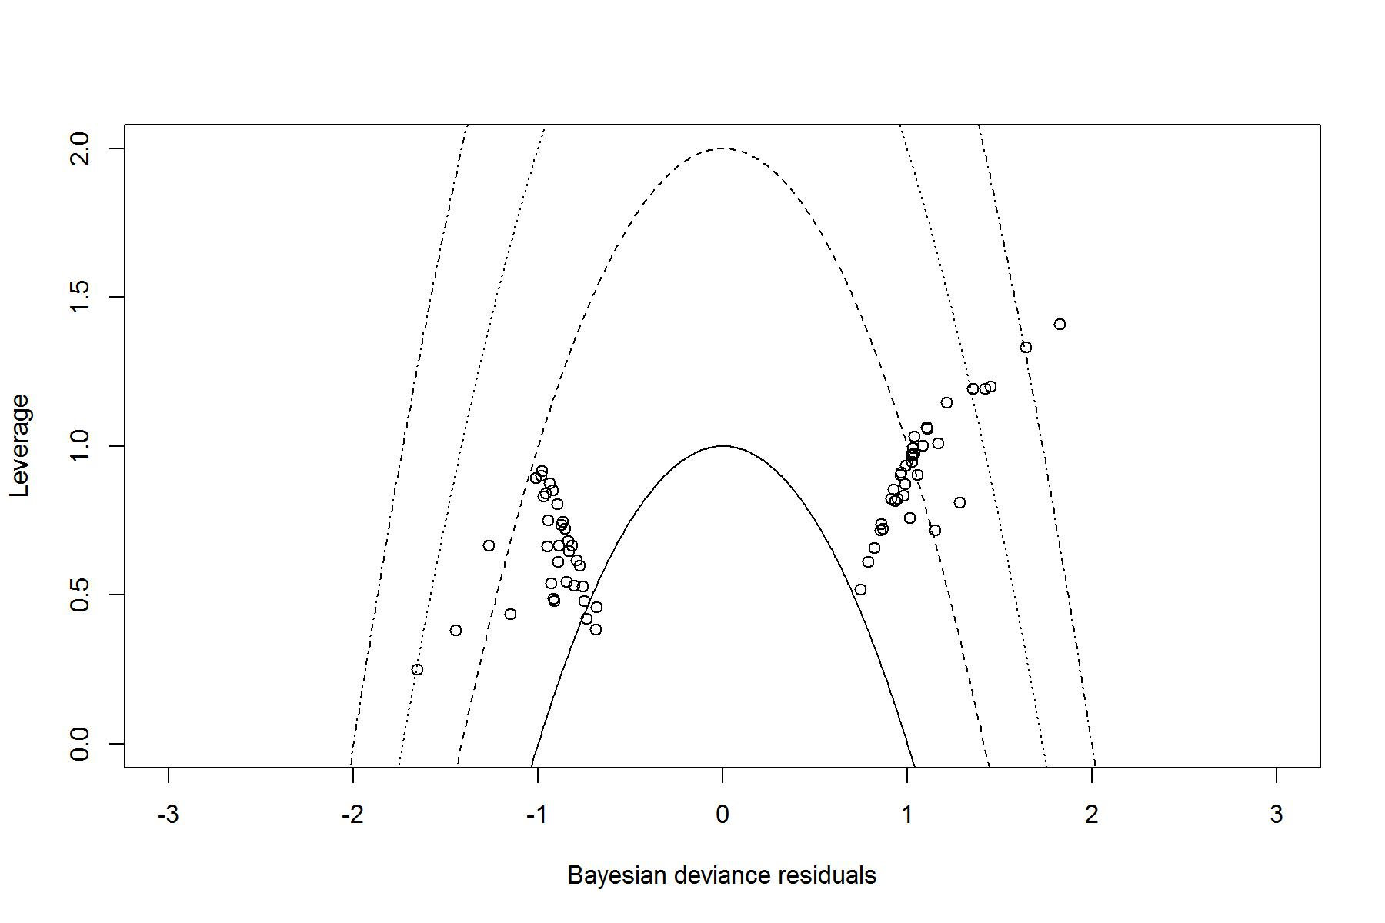
Figure 39: ST. Plot of leverage vs Bayesian deviance residual, with curves of the form x²+y=c, with c=1,2,3 and 4.

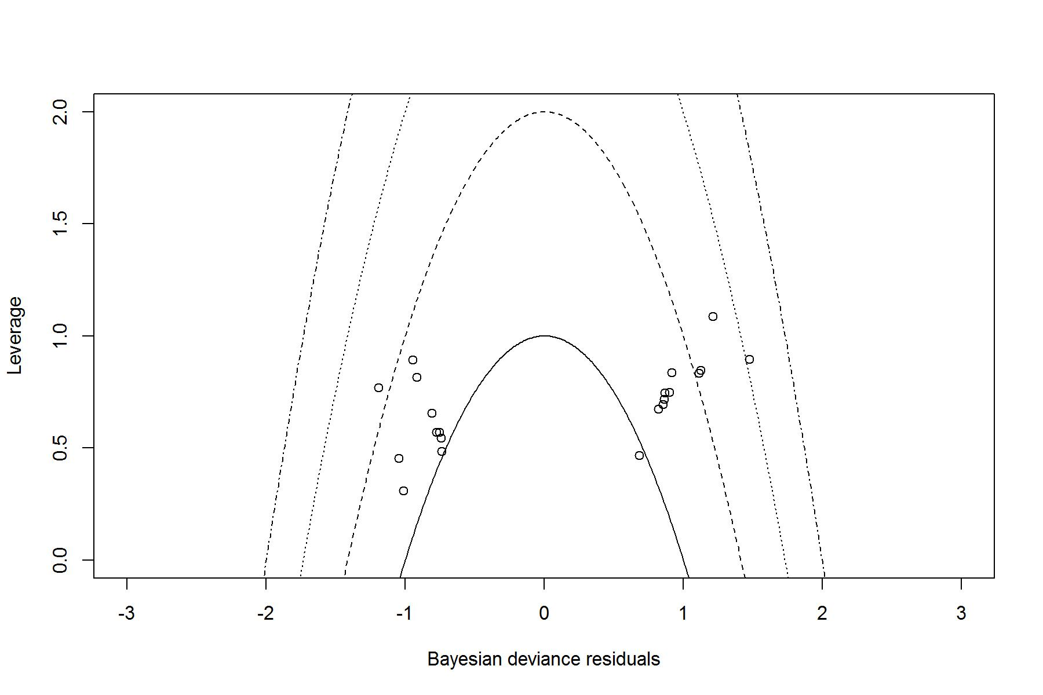
Figure 40: Major bleeding. Plot of leverage vs Bayesian deviance residual, with curves of the form x²+y=c, with c=1,2,3 and 4.

