Myeloperoxidase is a Potential Molecular Imaging and Therapeutic Target for the Identification and Stabilisation of High-Risk Atherosclerotic Plaque
Rashid I MBBS PhD^{1*}, Maghzal GJ PhD^{1,2*}, Chen Y-C PhD^{3*}, Cheng D PhD¹, Talib J PhD¹, Newington DL BSc¹, Ren MQ PhD⁴, Vajandar SK PhD⁴, Searle AK BBiomedSc³, Maluenda AC PhD³, Lindstedt EL PhD⁵, Jabbour A MBBS PhD^{1,6}, Kettle AJ PhD⁷, Bongers A PhD⁸, Power C PhD⁸, Michaëlsson E PhD⁵, Peter K MD PhD³, and Stocker R PhD^{1,2}
¹Victor Chang Cardiac Research Institute, Sydney, Australia
²St Vincent’s Clinical School, Faculty of Medicine, University of New South Wales, Sydney, Australia
³Atherothrombosis and Vascular Biology Laboratory, Baker Heart and Diabetes Institute, Melbourne, Australia
⁴Centre for Ion Beam Applications, Department of Physics, National University of Singapore, Singapore 117542
⁵Heart Failure Bioscience, Cardiovascular and Metabolic Diseases, IMED Biotech Unit, AstraZeneca, Gothenburg, Sweden
⁶Department of Cardiology, St Vincent’s Hospital, Sydney, Australia
⁷Centre for Free Radical Research, University of Otago Christchurch, New Zealand
⁸Biological Resources Imaging Laboratory, University of New South Wales, Sydney Australia
*These authors contributed equally
Corresponding Author: Prof Roland Stocker, Vascular Biology Division, Victor Chang Cardiac Research Institute, Lowy Packer Building, 405 Liverpool Street, Darlinghurst NSW 2010, Australia. Phone: +612 9295-8600, Email: r.stocker@victorchang.edu.au

SUPPLEMENTARY MATERIALS Rashid et al.
Expanded Methods

Animals
Male apolipoprotein E gene-deficient (Apoe–/–) mice, obtained originally from the Animal Resource Centre in Western Australia, were bred in the BioCORE facility at the Victor Chang Cardiac Research Institute. Myeloperoxidase gene-deficient (Mpo–/–) mice on a C57BL/6J background were derived originally from Prof. A.J. Lusis (UCLA, Los Angeles, CA)¹ and obtained from Prof. S.R. Holdsworth (Monash University, Melbourne, VIC, Australia). These mice were crossed with Apoe–/– mice to yield Mpo–/–Apoe–/– mice. Mice (6 weeks of age) were fed Western Diet (WD) containing 22% fat and 0.15% cholesterol (SF00-219, Specialty Feeds, Western Australia) for a total of 13 weeks. Six weeks after commencement of WD, tandem stenosis (TS) was introduced into the mice as described below. The Animal Ethics Committees of the Garvan Institute of Medical Research/St Vincent’s Hospital and the University of New South Wales approved all experiments.

AZM198 treatment
For pharmacological inhibition of MPO, AZM198 (AstraZeneca, Sweden) was administered by incorporation into WD at a daily dose of 500 µmol/kg bodyweight based on an average daily food consumption of ~3.7 g per mouse. This yielded a total plasma concentration of AZM198 of ~2 μM, corresponding to a free concentration of 0.6 μM.² Based on the potency of human MPO purified from HL60 cells (ascorbate oxidation) and iodination by human thyroid peroxidase expressed by transfected insect cells, this concentration corresponds to 98% inhibition of MPO activity and a marginal (8%) inhibition of thyroid peroxidase (Figure S2). In contrast, intracellular MPO inhibition (as assessed by intra-granular MPO activity in purified neutrophils) is predicted to require substantially higher concentrations of AZM198.² In our experiments, residual MPO activity was observed in AZM198-treated mice (20-40% depending on the methodology employed), in contrast to Mpo–/– mice. Thus, some of the MPO activity quantified in plaque with unstable phenotype may represent intracellular MPO in actively phagocytosing neutrophils and/or macrophages.

Tandem stenosis (TS) surgery
Six weeks after commencement of WD, male Apoe–/– mice were anaesthetised with 4% isoflurane. An incision was made in the neck and the right common carotid artery was dissected from circumferential connective tissues. Two stenoses with 150 μm outer diameter were placed with the distal stenosis 1 mm from the carotid artery bifurcation and the proximal stenosis 3 mm from the distal stenosis. To control for the extent of constriction caused by the stenosis, a 150-μm needle (Ethicon 8-0, Virgin silk blue, W1782) was placed on top of the exposed right common carotid artery before a 6-0 blue-braided polyester fiber suture (TICRON 0.7 Metric) was tied around both the artery and needle, and the needle then removed. Blood flow was measured before and after the addition of each ligature using a perivascular flow module (Transonic, TS420) and a 0.7 mm perivascular flow probe (Transonic MA0.7PSB). Flow for each ligature in the TS was defined as 70% of baseline flow after addition of the distal ligature and 20% of baseline flow after addition of the proximal ligature. Animals were euthanised 7 weeks after surgery by cardiac puncture and exsanguination. At this time, the segment proximal to the proximal suture in the right common carotid artery (referred to previously as Segment I³) contains plaque with unstable phenotype characterised by consistent thinning of the fibrous cap, abundant inflammatory cells, occasional neovessels, cap disruption and intraplaque haemorrhage, as well as luminal thrombus of fibrin and platelets.³ In contrast, the brachiocephalic trunk contains thick-cap and abundance of collagen in the atheroma area, features of a stable plaque.³
We chose to assess the brachiocephalic artery as a site of “stable” plaque because: (i) MR imaging at this site can be acquired simultaneously with plaque with unstable phenotype and normal vessel wall in the right and left common carotid arteries, respectively; (ii) the brachiocephalic artery is commonly used for atherosclerosis studies in Apoe–/– mice with lesions in this vessel being stable; and (iii) computational fluid dynamics demonstrate no significant reduction in vessel wall shear stress in this region following TS surgery.³

Assessment of MPO activity
Measurement of in vivo and ex vivo MPO activity followed the procedure described in Talib et al.⁴ In brief, for ex vivo MPO-activity, tissue was homogenised in PBS containing 0.05 M diethylenetriaminepentaacetic acid and 1 Roche cOmpleteTM (169749800) protease inhibitor. Following homogenisation, tissue was incubated with glucose (20 mg/mL) and glucose oxidase (40 μg/mL) in the presence of 20 mM Trolox® and 50 μM hydroethidine (HE, Tyger Scientific, Ewing, NJ) for 30 min at 37 °C in the dark. Hydroethidine and its oxidation products were then extracted by the addition of 80% ethanol containing 3 μM 2-chloroethidium-d₅ prior to LC-MS/MS analysis as previously described.⁴ In vivo MPO activity was determined following administration of 80 μL 20 mM HE dissolved in a 1:1 solution of dimethylsulfoxide:saline (vol/vol) to mice via retro-orbital injection 45 min before euthanasia. Tissue was collected and homogenised in 80% ethanol containing 0.4 nM 2-chloroethidium-d₅ prior to measurement of HE and its products using LC-MS/MS as previously described.⁴

Magnetic resonance imaging
At 7 weeks following TS surgery, isoflurane-anaesthetised mice were imaged in the prone position using a 9.4T Bruker Biospec 94/20 Avance III system (Bruker, Ettlingen, Germany) with a 50-mm quadrature radiofrequency coil and respiratory-gated image acquisition. Mice were imaged before and after intravenous administration of 0.3 mmol/kg of the MPO sensor bis-5-hydroxytryptamide-DTPA-Gd (MPO-Gd) or DTPA-Gd (Magnevist, Bayer, Leverkusen, Germany) via a tail vein catheter. Prior to contrast injection, a flow-compensated 2D-FLASH time-of-flight (TOF) angiography in a coronal slice orientation was performed to assess intra-vessel (luminal) volume and geometry using a flow-compensated 2D-GRE sequence (FLASH) for time-of-flight (TOF) angiography in an axial slice orientation with the following major parameters: TR 34 ms, TE 3 ms, slice thickness 0.5 mm, inter-slice distance 0.35 mm, 40 slices, matrix size 128 x 128, FOV 20 x 20 mm, in-plane resolution 156 x 156 μm. This was followed by a T1-weighted fast spin echo (TurboRARE, T1-TSE) acquired in the same orientation with the following parameters: TR 1500 ms, TE 8.5 ms, ETL 8, slice thickness 1 mm, FOV 20 x 20 mm, matrix size 192 x 192, in-plane resolution 104 x 104 μm. This T1-TSE protocol was then repeated in a scan series covering a period of one hour following contrast injection to assess contrast agent inflow and retention (Figure S9B). OsiriX (Version 7.0, Pixmeo, Switzerland) was used for image analysis. In T1-TSE images, separate regions of interest were assigned to the vessel wall, skeletal muscle (reference) and background (air). The contrast-to-noise ratio (CNR) was calculated as follows: CNR = (SI_{vessel wall} - SI_{skeletal muscle})/SD_{background}. The mean CNRs of three consecutive slices in plaque with unstable phenotype and corresponding segments of the left carotid artery (plaque-free), in addition to 1-2 consecutive slices in the brachiocephalic trunk (stable plaque, SP), were calculated. Segmental enhancement attributable to MPO was assessed by calculating the ∆CNR = CNR_{post-contrast} - CNR_{pre-contrast}.

Measurement of plasma AZM198
The chemical structure of AZM198 is not disclosed. For others to reproduce the data presented herein, AstraZeneca may provide the compound under a standard material transfer agreement. The purity of the AZM198 batch used for the present studies was 96%. The concentration of AZM198 in plasma was determined by LC-MS/MS using an Agilent 6490 Triple Quadrupole mass spectrometer (Agilent Technologies), equipped with an ESI source and connected to an Agilent 1290 UHPLC. To assess 50 µL of plasma, 5 µL of 100 nM verapamil (internal standard) was added and the solution extracted with 180 µL of ice-cold 0.2% formic acid in acetonitrile. After vigorous mixing for 1 min, solutions were placed on ice for 15 min, centrifuged at 13,000 g for 10 min at 4 °C, before the supernate was diluted in an equal volume of 0.2% formic acid. Five microliters of the diluted supernate were then injected onto an Acquity UHPLC HSS T3 C18 column (2.1 x 30 mm, 1.8 μm, Waters) eluted at 0.8 mL/min using a gradient of solvent A (0.2% formic acid in 98% water/2% acetonitrile) and B (0.2% formic acid in 100% acetonitrile) as follows: 4-95% solvent B over 0.8 min, held at 95% for 0.5 min, back to 4% B in 0.5 min and then held at 4% B for 2.2 min. Flow was then directed into the mass spectrometer with parameters set as follows: gas temperature = 290 °C; gas flow = 14 L/min; nebuliser pressure = 20 psi; sheath gas heater = 400 °C; sheath gas flow = 11 L/min; capillary voltage = 3500 V. Detection of AZM198 and verapamil was by multiple reaction monitoring (MRM) in positive ion mode using the above general mass spectrometry parameters with fragmentor voltage at 380 V and cell accelerator voltage at 5 V. In each case, the fragment ions generated by collision-induced dissociation of the [M+H]⁺ ions were used for quantification. Concentrations were calculated from matrix spiked calibration curves generated using authentic standards of AZM198 with verapamil as internal standard.

Tissue collection
At the end of the intervention or after scanning, mice were killed by exsanguination whilst anaesthetised with isoflurane. Blood was collected by cardiac puncture into a heparin-coated 1 mL syringe using a 25-gauge needle, and the animal then perfused with phosphate buffered saline administered under physiological pressure. Blood was centrifuged (2,000 g, 15 min, 4 °C), plasma collected and snap frozen on dry ice before being stored at -80 °C. The left and right common carotid arteries, brachiocephalic trunk, and heart were cleared of surrounding adipose and connective tissue before being excised, snap frozen on dry ice and stored at -80 °C for subsequent assessment of MPO activity or histology and immunohistochemistry. The left and right carotid arteries were embedded in optimal cutting temperature compound for cryosectioning and serially sectioned using a cryostat set to a thickness of 6 µm (for histology and immunohistochemistry) or 16 µm (Gd analysis by nuclear microscopy).

Histology
In a pilot study, the entire 3 mm long carotid artery segment proximal to the proximal suture in unstable plaque (previously referred to as Segment I³) was sectioned at 100 µm intervals. 6 sections per interval were obtained for representation. Fibrous cap thickness was defined by calculated positive birefringence area under polarised light in picrosirius red staining (Figure S1A). Lesion height was defined by the maximal distance from the vessel wall to the lumen in the plaque region (Figure S1, H/E stain). We observed most consistent values for cap thickness (Figure S1B) and cap:lesion height ratios between 1,500-2,000 μm proximal to the proximal suture (Figure S1C). For all subsequent studies, therefore, serial cryosections were obtained at 100 µm intervals at 1,500-2,000 µm proximal to the proximal suture in the right common carotid artery, and from the brachiocephalic trunk. Sections were stored at -20 °C until staining was performed. Picrosirius red staining was performed to visualise collagen within atherosclerotic plaque in the right common carotid artery (1,500 µm proximal to the proximal suture), as described previously.³ Briefly, frozen sections were fixed in 10% neutral buffered formalin, washed, stained for 1 h in picrosirius red solution [0.6% w/v of Direct red (Sigma Cat# 365548) in saturated picric acid], differentiated in 0.1 M HCl, dehydrated and covered with coverslips using DPX mounting media. Martius Scarlet Blue staining was used to visualise fibrin.⁵ Haemosiderin was detected using the Prussian Blue staining kit (Polysciences Cat#24199) to visualise stored iron. Haematoxylin and eosin staining was used for histomorphometry of aortic sinus and plaque burden, and for morphology to accompany the metal analysis. Images were obtained using a Leica Brightfield microscope. All histological data analyses were performed by an operator blinded to animal genotype or treatment.

Immunohistochemistry
The left and right common carotid arteries and brachiocephalic trunk were sectioned as described above. Sections were incubated in primary antibody [rat anti-mouse Ter-119 biotin (eBioscience 13-5921) 1:400; rabbit polyclonal anti-myeloperoxidase (Abcam ab9535) 1:50; and anti-smooth muscle actin antibody (ProteinTech 23081-1-AP) 1:200; anti-haemoglobin subunit alpha antibody (Abcam ab102758) 1:100; goat polyclonal anti-monocyte chemoattractant protein-1 (R&D systems AF-479) 1:100; and rat anti mouse macrophages/monocytes antibody (Bio-red MCA519) 1:100] at 4 °C overnight. After the wash steps and incubation in ABC reagent, DAB reagent was applied to each section. Conversion of the DAB substrate to a coloured product was monitored and slides were immersed in dH₂O to stop the reaction. Sections were dehydrated and covered with coverslips using DPX mounting media. Images were obtained using a light microscope (Leica Brightfield or Olympus BX50 microscope), and staining intensities quantified using ImageJ (for MPO staining) or Optimas (for all other markers). Each IHC protein marker, except MPO, was determined in at least three sections of atherosclerotic plaques obtained from each animal and taken between 1,500-2,000 µm (see Figure S2). For MPO, one section per mouse, taken between 1,500-2,000 µm, was used. The amount of protein present was quantified by an operator blinded to animal genotype or treatment, using Optimas 6.2 VideoPro-32 (or ImageJ). Results were expressed as a percentage of stained area over total plaque area, and the data shown for each animal and with means ± SD indicated.

Blood lipid analysis
Total plasma cholesterol, LDL- and HDL-cholesterol, and triglyceride concentrations were measured as described previously³ with the Cobas Integra® 400 plus autoanalyser using the following standard commercial enzymatic assay kits from Roche Diagnostics (Germany): cholesterol Gen.2, HDL-cholesterol plus 2nd generation, LDL-cholesterol plus 2nd generation, and triglycerides. Colorimetric changes were measured at 512 nm for total cholesterol and triglycerides, or at 583 nm for HDL- and LDL-cholesterol.

Nuclear microscopy
Nuclear microscopy experiments were performed at the Centre for Ion Beam Applications at the National University of Singapore, as described previously.⁶ Briefly, the samples were mounted onto a 3-axis stage within a scattering chamber maintained at < 5×10⁻⁶ mbar. A collimated proton beam (H⁺) at 2.1 MeV was generated using a 3.5 MV Singletron accelerator and kept incident onto the samples inclined at 45 degrees to the incident beam. The broad incident ion beam was focused down to a spot size of 1 µm and scanned across the region of interest. Data was acquired simultaneously using a combination of three ion beam analytical techniques namely proton induced X-ray emission (PIXE), Rutherford backscattering spectroscopy (RBS), and scanning transmission ion microscopy (STIM). PIXE data was collected using a Si(Li) detector placed at 20 mm from the samples to the Si(Li) crystal face. RBS and STIM data were measured by a passivated implanted planar silicon (PIPS) detector. The RBS detector was mounted at a back scattering angle of 160 degrees to the incident beam and the STIM detector was mounted at a forward angle of 20 degrees off-axis to the incident beam to collect the forward scattered proton beam that has undergone a small fraction of energy loss after passing through the thin biological samples.
Scanning transmission ion microscopy provides structural maps based on the energy lost by the protons as they pass through the relatively thin organic samples with thicknesses of 30 µm or less, enabling structural identification without fixing or staining. Trace elemental mapping was performed using particle-induced X-ray emission, which simultaneously provides multiple elements with high quantitative accuracy and sensitivity to a few parts per million in biological materials. Rutherford backscattering spectroscopy was used to measure the information on the sample thickness and matrix composition as well as calculating the charge that reflects the interactions between beam and samples. The obtained PIXE spectra were fitted using GUPIXWIN⁷ and the RBS spectra were fitted in SIMNRA.⁸ To examine the spatial resolution of Gd, higher resolution scans were carried out after the initial acquisition (680 µm scan size).

Statistical analysis

All numeric data were first analysed for normality using the Shapiro-Wilk normality test, with significance determined subsequently using the appropriate parametric or non-parametric test. The CNR for MPO-Gd-treated and DTPA-Gd-treated arteries were analysed using unpaired T-test to determine differences in retention of the MR probe. Differences in ΔCNR, MPO activity and histological analyses between TS Apoe–/– and Mpo–/–Apoe–/–, or between TS Apoe–/– fed WD ± AZM198 were assessed using the Mann-Whitney rank sum test, or unpaired T-test where appropriate. All statistical analyses were performed with GraphPad Prism version 7.0d for Mac (GraphPad Software, La Jolla California USA) and individual data shown with mean ± SD.

References
1. Brennan ML, Anderson MM, Shih DM, Qu XD, Wang X, Mehta AC, Lim LL, Shi W, Hazen SL, Jacob JS, Crowley JR, Heinecke JW and Lusis AJ. Increased atherosclerosis in myeloperoxidase-deficient mice. J Clin Invest. 2001;107:419-430.
2. Björnsdottir H, Welin A, Michaelsson E, Osla V, Berg S, Christenson K, Sundqvist M, Dahlgren C, Karlsson A and Bylund J. Neutrophil NET formation is regulated from the inside by myeloperoxidase-processed reactive oxygen species. Free Radic Biol Med. 2015;89:1024-1035.
3. Chen YC, Bui AV, Diesch J, Manasseh R, Hausding C, Rivera J, Haviv I, Agrotis A, Htun NM, Jowett J, Hagemeyer CE, Hannan RD, Bobik A and Peter K. A novel mouse model of atherosclerotic plaque instability for drug testing and mechanistic/therapeutic discoveries using gene and microRNA expression profiling. Circ Res. 2013;113:252-265.
4. Talib J, Maghzal GJ, Cheng D and Stocker R. Detailed protocol to assess in vivo and ex vivo myeloperoxidase activity in mouse models of vascular inflammation and disease using hydroethidine. Free Radic Biol Med. 2016;97:124-135.
5. Sluiter JC, Gijbels MJ and Heneman S. Detection of intraplaque hemorrhage in mouse atherosclerotic lesions. In: V. Andrés and B. Dorado, eds. Methods in mouse atherosclerosis New York: Springer Science+Business Media; 2015(1339): 339-348.
6. Minqin R, En H, Beck K, Rajendran R, Wu BJ, Halliwell B, Watt F and Stocker R. Nuclear microprobe investigation into the trace elemental contents of carotid artery walls of apolipoprotein E deficient mice. Nucl Inst and Meth in Phys Res B. 2007;260:240-244.
7. Maxwell JA, Campbell JL and Teesdale WJ. The Guelph PIXE software package. Nucl Inst and Meth in Phys Res B. 1989;43:218.
8. Mayer M. SIMNRA User’s Guide. Technical Report IPP 9/113. 2017;120:1-340.
9. Tidén AK, Sjogren T, Svensson M, Bernlind A, Senthilmohan R, Auchere F, Norman H, Markgren PO, Gustavsson S, Schmidt S, Lundquist S, Forbes LV, Magon NJ, Paton LN, Jameson GN, Eriksson H and Kettle AJ. 2-Thioxanthines are mechanism-based inactivators of myeloperoxidase that block oxidative stress during inflammation. J Biol Chem. 2011;286:37578-37589.
10. Witting PK, Pettersson K, Letters J and Stocker R. Site-specific anti-atherogenic effect of probucol in apolipoprotein E deficient mice. Arterioscler Thromb Vasc Biol. 2000;20:e26-e33.

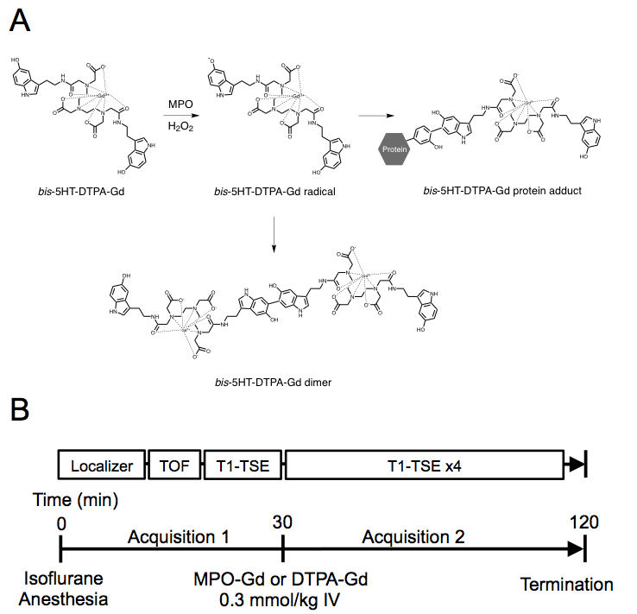
Figure S1. Scheme of action of bis-5HT-DTPA-Gd (MPO-Gd) and magnetic resonance imaging protocol. A, In the presence of H₂O₂, MPO oxidises the 5-hydroxytryptamine moiety of MPO-Gd to a phenoxyl radical, which then can give rise to either an MPO-Gd dimer or multimer (not shown) to amplify the signal. The phenoxyl radical-containing MPO-Gd may also covalently bind to proteins. This results in the retention of MPO-Gd in target tissues. B, Mice were imaged under isoflurane anaesthesia. Initial acquisition involved a localiser, time-of-flight and T1-weighted turbo spin echo (T1-TSE) imaging. Approximately 30 min after acquisition of baseline images, MPO-Gd (0.3 mmol/kg) was injected intravenously via the tail vein. Consecutive T1-TSE images were then acquired for 60 min following contrast injection. Segmental analysis of MPO activity was assessed by calculating the ∆CNR (CNR_{post-contrast} – CNR_{pre-contrast}) for unstable and stable plaque, and non-diseased arterial segments.

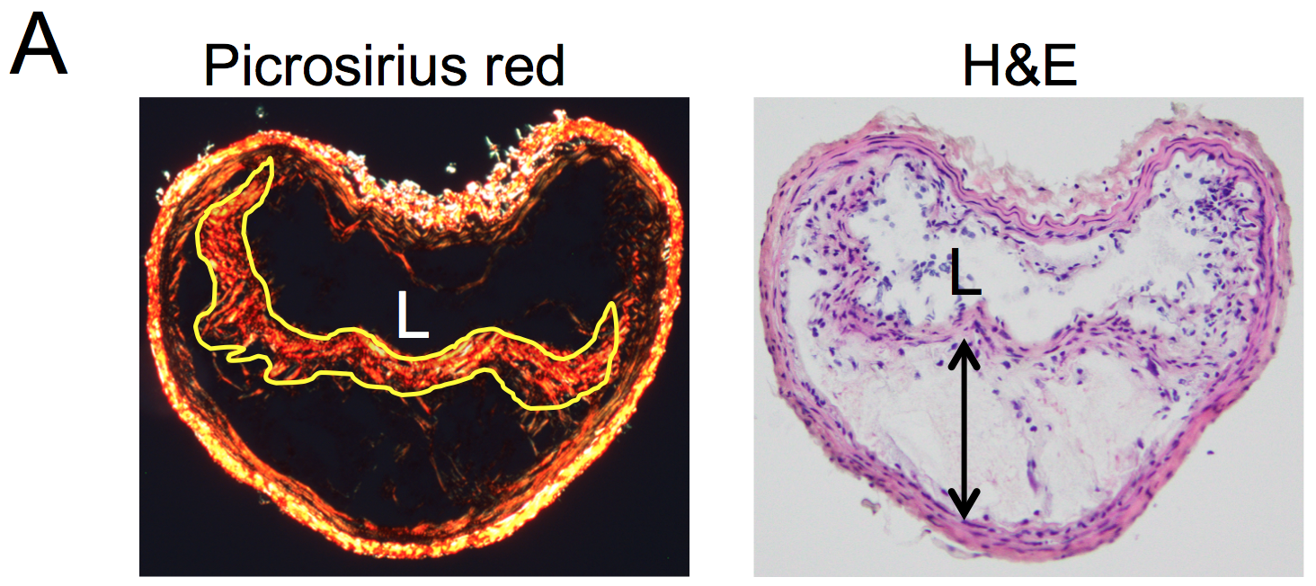
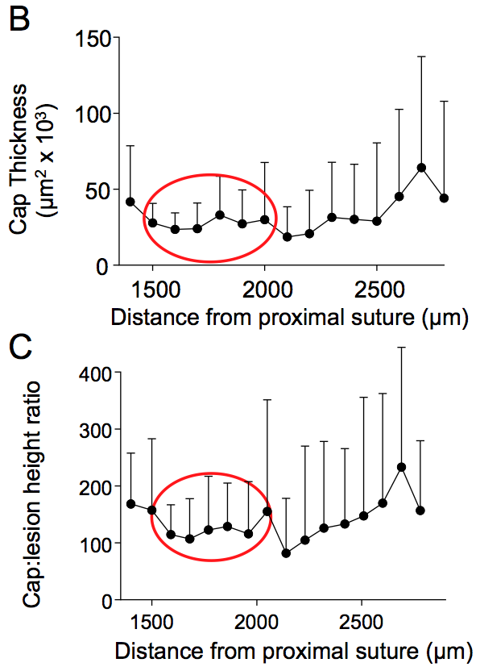
Figure S2. Assessment of fibrous cap thickness in plaque with unstable phenotype of TS mice. A, Picrosirius red (left) and haematoxylin and eosin (H&E) staining (right) of plaque with unstable phenotype in the right carotid artery. Cap thickness was determined as the area of picrosirius red-stained cap viewed under polarised light showing the fibrous cap (yellow line). Lesion height was determined from H&E stained sections (arrow). L = lumen. B, Fibrous cap thickness and C, cap-to-lesion height ratio in unstable plaque. In an initial pilot study, we sectioned the entire area (~3,000 μm) prone to vulnerable plaque in the right carotid artery at 100 μm intervals from the proximal suture. We observed most consistent values for cap thickness and cap:lesion height ratios between 1,500-2,000 μm proximal to the proximal suture (B and C). Data shown are mean ± SD; n = 10.

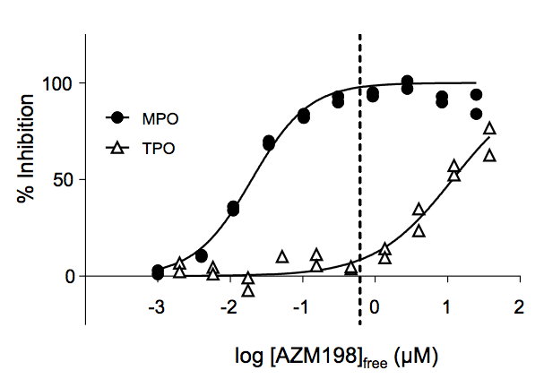
Figure S3. The potency of AZM198 on human MPO and thyroid peroxidase (TPO) in vitro. MPO activity was determined by measuring absorbance at 260 nm after activation of HL60-derived MPO with hydrogen peroxide in the presence of ascorbate as previously described.⁹ The activity of recombinant human TPO (expressed in insect cells, RSR Ltd, Cardiff, UK) was determined spectrophotometrically by iodination of hydrogen peroxide to form hypoiodous acid. In brief, 25 nM TPO was incubated with 1 mM methionine, 10 µM KI and 50 µM H₂O₂. After 20 min, the reaction was stopped by addition of 0.25 mg/mL catalase (Sigma). After an additional 5 min, the reaction mixture was acidified with 150 mM H₂SO₄. Finally, the dehydromethionine formed by hypoiodous acid from methionine was converted back to methionine by addition of an excess amount of KI (25 mM), resulting in the formation of triiodide that was monitored by measuring the absorbance at 353 nm. The data are normalised to non-stimulated and uninhibited controls and concentration-response curves were extrapolated in GraphPad Prism 7 using nonlinear regression of normalised data versus logarithmic concentration. The dashed line represents the free plasma concentration of AZM198 in the in vivo experiments, which corresponds to approximately 98 and 8% inhibition of MPO and TPO, respectively. In additional selectivity screens to assess off-target effects of AZM198, intravenous infusion of AZM198 at exposures 15 times higher than observed in the current study resulted in no functional cardiovascular effects (blood pressure, heart rate, cardiac contractility and relaxation). In vitro selectivity screens showed AZM198 to bind to adrenergic B1 and B2 receptors, which in activity assays resulted in antagonism of receptor activation with IC₅₀-values corresponding to a plasma concentration of 42 and 90 µmol/L, respectively, i.e., 20- and 45-fold higher than the exposures observed in the current study.

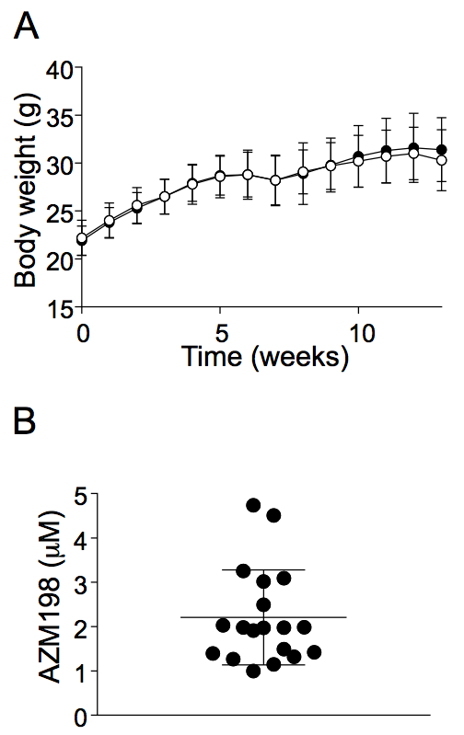
Figure S4. Effect of AZM198 on body weight of Apoe–/– mice and drug plasma concentration. AZM198 was incorporated into WD provided to the mice (20 g body weight) ad libitum. Assuming a daily food consumption of 3.7 g, the amount of AZM198 consumed corresponded to 500 μmol/kg body weight. A, Body weight of male mice (6 weeks old) receiving WD without (open circles) and with AZM198 (filled circles) for 13 weeks, with TS surgery performed after 6 weeks. Data shown are mean ± SEM of n = 25 mice. B, Plasma concentration of AZM198 at the end of the 13 weeks intervention. AZM198 was determined by LC-MS/MS. Data is shown for individual mice as well as mean ± SD (n = 19).
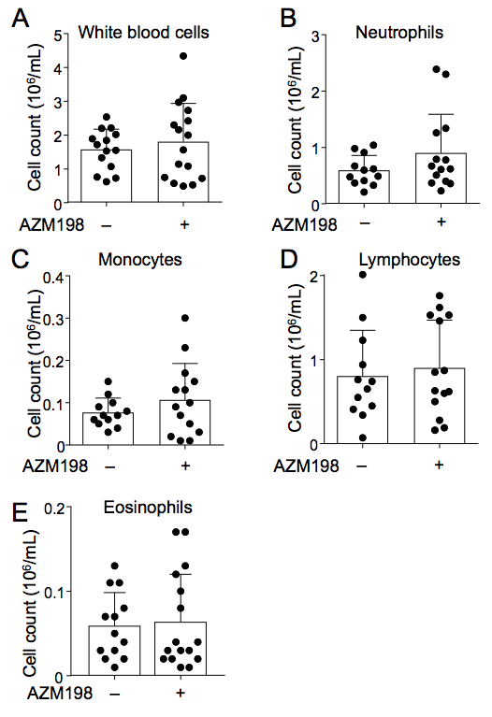
Figure S5. AZM198 does not affect circulating WBC count. At the end of the 13 weeks intervention, EDTA blood was collected from TS mice fed WD without (-) or with AZM198 (+), and analysed for (A) white blood cell count, (B) neutrophils, (C) monocytes, (D) lymphocytes, and (E) eosinophils. Data show individual values and mean + SD and were analysed by Mann-Whitney rank sum test.

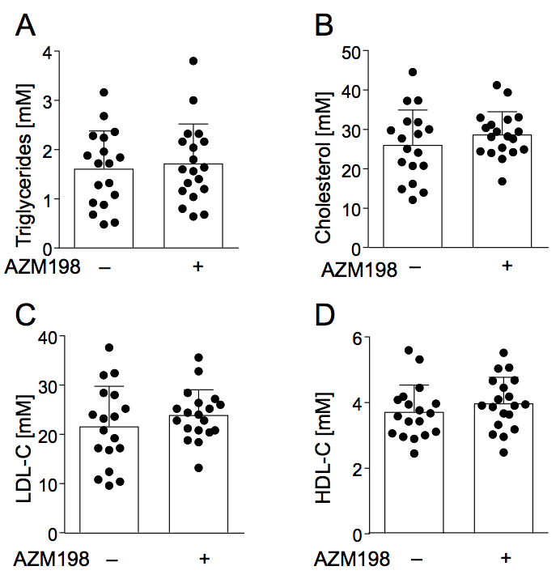
Figure S6. AZM198 does not affect plasma lipids. At the end of the 13 weeks intervention, heparinised blood was collected from TS mice fed WD without (-) (n=18) or with AZM198 (+) (n=19). Plasma was prepared from blood and analysed for (A) triglycerides, (B) total cholesterol, (C) low density lipoprotein cholesterol (LDL-C) and (D) high-density lipoprotein cholesterol (HDL-C). Data show individual values and mean + SD and were analysed by Mann-Whitney rank sum test.

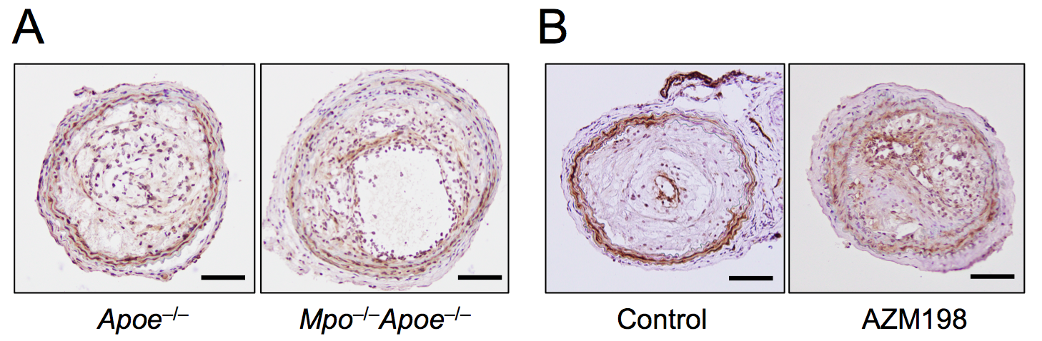
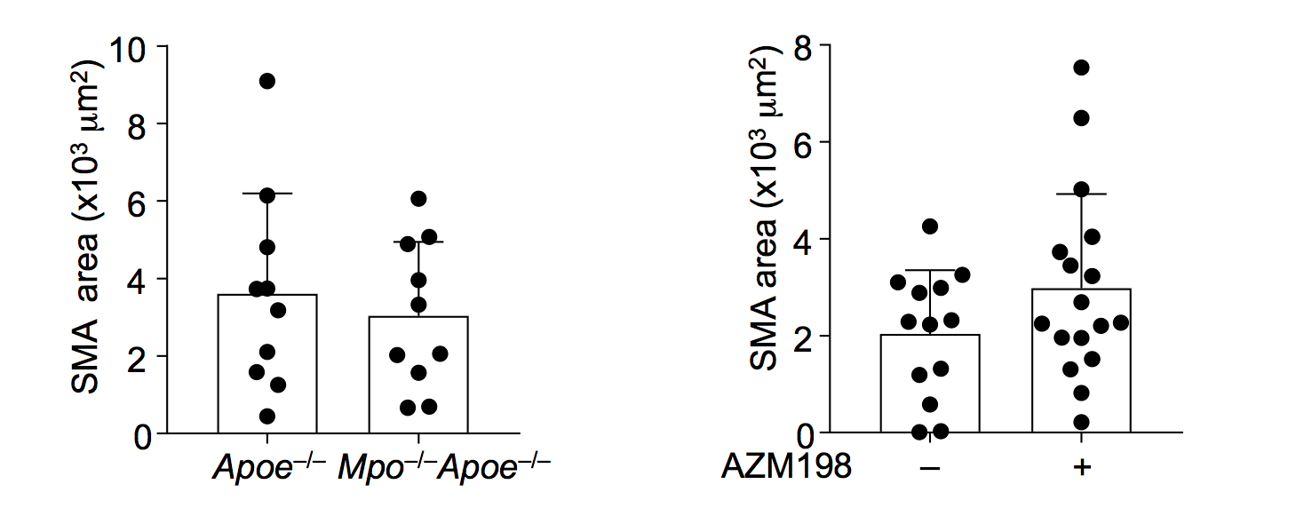
Figure S7. Effect of AZM198 or MPO deletion on smooth muscle actin content. Unstable plaque was analysed for smooth muscle actin (SMA) content by immunohistochemistry as described in the expanded methods of the supplemental material. A, Representative images of SMA staining in TS Apoe–/– and TS Mpo–/–Apoe–/– mice with the corresponding quantitative data showing individual data and mean + SD as SMA⁺ area. B, Representative images of SMA staining in TS Apoe–/– mice ± AZM198 with the corresponding quantitative data showing individual data and mean + SD as SMA⁺ area. No statistically significant differences were observed (Mann-Whitney rank sum test). Scale bar = 100 μm.

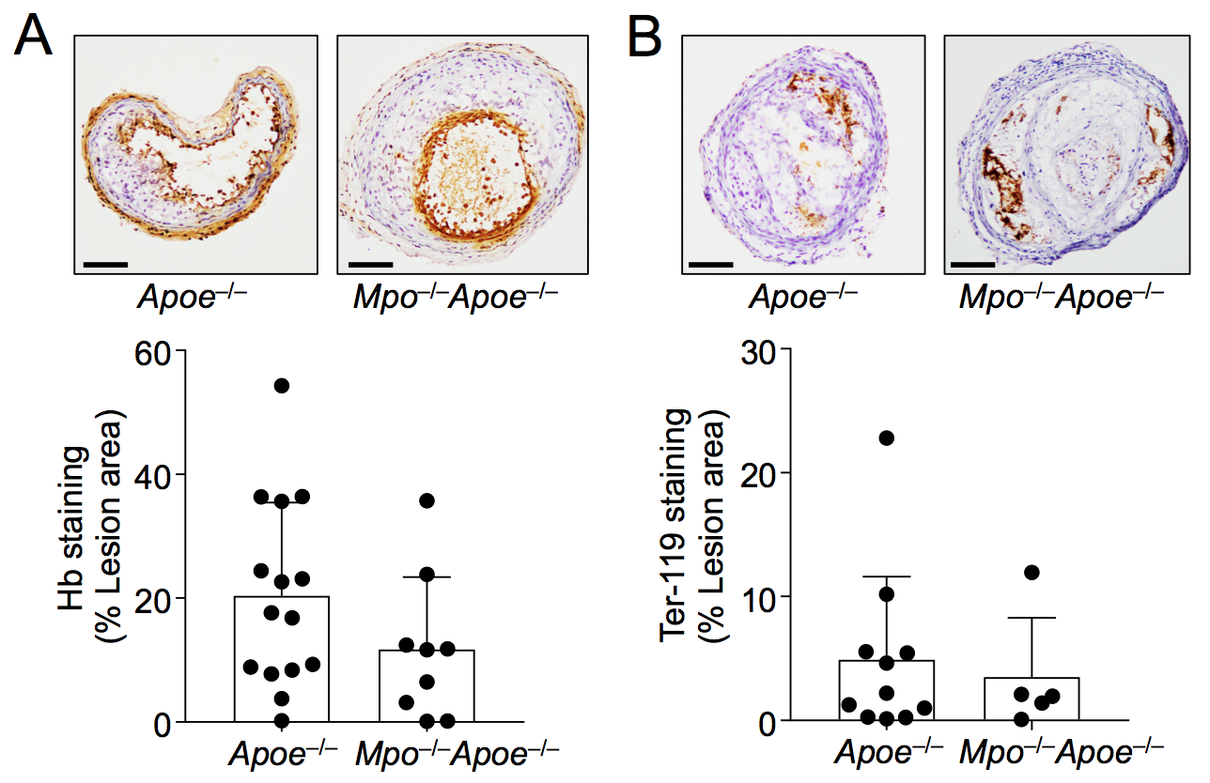
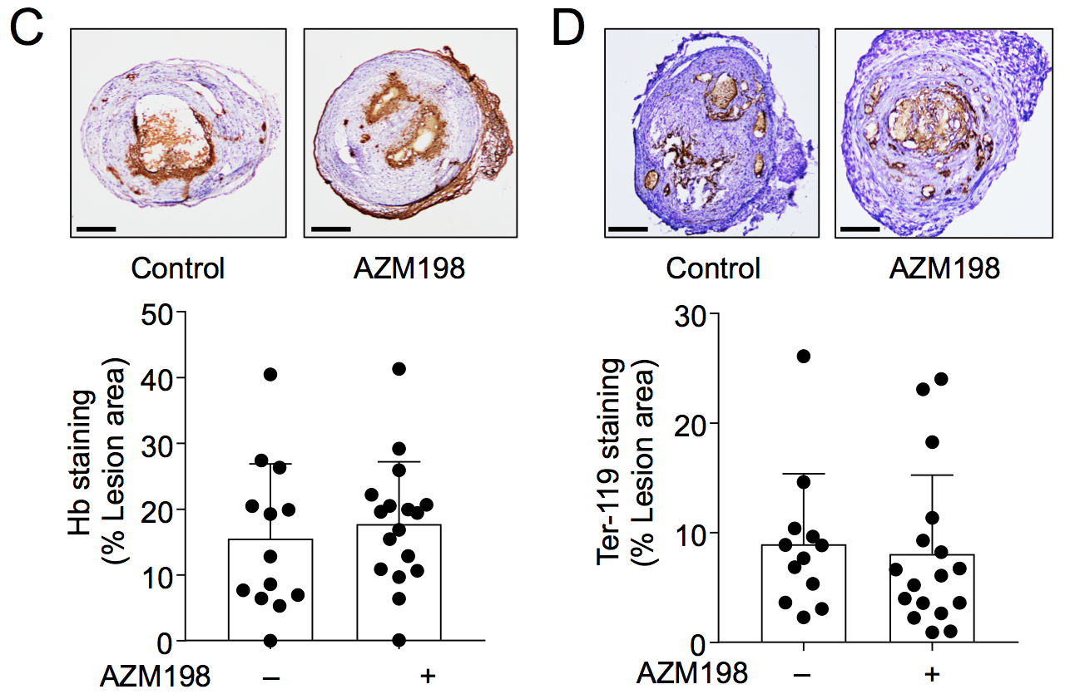
Figure S8. Effect of AZM198 or MPO deletion on intraplaque haemorrhage. Mice were placed on WD for 13 weeks with TS surgery performed after 6 weeks. Unstable plaque was analysed for the presence of haemoglobin (Hb) and red blood cells. Representative images of Hb for unstable plaque in (A) Apoe–/– and Mpo–/–Apoe–/–, and TS Apoe–/– mice fed WD ± AZM198 (C) and corresponding quantitative data showing individual data and mean + SD as Hb⁺ area calculated as percentage of stained areas per total lesion area. Representative images of Ter-119 staining, a mouse red blood cell marker, for unstable plaque in (B) Apoe–/– and Mpo–/–Apoe–/–, and TS Apoe–/– mice fed WD ± AZM198 (D) and corresponding quantitative data showing individual data and mean + SD as stained area per total lesion area. Numeric data shows mean + SD. No statistically significant differences were observed (Mann-Whitney rank sum test). Scale bar = 100 μm.
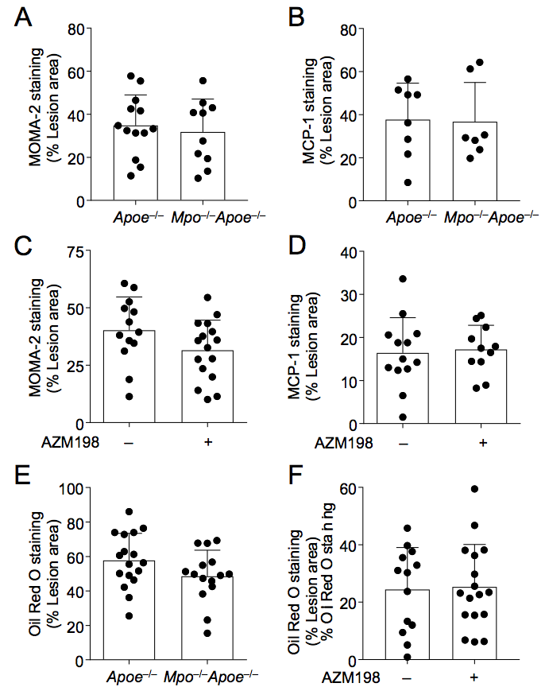
Figure S9. Effect of MPO inhibition or deletion on the composition of unstable plaque. Unstable plaque was analysed for the presence of macrophages (MOMA-2), monocyte chemoattractant protein-1 (MCP-1) as well as lipid content, with quantitative data calculated as percentage of stained area per total lesion area. A and B, MOMA-2 and MCP-1 results, respectively, in TS Apoe–/– and TS Mpo–/–Apoe–/– mice. C and D, MOMA-2 and MCP-1 staining, respectively, in TS Apoe–/– mice fed WD without (-) and with (+) AZM198. Oil Red O staining in (E) in TS Apoe–/– and TS Mpo–/–Apoe–/– mice and (F) TS Apoe–/– mice fed WD ± AZM198. Data show individual values with mean + SD. No statistically significant differences were observed (Mann-Whitney rank sum test). Scale bar = 100 μm.

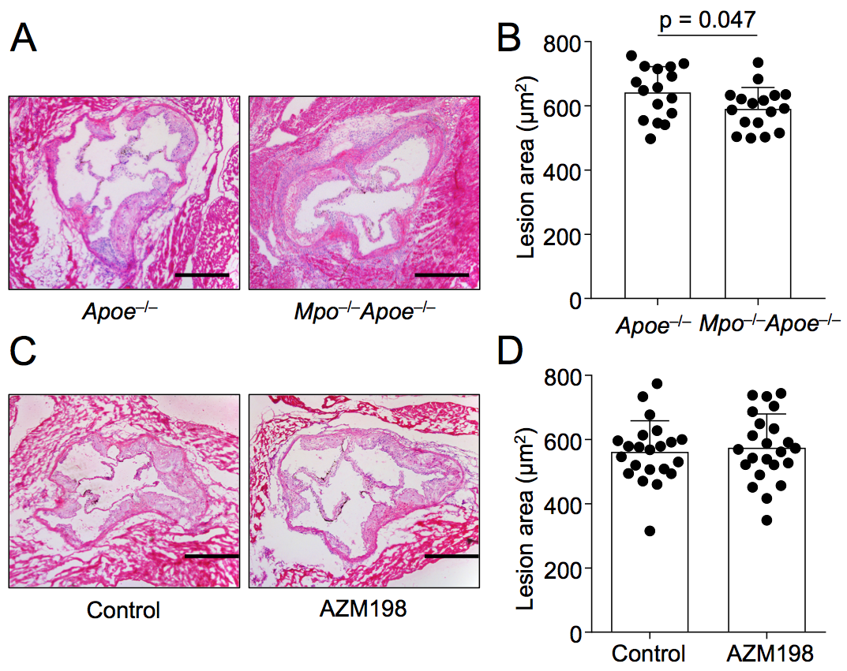
Figure S10. Effect of MPO deletion or AZM198 on the size of atherosclerotic lesions. TS mice were fed Western Diet ± AZM198 for 13 weeks with TS surgery after six weeks. Following the intervention, the size of atherosclerotic lesions in the aortic root was assessed by morphometry as described previously.¹⁰ A and B, Representative H&E stained sections of the aortic root from Apoe–/– (n=16) versus Mpo–/–Apoe–/– (n=17) and quantification of atherosclerotic lesion size. C and D, Representative H&E stained sections of the aortic root from TS mice without (-) (n=25) and with (+) AZM198 treatment (n=25) and quantification of lesion size. Numeric data show individual values with mean + SD, analysed by the Mann-Whitney rank sum test. Scale bar = 250 μm.

