Supplementary Material
Table of contents

Tables

p.2 – Table S1. Baseline characteristics and metabolic health status in members of the subcohort, by country
p.3 – Table S2. Sensitivity analysis: HR for CHD in different complete-case samples specific to each analysis.
p.4 – Table S3. Sensitivity analysis: HR for CHD where missing values are imputed by multiple imputation
p.5 – Table S4. Sensitivity analysis: HR for CHD after exclusion of first two years of follow-up across metabolically-defined body size phenotypes
p.6 – Table S5. Sensitivity analysis: HR for hard CHD (myocardial infarction) across metabolically-defined body size phenotypes
p.7 – Table S6. Sensitivity analysis: HR for CHD across metabolically-defined body size phenotypes in non-smokers only
p.8 – Table S7. Sensitivity analysis: HR for CHD events with the highest level of certainty across metabolically-defined body size phenotypes
p.9 – Table S8. Sensitivity analysis: HR for CHD across metabolically-defined body size phenotypes separately for men and women
p.10 – Table S9. Sensitivity analysis: HR for CHD in metabolically-defined body size phenotypes where the definition of MetS does not include the waist circumference criterion
p.11 – Table S10. Sensitivity analysis: HR for CHD in metabolically-defined body size phenotypes where “metabolically healthy” is defined as having none of the 4 abnormalities
p.12 – Table S11. Sensitivity analysis: HR for CHD in metabolically-defined body size phenotypes where obesity is defined by WC, and MetS does not include criteria on WC
p.13 – Table S12. Cross-classification in metabolically-defined body size phenotypes where body size is defined by BMI or by WC

Figures

p.14 – Figure S1. Schematic representation of the EPIC-CVD case-cohort design and sample included in the complete-case analysis
p.15 – Figure S2. Schematic representation of the analysis strategy
p.16 – Figure S3. Country-specific HRs across metabolically-defined body size phenotypes compared to metabolically healthy normal weight, Model B

Table S1. Baseline characteristics ª and metabolic health status in members of the subcohort, by country

 | Denmark | Greece | Germany | Italy | Netherlands | Spain | Sweden | United Kingdom
N | 1895 | 1124 | 1356 | 1800 | 1270 | 550 | 1481 | 998
Age (years) | 56.6 (4.4) | 52.2 (12.2) | 50 (8.7) | 50.3 (7.9) | 52.7 (10.7) | 50.6 (8.4) | 57.6 (7.7) | 57 (10.7)
Women (%) | 46.7 | 61.7 | 60.5 | 66.3 | 83.9 | 68.0 | 61.7 | 60.6
MetS (%) | 27.3 | 28.1 | 29.3 | 22.1 | 24.1 | 26.6 | 25.7 | 22.1
Normal weight (%) | 43.8 | 27.9 | 45.6 | 45.7 | 51.8 | 23.3 | 51.7 | 51.5
Overweight (%) | 42.6 | 42.0 | 39.3 | 39.4 | 36.4 | 46.9 | 37.0 | 37.5
Obese (%) | 13.7 | 30.1 | 15.1 | 14.8 | 11.8 | 29.8 | 11.3 | 11.0
MHO (% of the obese) | 38.6 | 55.0 | 31.7 | 46.8 | 48.7 | 57.9 | 37.1 | 40.9

ª Values are unadjusted means (SD) or percentages.
n= 10,474 members of the subcohort included in the analytical sample
Abbreviations: MHO, metabolically healthy obese; MetS, metabolic syndrome
Table S2. Sensitivity analysis: HR for CHD in different complete-case samples specific to each analysis.

 |  | HR ª | 95% CI | p | N cases | N total | I^{2 b} | 95% CI
BMI and Waist Circumference
Model 1 ^{c}
BMI |  | 1.24 | (1.17, 1.30) | <.0001 | 9212 | 23634 | 55% | (6%, 79%)
Waist circumference |  | 1.31 | (1.24, 1.38) | <.0001 | 9212 | 23634 | 47% | (0%, 76%)
Model 2 ^{d}
BMI |  | 1.05 | (0.97, 1.14) | 0.23 | 9212 | 23634 | 33% | (0%, 69%)
Waist circumference |  | 1.24 | (1.12, 1.37) | <.0001 | 9212 | 23634 | 40% | (0%, 73%)
Model 3 ^{e}
BMI |  | 1.06 | (1.01, 1.10) | 0.01 | 8319 | 18700 | 6% | (0%, 68%)
Waist circumference |  | 1.07 | (1.01, 1.14) | 0.01 | 8319 | 18700 | 21% | (0%, 63%)
Metabolically-defined body size phenotypes
Model B ^{f}
BMI | MetS
Normal weight | Metabolically Healthy | 1.00 | (ref) |  | 2833 | 7664
Overweight | Metabolically Healthy | 1.26 | (1.15, 1.38) | <.0001 | 2513 | 6748 | 0% | (0%, 68%)
Obese | Metabolically Healthy | 1.41 | (1.15, 1.72) | <.0001 | 687 | 2159 | 47% | (0%, 77%)
Normal weight | Metabolically Unhealthy | 1.98 | (1.67, 2.35) | <.0001 | 530 | 929 | 0% | (0%, 68%)
Overweight | Metabolically Unhealthy | 2.26 | (1.90, 2.67) | <.0001 | 2172 | 3703 | 63% | (19%, 83%)
Obese | Metabolically Unhealthy | 2.44 | (2.11, 2.82) | <.0001 | 1356 | 2495 | 4% | (0%, 69%)

ª Country-specific HRs were estimated from Prentice-weighted Cox proportional hazards models, and 95%CI estimated with robust variance, to take into account the case-cohort design. HRs were combined by multivariate random-effect meta-analysis across 8 countries. Age was used as the underlying time scale, models were stratified by sex and centre.
^{b} Heterogeneity across 8 European countries.
^{c} Model 1. HRs adjusted for age, smoking, physical activity, Mediterranean diet score, energy and alcohol intake, educational level
^{d} Model 2. Model 1 + waist circumference (for BMI) or BMI (for waist circumference)
^{e} Model 3. HRs adjusted for age, smoking, systolic blood pressure, total cholesterol, HDL cholesterol, history of diabetes
^{f} Model B. HRs adjusted for age, smoking, educational level, physical activity, Mediterranean diet score, energy and alcohol intake

Table S3. Sensitivity analysis: HR for CHD where missing values are imputed by multiple imputation

 |  | HR ª | 95% CI | p
BMI and Waist Circumference
Model 1 ^{b}
BMI |  | 1.28 | (1.24, 1.33) | <.0001
Waist circumference |  | 1.32 | (1.27, 1.39) | <.0001
Model 2 ^{c}
BMI |  | 1.16 | (1.07, 1.24) | <.0001
Waist circumference |  | 1.15 | (1.05, 1.25) | 0.002
Model 3 ^{d}
BMI |  | 1.11 | (1.06, 1.16) | <.0001
Waist circumference |  | 1.10 | (1.04, 1.16) | <.0001
Metabolically-defined body size phenotypes
Model B ^{e}
BMI | MetS
Normal weight | Metabolically Healthy | 1.00 | (ref)
Overweight | Metabolically Healthy | 1.35 | (1.20, 1.52) | <.0001
Obese | Metabolically Healthy | 1.67 | (1.39, 1.99) | <.0001
Normal weight | Metabolically Unhealthy | 1.78 | (1.46, 2.18) | <.0001
Overweight | Metabolically Unhealthy | 2.22 | (1.98, 2.49) | <.0001
Obese | Metabolically Unhealthy | 2.43 | (2.09, 2.81) | <.0001

ª HRs were estimated from Prentice-weighted Cox proportional hazards models, and 95%CI estimated with robust variance, to take into account the case-cohort design. Age was used as the underlying time scale, models were stratified by sex and centre. N=25,653 (12,240 cases). 5 imputed datasets, results combined by Rubin’s rules.
^{b} Model 1. HRs adjusted for age, smoking, physical activity, Mediterranean diet score, energy and alcohol intake, educational level
^{c} Model 2. Model 1 + waist circumference (for BMI) or BMI (for waist circumference)
^{d} Model 3. HRs adjusted for age, smoking, systolic blood pressure, total cholesterol, HDL cholesterol, history of diabetes
^{e} Model B. HRs adjusted for age, smoking, physical activity, Mediterranean diet score, energy and alcohol intake, educational level
Table S4. Sensitivity analysis: HR for CHD after exclusion of first two years of follow-up across metabolically-defined body size phenotypes

BMI | MetS | HR ª | 95%CI |  | p-value | N cases | N total | I^{2 b} | 95% CI
Model A ^{c}
Normal weight | Metabolically Healthy | 1.00 | (ref) |  |  | 1802 | 5961
Overweight | Metabolically Healthy | 1.22 | (1.10, 1.35) |  | <.0001 | 1581 | 4241 | 0% | (0%, 68%)
Obese | Metabolically Healthy | 1.24 | (0.99, 1.57) |  | 0.07 | 323 | 1059 | 37% | (0%, 72%)
Normal weight | Metabolically Unhealthy | 2.12 | (1.74, 2.58) |  | <.0001 | 428 | 778 | 0% | (0%, 68%)
Overweight | Metabolically Unhealthy | 2.30 | (1.96, 2.72) |  | <.0001 | 1678 | 2946 | 50% | (0%, 78%)
Obese | Metabolically Unhealthy | 2.54 | (2.23, 2.91) |  | <.0001 | 976 | 1829 | 0% | (0%, 68%)
Model B ^{d}
Normal weight | Metabolically Healthy | 1.00 | (ref) |  |  | 1802 | 5961
Overweight | Metabolically Healthy | 1.23 | (1.11, 1.37) |  | <.0001 | 1581 | 4241 | 0% | (0%, 68%)
Obese | Metabolically Healthy | 1.25 | (0.99, 1.58) |  | 0.06 | 323 | 1059 | 35% | (0%, 71%)
Normal weight | Metabolically Unhealthy | 2.09 | (1.72, 2.54) |  | <.0001 | 428 | 778 | 0% | (0%, 68%)
Overweight | Metabolically Unhealthy | 2.29 | (1.90, 2.75) |  | <.0001 | 1678 | 2946 | 58% | (7%, 81%)
Obese | Metabolically Unhealthy | 2.46 | (2.14, 2.82) |  | <.0001 | 976 | 1829 | 0% | (0%, 68%)

ª Country-specific HRs were estimated from Prentice-weighted Cox proportional hazards models, and 95%CI estimated with robust variance, to take into account the case-cohort design. HRs were combined by multivariate random-effects meta-analysis across 8 countries. Age was used as the underlying time scale, models were stratified by sex and centre. n=16,814 (6,788 CHD cases).
^{b} Heterogeneity across 8 European countries
^{c} Model A. HRs adjusted for age, smoking, educational level.
^{d} Model B included the same variables as model A + physical activity, Mediterranean diet score, energy and alcohol intake

Table S5. Sensitivity analysis: HR for hard CHD (myocardial infarction) across metabolically-defined body size phenotypes

BMI | MetS | HR ª | 95%CI | p-value |  | N cases | N total | I^{2 b} | 95% CI
Model A^{c}
Normal weight | Metabolically Healthy | 1.00 | (ref) |  |  | 1303 | 6165
Overweight | Metabolically Healthy | 1.23 | (1.07, 1.41) | 0.003 |  | 1144 | 4451 | 0% | (0%, 68%)
Obese | Metabolically Healthy | 1.32 | (1.01, 1.73) | 0.045 |  | 234 | 1103 | 43% | (0%, 75%)
Normal weight | Metabolically Unhealthy | 2.13 | (1.70, 2.67) | <.0001 |  | 325 | 842 | 12% | (0%, 71%)
Overweight | Metabolically Unhealthy | 2.21 | (1.92, 2.55) | <.0001 |  | 1283 | 3200 | 19% | (0%, 62%)
Obese | Metabolically Unhealthy | 2.57 | (2.17, 3.04) | <.0001 |  | 773 | 1972 | 12% | (0%, 72%)
Model B ^{d}
Normal weight | Metabolically Healthy | 1.00 | (ref) |  |  | 1303 | 6165
Overweight | Metabolically Healthy | 1.24 | (1.08, 1.43) | 0.002 |  | 1144 | 4451 | 3% | (0%, 69%)
Obese | Metabolically Healthy | 1.30 | (1.00, 1.70) | 0.049 |  | 234 | 1103 | 39% | (0%, 73%)
Normal weight | Metabolically Unhealthy | 2.10 | (1.71, 2.58) | <.0001 |  | 325 | 842 | 0% | (0%, 68%)
Overweight | Metabolically Unhealthy | 2.21 | (1.89, 2.57) | <.0001 |  | 1283 | 3200 | 26% | (0%, 67%)
Obese | Metabolically Unhealthy | 2.46 | (2.10, 2.90) | <.0001 |  | 773 | 1972 | 1% | (0%, 68%)

ª Country-specific HRs were estimated from Prentice-weighted Cox proportional hazards models, and 95%CI estimated with robust variance, to take into account the case-cohort design. HRs were combined by multivariate random-effects meta-analysis across 8 countries. Age was used as the underlying time scale, models were stratified by sex and centre. n=17,733 participants (5,062 CHD cases)
^{b} Heterogeneity across 8 European countries
^{c} Model A. HRs adjusted for age, smoking, educational level.
^{d} Model B included the same variables as model A + physical activity, Mediterranean diet score, energy and alcohol intake

Table S6. Sensitivity analysis: HR for CHD events across metabolically-defined body size phenotypes in non-smokers only

BMI | MetS | HR ª | 95%CI | p-value | N cases | N total | I^{2 b} | 95% CI
Model A ^{c}
Normal weight | Metabolically Healthy | 1.00 | (ref) |  | 1193 | 4166
Overweight | Metabolically Healthy | 1.22 | (1.04, 1.38) | 0.003 | 1173 | 3215 | 0% | (0%,68%)
Obese | Metabolically Healthy | 1.26 | (0.96, 1.67) | 0.10 | 272 | 871 | 45% | (0%,76%)
Normal weight | Metabolically Unhealthy | 2.15 | (1.72, 2.69) | <.0001 | 277 | 506 | 0% | (0%,68%)
Overweight | Metabolically Unhealthy | 2.32 | (2.00, 2.70) | <.0001 | 1233 | 2193 | 7% | (0%,70%)
Obese | Metabolically Unhealthy | 2.59 | (2.21, 3.03) | <.0001 | 763 | 1443 | 0% | (0%,68%)
Model B^{d}
Normal weight | Metabolically Healthy | 1.00 | (ref) |  | 1193 | 4166
Overweight | Metabolically Healthy | 1.23 | (1.08,1.40) | 0.002 | 1173 | 3215 | 47% | (0%, 80%)
Obese | Metabolically Healthy | 1.29 | (0.99,1.67) | 0.06 | 272 | 871 | 0% | (0%, 79%)
Normal weight | Metabolically Unhealthy | 2.15 | (1.71,2.71) | <.0001 | 277 | 506 | 35% | (0%, 75%)
Overweight | Metabolically Unhealthy | 2.32 | (1.97,2.73) | <.0001 | 1233 | 2193 | 44% | (0%, 80%)
Obese | Metabolically Unhealthy | 2.58 | (2.18,3.04) | <.0001 | 763 | 1443 | 0% | (0%, 79%)

ª Country-specific HRs were estimated from Prentice-weighted Cox proportional hazards models, and 95%CI estimated with robust variance, to take into account the case-cohort design. HRs were combined by multivariate random-effects meta-analysis across 8 countries. Age was used as the underlying time scale, models were stratified by sex and centre. n=12,394 (4,911 cases)
^{b} Heterogeneity across 8 European countries
^{c} Model A. HRs age, smoking (never, former), educational level.
^{d} Model B included the same variables as model A + physical activity, Mediterranean diet score, energy and alcohol intake

Table S7. Sensitivity analysis: HR for CHD events with the highest level of certainty across metabolically-defined body size phenotypes

BMI | MetS | HR ª | 95%CI | p-value | N cases | N total | I^{2 b} | 95% CI
Model A ^{c}
Normal weight | Metabolically Healthy | 1.00 | (ref) |  | 268 | 3159
Overweight | Metabolically Healthy | 1.39 | (1.04, 1.86) | 0.03 | 325 | 2598 | 40% | (0%, 78%)
Obese | Metabolically Healthy | 1.11 | (0.79, 1.55) | 0.55 | 65 | 738 | 0% | (0%, 79%)
Normal weight | Metabolically Unhealthy | 2.58 | (1.68, 3.95) | <.0001 | 75 | 374 | 21% | (0%, 66%)
Overweight | Metabolically Unhealthy | 2.78 | (2.17, 3.57) | <.0001 | 389 | 1707 | 3% | (0%, 80%)
Obese | Metabolically Unhealthy | 2.99 | (2.36, 3.79) | <.0001 | 262 | 1218 | 0% | (0%, 79%)
Model B^{d}
Normal weight | Metabolically Healthy | 1.00 | (ref) |  | 268 | 3159
Overweight | Metabolically Healthy | 1.44 | (1.05, 1.99) | 0.03 | 325 | 2598 | 47% | (0%, 80%)
Obese | Metabolically Healthy | 1.13 | (0.81, 1.59) | 0.47 | 65 | 738 | 0% | (0%, 79%)
Normal weight | Metabolically Unhealthy | 2.79 | (1.73, 4.49) | <.0001 | 75 | 374 | 35% | (0%, 75%)
Overweight | Metabolically Unhealthy | 2.88 | (2.09, 3.98) | <.0001 | 389 | 1707 | 44% | (0%, 80%)
Obese | Metabolically Unhealthy | 2.93 | (2.29, 3.77) | <.0001 | 262 | 1218 | 0% | (0%, 79%)

ª Country-specific HRs were estimated from Prentice-weighted Cox proportional hazards models, and 95%CI estimated with robust variance, to take into account the case-cohort design. HRs were combined by multivariate random-effects meta-analysis across 8 countries. Age was used as the underlying time scale, models were stratified by sex and centre. n=9,794 (1,384 cases)
^{b} Heterogeneity across 8 European countries
^{c} Model A. HRs adjusted for age, smoking, educational level.
^{d} Model B included the same variables as model A + physical activity, Mediterranean diet score, energy and alcohol intake

Table S8. Sensitivity analysis: HR for CHD across metabolically-defined body size phenotypes separately for men and women

BMI | MetS | HR ª | 95%CI | p-value | N cases | N total | I^{2 b} | 95% CI
Men
Normal weight | Metabolically Healthy | 1.00 | (ref) |  | 1053 | 2310
Overweight | Metabolically Healthy | 1.32 | (1.16, 1.51) | <.0001 | 1168 | 2328 | 0% | (0%,68%)
Obese | Metabolically Healthy | 1.28 | (0.99, 1.65) | 0.06 | 184 | 415 | 7% | (0%,70%)
Normal weight | Metabolically Unhealthy | 2.53 | (1.90, 3.37) | <.0001 | 243 | 346 | 45% | (0%,76%)
Overweight | Metabolically Unhealthy | 2.35 | (2.03, 2.73) | <.0001 | 1239 | 1861 | 25% | (0%,66%)
Obese | Metabolically Unhealthy | 2.47 | (2.06, 2.95) | <.0001 | 622 | 954 | 0% | (0%,68%)
Women
Normal weight | Metabolically Healthy | 1.00 | (ref) |  | 925 | 3855
Overweight | Metabolically Healthy | 1.19 | (1.03, 1.38) | 0.02 | 609 | 2123 | 0% | (0%,68%)
Obese | Metabolically Healthy | 1.28 | (1.02, 1.60) | 0.03 | 176 | 688 | 0% | (0%,68%)
Normal weight | Metabolically Unhealthy | 1.85 | (1.48, 2.31) | <.0001 | 248 | 496 | 0% | (0%,68%)
Overweight | Metabolically Unhealthy | 2.36 | (2.01, 2.76) | <.0001 | 677 | 1339 | 26% | (0%,67%)
Obese | Metabolically Unhealthy | 2.72 | (2.27, 3.26) | <.0001 | 493 | 1018 | 30% | (0%,69%)

ª Country-specific HRs were estimated from Prentice-weighted Cox proportional hazards models, and 95%CI estimated with robust variance, to take into account the case-cohort design. HRs were combined by multivariate random-effects meta-analysis across 8 countries. Age was used as the underlying time scale, models were stratified by sex and centre. n=8,214 men (4,509 cases) and n=9,519 (n=3,128 cases).
HRs adjusted for age, smoking (never, former), educational level, physical activity, Mediterranean diet score, energy and alcohol intake
^{b} Heterogeneity across 8 European countries

Table S9. Sensitivity analysis: HR for CHD in metabolically-defined body size phenotypes where the definition of MetS does not include the waist circumference criterion

BMI | MetS without WC | HR ª | 95%CI | p-value | N cases | N total | I^{2 b} | 95% CI
Model A ^{c}
Normal weight | Metabolically Healthy | 1.00 | (ref) |  | 1458 | 5166
Overweight | Metabolically Healthy | 1.36 | (1.20, 1.56) | <.0001 | 1532 | 3999 | 6% | (0%, 69%)
Obese | Metabolically Healthy | 1.43 | (1.13, 1.81) | 0.003 | 357 | 1095 | 42% | (0%, 74%)
Normal weight | Metabolically Unhealthy | 2.01 | (1.72, 2.35) | <.0001 | 1011 | 1841 | 19% | (0%, 62%)
Overweight | Metabolically Unhealthy | 2.52 | (2.17, 2.94) | <.0001 | 2161 | 3652 | 41% | (0%, 74%)
Obese | Metabolically Unhealthy | 2.92 | (2.54, 3.34) | <.0001 | 1118 | 1980 | 0% | (0%, 68%)
Model B ^{d}
Normal weight | Metabolically Healthy | 1.00 | (ref) |  | 1458 | 5166
Overweight | Metabolically Healthy | 1.38 | (1.20, 1.57) | <.0001 | 1532 | 3999 | 7% | (0%, 70%)
Obese | Metabolically Healthy | 1.43 | (1.14, 1.81) | 0.002 | 357 | 1095 | 39% | (0%, 73%)
Normal weight | Metabolically Unhealthy | 2.00 | (1.72, 2.32) | <.0001 | 1011 | 1841 | 8% | (0%, 70%)
Overweight | Metabolically Unhealthy | 2.49 | (2.11, 2.94) | <.0001 | 2161 | 3652 | 48% | (0%, 77%)
Obese | Metabolically Unhealthy | 2.82 | (2.45, 3.25) | <.0001 | 1118 | 1980 | 0% | (0%, 68%)

ª Country-specific HRs were estimated from Prentice-weighted Cox proportional hazards models, and 95%CI estimated with robust variance, to take into account the case-cohort design. HRs were combined by multivariate random-effect meta-analysis across 8 countries. Age was used as the underlying time scale, models were stratified by sex and centre. n=17,733 participants (7,637 CHD cases)
^{b} Heterogeneity across 8 European countries
^{c} Model A. HRs adjusted for age, smoking, educational level.
^{d} Model B included the same variables as model A + physical activity, Mediterranean diet score, energy and alcohol intake

Table S10. Sensitivity analysis: HR for CHD in metabolically-defined body size phenotypes where “metabolically healthy” is defined as having none of the 4 abnormalities

BMI | Healthy defined as having 0 abnormality | HR ª | 95%CI | p-value | N cases | N total | I^{2 b} | 95% CI
Model A ^{c}
Normal weight | Metabolically Healthy | 1.00 | (ref) |  | 390 | 2148
Overweight | Metabolically Healthy | 1.24 | (0.99, 1.56) | 0.06 | 260 | 1040 | 0% | (0%, 68%)
Obese | Metabolically Healthy | 1.15 | (0.72, 1.84) | 0.55 | 36 | 198 | 0% | (0%, 68%)
Normal weight | Metabolically Unhealthy | 1.93 | (1.62, 2.31) | <.0001 | 2079 | 4859 | 0% | (0%, 68%)
Overweight | Metabolically Unhealthy | 2.67 | (2.29, 3.12) | <.0001 | 3433 | 6611 | 0% | (0%, 68%)
Obese | Metabolically Unhealthy | 3.19 | (2.64, 3.85) | <.0001 | 1439 | 2877 | 0% | (0%, 68%)
Model B ^{d}
Normal weight | Metabolically healthy | 1.00 | (ref) |  | 390 | 2148
Overweight | Metabolically Healthy | 1.24 | (0.99, 1.56) | 0.06 | 260 | 1040 | 0% | (0%, 68%)
Obese | Metabolically Healthy | 1.21 | (0.76, 1.92) | 0.43 | 36 | 198 | 0% | (0%, 68%)
Normal weight | Metabolically Unhealthy | 1.94 | (1.62, 2.32) | <.0001 | 2079 | 4859 | 0% | (0%, 68%)
Overweight | Metabolically Unhealthy | 2.68 | (2.28, 3.14) | <.0001 | 3433 | 6611 | 0% | (0%, 68%)
Obese | Metabolically Unhealthy | 3.12 | (2.57, 3.80) | <.0001 | 1439 | 2877 | 2% | (0%, 68%)

ª Country-specific HRs were estimated from Prentice-weighted Cox proportional hazards models, and 95%CI estimated with robust variance, to take into account the case-cohort design. HRs were combined by multivariate random-effects meta-analysis across 8 countries. Age was used as the underlying time scale, models were stratified by sex and centre. n=17,733 participants (7,637 CHD cases)
^{b} Heterogeneity across 8 European countries
^{c} Model A. HRs adjusted for age, smoking, educational level.
^{d} Model B included the same variables as model A + physical activity, Mediterranean diet score, energy and alcohol intake

Table S11. Sensitivity analysis: HR for CHD in metabolically-defined body size phenotypes where obesity is defined by WC, and MetS does not include criteria on WC

WC | MetS without WC | HR ª | 95%CI | p-value | N cases | N total | I^{2 b} | 95% CI
Model A ^{c}
Normal WC ^{d} | Metabolically Healthy | 1.00 | (ref) |  | 1653 | 5707
Overweight ^{e} | Metabolically Healthy | 1.40 | (1.15, 1.69) | 0.001 | 1031 | 2729 | 55% | (0%, 80%)
Obese ^{f} | Metabolically Healthy | 1.37 | (1.11, 1.69) | 0.003 | 663 | 1824 | 50% | (0%, 78%)
Normal WC ^{d} | Metabolically Unhealthy | 1.96 | (1.70, 2.25) | <.0001 | 1143 | 2075 | 0% | (0%, 68%)
Overweight ^{e} | Metabolically Unhealthy | 2.43 | (2.09, 2.82) | <.0001 | 1340 | 2292 | 20% | (0%, 62%)
Obese ^{f} | Metabolically Unhealthy | 2.92 | (2.47, 3.45) | <.0001 | 1807 | 3106 | 47% | (0%, 76%)
Model B ^{g}
Normal WC ^{d} | Metabolically Healthy | 1.00 | (ref) |  | 1653 | 5707
Overweight ^{e} | Metabolically Healthy | 1.41 | (1.17, 1.70) | <.0001 | 1031 | 2729 | 53% | (0%, 79%)
Obese ^{f} | Metabolically Healthy | 1.39 | (1.12, 1.73) | 0.003 | 663 | 1824 | 51% | (0%, 78%)
Normal WC ^{d} | Metabolically Unhealthy | 1.94 | (1.68, 2.24) | <.0001 | 1143 | 2075 | 0% | (0%, 68%)
Overweight ^{e} | Metabolically Unhealthy | 2.43 | (2.09, 2.84) | <.0001 | 1340 | 2292 | 24% | (0%, 65%)
Obese ^{f} | Metabolically Unhealthy | 2.84 | (2.38, 3.39) | <.0001 | 1807 | 3106 | 50% | (0%, 77%)
Model C ^{h}
Normal WC ^{d} | Metabolically Healthy | 1.00 | (ref) |  | 1653 | 5707
Overweight ^{e} | Metabolically Healthy | 1.33 | (1.10, 1.60) | <.0001 | 1031 | 2729 | 44% | (0%, 75%)
Obese ^{f} | Metabolically Healthy | 1.22 | (0.99, 1.51) | 0.06 | 663 | 1824 | 25% | (0%, 66%)
Normal WC ^{d} | Metabolically Unhealthy | 1.93 | (1.66, 2.24) | <.0001 | 1143 | 2075 | 0% | (0%, 68%)
Overweight ^{e} | Metabolically Unhealthy | 2.26 | (1.92, 2.66) | <.0001 | 1340 | 2292 | 21% | (0%, 63%)
Obese ^{f} | Metabolically Unhealthy | 2.44 | (1.99, 2.99) | <.0001 | 1807 | 3106 | 25% | (0%, 66%)

ª Country-specific HRs were estimated from Prentice-weighted Cox proportional hazards models, and 95%CI estimated with robust variance, to take into account the case-cohort design. HRs were combined by multivariate random-effect meta-analysis across 8 countries. Age was used as the underlying time scale, models were stratified by sex and EPIC study centre. n=17,733 participants (7,637 CHD cases); ^{b} Heterogeneity across 8 countries;
^{c} Model A. HRs adjusted for age, smoking, educational level.;
^{d} Normal WC: WC<94 for men, 80 for women; ^{e} Overweight: 94≤WC<102 for men, 80≤WC<88 for women; ^{f} Obese: WC≥102 for men, 88 for women
^{g} Model B included the same variables as model A + physical activity, Mediterranean diet score, energy and alcohol intake
^{h} Model C included the same variables as model B + BMI

Table S12. Cross-classification in metabolically-defined body size phenotypes where body size is defined by BMI or by WC

BMI-defined | WC-defined
 | MHANW | MUANW | MHAOW | MUAOW | MHAO | MUAO | Total
MHNW | 4447 | 999 | 648 | 0 | 71 | 0 | 6165
MUNW | 0 | 394 | 0 | 391 | 0 | 57 | 842
MHOW | 1246 | 452 | 1905 | 0 | 848 | 0 | 4451
MUOW | 0 | 218 | 0 | 1753 | 0 | 1229 | 3200
MHO | 14 | 8 | 176 | 0 | 905 | 0 | 1103
MUO | 0 | 4 | 0 | 148 | 0 | 1820 | 1972
Total | 5707 | 2075 | 2729 | 2292 | 1824 | 3106 | 17733

Abbreviations: MHNW, metabolically healthy normal weight; MUNW, metabolically unhealthy normal weight; MHOW, metabolically healthy overweight; MUOW, metabolically unhealthy overweight; MHO, metabolically healthy obese; MUO, metabolically unhealthy obese; MHANW, metabolically healthy abdominally normal weight; MUANW, metabolically unhealthy abdominally normal weight; MHAOW, metabolically healthy abdominally overweight; MUAOW, metabolically unhealthy abdominally overweight; MHAO, metabolically healthy abdominally obese; MUAO, metabolically unhealthy abdominally obese.

Weighted kappa (95%CI), measuring agreement between two classifications, was 0.667 (0.660- 0.674)

Figure S1. Schematic representation of the EPIC-CVD case-cohort design and sample included in the complete-case analysis

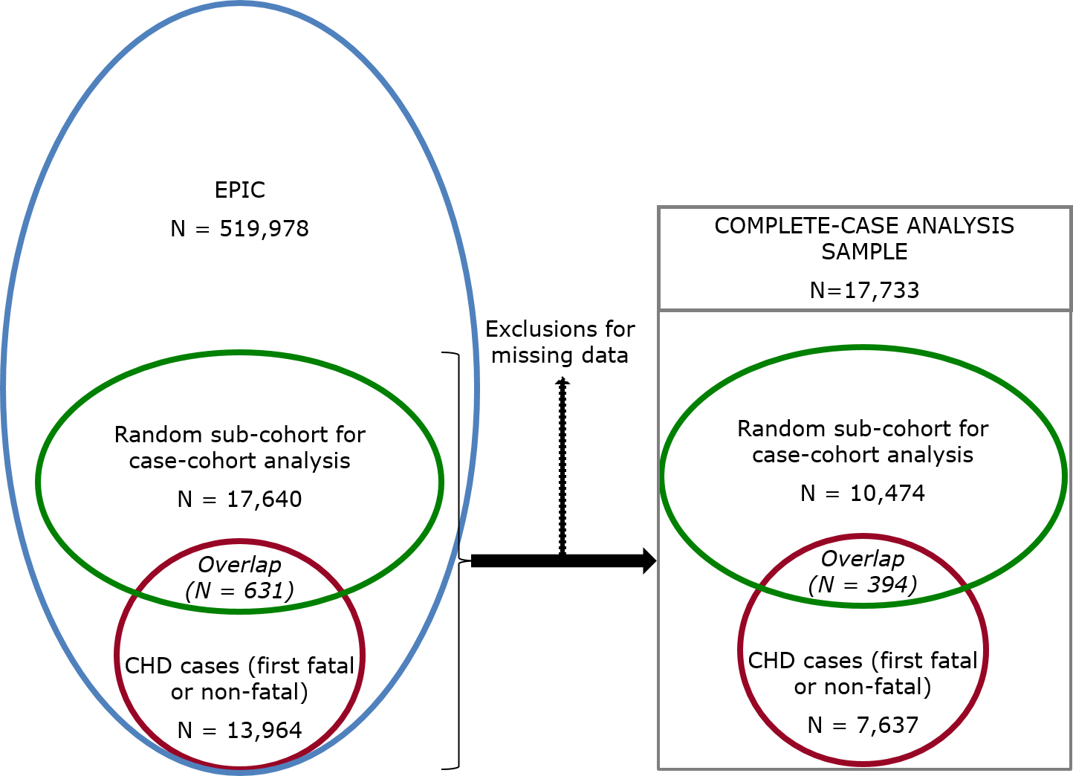
Figure S2. Schematic representation of the analysis strategy

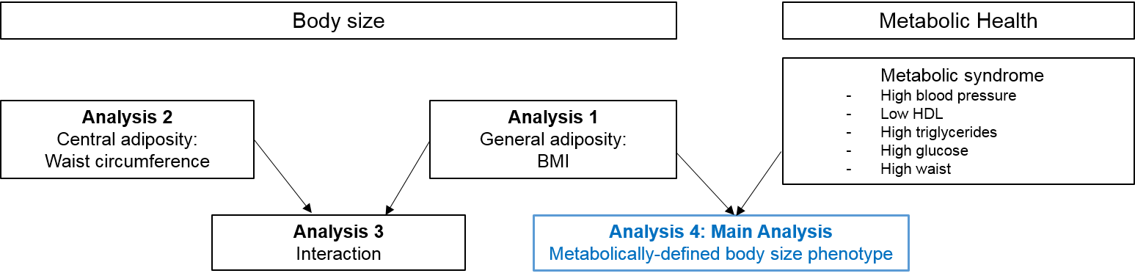
Figure S3. Country-specific HRs across metabolically-defined body size phenotypes compared to metabolically healthy normal weight, Model B ª
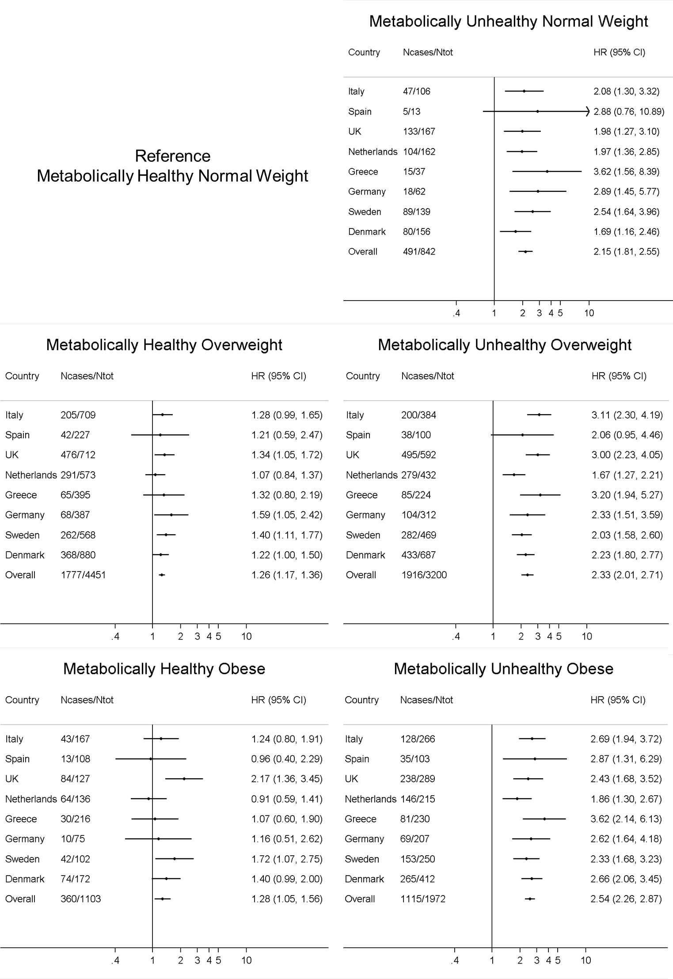

ª Model B was adjusted for age, smoking, educational level, physical activity, Mediterranean diet score, energy and alcohol intake

