Online supplementary materials
  - Article: Setting your clock: associations between timing of objective physical activity and cardiovascular disease risk in the general population
Gali Albalak, MSc
Marjon Stijntjes, PhD
David van Bodegom, MD, PhD
J Wouter Jukema MD, PhD
Douwe E Atsma, MD, PhD
Diana van Heemst, PhD
Raymond Noordam, PhD

Content
eFigure 1. Within Sum of Square plot 2
eFigure 2. Pattern of average acceleration 3
eTable 1. Hazard ratios for cardiovascular disease by clusters model 2 4
eFigure 3. Associations between physical activity timing and cardiovascular disease 5
stratified by sex
eTable 2. Hazard ratios for cardiovascular disease by clusters, stratified analysis for sex 6
eFigure 4. Associations between physical activity timing and cardiovascular disease 7
stratified by total physical activity.
eTable 3. Hazard ratios for cardiovascular disease by clusters , stratified analysis 8
for activity level
eFigure 5. Associations between physical activity timing and cardiovascular disease 9
stratified by chronotype
eTable 4. Hazard ratios for cardiovascular disease by clusters, stratified analysis for 10
sleep chronotype

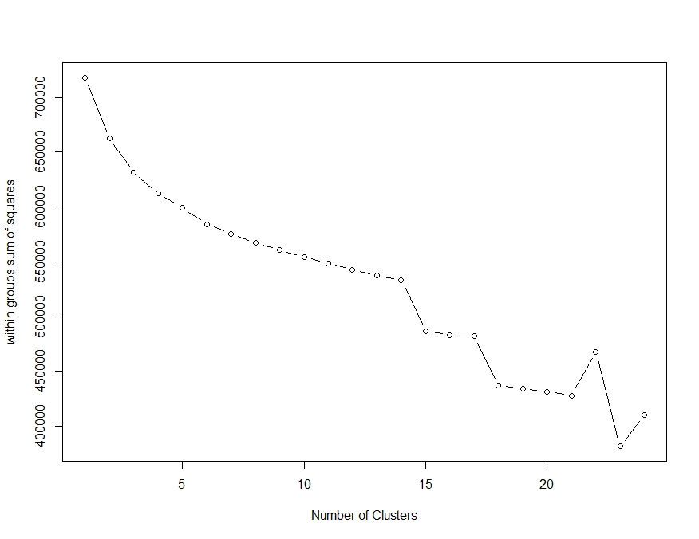
eFigure 1. Within Sum of Square plot. Within Sum of Squares plot to determine number of clusters for K-means clustering analysis. Finally, the number of clusters considered for clustering analysis was four.

eFigure 2. Pattern of average acceleration. Pattern of mean daily acceleration of the total study group (N=86,657) shown in milligravity (mg).

eTable 1. Hazard ratios for cardiovascular disease by clusters model 2
 | Cases | Non-cases | Hazard Ratio  (95% CI)
CAD
Cluster 1 | 1071 | 26,481 | [Ref.]
Cluster 2 | 552 | 19,291 | 0.96 (0.84, 1.09)
Cluster 3 | 812 | 21,836 | 0.91 (0.81, 1.02)
Cluster 4 | 476 | 16,138 | 1.12 (0.97, 1.28)
Stroke
Cluster 1 | 297 | 27,255 | [Ref.]
Cluster 2 | 160 | 19,683 | 0.96 (0.76, 1.21)
Cluster 3 | 230 | 22,418 | 0.81 (0.66, 1.00)
Cluster 4 | 109 | 16,505 | 0.94 (0.72, 1.24 )
Ischaemic stroke
Cluster 1 | 206 | 27,346 | [Ref.]
Cluster 2 | 105 | 19,738 | 0.89 (0.67, 1.18)
Cluster 3 | 152 | 22,496 | 0.73 (0.57, 0.94)
Cluster 4 | 72 | 16,542 | 0.88 (0.63, 1.23)
HR, Hazard Ratio; CAD, coronary artery disease; CI confidence interval. Table shows outcomes from Cox-proportional hazard models adjusted for age, sex, BMI, smoking status, Townsend Deprivation Index, cholesterol lowering medicine and blood pressure lowering medicine (model 2). Results represent the risk of CAD, stroke and ischaemic stroke compared to the reference group [Ref.] and are presented as hazard ratios with accompanying 95% confidence interval.
Definitions cluster: cluster 1; average pattern of acceleration close to the average pattern of absolute acceleration of the total UK-Biobank population, cluster 2; ‘early morning peak’, cluster 3; ‘late morning peak’, cluster 4; ‘evening peak’

eFigure 3. Associations between physical activity timing and cardiovascular disease stratified by sex.HR, Hazard Ratio; CAD, coronary artery disease; CI confidence interval. Hazard ratios for CAD, stroke, and ischaemic stroke incidence for every chronoactivity cluster stratified for sex. Cox- proportional hazard models were adjusted for age. P-values for interaction shown, p<0.05 indicates an effect interaction between men and women
Definitions cluster: cluster 1; average pattern of acceleration close to the average pattern of absolute acceleration of the total UK-Biobank population, cluster 2; ‘early morning peak’, cluster 3; ‘late morning peak’, cluster 4; ‘evening peak’.

eTable 2. Hazard ratios for cardiovascular disease by clusters, stratified analysis for sex
 | Group | Cases |  | Non-cases | Model 2  HR (95% CI)
CAD
Cluster 1 | Women | 429 |  | 15,512 | [Ref.]
 | Men | 642 |  | 10,969 | [Ref.]
Cluster 2 | Women | 167 |  | 11,119 | 0.78 (0.62, 0.97)
 | Men | 385 |  | 8172 | 1.08 (0.92, 1.27)
Cluster 3 | Women | 313 |  | 13,167 | 0.76 (0.63, 0.92)
 | Men | 499 |  | 8669 | 1.01 (0.88, 1.17)
Cluster 4 | Women | 163 |  | 9032 | 1.03 (0.81, 1.29)
 | Men | 313 |  | 7106 | 1.18 (0.99, 1.40)
Stroke
Cluster 1 | Women | 131 |  | 15,810 | [Ref.]
 | Men | 166 |  | 11,445 | [Ref.]
Cluster 2 | Women | 65 |  | 11,221 | 0.85 (0.59, 1.22)
 | Men | 95 |  | 8462 | 1.06 (0.78, 1.45)
Cluster 3 | Women | 99 |  | 13,381 | 0.65 (0.47, 0.89)
 | Men | 131 |  | 9037 | 0.97 (0.73, 1.28)
Cluster 4 | Women | 44 |  | 9151 | 0.90 (0.59, 1.36)
 | Men | 65 |  | 7354 | 0.99 (0.69, 1.42)
Ischaemic stroke
Cluster 1 | Women | 90 |  | 15,851 | [Ref.]
 | Men | 116 |  | 11,495 | [Ref.]
Cluster 2 | Women | 42 |  | 11,244 | 0.73 (0.42, 1.24)
 | Men | 63 |  | 8494 | 0.96 (0.65, 1.41)
Cluster 3 | Women | 66 |  | 13,414 | 0.56 (0.38, 0.83)
 | Men | 86 |  | 9082 | 0.90 (0.64, 1.26)
Cluster 4 | Women | 26 |  | 9169 | 0.82 (0.53, 1.27)
 | Men | 46 |  | 7373 | 1.01 (0.66, 1.54)
HR, Hazard Ratio; CAD, coronary artery disease; CI confidence interval. Table shows outcomes from Cox-proportional hazard models adjusted for age, sex, BMI, smoking status, Townsend Deprivation Index, cholesterol lowering medicine and blood pressure lowering medicine (model 2) from stratified analyses for sex. Results represent the risk of CAD, stroke and ischaemic stroke compared to the reference group [Ref.] and are presented as hazard ratios with accompanying 95% confidence interval.
Definitions cluster: cluster 1; average pattern of acceleration close to the average pattern of absolute acceleration of the total UK-Biobank population, cluster 2; ‘early morning peak’, cluster 3; ‘late morning peak’, cluster 4; ‘evening peak’

eFigure 4. Associations between physical activity timing and cardiovascular disease stratified by total physical activity. HR, Hazard Ratio; CAD, coronary artery disease; CI confidence interval. Hazard ratios for CAD, stroke, and ischaemic stroke incidence for every chronoactivity cluster stratified for mean activity level. Cox- proportional hazard models were adjusted for age and sex. P-values for interaction shown, p<0.05 indicates an effect interaction between the less- and more active group.
Definitions cluster: cluster 1; average pattern of acceleration close to the average pattern of absolute acceleration of the total UK-Biobank population, cluster 2; ‘early morning peak’, cluster 3; ‘late morning peak’, cluster 4; ‘evening peak’.

eTable 3. Hazard ratios for cardiovascular disease by clusters , stratified analysis for activity level
 | Group | Cases | Non-cases | Model 2  HR (95% CI)
CAD
Cluster 1 | Less active | 676 | 14,003 | [Ref.]
 | More active | 395 | 12,478 | [Ref.]
Cluster 2 | Less active | 320 | 8282 | 0.99 (0.84, 1.17)
 | More active | 232 | 11,009 | 0.93 (0.76, 1.14)
Cluster 3 | Less active | 517 | 11,519 | 0.89 (0.77, 1.03)
 | More active | 295 | 10,317 | 0.95 (0.78, 1.14)
Cluster 4 | Less active | 300 | 7725 | 1.16 (0.98, 1.38)
 | More active | 176 | 8413 | 1.04 (0.83, 1.31)
Stroke
Cluster 1 | Less active | 189 | 14,490 | [Ref.]
 | More active | 108 | 12,765 | [Ref.]
Cluster 2 | Less active | 94 | 8508 | 0.98 (0.72, 1.34)
 | More active | 66 | 11,175 | 0.94 (0.65, 1.35)
Cluster 3 | Less active | 152 | 11,884 | 0.81 (0.63, 1.06)
 | More active | 78 | 10,534 | 0.81 (0.57, 1.15)
Cluster 4 | Less active | 63 | 7962 | 0.92 (0.65, 1.30 )
 | More active | 46 | 8543 | 0.97 (0.63, 1.51)
Ischaemic stroke
Cluster 1 | Less active | 135 | 14,544 | [Ref.]
 | More active | 71 | 12,802 | [Ref.]
Cluster 2 | Less active | 62 | 8540 | 0.84 (0.57, 1.23)
 | More active | 43 | 11,198 | 0.98 (0.63, 1.54)
Cluster 3 | Less active | 101 | 11,935 | 0.71 (0.52, 0.97)
 | More active | 51 | 10,561 | 0.80 (0.52, 1.22)
Cluster 4 | Less active | 44 | 7981 | 0.81 (0.53, 1.23)
 | More active | 28 | 8561 | 1.02 (0.59, 1.74)
HR, Hazard Ratio; CAD, coronary artery disease; CI confidence interval. Table shows outcomes from Cox-proportional hazard models adjusted for age, sex, BMI, smoking status, Townsend Deprivation Index, cholesterol lowering medicine and blood pressure lowering medicine (model 2) from stratified analyses for total physical activity level. Results represent the risk of CAD, stroke and ischaemic stroke compared to the reference group [Ref.] and are presented as hazard ratios with accompanying 95% confidence interval.
Definitions cluster: cluster 1; average pattern of acceleration close to the average pattern of absolute acceleration of the total UK-Biobank population, cluster 2; ‘early morning peak’, cluster 3; ‘late morning peak’, cluster 4; ‘evening peak’

eFigure 5. Associations between physical activity timing and cardiovascular disease stratified by chronotype. HR, Hazard Ratio; CAD, coronary artery disease; CI confidence interval. Hazard ratios for CAD, stroke, and ischaemic stroke incidence for every chronoactivity cluster stratified for chronotype. Cox- proportional hazard models were adjusted for age and sex. P-values for interaction shown, p<0.05 indicates an effect interaction between morning and evening chronotypes
Definitions cluster: cluster 1; average pattern of acceleration close to the average pattern of absolute acceleration of the total UK-Biobank population, cluster 2; ‘early morning peak’, cluster 3; ‘late morning peak’, cluster 4; ‘evening peak’.

eTable 4. Hazard ratios for cardiovascular disease by clusters, stratified analysis for sleep chronotype
 | Group | Cases | Non-cases | Model 2  HR (95% CI)
CAD incident
Cluster 1 | Morning | 517 | 12,578 | [Ref.]
 | Evening | 432 | 10,901 | [Ref.]
Cluster 2 | Morning | 393 | 13,681 | 1.00 (0.84, 1.18)
 | Evening | 101 | 3900 | 0.94 (0.71, 1.24)
Cluster 3 | Morning | 537 | 14,389 | 0.98 (0.84, 1.14)
 | Evening | 193 | 5158 | 0.91 (0.74, 1.11)
Cluster 4 | Morning | 206 | 6892 | 1.17 (0.96, 1.44)
 | Evening | 215 | 7481 | 1.06 (0.86, 1.31)
Stroke
Cluster 1 | Morning | 156 | 12,939 | [Ref.]
 | Evening | 119 | 11,214 | [Ref.]
Cluster 2 | Morning | 124 | 13,950 | 0.92 (0.69, 1.23)
 | Evening | 25 | 3976 | 0.88 (0.52, 1.50)
Cluster 3 | Morning | 147 | 14,779 | 0.74 (0.56, 0.98)
 | Evening | 56 | 5295 | 0.72 (0.48, 1.07)
Cluster 4 | Morning | 56 | 7042 | 1.13 (0.78, 1.62)
 | Evening | 37 | 7659 | 0.59 (0.36, 0.95)
Ischaemic stroke
Cluster 1 | Morning | 105 | 12,990 | [Ref.]
 | Evening | 85 | 11,248 | [Ref.]
Cluster 2 | Morning | 81 | 13,993 | 0.92 (0.64, 1.32)
 | Evening | 19 | 3982 | 0.91 (0.50, 1.67)
Cluster 3 | Morning | 101 | 14,825 | 0.75 (0.54, 1.05)
 | Evening | 33 | 5318 | 0.53 (0.32, 0.89)
Cluster 4 | Morning | 37 | 7061 | 1.13 (0.72, 1.78)
 | Evening | 24 | 7672 | 0.48 (0.26, 0.89)
HR, Hazard Ratio; CAD, coronary artery disease; CI confidence interval. Table shows outcomes from Cox-proportional hazard models adjusted for age, sex, BMI, smoking status, Townsend Deprivation Index, cholesterol lowering medicine and blood pressure lowering medicine (model 2) from stratified analyses for chronotype. Results represent the risk of CAD, stroke and ischaemic stroke compared to the reference group [Ref.] and are presented as hazard ratios with accompanying 95% confidence interval.
Definitions cluster: cluster 1; average pattern of acceleration close to the average pattern of absolute acceleration of the total UK-Biobank population, cluster 2; ‘early morning peak’, cluster 3; ‘late morning peak’, cluster 4; ‘evening peak’

