SUPPLEMENTARY MATERIAL

Figure S1.
Figure S1: 12-lead ECG was recorded and transmitted using the nurse smartphone as internet access point for Home-treated patients.

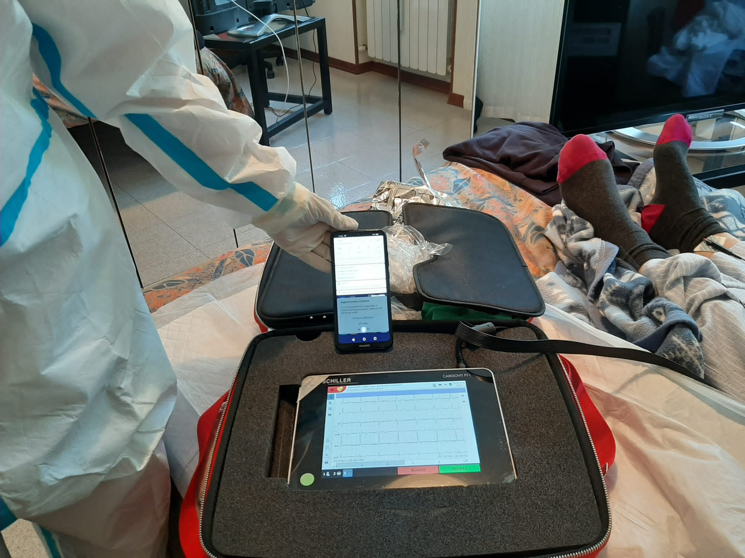

Figure S2

Figure S2 – Fridericia QTc distribution at T₀ (upper panels) and at last available ECG (lower panels) for the three different clinical settings. Median values reached at last available ECG resulted comparable among different clinical settings.
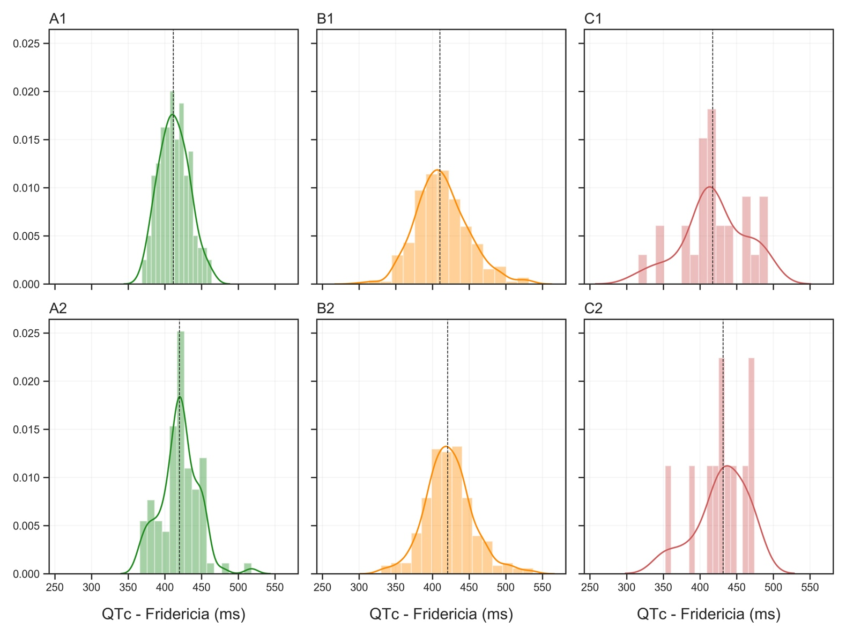
Panel A1/A2: Home therapy; Panel B1/B2: Medical Ward; Panel C1/C2: ICU.
Dot-dash line: median value

Figure S3

Figure S3: the image shows the relation between changes in body temperature between T₀₋₂ and changes in Heart Rate between T₀₋₂; an increase in body temperature significantly correlates (p < 0.001) with an increase in heart rate

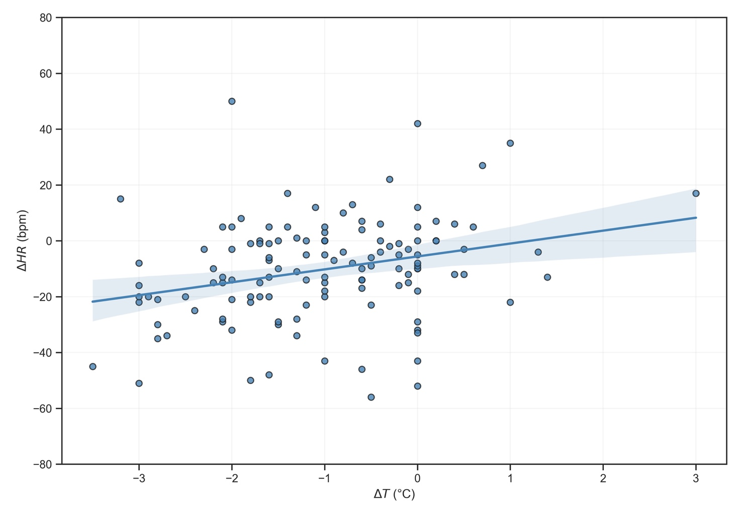

Figure S4

Figure S4: linear correlation between differences in Heart Rate (bpm) and QT/QTc variations (ΔQT / ΔQTc) (ms).
Panel A – QT interval; Panel B – QTc Bazett; Panel C: QTc Fridericia; Panel D: QTc Framingham
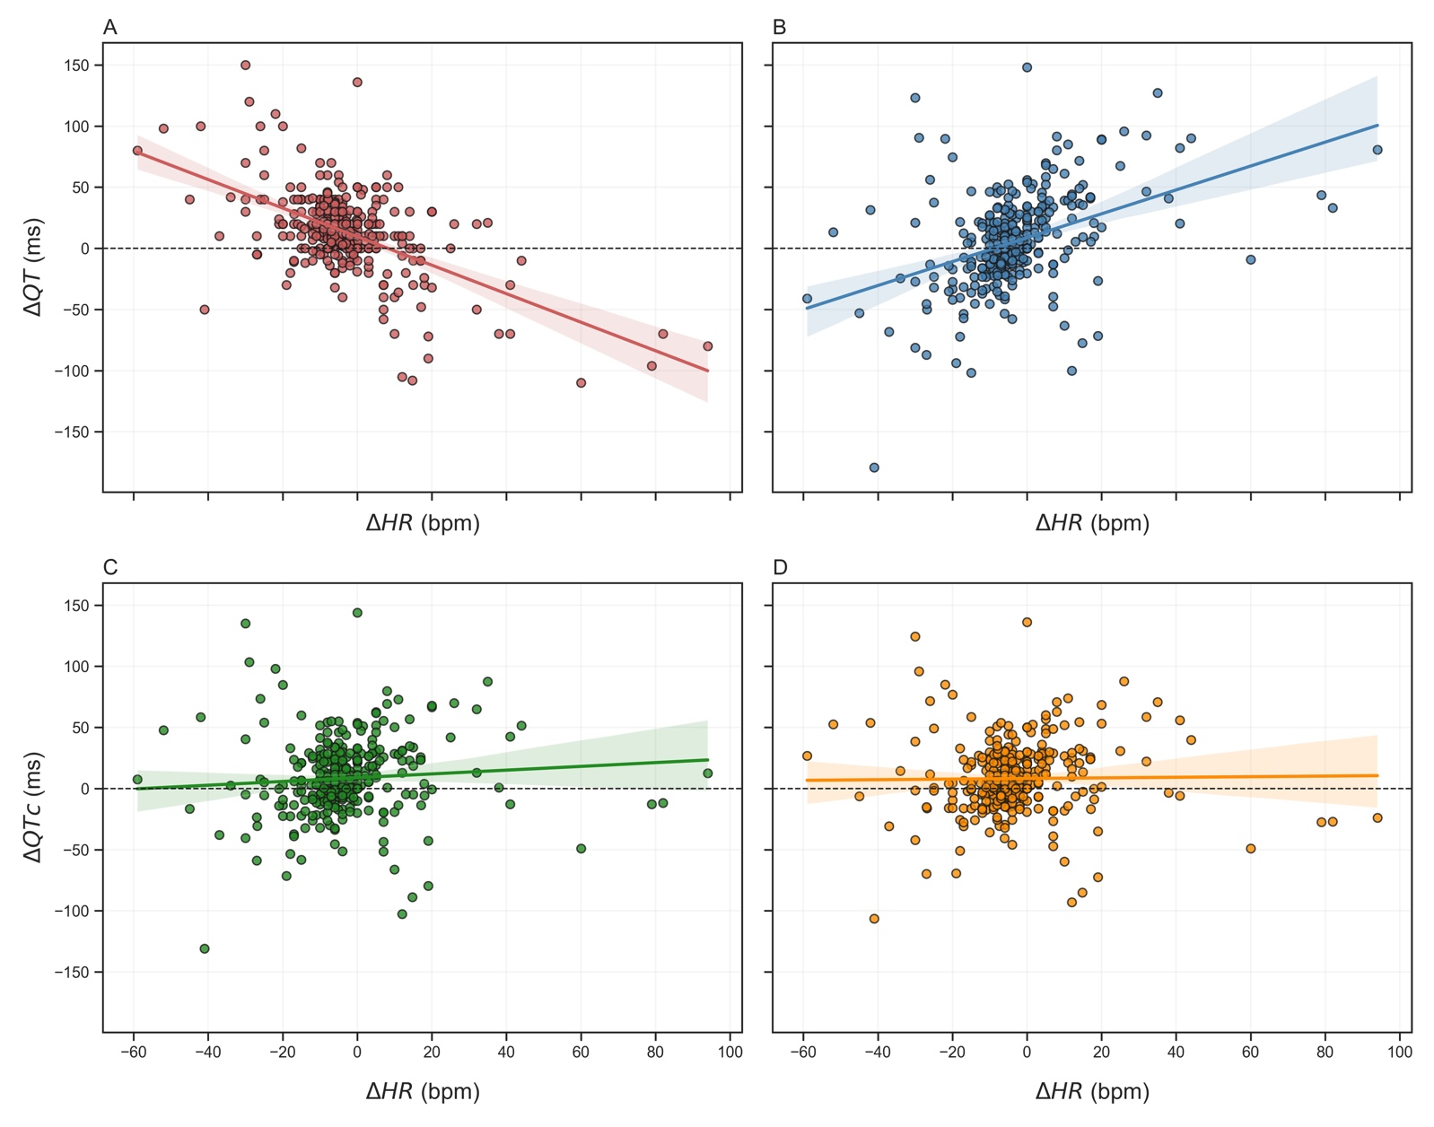

Figure S5

Figure S5: tracing of monomorphic ventricular tachycardia events in patients treated with hydroxychloroquine. Panel A-B: patient 1; panel C-D: patient 2
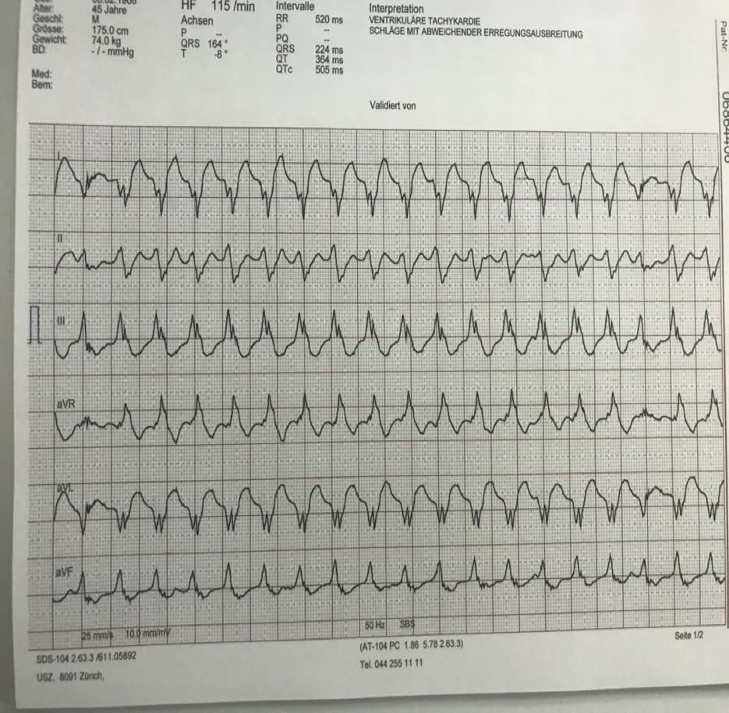
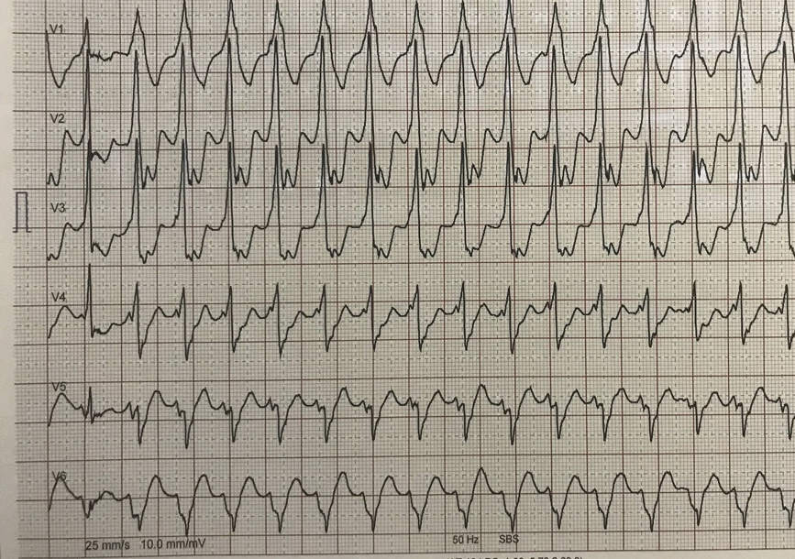
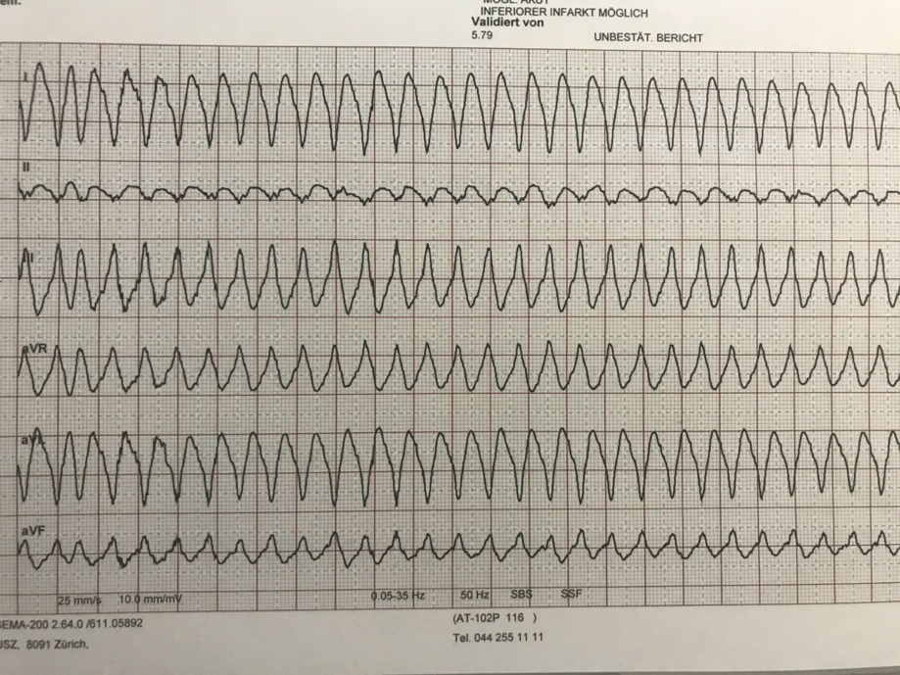
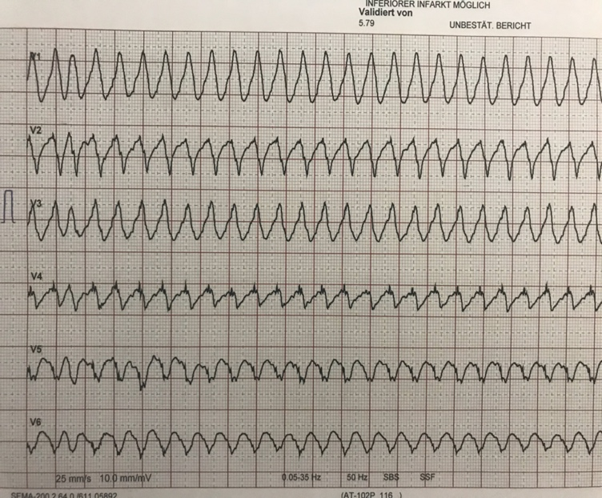
A
B
C
D

Table S2 – QT/QTc modifications per clinical setting: no significant differences in the entity of the QT/QTc modification from baseline was observed among groups
ΔQT/QTc represents a difference between the QT/QTc value at overall and at baseline ECG trace.

TableS1 – QT/QTc modifications per clinical setting
 | HT  (n=126) | MW  (n=495) | ICU  (n=28) | p
ΔQT_{overall-0} (ms), median [IQR] | +14  [+11; +18] | +13  [+9; +18] | +3  [-21; +23] | 0.498
ΔQTc Bazett_{overall-0} (ms), median [IQR] | -1  [-5; +4] | +7  [+2; +12] | +23  [-2; +48] | 0.065
ΔQTc Fridericia_{overall-0} (ms), median [IQR] | +5  [+1; +9] | +9  [+5; +13] | +15  [-4; +31] | 0.382
ΔQTc Framingham_{overall-0} (ms), median [IQR] | +5  [+1; +8] | +9  [+5; +13] | +13  [-6; + 34] | 0.333

TableS2 - Univariate Impact on QT prolongation at different time points
 | On ECG at T₁ (n=348)
 | CoeffdQT | p | CoeffdQTc (Bz) | p | CoeffdQTc (Fri) | p | CoeffdQTc (Fra) | p
Age (years) |  | 0.847 |  | 0.798 |  | 0.780 |  | 0.833
Female gender |  | 0.367 |  | 0.149 |  | 0.483 |  | 0.616
ΔHR₁₋₀(bpm) | -0.45  [-0.54;-0.36] | < 0.001 | +0.98  [+0.75;+1.2] | < 0.001 |  | 0.08 |  | 0.8
Fever | -16.55  [-31.97;-1.122] | 0.036 | -27.3  [-44.6;-10.0] | 0.002 | -23.4  [-37.9;-8.8] | 0.002 | -20.2  [-33.8;-6.6] | 0.004
Baseline QT(ms) | -0.33  [-0.41;-0.26] | < 0.001 | -0.27  [-0.36;-0.18] | < 0.001 | -0.47  [-0.55;-0.39] | < 0.001 | -0.48  [-0.56;-0.40] | <0.001
Azithromycin |  | 0.976 |  | 0.715 |  | 0.769 |  | 0.547
Lopinavir/Ritonavir |  | 0.901 |  | 0.088 |  | 0.180 | +8.61  [+0.16;+7.1] | 0.046
Boost dose |  | 0.139 | -12.0  [-20.1 -3.9] | 0.004 |  | 0.107 |  | 0.07
 | On ECG at T2 (n=404)
 | CoeffdQT | p | CoeffdQTc (Bz) | p | CoeffdQTC (Fr) | p | CoeffdQTc (Fra) | p
Age(years) |  | 0.571 |  | 0.086 |  | 0.141 |  | 0.340
Female gender |  | 0.870 |  | 0.768 |  | 0.822 |  | 0.914
ΔHR₂₋₀(bpm) | -1.32  [-1.47;-1.16] | < 0.001 | +0.90  [0.72;+1.1] | < 0.0001 |  | 0.520 |  | 0.274
Fever |  | 0.987 | +16.4  [+4.7;+28.1] | 0.006 | +13.9  [+4.0;+23.7] | 0.006 | +13.0  [+3.9;+22.2] | 0.005
Baseline QT(ms) | -0.52  [-0.60;-0.44] | < 0.001 | -0.57  [-0.66;-0.48] | < 0.001 | -0.55  [-0.64;-0.48] | < 0.001 | -0.55  [-0.63;-0.47] | <0.0001
Azithromycin | +9.3  [+0.25;+18.4] | 0.044 |  | 0.275 |  | 0.085 |  | 0.065
Lopinavir/Ritonavir |  | 0.357 |  | 0.690 |  | 0.897 |  | 0.864
Boost dose |  | 0.079 |  | 0.238 |  | 0.093 |  | 0.092
ΔT (ºC)# |  | 0.121 |  | 0.115 |  | 0.693 |  | 0.739
 | On Overall ECG* (n=649)
 | CoeffdQT | p | CoeffdQTc (Bz) | p | CoeffdQTC (Fr) | p | CoeffdQTc (Fra) | p
Age(years) |  | 0.757 |  | 0.827 |  | 0.802 |  | 0.829
Female gender |  | 0.797 |  | 0.177 |  | 0.531 |  | 0.606
ΔHR_{overall-0}(bpm) | -1.35  [-1.47;-1.22] | < 0.001 | +0.97  [+0.75;+1.19] | <0.001 |  | 0.159 |  | 0.791
Fever |  | 0.987 | -27.0  [-44.2;-9.9] | 0.002 | -23.2  [-37.7;-8.7] | 0.002 | -20.2  [-33.7;-6.6] | 0.004
Baseline QT (ms) | -0.45  [-0.51;-0.36] | < 0.001 | -0.52  [-0.60;-0.44] | < 0.001 | -0.47  [-0.55 ;-0.40] | < 0.001 | -0.474  [-0.55;-0.39] | < 0.001
Azithromycin |  | 0.198 |  | 0.493 |  | 0.599 |  | 0.575
Lopinavir/Ritonavir |  | 0.359 | +11.1  [+0.5;+21.7] | 0.004 |  | 0.113 |  | 0.052
Boost dose |  | 0.152 | -12.9  [-20.8;-4.9] | 0.002 |  | 0.077 |  | 0.074

# This sub-analysis was performed on 144 pts, as described in the result section
*Overall analysis was performed on the last ECG available, and time was defined as number of days from beginning of the therapy to last available ECG
ΔHR_{1-0; 2-0; overall-0}: difference in heart rate between Time 1 and baseline, Time 2 and baseline, and overall and baseline ECG, respectively
ΔΤ: difference in temperature between Time 2 and baseline

Table S3 – Multivariate models
Multivariate Analysis on dQT
 | Coeff | p
Baseline QT (ms) | -0.29  [-0.34;-0.23] | < 0.001
ΔHR_{overall-0} (bpm) | -1.14  [-1.27;-1.0] | < 0.001
Fever |  | 0.87
Lopinavir/Ritonavir |  | 0.730
Dose Boost |  | 0.315
Multivariate Analysis on dQTc (Bazett)
 | Coeff | p
Baseline QTc (ms) | -0.44  [-0.53;-0.36] | < 0.001
ΔHR_{overall-0} (bpm) | +0.71  [+0.51;+0.91] | < 0.001
Fever | -18.7  [-32.6;-4.8] | 0.009
Lopinavir/Ritonavir |  | 0.235
Dose Boost |  | 0.162
Multivariate Analysis on dQTc (Fridericia)
 | Coeff | p
Baseline QTc (ms) | -0.48  [-0.59;-0.39] | < 0.001
ΔHR_{overall-0} (bpm) |  | 0.360
Fever | -16.9  [-29.6;-4.2] | 0.009
Lopinavir/Ritonavir |  | 0.376
Dose Boost |  | 0.072
Multivariate Analysis on dQTc (Framingham)
 | Coeff | p
Baseline QT (ms) | -0.48  [-0.56;-0.40] | < 0.001
ΔHR_{overall-0} (bpm) |  | 0.795
Fever | -14.7  [-26.6;-2.8] | 0.015
Lopinavir/Ritonavir |  | 0.266
Dose Boost |  | 0.083
TableS3 – Multivariate models for QT/QTc modifications

ΔHR_{overall-0}: difference in heart rate from baseline ECG to overall ECG

Supplementary Bibliography
1. Tisdale JE, Jaynes HA, Kingery JR, Mourad NA, Trujillo TN, Overholser BR, Kovacs RJ. Development and Validation of a Risk Score to Predict QT Interval Prolongation in Hospitalized Patients. Circ Cardiovasc Qual Outcomes 2013;6:479–487.

