Supplementary Material to:

**Thiosulfate- and hydrogen-driven autotrophic denitrification by a microbial consortium enriched from groundwater of an oligotrophic limestone aquifer**

Swatantar Kumar1,2, Martina Herrmann1,3, Annika Blohm2,4, Ines Hilke2, Torsten Frosch4,5, Susan E. Trumbore2, Kirsten Küsel1,3*

1Aquatic Geomicrobiology, Institute of Biodiversity, Friedrich Schiller University Jena, Dornburger Strasse 159, D-07743 Jena, Germany

2Max Planck Institute for Biogeochemistry, Hans-Knöll-Strasse 10, D-07745 Jena, Germany

3German Center for Integrative Biodiversity Research (iDiv) Halle-Jena-Leipzig, Deutscher Platz 5e, D-04103 Leipzig, Germany

4Leibniz Institute of Photonic Technology, Albert-Einstein-Strasse 9, D-07745 Jena, Germany

5Institute of Physical Chemistry and Abbe Center of Photonics, Albert-Einstein-Strasse 6, D-07745, Jena, Germany

**\* Corresponding author:**

Aquatic Geomicrobiology, Institute of Biodiversity, Friedrich Schiller University Jena, Dornburger-Strasse 159, 07743 Jena, Germany. phone: +49 3641 949461;   
fax: +49 3641 949462;

E-mail: kirsten.kuesel@uni-jena.de

**Supplementary Material - Methods**

**Cavity-enhanced Raman gas spectroscopy**

Analysis of 15N2, 15N2O, CO2, H2, 14N2 and O2 in the headspace of the serum bottles during the two microcosm experiments was carried out using a specially designed Raman gas sensor based on cavity enhanced Raman spectroscopy (CERS). For the measurement of the headspace, the measurement system was flushed with argon (Raman inactive) for several minutes until no gas was detectable anymore. Then the serum bottle was connected and a closed loop was established using a pump integrated in the setup to circulate the gas. That way, the headspace from the bottle was cycled through the spectrometer and back into the bottle, mixing it with the argon already present in the measurement setup. The original concentration of gases in the bottle headspace could be calculated, as the volume of the measurement cycle is exactly known and the gas composition is not altered during the measurement. To avoid diffusion of ambient air into the system, the measurement time was limited to five minutes.

**Supplementary Table 1:** Estimated per cell activities of nitrate reduction, sulfate production (experiment M_I) and of N2 formation and H2 consumption (experiment M_II). Cell abundances were estimated based on bacterial 16S rRNA gene-targeted qPCR. Per cell activities were estimated for 24- or 48-hour intervals during the two incubation experiments when bacterial abundances increased only slightly during that interval (between day 6 and 7 in M_I and between day 10 and 12 in M_II).

|  |  |  |  |
| --- | --- | --- | --- |
| **activity** | **experiment** | **time interval** | **estimated per cell activity  (fmol cell−1 h−1)** |
| nitrate reduction | M_I | day 6 - day 7 | 0.42 ± 0.35 |
| sulfate production | M_I | day 6 - day 7 | 0.59 ± 0.36 |
| N2 production | M_II | day 10 - day 12 | 0.06 ± 0.004 |
| H2 consumption | M_II | day 10 - day 12 | 0.03 ± 0.02 |

**Supplementary Table 2:** Results of MiSeq Illumina amplicon sequencing of *nirS* genes in the groundwater of four wells across the two aquifer assemblages. Values are given for data sets after subsampling to 3113 sequence reads per sample. OTUs were assigned on a 0.18 distance cut-off level. n before subsampling = number of sequence reads before subsampling; Shannon = Shannon diversity index. (Samples from 6 sampling events July, August; 2014, January, March, June, August 2015; at sites H43, H53 (HTU), and H41, H51 (HTL)). Sequence data from August 2014 were integrated from a previous publication (Kumar *et al*. 2017).

|  |  |  |  |  |  |
| --- | --- | --- | --- | --- | --- |
| **groundwater well** | **month** | **n before subsampling** | **observed OTUs** | **coverage (%)** | **Shannon diversity index** |
| H43 | July 2014 | 103621 | 88 | 0.9998 | 2.07 |
| H43 | Aug 2014 | 3113 | 57 | 0.9939 | 2.18 |
| H43 | Jan 2015 | 102316 | 78 | 0.9998 | 2.17 |
| H43 | Mar 2015 | 73392 | 85 | 0.9997 | 2.35 |
| H43 | June 2015 | 93434 | 74 | 0.9999 | 2.07 |
| H43 | Aug 2015 | 77476 | 80 | 0.9997 | 2.12 |
| H53 | July 2014 | 134580 | 85 | 0.9998 | 1.17 |
| H53 | Aug 2014 | 17982 | 47 | 0.9991 | 0.95 |
| H53 | Jan 2015 | 120857 | 67 | 0.9998 | 0.91 |
| H53 | Mar 2015 | 91030 | 74 | 0.9998 | 1.20 |
| H53 | June 2015 | 106533 | 95 | 0.9997 | 1.36 |
| H53 | Aug 2015 | 149290 | 93 | 0.9998 | 1.12 |
| H41 | July 2014 | 173087 | 103 | 0.9998 | 1.16 |
| H41 | Aug 2014 | 3308 | 58 | 0.9985 | 2.75 |
| H41 | Jan 2015 | 72281 | 110 | 0.9996 | 2.66 |
| H41 | Mar 2015 | 66455 | 123 | 0.9995 | 2.64 |
| H41 | June 2015 | 67115 | 123 | 0.9995 | 2.08 |
| H41 | Aug 2015 | 80622 | 117 | 0.9996 | 2.21 |
| H51 | July 2014 | 95293 | 119 | 0.9997 | 1.98 |
| H51 | Aug 2014 | 5409 | 61 | 0.9991 | 2.84 |
| H51 | Jan 2015 | 42456 | 113 | 0.9992 | 2.02 |
| H51 | Mar 2015 | 44694 | 86 | 0.9994 | 1.64 |
| H51 | June 2015 | 53974 | 118 | 0.9995 | 1.94 |
| H51 | Aug 2015 | 44629 | 117 | 0.9993 | 1.91 |



**Supplementary Figure 1:** Setup for Raman gas spectroscopy during microcosm experiment M_II.

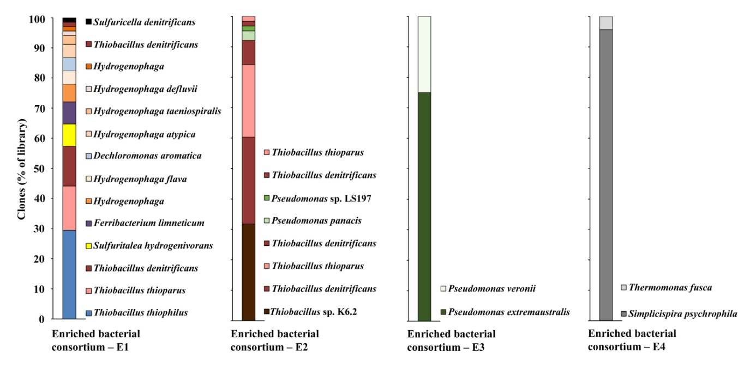

**Supplementary Figure 2:** Community structure of the enriched consortia in four enrichment cultures (E1, E2, E3, E4) after the 35th transfer, assessed by 16S rRNA gene-targeted clone library analysis.



**Supplementary Figure 3:** Estimated bacterial cell numbers per L during incubation experiment M_I and M_II. Bacterial cell numbers were estimated based on bacterial 16S rRNA gene abundances using a correction factor of 2.2 and 2.28, respectively, to correct for multiple 16S rRNA operons per cell.



**Supplementary Figure 4:** Changes of community composition of the enriched consortium E1 during the two microcosm experiments M_I and M_II.Data are results of 16S rRNA gene-targeted MiSeq amplicon sequencing. Bacterial taxa are presented on the phylum level (class level for Proteobacteria).