Figure S1 Linkage disequilibrium structure at CD55 gene locus

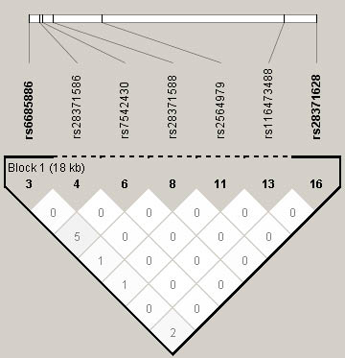
LD pattern is represented by pairwise r² values between SNPs with MAF>1% based on genotypes of 831 severe malaria cases and 903 controls. r² values (x100) for each comparison is given in the squares. White squares represent r² values equal to 0. Squares that are shades of grey represent values between 0 and 1.

