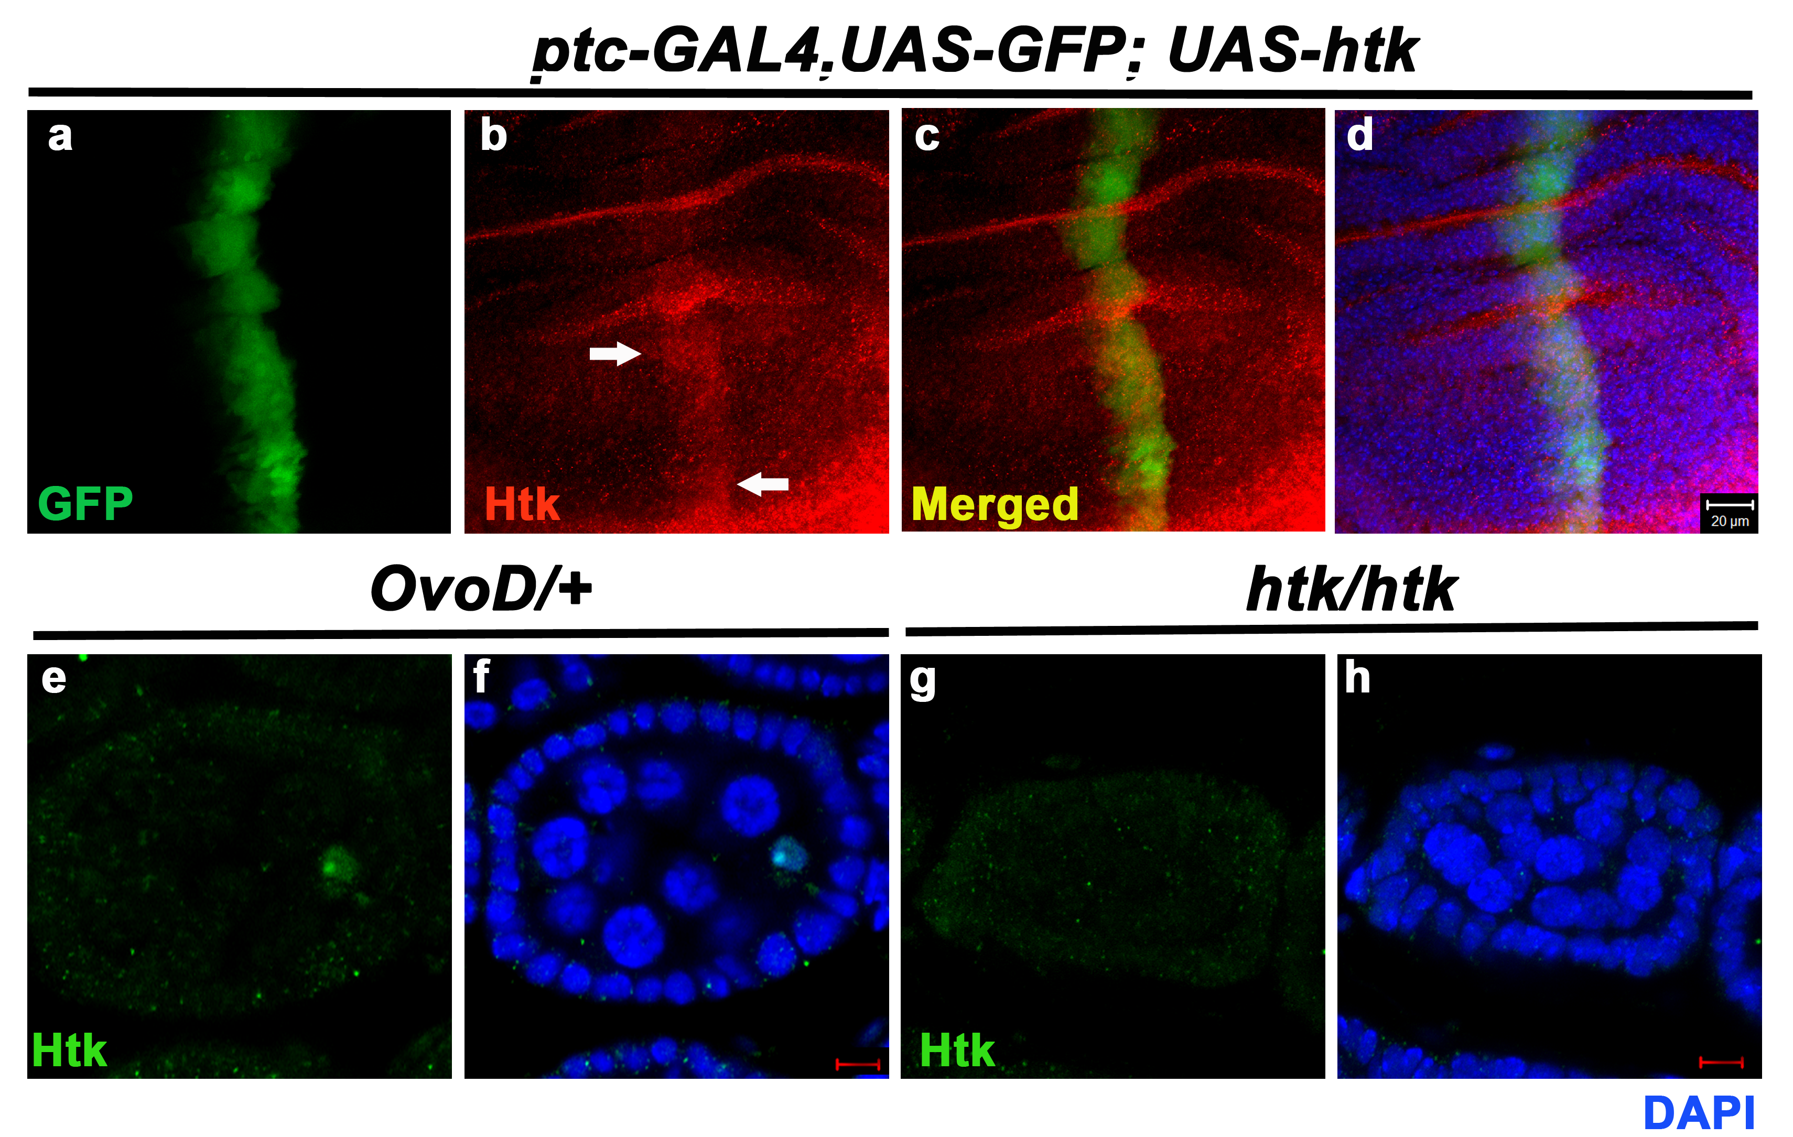
Figure S1. Analysis of the speciﬁcity of the rabbit anti-Htk antibody. a-d. Htk was ectopically overexpressed at the anterior-posterior (A-P) boundary region [marked by GFP, (a)] of wing disc using ptc-GAL4 driver. (b-d) Anti-Htk antibody detects both ectopically overexpressed Htk at A-P boundary (marked by arrow) as well as wild type Htk. e-h. Anti-Htk antibody detects wild type Htk protein in the nucleus of control oocyte (e-f), but no Htk protein was observed in the projection image of the oocyte of htk-/- egg chamber (g-h). Scale bars, 20 µm (a-d), 10 µm (e-h).

