Supplementary materials

Table S1. Query sequences for BLAST.
 | N. crassa | S. pombe | M. circinelloides
DICER | XP_961898.1 | CAB41233.2 | OAD03695.1
 | XP_963538.3 |  | CAZ65730.1
ARGONAUTE/PIWI | XP_011394904.1 | CAA19275.1 | EPB81851.1
 | XP_011394903.1 |  | EPB81974.1
 |  |  | EPB92043.1
RDRP | XP_963405.1 | CAB11093.1 | OAD02682.1
 | XP_959047.1 |  | OAD02683.1
 | XP_964248.3 |  | OAD09244.1

Table S2. Summarized result of homologs of core proteins of RNAi in R. irregulare. GenBank accession numbers of R. irregulare sequences used in this study. All these sequences were successfully tested using reciprocal BLAST as well as protein domain architecture analysis. Surprisingly, there were two homologs of ribonuclease III (RIRNC2 and RIRNC3, shaded in yellow) whose best GenBank BLAST hits were cyanobacterial ribonuclease III, while all other homologs (three homologs of RDRP and 26 homologs of AGO) have fungal orthologs as their best GenBank BLAST hits.
Name of component  (Genbank Accession code) | Comparison with top reciprocal hit  (N. crassa)  E-value / (%identity) | Comparison with top reciprocal hit  (S. pombe)  E-value / (%identity) | Comparison with top reciprocal hit  (M.circinelloides)  E-value / (%identity) | Best Genbank BLAST hit  E-value / (%identity) | Best BLAST hit information  [organism name]
RDRP1  (EXX60053.1) | XP_959047.1  3e-51/(31%) | CAB11093.1  2e-33/(25%) | OAD02682.1  1e-116/(31%) | XP_018290421.1  7e-115/(31%) | RNA-dependent RNA polymerase RdRP [Phycomyces blakesleeanus]
RDRP2  (EXX62399.1) | XP_959047.1  3e-42/(27%) | CAB11093.1  1e-30/(25%) | OAD02682.1  2e-115/(28%) | CDH49104.1  2e-132/(33%) | RNA-directed RNA polymerase [Lichtheimia corymbifera]
RDRP3  (EXX74509.1) | XP_959047.1  6e-50/(26%) | CAB11093.1  1e-29/(27%) | OAD02682.1  1e-119/(31%) | XP_018293829.1  2e-129/(33%) | RNA-dependent RNA polymerase RdRP [Phycomyces blakesleeanus]
AGO1  (EXX56889.1) | XP_958586.1  8e-125/(31%) | CAA19275.1  0.0/(37%) | EPB81851.1  0.0/(62%) | OBZ91340.1  0.0/(64%) | Protein argonaute 1 [Choanephora cucurbitarum]
AGO2  (EXX56891.1) | XP_958586.1  1e-124/(31%) | CAA19275.1  0.0/(37%) | EPB81851.1  0.0/(62%) | OBZ91340.1  0.0/(63%) | Protein argonaute 1 [Choanephora cucurbitarum]
AGO3  (EXX56890.1) | XP_958586.1  1e-116/(31%) | CAA19275.1  5e-177/(37%) | EPB81851.1  0.0/(63%) | OBZ91340.1  0.0/(63%) | Protein argonaute 1 [Choanephora cucurbitarum]
AGO4  (EXX59523.1) | XP_958586.1  2e-119/(31%) | CAA19275.1  5e-178/(35%) | EPB81851.1  0.0/(58%) | OBZ91340.1  0.0/(60%) | Protein argonaute 1 [Choanephora cucurbitarum]
AGO5  (EXX72566.1) | XP_958586.1  2e-105/(29%) | CAA19275.1  4e-179/(38%) | EPB81851.1  0.0/(58%) | OBZ91340.1  0.0/(60%) | Protein argonaute 1 [Choanephora cucurbitarum]
AGO6  (EXX58072.1) | XP_958586.1  5e-110/(29%) | CAA19275.1  0.0/(37%) | EPB81851.1  0.0/(63%) | OBZ91340.1  0.0/(64%) | Protein argonaute 1 [Choanephora cucurbitarum]
AGO7  (EXX59521.1) | XP_958586.1  5e-106/(29%) | CAA19275.1  0.0/(38%) | EPB81851.1  0.0/(56%) | OBZ91340.1  0.0/(57%) | Protein argonaute 1 [Choanephora cucurbitarum]
AGO8  (EXX62045.1) | XP_958586.1  2e-105/(28%) | CAA19275.1  0.0/(38%) | EPB81851.1  0.0/(60%) | OBZ91340.1  0.0/(60%) | Protein argonaute 1 [Choanephora cucurbitarum]
AGO9  (EXX60142.1) | XP_958586.1  8e-124/(31%) | CAA19275.1  0.0/(39%) | EPB81851.1  0.0/(62%) | OBZ91340.1  0.0/(62%) | Protein argonaute 1 [Choanephora cucurbitarum]
AGO10  (EXX71200.1) | XP_958586.1  6e-112/(30%) | CAA19275.1  0.0/(38%) | EPB81851.1  0.0/(61%) | OBZ91340.1  0.0/(62%) | Protein argonaute 1 [Choanephora cucurbitarum]
AGO11  (EXX68513.1) | XP_958586.1  1e-108/(30%) | CAA19275.1  7e-166/(34%) | EPB81851.1  0.0/(55%) | OBZ91340.1  0.0/(56%) | Protein argonaute 1 [Choanephora cucurbitarum]
AGO12  (EXX53458.1) | XP_958586.1  4e-111/(30%) | CAA19275.1  7e-176/(36%)  7e-176 36% | EPB81851.1  0.0/(53%) | OBZ91340.1  0.0/(54%) | Protein argonaute 1 [Choanephora cucurbitarum]
AGO13  (EXX59522.1) | XP_958586.1  1e-115/(31%) | CAA19275.1  2e-174/(36%) | EPB81851.1  0.0/(54%) | OBZ91340.1  0.0/(55%) | Protein argonaute 1 [Choanephora cucurbitarum]
AGO14  (EXX76428.1) | XP_958586.1  2e-112/(29%) | CAA19275.1  0.0/(37%) | EPB81851.1  0.0/(58%) | OBZ91340.1  0.0/(59%) | Protein argonaute 1 [Choanephora cucurbitarum]
AGO15  (EXX73036.1) | XP_958586.1  7e-108/(28%) | CAA19275.1  0.0/(37%) | EPB81851.1  0.0/(57%) | OBZ91340.1  0.0/(57%) | Protein argonaute 1 [Choanephora cucurbitarum]
AGO16  (EXX54101.1) | XP_958586.1  7e-96/(28%) | CAA19275.1  2e-154/(33%) | EPB81851.1  0.0/(51%) | OBZ91340.1  0.0/(52%) | Protein argonaute 1 [Choanephora cucurbitarum]
AGO17  (EXX60325.1) | XP_958586.1  3e-94/(28%) | CAA19275.1  2e-162/(34%) | EPB81851.1  0.0/(52%) | OBZ91340.1  0.0/(53%) | Protein argonaute 1 [Choanephora cucurbitarum]
AGO18  (EXX75353.1) | XP_958586.1  7e-91/(27%) | CAA19275.1  2e-152/(34%) | EPB81851.1  0.0/(52%) | OBZ91340.1  0.0/(53%) | Protein argonaute 1 [Choanephora cucurbitarum]
AGO19  (EXX76429.1) | XP_958586.1  8e-98/(28%) | CAA19275.1  6e-176/(37%) | EPB81851.1  0.0/(54%) | OBZ91340.1  0.0/(55%) | Protein argonaute 1 [Choanephora cucurbitarum]
AGO20  (EXX68714.1) | XP_958586.1  5e-81/(27%) | CAA19275.1  4e-124/(32%) | EPB81851.1  0.0/(52%) | OBZ91340.1  0.0/(53%) | Protein argonaute 1 [Choanephora cucurbitarum]
AGO21  (EXX62871.1) | XP_958586.1  2e-63/(25%) | CAA19275.1  1e-108/(30%) | EPB81851.1  0.0/(51%) | OBZ91340.1  0.0/(52%) | Protein argonaute 1 [Choanephora cucurbitarum]
AGO22  (EXX71201.1) | XP_958586.1  5e-71/(27%) | CAA19275.1  5e-135/(35%) | EPB81851.1  0.0/(59%) | OBZ91340.1  0.0/(60%) | Protein argonaute 1 [Choanephora cucurbitarum]
AGO23  (EXX52393.1) | XP_958586.1  7e-80/(26%) | CAA19275.1  4e-129/(31%) | EPB81851.1  0.0/(39%) | OBZ91340.1  0.0/(40%) | Protein argonaute 1 [Choanephora cucurbitarum]
AGO24  (EXX67924.1) | XP_958586.1  5e-86/(27%) | CAA19275.1  7e-125/(32%) | EPB81851.1  0.0/(37%) | OBZ91340.1  0.0/(37%) | Protein argonaute 1 [Choanephora cucurbitarum]
AGO25  (EXX57432.1) | XP_958586.1  1e-80/(28%) | CAA19275.1  6e-113/(30%) | EPB81851.1  0.0/(39%) | OBZ91340.1  0.0/(39%) | Protein argonaute 1 [Choanephora cucurbitarum]
AGO26  (EXX69221.1) | XP_958586.1  7e-63/(27%) | CAA19275.1  9e-118/(30%) | EPB81851.1  7e-168/(36%) | OBZ91340.1  7e-164/(36%) | Protein argonaute 1 [Choanephora cucurbitarum]
RIDCL1  (EXX59830.1) | XP_961898.1  0.0/(34%) | CAB41233.2  9e-154/(29%) | OAD03695.1  0.0/(38%) | XP_018289885.1  0.0/(44%) | dsRNA-specific ribonuclease III dicer [Phycomyces blakesleeanus]
RIRNC2  (EXX75321.1) | XP_961898.1  1e-07/(24%) | AAU05314.1  1e-20/(27%) | OAD03695.1  8e-19/(35%) | WP_039725904.1  2e-46/(39%) | ribonuclease III [Lyngbya confervoides]
RIRNC3  (EXX54746.1) | XP_961898.1  4e-08/(26%) | AAU05314.1  1e-21/(31%) | OAD03695.1  3e-16/(33%) | WP_096577203.1  4e-49/(43%) | ribonuclease III [Anabaenopsis circularis]

Table S3. Primers and probes used in PCR and qPCR assays.
Name | Target gene | Sequence (5'->3') | Length (bp) | modification
Forward | ridcl1  (fungal) | 5'-CCTGAGGATCGTAAATTACAAATG-3' | 24
Reverse | ridcl1  (fungal) | 5'-TAACTCAATAATGCACCTGTTTCA-3' | 24
Probe | ridcl1  (fungal) | 5'-CGGATGATTCGGATGATGAAGAAGGACA-3' | 28 | 5'-6-FAM | 3'-BHQ-1
Forward | rirnc2 (bacterial) | 5'-CAACTTATTAAGGAAAGTCTTGCC-3' | 24
Reverse | rirnc2 (bacterial) | 5'-GGATCTGATTCAGGAGGTAAATC-3' | 23
Probe | rirnc2 (bacterial) | 5'-ACTCCCATTGATCCTAGCCGTCCTAC-3' | 26 | 5'-6-FAM | 3'-BHQ-1
Forward | 18s rrna | 5'-GCTGAAACTTAAAGGAATTGACG-3' | 23
Reverse | 18s rrna | 5'-TGTCAATCCTTACTATGTCTGGA-3' | 23
Probe | 18s rrna | 5'-TGCGGCTTAATTTGACTCAACACGG-3' | 25 | 5'-6-FAM | 3'-BHQ-1
Forward | ubiquitin | 5'-AGACCAAGTTAAAGCAAAGATTC-3' | 23
Reverse | ubiquitin | 5'-TATAGTCTGACAATGTACGACCA-3' | 23
Probe | ubiquitin | 5'-ATCAACAACGCTTGATCTTCGCTGGT-3' | 26 | 5'-6-FAM | 3'-BHQ-1

Table S4. Comparison of eukaryotic and prokaryotic RIBOc domains by BLAST. Two RIBOc domains (Domain A and B) from eukaryotic ribonuclease III homolog (RIDCL 1) and two RIBOc domains from two different prokaryotic ribonuclease III homologs (RIRNC 2 and 3) of R. irregulare were analyzed with BLAST with maximum number of target sequences 5,000.
- Eukaryotic RIBOc domain (two domains from RIDCL 1)
  - A domain
Taxonomy | Number of hits | Number of Organisms
Total | 1304 | 566
Eukaryota | 1304 | 566
1. Opisthokonta | 1018 | 489
1.1. Fungi | 1014 | 485
1.2. Metazoa | 4 | 4
2. Embryophyta | 286 | 77
  - B domain
Taxonomy | Number of hits | Number of Organisms
Total | 1368 | 509
Eukaryota | 1368 | 509
1. Opisthokonta | 620 | 399
1.1. Fungi | 379 | 273
1.2. Eumetazoa | 241 | 126
2. Streptophyta | 748 | 110
- Prokaryotic RIBOc domain
  - Domain from RIRNC 2
Taxonomy | Number of hits | Number of Organisms
Total | 9779 | 5598
Bacteria | 9778 | 5597
1. Terrabacteria group | 8613 | 4809
1.1. Cyanobacteria | 295 | 227
1.2. Firmicutes | 8244 | 4536
1.3. Chloroflexi | 31 | 20
1.4. Actinobacteria | 41 | 25
1.5. Acholeplasma brassicae | 2 | 1
2. unclassified Bacteria | 296 | 291
3. uncultured bacterium | 4 | 1
4. Proteobacteria | 840 | 477
5. Spirochaetes | 7 | 4
6. unclassified Synergistales | 2 | 2
7. Nitrospirae | 7 | 5
8. Bacteroidetes/Chlorobi group | 6 | 5
9. Rubritalea squalenifaciens DSM 18772 | 1 | 1
10. Calditerrivibrio | 2 | 2
uncultured prokaryote | 1 | 1
  - Domain from RIRNC 3
Taxonomy | Number of hits | Number of Organisms
Total | 9515 | 5471
Bacteria | 9514 | 5470
1. Terrabacteria group | 8782 | 4938
1.1. Cyanobacteria | 348 | 263
1.2. Chloroflexi | 50 | 32
1.3. Firmicutes | 1 | 4594
1.4. Actinobacteria | 93 | 49
2. unclassified Bacteria | 200 | 198
3. uncultured bacterium | 3 | 1
4. Proteobacteria | 515 | 322
5. Rhodothermus | 4 | 3
6. PVC group | 6 | 4
7. Chloracidobacterium | 2 | 2
8. Thermovirga | 2 | 2
uncultured prokaryote | 1 | 1

Table S5. Top 100 and 5000 hits of BLAST of RIRNC 2 and 3. Two different prokaryotic ribonuclease III homologs (RIRNC 2 and 3) of R. irregulare were analyzed using BLAST with maximum number of target sequences 100 and 5,000, respectively.
- RIRNC 2 (Max target sequences: 100)
Taxonomy | Number of hits | Number of Organisms
Bacteria | 194 | 149
1. Terrabacteria group | 158 | 113
1.1. Cyanobacteria | 113 | 92
1.2. Bacilli | 42 | 18
1.3. Chloroflexi | 3 | 3
2. unclassified Bacteria | 32 | 32
3. unclassified Nitrospirae | 3 | 3
4. uncultured bacterium | 1 | 1

- RIRNC 2 (Max target sequences: 5,000)
Taxonomy | Number of hits | Number of Organisms
Total | 3315 | 1454
Bacteria | 3314 | 1453
1. Terrabacteria group | 2894 | 1108
1.1. Cyanobacteria/Melainabacteria group | 323 | 247
1.2. Firmicutes | 2521 | 822
1.3. Chloroflexi | 41 | 32
1.4. Actinobacteria | 7 | 6
1.5. Acholeplasma brassicae | 2 | 1
2. unclassified Bacteria | 163 | 162
3. Nitrospirae | 31 | 26
4. uncultured bacterium | 5 | 1
5. Proteobacteria | 193 | 129
6. Calditerrivibrio | 2 | 2
7. Bacteroidetes/Chlorobi group | 11 | 10
8. unclassified Synergistales | 2 | 2
9. unclassified Spirochaetes | 7 | 7
10. unclassified Nitrospinae | 2 | 2
11. Caviibacter abscessus | 1 | 1
12. unclassified Lentisphaerae  (miscellaneous) | 2 | 2
13. Elusimicrobia bacterium | 1 | 1
uncultured prokaryote | 1 | 1

- RIRNC 3 (Max target sequences: 100)
Taxonomy | Number of hits | Number of Organisms
Bacteria | 156 | 125
1. Terrabacteria group | 143 | 113
1.1. Cyanobacteria | 131 | 104
1.2. Chloroflexi | 7 | 6
1.3. Firmicutes | 5 | 3
2. Patescibacteria group | 11 | 11
3. uncultured bacterium | 2 | 1

- RIRNC 3 (Max target sequences: 5,000)
Taxonomy | Number of hits | Number of Organisms
Total | 3597 | 1578
Bacteria | 3596 | 1577
1. Terrabacteria group | 3062 | 1107
1.1. Cyanobacteria/Melainabacteria group | 367 | 267
1.2. Chloroflexi | 60 | 44
1.3. Firmicutes | 2607 | 776
1.4. Actinobacteria | 28 | 20
2. unclassified Bacteria | 297 | 294
3. uncultured bacterium | 5 | 1
4. Nitrospirae | 19 | 16
5. Elusimicrobia | 13 | 12
6. Proteobacteria | 179 | 127
7. Bacteroidetes/Chlorobi group | 3 | 3
8. Synergistales | 4 | 4
9. PVC group | 8 | 8
10. Calditerrivibrio | 2 | 2
11. Brachyspira | 4 | 3
uncultured prokaryote | 1 | 1

Table S6. Codon Adaptation Index (CAI) score calculated. A set of 200 Coding Sequences (CDSs) from model AMF species, R. irregulare, used as reference set. Top BLAST hits of eukaryotic and prokaryotic ribonuclease III enzymes (RIDCL1, RIRNC 2 and RIRNC 3), were compared with CDSs from R. irregulare. Calculations were conducted by two different method ((a) and (b)) (Eyre-Walker 1996; Sharp and Li 1987). All of the CDSs examined showed high CAI scores (>0.5), indicating their higher proportion of the most abundant codons in R. irregulare.
- Sharp & Li (1987)
Gene No. | Description | Length  (bp) | CAI
1 | Rhizoglomus_irregulare_ridcl1_CDS | 4293 | 0.503
2 | Phycomyces_blakesleeanus_CDS_closest_to_RIDCL1 | 4707 | 0.502
3 | Rhizoglomus_irregulare_rirnc2_CDS | 795 | 0.503
4 | Planktothricoides_sp.SR001_CDS_closest_to_RIRNC2 | 1221 | 0.500
5 | Rhizoglomus_irregulare_rirnc3_CDS | 876 | 0.502
6 | Anabaenopsis_circularis_NIES21_CDS_closest_to_RIRNC3 | 1185 | 0.503

- Eyre-Walker (1996)

Gene No. | Description | Length  (bp) | CAI
1 | Rhizoglomus_irregulare_ridcl1_CDS | 4293 | 0.507
2 | Phycomyces_blakesleeanus_CDS_closest_to_RIDCL1 | 4707 | 0.505
3 | Rhizoglomus_irregulare_rirnc2_CDS | 795 | 0.505
4 | Planktothricoides_sp.SR001_CDS_closest_to_RIRNC2 | 1221 | 0.507
5 | Rhizoglomus_irregulare_rirnc3_CDS | 876 | 0.503
6 | Anabaenopsis_circularis_NIES21_CDS_closest_to_RIRNC3 | 1185 | 0.505

Figure S1
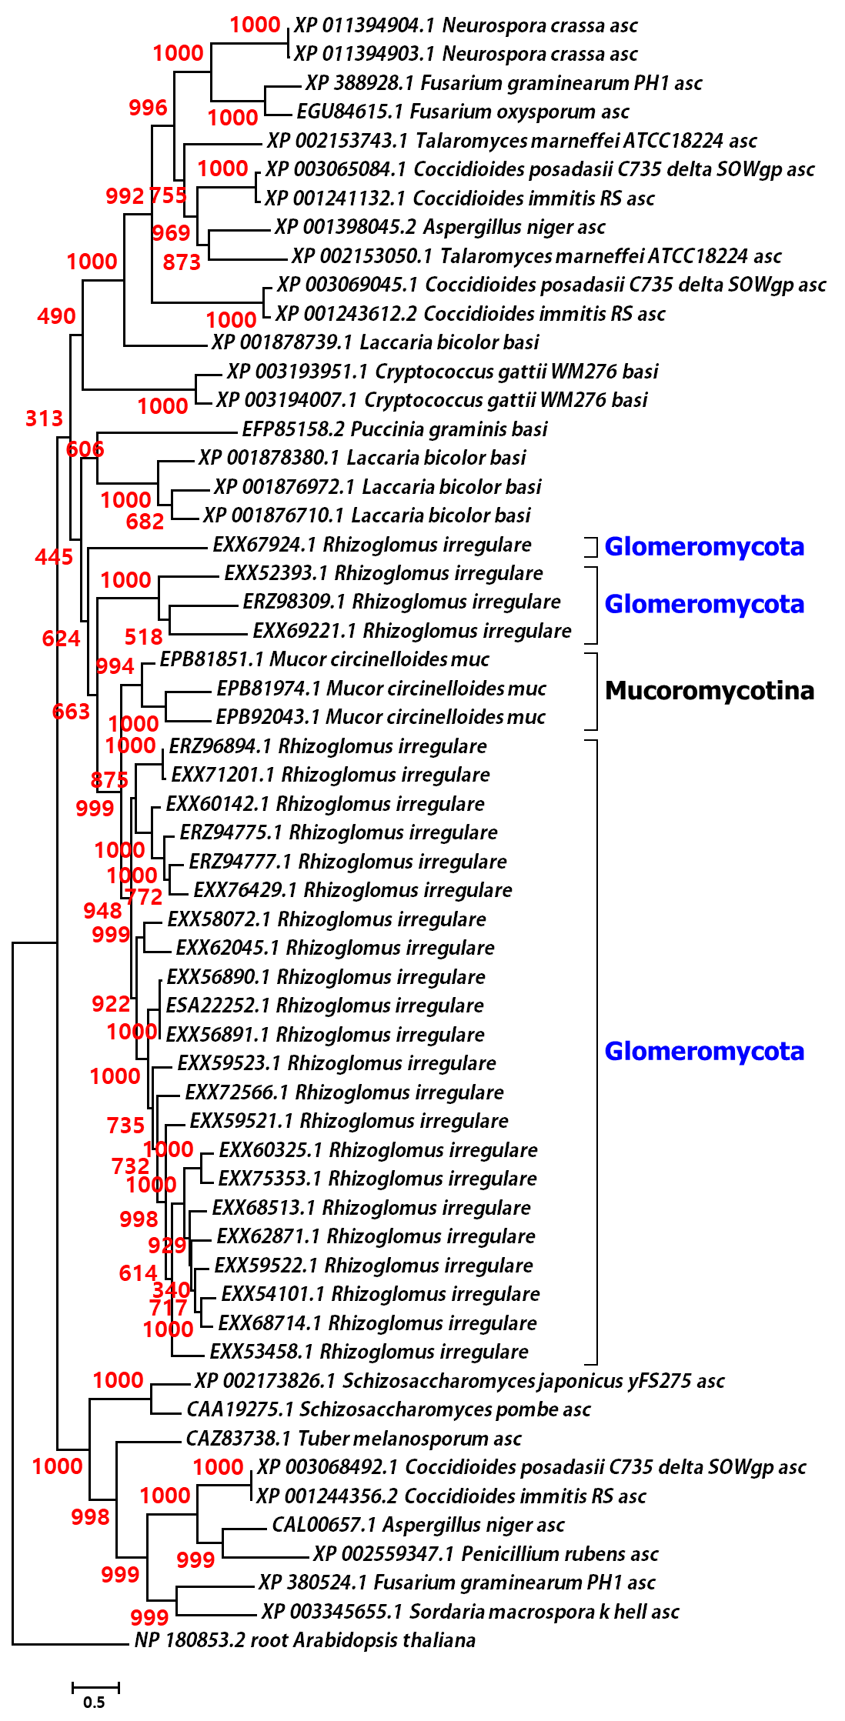
Figure S1. Phylogeny of three core proteins of RNAi system in AMF with other fungal species. Maximum likelihood of amino acid sequences of AGO were analyzed with the WAG+I+G (with four distinct gamma categories) phylogenetic model which showed the lowest AIC value. The R. irregulare (synonym of Rhizophags irregularis) and Mucoromycotina sequences were annotated in right side of taxon names, respectively. The numbers at branches correspond to bootstrap support values generated with 1,000 bootstrap replicates. Tree was rooted using Drosophila melanogaster.

Figure S2.
- Eukaryotic RIBOc domain (two domains from RIDCL 1)
  - A domain

  - B domain

- Prokaryotic RIBOc domains (domains from RIRNC 2 and 3)
  - Domain from RIRNC 2

  - Domain from RIRNC 3

Figure S2. Summary of BLAST results of eukaryotic and prokaryotic RIBOc domains. Two RIBOc domains (Domain A and B) from eukaryotic ribonuclease III homolog (RIDCL 1) and two RIBOc domains from two different prokaryotic ribonuclease III homologs (RIRNC 2 and 3) of R. irregulare were analyzed with BLASTP with maximum number of target sequences 5,000.
Figure S3
- RIRNC 2 (Max target sequences: 100)

- RIRNC 2 (Max target sequences: 5,000)

- RIRNC 3 (Max target sequences: 100)

- RIRNC 3 (Max target sequences: 5,000)

Figure S3. Summary of Top 100 and 5000 hits of BLAST of RIRNC 2 and 3. Two different prokaryotic ribonuclease III homologs (RIRNC 2 and 3) of R. irregulare were analyzed with BLAST with maximum number of target sequences 100 and 5,000, respectively.
Figure S4
- The neighboring genes of rirnc 2
  - 5’ upstream neighbor (PEK1 ,8 intron)
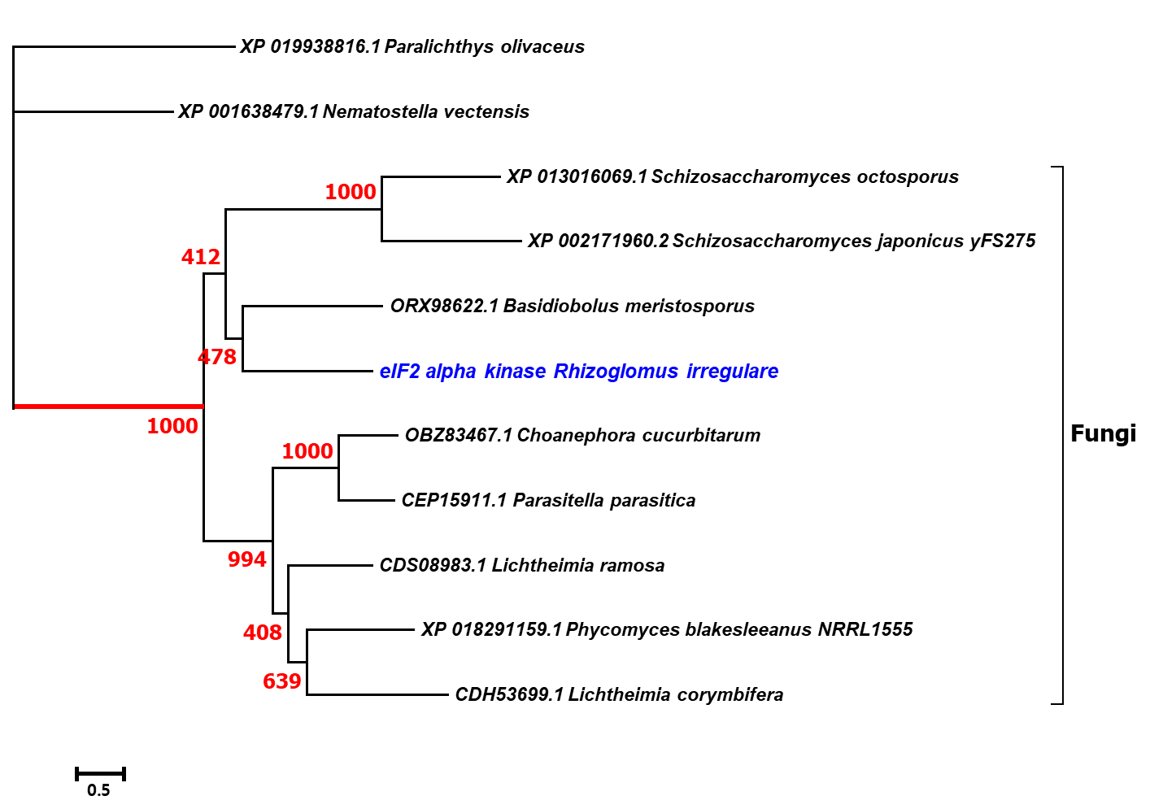
  - 3’ downstream neighbor ( PEK2, 10 introns)
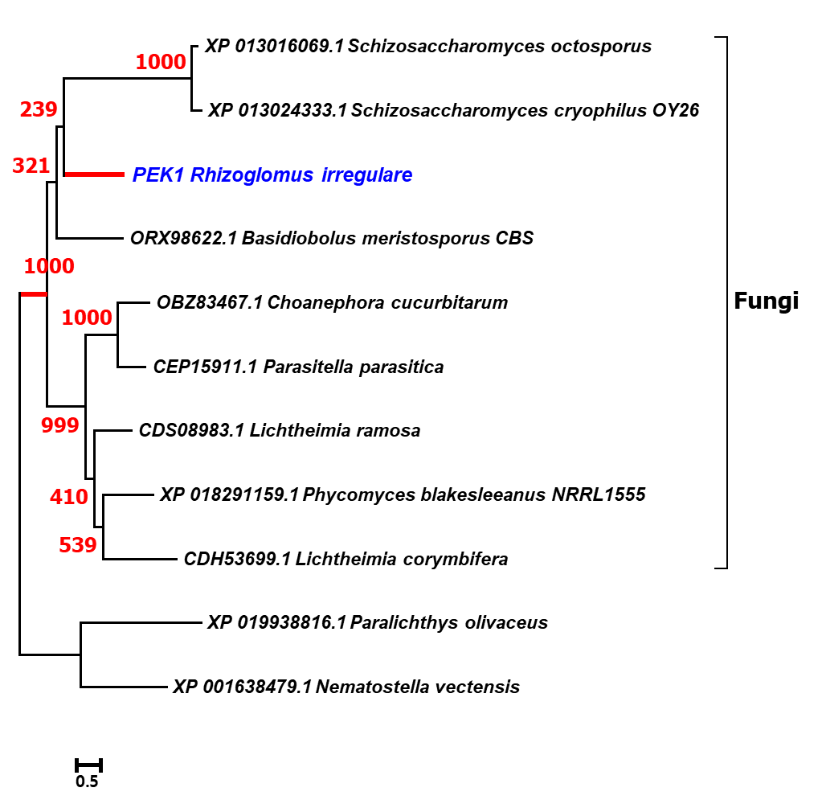
- The neighboring genes of rirnc 3
  - 5’ upstream neighbor (adenine nucleotide alpha hydrolases-like protein, 4 introns)
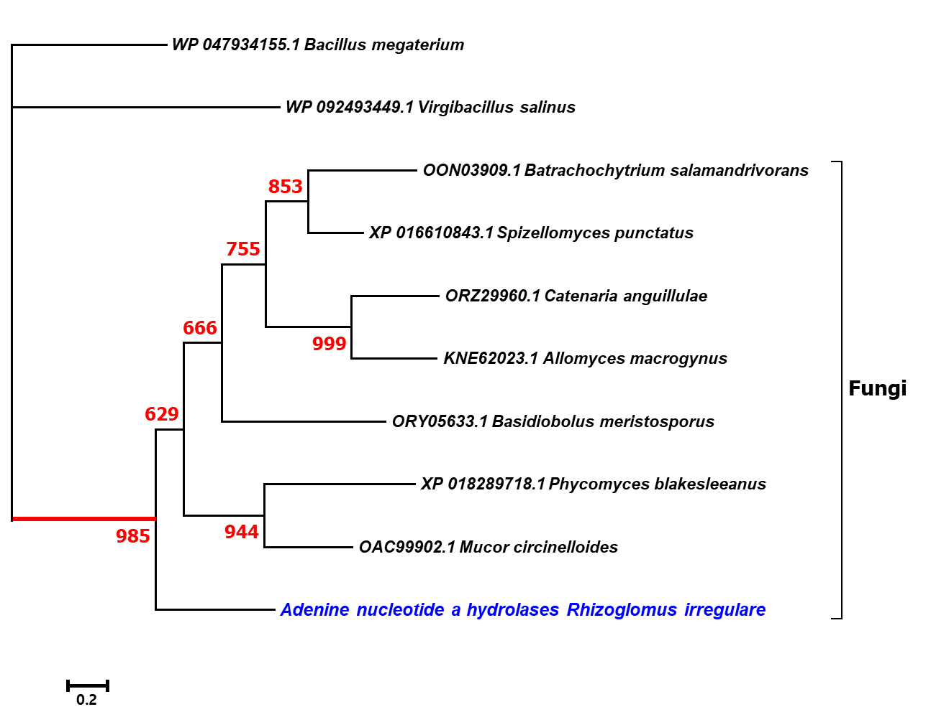
  - 3’ downstream neighbor (cell devision controlling protein 73, no intron)
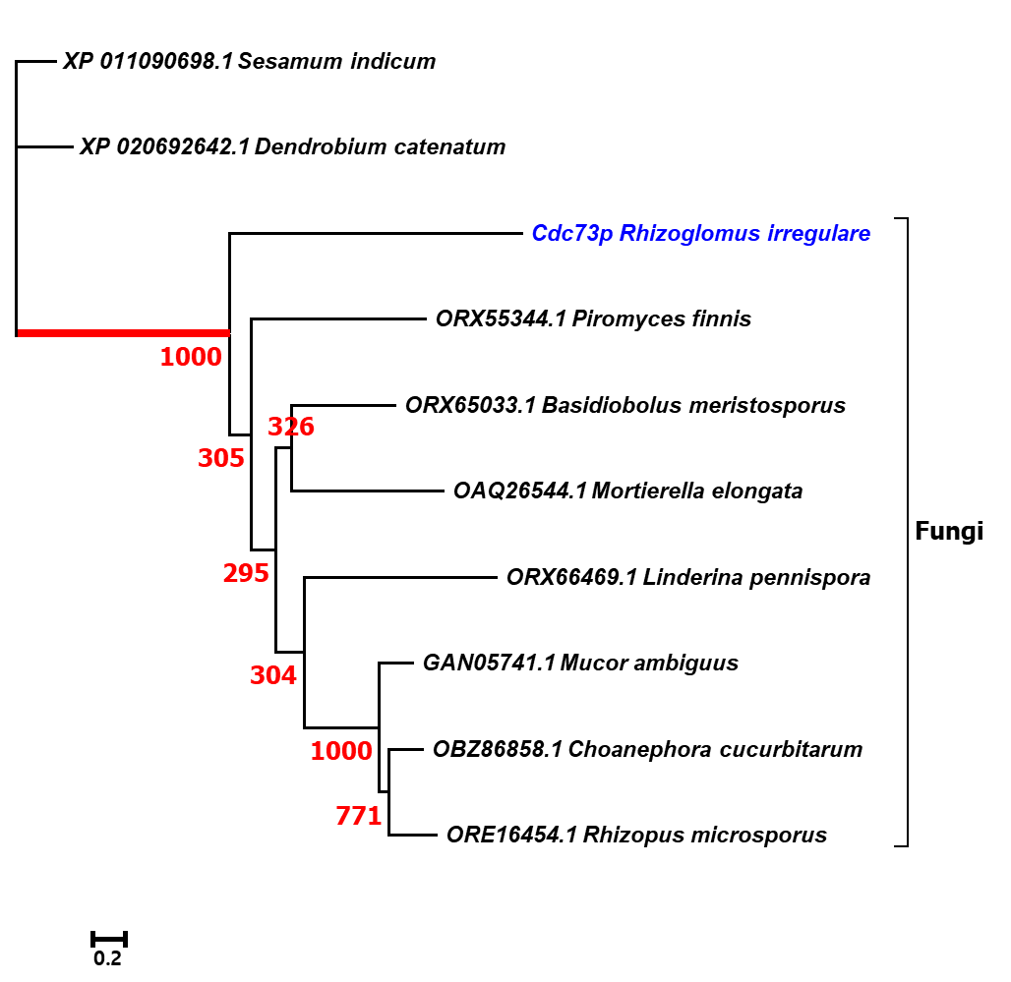
Figure S4. Phylogenetic analysis of the proteins encoded by upstream/downstream neighboring genes of rirnc 2 and 3. Maximum likelihood of amino acid sequences were analyzed with the LG+I+G (with four distinct gamma categories) phylogenetic model which showed the lowest AIC value. AMF sequences were colored in blue. The numbers at branches correspond to bootstrap support values generated with 1,000 bootstrap replicates. All of four genes were showing their closest homology with sequences from fungi. If there is no prokaryotic homolog available as the gene is eukaryotic specific (PEK1 and PEK2 protein kinases and CDC73), closest homologs from other eukaryotes (plants or animal) were chosen as outgroups. All sequences from R. irregulare clearly grouped with other fungal homologs, with clear separation from outgroups.

Figure S5.
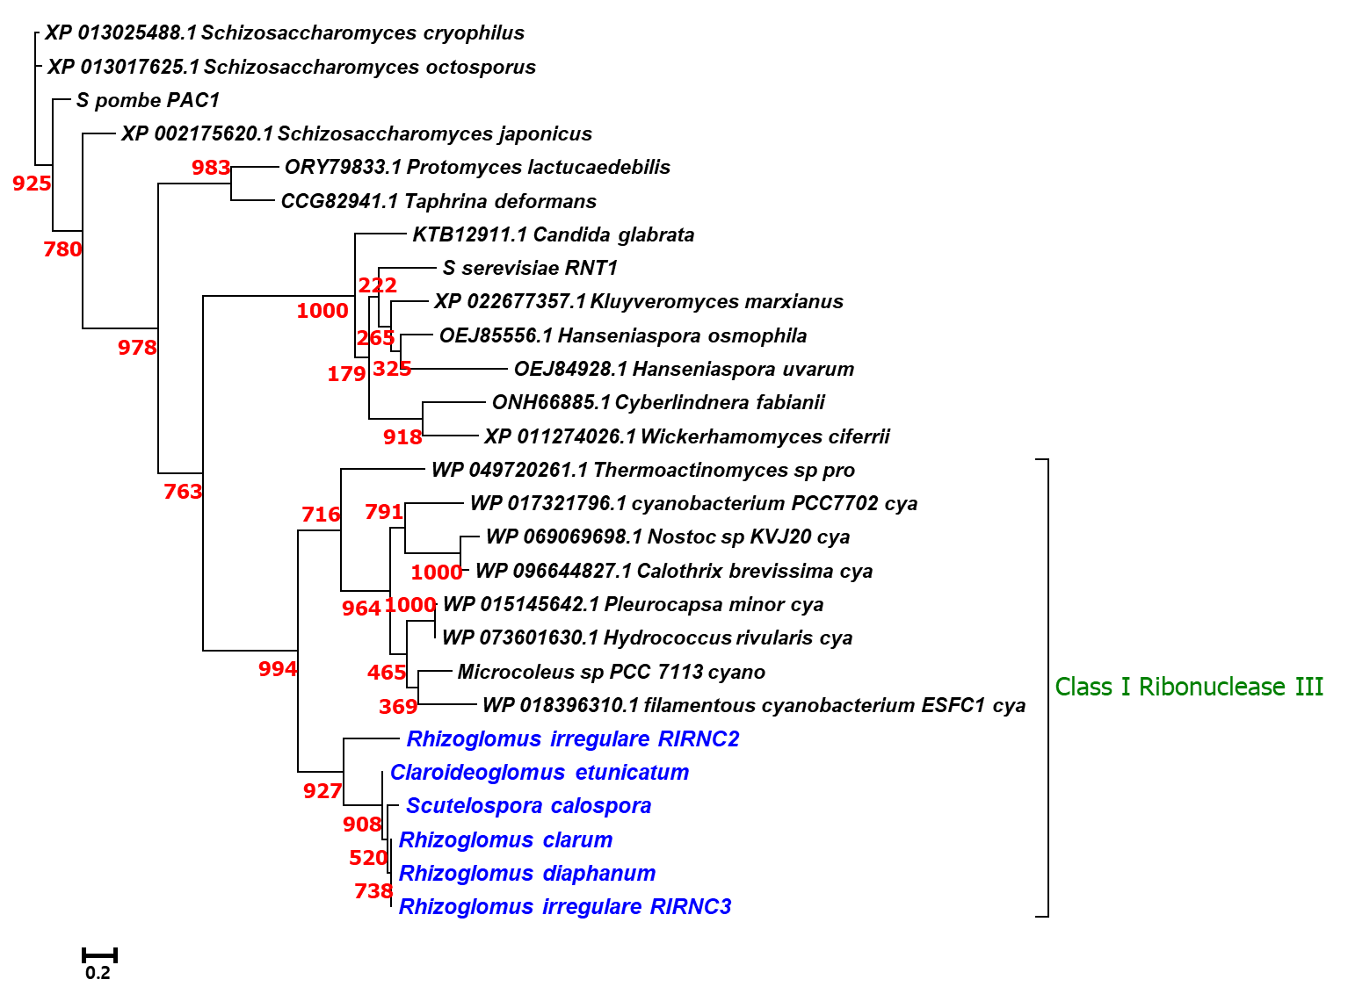
Figure S5. Phylogenetic analysis of RIBOc domains of class I (prokaryotic) ribonuclease III enzymes and the most structurally similar class II (eukaryotic) ribonuclease III. Maximum likelihood of amino acid sequences of Class I and II ribonuclease III enzymes were analyzed with the LG+I+G (with four distinct gamma categories) phylogenetic model which showed the lowest AIC value. AMF sequences were colored in blue. The numbers at branches correspond to bootstrap support values generated with 1,000 bootstrap replicates. All of the class I ribonuclease III enzymes were clearly separated with class II ribonuclease III enzymes with high bootstrap supporting (994/1000) indicating the sequence differences in their core catalytic domain (RIBOc). Internal difference between R. irregulare RIRNC 2 and 3 were also detected by monophyletic clustering of sequences from RIRNC 3 homologs, apart from RIRNC 2 (908/1000). Three species of the Rhizoglomus genus show their high level of sequence similarity in RIBOc domain of RIRNC 3 (738/1000), compared with other two species of non-Rhizoglomus genus.

Figure S6
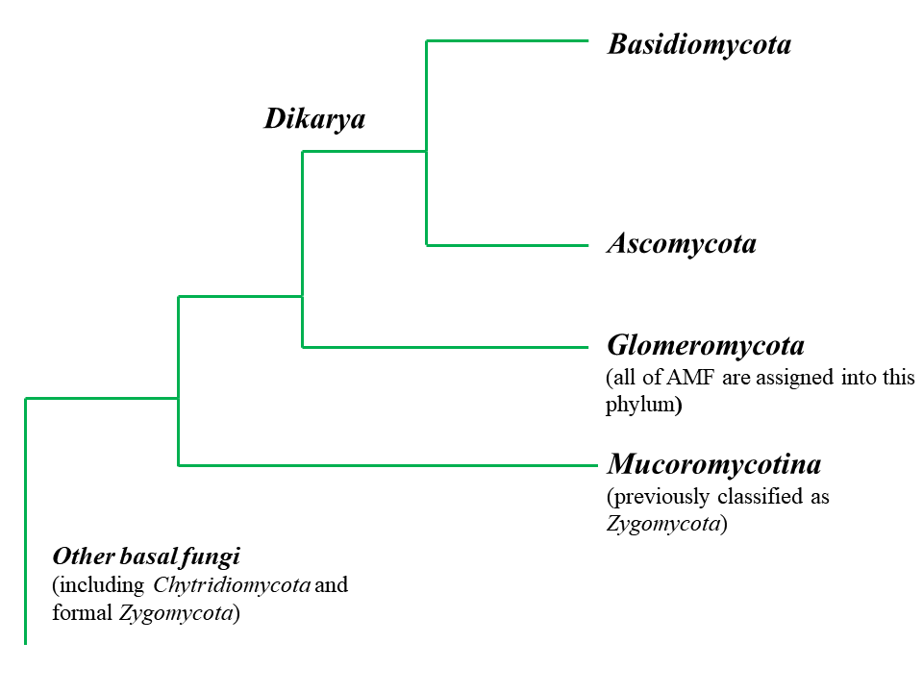
Figure S6. Conventional fungal phylogenetic tree regarding Glomeromycota. The conventional tree was created with reference fungal phylogenetic tree from (Hibbett, et al. 2007). The query species, N. crassa, S. pombe and M. circinelloides were assigned to Ascomycota, Ascomycota and Mucoromycotina, respectively.

