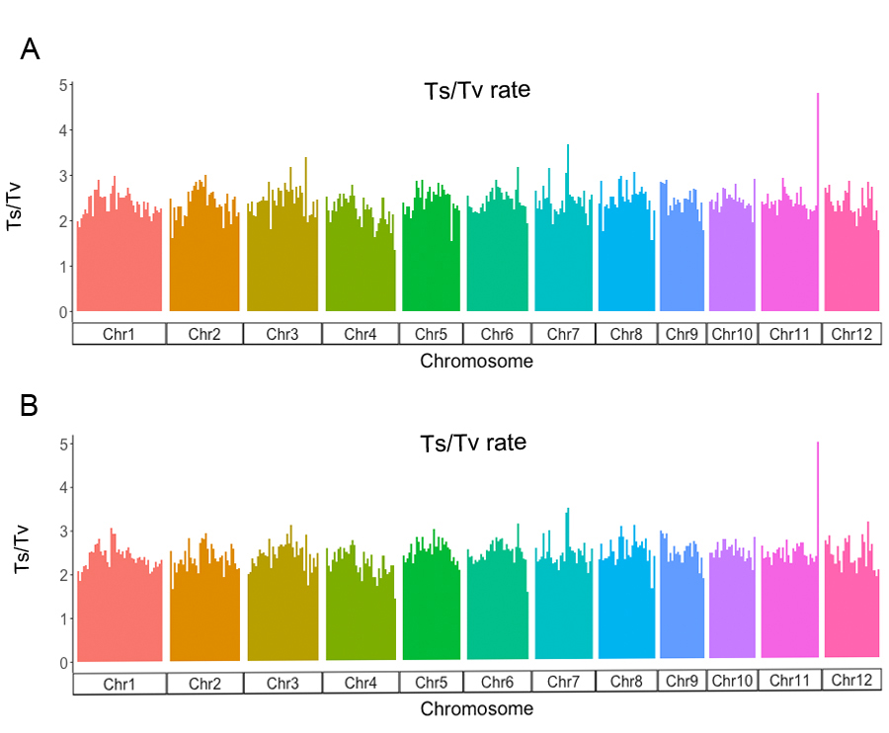

Figure S1. Average transition/transversion (Ts/Tv) rate per Mb window in TXBN (A) and TXHH (B) aromatic rice cultivars. Different colors correspond to different chromosomes.

