Supporting Information

Hill-Robertson Interference Reduced Genetic Diversity on a Young Plant Y-chromosome
Josh Hough, Wei Wang, Spencer C. H. Barrett, and Stephen I. Wright

Editor: Bret Payseur
Article Type: Genetics of Sex
TOC Subsection Heading: Population and Evolutionary Genetics
Corresponding Author: Josh Hough
Keywords: Deleterious mutations; Interference Selection; Nucleotide diversity; Suppressed recombination

SI Tables

Table S1. Population identities (ID) and location information for R. hastatulus samples
Population ID | Location | Altitude | Latitude | Longitude
TX-MTP | Mount Pleasant, Texas | 130 | 33.17453 | 94.98799
OK-RAT | Rattan, Oklahoma | 138 | 34.15755 | 95.41325
TX-LIV | Livingston, Texas | 83 | 30.69947 | 94.79981
LA-DER | De Ridder, Lousiana | 67 | 30.8941 | 93.3143
TX-ATH | Athens, Texas | 145 | 32.18471 | 95.8032
OK-WIL | Willis, Oklahoma | 211 | 33.89663 | 96.83533

Table S2. Mapping statistics for male and female alignments to XX reference transcriptome
 | Mapped reads | Unmapped reads | Proper-pair | Quality </= 30 | MAPQ score
females | 75.7 % | 24.3 % | 67.7 % | 13.5 % | median: 60  mean: 45.5
males | 75.2 % | 24.9 % | 67.1 % | 13.4 % | median: 60  mean: 42.2

SI Figures
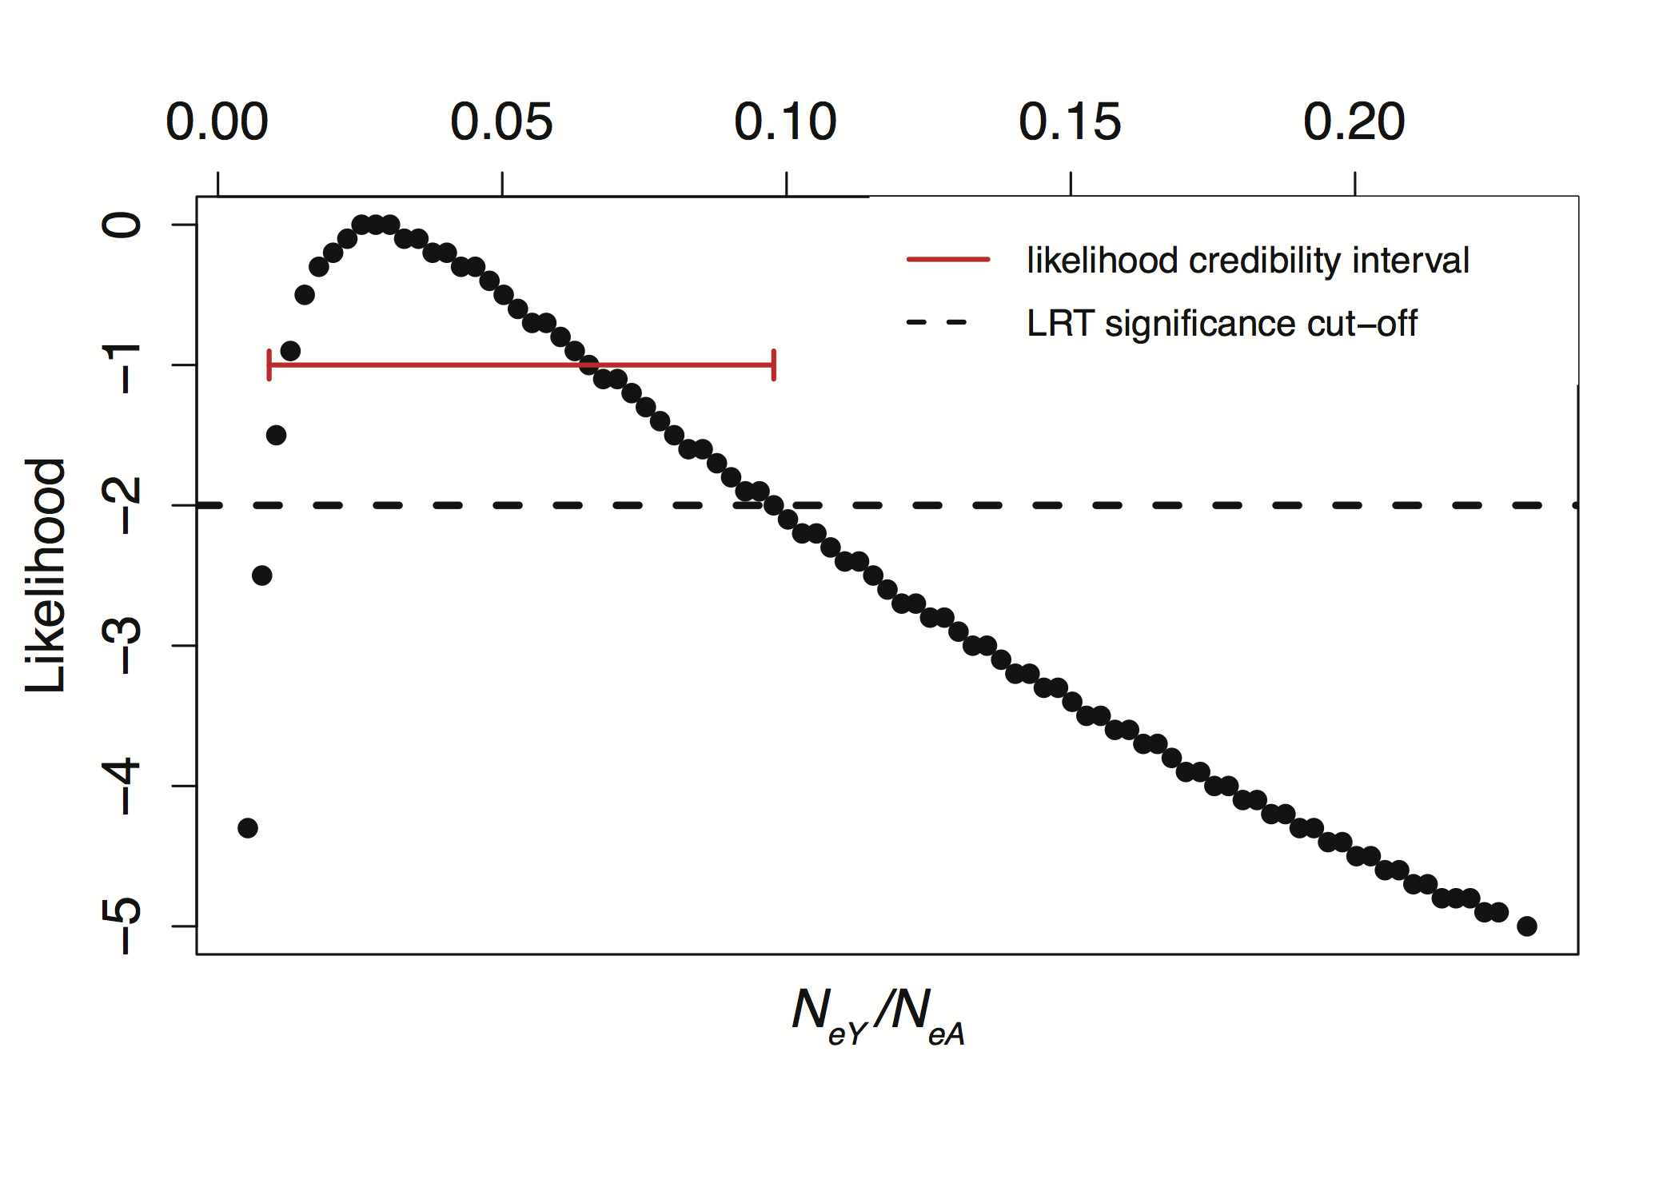
Figure S1. Likelihood estimation of the Y/A ratio

Simulation code

To study the effects of purifying selection on expected levels of Y-chromosome diversity, we conducted forward-time simulations of haploid Y chromosomes under a multiplicative selection model using the software SFS_CODE (Hernandez 2008). The SFS_CODE source code was obtained from: http://sfscode.sourceforge.net/SFS_CODE/index/index.html. Simulation commands for purifying selection and purifying + positive selection are given below. All simulations used the default 5 x PN burn in time, where P is the ploidy and N is the initial simulation population size.

purifying selection alone
./sfs_code 1 50000 -r 0 -t 0.0011 -P 1 -TE 1 -L 2 45331 $L -a N -W L 1 2 0 1 1 0.258 0.002 -n 6 -N 500 -A

Where we varied $L, the number of sites under selection, over a grid of values from 50000 to 5000000. We ran 50,000 replicate simulations per parameter set.

purifying and positive selection
./sfs_code 1 20000 -r 0 -t 0.0011 -P 1 -TE 1 -L 2 45331 $L -a N -W L 1 2 $p 0.258 0.002 0.258 0.002 -n 6 -N 500 -A

Where we varied $L, the number of sites under selection, over a grid of values from 50000 to 1300000, and $p, the proportion of sites subject to positive selection, from 0 to 0.005 (see Figure 5) and we ran 20,000 replicate simulations per parameter set.

