APPENDIX
Supplementary Figure 1. Factor models tested via Confirmatory Factor Analysis: 2-Factor Model (Panel A), 1-Factor Model (Panel B), Bi-factor Model, 9 items (Panel C), and Bi-factor Model, 7 items (Panel D)
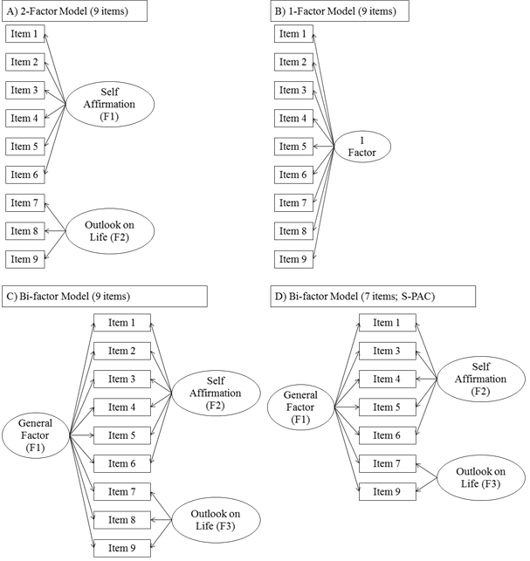

Supplementary Table 1. Caregiver and care-recipient characteristics (N=1,132)
 | Mean (SD) or Frequency (%)
Caregiver characteristics
Age (in years; range: 20 to 95) | 55.4 (12.4)
Female | 678 (59.9%)
Ethnicity
Chinese | 710 (62.7%)
Malay | 325 (28.7%)
Indian | 88 (7.8%)
Others | 9 (0.8%)
Care-recipient characteristics
Age (in years; range: 75 to 104) | 83.4 (5.5)
Female | 779 (68.8%)
Ethnicity
Chinese | 710 (62.7%)
Malay | 327 (28.9%)
Indian | 88 (7.8%)
Others | 7 (0.6%)
ADL limitations
Number of limitations (range: 1 to 7) | 4.5 (2.3)
Limitation in walking | 1020 (90.1%)
Limitation in showering | 858 (75.8%)
Limitation in toileting | 770 (68.0%)
Limitation in transferring | 733 (64.8%)
Limitation in dressing | 695 (61.4%)
Limitation in grooming | 543 (48.0%)
Limitation in eating | 517 (45.7%)
IADL limitations
Number of limitations (range: 0 to 7) | 6.1 (1.3)
Limitation in using transportation | 1115 (98.5%)
Limitation in shopping | 1110 (98.1%)
Limitation in doing housework | 1109 (98.0%)
Limitation in cooking | 1053 (93.0%)
Limitation in taking medication | 886 (78.3%)
Limitation in financial management | 787 (69.5%)
Limitation in using telephone | 784 (69.3%)
ADL: Activity of Daily Living; IADL: Instrumental Activity of Daily Living; SD: Standard deviation

Supplementary Table 2: Correlation of score on the CES-D scale and CE subscale of the CRA with scores on the 9-item Positive Aspects of Caregiving (PAC) scale (Panel A) and the 7-item Short-PAC scale (Panel B)
 | CES-D | CE subscale of the CRA

Panel A (9-item PAC scale)
SA Subscale | -0.13* | 0.27*
OL Subscale | -0.21* | 0.15*
Overall Scale | -0.17* | 0.25*

Panel B (7-item S-PAC scale)
SA Subscale | -0.13* | 0.27*
OL Subscale | -0.19* | 0.16*
Overall Scale | -0.16* | 0.25*
CE: Caregiver esteem; CES-D: Center for Epidemiologic Studies-Depression Scale; CRA: Caregiver Reaction Assessment; PAC: Positive Aspects of Caregiving; OL: Outlook-on-life; SA: Self affirmation; S-PAC: Short-Positive Aspects of Caregiving
*p less-than 0.0001

