Supplemental Materials

Supplemental Figure 1. Visual function by electroretinogram. (a) Graphical representation of ERG median intensity (μV) of (a) a-wave and (b) b-wave after white flash (9.95 cd•s/m²) under scotopic conditions. (c) Graphical representation of the sum of the time to peak of four oscillatory potential peaks. (d) Graphical representation of the sum of the amplitude of four oscillatory potential peaks. All error bars represent median absolute deviation. For wild type, Ndufs4 KO Veh, Ndufs4 KO PPV, Ndufs4 KO Zolp, Ndufs4 KO Rapa, and Ndufs4 KO Ideb, n = 8, 8, 7, 6, 6, and 5, respectively. Statistical significance determined by two-tailed student’s t test. * P < 0.05, ** P < 0.01 *** P < 0.001, **** P < 0.0001.

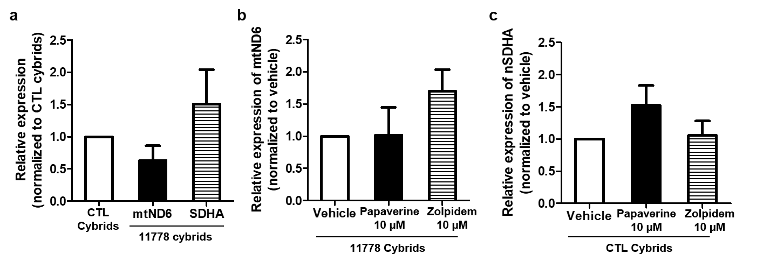
Supplemental Figure 2. Mitochondrial complex 1 and 2 expression in LHON cells.
Graphical representation of qRT-PCR data of (a) mtND6 and SDHA in control and LHON cybrid cell lines; (b) mtND6 in LHON cybrid cells treated with vehicle, PPV, and Zolp; and (c) SDHA in LHON cybrid cells treated with vehicle, PPV, and Zolp. No statistical significance was observered, however the data suggests that PPV is increasing complex 2 activity and Zolp is restoring complex 1 activity.

Supplemental Table 1. List of qRT-PCR primers.
Cd68 | Forward | CACAAGAAGCCGAATCAGCC
 | Reverse | TGTCAGCGTTACTATCCCGC

