Table of Contents
Description of the three replication cohorts 5
Functional annotation and gene expression 6
Candidate SNP analysis 6
SNP-heritability estimates 7
Proportion of variance explained 7
Supplementary Figure 1. Study design 9
Supplementary Figure 2. Manhattan plot for total bitter beverages 10
Supplementary Figure 3. QQ plot for total bitter beverages (λ=1.11, LD score regression intercept=1.014) 11
Supplementary Figure 4. Manhattan plot for bitter non-alcoholic beverages 12
Supplementary Figure 5. QQ plot for bitter non-alcoholic beverages (λ=1.12, LD score regression intercept=1.009) 13
Supplementary Figure 6. Manhattan plot for bitter alcoholic beverages 14
Supplementary Figure 7. QQ plot for bitter alcoholic beverages ((λ=1.29, LD score regression intercept=1.003) 15
Supplementary Figure 8. Manhattan plot for coffee 16
Supplementary Figure 9. QQ plot for coffee (λ=1.21, LD score regression intercept=1.018) 17
Supplementary Figure 10. Manhattan plot for sugar sweetened beverages 18
Supplementary Figure 11. QQ plot for sugar sweetened beverages (λ=1.04, LD score regression intercept=1.009) 19
Supplementary Figure 12. QQ plot for tea (λ=1.25, LD score regression intercept=1.012) 20
Supplementary Figure 13. QQ plot for grapefruit juice (λ=1.02, LD score regression intercept=1.003) 21
Supplementary Figure 14. QQ plot for total sweet beverages (λ=1.06, LD score regression intercept=1.006) 22
Supplementary Figure 15. QQ plot for artificially sweetened beverages (λ=1.04, LD score regression intercept=1.007) 23
Supplementary Figure 16. QQ plot for pure non-grapefruit juices (λ=1.04, LD score regression intercept=1.005) 24
Supplementary Figure 17: Regional plot for the top lead SNP (rs1260326, 2:27730940) at locus 2p23.3, for total bitter beverages phenotype 25
Supplementary Figure 18: Regional plot for the top lead SNP (rs1481012, 4:89039082) at locus 4q22.1, for total bitter beverages phenotype 26
Supplementary Figure 19: Regional plot for the top lead SNP (rs4410790, 7:17284577) at locus 7p21.1, for total bitter beverages phenotype 27
Supplementary Figure 20: Regional plot for the top lead SNP (rs17685, 7:75616105) at locus 7q11.23, for total bitter beverages phenotype 28
Supplementary Figure 21: Regional plot for the top lead SNP (rs2472297, 15:75027880) at locus 15q24, for total bitter beverages phenotype 29
Supplementary Figure 22: Regional plot for the top lead SNP (rs12405726, 1:150956128) at locus 1q21.3, for bitter non-alcoholic beverages phenotype 30
Supplementary Figure 23: Regional plot for the top lead SNP (rs4410790, 7:17284577) at locus 7p21.1, for bitter non-alcoholic beverages phenotype 31
Supplementary Figure 24: Regional plot for the top lead SNP (rs35855035, 7:73047551) at locus 7q11.23, for bitter non-alcoholic beverages phenotype 32
Supplementary Figure 25: Regional plot for the top lead SNP (rs1057868, 7:75615006) at locus 7q11.23, for bitter non-alcoholic beverages phenotype 33
Supplementary Figure 26: Regional plot for the top lead SNP (rs2472297, 15:75027880) at locus 15q24, for bitter non-alcoholic beverages phenotype 34
Supplementary Figure 27: Regional plot for the top lead SNP (rs9607819, 22:41958862) at locus 22q13.2, for bitter non-alcoholic beverages phenotype 35
Supplementary Figure 28: Regional plot for the top lead SNP (rs1260326, 2:27730940) at locus 2p23.3, for bitter alcoholic beverages phenotype 36
Supplementary Figure 29: Regional plot for the top lead SNP (rs11940694, 4:39414993) at locus 4p14, for bitter alcoholic beverages phenotype 37
Supplementary Figure 30: Regional plot for the top lead SNP (rs1229984, 4:100239319) at locus 4q23, for bitter alcoholic beverages phenotype 38
Supplementary Figure 31: Regional plot for the top lead SNP (rs7935528, 11:47722819) at locus 11p11.2, for bitter alcoholic beverages phenotype 39
Supplementary Figure 32: Regional plot for SNP (rs574367, 1:177873210) at locus 1q25.2, for coffee phenotype 40
Supplementary Figure 33: Regional plot for the top lead SNP (rs10865548, 2:631606) at locus 2p25.3, for coffee phenotype 41
Supplementary Figure 34: Regional plot for the top lead SNP (rs1260326, 2:27730940) at locus 2p23.3, for coffee phenotype 42
Supplementary Figure 35: Regional plot for the top lead SNP (rs4410790, 7:17284577) at locus 7p21.1, for coffee phenotype 43
Supplementary Figure 36: Regional plot for the top lead SNP (rs34060476, 7:73037956) at locus 7q11.23, for coffee phenotype 44
Supplementary Figure 37: Regional plot for the top lead SNP (rs1057868, 7:75615006) at locus 7q11.23, for coffee phenotype 45
Supplementary Figure 38: Regional plot for the top lead SNP (rs597045, 11:56272114) at locus 11q12.1, for coffee phenotype 46
Supplementary Figure 39: Regional plot for the top lead SNP (rs1956218, 14:33075243) at locus 14q12, for coffee phenotype 47
Supplementary Figure 40: Regional plot for the top lead SNP (rs2472297, 15:75027880) at locus 15q24, for coffee phenotype 48
Supplementary Figure 41: Regional plot for the top lead SNP (rs66723169, 18:57808978) at locus 18q21.32, for coffee phenotype 49
Supplementary Figure 42: Regional plot for the top lead SNP (rs2330783, 22:24747031) at locus 22q11.23, for coffee phenotype 50
Supplementary Figure 43: Regional plot for the top lead SNP (rs55872725, 16:53809123) at locus 16q12.2, for sugar sweetened beverages phenotype 51
Supplementary Figure 44. MAGMA gene expression analysis for total bitter beverages: 30 general tissue types and 53 tissue types. Significant results are highlighted in red. 52
Supplementary Figure 45. MAGMA gene expression analysis for bitter non-alcoholic beverages: 30 general tissue types and 53 tissue types. Significant results are highlighted in red. 53
Supplementary Figure 46. MAGMA gene expression analysis for bitter alcoholic beverages: 30 general tissue types and 53 tissue types. Significant results are highlighted in red. 54
Supplementary Figure 47. MAGMA gene expression analysis for coffee: 30 general tissue types and 53 tissue types. Significant results are highlighted in red. 55
Supplementary Figure 48. MAGMA gene expression analysis for sugar sweetened beverages: 30 general tissue types and 53 tissue types. Significant results are highlighted in red. 56
Supplementary Table 1. Phenotype definitions 57
Supplementary Table 5. Associations between 97 BMI loci and SSB consumption, ranked by P value based on joint meta-analysis of stage 1 and 2 samples 58
Supplementary Table 6: Energy adjusted Pearson correlation across primary and secondary phenotypes 62
Supplementary Table 7. Post hoc analysis for evaluating substitution effect due to the observation of the opposite direction of the association for certain SNPs between two beverage phenotypes* 63
Supplementary Table 8. Non-synonymous variants in linkage disequilibrium (r²≥0.8) with the replicated independent SNPs* 64
Supplementary Table 9. GWAS results with the SNPs related to taste receptor genes that had p <5 x 10⁻⁶ in stage 1 65
Supplementary Table 10. Heritability estimates in the UK Biobank 66
Supplementary Table 11. Variance explained (i.e., r-squared) by the most significant SNP from each locus that was successfully replicated 67
Supplementary Table 12. Summary of the published GWAS for all genome-wide significant associations with our replicated independent SNPs and those in high LD (r² ≥0.8) 68

Description of the three replication cohorts

Health Professionals Follow-up Study (HPFS Affy, HPFS Illumina, HPFS Omni): Initiated in 1986, the HPFS enrolled 51,529 male health professionals aged 40-75 years in the US.¹ Participants completed a validated semi-quantitative food frequency questionnaire (FFQ) every 4 years and other questionnaires on lifestyle and health status every 2 years. Genetic data contributing to the current study were obtained from 8 independent GWAS nested within the HPFS cohort, initially designed for outcomes of type 2 diabetes, coronary heart disease, gout, kidney stone, open-angle glaucoma, prostate cancer, pancreatic cancer, and colon cancer. Studies were genotyped on Affymatrix (HPFS Affy), Illumina (HPFS Illumina) and Omni (HPFS Omni) platforms.²

Nurses’ Health Study (NHS Affy, NHS Illumina, NHS Omni): The NHS was established in 1976 and is a largest prospective cohort study of 121,700 female registered nurses aged 30-55 years in the US.³ Participants completed a mailed questionnaire on medical history and lifestyle characteristics every 2 years and a validated semi-quantitative FFQ every 2-4 years. Genetic data contributing to the current study were obtained from 10 independent GWAS nested within the NHS cohort, initially designed for outcomes of type 2 diabetes, coronary heart disease, gout, kidney stones, open-angle glaucoma, mammographic density, pancreatic cancer, colon cancer, endometrial cancer, and breast cancer. Studies were genotyped on Affymatrix (NHS Affy), Illumina (NHS Illumina) and Omni (NHS Omni).²

To allow for maximum efficiency and power, we pooled HPFS and NHS samples genotyped on the same platforms, which resulted in 3 datasets herein referred to as Affy, Illumina and Omni. Detailed methods and quality assurance pertaining to these genetic datasets have been reported elsewhere.² Any samples that had substantial genetic similarity to non-European reference samples were excluded. For each of the 3 datasets, we imputed SNPs based on the Haplotype Reference Consortium (HRC version 1.1 2016) European (EUR) reference panel. SNP genotypes were imputed in 2 steps. First, genotypes on each chromosome were phased using ShapeIT (v2.r837). In the second step, phased data were submitted to Michigan Imputation Server. The server uses Minimac3 to impute the phased genotypes to approximately 39 million in HRC EUR population. For the current analysis, NHS and HPFS were analyzed separately resulting in 3 datasets each: HPFS (Affy, Illumina, Omni) and NHS (Affy, Illumina, Omni).

Women’s Genome Health Study (WGHS): WGHS (over 25,000 participants) was derived from the parent Women’s Health Study (WHS) that included 39,876 initially healthy, female North American health care professionals aged 45 or older at baseline.⁴ Participants provided baseline blood sample and informed consent for blood based analysis in the WHS. The WHS was began in 1992 to initially study the effect of vitamin E and low dose aspirin in prevention of cancer and cardiovascular disease. The randomized trial ended in March 2004, but observational follow up of the WHS continues. Genotyping in the WGHS sample was performed using the HumanHap300 Duo ‘‘+ ’’ chips or the combination of the HumanHap300 Duo and iSelect chips with the Infinium II protocol. A subset of individuals with self-reported European ancestry were verified on the basis of multidimensional scaling analysis of identity by state using 1443 ancestry informative markers in PLINK. SNPs were imputed based on the HRC EUR reference panel and followed a similar approach to that described for HPFS and NHS above.

All three cohorts used the same FFQ to collect the average dietary intake in the past year.^{1,3,4} A commonly used unit or portion size (eg, 1 egg or 1 slice of bread) is specified for each food in the FFQ. There are nine eating frequencies, ranging from “never” to “6 or more times per day.” The median of the each frequency is used to determine the intake level. For example, 2-4 per week is equal to 0.429 (i.e., 3/7) serving per day.

The WGHS’ FFQ data were collected at baseline in 1992-1994. The GWAS analysis was performed using ProbABEL⁵ (Version 0.3.0.), adjusting for age, total caloric intake, top 10 eigenvectors of population substructure, and BMI.

For the present analysis of NHS, we included the participants’ mean beverage intakes of the 1984 and 1986 FFQs. For the present analysis of HPFS, we included the participants’ mean beverage intakes of the 1986 and 1990 FFQs. For both cohorts, GWAS analysis was performed using RVTESTS,⁶ adjusting for age, total caloric intake, case-control study, top 4 eigenvectors of population substructure, and BMI.

Functional annotation and gene expression
Functional annotation, mapping, and gene expression analyses of the full stage 1 GWAS results were conducted with FUMA, a web-based platform integrating information from multiple biological resources.⁷ We focused these analyses on replicated independent SNPs (FUMA’s “lead SNPs”) which we specified a priori.

Candidate SNP analysis
Using the stage 1 GWAS results, we looked up SNPs mapping to 68 candidate genes based on the sweet and bitter taste transduction pathways as defined by Kegg.⁸ These genes included genes related to bitter taste perception identified by previous GWAS.⁹

SNP-heritability estimates
SNP-heritability (h_{g}²) of bitter and sweet phenotypes in the UK Biobank was estimated using BOLT-REML v2.3.2¹⁰ and LD score regression.¹¹ BOLT-REML applies variance components analysis to estimate h_{g}² and was performed on individual-level phenotype (no covariates) and genotyped data. LD score regression uses GWAS summary statistics (adjusted for covariates and PCs) and assesses h_{g}² based on the expected relationship between LD of neighboring SNPs and strength of association under a polygenic model. We used publicly available, pre-computed LD structure data files specific to European populations of the HAPMAP 3 reference panel.

Proportion of variance explained
Proportion of variance explained (r²) for bitter and sweet phenotypes in the UK Biobank was estimated using PROC REG in SAS with either putting lead SNPs individually or together. No covariate was added to the models.

References:
1. Rimm EB, Giovannucci EL, Stampfer MJ, Colditz GA, Litin LB, Willett WC. Reproducibility and Validity of an Expanded Self-Administered Semiquantitative Food Frequency Questionnaire among Male Health-Professionals. Am J Epidemiol. 1992;135(10):1114-1126.
2. Lindstrom S, Loomis S, Turman C, et al. A comprehensive survey of genetic variation in 20,691 subjects from four large cohorts. PLoS One. 2017;12(3):e0173997.
3. Bao Y, Bertoia ML, Lenart EB, et al. Origin, Methods, and Evolution of the Three Nurses' Health Studies. Am J Public Health. 2016;106(9):1573-1581.
4. Ridker PM, Chasman DI, Zee RYL, et al. Rationale, design, and methodology of the women's genome health study: A genome-wide association study of more than 25 000 initially healthy American women. Clin Chem. 2008;54(2):249-255.
5. Aulchenko YS, Struchalin MV, van Duijn CM. ProbABEL package for genome-wide association analysis of imputed data. BMC Bioinformatics. 2010;11:134.
6. Zhan XW, Hu YN, Li BS, Abecasis GR, Liu DJJ. RVTESTS: an efficient and comprehensive tool for rare variant association analysis using sequence data. Bioinformatics. 2016;32(9):1423-1426.
7. Watanabe K, Taskesen E, van Bochoven A, Posthuma D. Functional mapping and annotation of genetic associations with FUMA. Nat Commun. 2017;8(1):1826.
8. Kanehisa M, Goto S. KEGG: kyoto encyclopedia of genes and genomes. Nucleic Acids Res. 2000;28(1):27-30.
9. Hwang L-D. Bivariate genome-wide association analysis strengthens the role of bitter receptor clusters on chromosomes 7 and 12 in human bitter taste. bioRxiv. 2018.
10. Loh PR, Kichaev G, Gazal S, Schoech AP, Price AL. Mixed-model association for biobank-scale datasets. Nat Genet. 2018;50(7):906-908.
11. Bulik-Sullivan BK, Loh PR, Finucane HK, et al. LD Score regression distinguishes confounding from polygenicity in genome-wide association studies. Nat Genet. 2015;47(3):291-295.

Supplementary Figure 1. Study design
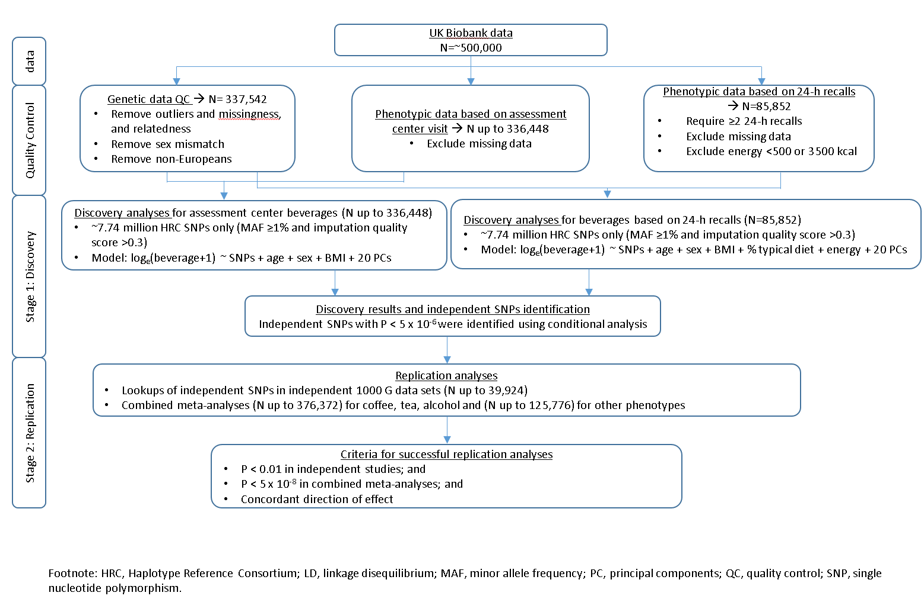

Supplementary Figure 2. Manhattan plot for total bitter beverages
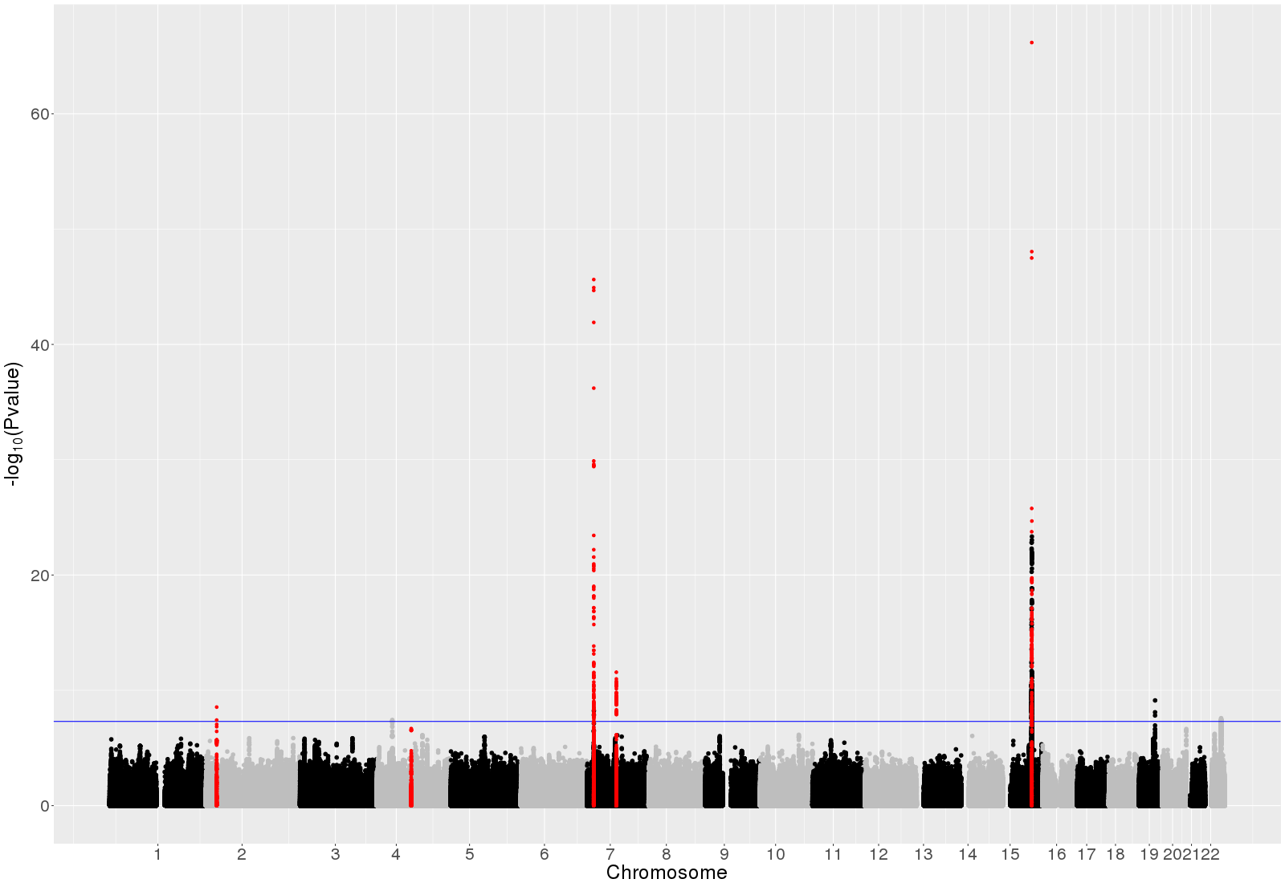
Replicated loci were in red. The plot was based on stage 1 results. We highlighted the replicated independent SNPs and those SNPs within 500 kb, for illustration purpose.

Supplementary Figure 3. QQ plot for total bitter beverages (λ=1.11, LD score regression intercept=1.014)
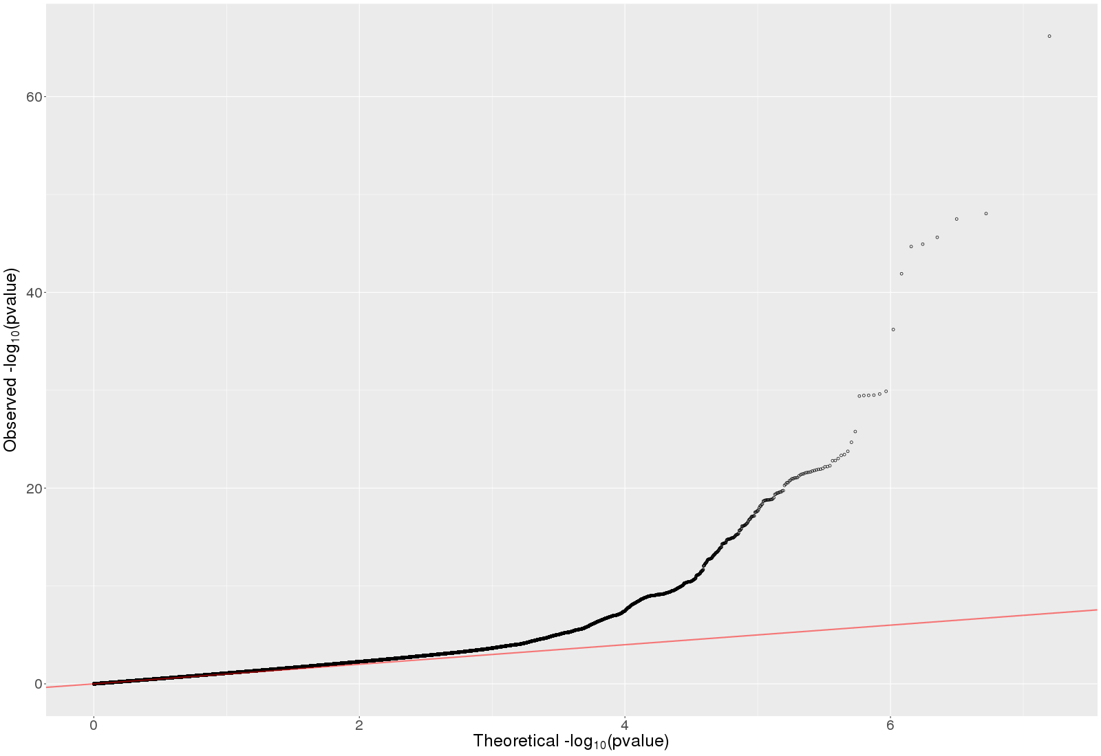
The plot was based on stage 1 results.

Supplementary Figure 4. Manhattan plot for bitter non-alcoholic beverages
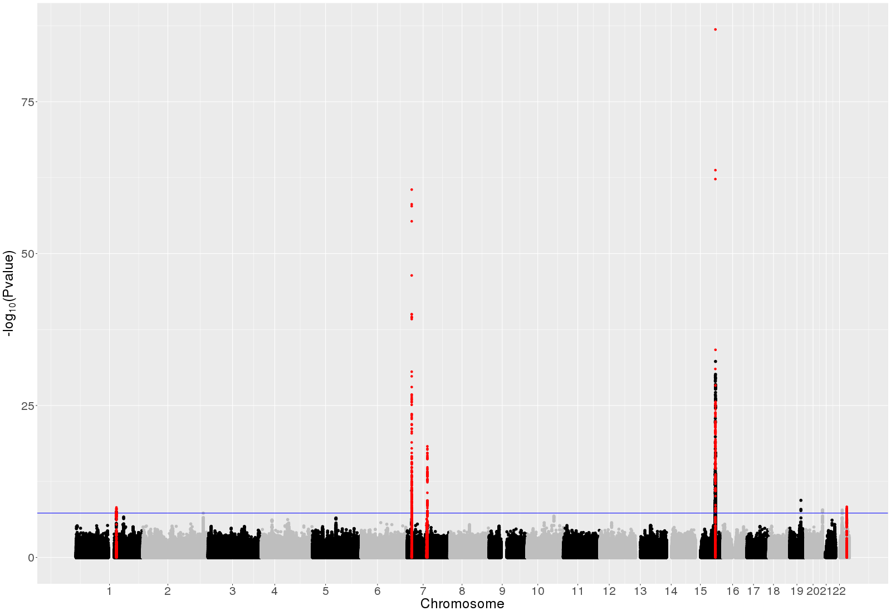
Replicated loci were in red. The plot was based on stage 1 results. We highlighted the replicated independent SNPs and those SNPs within 500 kb, for illustration purpose.

Supplementary Figure 5. QQ plot for bitter non-alcoholic beverages (λ=1.12, LD score regression intercept=1.009)
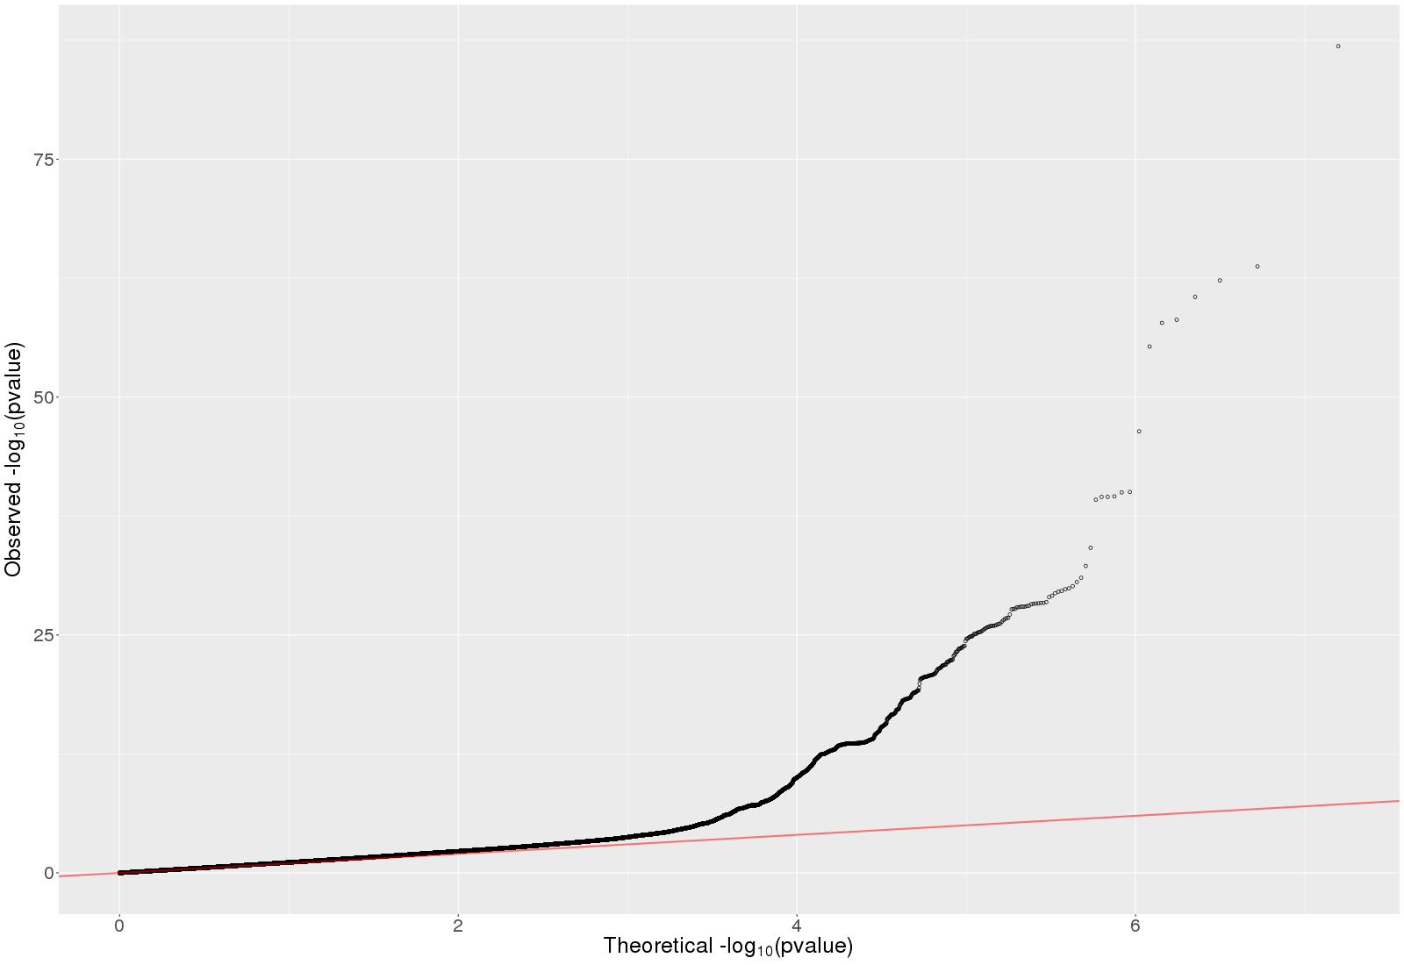
The plot was based on stage 1 results.

Supplementary Figure 6. Manhattan plot for bitter alcoholic beverages 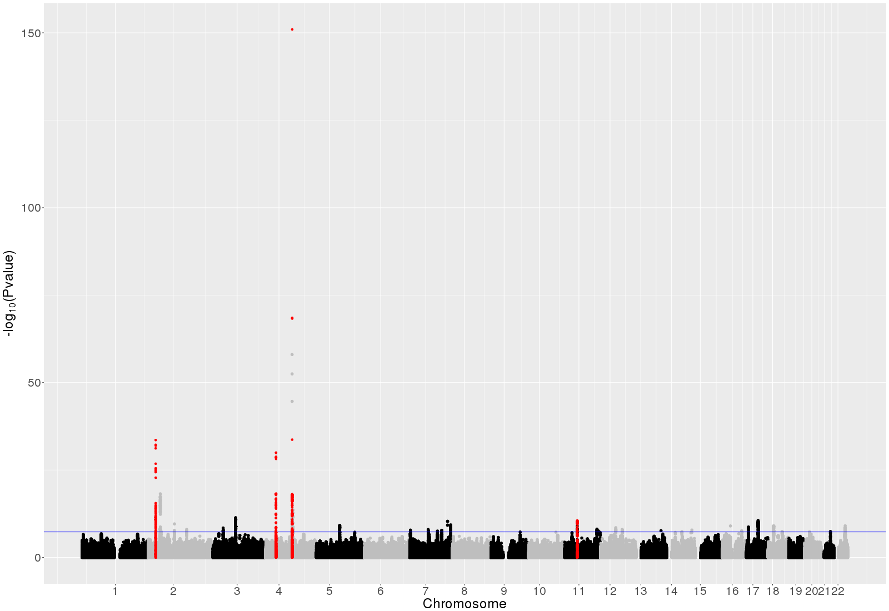
Replicated loci were in red. The plot was based on stage 1 results. We highlighted the replicated independent SNPs and those SNPs within 500 kb, for illustration purpose.

Supplementary Figure 7. QQ plot for bitter alcoholic beverages ((λ=1.29, LD score regression intercept=1.003)
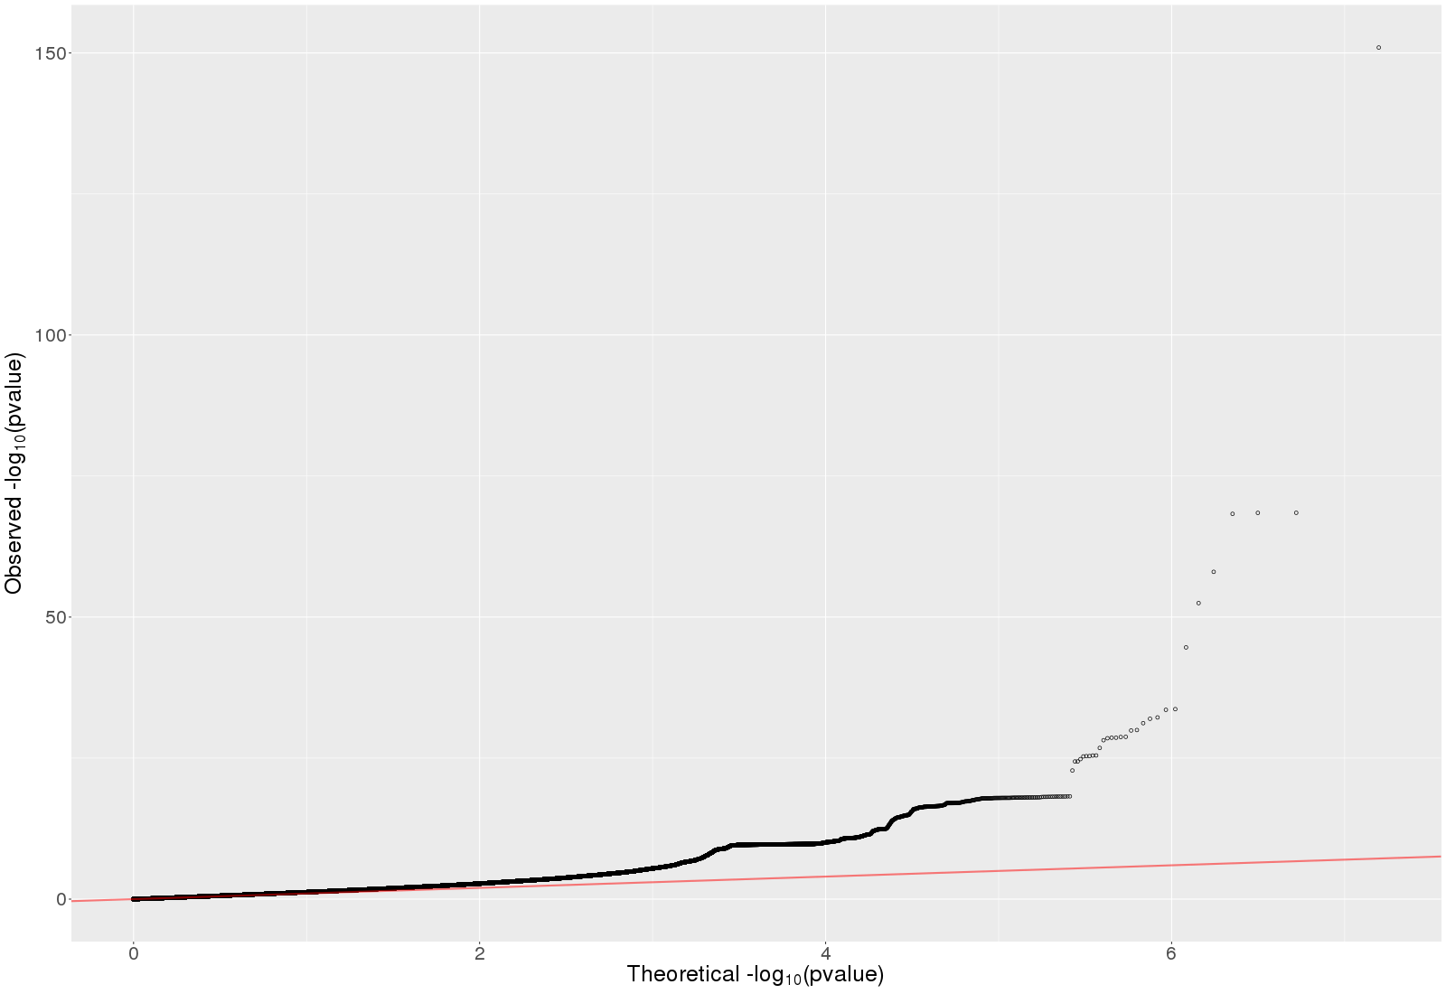
The plot was based on stage 1 results.

Supplementary Figure 8. Manhattan plot for coffee
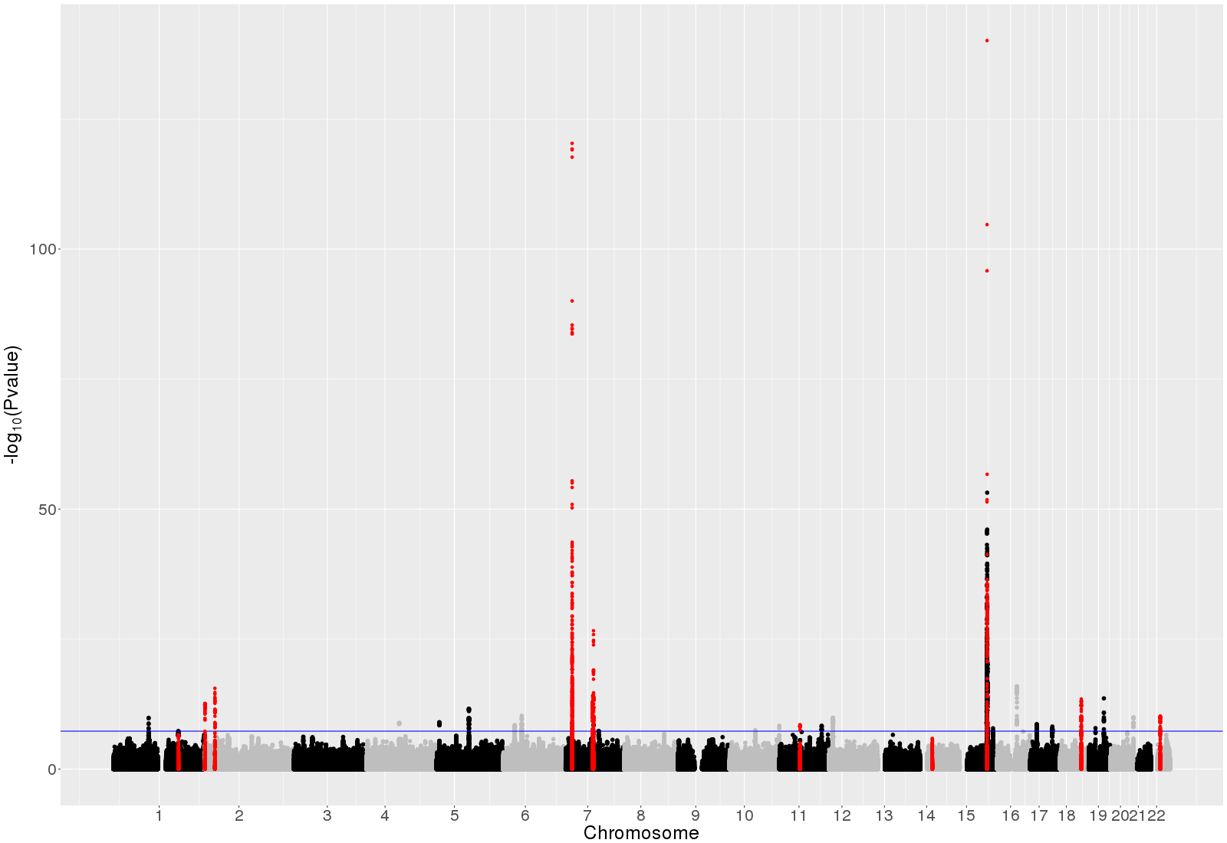
Replicated loci were in red. The plot was based on stage 1 results. We highlighted the replicated independent SNPs and those SNPs within 500 kb, for illustration purpose.

Supplementary Figure 9. QQ plot for coffee (λ=1.21, LD score regression intercept=1.018)
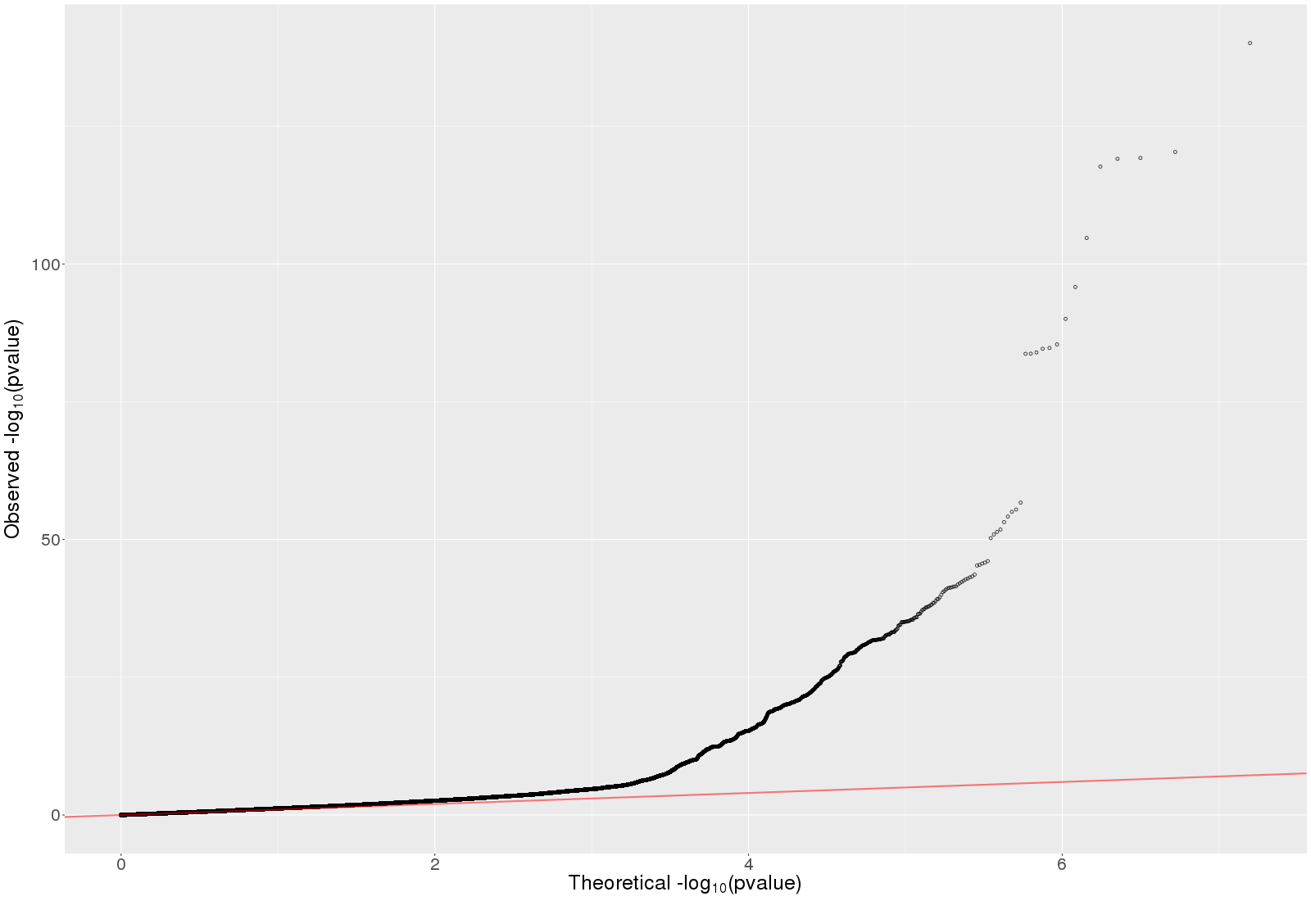
The plot was based on stage 1 results.

Supplementary Figure 10. Manhattan plot for sugar sweetened beverages
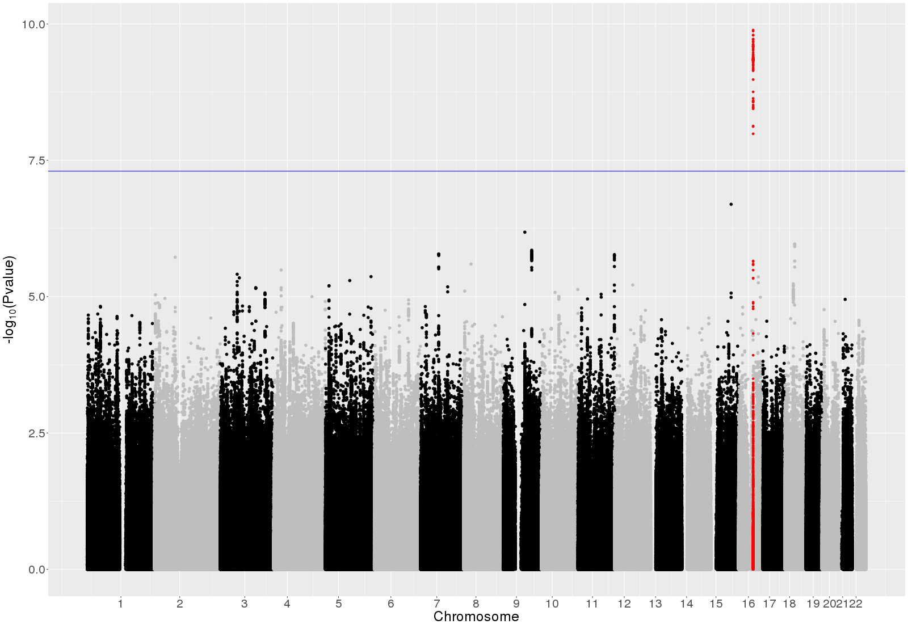
Replicated loci were in red. The plot was based on stage 1 results. We highlighted the replicated independent SNPs and those SNPs within 500 kb, for illustration purpose.

Supplementary Figure 11. QQ plot for sugar sweetened beverages (λ=1.04, LD score regression intercept=1.009)
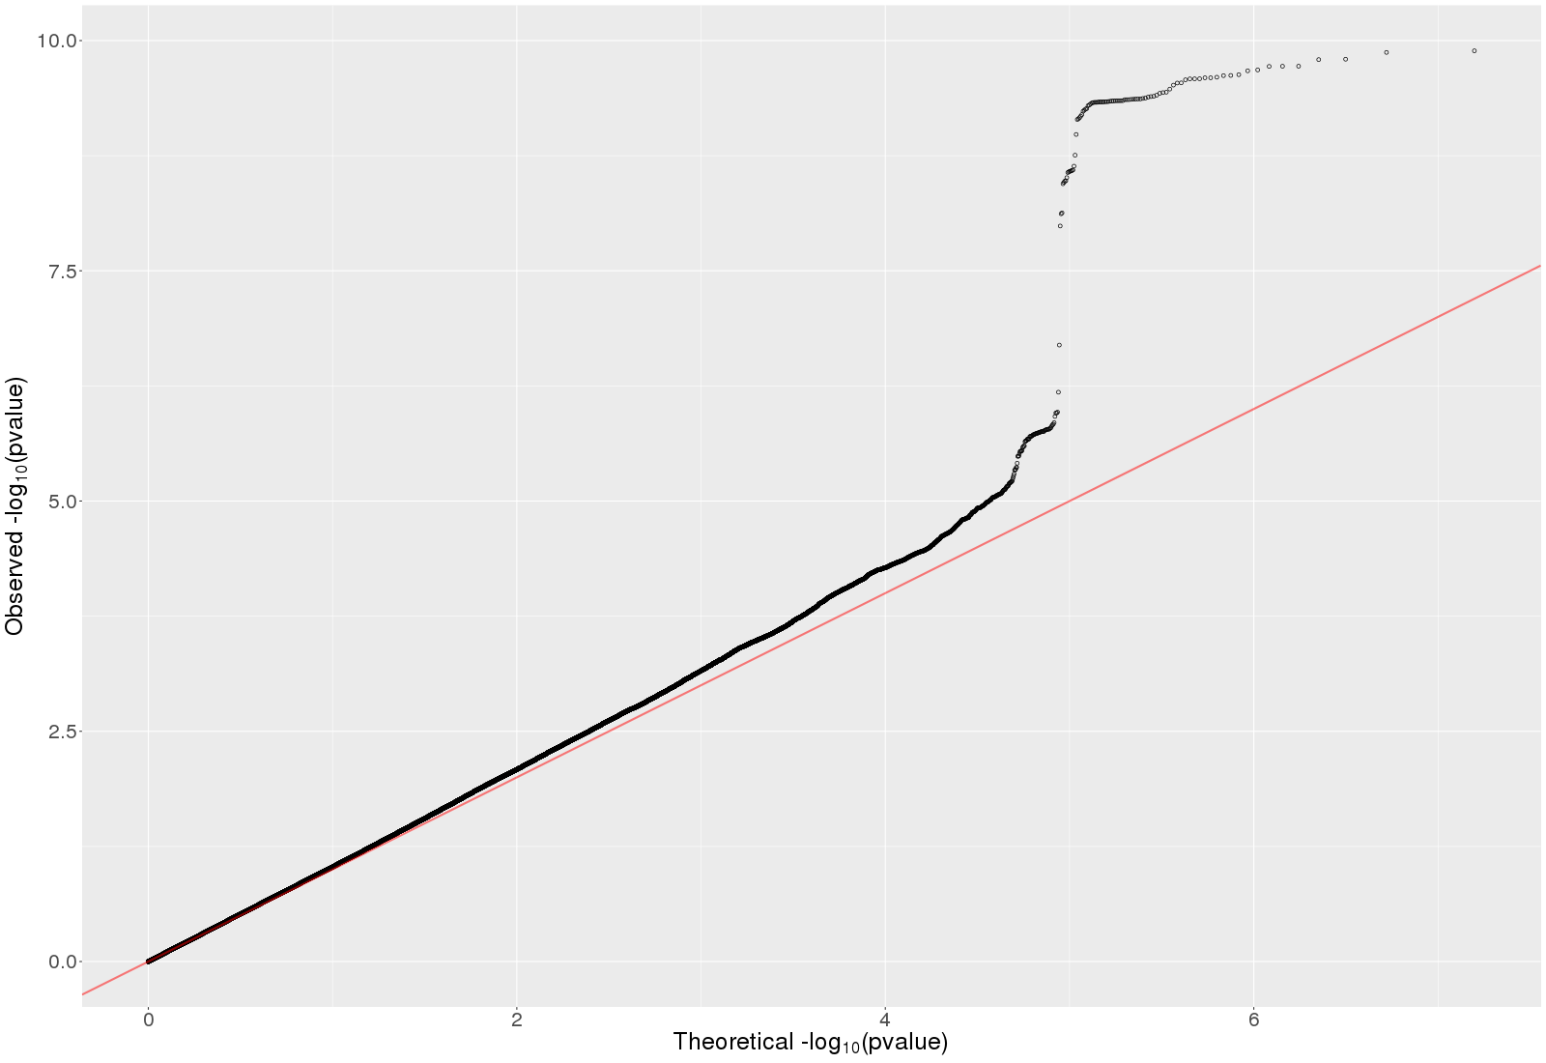
The plot was based on stage 1 results.

Supplementary Figure 12. QQ plot for tea (λ=1.25, LD score regression intercept=1.012)
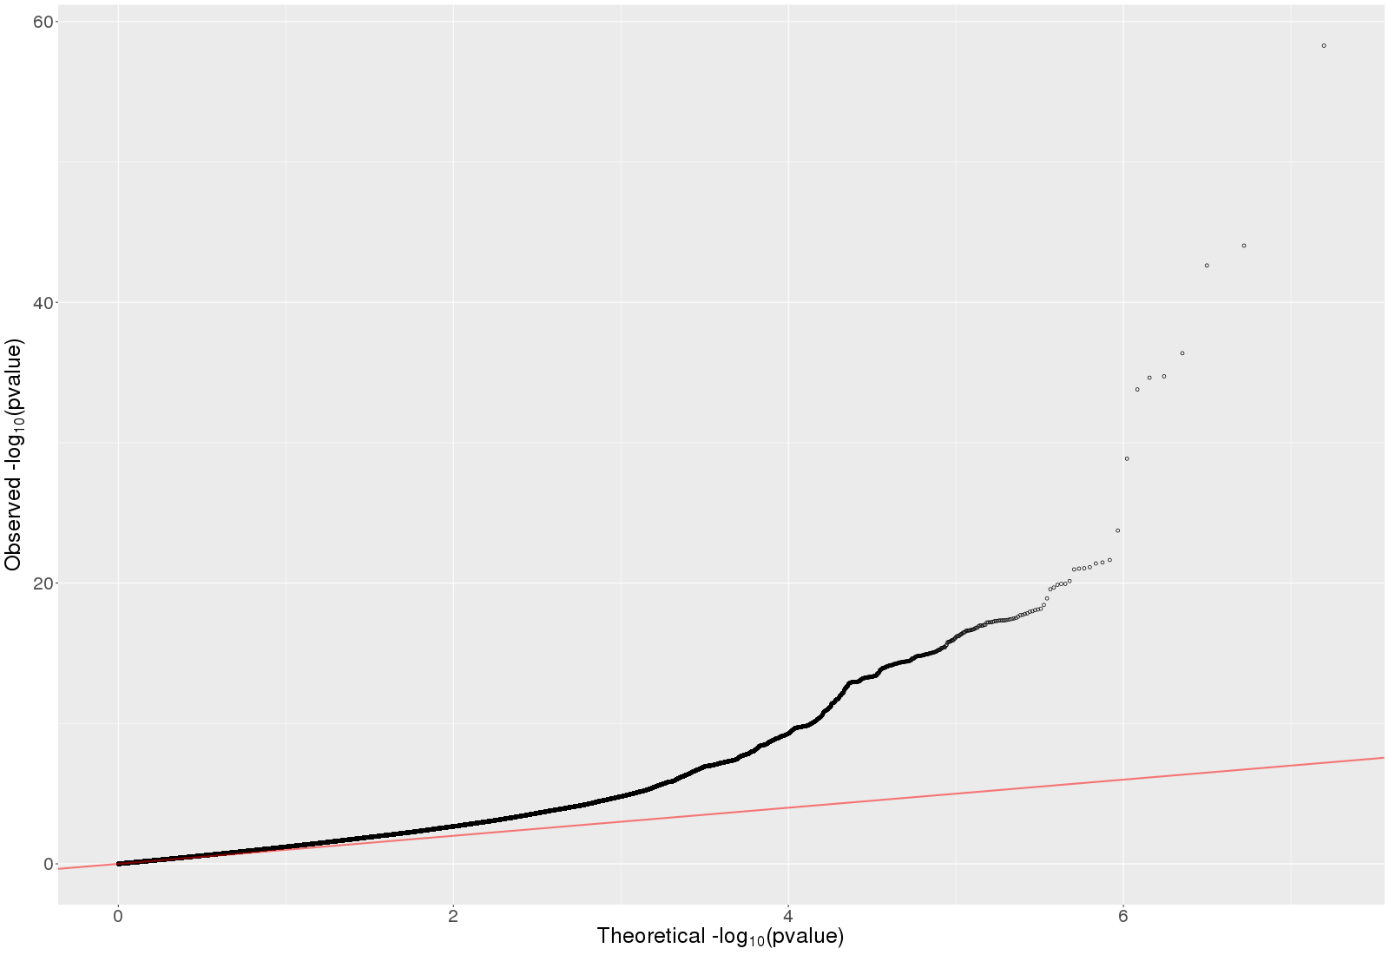
The plot was based on stage 1 results.

Supplementary Figure 13. QQ plot for grapefruit juice (λ=1.02, LD score regression intercept=1.003)
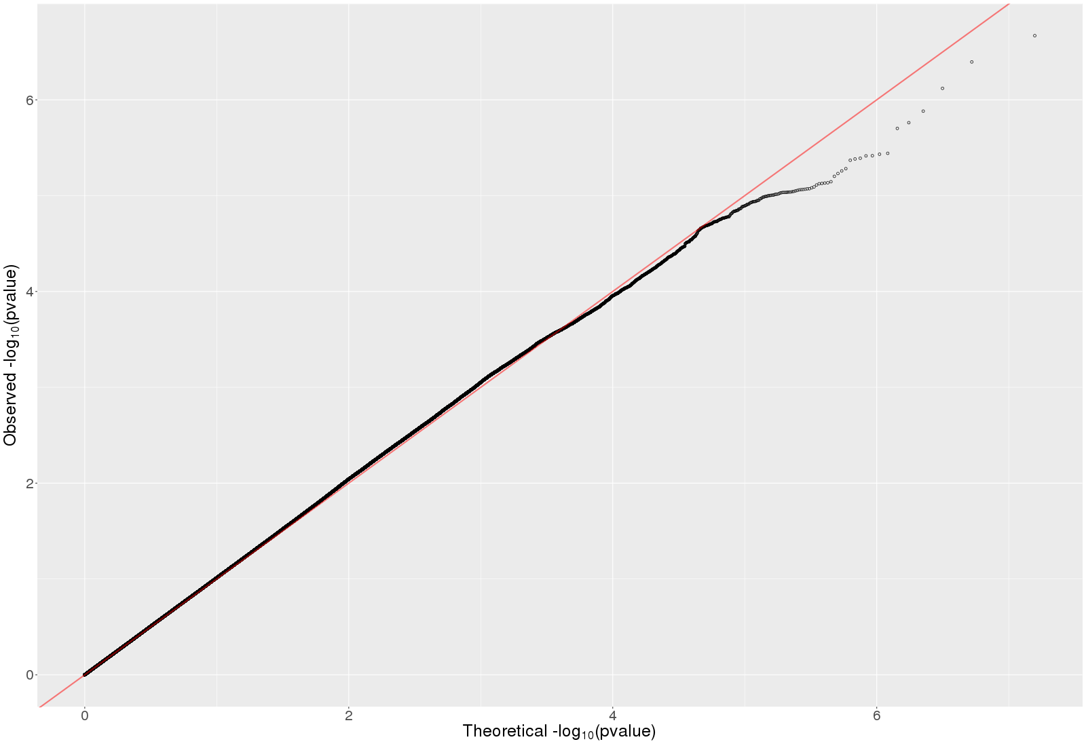
The plot was based on stage 1 results.

Supplementary Figure 14. QQ plot for total sweet beverages (λ=1.06, LD score regression intercept=1.006)
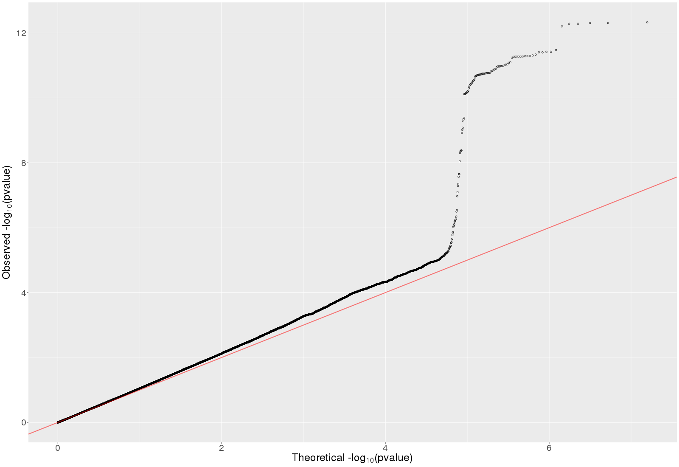
The plot was based on stage 1 results.

Supplementary Figure 15. QQ plot for artificially sweetened beverages (λ=1.04, LD score regression intercept=1.007)
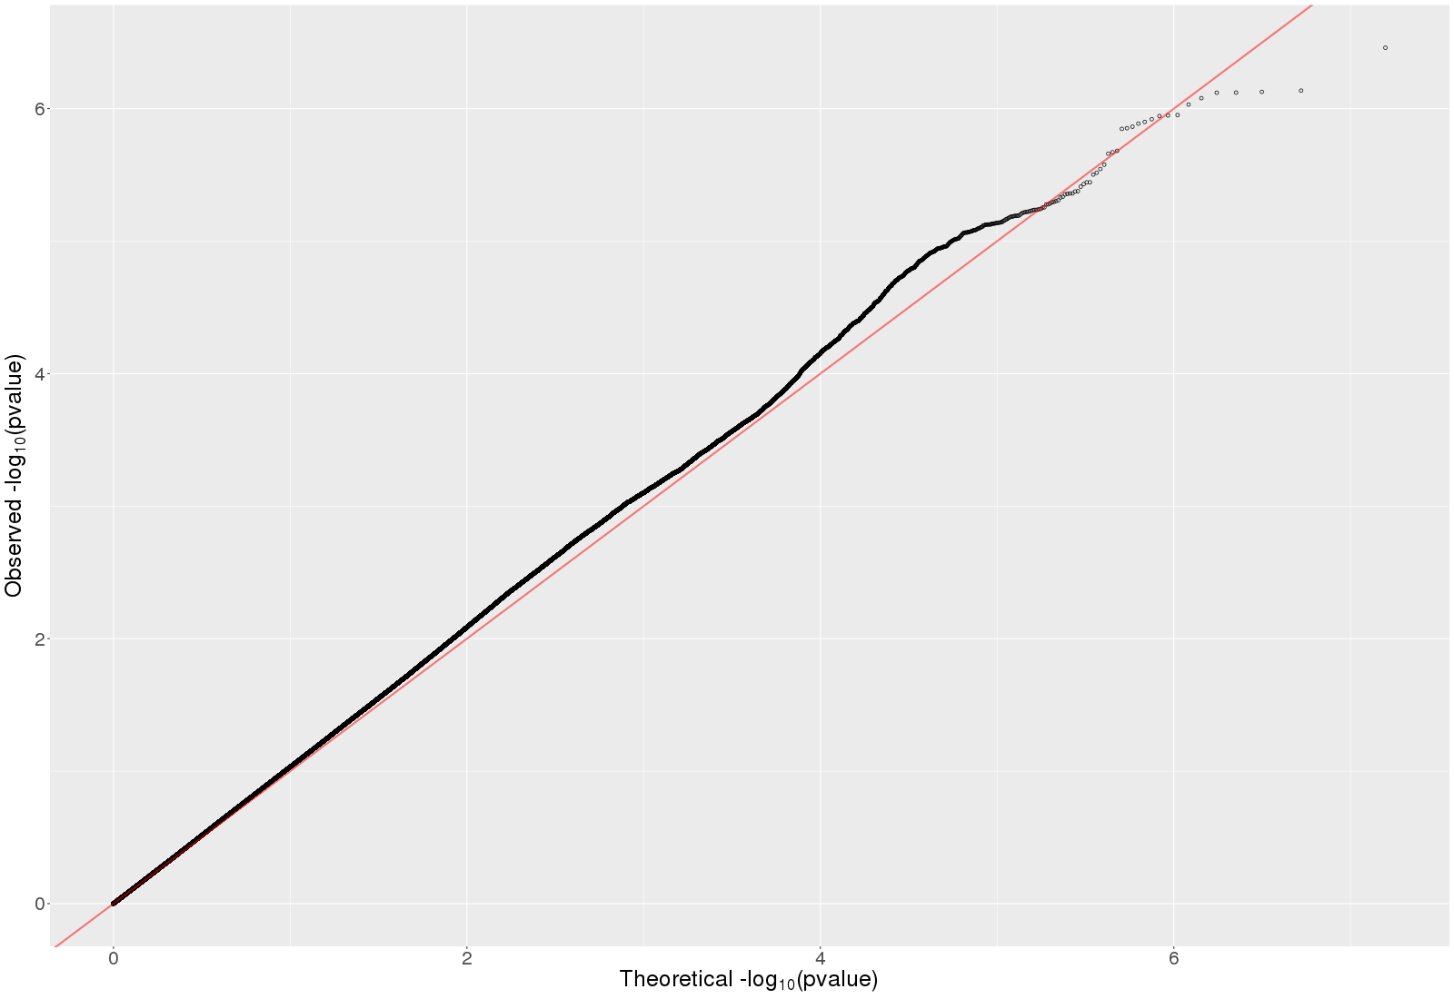
The plot was based on stage 1 results.

Supplementary Figure 16. QQ plot for pure non-grapefruit juices (λ=1.04, LD score regression intercept=1.005)
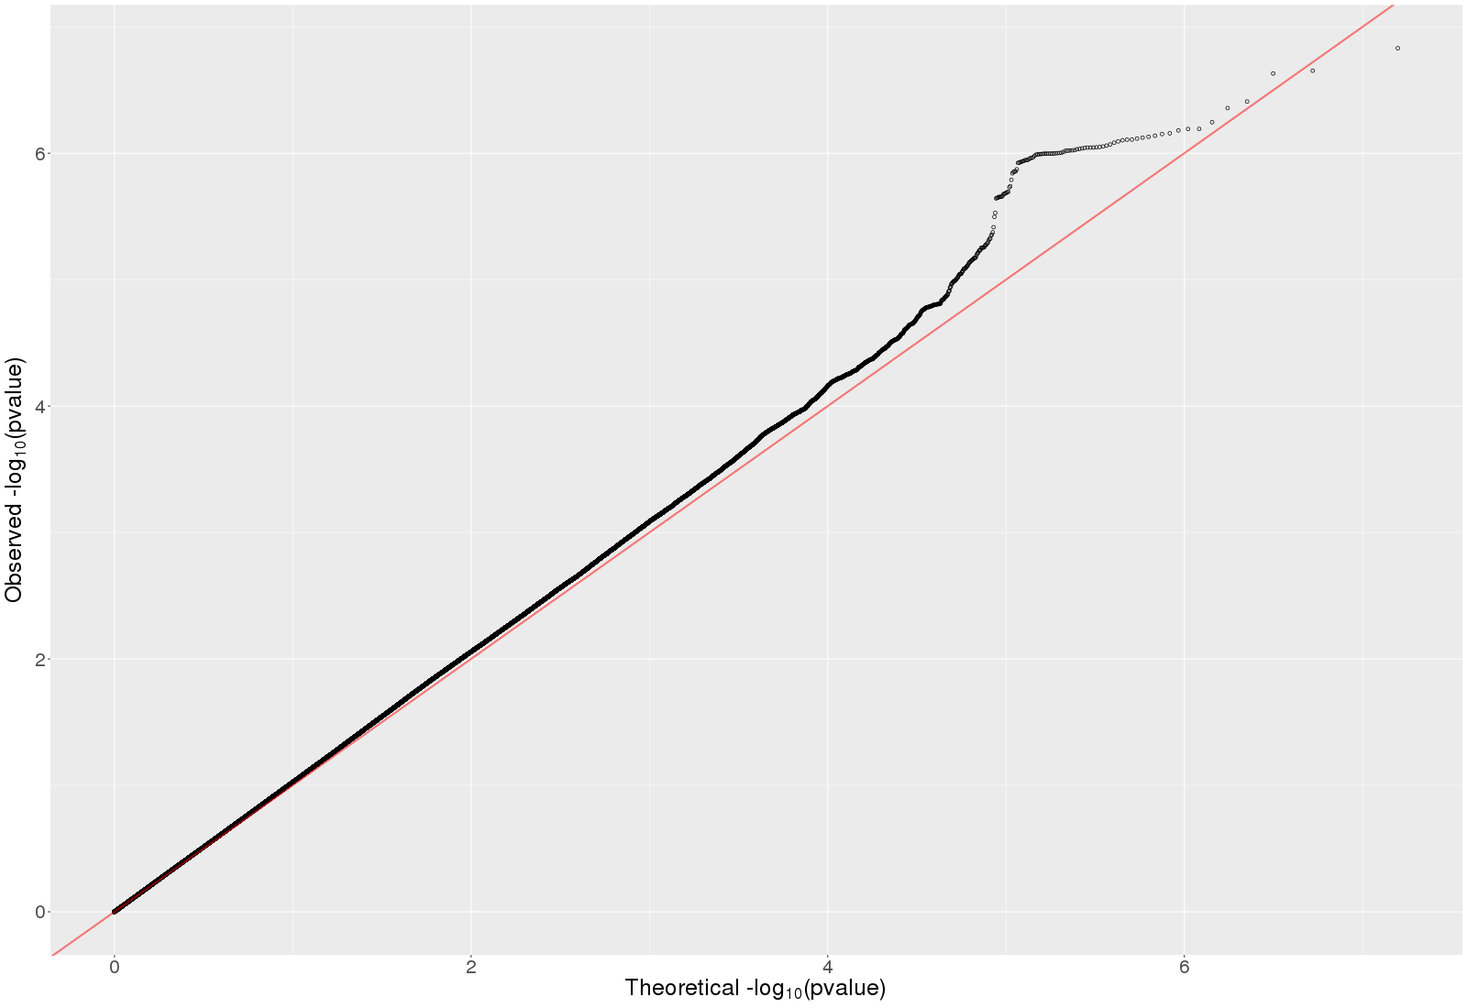
The plot was based on stage 1 results.

Supplementary Figure 17: Regional plot for the top lead SNP (rs1260326, 2:27730940) at locus 2p23.3, for total bitter beverages phenotype
The SNPs on the top are non-HRC SNPs or non-GWAS tagged SNPS

Supplementary Figure 18: Regional plot for the top lead SNP (rs1481012, 4:89039082) at locus 4q22.1, for total bitter beverages phenotype

The SNPs on the top are non-HRC SNPs or non-GWAS tagged SNPS

Supplementary Figure 19: Regional plot for the top lead SNP (rs4410790, 7:17284577) at locus 7p21.1, for total bitter beverages phenotype
The SNPs on the top are non-HRC SNPs or non-GWAS tagged SNPS

Supplementary Figure 20: Regional plot for the top lead SNP (rs17685, 7:75616105) at locus 7q11.23, for total bitter beverages phenotype
The SNPs on the top are non-HRC SNPs or non-GWAS tagged SNPS

Supplementary Figure 21: Regional plot for the top lead SNP (rs2472297, 15:75027880) at locus 15q24, for total bitter beverages phenotype
The SNPs on the top are non-HRC SNPs or non-GWAS tagged SNPS

Supplementary Figure 22: Regional plot for the top lead SNP (rs12405726, 1:150956128) at locus 1q21.3, for bitter non-alcoholic beverages phenotype
The SNPs on the top are non-HRC SNPs or non-GWAS tagged SNPS

Supplementary Figure 23: Regional plot for the top lead SNP (rs4410790, 7:17284577) at locus 7p21.1, for bitter non-alcoholic beverages phenotype

The SNPs on the top are non-HRC SNPs or non-GWAS tagged SNPS

Supplementary Figure 24: Regional plot for the top lead SNP (rs35855035, 7:73047551) at locus 7q11.23, for bitter non-alcoholic beverages phenotype
The SNPs on the top are non-HRC SNPs or non-GWAS tagged SNPS

Supplementary Figure 25: Regional plot for the top lead SNP (rs1057868, 7:75615006) at locus 7q11.23, for bitter non-alcoholic beverages phenotype
The SNPs on the top are non-HRC SNPs or non-GWAS tagged SNPS

Supplementary Figure 26: Regional plot for the top lead SNP (rs2472297, 15:75027880) at locus 15q24, for bitter non-alcoholic beverages phenotype
The SNPs on the top are non-HRC SNPs or non-GWAS tagged SNPS

Supplementary Figure 27: Regional plot for the top lead SNP (rs9607819, 22:41958862) at locus 22q13.2, for bitter non-alcoholic beverages phenotype
The SNPs on the top are non-HRC SNPs or non-GWAS tagged SNPS

Supplementary Figure 28: Regional plot for the top lead SNP (rs1260326, 2:27730940) at locus 2p23.3, for bitter alcoholic beverages phenotype
The SNPs on the top are non-HRC SNPs or non-GWAS tagged SNPS

Supplementary Figure 29: Regional plot for the top lead SNP (rs11940694, 4:39414993) at locus 4p14, for bitter alcoholic beverages phenotype
The SNPs on the top are non-HRC SNPs or non-GWAS tagged SNPS

Supplementary Figure 30: Regional plot for the top lead SNP (rs1229984, 4:100239319) at locus 4q23, for bitter alcoholic beverages phenotype

The SNPs on the top are non-HRC SNPs or non-GWAS tagged SNPS

Supplementary Figure 31: Regional plot for the top lead SNP (rs7935528, 11:47722819) at locus 11p11.2, for bitter alcoholic beverages phenotype

The SNPs on the top are non-HRC SNPs or non-GWAS tagged SNPS

Supplementary Figure 32: Regional plot for SNP (rs574367, 1:177873210) at locus 1q25.2, for coffee phenotype
The SNPs on the top are non-HRC SNPs or non-GWAS tagged SNPS

Supplementary Figure 33: Regional plot for the top lead SNP (rs10865548, 2:631606) at locus 2p25.3, for coffee phenotype
The SNPs on the top are non-HRC SNPs or non-GWAS tagged SNPS

Supplementary Figure 34: Regional plot for the top lead SNP (rs1260326, 2:27730940) at locus 2p23.3, for coffee phenotype
The SNPs on the top are non-HRC SNPs or non-GWAS tagged SNPS

Supplementary Figure 35: Regional plot for the top lead SNP (rs4410790, 7:17284577) at locus 7p21.1, for coffee phenotype
The SNPs on the top are non-HRC SNPs or non-GWAS tagged SNPS

Supplementary Figure 36: Regional plot for the top lead SNP (rs34060476, 7:73037956) at locus 7q11.23, for coffee phenotype
The SNPs on the top are non-HRC SNPs or non-GWAS tagged SNPS

Supplementary Figure 37: Regional plot for the top lead SNP (rs1057868, 7:75615006) at locus 7q11.23, for coffee phenotype
The SNPs on the top are non-HRC SNPs or non-GWAS tagged SNPS

Supplementary Figure 38: Regional plot for the top lead SNP (rs597045, 11:56272114) at locus 11q12.1, for coffee phenotype
The SNPs on the top are non-HRC SNPs or non-GWAS tagged SNPS

Supplementary Figure 39: Regional plot for the top lead SNP (rs1956218, 14:33075243) at locus 14q12, for coffee phenotype
The SNPs on the top are non-HRC SNPs or non-GWAS tagged SNPS

Supplementary Figure 40: Regional plot for the top lead SNP (rs2472297, 15:75027880) at locus 15q24, for coffee phenotype
The SNPs on the top are non-HRC SNPs or non-GWAS tagged SNPS

Supplementary Figure 41: Regional plot for the top lead SNP (rs66723169, 18:57808978) at locus 18q21.32, for coffee phenotype
The SNPs on the top are non-HRC SNPs or non-GWAS tagged SNPS

Supplementary Figure 42: Regional plot for the top lead SNP (rs2330783, 22:24747031) at locus 22q11.23, for coffee phenotype

The SNPs on the top are non-HRC SNPs or non-GWAS tagged SNPS

Supplementary Figure 43: Regional plot for the top lead SNP (rs55872725, 16:53809123) at locus 16q12.2, for sugar sweetened beverages phenotype

The SNPs on the top are non-HRC SNPs or non-GWAS tagged SNPS

Supplementary Figure 44. MAGMA gene expression analysis for total bitter beverages: 30 general tissue types and 53 tissue types. Significant results are highlighted in red.
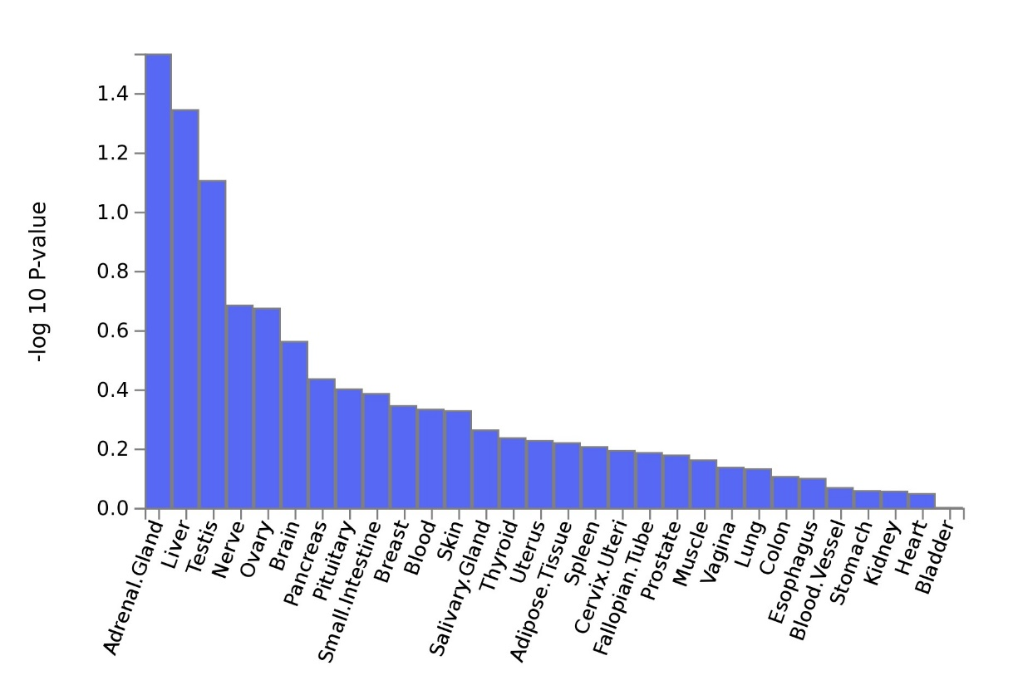
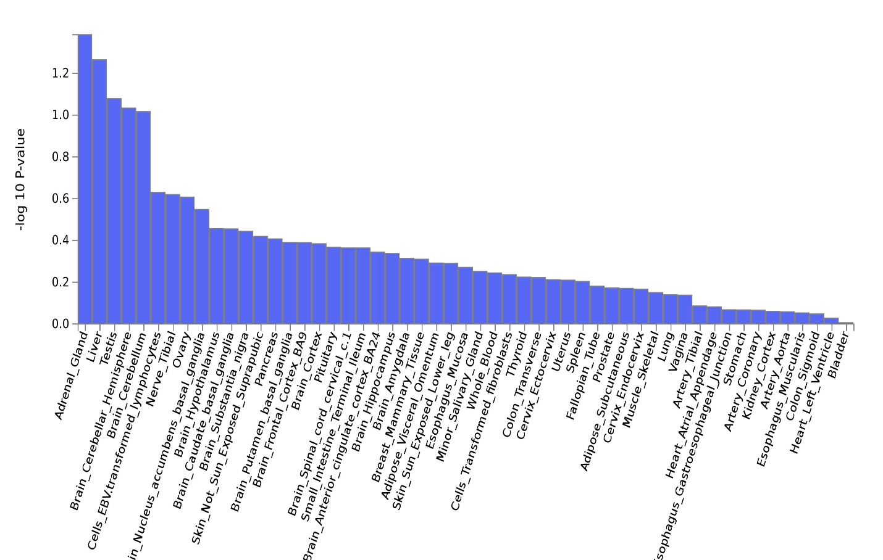

Supplementary Figure 45. MAGMA gene expression analysis for bitter non-alcoholic beverages: 30 general tissue types and 53 tissue types. Significant results are highlighted in red.
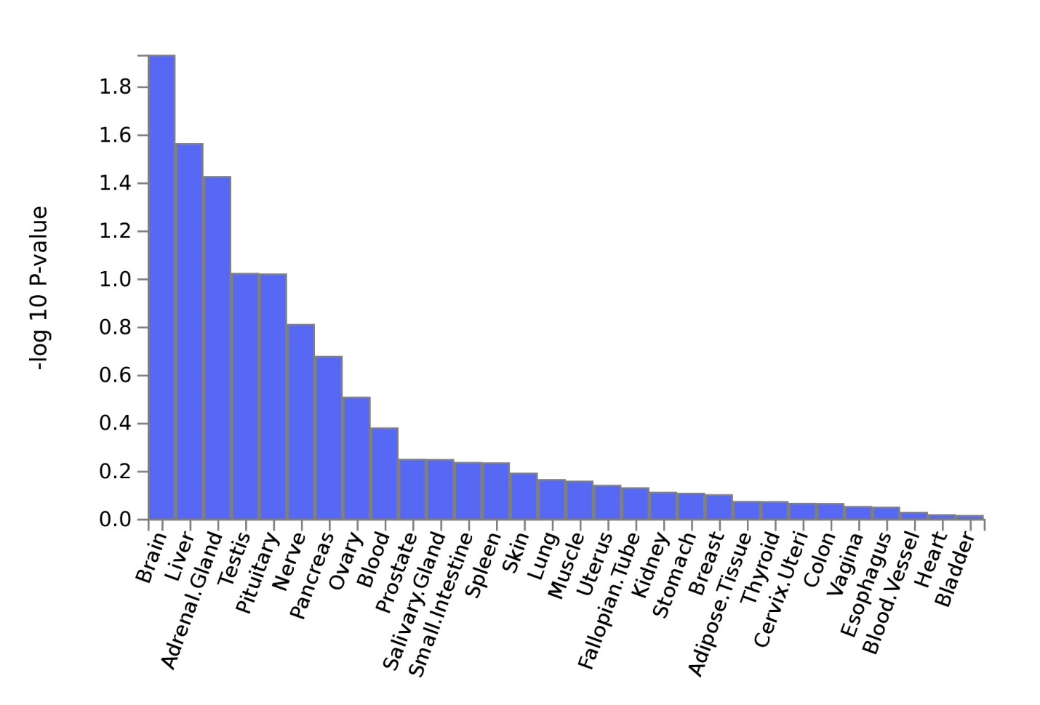
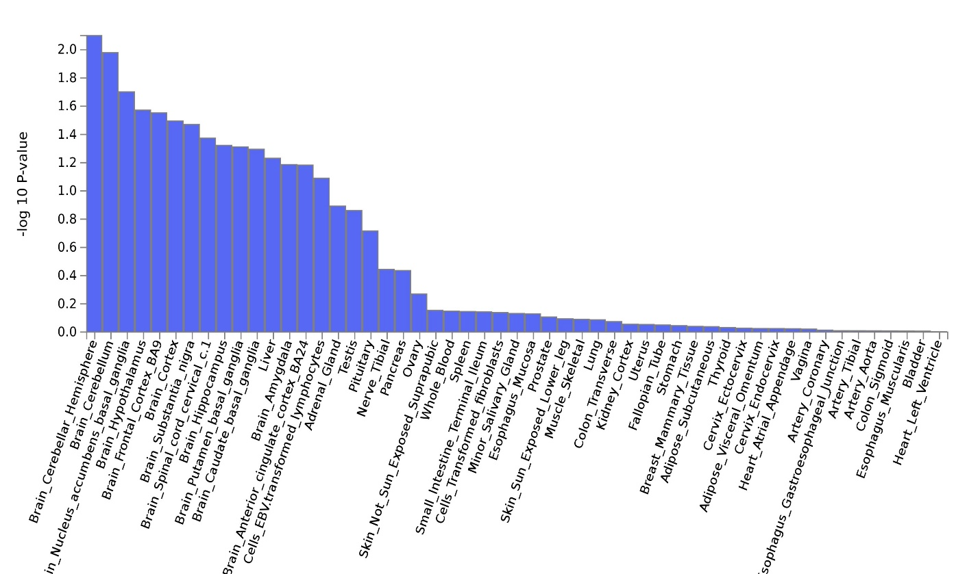

Supplementary Figure 46. MAGMA gene expression analysis for bitter alcoholic beverages: 30 general tissue types and 53 tissue types. Significant results are highlighted in red.
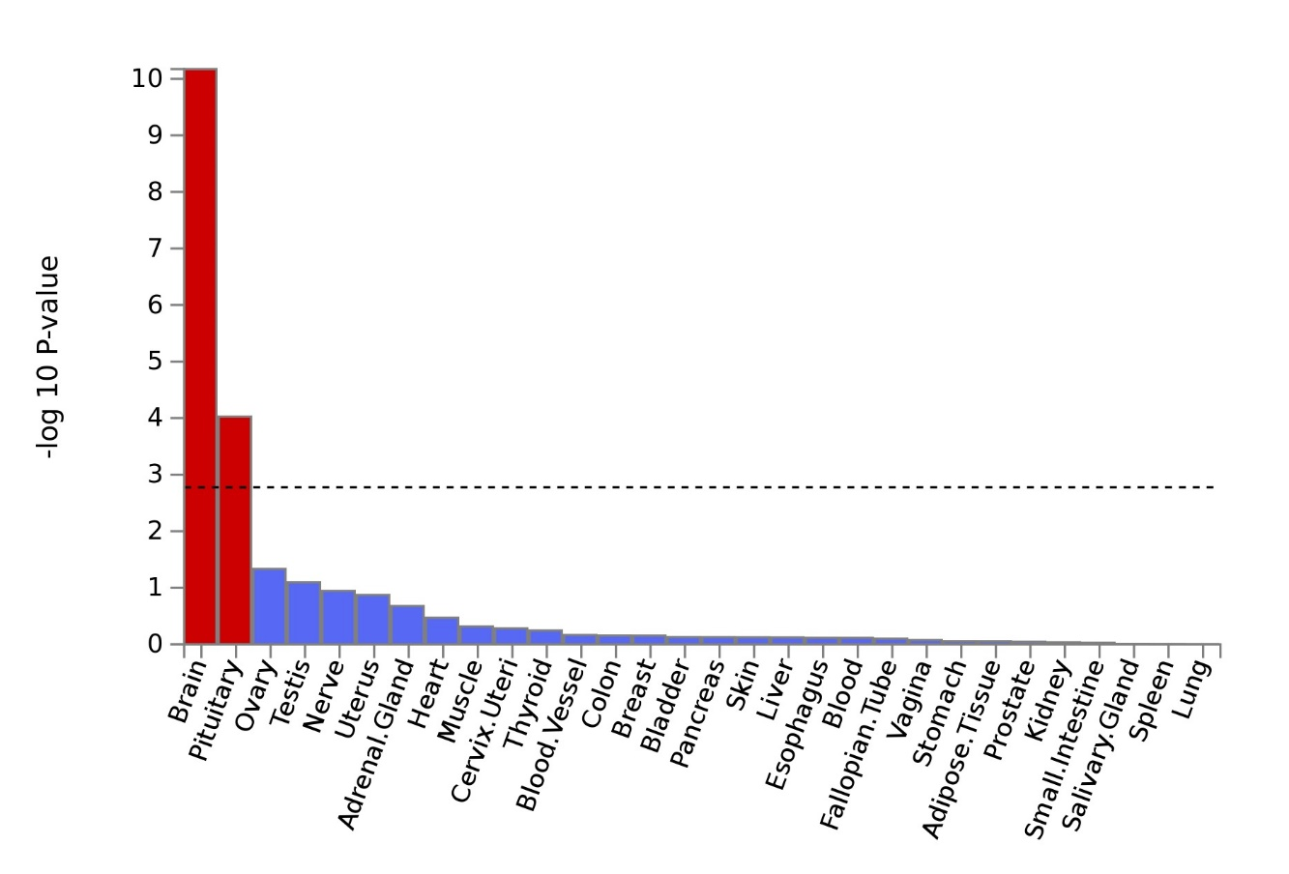
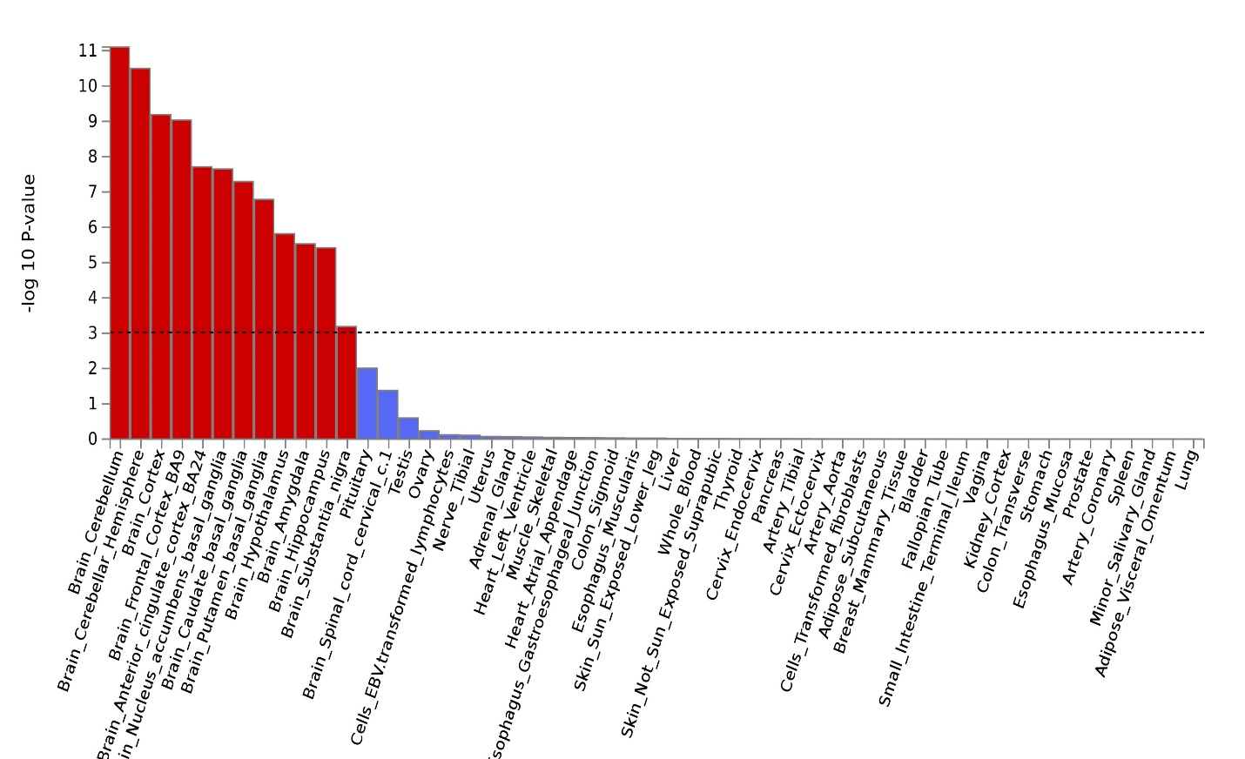

Supplementary Figure 47. MAGMA gene expression analysis for coffee: 30 general tissue types and 53 tissue types. Significant results are highlighted in red.
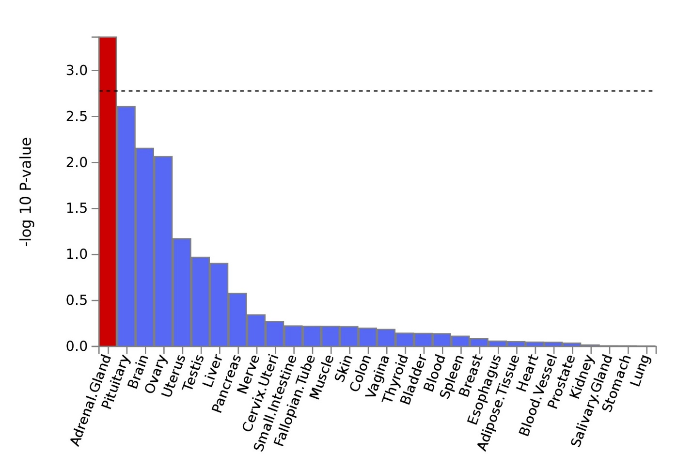
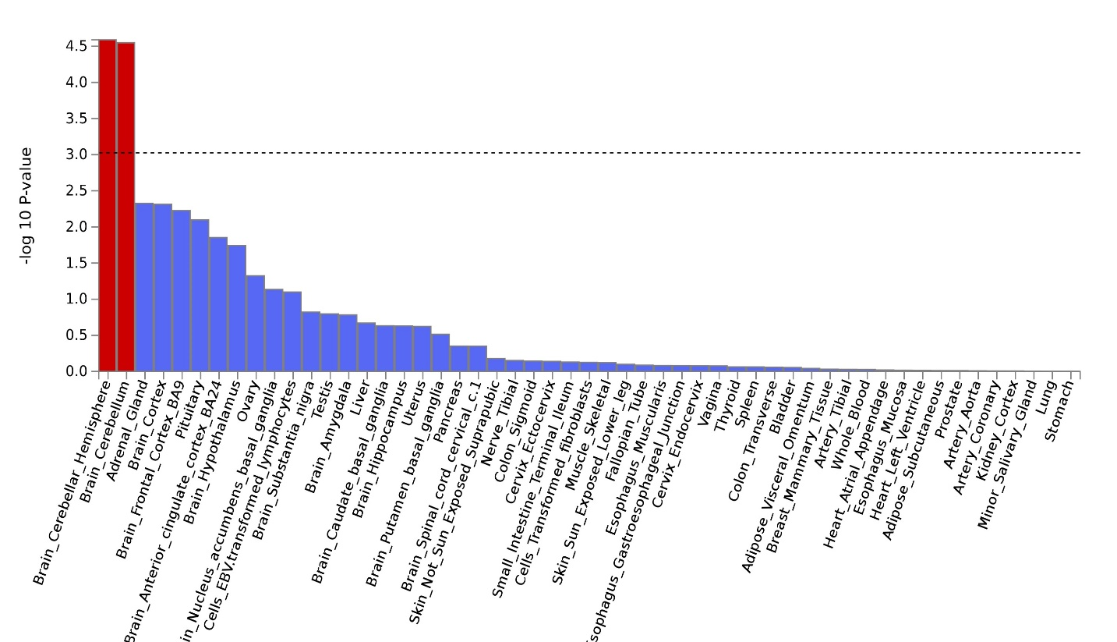

Supplementary Figure 48. MAGMA gene expression analysis for sugar sweetened beverages: 30 general tissue types and 53 tissue types. Significant results are highlighted in red.
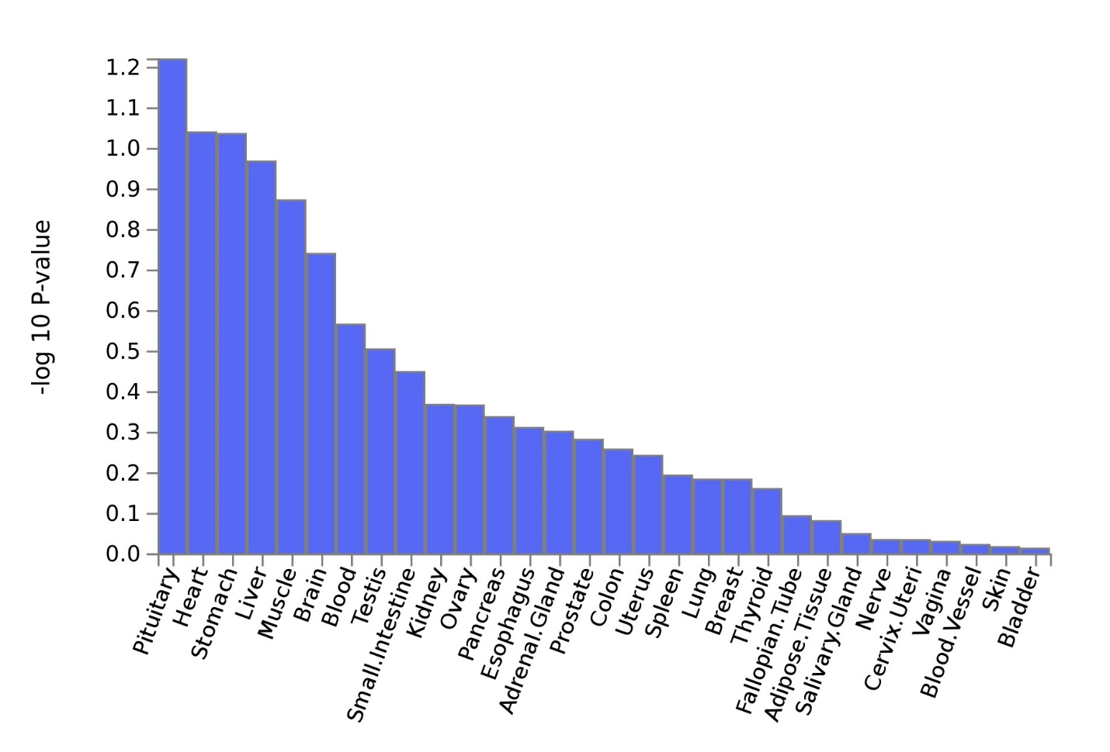
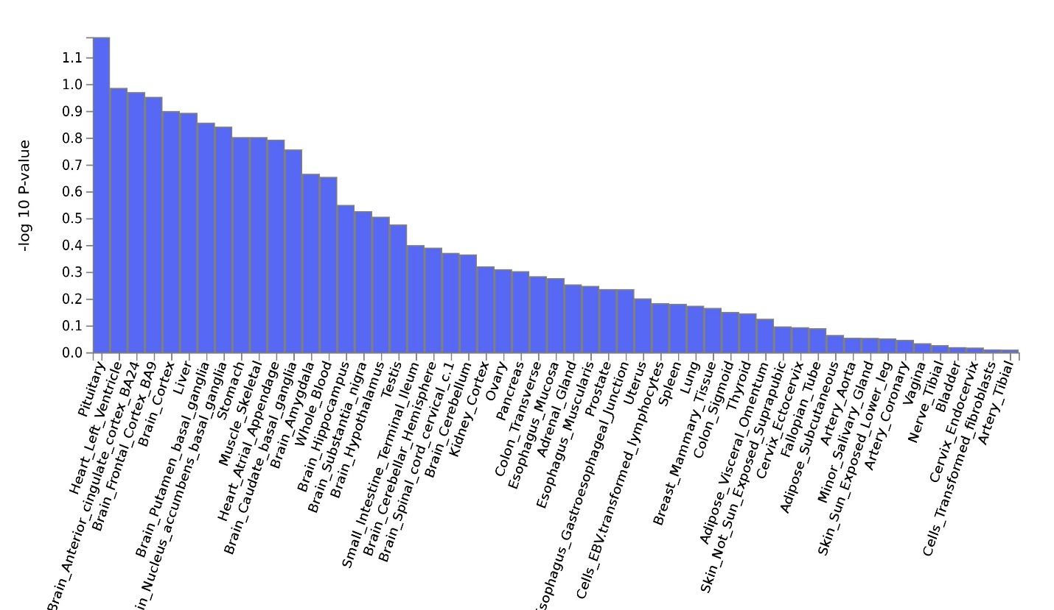

Supplementary Table 1. Phenotype definitions
Phenotypes | Components | Data source
Bitter beverages
Total | Coffee (any type), tea (any type), grapefruit juice, beer/cider*, red wine, spirit/liquor | Web-based 24-h recall questionnaire
Bitter alcoholic beverages | Beer/cider*, red wine, spirit/liquor | Touchscreen questionnaire at assessment center visit and Web-based 24-h recall questionnaire
Bitter non-alcoholic beverages | Coffee (any type), tea (any type), grapefruit juice | Web-based 24-h recall questionnaire
Coffee | Any type (i.e., regular/decaf, instant/ground) | Touchscreen questionnaire at assessment center visit and Web-based 24-h recall questionnaire
Tea | Any type (i.e., regular/decaf, herbal/non-herbal) | Touchscreen questionnaire at assessment center visit and Web-based 24-h recall questionnaire
Grapefruit juice |  | Web-based 24-h recall questionnaire
Sweet beverages
Total | Sugary carbonated beverages, flavoured juice beverages with sugar, any low-calorie or diet non-alcoholic beverages, pure fruit juice (excluding grapefruit juice), flavored milk, hot chocolate | Web-based 24-h recall questionnaire
Sugar sweetened beverages (SSBs) | Sugary carbonated beverages, flavoured juice beverages with sugar | Web-based 24-h recall questionnaire
Artificially sweetened beverages (ASBs) | Any low-calorie or diet non-alcoholic beverages | Web-based 24-h recall questionnaire
Pure non-grapefruit juices | Excluding grapefruit juice | Web-based 24-h recall questionnaire
* Beer and cider were asked together in the UK Biobank, and cider is generally not considered as a bitter beverage.

Supplementary Table 5. Associations between 97 BMI loci and SSB consumption, ranked by P value based on joint meta-analysis of stage 1 and 2 samples
DbSNP ID | Chr:pos | Gene | EA*/RA | EAF | BMI adjustment |  |  | BMI unadjustment
 |  |  |  |  | Beta | SE | P | Beta | SE | P
rs1558902 | 16:53803574 | FTO | A/T | 0.4088 | -0.0106 | 0.0013 | 4.11E-17 | -0.0094 | 0.0013 | 5.91E-14
rs543874 | 1:177889480 | SEC16B | G/A | 0.2028 | -0.0048 | 0.0015 | 0.001789 | -0.0041 | 0.0015 | 0.006869
rs11030104 | 11:27684517 | BDNF | A/G | 0.7938 | -0.0045 | 0.0015 | 0.003033 | -0.004 | 0.0015 | 0.009013
rs3849570 | 3:81792112 | GBE1 | A/C | 0.3415 | 0.0037 | 0.0013 | 0.004273 | 0.0038 | 0.0013 | 0.003447
rs7138803 | 12:50247468 | BCDIN3D | A/G | 0.3725 | -0.0033 | 0.0013 | 0.009833 | -0.0031 | 0.0013 | 0.01506
rs10938397 | 4:45182527 | GNPDA2 | G/A | 0.4346 | -0.003 | 0.0012 | 0.01546 | -0.0026 | 0.0012 | 0.03587
rs2176598 | 11:43864278 | HSD17B12 | T/C | 0.2444 | 0.0033 | 0.0014 | 0.01962 | 0.0036 | 0.0014 | 0.01217
rs7715256 | 5:153537893 | GALNT10 | G/T | 0.4293 | -0.0029 | 0.0012 | 0.02014 | -0.0027 | 0.0012 | 0.03115
rs2207139 | 6:50845490 | TFAP2B | G/A | 0.1673 | -0.0037 | 0.0016 | 0.02261 | -0.0033 | 0.0016 | 0.04263
rs205262 | 6:34563164 | C6orf106 | G/A | 0.2722 | -0.0031 | 0.0014 | 0.02649 | -0.0026 | 0.0014 | 0.05762
rs11583200 | 1:50559820 | ELAVL4 | C/T | 0.3864 | 0.0027 | 0.0013 | 0.03497 | 0.003 | 0.0013 | 0.01882
rs16951275 | 15:68077168 | MAP2K5 | T/C | 0.7701 | -0.003 | 0.0015 | 0.03944 | -0.0026 | 0.0015 | 0.07939
rs1441264 | 13:79580919 | MIR548A2 | A/G | 0.5986 | -0.0025 | 0.0013 | 0.04753 | -0.0023 | 0.0013 | 0.06958
rs6567160 | 18:57829135 | MC4R | C/T | 0.2372 | -0.0028 | 0.0014 | 0.05219 | -0.002 | 0.0014 | 0.1603
rs16851483 | 3:141275436 | RASA2 | T/G | 0.065 | 0.0048 | 0.0025 | 0.05634 | 0.005 | 0.0025 | 0.04446
rs2080454 | 16:49062590 | CBLN1 | C/A | 0.3856 | -0.0024 | 0.0013 | 0.05856 | -0.0023 | 0.0013 | 0.0751
rs13107325 | 4:103188709 | SLC39A8 | T/C | 0.0723 | 0.0043 | 0.0024 | 0.06826 | 0.0051 | 0.0024 | 0.03223
rs1016287 | 2:59305625 | FLJ30838 | T/C | 0.2954 | -0.0024 | 0.0013 | 0.07218 | -0.0022 | 0.0013 | 0.1083
rs11688816 | 2:63053048 | EHBP1 | G/A | 0.5341 | 0.0022 | 0.0012 | 0.07355 | 0.0023 | 0.0012 | 0.06197
rs12885454 | 14:29736838 | PRKD1 | C/A | 0.6462 | -0.0021 | 0.0013 | 0.1094 | -0.0018 | 0.0013 | 0.1568
rs11057405 | 12:122781897 | CLIP1 | G/A | 0.8962 | 0.0033 | 0.002 | 0.1103 | 0.0038 | 0.002 | 0.0629
rs10132280 | 14:25928179 | STXBP6 | C/A | 0.6968 | -0.0021 | 0.0013 | 0.1199 | -0.0019 | 0.0013 | 0.1643
rs1460676 | 2:164567689 | FIGN | C/T | 0.1603 | -0.0025 | 0.0017 | 0.1315 | -0.0021 | 0.0017 | 0.2122
rs2287019 | 19:46202172 | QPCTL | C/T | 0.8124 | -0.0023 | 0.0016 | 0.1549 | -0.0019 | 0.0016 | 0.2399
rs7141420 | 14:79899454 | NRXN3 | T/C | 0.5168 | -0.0017 | 0.0012 | 0.1623 | -0.0015 | 0.0012 | 0.24
rs2245368 | 7:76608143 | PMS2L11 | C/T | 0.1704 | -0.0023 | 0.0017 | 0.1708 | -0.0018 | 0.0017 | 0.2758
rs4256980 | 11:8673939 | TRIM66 | G/C | 0.6497 | -0.0017 | 0.0013 | 0.1917 | -0.0015 | 0.0013 | 0.2555
rs6465468 | 7:95169514 | ASB4 | T/G | 0.3092 | 0.0016 | 0.0013 | 0.2185 | 0.0016 | 0.0013 | 0.2187
rs2650492 | 16:28333411 | SBK1 | A/G | 0.2966 | -0.0017 | 0.0014 | 0.2185 | -0.0013 | 0.0014 | 0.3302
rs7243357 | 18:56883319 | GRP | T/G | 0.8245 | -0.0019 | 0.0016 | 0.232 | -0.0018 | 0.0016 | 0.2763
rs7599312 | 2:213413231 | ERBB4 | G/A | 0.7302 | -0.0017 | 0.0014 | 0.2328 | -0.0014 | 0.0014 | 0.3148
rs9914578 | 17:2005136 | SMG6 | G/C | 0.2014 | 0.0018 | 0.0015 | 0.2406 | 0.0019 | 0.0015 | 0.2111
rs4740619 | 9:15634326 | C9orf93 | T/C | 0.5463 | 0.0014 | 0.0012 | 0.2557 | 0.0018 | 0.0012 | 0.1414
rs2176040 | 2:227092802 | LOC646736 | A/G | 0.3532 | -0.0014 | 0.0013 | 0.259 | -0.0014 | 0.0013 | 0.2701
rs9641123 | 7:93197732 | CALCR | C/G | 0.4095 | -0.0013 | 0.0013 | 0.3068 | -0.0012 | 0.0013 | 0.353
rs2836754 | 21:40291740 | ETS2 | C/T | 0.638 | -0.0013 | 0.0013 | 0.3122 | -0.0012 | 0.0013 | 0.3535
rs9540493 | 13:66205704 | MIR548X2 | A/G | 0.4519 | -0.0012 | 0.0012 | 0.3352 | -0.0011 | 0.0013 | 0.4013
rs3736485 | 15:51748610 | DMXL2 | A/G | 0.4588 | -0.0012 | 0.0012 | 0.3358 | -0.001 | 0.0012 | 0.4117
rs2075650 | 19:45395619 | TOMM40 | A/G | 0.8574 | 0.0017 | 0.0018 | 0.3456 | 0.0019 | 0.0018 | 0.294
rs17724992 | 19:18454825 | PGPEP1 | A/G | 0.7327 | -0.0013 | 0.0014 | 0.3464 | -0.0012 | 0.0014 | 0.406
rs13191362 | 6:163033350 | PARK2 | A/G | 0.8769 | 0.0017 | 0.0019 | 0.3548 | 0.002 | 0.0019 | 0.2955
rs11191560 | 10:104869038 | NT5C2 | C/T | 0.081 | -0.002 | 0.0023 | 0.374 | -0.0015 | 0.0023 | 0.5144
rs6804842 | 3:25106437 | RARB | G/A | 0.5749 | -0.0011 | 0.0012 | 0.387 | -0.0009 | 0.0012 | 0.4561
rs1167827 | 7:75163169 | HIP1 | G/A | 0.5663 | -0.0011 | 0.0012 | 0.3872 | -0.0009 | 0.0012 | 0.4891
rs12286929 | 11:115022404 | CADM1 | G/A | 0.528 | -0.001 | 0.0012 | 0.3939 | -0.0007 | 0.0012 | 0.5522
rs17001654 | 4:77129568 | SCARB2 | G/C | 0.1525 | 0.0015 | 0.0017 | 0.3975 | 0.0015 | 0.0017 | 0.3947
rs492400 | 2:219349752 | USP37 | C/T | 0.4272 | 0.001 | 0.0012 | 0.4039 | 0.0012 | 0.0012 | 0.3376
rs3101336 | 1:72751185 | NEGR1 | C/T | 0.6104 | -0.001 | 0.0013 | 0.4136 | -0.0007 | 0.0013 | 0.5981
rs9581854 | 13:28017782 | MTIF3 | T/C | 0.1824 | -0.0013 | 0.0016 | 0.417 | -0.0011 | 0.0016 | 0.4895
rs2365389 | 3:61236462 | FHIT | C/T | 0.5912 | -0.001 | 0.0012 | 0.4191 | -0.0009 | 0.0012 | 0.4828
rs11847697 | 14:30515112 | PRKD1 | T/C | 0.0439 | -0.0024 | 0.003 | 0.4191 | -0.0019 | 0.003 | 0.5284
rs10733682 | 9:129460914 | LMX1B | A/G | 0.4765 | -0.001 | 0.0012 | 0.4377 | -0.0008 | 0.0012 | 0.5181
rs2033529 | 6:40348653 | TDRG1 | G/A | 0.2841 | 0.001 | 0.0014 | 0.4644 | 0.0014 | 0.0014 | 0.3102
rs3888190 | 16:28889486 | ATP2A1 | A/C | 0.3947 | -0.0009 | 0.0013 | 0.4646 | -0.0005 | 0.0013 | 0.7165
rs11727676 | 4:145659064 | HHIP | T/C | 0.9057 | -0.0016 | 0.0021 | 0.4658 | -0.0016 | 0.0021 | 0.4556
rs12940622 | 17:78615571 | RPTOR | G/A | 0.5617 | -0.0009 | 0.0012 | 0.4667 | -0.0007 | 0.0012 | 0.5981
rs11165643 | 1:96924097 | PTBP2 | T/C | 0.5899 | -0.0009 | 0.0012 | 0.4695 | -0.0007 | 0.0013 | 0.5965
rs2112347 | 5:75015242 | POC5 | T/G | 0.6387 | -0.0008 | 0.0013 | 0.5119 | -0.0004 | 0.0013 | 0.7484
rs7903146 | 10:114758349 | TCF7L2 | C/T | 0.708 | 0.0009 | 0.0013 | 0.5241 | 0.0011 | 0.0014 | 0.4091
rs13201877 | 6:137675541 | IFNGR1 | G/A | 0.1342 | -0.0011 | 0.0018 | 0.5406 | -0.001 | 0.0018 | 0.5991
rs2121279 | 2:143043285 | LRP1B | T/C | 0.1262 | -0.0011 | 0.0019 | 0.5519 | -0.0009 | 0.0019 | 0.6303
rs6477694 | 9:111932342 | EPB41L4B | C/T | 0.3522 | 0.0008 | 0.0013 | 0.5536 | 0.0009 | 0.0013 | 0.4719
rs9400239 | 6:108977663 | FOXO3 | C/T | 0.7053 | -0.0007 | 0.0013 | 0.5921 | -0.0006 | 0.0013 | 0.6589
rs12446632 | 16:19935389 | GPRC5B | G/A | 0.8586 | -0.0009 | 0.0018 | 0.5955 | -0.0006 | 0.0018 | 0.7526
rs6091540 | 20:51087862 | ZFP64 | C/T | 0.7088 | -0.0007 | 0.0014 | 0.6215 | -0.0004 | 0.0014 | 0.7542
rs657452 | 1:49589847 | AGBL4 | A/G | 0.3914 | 0.0006 | 0.0013 | 0.6229 | 0.0009 | 0.0013 | 0.4583
rs977747 | 1:47684677 | TAL1 | T/G | 0.4083 | -0.0006 | 0.0012 | 0.6434 | -0.0004 | 0.0013 | 0.7301
rs17024393 | 1:110154688 | GNAT2 | C/T | 0.0267 | -0.0017 | 0.0038 | 0.652 | -0.0012 | 0.0038 | 0.7628
rs1928295 | 9:120378483 | TLR4 | T/C | 0.5634 | -0.0005 | 0.0012 | 0.6683 | -0.0003 | 0.0012 | 0.7809
rs1516725 | 3:185824004 | ETV5 | C/T | 0.8655 | -0.0007 | 0.0018 | 0.677 | -0.0004 | 0.0018 | 0.845
rs9374842 | 6:120185665 | LOC285762 | T/C | 0.7689 | 0.0006 | 0.0015 | 0.6925 | 0.0008 | 0.0015 | 0.5937
rs1000940 | 17:5283252 | RABEP1 | G/A | 0.3024 | -0.0005 | 0.0013 | 0.6985 | -0.0003 | 0.0013 | 0.8307
rs7239883 | 18:40147671 | LOC284260 | G/A | 0.3817 | 0.0004 | 0.0013 | 0.7507 | 0.0005 | 0.0013 | 0.682
rs7164727 | 15:73093991 | LOC100287559 | T/C | 0.6692 | -0.0004 | 0.0013 | 0.7679 | -0.0001 | 0.0013 | 0.9226
rs3817334 | 11:47650993 | MTCH2 | T/C | 0.408 | -0.0004 | 0.0012 | 0.7681 | -0.0001 | 0.0012 | 0.9492
rs1808579 | 18:21104888 | C18orf8 | C/T | 0.519 | -0.0004 | 0.0012 | 0.7683 | -0.0001 | 0.0012 | 0.9064
rs2820292 | 1:201784287 | NAV1 | C/A | 0.5581 | 0.0004 | 0.0012 | 0.7767 | 0.0007 | 0.0012 | 0.5671
rs13078960 | 3:85807590 | CADM2 | G/T | 0.2031 | -0.0004 | 0.0015 | 0.7785 | -0.0001 | 0.0015 | 0.9727
rs11126666 | 2:26928811 | KCNK3 | A/G | 0.2578 | 0.0004 | 0.0014 | 0.7787 | 0.0004 | 0.0014 | 0.7756
rs12401738 | 1:78446761 | FUBP1 | A/G | 0.3708 | -0.0004 | 0.0013 | 0.7814 | -0.0002 | 0.0013 | 0.8964
rs17203016 | 2:208255518 | CREB1 | G/A | 0.1957 | 0.0004 | 0.0016 | 0.7865 | 0.0006 | 0.0016 | 0.679
rs7899106 | 10:87410904 | GRID1 | G/A | 0.0499 | 0.0007 | 0.0028 | 0.7936 | 0.0011 | 0.0028 | 0.7096
rs9925964 | 16:31129895 | KAT8 | A/G | 0.6352 | -0.0003 | 0.0013 | 0.8272 | -0.0001 | 0.0013 | 0.9332
rs1528435 | 2:181550962 | UBE2E3 | T/C | 0.6213 | -0.0003 | 0.0013 | 0.8317 | -0.0001 | 0.0013 | 0.9165
rs4787491 | 16:30015337 | INO80E | G/A | 0.5346 | 0.0002 | 0.0012 | 0.8489 | 0.0005 | 0.0012 | 0.6702
rs13021737 | 2:632348 | TMEM18 | G/A | 0.8261 | 0.0003 | 0.0016 | 0.8576 | 0.001 | 0.0016 | 0.5519
rs29941 | 19:34309532 | KCTD15 | G/A | 0.6775 | 0.0002 | 0.0013 | 0.8685 | 0.0003 | 0.0013 | 0.7975
rs12566985 | 1:75002193 | FPGT-TNNI3K | G/A | 0.434 | 0.0002 | 0.0012 | 0.8696 | 0.0004 | 0.0012 | 0.7561
rs758747 | 16:3627358 | NLRC3 | T/C | 0.2796 | 0.0002 | 0.0014 | 0.8814 | 0.0004 | 0.0014 | 0.7732
rs12429545 | 13:54102206 | OLFM4 | A/G | 0.13 | 0.0002 | 0.0018 | 0.9006 | 0.0007 | 0.0018 | 0.7151
rs2033732 | 8:85079709 | RALYL | C/T | 0.7465 | 0.0001 | 0.0014 | 0.919 | 0.0004 | 0.0014 | 0.7751
rs10182181 | 2:25150296 | ADCY3 | G/A | 0.4802 | -0.0001 | 0.0012 | 0.9254 | 0.0004 | 0.0012 | 0.7387
rs17094222 | 10:102395440 | HIF1AN | C/T | 0.2139 | 0.0001 | 0.0015 | 0.9367 | 0.0004 | 0.0015 | 0.7993
rs16907751 | 8:81375457 | ZBTB10 | C/T | 0.9011 | 0.0001 | 0.0021 | 0.9697 | 0.0003 | 0.0021 | 0.8892
rs3810291 | 19:47569003 | ZC3H4 | A/G | 0.677 | 0 | 0.0013 | 0.9795 | 0.0004 | 0.0013 | 0.761
rs10968576 | 9:28414339 | LINGO2 | G/A | 0.3187 | 0 | 0.0013 | 0.9901 | 0.0004 | 0.0013 | 0.7869
rs17405819 | 8:76806584 | HNF4G | T/C | 0.7012 | 0 | 0.0013 | 0.9943 | 0.0003 | 0.0013 | 0.8457
Chr:pos, chromosome:position. EA, effect allele; EAF, effect allele frequency; RA, reference allele; SE, standard error.
* Effect allele is the BMI increasing allele.

Supplementary Table 6: Energy adjusted Pearson correlation across primary and secondary phenotypes
 | Total bitter beverages | Bitter non-alcoholic beverages | Bitter alcoholic beverages | Coffee | Tea | Grapefruit juice | Total sweet beverages | SSBs | ASBs | Pure non-grapefruit juices
Total bitter beverages | 1.00 | 0.75 | 0.59 | 0.29 | 0.45 | 0.04 | -0.24 | -0.18 | -0.11 | -0.11
Bitter non-alcoholic beverages |  | 1.00 | -0.09 | 0.33 | 0.65 | 0.05 | -0.23 | -0.17 | -0.13 | -0.11
Bitter alcoholic beverages |  |  | 1.00 | 0.04 | -0.11 | 0.01* | -0.08 | -0.06 | 0* | -0.03
Coffee |  |  |  | 1.00 | -0.50 | 0* | -0.03 | -0.04 | 0.02 | -0.03
Tea |  |  |  |  | 1.00 | -0.03 | -0.19 | -0.12 | -0.14 | -0.08
Grapefruit juice |  |  |  |  |  | 1.00 | -0.03 | -0.02 | -0.02 | -0.02
Total sweet beverages |  |  |  |  |  |  | 1.00 | 0.62 | 0.59 | 0.47
SSBs |  |  |  |  |  |  |  | 1.00 | 0.11 | 0*
ASBs |  |  |  |  |  |  |  |  | 1.00 | -0.05
Pure non-grapefruit juices |  |  |  |  |  |  |  |  |  | 1.00
ASBs, artificially sweetened beverages; SSBs, sugar sweetened beverages. All P values <0.0001 except those indicated by *.

Supplementary Table 7. Post hoc analysis for evaluating substitution effect due to the observation of the opposite direction of the association for certain SNPs between two beverage phenotypes*
 |  |  |  |  | Model 1 (original analysis) |  |  |  | Model 2 (sensitivity analysis) |  |  | Change in beta
Phenotype | rs Number | Closest Gene | EA /NEA | EAF | Beta | SE | P |  | Beta | SE | P
Total bitter beverages | rs4410790 | AHR | C/T | 0.63 | 0.18 | 0.01 | 2.36E-46 |  | 0.16 | 0.01 | 1.20E-40 | -9.7%
Total bitter beverages | rs2472297 | CYP1A1/2 | T/C | 0.26 | 0.24 | 0.01 | 6.58E-67 |  | 0.22 | 0.01 | 1.43E-61 | -7.4%
SSBs | rs55872725 | FTO | C/T | 0.59 | 0.07 | 0.01 | 1.29E-10 |  | 0.07 | 0.01 | 3.22E-10 | -2.2%
SSBs, sugar sweetened beverages.
* Analysis was conducted in the UK Biobank only (i.e., stage 1 sample). Model 2 adjustment explanation: total bitter beverages adjusted for total sweet beverages; SSBs adjusted for coffee. Other adjustment covariates for Model 1 and 2 included age, sex, BMI, energy, proportion of 24-h recalls reporting typical diet, and 20 principal components.

Supplementary Table 8. Non-synonymous variants in linkage disequilibrium (r²≥0.8) with the replicated independent SNPs*
Locus | Index SNP | Coding SNP | r² with index SNP | MAF† | Coding Gene | Coding change
2p23.3 | rs1260326 | rs1260326 | 1.00 | 0.41 | GCKR | Leu446/256Pro
4q22.1 | rs1481012 | rs2231142 | 0.94 | 0.10 | ABCG2 | Gln141Lys
4q23 | rs1229984 | rs1229984 | 1.00 | 0.02 | ADH1B | His48/8Pro/Arg
7q11.23 | rs17685 | rs1057868 | 0.96 | 0.30 | POR | Ala503Val
7q11.23 | rs1057868 | rs1057868 | 1.00 | 0.30 | POR | Ala503Val
7q11.23 | rs34060476 | rs35332062 | 0.88 | 0.12 | MLXIPL | Ala358/423/82/55Val
 |  | rs3812316 | 0.92 | 0.12 | MLXIPL | Gln241/306His
11p11.2 | rs7935528 | rs12286721 | 0.90 | 0.43 | AGBL2 | Met671/633/615/597/588/535/595Ile
22q13.2 | rs9607819 | rs739134 | 0.85 | 0.20 | C22orf46 | Trp125Arg
MAF, minor allele frequency.
* Shown are non-synonymous replicated independent SNPs and/or close proxies (r²≥0.8) associated with bitter and sweet phenotypes.
† MAF for coding SNP based on 1000 Genomes Phase 1 Frequencies in Europeans.

Supplementary Table 9. GWAS results with the SNPs related to taste receptor genes that had p <5 x 10⁻⁶ in stage 1
 |  |  |  |  |  | Stage 1 |  |  | Stage 2 |  |  | Joint meta-analysis
Locus | Chromosome : position | rs Number | Closest Gene | EA /NEA | EAF | Beta | SE | P | Beta | SE | P | Beta | SE | P | N
Bitter alcohol (n=336,448)
7q34 | 7:141668403 | rs4726481 | TAS2R38 | G/T | 0.60 | 0.05 | 0.01 | 4.51E-11 | 0.01 | 0.02 | 0.43 | 0.05 | 0.01 | 2.63E-10 | 376 372
Coffee (n=335,909)
12p13.2 | 12:11183191 | rs116737741 | TAS2R31 | C/T | 0.16 | 0.09 | 0.01 | 5.97E-09 | 0.00 | 0.04 | 0.92 | 0.08 | 0.01 | 2.84E-08 | 375 833
Tea (n=335,812)
5p15.31 | 5:9629529 | rs2234233 | TAS2R1 | A/G | 0.17 | 0.08 | 0.02 | 4.80E-07 | 0.00 | 0.03 | 0.90 | 0.06 | 0.01 | 9.98E-06 | 375 736
7q34 | 7:141673345 | rs713598 | TAS2R38 | G/C | 0.40 | 0.07 | 0.01 | 1.11E-09 | 0.05 | 0.02 | 0.03 | 0.07 | 0.01 | 1.51E-10 | 375 736
12p13.2 | 12:10983074 | rs669503 | TAS2R10 | C/T | 0.87 | 0.11 | 0.02 | 9.69E-10 | -0.01 | 0.04 | 0.74 | 0.08 | 0.02 | 9.52E-08 | 375 736
12p13.2 | 12:11337442 | rs319277 | TAS2R42 | A/G | 0.84 | 0.12 | 0.02 | 3.71E-14 | 0.01 | 0.03 | 0.65 | 0.10 | 0.01 | 2.62E-12 | 375 736
EA, effect allele; EAF, effect allele frequency; NEA, non-effect allele; SE, standard error. Adjustment covariates: age, sex, BMI, and top 20 principal components of population sub-structure.

Supplementary Table 10. Heritability estimates in the UK Biobank
Phenotypes | No adjustment* |  |  | BMI unadjusted† |  |  | BMI adjusted† |  |  | R-squared‡
 | Heritability | Standard  error |  | Heritability | Standard error |  | Heritability | Standard error
Bitter beverages, servings/day
Total | 0.151 | 0.007 |  | 0.087 | 0.009 |  | 0.089 | 0.009 |  | 0.0076
Bitter alcoholic beverages | 0.087 | 0.002 |  | 0.065 | 0.003 |  | 0.065 | 0.003 |  | 0.0022
Bitter non-alcoholic beverages | 0.164 | 0.007 |  | 0.101 | 0.010 |  | 0.103 | 0.010 |  | 0.0114
Coffee | 0.083 | 0.002 |  | 0.052 | 0.004 |  | 0.050 | 0.004 |  | 0.0048
Tea |  |  |  | 0.058 | 0.003 |  | 0.057 | 0.003 |  | --
Grapefruit juice | 0.017 | 0.006 |  | 0.008 | 0.005 |  | 0.008 | 0.005 |  | --
Sweet beverages, servings/day
Total | 0.070 | 0.007 |  | 0.050 | 0.006 |  | 0.044 | 0.006 |  | --
Sugar sweetened beverages | 0.048 | 0.007 |  | 0.028 | 0.006 |  | 0.027 | 0.006 |  | 0.0003
Artificially sweetened beverages | 0.086 | 0.007 |  | 0.050 | 0.007 |  | 0.028 | 0.006 |  | --
Pure non-grapefruit juices | 0.057 | 0.007 |  | 0.025 | 0.005 |  | 0.024 | 0.005 |  | --
*Based on individual-level data. The estimates were not adjusted.
†Based on GWAS summary statistics from the UK Biobank. The estimates were further adjusted for age, sex, top 20 principal components of population sub-structure, total energy, and proportion of 24-h recalls self-reported as capturing “typical intake”. The last two were not adjusted for bitter alcoholic beverages, coffee, and tea since these two covariates were not available at assessment center.
‡ The single most significant SNP from each locus was included for phenotypes with replicated loci to estimate explained variance. The following SNPs were used for total bitter beverages: rs1260326, rs1481012, rs4410790, rs17685, and rs2472297. For bitter non-alcoholic beverages: rs12405726, rs4410790, rs1057868, rs2472297, and rs9607819. For bitter alcoholic beverages: rs1260326, rs11940694, rs1229984, and rs7935528. For coffee: rs574367, rs10865548, rs1260326, rs4410790, rs1057868, rs597045, rs1956218, rs2472297, rs66723169, and rs2330783. For sugar sweetened beverage: rs55872725.

Supplementary Table 11. Variance explained (i.e., r-squared) by the most significant SNP from each locus that was successfully replicated
Locus | Chr:pos | dbSNP ID | Closest gene | EA /RA | EAF | R-squared* | R-squared†
Total bitter beverages
2p23.3 | 2:27730940 | rs1260326 | GCKR | C/T | 0.61 | 0.0004 | 0.0076
4q22.1 | 4:89039082 | rs1481012 | ABCG2 | A/G | 0.89 | 0.0003
7p21.1 | 7:17284577 | rs4410790 | AHR | C/T | 0.63 | 0.0027
7q11.23 | 7:75616105 | rs17685 | POR | A/G | 0.28 | 0.0006
15q24.1 | 15:75027880 | rs2472297 | CYP1A1/2 | T/C | 0.26 | 0.0036
Bitter non-alcoholic beverages
1q21.3 | 1:150956128 | rs12405726 | ANXA9 | A/G | 0.35 | 0.0005 | 0.0114
7p21.1 | 7:17284577 | rs4410790 | AHR | C/T | 0.63 | 0.0004
7q11.23 | 7:75615006 | rs1057868 | POR | T/C | 0.29 | 0.0011
15q24.1 | 15:75027880 | rs2472297 | CYP1A1/2 | T/C | 0.26 | 0.0053
22q13.2 | 22:41958862 | rs9607819 | CSDC2 | G/C | 0.81 | 0.0005
Bitter alcoholic beverages
2p23.3 | 2:27730940 | rs1260326 | GCKR | C/T | 0.61 | 0.0004 | 0.0022
4p14 | 4:39414993 | rs11940694 | KLB | G/A | 0.60 | 0.0003
4q23 | 4:100239319 | rs1229984 | ADH1B | C/T | 0.98 | 0.0015
11p11.2 | 11:47722819 | rs7935528 | AGBL2 | A/G | 0.45 | 0.0001
Coffee
1q25.2 | 1:177873210 | rs574367 | SEC16B | T/G | 0.21 | 0.0001 | 0.0048
2p25.3 | 2:631606 | rs10865548 | TMEM18 | G/A | 0.83 | 0.0002
2p23.3 | 2:27730940 | rs1260326 | GCKR | C/T | 0.61 | 0.0002
7p21.1 | 7:17284577 | rs4410790 | AHR | C/T | 0.63 | 0.0016
7q11.23 | 7:75615006 | rs1057868 | POR | T/C | 0.29 | 0.0004
11q12.1 | 11:56272114 | rs597045 | OR8U8 | A/T | 0.69 | 0.0001
14q12 | 14:33075243 | rs1956218 | AKAP6 | G/A | 0.56 | 0.0001
15q24.1 | 15:75027880 | rs2472297 | CYP1A1/2 | T/C | 0.27 | 0.0019
18q21.32 | 18:57808978 | rs66723169 | MC4R | A/C | 0.23 | 0.0002
22q11.23 | 22:24747031 | rs2330783 | SPECC1L-ADORA2A | G/T | 0.99 | 0.0001
Sugar sweetened beverages
16q12.2 | 16:53809123 | rs55872725 | FTO | C/T | 0.59 | 0.0003 | 0.0003
Chr:pos, chromosome:position. EA, effect allele; EAF, effect allele frequency; RA, reference allele.
*R-square for each individual SNP.
†R-squared for the model that included all individual SNPs.

Supplementary Table 12. Summary of the published GWAS for all genome-wide significant associations with our replicated independent SNPs and those in high LD (r² ≥0.8)
Locus | Top SNP* | Closest gene | Previous GWAS†
1q21.3 | rs12405726 | ANXA9 | --
1q25.2 | rs574367 | SEC16B | BMI, waist circumference, hip circumference, obesity, menarche
2p23.3 | rs1260326 | GCKR | Triglyceride levels, C-reactive protein, blood alanine levels, blood mannose levels, blood glucose/mannose ratio, total cholesterol, plasma lactate levels, urate levels, lipoprotein metabolism phenotypes, platelet count, alcohol consumption, blood cell traits, serum albumin levels, serum alanine/glutamine ratio, serum alpha1-antitrypsin levels, resting heart rate, inflammatory bowel disease, glomerular filtration rate, chronic kidney disease, hypertriglyceridemia, liver enzyme levels, fasting plasma glucose, fasting c-peptide levels, gout, Crohn’s disease, 2 hour glucose challenge, nonalcoholic fatty liver disease, non-albumin protein levels, waist circumference, serum total protein levels, coffee consumption, gallstone disease, caffeine metabolites, phospholipid levels, metabolic syndrome, uric acid levels, height, calcium levels, serum sex hormone-binding globulin levels, plasma palmitoleic acid levels
2p25.3 | rs10865548 | TMEM18 | Menarche, BMI, obesity, type 2 diabetes
4p14 | rs11940694 | KLB | Alcohol consumption
4q22.1 | rs1481012 | ABCG2 | Urate levels, uric acid levels, gout, coffee consumption, LDL cholesterol response to statin therapy
4q23 | rs1229984 | ADH1B | Esophageal cancer, upper aerodigestive tract cancers, alcohol dependence, alcohol consumption
7p21.1 | rs4410790 | AHR | Coffee consumption, plasma caffeine metabolites
7q11.23 | rs1057868 | POR | Coffee consumption
11p11.2 | rs7935528 | AGBL2 | --
11q12.1 | rs597045 | OR8U8 | --
14q12 | rs1956218 | AKAP6 | --
15q24.1-2 | rs2472297 | CYP1A1/2 | Coffee consumption, plasma caffeine metabolites
16q12.2 | rs55872725 | FTO | Obesity, dietary macronutrient intake, weight circumference, BMI, body fat percentage, breast cancer, breast size, type 2 diabetes, adiposity, menarche, metabolic syndrome, HDL cholesterol, triglycerides
18q21.32 | rs66723169 | MC4R | Fat body mass, BMI, obesity, HDL cholesterol, height
22q11.23 | rs2330783 | ADORA2A | --
22q13.2 | rs9607819 | CSDC2 | --
* Top SNP was the most significant replicated independent SNP within the locus. † We searched the top SNPs and these in high LD (r² ≥0·8) in the NHGRI-EBI Catalog: https://www.ebi.ac.uk/gwas/search.

