Supplementary Information. Study Protocol and detailed instructions

Content

PubMed search strategy

Screening Round 1: Title/Abstract

Screening Round 2: Full Text

Finalizing Full Text Screening Round

Data Extraction

Data estimation

PubMed Search Strategy
("Sperm Count"[Mesh] OR ((((((((((((sperm count[Title/Abstract] OR sperm counts[Title/Abstract]) OR semen count[Title/Abstract]) OR semen counts[Title/Abstract]) OR sperm number[Title/Abstract]) OR sperm numbers[Title/Abstract]) OR sperm density[Title/Abstract]) OR sperm densities[Title/Abstract]) OR semen density[Title/Abstract]) OR sperm concentration[Title/Abstract]) OR sperm concentrations[Title/Abstract]) OR semen concentration[Title/Abstract]) OR semen concentrations[Title/Abstract])) NOT ("animals"[MeSH Terms] NOT ("animals"[MeSH Terms] AND "humans"[MeSH Terms])) AND (("1981/01/01"[PDAT]: "2013/12/31"[PDAT]) AND English[lang])

Screening Round 1: Title/Abstract

Instructions for abstract screening
The aim of the abstract screening phase is to refer for the next phase of full-text (F/T) screening any publication that might be relevant to our meta-analysis.
Technical Instructions
Please read these instructions carefully in their entirety before commencing screening.
Studies for abstract screening will be available in PubMed collections. To access the collection that you need to screen follow the instructions bellow:
1. Go to PubMed - http://www.ncbi.nlm.nih.gov/pubmed/.
2. Click Sign in to NCBI (upper right corner of screen – see screenshot below). If you are logged in another account, you need to logout.
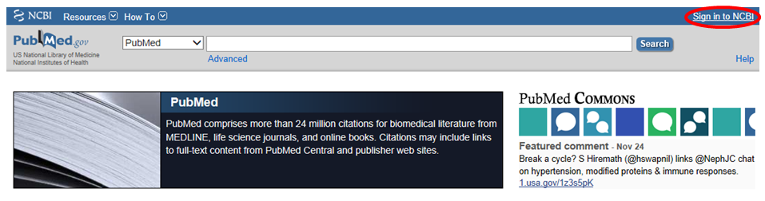
3. Login using following credentials (note that password field is case-sensitive)*:
Username: Available upon request – Please contact corresponding author for access
Password: Available upon request – Please contact corresponding author for access
* You can let your browser save the password but please use our account only for the meta-analysis (i.e. do not conduct searches or save collections on this account that do not pertain to our study).
4. Once page refreshes, click My NCBI link in upper right hand corner of screen.
5. Scroll down (if necessary) to the Collections Box and click on the collection named SC Meta All Records Screening Collection. If you don’t see the collection listed there, use the scroll bar to scroll down until you locate the collection.
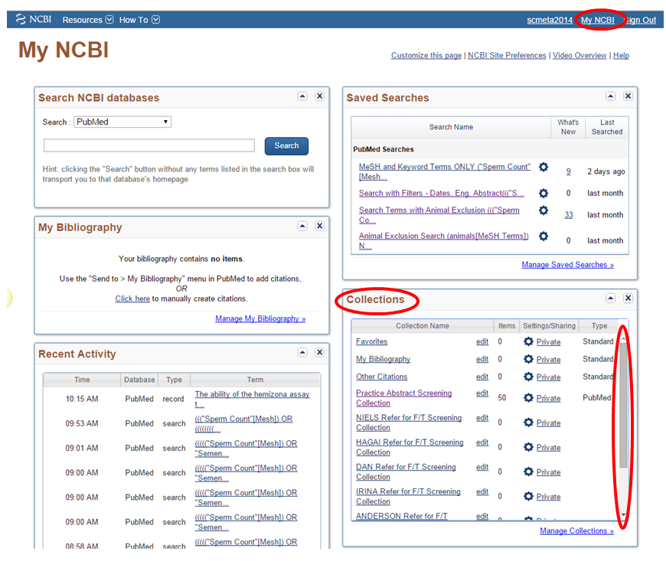
6. Once page loads click the Display Settings box to double check that the following settings have been selected. Rachel has set these settings to be the default display, but since this step is crucially important, please double check these settings are selected before proceeding. (See screenshot below.)
Format: Abstract [Note: NOT Abstract(text)]
Items per page: 200
Sort by: Title
Select Apply

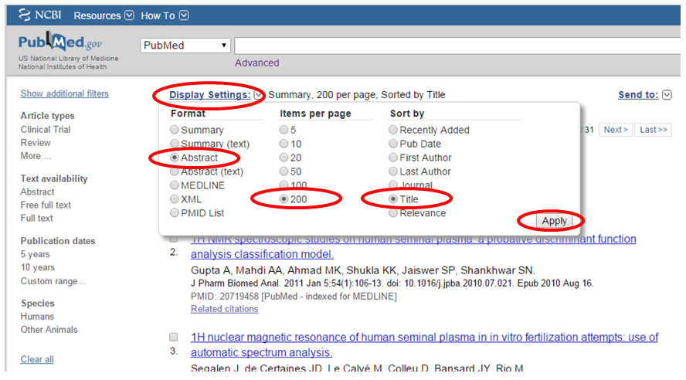
7. Once you have confirmed that the records are displaying in the correct order, locate the results page(s) you are responsible for screening. (See table below.)
Results page numbers | Result number | Name of screener
1-5 | 1-1000 | Anderson
6-10 | 1001-2000 | Dan
11-15 | 2001-3000 | Irina
16-20 | 3001-4000 | Jaime
21-25 | 4001-5000 | John
26-30 | 5001-6000 | Niels
31 | 6001 | Hagai

To jump to a page, insert your curser into the page number box near the top of the page and enter the page number you wish to jump to, then hit enter. (See screenshot below.)
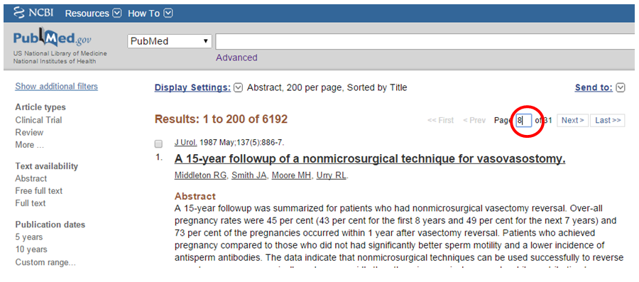
8. Among the publications you are screening, for only those you wish to refer to full text screening, click the check box next to the result (see screenshot below).
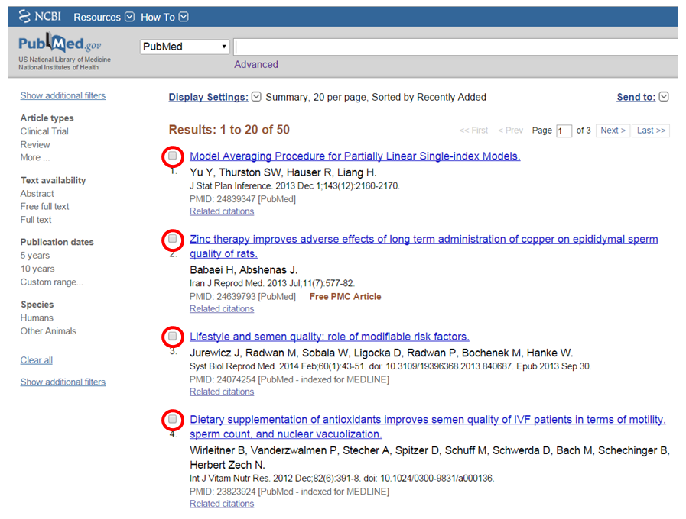
9. Either when you are finished with your working session or at intervals of your choose (e.g. after every 200 records screened), scroll to the top or bottom of the page and click Send To, then select Collections, then click Add to Collections (see screenshot below).
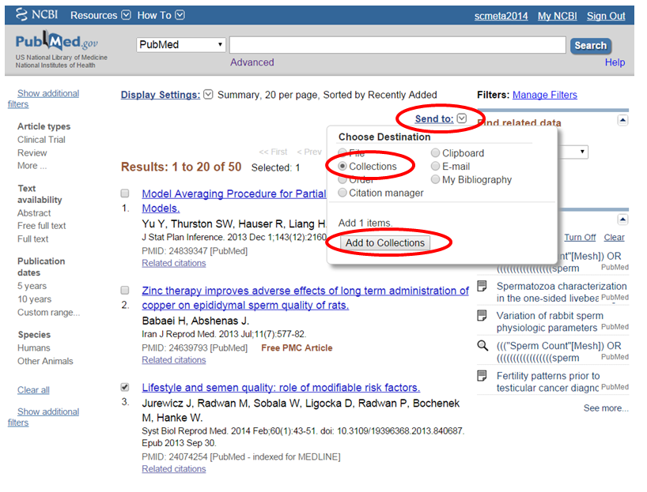
10. On the next page, the Append to an existing collection option should be selected by default. From the dropdown list, select [YOUR FIRST NAME] Refer for F/T Screening (e.g. NIELS Refer for F/T Screening). Then click “save”.
A few important notes about adding items to collections:
A. Best practice: As you go along, have your meta-analysis notebook out and write the number of results you have checked off (meaning the number next to the checkbox). If you stop from any reason, write down the number you arrived. This way in case of emergency (e.g. your internet connection falters or your laptop dies), you will have a record of your work.
B. Your selections carry over from page to page. So if, for example, you select 12 items on the first page of results and then click to advance to the second page of results, your 12 selections will remain selected. Thus you only need to move items to your ‘Refer for F/T Screening’ at the conclusion of each work session. You can do so more frequently if you prefer, but for reasons outlined below, that may not be the most convenient option.
C. Each time you add items to a collection, you will be taken to a page which confirms that [x] number of items has been added to your collection. The number [x] reflects only those items you just added to your collection, not the total number of items in your collection overall.
D. Since when you move items into your ‘Refer for F/T Screening’ collection, you end up on the aforementioned confirmation page, each time you do so, you will then need to navigate back to the collection of results you have been assigned to review for the abstract round. You can do so by following the instructions in Step 5 above. Because this is a bit cumbersome, it is recommended that you only move items to your ‘Refer for F/T Screening’ at the conclusion of each work session.
11. At the conclusion of each work session, enter your progress (date and what result number you screened through), along with any questions and comments you might have, on the Google Docs Spreadsheet.
Mode of operation
You will select articles by checking the box next to the article title and sending them to a defined collection as explained above in steps 7-9 of the technical instructions. All articles without abstracts must be selected for full-text screening. Carefully read the title and the full abstract and exclude articles if they meet any of the exclusion criteria listed below. Pay attention to all possible populations in the publication, for example, there could be a control group that is relevant. Notice that we found in the pilot many cases that the title and abstract hinted implied very low chance that the publication will be eligible. However, when we read the full text, the article was relevant. For example, the study could be about infertile men, but there is a control group which meets our criteria. You should only exclude an article if it clearly meets the exclusion criteria. The study could be an intervention and baseline data, which is relevant for us, were not described in the abstract. Note that exclusion criteria are more cautious than those we will have in the F/T screening, as then we will have all details in the publication.
Questions and Issues
Q: What if I accidentally send citations to the wrong collection?
A: Alert Rachel immediately, providing as much detail about the citations as possible.

Q. Can I enlarge the text?
A: Yes, hit Ctrl and + to zoom in. This should work on all browsers.

Q: What if I’m on the fence—not sure whether or not to refer to full text screening?
A: Always refer to full text if you are unsure. If the issue in question may be relevant to others, record on Google Doc spreadsheet.

Q: Should I refer for full text a study of occupational exposure?
A: We learned from the pilot that such studies may contain a control group that is not even mentioned in the abstract. So refer to full text. Same for other criteria not mentioned in the instructions for abstract screening.

Q: What is non masturbation collection method?
A: Collection methods not by masturbation include, for example: Coitus interruptus, electrically stimulated ejaculation, biopsy.

Exclusion criteria
- Not in humans. [Not humans]
- Not original data (reviews/commentaries/opinions/etc). [No original data]
- Studies with fewer than 10 men. [<10 men]
- Only including men selected by [Selected by X]
  - Infertility or subfertility (i.e.: infertile couples or men referred for fertility check-up because of suspected infertility or sub-fertility). [Infertility]
  - Semen parameters [Semen]¹
  - Genital abnormalities (such as varicocele, cryptorchidism, hypospadias, etc) or any other disease or medication use. [Disease]
  - Undergoing intervention in a trial and no baseline data. [Intervention]
- Studies in which collection method was not by masturbation. [Not masturbation]²
- Studies in which assessment of sperm concentration/count was done by other methods than by haemocytometer. [Count method not haemocytometer]³
- Do not include any data on semen parameters. [No semen]⁴
¹ Study selecting only normospermic men (or oligospermic men) should be excluded.
² Do not exclude in the case of missing information on collection method. Collection methods not by masturbation include, for example: Coitus interruptus, electrically stimulated ejaculation, biopsy.
³ “Not haemocytometer” include Makler chamber, Coulter chamber, Microcell chamber, CASA (Computer Assisted Sperm Analysis) or Flow Cytometry. You should not exclude studies where: (a) sperm concentrations were assessed by haemocytometers (Bürker-Türk, Neubauer, Improved Neubauer, Malasses cell, other haemocytometers); (b) World Health Organization (WHO) was stated as count method; (c) if you are not sure about count method. Pay close attention that in many publications assessment of sperm count was done by haemocytometer while other measure (such as motility) was done by other methods, such as CASA. Those studies should not be excluded.
⁴ Note that the main objective of the article may not be semen analysis, but it can still include data on sperm counts. Only exclude studies if you are sure that there is no data on semen parameters. Some studies on sperm morphology, motility, and sperm DNA damage may not present data on sperm concentration in the abstract, but this information may be available in the full-text.

Screening Round 2: Full Text

Instructions for full text (FT) screening
The aim of the FT screening phase is to identify publications that meet our eligibility criteria and should be referred for the next phase of data extraction.
Any publication excluded should be given at least one clear reason for exclusion based on evidence.
If you don’t have a clear reason – don’t exclude. We will re-assess eligibility during data extraction so there is no serious harm in referring for data extraction besides extra work. We will not go back and miss if we mistakenly exclude publications.
Please read all these instructions carefully in their entirety before commencing screening.
Please note that FT screening requires a different perspective than abstract screening, and, in most cases in-depth review of the publication.
General mode of operation
We will use Endnote software to handle decisions by copying publications into appropriate groups. The mode of operation is to exclude studies that meet the exclusion criteria (Appendix 1, Available upon request – Contact corresponding author for access). Publications that you do not exclude have to be assigned to one of two categories B1 (CONCERN) or B2 (No concern). Choose “No concern” only if you are sure that the study does not meet any exclusion criteria and should go to data extraction, as these studies will not be discussed further. For publications with concern: document your concern and discuss later with your partner and document your discussion.
Partners: Niels-Jaime, Anderson-Irina, Hagai-Dan.

Principles for exclusion
Identify all populations in the publication (i.e. cases and controls) and check exclusion criteria for each population. If you have clearly identified a reason why a publication should be excluded (i.e. not in humans), you don’t have to read the rest of the full text. However, when excluding due to “No sperm count” or “Count method missing” or “Selection missing”, review the entire article to ensure the relevant information is not included. If you are not sure, refer to CONCERN. Pay attention to any relevant information, including tables, figures, supplementary material, references to methods in other papers etc.

Multiple publications from the same study
Among publications you referred to the No Concern group, if/when you suspect that there are other publications from the same study, make a note of this on the Google Docs Spreadsheet (on the Duplicate Publications sheet). The purpose of this note is to help us identify potential duplicate data prior to extraction.

Specific Instructions for FT screening
1. Because EndNote files are too large to share via email, we have created a DropBox account for file sharing. To access the file(s):
- Go to https://www.dropbox.com/
- Click the Sign In link (Note: Not the Sign Up link.)
- Email = [Available upon request – Contact corresponding author for access], Password = [Available upon request – Contact corresponding author for access]
2. Click the Full Text Screening STUDY round folder. Click on the SC Meta Full Text Endnote Library 01222015.enlx file and on the pop-up window, click download [As this is a large file, use good internet connection]. Select where on your computer you wish to save the file, then go to the file location and double-click on the file to unzip and open it. This should cause the EndNote program to open and the EndNote library file you downloaded to open within the program.
IMPORTANT: Immediately go to the File menu, select Save a Copy, choose the location you wish to save the new file and save it with your name at the beginning of the file name (e.g. Anderson SC Meta Full Text Endnote Library 01222015) - see screenshot on next page. If you wish, you can now delete the original file you downloaded from Dropbox.
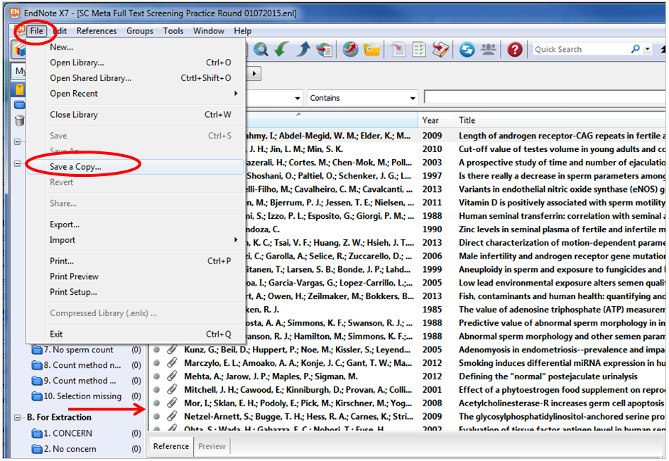
3. Along the left hand side, you should see a My Library panel which contains several groups (visible underneath File menu in screenshot above). If you don’t see this panel, click the grey bar (indicated by arrow in screenshot above) and drag it to the right to display this panel. Ensure publications are sorted by first author last name alphabetically from A to Z. Click on a publication record to display it and read the full text, either in the Attached PDFs window within the main EndNote library or by “popping out” the attached pdf into its own window using the Open PDF icon. See screenshot below. Please note your EndNote library may look different. Using the Layout menu, there are several options for how you can configure your EndNote library.
>>>>> You can work with EndNote in various ways so part of your assignment during the practice round is to figure out what works best for you. For example you can pop-out the PDF pane to maximize it or you can set up your screen so that the PDF pane takes up most of the screen and you don’t need to pop-out a separate window. <<<<<
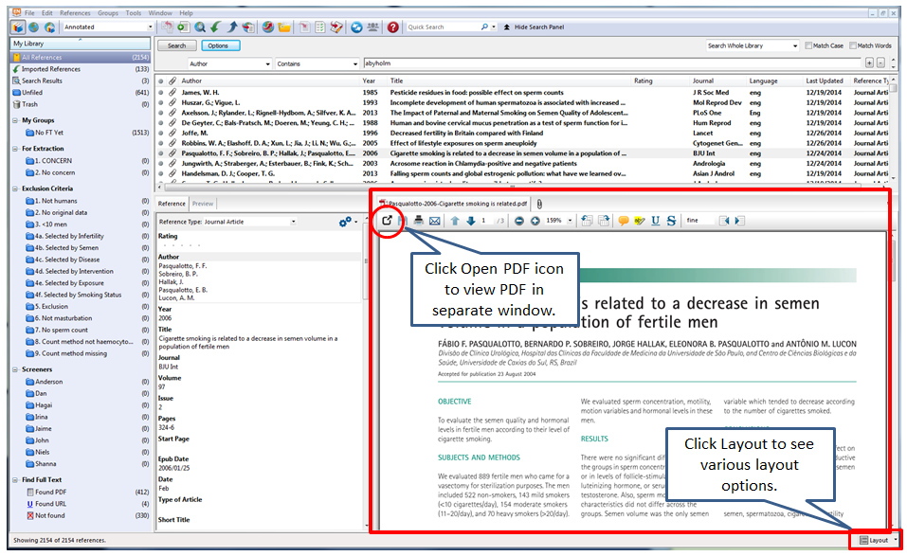
4. Your assigned publications (~325 for each) are in a group with your name. Open this library, verify that it is ordered by first author last name and always screen only publications in this group. After screening, once you decided to which group you want to classify the publication, click on it (using left clicker of mouse) and drag it to the appropriate group (underneath either the Exclusion Criteria or For Extraction category) along the left panel. See screenshot below.
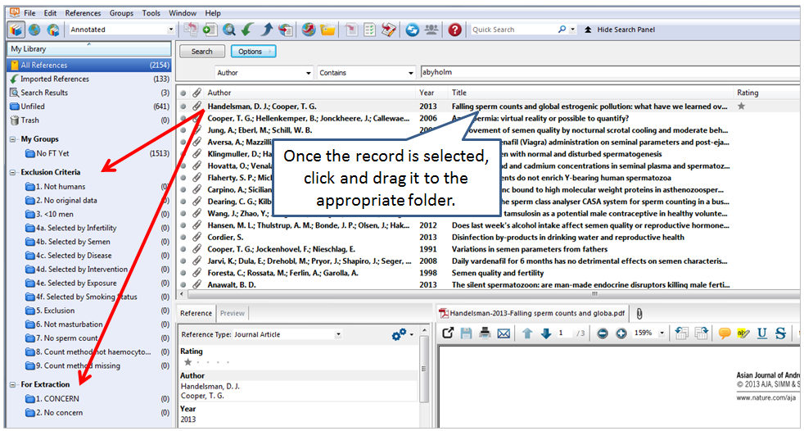
NOTE: When you “move” (drag & drop) a reference to a group, you are not actually moving that record from one group to another (e.g. from All References group to Not Humans group), you are creating a COPY of that reference that will “live” in the group to which you moved it.
5. Once you have assigned a publication to the appropriate group, mark a star to the record in the Rating column to help you keep track of which records you have already read. See screenshot below. Note that in order to assign a star, the item must be selected. Repeat the process for all publications. Please document your progress once a week (by first author last name) and add any questions or comments in the Google Docs spreadsheet.
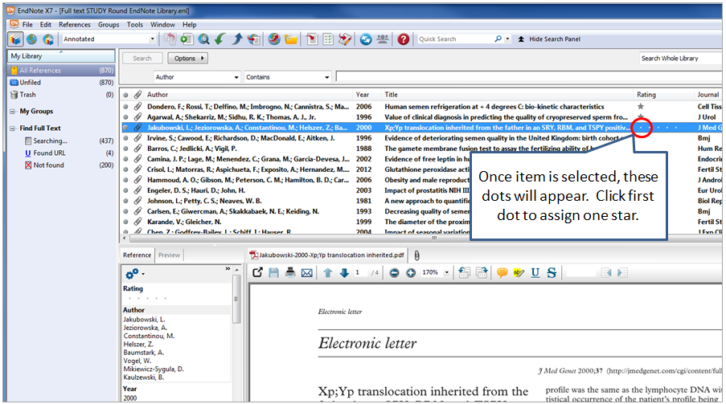
6. For publications with CONCERN (B1): Highlight important sections of the publication. Write (in a bubble) on the publication your concern (as a letter and number, i.e. A4d) and explain. Verify that examined all exclusion criteria. If you found another evidence to exclude – drag it to the appropriate exclusion group and there is no need to discuss. Write down all concern details in the Googledoc according to the format in the sheet named: YOUR NAME CONCERN for discussion. Note to write all concerns you might have for a publication. When you meet your partner, present him/her all your concerns for each publication, discuss and document your decision in the Googledoc. Drag the publication (in your Endnote library only) to the appropriate group and add a second star (don’t delete from CONCERN group). If the pair can’t reach decision, contact Hagai for further discussion.
7. When you finished all your publications, please notify Hagai. You will compress your library (file-> compress library) on your computer and then upload to the folder in the Dropbox with your name. Please document your results in the Google doc: spreadsheet “Full Text Screening Results Summary”.
Timeline:
We will finish FT screening by February 27. It is recommended to screen at least 65 every week and have a discussion meeting with your partner every week. If there are any problems in meeting this goal, please notify Hagai.
FT screening: Questions and Issues
Q: I am having technical problems working with Endnote, what should I do?
A: Schedule time to meet with Rachel (either in person or virtually) so she can assist you in making the system work best for you.
Q: I am not sure I fully understand the exclusion criteria or have a general question or critique on the selection of studies, what should I do?
A: Contact Hagai by email or in person and resolve the issue or post a question
Q: I am not sure about a specific publication – if it should be excluded or not.
A: Carefully read the instructions and the article. Learn more if needed (i.e. on specific count method). If still in doubt, put in 1. For extraction/concern, discuss with you partner, and if not resolved, progress according to instructions that will be posted later.
Q: What should I do if I dragged a publication to the wrong group?
A: Click on to the group that you erroneously added the reference to (not from your group or from All References) and locate the publication in question. Click on the reference in question to select it, then use the keyboard command Ctrl + D, or right click and select Remove References from Group. Go back to your group and drag the publication to the correct group.
Q: What should I do if the PDF is missing, low quality or wrong so I cannot reach a decision?
A: First check Drag to “C. Missing or wrong FT”. Notify Rachel by email and give publication/s details. After you receive correct PDF, review and drag the publication to the correct library (so a copy will stay in the C group).

Finalizing Full Text Screening Round

Finalizing the full text screening results
To finalize the FT screening phase we need you to do three things: summarize the results, upload no concern to Dropbox and give a copy of the final Endnote library to Hagai.
Summarizing your findings
Verify what is the total number of publications you are responsible for FT screening (i.e. Jaime – 331+50=381).
Open the Googledoc spreadsheet to the Full Text Screening Summary Page. Record the number of articles you put into each EndNote group on the corresponding cell on the spreadsheet. Notice that all your CONCERN should be decided and copied to another group by now. The total number does not include the number in concern group.
After your record your results, the number in the Total column should match the total number of publications that you were responsible for screening. We remind you that publications should not be recorded in more than one group of exclusion.
If the numbers don’t match, check yourself and consult Hagai if needed.

Uploading your no concern library (PC Instructions – Not for Mac Users)

- In EndNote, click on your No Concern Group.
- In the main window which contains the list of citations, click Ctrl + A to select all references.
- Right click. On the menu that will appear, hover your mouse over Copy References To, then click New Library. (See screenshot below.)
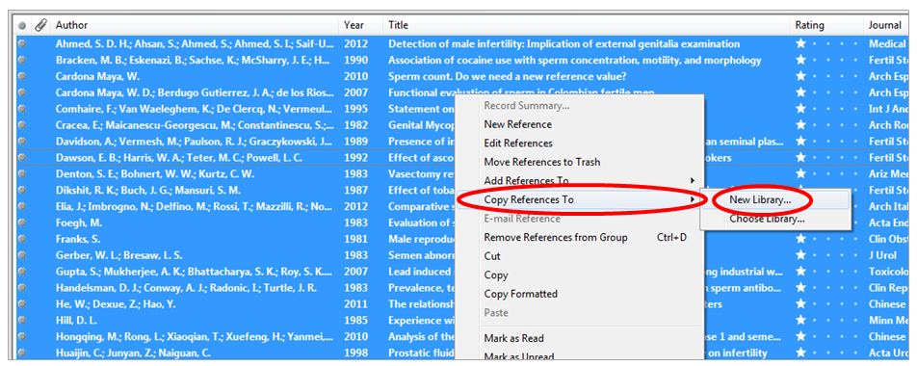
- Select where on your computer you wish to store the library. Create a folder to house the new library. The default file name will be My EndNote Library. In the file name box, change the file name to Your Name_ No Concern. (e.g. Rachel_No Concern) Then click Save.
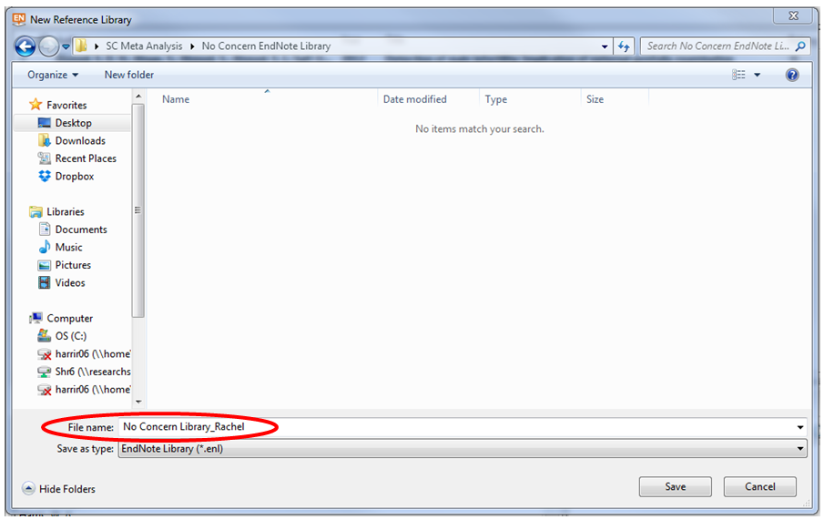
- Upon clicking Save, a new EndNote library will pop open and be automatically populated with your No Concern references. Click the File option, then select Compressed Library (.enlx) … (See screenshot below.
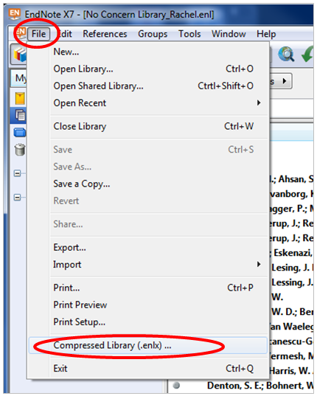
- The default options will be Create, With File Attachments, All References in Library. Leave the default options selected, just click Next.
- Choose the location where you wish to save this file on your computer. It can be the same folder where you saved your No Concern library originally. Click Save. (By default it will be saved under the same name, just with a .enlx rather than an .enl file extension.)
- Open a web browser and go to Dropbox.com. Click Sign In. Login using the following credentials:
Email: [Available upon request – Contact corresponding author for access]
Password: [Available upon request – Contact corresponding author for access]

- Click on the folder with named FT screening NO CONCERN results. At the top of the page, click the Upload file icon (a piece of paper with a little plus sign—see screenshot below).

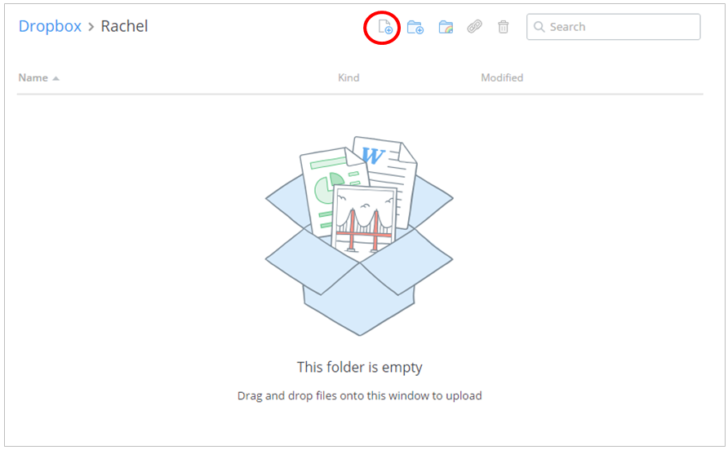
- Click Choose files. On the box that pops up, find the location on your computer where you stored the compressed version of the EndNote Library. The compressed version will have a .enlx file extension (as opposed to .enl file extension for the non-compressed version). Select the file and click Open. Dropbox will show you your file upload progress. It may take a little while for the upload to complete. Once it is complete, you will see a little green check box and you can click Done.

Copy final library to Hagai

In addition to uploading your No Concern library to Dropbox, we also need to have a record of your full final EndNote library.

- In your final EndNote library click the File option, then select Compressed Library (.enlx)
- The default options will be Create, With File Attachments, All References in Library. Unlike when you did this process for your no concern library, you need to change the file attachments select to Without File Attachments. (See screenshot below.)
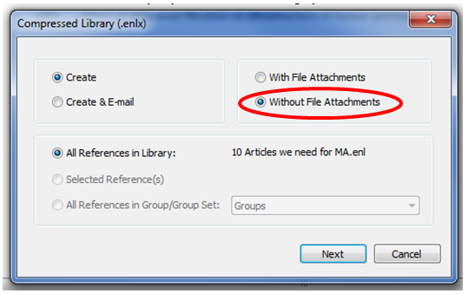
- Select where on your computer you wish to store the library. Create a folder to house the new library. The default file name will be My EndNote Library. In the file name box, change the file name to Your Name_FT Screening Final Library. Then click Save.
- Open a web browser and go to Dropbox.com. Click Sign In. Login using the following credentials:
Email: [Available upon request – Contact corresponding author for access]
Password: [Available upon request – Contact corresponding author for access]
- Click on the FT Screening Final Libraries folder. Click the Upload file icon at the top of the page.
- Click Choose files. On the box that pops up, find the location on your computer where you stored the compressed version of the Your Name_ FT Screening Final Library. The compressed version will have a .enlx file extension (as opposed to .enl file extension for the non-compressed version). Select the file and click Open. Dropbox will show you your file upload progress. It may take a little while for the upload to complete. Once it is complete, you will see a little green check box and you can click Done.
Thank you & congratulations! Now you are ready for the data extraction practice round.

Data Extraction

Instructions for data extraction-Final
The aim of the extraction phase is to extract relevant data from eligible publications, which will be used in the analysis.
Please print and read all these instructions carefully in their entirety before commencing extraction.
Please note that data extraction requires a different perspective than screening, and requires a complete review of the publication.
General mode of operation
Download the master endnote library and master excel format from the Dropbox:
1. Because EndNote files are too large to share via email, we have created a Dropbox account for file sharing. To access the file(s):
- Go to https://www.dropbox.com/
- Click the Sign In link (Note: Not the Sign Up link.)
- Email: [Available upon request – Contact corresponding author for access], Password: [Available upon request – Contact corresponding author for access]
2. Click the Data extraction STUDY round folder. Click on the Data Extraction Master Endnote Library 03232015.enlx file and on the pop-up window, click download [As this is a large file, use good internet connection]. Select where on your computer you wish to save the file, then go to the file location and double-click on the file to unzip and open it. This should cause the EndNote program to open and the EndNote library file you downloaded to open within the program. Find you assigned publications in your group and sort by title. In addition, you received Data Extraction Format 03232015.xlsx by email. Add your name at the beginning of the Excel file (Dan Data Extraction Format 03232015.xlsx).
3. We recommend using printed publication for easy reading. Mark or highlight on the printed publication any important information. We used the validation function in excel, so you are limited to valid data. You have comments on top of each column. For continuous variables (data) always use -1 to document missing. For categorical variables – decide on most suitable category (missing is usually not an option). For example, if the publication not stated that participants were recruited from pre-vasectomy candidates, choose 1 (no) for the Pre-vasectomy study variable, as no is also probably no. If data is given in other units or form, enter -1 and document in comments.
4. Before you begin extraction:
- Conduct the FT screening process: Confirm that the study is eligible - the study doesn't meet any of the exclusion criteria.*
- Check if the study data was reported in another publication in our master library (multiple publications).* Instructions for multiple publications from the same study are drafted in Appendix 2 (Available upon request – Contact corresponding author for access).
*If you have concern, before or during data extraction, don't continue with extraction until you make decision. Record your decision in decision variable (column E): Extraction or excluded because multiple publication or any other exclusion criteria as in screening phase (can use column CI for explanation). If excluded because data are extracted in another publications (multiple publications), record as multiple publication and give in comments the running number of the publication that will be extracted for this data.
5. Specific instructions for data extraction
- Extract data for all variables possible (i.e. even if you have mean sperm concentration [SC], extract median sperm concentration). All variables should be filled for all studies – no blanks. Unless specifically stated – only give the data as appears in the publications, don’t estimated, calculate or infer data. However, you can use common sense, i.e. if all participants were 19 years old, then all age variables are 19.
- Read the entire publication and pay attention to all sections of the publication for relevant data including tables and figures, previous screeners comments, errata, supplementary material and reference to other publications (especially for the methods, you have most studies in the original endnote library for FT screening). Pay attention to any appearance of the data, with special focus on SC measures. Our primary outcome is SC and secondary outcome total sperm count (TSC). If there is no unadjusted mean, median, percentiles or geometric mean (GM) of SC or TSC – verify with Hagai that publications is relevant. If you need additional material of the study – contact Rachel. Write (and verify) running number (which appears on the name of the reference in the Endnote library, we recommend to write it on the printed publication as well), first author last name, year of publication, extractor first name (yours!).
- Clearly define subgroups for data extraction in subgroup classification and name of subgroup. Data on subgroup that are not eligible (i.e. infertile men subgroup) are irrelevant and should not be extracted – total always means total of eligible population. If there is only one sub-group of the study of interest, state that in subgroup classification (1) and extract the data for this group. If there is more than one sub-group of interest with data on SC (i.e. categorization by population selection, geographic location or study site, year of collection or birth year, age, more than one classification or other), extract all data both for total and for each subgroup according to the following instructions (you can copy-paste from other rows if needed). If there are several subgroups of interest (i.e. by age and by study site), extract data for all relevant subgroups. If there are several subgroups, but categorization is not of our interest (i.e. categorization by life-style or environmental exposure, etc.), extract only the total. If total is not given – extract for each of the subgroups (and Hagai will calculate the mean later based on the data). If there are several subgroups and you don't know which to take or mismatch in the N - consult Hagai.
You will need a row for each subgroup, so add the proper number of rows below (copy the same running number, first author last name and year of publication). Leave the first row of the study for the total. Document subgroup classification and name of subgroup for each. Extract data for each sub-group in separate, noticing that there could be a difference in any of the fields.
- Extract the data. You have a detailed description of the variables columns in excel, names, definition (including units), range/categories and comments in Appendix 3 (Available upon request – Contact corresponding author for access) as well as comments on top row of excel file. For numerical data, write the numbers as appear in the publication (no need for rounding). For categorical variables, write the number of the category. We recommend extracting the data by order of variables in order to be systematic and avoid mistakes.
- Don't change columns order or definitions. Pay attention to units of each variable. Don't estimate data. Don't calculate unless instructed specifically in Appendix 3 (i.e. conversion of abstinence time to hours). If estimation is needed – record it in the comments (last column) as well as any other comments. If you did not find data for a variable (missing), verify it and write -1. If you are not sure about the correct data to extract, read again the publication and instructions. If you are still not sure, record your thoughts in comments. At any point you can document your general questions/comments in the Googledoc. Please update your progress at least once in every two weeks.

Data estimation

After data extraction, an additional round of data editing, quality control and estimation was conducted by HL. For key variables, we estimated missing values whenever possible. For studies that only reported median SC, we estimated mean SC by adding the average difference between the mean and median in studies for which both were reported to median SC. For studies that did not report year of sample collection, this was estimated by subtracting the average difference between year of publication and midpoint year of sample collection in studies for which both were reported from publication year. Standard errors (SE) of SC or TSC were calculated by dividing the standard deviation by the square root of sample size for each estimate. For studies that did not report standard deviation or SE of SC or TSC, we estimated SE by dividing the mean standard deviation of studies that reported standard deviation by the square root of sample size for this estimate. If mean TSC was not reported it was calculated by multiplying mean SC by mean SV. If SV was not reported we substituted the mean SV (3.25 ml; median=3.3 ml).

