Supplements
Levine H, et al. Temporal trends in sperm count: A systematic review and meta-regression analysis of samples collected globally in the 20th and 21st centuries

Supplementary Table SI. Meta-analysis of observational studies in epidemiology (MOOSE) Guidelines: Checklist for authors.

Brief description of how the criteria were handled in the meta-analysis | Criterion
Reporting of background should include
Has sperm count declined over the past 50 years? | Problem definition
Sperm concentration (SC) and total sperm count (TSC) has declined over the past 50 years. | Hypothesis statement
The rate of change (slope) in SC and TSC by sample collection year. | Description of study outcome(s)
Time trend. | Type of exposure or intervention used
Studies with primary SC data in humans. | Type of study designs used
Men with measured SC in four fertility/geographic categories: i) Unselected NEA; ii) Fertile NEA; iii) Unselected SAA; and iv) Fertile SAA. | Study population
Reporting of search strategy should include
Epidemiologists, andrologists, and qualified medical librarian. | Qualifications of researchers (e.g. librarians and investigators)
Bibliographic databases searched 1981-2019 for "sperm count" and 13 related keywords/phrases in the title/abstract fields as well as appropriate subject headings | Search strategy, including time period included in the synthesis and keywords
Wide search to include all available studies. Estimated measures when not given with same measure of central tendency (e.g. median instead of mean). Authors were not contacted. | Efforts to include all available studies, including contact with authors
MEDLINE and Embase | Databases and registries searched
No use of other search software * For sorting the studies in the screening and data extraction phases, we used Covidence software. | Search software used, name and version, including special features used (e.g, explosion)
No use of hand searching. | Use of hand searching (e.g. references list of obtained articles)
Search process and exclusion categories is described in methods. List of eligible articles is supplied in references. List of excluded articles with reasons for exclusion available upon request. | List of citations located and those excluded, including justification
Non-English articles were excluded during the search process. | Method of addressing articles published in languages other than English
No use of unpublished abstract-only studies. | Method of handling abstracts of unpublished studies
Authors were not contacted. | Description of any contract with authors
Reporting of methods should include
The inclusion and exclusion criteria are in detailed in methods. | Description of relevance or appropriateness of studies assembled for assessing the hypothesis to be tested
SC and TSC are important measures of male fecundity and the most consistently measured over time. We collected data on covariates previously reported to be associated with SC. Information on data completeness was also recorded. | Rationale for the selection and coding of data (e.g., sound clinical principles or convenience)
Data were extracted by investigators. As a quality control measure, all investigators reviewed and extracted data from the same three publications. Results were compared and protocols clarified as needed. Ranges for permissible values, both for categorical and numerical variables were included. After data extraction, an additional round of data editing, quality control was conducted by HL and MJ. The data extraction protocol is provided in methods and in previous publication. | Documentation of how data were classified and coded (e.g., multiple raters, blinding, and interrater reliability)
We controlled for a pre-determined set of potential confounders: fertility group, geographic group, age, abstinence time, whether semen collection and counting methods were reported, number of samples per man and indicators for study selection of population exclusion criteria (some vasectomy candidates, some semen donor candidates, exclusion of men with chronic diseases, exclusion by other reasons not related to fertility, selection by occupation not related to fertility). We also controlled for dummy variable which indicated whether or not estimation (for mean SC or mean TSC, SE or year of collection) had been used. | Assessment of confounding (e.g. comparability of cases and controls in studies where appropriate)
Study quality was not quantified. Studies that used non-standard methods to collect or count sperm were excluded. | Assessment of study quality, including blinding of quality assessors; stratification or regression on possible predictors of study results
Not relevant. | Assessment of heterogeneity
Simple linear and weighted meta-regression were used. A detailed Description of statistical methods and sensitivity analyses is detailed in the "Statistical Analysis" section. | Description of statistical methods (e.g, complete description of fixed or random effects models, justification of whether the chosen models account for predictors of study results, dose-response models, or cumulative meta-analysis) in sufficient detail to be replicated
Three tables and four figures are provided in the main text and three figure and five tables in the supplement. | Provision of appropriate tables and graphics
Reporting of results should include
Figure 1 present flow chart that showing the selection of studies eligible for meta-regression analysis.2a and 2b provide slope for meta-regression analyses for SC and TSC among Unselected men for whole period of study and restricted to studies post 2000. Figure 3a and 3b provide slopes of meta-regression analyses for Unselected men by different continents. Figure 4 present precent of change by year according to periods of years for SC and TSC. | Graphic summarizing individual study estimates and overall estimate
See references for citations (description of 223 studies is not feasible). | Table giving descriptive information for each study included
We added cubic and quadratic terms for year of sample collection in meta-regression analyses to assess non-linearity. Results were robust in extensive sensitivity analyses detailed in the manuscript. | Results of sensitivity testing (e.g, subgroup analysis)
95% confidence intervals and p-values are included for all slopes. | Indication of statistical uncertainty of findings
Reporting of discussion should include
Not relevant. | Quantitative assessment of bias (e.g. publication bias)
Justification for exclusions is given in methods. We excluded non-English language studies because it was not practical for us to systematically review the non-English literature. | Justification for exclusion (e.g. exclusion of non-English-language citations)
No numerical assessment of study quality except for weighting by SE. We also indicated whether year of collection or arithmetic mean or SE of SC were estimated and adjusted for it in the meta-regression. | Assessment of quality of included studies
Reporting of conclusions should include
See Discussion. | Considerations of alternative explanations of observed results
Generalization is limited by a limited number of studies from SAA countries, and exclusion of non-English studies. | Generalization of conclusions (i.e., appropriate for data presented and within the domain of the literature review)
See Discussion. | Guidelines for future research
All funding sources are acknowledged. | Disclosure of funding source

Supplementary Table SII. Distribution of covariates and their associations with sperm concentration (SC) in the meta-regression model.ª

Beta for covariate (95% CI) |  | N (%) |  | Covariate value | Covariate
Total | Unselected | Total | Unselected
 | NA | 288 (100) | 153 (100) | All | Total
Ref.  -17.0 (-36.4 to 2.4) | Ref.  7.63 (-3.17 to 18.4) | 199 (69.1)  89 (31.9) | 118 (77.1)  35 (22.9) | NEA  SAA | Continent^{b}
Ref  -2.0 (-10.4 to 6.3)  -1.8 (-10.5 to 6.9) | Ref.  -2.2 (-14.2 to 9.8)  -0.1 (-12.7 to 12.6) | 85 (29.5)  93 (33.3)  110 (38.1) | 64 (41.8)  50 (32.7)  39 (25.5) | All men ≤ 40 years of age  Some men >40 years of age  No information | Age
Ref.  0.2 (-8.4 to 8.7) | Ref.  -7.7 (-20.3 to 4.9) | 236 (81.9)  52 (18.1) | 131 (85.6)  22 (14.4) | Masturbation stated  Masturbation implied | Method of semen collection
Ref.  6.0 (-1.3 to 13.3) | Ref.  20.5 (9.5 to 31.5) | 146 (50.7)  142 (49.3) | 92 (60.1)  61 (39.9) | Haemocytometer stated  Haemocytometer implied | Method of counting sperm
Ref.  5.5 (-7.2 to 18.1) | Ref.  19.6 (-4.6 to 43.7) | 266 (92.3)  22 (7.6) | 148 (96.7)  5 (3.3) | None  Some | Participants: pre-vasectomy
Ref.  -4.5 (-17.6 to 8.5) | Ref.  -5.8 (-21.7 to 10.1) | 246 (85.4)  42 (14.6) | 124 (81.1)  29 (18.9) | None  Some | Participants: semen donors
Ref.  -5.5 (-14.3 to 3.3) | Ref.  -13.0 (-25.7 to --0.39) | 239 (83.0)  49 (17.0) | 122 (79.7)  31 (20.3) | No  Yes | Participants: excluding men with chronic diseases or drug treatment
Ref.  6.6 (-1.6 to 14.8) | Ref.  7.3 (--3.6 to 18.2) | 209 (72.6)  79 (27.4) | 99 (64.7)  54 (35.3) | No  Yes | Participants: other exclusion criteria not related to fertility
Ref.  0.8 (-10.2 to 11.8) | Ref.  0.2 (-12.4 to 12.8) | 262 (91.0)  26 (9.0) | 129 (84.3)  24 (15.7) | No  Yes | Participants selected by occupation (unrelated to fertility)
Ref.  -12.5 (-21.9 to -3.1) | Ref.  -9.3 (-21.4 to -2.7) | 245 (85.1)  43 (14.9) | 125 (81.7)  28 (18.3) | One per man  More than one per man | Number of samples
Ref.  -4.7 (-17.0 to 7.5)  -0.6 (-9.1 to 7.8)  -2.0 (-11.0 to 7.0) | Ref.  -19.2 (-44.1 to 5.8)  3.6 (-8.23 to 15.4)  3.1 (-9.7 to 15.8) | 156 (54.2)  18 (6.2)  63 (21.9)  51 (17.7) | 91 (59.5)  4 (2.6)  37 (24.2)  21 (13.7) | Restricted by protocol  None < 3 days  Some < 3 days  No information | Abstinence time
Ref.  0.9 (-11.9 to 13.8) | Ref.  -0.7 (-23.8 to 22.4) | 206 (71.5)  82 (28.5) | 95 (62.1)  58 (37.9) | No  Yes | SC estimated
Ref.  4.5 (-7.1 to 16.1) | Ref.  2.7 (-19.2 to 24.6) | 186 (64.6)  102 (35.4) | 90 (58.8)  63 (41.2) | No  Yes | SE estimated
Ref.  -0.8 (-7.8 to 6.1) | Ref.  -5.8 (-15.7 to 4.1) | 161 (55.9)  127 (44.1) | 99 (64.7)  54 (35.3) | No  Yes | Year estimated

ªAdjusted for all covariates, fertility status, region and interaction term with fertility status and region as well as indicators for studies with more than one estimate, weighted by standard error.
^{b}NEA includes studies from North America-Europe-Australia. SAA includes studies from South/Central America-Asia-Africa.

Supplementary Table SIII. List of countries from which articles classified according to continents.

Fertility category | Continent categoryª | Study country (N of estimates)
Unselected men | North America-Europe-Australia (NEA) | Australia (11), Belgium (3), Czech Republic (2), Denmark (18), Estonia (4), Finland (6), France (2), Germany (8), Greece (1), Italy (3), Latvia (1), Lithuania (1), New Zealand (16), Norway (3), Russia (1), Spain (6), Sweden (5), United Kingdom (1), United States (26)
 | South/Central America-Asia-Africa (SAA) | Brazil (1), Chile (1), China (3), Egypt (2), India (7), Indonesia (1), Iran (1), Japan (5), Libya (1), Malaysia (1), Mexico (3), Nigeria (3), Pakistan (1), Peru (1), South Africa (2), Taiwan (2)
Fertile men | North America-Europe-Australia (NEA) | Australia (2), Belgium (1), Canada (1), Denmark (3), Finland (1), France (14), Germany (7), Greece (4), Greenland (1), Ireland (2), Italy (9), Netherlands (1), Norway (2), Poland (2), Slovenia (1), Spain (7), Sweden (4), Ukraine (1), United Kingdom (3), United States (15)
 | South/Central America-Asia-Africa (SAA) | Bangladesh (1), Brazil (3), China (6), Cuba (1), Egypt (1), India (16), Indonesia (1), Iran (4), Iraq (2), Israel (1), Japan (2), Jordan (1), Kenya (1), Libya (1), Nigeria (2), Pakistan (4), Singapore (1), United Republic of Tanzania (1), Thailand (1), Tunisia (1), Turkey (3)
ª The division of the continents was made according to public-open data. Available in: https://public.opendatasoft.com/explore/embed/dataset/world-administrative-boundaries/map/?location=2,42.03297,0&basemap=jawg.light
Supplementary Table SIV. Simple linear regression for sperm concentration (SC) and total sperm count (TSC) for Total, Unselected and Fertile men groups.
Category | N (estimates) | First Year | First year SC  (million/ml) | Last Year | Last year SC  (million/ml) | %change/  year | Slope (95% CI),  million/ml/year
Total men | 288 | 1973 | 93.4 | 2018 | 54.6 | -0.93 | -0.87 (-0.89 to -0.86)
Unselected | 153 | 1973 | 102.8 | 2018 | 47.9 | -1.20 | -1.23 (-1.25 to -1.20)
Fertile | 135 | 1977 | 81.6 | 2017 | 69.4 | -0.37 | -0.30 (-0.33 to -0.27)
Category | N (estimates) | First Year | First year TSC  (million) | Last Year | Last year TSC  (million) | %change/  year | Slope (95% CI),  million/year
Total men | 288 | 1973 | 299.1 | 2018 | 174.6 | -0.94 | -2.80 (-2.86 to -2.74)
Unselected | 153 | 1973 | 320.0 | 2018 | 152.3 | -1.18 | -3.77 (-3.83 to -3.71)
Fertile | 135 | 1977 | 265.8 | 2017 | 230.9 | -0.32 | -0.86 (-0.98 to -0.74)

Supplementary Table SV. Sensitivity analyses of meta-regression models of sperm concentration (SC) over time.
Slope when covariate is removed from the model^{d}  Total | Slope when covariate is removed from the model^{c} Unselected | Slope  Excluding group^{b}  Total | Slope  Excluding groupª  Unselected | Group excluded | Covariate
-1.27 | -1.17 | -1.27 | -1.17 | - | Total
-1.25 | -1.16 | -1.02 | -0.94 | No information | Age
-1.27 | -1.90 | -1.46 | -1.39 | Masturbation implied | Method of semen collection
-1.27 | -1.15 | -1.33 | -1.27 | Haemocytometer implied | Method of counting sperm
-1.29 | -1.21 | -1.25 | -1.17 | Some | Participants: pre-vasectomy
-1.26 | -1.15 | -1.29 | -1.26 | Some | Participants: semen donors
-1.26 | -1.16 | -1.57 | -1.69 | Yes | Participants: excluding men with chronic diseases or drug treatment
-1.22 | -1.13 | -1.30 | -1.32 | Yes | Participants: other exclusion criteria not related to fertility
-1.28 | -1.17 | -1.43 | -1.22 | Yes | Participants selected by occupation (unrelated to fertility)
-1.23 | -1.13 | -1.28 | -1.28 | More than one per man | Number of samples
-1.29 | -1.24 | -1.13 | -1.05 | No information | Abstinence time
-1.27 | -1.17 | -1.34 | -1.38 | Yes | SC estimated
-1.29 | -1.17 | -1.37 | -1.40 | Yes | SE estimated
-1.28 | -1.17 | -1.31 | -1.13 | Yes | Year estimated

ªSlope (change of SC by million/ml per year) in regression, without interaction terms for Unselected men. Both Unselected and Total men models adjusted for covariates as well as indicators for studies with more than one estimate, weighted by standard error, after excluding specific group for each covariate, such as the group with incomplete information.
^{b}Slope (change of SC per year) in regression, without interaction terms for Unselected men. Both Unselected and Total men models adjusted for all covariates as well as indicators for studies with more than one estimate, weighted by standard error, removing covariates one at a time from the model.

Supplementary Table SVI. Additional sensitivity analyses (each continent removed) of meta-regression models of sperm concentration (SC) of Unselected men (n=153) over time.

Continents/countries removed | Number of estimates removed | Slope (95% CI),  million/ml/year | P value
Europe | 65 | -1.56 (-2.35 to -0.76) | <0.001
North America | 26 | -1.00 (-1.57 to -0.42) | 0.001
South/Central America | 6 | -1.39 (-1.85 to -0.92) | <0.001
Australia | 27 | -1.04 (-1.56 to -0.53) | <0.001
Asia | 21 | -1.11 (-1.70 to -0.63) | <0.001
Africa | 8 | -1.19 (-1.71 to -0.66) | <0.001

Supplementary Figure S1. World map divided into continents with number of studies from each country that were included in the meta-analysis.
NEA: North America-Europe-Australia; SAA: South/Central America-Asia-Africa.
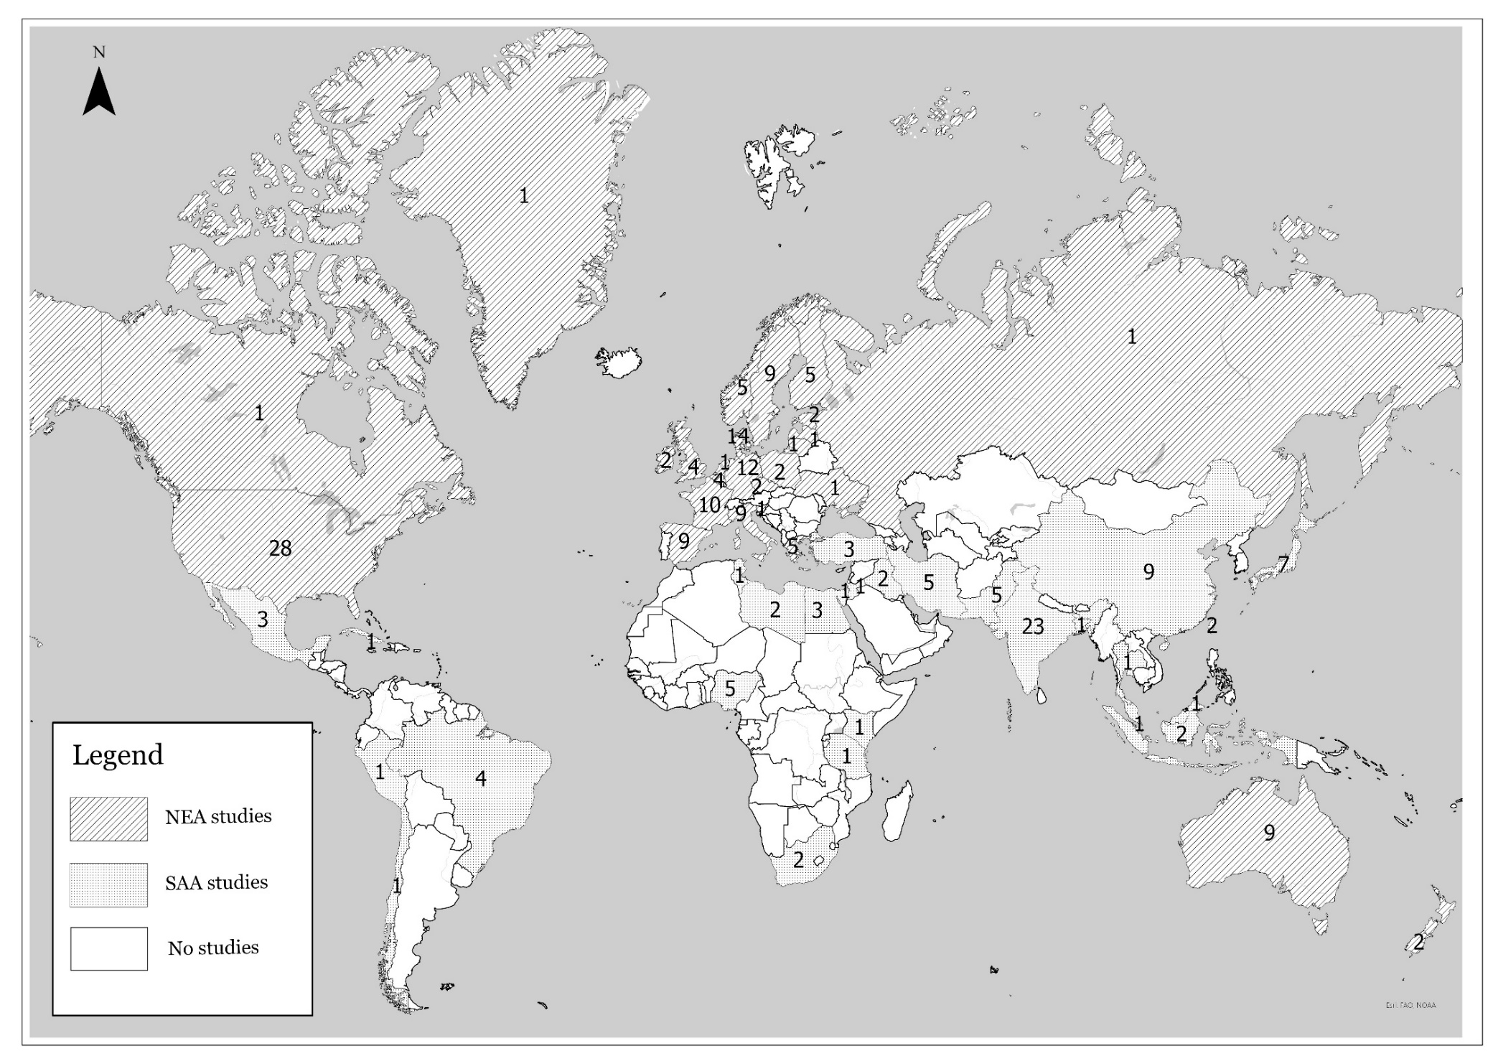
Supplementary Figure S2. Mean sperm concentration and total sperm count by collection year in 288 estimates collected in 1973–2018 and simple linear regression, weighted by sample size. (a) Sperm concentration (b) Total sperm count.
NEA: North America-Europe-Australia; SAA: South/Central America-Asia-Africa.

Supplementary Figure S3. Meta-regression models for mean sperm concentration (SC) and total sperm count (TSC) by fertility and geographic groups, adjusted for potential confounders. (a) Sperm concentration. (b) Total sperm count.
NEA: North America-Europe-Australia; SAA: South/Central America-Asia-Africa. SC Meta-regression model weighted by SC SE, adjusted for fertility group, time × fertility group interaction, geographic group, time × geographic group interaction, age, abstinence time, semen collection method reported, counting method reported, having more than one sample per men, indicators for study selection of population and exclusion criteria (some vasectomy candidates, some semen donor candidates, exclusion of men with chronic diseases, exclusion by other reasons not related to fertility, selection by occupation not related to fertility), whether collection year was estimated, whether arithmetic mean of SC was estimated, whether SE of SC was estimated and indicator variable to denote studies with more than one estimate. TSC meta-regression models weighted by TSC SE, adjusted for similar covariates and method used to assess semen volume.
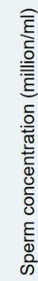

NEA: North America-Europe-Australia &Oceania; SAA: South/Central America-Asia-Africa

