The artificial sweetener Splenda® promotes gut Proteobacteria, dysbiosis and myeloperoxidase reactivity in Crohn's disease-like ileitis

Alexander Rodriguez-Palacios, DVM, PhD,¹ Andrew Harding, MD,¹ Paola Menghini, PhD,¹ Catherine Himmelman,¹ Mauricio Retuerto, BSc,² Kourtney P. Nickerson, PhD,³ Minh Lam, PhD,¹ Colleen M. Croniger, PhD,⁴ Mairi H McLean, MBChB PhD,^{6,7} Scott K. Durum, PhD,⁶ Theresa T. Pizarro, PhD,⁵ Mahmoud A. Ghannoum, PhD,² Sanja Ilic, PhD,⁸ Christine McDonald, PhD,³ and Fabio Cominelli, MD, PhD^{1,9}

Supplementary Material:
- Supplementary Figure 1.
- Supplementary Table 1.
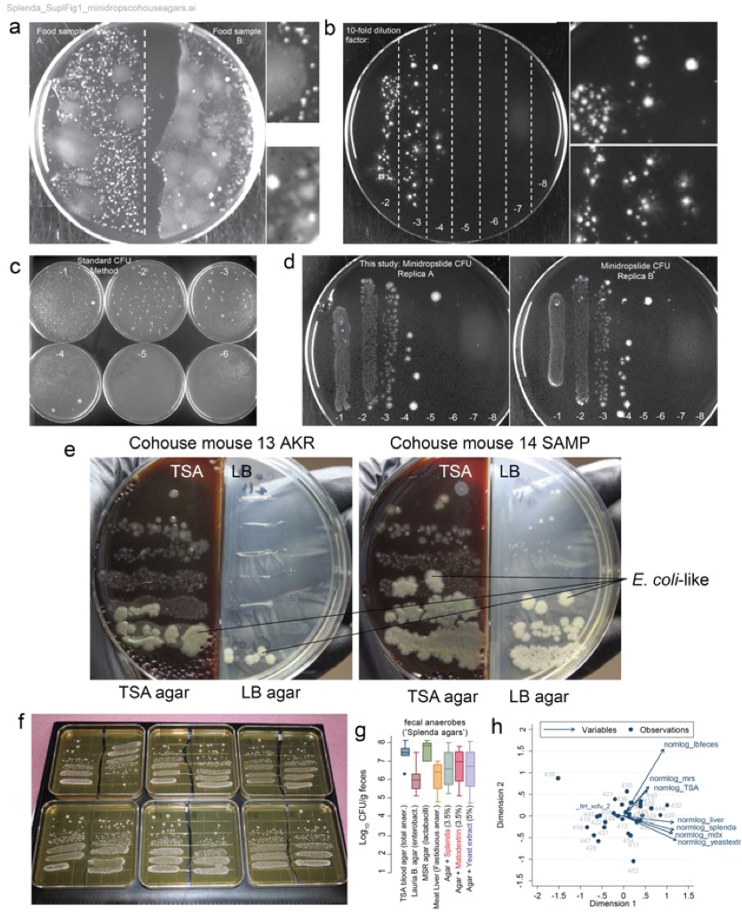

Supplementary Figure 1: Development of a ‘Parallel Lanes Platting’ method for relative enumeration of bacteria in complex communities.
a) Two food samples (retail ground meat) on TSA illustrate diverse bacterial colonies at different concentrations in a relatively simple community (100 μL/half plate). b) ‘Parallel minidrop lanes platting’ of Clostridium difficile monocultures (10-20 μL/lane) illustrates that several solutions can be incubated on a single agar plate and quantified based on colony morphology. TSA and UV transilluminator. Multichannel pipettes allow the transfer of 8 dilutions on a single media plate. c) Standard plating methods use 100 μL/plate, making it agar intensive and difficult to track as the number of plates increase. d) The parallel minidrop lanes platting method is highly reproducible. e) Herein, we illustrate the use of the method on fecal samples from two cohoused mice in TSA and LB agars. Notice that SAMP has more E. coli bacteria relative to the total number of bacteria. f) The same approach in square plates was used for Splenda® experiments to increase ability to select single colonies for PCR. MRS agar (lactobacilli). g) ‘Parallel Lanes Platting’ of fecal samples using in house agars (‘maltodextrin and Splenda® agars’). h) Multivariable analysis revealed that several agars yielded similar bacterial counts to assess the effect of Splenda® on SAMP mice. Meat liver base agar enables the quantification of strict and fastidious anaerobes, while allows (e.g., some Clostridium spp.) sulfite reducers to produce hydrogen sulfide (H₂S), which allows the blackening of colonies due to presence of ferric ammonium citrate.
Supplementary Table 1. Summary of MPO activity in tissues of mice after supplementation with Splenda®

SAMP1/YitFc | Treatment | N | Minimum | Q1 | Median | Q3 | Maximum | 95% Median CI
Colon | H2O | 7 | 5.133 | 6.372 | 8.437 | 10.560 | 16.991 | (6.041, 12.275)
 | Splenda® 3.5% | 7 | 3.127 | 3.481 | 7.316 | 10.855 | 23.245 | (3.386, 14.159)
Ileum | H2O | 7 | 79.35 | 92.30 | 103.72 | 150.27 | 153.22 | (88.85, 151.05)
 | Splenda® 3.5% | 7 | 70.68 | 124.54 | 172.39 | 223.83 | 294.28 | (110.18, 242.62)

AKR/J mice
Colon | H2O | 5 | 2.5369 | 2.5959 | 3.1268 | 3.6283 | 3.7758 | (2.5369, 3.7758)
 | Splenda® 3.5% | 6 | 0.5310 | 2.6106 | 4.1003 | 6.6077 | 6.6077 | (1.5213, 6.6077)
Ileum | H2O | 5 | 3.07 | 3.07 | 3.07 | 46.17 | 48.97 | (3.07, 48.97)
 | Splenda® 3.5% | 6 | 5.192 | 7.670 | 12.611 | 48.230 | 53.540 | (6.372, 51.011)

