Supplementary material: ICES Journal of Marine Science

Effects of a large-scale and offshore marine protected area on demersal fish assemblage in the Southwest Atlantic

Daniela Alemany, Oscar O. Iribarne and Eduardo M. Acha

Table S1. Number of bottom trawling stations for each area and year during scientific research cruises in the Patagonian shelf. EH: RV “Dr. E. Holmberg”. Abbreviations as in Figure 1.

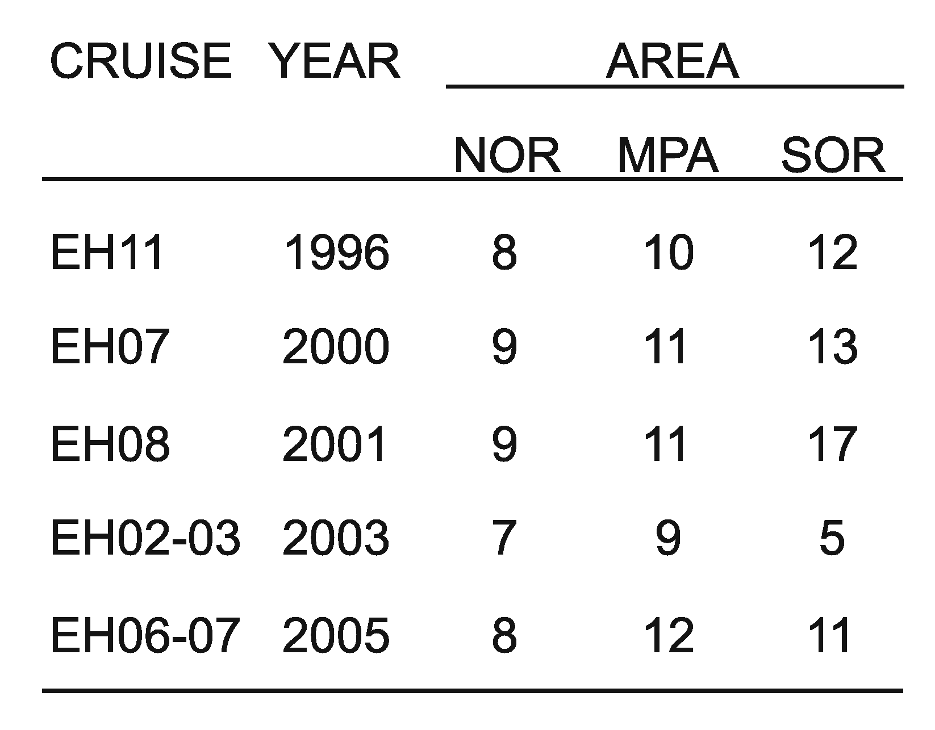

Table S2. Number of Argentine hakes measured for each category (area, year, adults or juvenile). Abbreviations as in Figure 1.

Table S3. Occurrence of fish taxa at each zone of the Patagonian Shelf. Abbreviations as in Figure 1.

