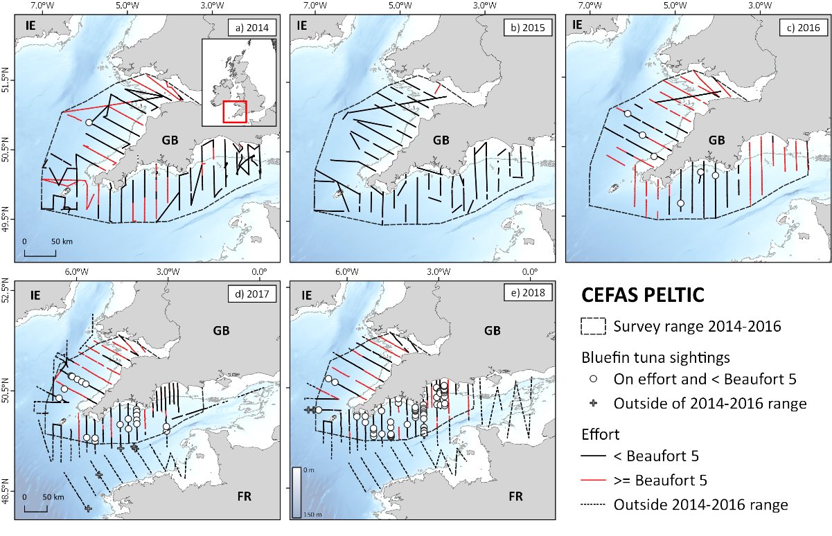

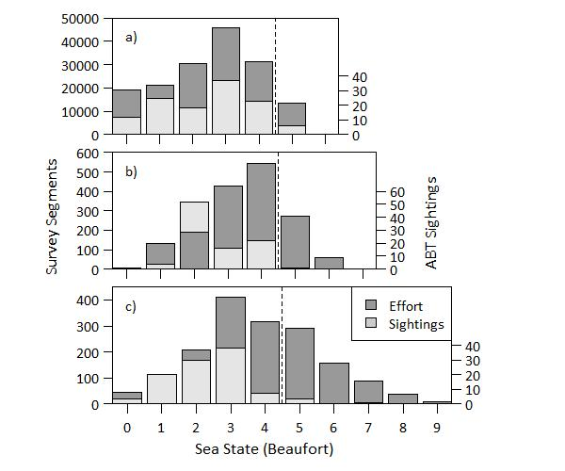

Supplemental Figure 1. Surface sightings of Atlantic bluefin tuna and sea state. Records of surface-feeding shoals of bluefin tuna from 2014 to 2018 across all scale sea conditions recorded (Beaufort) collated from a) opportunistic sampling on a vessel of opportunity, b) the CEFAS PELTIC survey in the western English Channel, and c) the Marine Institute CSHAS off the southern Irish coast. Vertical dotted lines denote the cut off for effort and sightings data included in sightings per unit effort (SPUE) analyses.

Confidence Rating |  | Characteristics | Comment
1 | Definite | Visual/photographic confirmation of ABT by confirmation of one or more of the following morphological characteristics: 1) large size, 2) yellow tail finlets, darker colour of second dorsal fin, 3) dark dorsal colouration; 4) golden streak on flank, and/or, 5) vertical orientation of caudal fin. | ABT Confirmed
2 | Probable | Definite large tuna features observed, specifically vertical tail or head, either as an individual or as part of larger feeding activity. No additional features that can confirm species, i.e. none of the specific morphological characteristics (described under “1”) could be observed. | No clear ABT specific features were observed (above) although records of alternative species of similar size such as yellowfin and bigeye are extremely rare in the area. Albacore are smaller and not found in inshore waters.
3 | Possible | Individual splash | In the English Channel there are few alternative species that may cause this; most cetaceans, particularly common dolphin, the most abundant large animal in the area, resurface regularly and with far less intensity. White-sided dolphin is not found here. Similar splashes have been observed followed by clear views of ABT.

Supplemental Table 1. Criterial for assignation of confidence ratings to ABT sightings. General characteristics of ABT sightings common across all survey platforms. For ecotour operator C, sightings are confirmed by closer visual inspection.

Supplemental Figure 2. Albacore catch in the Irish mid-water pair-trawl fishery. Map showing spatial variability in Albacore catches in the Irish mid-water trawl fishery for albacore in the northeast Atlantic averaged across all years (2003 to 2017). Bold black lines delineate areas used to calculate regional time series for ABT SPUE (labelled in bold).
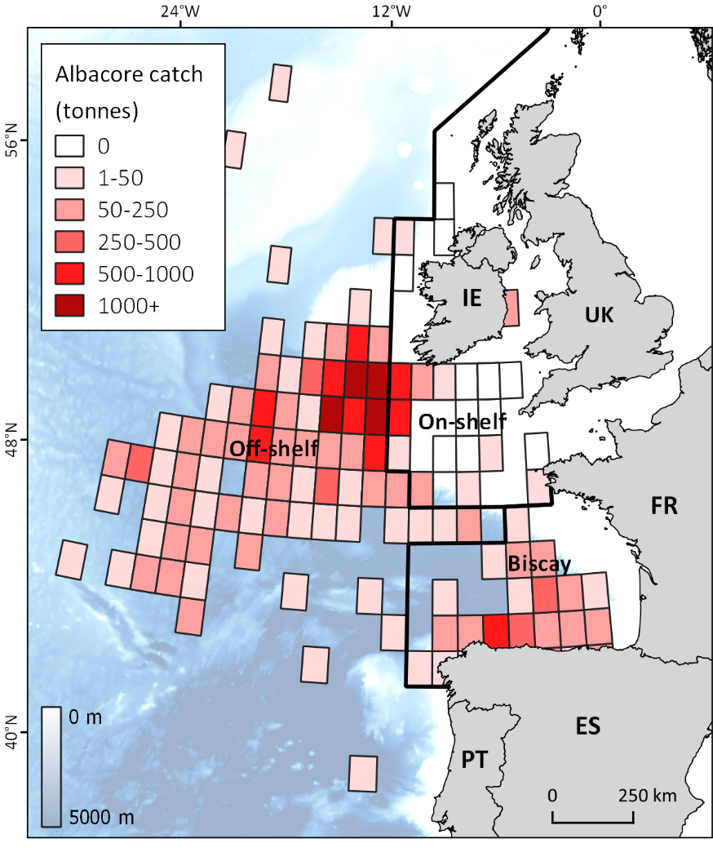

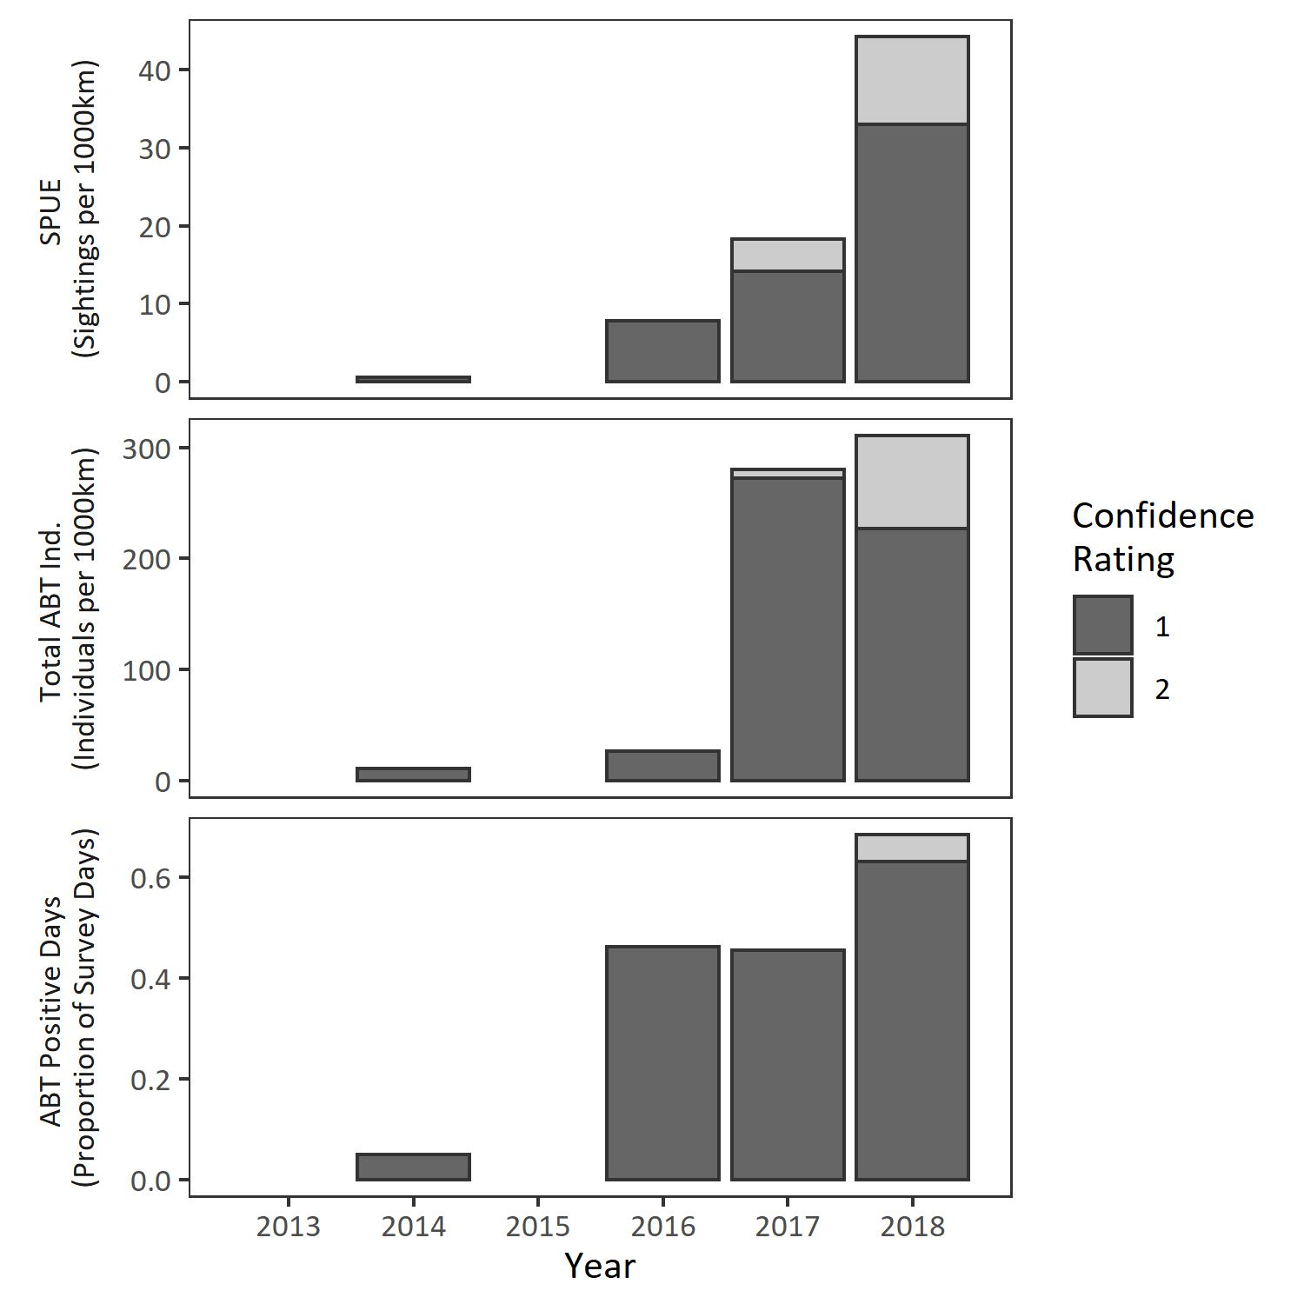
- r_{s} = 0.9, P = 0.0149

b) r_{s} = 0.84, P = 0.0361

c) r_{s} = 0.84, P = 0.0361

Supplemental Figure 3. Sensitivity analysis for sightings recorded during the PELTIC survey. Stacked barplots showing, a) the number of days when Atlantic bluefin tuna (ABT) were recorded within the core survey area and in sea states less than a Beaufort 4 as a proportion of total survey days, b) the total number of ABT observed from summing shoal size for all sightings, and, c) Sightings per unit effort (SPUE). Shading denotes proportion of analysis attributed to sightings assigned confidence ratings of either definite (“1”) or probable (“2”) with total bar height indicating definite and probable combined. For only definite sightings in each group (“1”) Spearman’s correlation tests were conducted and the results stated by figure labels.

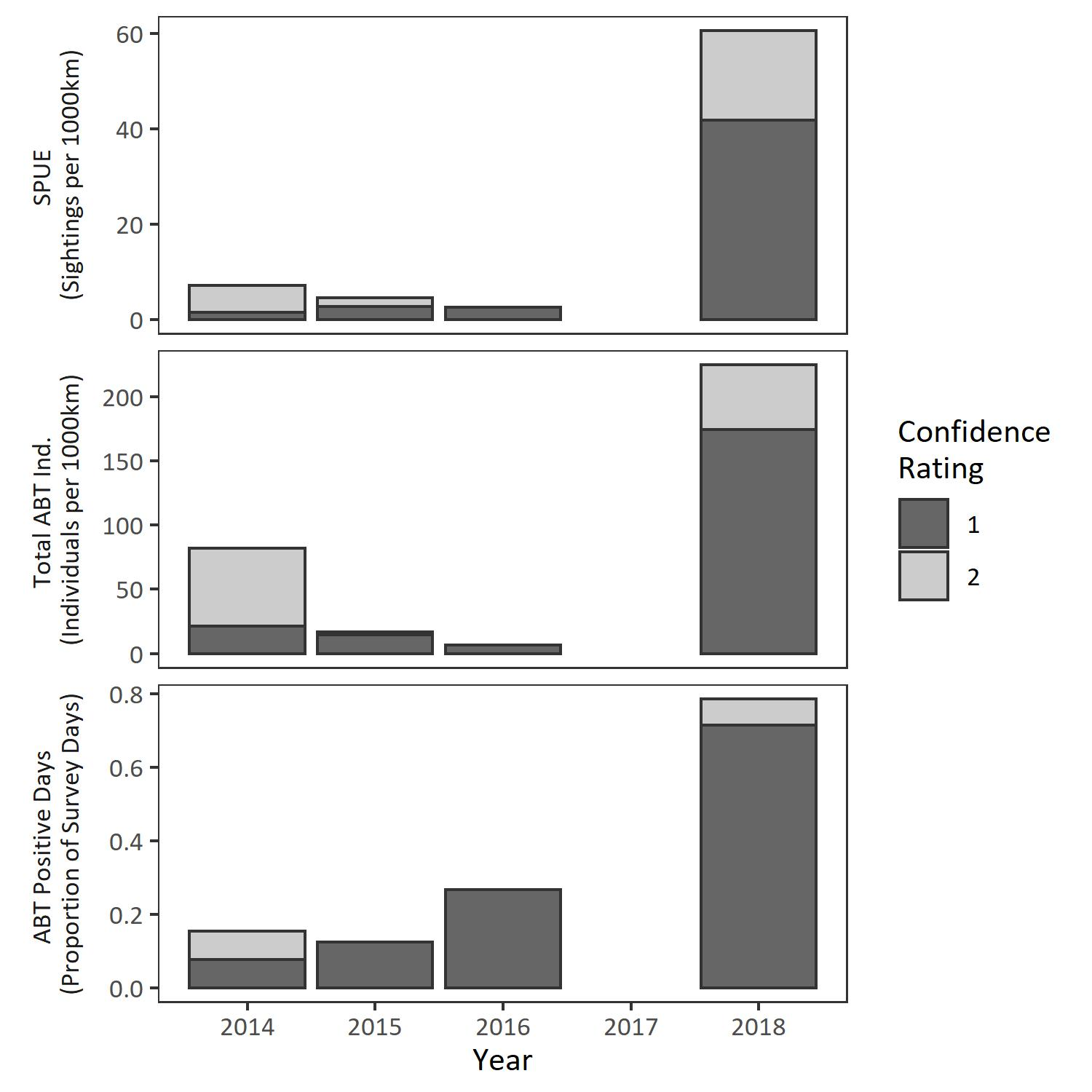
- r_{s} = 0.8, P = 0.3

b) r_{s} = 0.2, P = 0.917

c) r_{s} = 1, P = 0.0833

Supplemental Figure 4. Sensitivity analysis for sightings recorded during the CSHAS survey. Stacked barplots showing, a) the number of days when Atlantic bluefin tuna (ABT) were recorded within the core survey area and in sea states less than a Beaufort 4 as a proportion of total survey days, b) the total number of ABT observed from summing shoal size for all sightings, and, c) Sightings per unit effort (SPUE). Shading denotes proportion of analysis attributed to sightings assigned confidence ratings of either definite (“1”) or probable (“2”) with total bar height indicating definite and probable combined. For only definite sightings in each group (“1”) Spearman’s correlation tests were conducted and the results stated by figure labels.

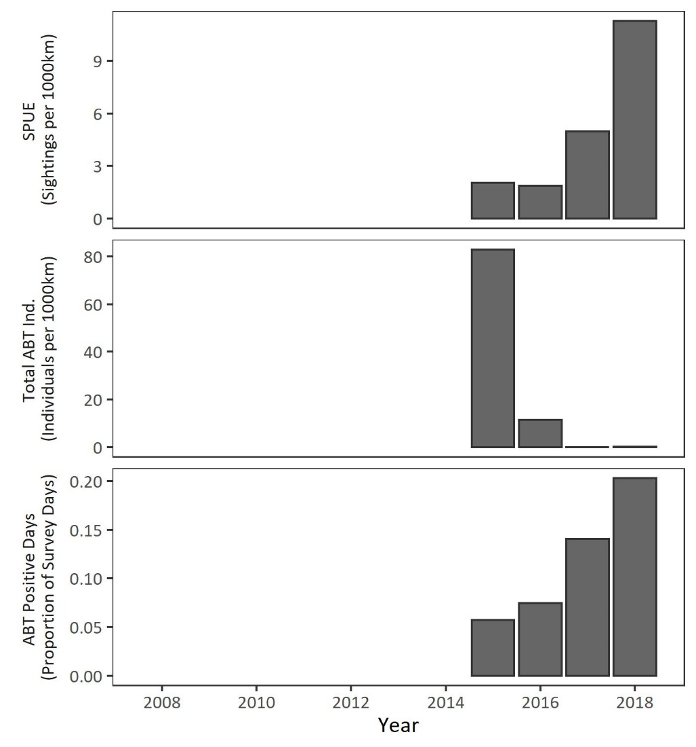
a) r_{s} = 0.85, P = 0.0008

b) r_{s} = 0.6, P = 0.0504

c) r_{s} = 0.86, P = 0.0006

Supplemental Figure 5. Sensitivity analysis for sightings recorded by ecotour operator C. Stacked barplots showing, a) the number of days when Atlantic bluefin tuna (ABT) were recorded within the core survey area and in sea states less than a Beaufort 4 as a proportion of total survey days, b) the total number of ABT observed from summing shoal size for all sightings, and, c) Sightings per unit effort (SPUE). Only definite (“1”) sightings were reported for this survey. Shoal size was only recorded numerically until part-way through 2016. After this, shoals were described as “individual fish”, “small shoal”, “medium shoal” and “large shoal” denoted by the area occupied by the encounter. This further reflects the challenges associated with logging shoal sizes. Spearman’s correlation tests were conducted for each group and the results stated by figure labels.

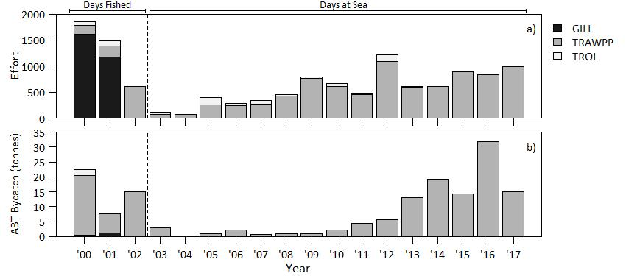

Supplemental Figure 6. Gear and effort characteristics of the Irish albacore fishery. Time series from 2000 to 2017 of a) effort expended by gear type, and b) ABT bycatch by gear type. Annotated bars denote the effort type reported over that period and the dashed vertical line denotes the beginning of the period used in the present bycatch per unit effort (BPUE) analysis.

Deleted Variable  d) | Df | Deviance | AIC
None |  | 0.2584 | 8.1579
SSB | 1 | 9.3088 | 27.6625
Prey Biomass | 1 | 2.1162 | 18.7745
Mean AMO | 1 | 3.3961 | 21.6124
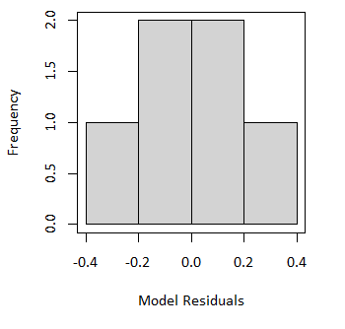
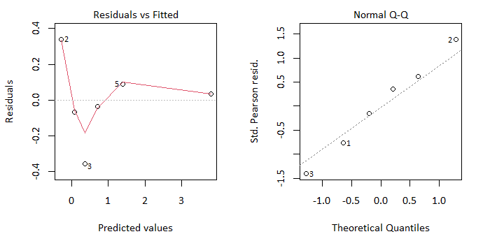
c)
b)
a)

Supplemental Figure 7. Diagnostic plots for PELTIC GLM. For the model structure glm(SPUE ~ annual mean AMO + summed prey + SSB): a) model residuals plotted against fitted values, b) Normal Q-Q plot, 3) histogram of model residuals, and, d) table showing the effect of deletion of fixed terms on model fit.

 | Effort (km)
Year | Total | < SS5 | < SS5 & 13-16 area | Sightings | SPUE  (ABT 100 km ⁻¹)
2014 | 2664 | 1833 | 1833 | 1 (0) | 0.1
2015 | 1959 | 1943 | 1943 | 0 (0) | 0
2016 | 1899 | 894 | 894 | 6 (0) | 0.7
2017 | 3854 | 2662 | 1481 | 22 (5) | 1.5
2018 | 3724 | 2447 | 1514 | 58 (6) | 3.8
ALL | 2820 ± 935 | 1956 ± 686 | 1533 ± 409 | 87 (11) | 1.2 ± 1.6

 | Effort (km)
Year | Total | < SS5 | < SS5 & 14-15 area | Sightings | SPUE  (ABT 100 km ⁻¹)
2014 | 1246 | 696 | 696 | 5 (0) | 0.7
2015 | 1392 | 1130 | 1114 | 5 (0) | 0.4
2016 | 1886 | 1800 | 1522 | 3 (1) | 0.2
2018 | 1504 | 1353 | 1172 | 63 (8) | 5.4
ALL | 1507 ± 274 | 1245 ± 460 | 1126 ± 460 | 76 (85) | 1.7 ± 2.5
Supplemental Table 2. Summary statistics for the CEFAS PELTIC survey. For “Sightings” values are the number of occasions ABT were sighted with a confidence of one or two with sightings during off-effort periods or outside of the consistently surveyed range given in parenthesis.

Supplemental Table 3. Summary statistics for the Marine Institute’s CSHAS survey. For “Sightings” values are the number of occasions ABT were sighted with a confidence of one or two with sightings during off-effort periods or outside of the consistently surveyed range given in parentheses.

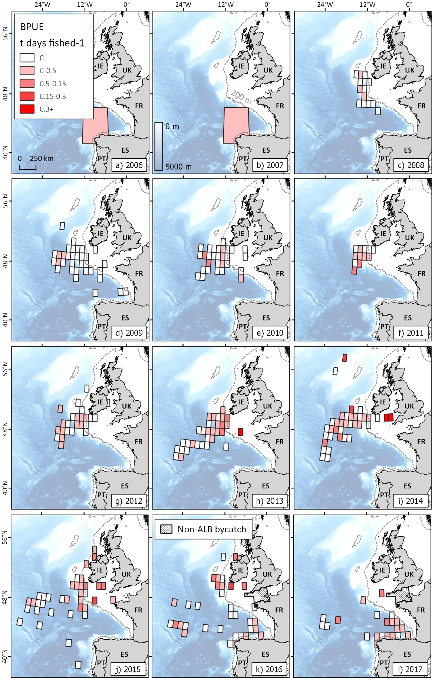

Supplemental Figure 8. Spatial time-series of bluefin tuna bycatch in the Irish albacore fishery. Annual maps showing spatial variability in ABT bycatch per unit effort (BPUE) in the Irish mid-water trawl fishery for albacore in the northeast Atlantic averaged from 2003 to 2017. Spatial resolution of reported data changed from 5° x 5° to 1° x 1° in 2008, which is reflected in the different grid sizes of a-b) to c-l). Other bycatch locations in 2016 and 2017 are reported as “Non-ALB bycatch”.

 | Biscay |  |  |  |  | On-shelf |  |  |  |  | Off-shelf
Year | BFT Catch  (kg) | ALB Catch (kg) | Prop.  BFT/  ALB | Effort  (days fished) | BPUE (kg d. fished⁻¹) | BFT Catch  (kg) | ALB Catch (kg) | Prop.  BFT/  ALB | Effort  (days fished) | BPUE (kg d. fished⁻¹) | BFT Catch  (kg) | ALB Catch (kg) | Prop.  BFT/  ALB | Effort  (days fished) | BPUE (kg d. fished⁻¹)
2003 | 3000 | 594000 | 0.005 | 78 | 38.5 | - | - | - | - | - | - | - | - | - | -
2004 | - | - | - | - | - | - | - | - | - | - | 20 | 38976 | 0.001 | 72 | 0.3
2005 | 950 | 258418 | 0.004 | 253 | 3.8 | - | - | - | - | - | - | - | - | - | -
2006 | 2323 | 504833 | 0.005 | 236 | 9.8 | - | - | - | - | - | - | - | - | - | -
2007 | 614 | 586222 | 0.001 | 266 | 2.3 | - | - | - | - | - | - | - | - | - | -
2008 | - | - | - | - | - | 0 | 7010 | 0 | 11 | 0 | 873 | 1507453 | 0.001 | 422 | 2.1
2009 | 0 | 8800 | 0 | 19 | 0 | 0 | 44137 | 0 | 34 | 0 | 1045 | 1943779 | 0.001 | 709 | 1.5
2010 | - | - | - | - | - | 0 | 48103 | 0 | 62 | 0 | 2150 | 736521 | 0.003 | 546 | 3.9
2011 | - | - | - | - | - | 706 | 565356 | 0.001 | 90 | 7.9 | 3684 | 3029800 | 0.001 | 370 | 10
2012 | - | - | - | - | - | 1958 | 691853 | 0.003 | 387 | 5.1 | 3740 | 1867673 | 0.002 | 708 | 5.3
2013 | - | - | - | - | - | 1638 | 128347 | 0.013 | 37 | 44.3 | 11462 | 2102193 | 0.005 | 556 | 20.6
2014 | - | - | - | - | - | 2843 | 84350 | 0.033 | 57 | 49.9 | 16330 | 2355515 | 0.007 | 556 | 29.4
2015 | - | - | - | - | - | 5690 | 154431 | 0.036 | 103 | 55.2 | 8543 | 2235802 | 0.004 | 785 | 10.9
2016 | 3830 | 512900 | 0.007 | 273 | 14 | 4739 | 90580 | 0.05 | 80 | 59.2 | 23178 | 1733440 | 0.013 | 477 | 48.6
2017 | 9908 | 2090222 | 0.005 | 915 | 10.8 | 295 | 0 | 1 | 4 | 73.8 | 4830 | 352850 | 0.014 | 79 | 61.1
Total | 20625 | 4555395 | 0.027 | 2040 | 80 | 17869 | 1814167 | 1.136 | 865 | 221 | 75855 | 17904002 | 0 | 5280 | 191
Mean | 2946 ± 3360 | 650771 ± 669052 | 0.004 ± 0.002 | 291 ± 293 | 11 ± 13 | 1787 ± 2057 | 181417 ± 242469 | 0.114 ± 0.312 | 87 ± 110 | 25 ± 26 | 6896 ± 7366 | 1627637 ± 906485 | 0.005 ± 0.005 | 480 ± 236 | 17 ± 20
Supplemental Table 4. Summary statistics for the Irish mid-water pair trawl fishery.

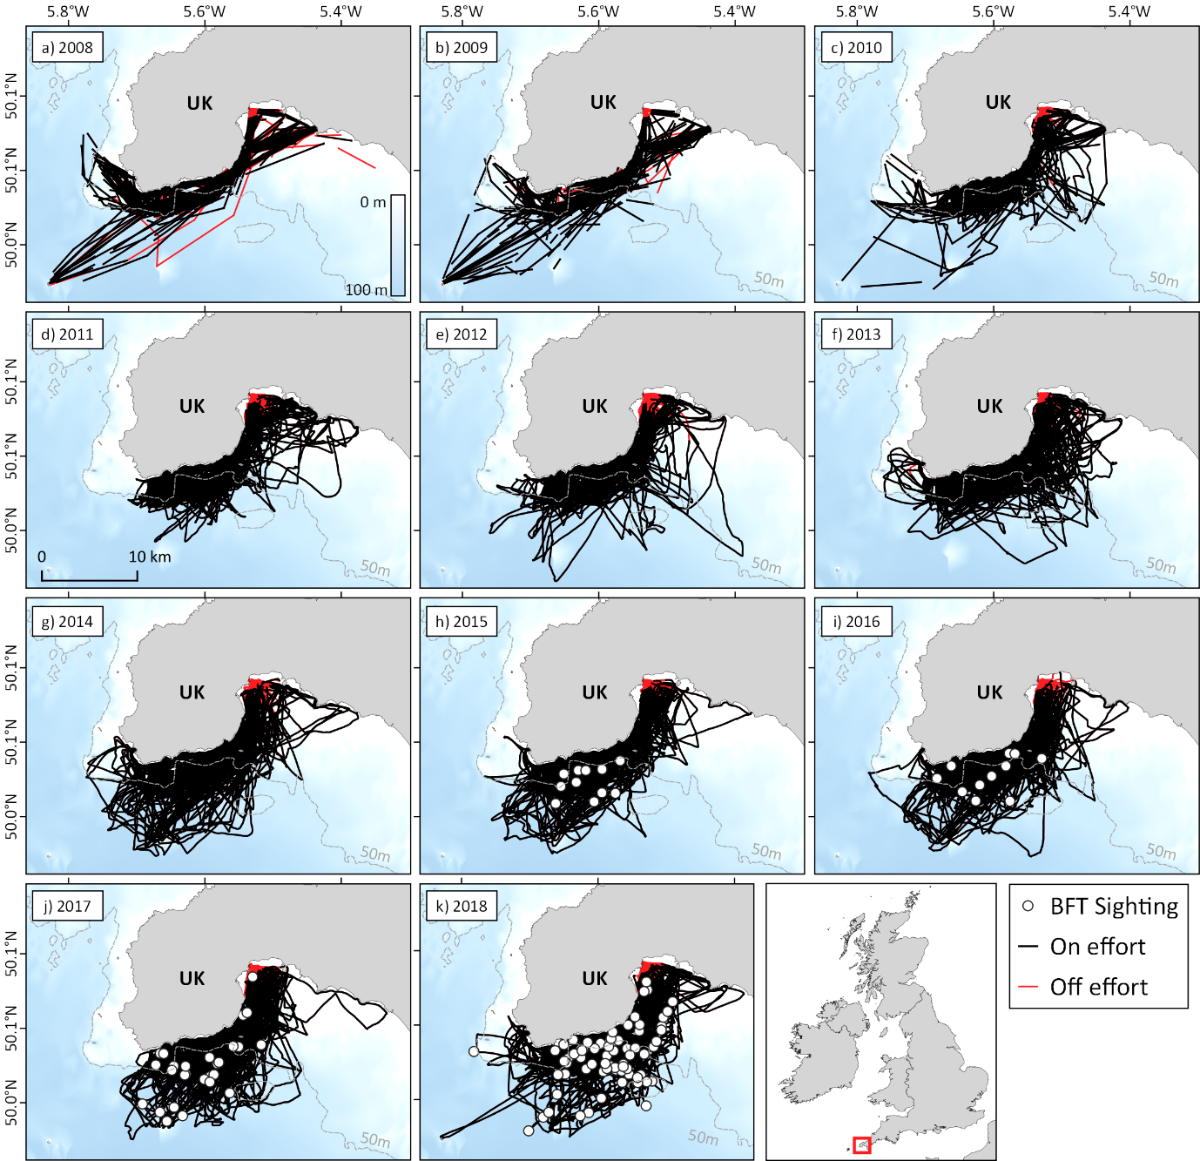

Supplemental Figure 9. Spatio-temporal distribution of survey effort and Atlantic bluefin tuna sightings for surveys aboard the platform of opportunity. Spatial characteristics of the vessel of opportunity dataset from 2008 to 2018. Bathymetry courtesy of the Generalised Bathymetric Chart of the Oceans (GEBCO, https://www.gebco.net/).

Year | Trips <SS5 | Trip Distance <SS5 (km) | Total Distance (km) | Sightings | SPUE
2008 | - | - | 3738 | 0 | 0
2009 | - | - | 3165 | 0 | 0
2010a | - | - | 1107 | 0 | 0
2010b | 57 | 33 ± 8 | 1872 | 0 | 0
2011 | 165 | 31 ± 9 | 5072 | 0 | 0
2012 | 175 | 32 ± 9 | 5650 | 0 | 0
2013 | 181 | 33 ± 9 | 6039 | 0 | 0
2014 | 183 | 37 ± 10 | 6826 | 0 | 0
2015 | 175 | 37 ± 9 | 6492 | 11 | 0.2
2016 | 201 | 36 ± 8 | 7266 | 11 | 0.2
2017 | 188 | 35 ± 8 | 6637 | 27 | 0.5
2018 | 222 | 35 ± 9 | 7867 | 72 | 1.1
ALL | 186 ± 18 | 34 ± 2 | 6481 ± 891 | 121 | 0.2 ± 0.3

Supplemental Table 5. Summary statistics for the platform of opportunity. For “Trips <SS5” values are number of trips conducted whilst environmental conditions did not exceed a Beaufort sea state four. For “Trip Distance <SS5” values are the mean length of each individual trip ± one standard deviation.

