Signal linewidth/B₀ shimming
Transverse (T₂) relaxation times of metabolites are generally shorter in vivo relative to ex vivo conditions, such as NMR spectroscopy of biofluids or tissue extracts. In vivo T₂ relaxation times of metabolites are reduced with increasing field strength and range between 90 to 170 ms at 7 T (43), which correspond to spectral linewidths of 1.9 – 3.5 Hz. However, such a resolution is not achievable by ¹H-MRS because of the additional line broadening caused by microscopic B₀ field heterogeneity. This microscopic heterogeneity originates from magnetic susceptibility variations on a cellular and microvascular level and from the magnetic properties of deoxyhemoglobin, which is strongly paramagnetic. Consequently, a spectral linewidth of about 9 Hz appears to be the best achievable in ¹H-MRS in the human brain at 7 T, assuming macroscopic B₀ field homogeneity within the measured volume of interest (VOI). Because of this inherently broader linewidth, additional line broadening caused by macroscopic B₀ inhomogeneity within the VOI is not acceptable and has to be eliminated. Successful correction of these B₀ field inhomogeneities (B₀ shimming) requires an efficient B₀ mapping technique and a powerful B₀ shimming system (shim coils and drivers). The 3D B₀ field mapping methods (67, 68) widely used on MRI scanners work well for global B₀ shimming. However, for fine adjustments of the B₀ homogeneity within the VOI, these 3D B₀ mapping techniques are clearly outperformed by methods using B₀ mapping along projections, such as FASTMAP (29, 30). Linear and strong 2nd-order shims are often sufficient to compensate for most B₀ field distortions within the VOIs used for brain ¹H-MRS (1 – 10 ml). With increasing size of VOIs, however, the B₀ field heterogeneities become more complex (higher-order symmetry) and cannot be fully compensated using the 1st and 2nd-order shim coils that are available on most human MRI scanners. Consequently, the spectral resolution achievable in large volumes is usually much worse than in small VOIs (< 10 ml).

Volume selection in ¹H-MRS
Volume selection is a fundamental feature of in vivo ¹H-MRS data acquisition techniques, which makes it significantly different than high-resolution ¹H NMR spectroscopy of liquids. Single voxel spatial localization is generally achieved by three orthogonal slice-selective pulses (band-selective RF pulses applied simultaneously with magnetic field gradients). These slice-selective pulses can be combined in a pulse sequence to generate a spin echo (Point-RESolved Spectroscopy, PRESS) (69) or a stimulated echo (STimulated Echo Acquisition Mode, STEAM) (70). In theory, these localization pulse sequences should provide ¹H NMR spectra that originate from inside of the selected VOI exclusively. However, in practice these pulses generate a number of additional coherences from outside of the VOI that must be eliminated from the acquired spectrum. These unwanted coherences are primarily suppressed using spoiler (crusher) gradient pulses. Because the gradient dephasing is not always fully sufficient, phase cycling is used for further elimination of unwanted coherences. While phase cycling is widely used for the coherence selection in high-resolution ¹H NMR spectroscopy in liquids, this approach is far less efficient in ¹H-MRS due to small fluctuations in resonance frequency caused by physiological motion and respiration. The localization performance also depends on the excitation profiles of the RF pulses used for volume selection. For example, sidelobes of the sinc-shaped RF pulse excite magnetization outside of the VOI, which cannot be removed by phase cycling. These sidelobes can easily excite unwanted subcutaneous lipid signals from outside of the VOI, which is the most common type of contamination in ¹H MR spectra from the human brain. The localization performance can be improved by combining outer volume suppression (OVS) with the localization sequence (e.g. PRESS or STEAM).
Volume selection is even more complex due to off-resonance effects. The desired VOI is correctly selected only for resonances coinciding with the reference frequency, and the volumes selected for off-resonance signals are spatially displaced from the prescribed VOI. This effect is called chemical shift displacement error (CSDE). It means that two metabolites with different chemical shifts (e.g. NAA and Cr) are selected from slightly different volumes of the brain. The relative displacement along the direction of each slice selection gradient is proportional to the ratio of the chemical shift difference (in Hz) to the RF pulse bandwidth. Obviously, CSDE becomes a serious problem for ¹H-MRS at high fields due to increased chemical shift dispersion (in Hz), which is proportional to the field strength. For example, most signals of brain metabolites detectable by ¹H-MRS fall between 1 and 4 ppm. This 3 ppm range corresponds to a 900 Hz chemical shift difference at 7 T, which results in a 30% VOI displacement along the slice-selection direction for a standard 2 ms 90º sinc-shaped RF pulse (3 kHz bandwidth). These unwanted effects of the volume selection can be reduced or minimized by increasing the bandwidth of the RF pulses used for slice-selection. Since the maximum achievable bandwidth of amplitude-modulated 90º RF pulses is twice as high as 180º RF pulses, the STEAM sequence (90º – 90º – 90º) is preferential over the PRESS sequence (90º – 180º – 180º) at high magnetic fields despite the reduced signal intensity of the stimulated echo relative to the spin echo. To improve CSDE, one may alternatively substitute amplitude-modulated RF pulses for frequency-modulated RF pulses for localization, as is done in the LASER (Localized by Adiabatic SElective Refocusing) pulse sequence (31). By using three pairs of broadband adiabatic full-passage RF pulses for volume selection, the LASER sequence provides significantly improved localization with respect to PRESS. Additionally, this VOI selection is independent of the applied transmit field (B₁⁺) once the adiabaticity threshold is reached. This property is highly beneficial for ¹H-MRS studies utilizing surface RF coils that produce spatially inhomogeneous transmit B₁⁺ fields. LASER’s volume selection advantages come at the cost of an increased minimum echo-time. Consequently, “absolute” quantification of metabolites from LASER spectra requires corrections for T₂ relaxation, but precise metabolite T₂ values are not always available. More recently, the semi-LASER localization technique was introduced (33), which currently appears to be the best compromise for superior localization performance and reasonably short TE (24 – 28 ms) for transmit B₁⁺ fields typically available on human MRI caners.

Water signal suppression
Water accounts for 70% – 80% of brain tissue, while the highest concentration of brain metabolites (e.g. NAA and tCr) is only around 10 µmol/g. This means that the intensity of the strongest metabolite peaks is about four orders of magnitude smaller than the unsuppressed water signal. Moreover, localization based on slice selective pulses causes a modulation of the water signal due to gradient coil vibration, resulting in water signal satellites that overlap with metabolite resonances. These effects make metabolite quantification from spectra without water suppression extremely challenging. Therefore, robust and highly efficient water suppression is one of the key factors for reliable quantification of an extended range of metabolites. Several water suppression schemes have been developed, but it appears that the VAPOR (VAriable Power and Optimized Relaxation delays) technique (25, 34) provides the most efficient water signal suppression in comparison to other methods currently available. This technique can routinely suppress the water signal by at least four orders of magnitude using fully automatic setting of parameters without the need for fine experimental adjustment (26, 36).

Data preprocessing
The deuterium lock, which is routinely used in high-resolution ¹H NMR spectroscopy of liquids for frequency stability, is not available for in vivo applications. Consequently, magnetic field (B₀) drift combined with frequency and phase fluctuations induced by physiological motion (respiratory and cardiac cycles) can severely compromise the quality of in vivo ¹H MR spectra. Therefore, for in vivo applications, a single scan averaging mode (where each individual scan is stored separately) is highly advantageous. This allows for frequency and phase correction of individual scans before summation, which maintains the signal intensity and high spectral resolution of the averaged spectra. In addition, if a single scan averaging mode is used, uncorrectable data, e.g. corrupted by major head motion, can simply be eliminated before summation. In the final preprocessing step, the effects of residual eddy currents that alter the line shapes have to be removed from metabolite spectra using an unsuppressed water signal acquired from the same VOI (25, 71).

References
67. Hetherington HP, Chu WJ, Gonen O, Pan JW. Robust fully automated shimming of the human brain for high-field 1H spectroscopic imaging. Magn Reson Med 2006 Jul;56(1): 26-33.
68. Schneider E, Glover G. Rapid in vivo proton shimming. Magn Reson Med 1991 Apr;18(2): 335-47.
69. Bottomley PA. Spatial localization in NMR spectroscopy in vivo. Annals of the New York Academy of Sciences 1987;508: 333-48.
70. Frahm J, Merboldt KD, Hanicke W. Localized Proton Spectroscopy Using Stimulated Echoes. J Magn Reson 1987 May;72(3): 502-8.
71. Klose U. In vivo proton spectroscopy in presence of eddy currents. Magn Reson Med 1990 Apr;14(1): 26-30.

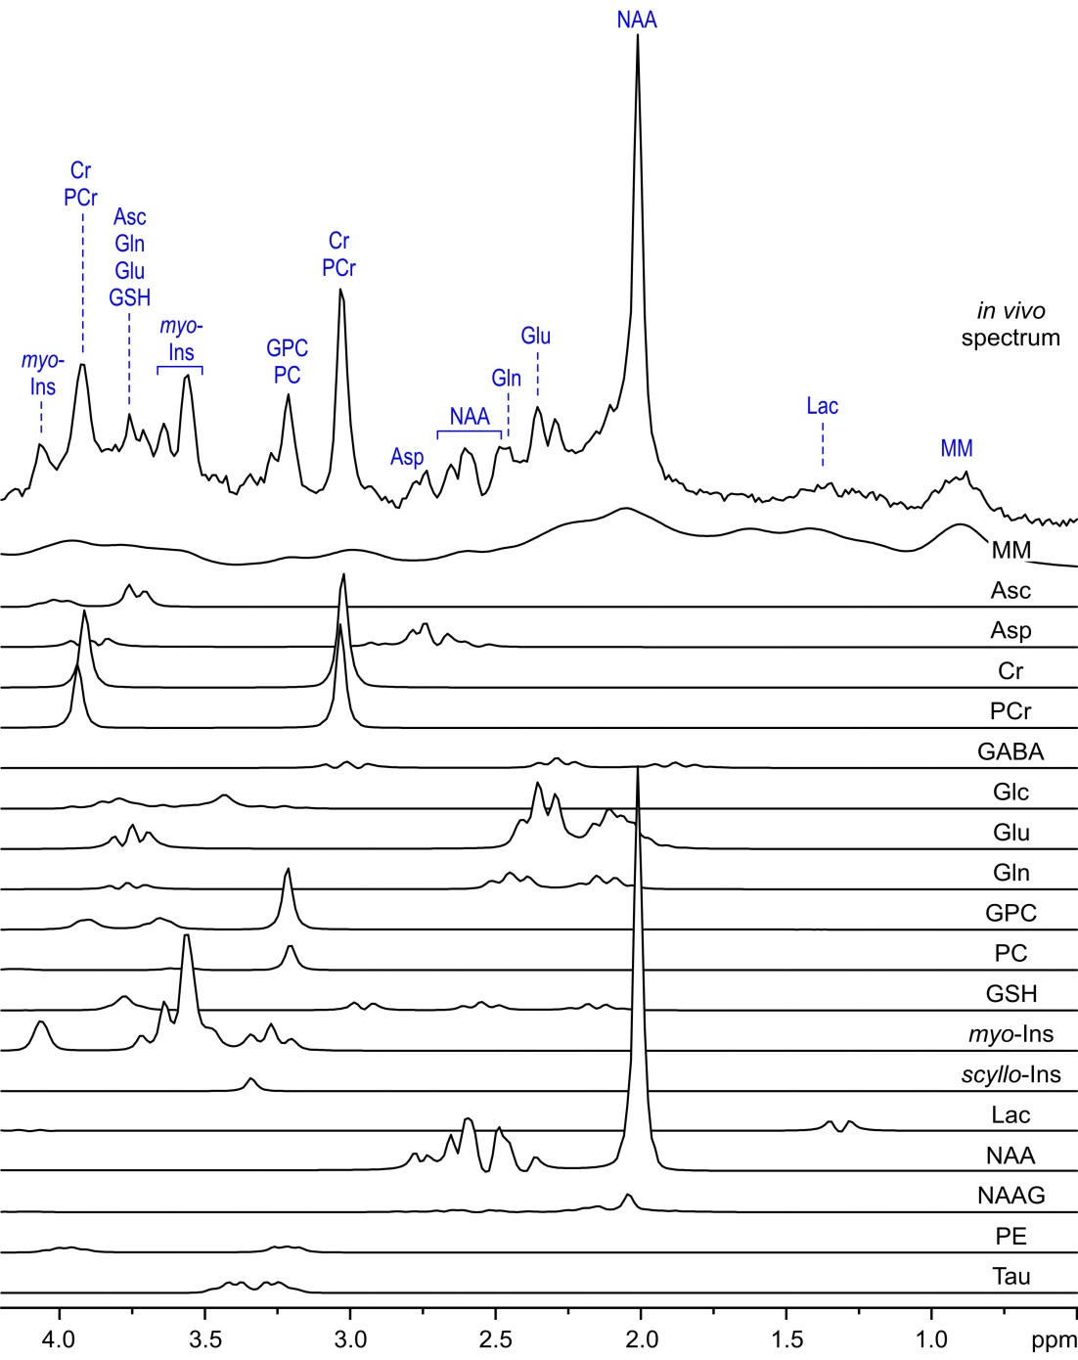

Supplements Figure 8. LCModel analysis of an in vivo ¹H MR spectrum acquired from the human brain at 3 T (semi-LASER, TE = 28 ms, TR = 5 s, NT = 160, VOI = 8 ml, gray-matter-rich occipital cortex). Courtesy of Dr. Petr Bednařík from the University of Minnesota.

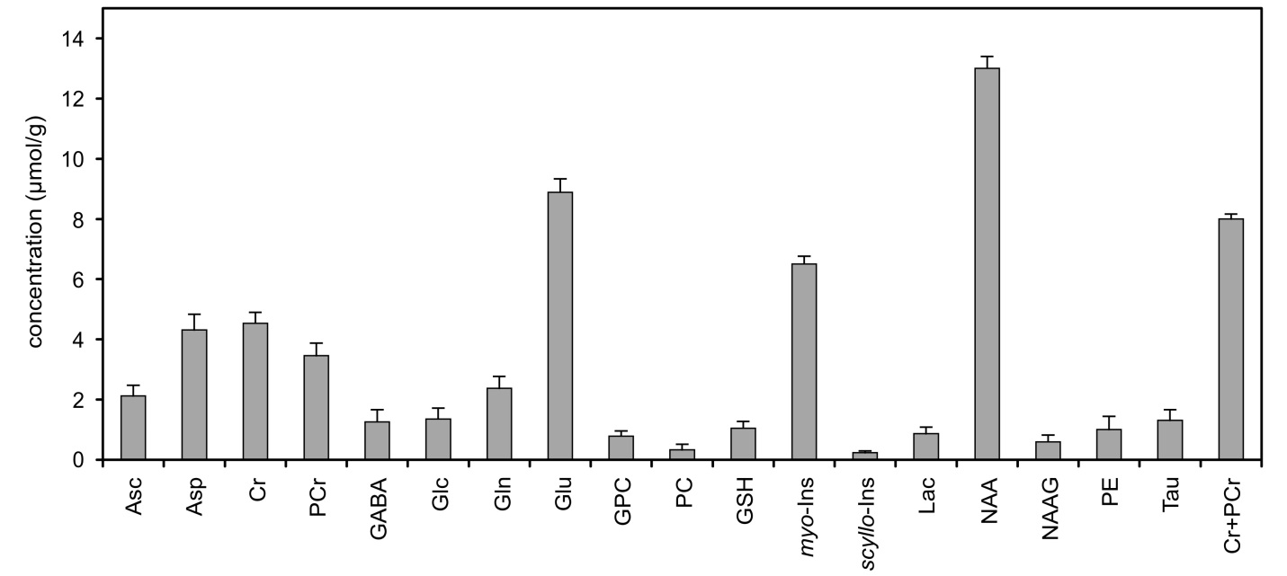
Supplements Figure 9. The neurochemical profile of the gray-matter-rich occipital cortex quantified from the in vivo ¹H-MR spectrum measured at 3 T (Fig. 8). Error bars indicate estimated errors of the fit (Cramér-Rao lower bounds). Courtesy of Dr. Petr Bednařík from the University of Minnesota.

