Supplementary Figure 1: Provincial mortality level across China 1956-64

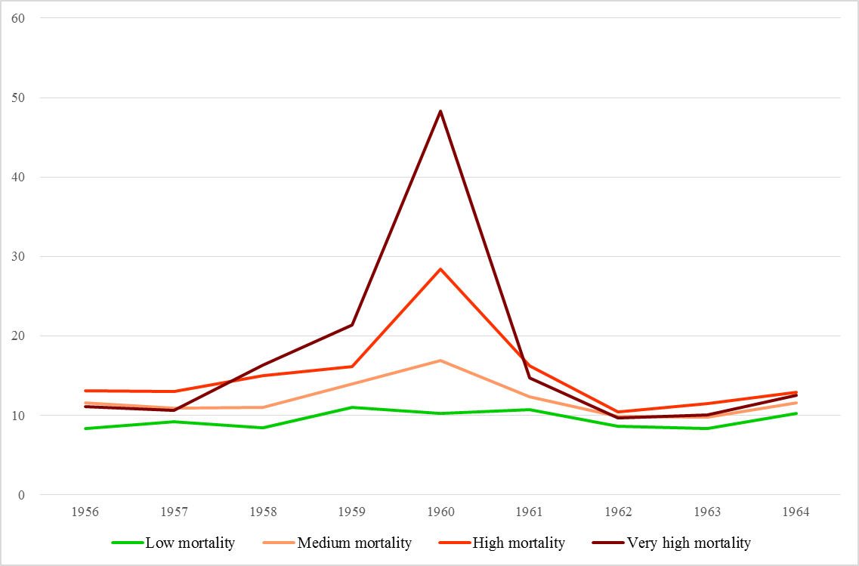

All-cause mortality rate per thousand population across different provinces of China in 1956-64. The very high mortality group includes Anhui, Sichuan, Guizhou, Gansu, Qinghai, and Henan; the high mortality group includes Guangxi, Hunan, and Yunnan; the medium group includes Shandong, Huibei, Jiangsu, Jiangxi, Hebei, Xinjiang, Fujian, Guangdong, Shansi, and Ningxia; the low group includes Shanxi, Zhejiang, Liaoning, Heilongjiang, Tianjin, Jilin, Neimong, Beijing, and Shanghai. Data from Lin and Yang (2000)⁹

