Supplementary Figure 2: Number of provinces by survey type and provincial mortality level in studied provinces

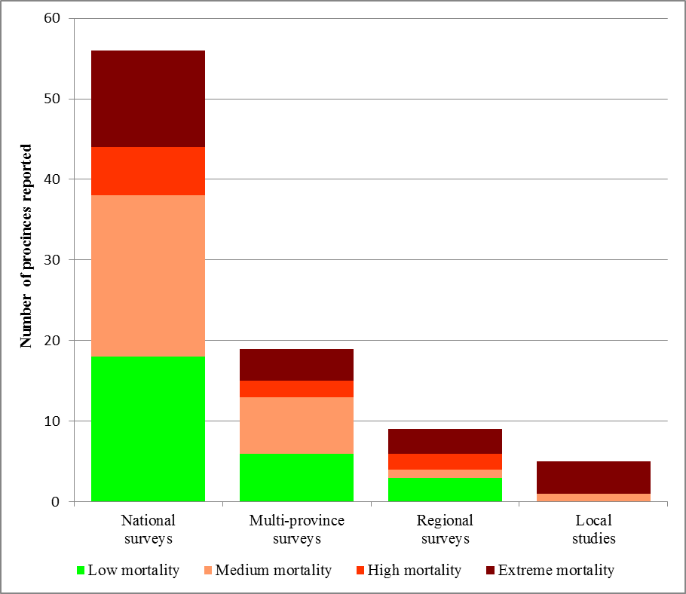
By addition of province counts in surveys and studies

