Supplementary Material:

Genetically low vitamin D concentrations and myopic refractive error: a Mendelian randomization study

 |  |  |  | European Descent |  |  |  | Asian Descent
SNP | Gene | Reference Allele | Other Allele | Beta | s.e. | P-value | Number of studies | Beta | s.e. | P-value | Number of studies
rs10741657 | CYP2R1 | G | A | 0.007 | 0.017 | 0.691 | 25 | 0.024 | 0.050 | 0.626 | 5
rs10766197 | CYP2R1 | A | G | -0.005 | 0.016 | 0.734 | 27 | 0.019 | 0.037 | 0.605 | 4
rs12794714 | CYP2R1 | G | A | 0.015 | 0.016 | 0.365 | 26 | -0.015 | 0.042 | 0.717 | 5
rs1562902 | CYP2R1 | T | C | -0.011 | 0.016 | 0.480 | 27 | -0.008 | 0.034 | 0.804 | 5
rs2060793 | CYP2R1 | G | A | 0.008 | 0.016 | 0.643 | 27 | 0.023 | 0.050 | 0.638 | 5
rs2282679 | GC | T | G | -0.022 | 0.018 | 0.217 | 28 | 0.039 | 0.039 | 0.324 | 5
rs7041 | GC | C | A | -0.009 | 0.017 | 0.591 | 29 | -0.007 | 0.035 | 0.840 | 5
rs705117 | GC | T | C | 0.027 | 0.028 | 0.350 | 28 | -0.051 | 0.036 | 0.158 | 5
rs7944926 | DHCR7 | G | A | 0.011 | 0.018 | 0.537 | 27 | -0.020 | 0.042 | 0.630 | 5
rs11234027 | DHCR7 | G | A | -0.014 | 0.022 | 0.513 | 25 | -0.040 | 0.036 | 0.260 | 5
rs12785878 | DHCR7 | T | G | 0.010 | 0.019 | 0.600 | 25 | -0.025 | 0.042 | 0.554 | 5
rs3829251 | DHCR7 | G | A | -0.012 | 0.022 | 0.589 | 27 | -0.037 | 0.036 | 0.296 | 5
rs6013897 | CYP24A1 | A | T | 0.012 | 0.067 | 0.567 | 27 | -0.032 | 0.042 | 0.448 | 5
Supplementary Table 1. Association between vitamin D SNPs and refractive error obtained from a genome-wide association study (GWAS) meta-analysis carried out by the Consortium for Refractive Error and Myopia (CREAM)¹.

European Cohorts
Study | N | Mean age | age s.d. | Mean SPHEQ | SPHEQ s.d.
1985 British Birth Cohort | 1658 | 42 | 0 | -0.96 | 2
ALSPAC (Mothers) | 1865 | 45 | 4.5 | -0.76 | 2.16
ANZRAG | 402 | 79.9 | 12 | -0.26 | 2.36
AREDS1a1b | 485 | 73.4 | 24.2 | 0.73 | 1.9
AREDS1c | 1877 | 67.9 | 4.7 | 0.56 | 2.15
BMES | 1550 | 73.8 | 7.76 | 0.62 | 2.12
CROATIA Korcula | 822 | 56.3 | 13.3 | -0.15 | 1.6
CROATIA Split | 344 | 51.2 | 13 | -1.68 | 1.61
CROATIA Vis | 527 | 56.3 | 13.3 | -0.13 | 1.75
DCCT | 791 | 31.4 | 4.1 | -1.47 | 1.8
EGCUT | 782 | 57.2 | 17.8 | 0.48 | 3.18
ERF | 2028 | 48.5 | 14.3 | 0.08 | 2.14
FECD | 412 | 71.5 | 9.2 | 0.14 | 2.49
FITSA | 98 | 68.1 | 3.7 | 1.54 | 1.7
Framingham | 1497 | 55.6 | 8.9 | 0.03 | 2.41
Gutenberg Health Study 1 | 2750 | 55.6 | 10.8 | -0.38 | 2.44
Gutenberg Health Study 2 | 1143 | 54.8 | 10.8 | -0.41 | 2.58
KORA | 1860 | 55.6 | 11.8 | -0.82 | 7.33
OGP Talana | 627 | 52.6 | 16.3 | -0.2 | 2.04
ORCADES | 504 | 57.6 | 13.5 | 0.03 | 2.08
RS1 | 5328 | 68.5 | 8.6 | 0.86 | 2.44
RS2 | 2009 | 64.2 | 7.4 | 0.48 | 2.51
RS3 | 1970 | 60.8 | 5.5 | -0.35 | 2.62
TEST/BATS | 403 | 38.7 | 13.7 | -0.28 | 1.05
TwinsUK | 3865 | 53.8 | 11 | -0.4 | 2.73
WESDR | 306 | 34.7 | 8.2 | -1.5 | 2.02
Young Finns Study | 1479 | 41.9 | 5 | -1.04 | 2.01
Asian Cohorts
Beijing Eye Study | 578 | 62.1 | 8.8 | 2.45 | 15.73
SCES | 1723 | 57.5 | 9 | -0.77 | 2.65
SIMES | 2273 | 58 | 10.8 | -0.05 | 1.86
SINDI | 2108 | 55.8 | 8.8 | 0.01 | 2.14
SP2 | 1694 | 47.7 | 10.8 | -1.66 | 2.93
Supplementary Table 2. Description of cohorts included in the GWAS meta-analysis carried out by CREAM¹.

Body Mass Index²
SNP | EA | NEA | Effect | P
rs10741657 | G | A | -0.0086 | 0.02363
rs11234027 | A | G | 0.0041 | 0.4027
rs12785878 | G | T | 0.0017 | 0.6857
rs12794714 | G | A | 0.0092 | 0.0129
rs2282679 | T | G | 0.0027 | 0.5203
rs6013897 | T | A | -0.0014 | 0.7609
rs7944926 | A | G | 0.0016 | 0.7032
Cigars Per Day³
rs10741657 | A | G | 0.0109 | 0.8965
rs11234027 | A | G | -0.1132 | 0.3023
rs12785878 | T | G | 0.1218 | 0.1834
rs12794714 | A | G | -0.0013 | 0.9871
rs2282679 | T | G | 0.0232 | 0.8012
rs6013897 | A | T | 0.0354 | 0.7253
rs7944926 | A | G | -0.1154 | 0.2077
Education Years⁴
rs10741657 | A | G | -0.002 | 0.429
rs11234027 | A | G | -0.005 | 0.1307
rs12785878 | T | G | 0.005 | 0.05727
rs12794714 | A | G | 0.003 | 0.184
rs2282679 | T | G | -0.002 | 0.5373
rs6013897 | A | T | -0.003 | 0.2904
rs7944926 | A | G | -0.005 | 0.05595
Supplementaty Table 3. Association between the SNPs using in the Mendelian Randomization and potential confounders.

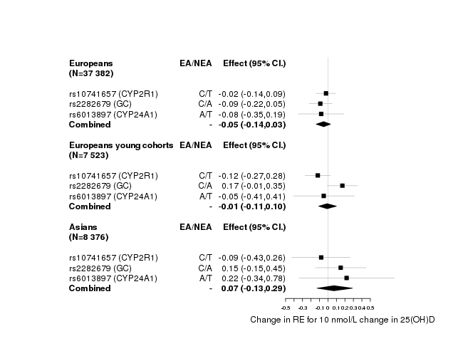
Supplementary Figure 1. Mendelian Randomization results excluding the SNP in DHCR7.

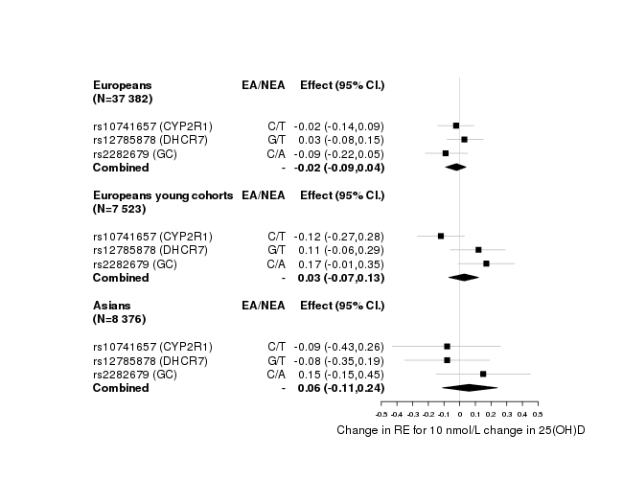
Supplementary Figure 2. Mendelian Randomization results excluding the SNP in CYP24A1.

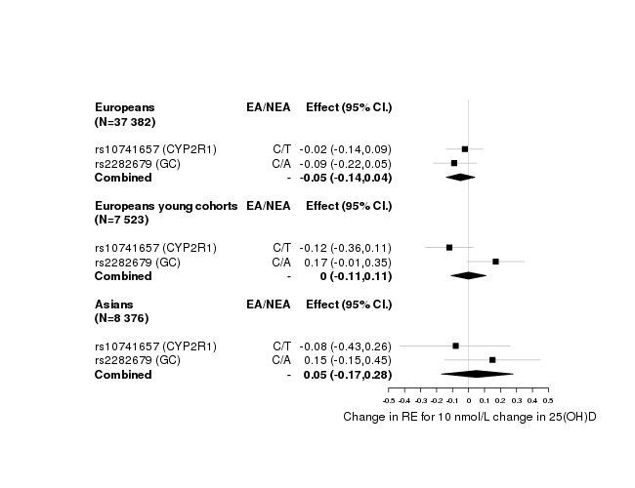
Supplementary Figure 3. Mendelian Randomization excluding SNPs in DHCR7 and CYP24A1.

1. Verhoeven VJ, Hysi PG, Wojciechowski R, et al. Genome-wide meta-analyses of multiancestry cohorts identify multiple new susceptibility loci for refractive error and myopia. Nature genetics 2013; 45: 314-8.
2. Locke AE, Kahali B, Berndt SI, et al. Genetic studies of body mass index yield new insights for obesity biology. Nature 2015; 518: 197-206.
3. Vink JM, Smit AB, de Geus EJ, et al. Genome-wide association study of smoking initiation and current smoking. Am J Hum Genet 2009; 84: 367-79.
4. Okbay A, Beauchamp JP, Fontana MA, et al. Genome-wide association study identifies 74 loci associated with educational attainment. Nature 2016; 533: 539-42.

