Is it safe to go back in the water? A systematic review and meta-analysis of the risk of acquiring infections from recreational exposure to seawater

Supplementary Material

Contents

1) Additional information for Methods 2

Table S1. The selection criteria used to screen titles and abstracts, how these criteria were applied and the rationale for each criterion. 3

Table S2. Electronic databases searched 5

Table S3 Search strategy used in MEDLINE (run 5/7/13). 6

Table S4. List of websites searched, dates searched and number of items found by the search. Only the first 50 titles were screened. 7

Table S5. Data extraction form 8

Table S6. The symptoms and illnesses considered in each of the health outcome categories (any, ear, gastrointestinal, eye, other, respiratory, skin, urinary tract, infections caused by specific microorganisms) 12

Table S7. Using the CASP quality appraisal rating system: Interpretation of criteria and rationale for quality appraisal 14

**2)** **Results** 31

**A)** **Included studies and case definitions** 31

Table S8 Reference list of publications in each included study. 31

Table S9 List of studies reporting on health effects associated with fresh water exposure 33

Table S10 Case definitions reported by studies that were included in meta-analyses 34

**B)** **Forest plots for main analyses** 38

Any exposure to seawater 38

Bather head immersion analyses 45

Funnel plot 51

**C)** **Results of sensitivity analyses** 52

3) References of the included studies 58

# Additional information for Methods

## Table S1. The selection criteria used to screen titles and abstracts, how these criteria were applied and the rationale for each criterion.

|  |  |  |
| --- | --- | --- |
| Selection criteria | How it was applied | Rationale |
| 1. The study measures health outcomes in humans | Exclude reviews, studies that model or predict outcomes, commentaries, and studies investigating health outcomes in non-human subjects. Include physician-diagnosed and lab-diagnosed infections as well as self-reported symptoms of ill health. | The systematic review’s population of interest is restricted to humans, and to the risk of acquiring infections among bathers. |
| 1. The study does not restrict the study population to people with a pre-existing medical condition | Exclude studies if the study population was restricted to patients or subjects with conditions such as HIV/AIDS. Include case-control studies retrospectively investigating waterborne diseases. | While the general population will contain people with such conditions, restricting the study population to people with conditions that compromise the immune system is likely to result in an over-estimate the risk of illness in the wider population. |
| 1. The study has been conducted in a developed country (a country that is a member of the Organisation for Economic Co-operation and Development) (OECD) | Exclude studies conducted before 1961. Exclude studies conducted in countries that aren’t members of the OECD. The countries belonging to the OECD and the dates they joined are available online (OECD 2016). Exclude studies conducted in countries that weren’t members on the dates they were conducted. Exclude countries that are territories of member countries (e.g. Puerto Rico, the Virgin Islands). | The OECD was started in 1961, and this is when the first members of the OECD joined. Endemic levels of illness, particularly diarrhoeal diseases, are much higher in low- and middle-income countries compared to those in high-income countries, due partially to a lack of adequate sanitation. Therefore an association between bathing in natural waters and the risk of infection will be harder to attribute to bathing. High-income nations also have more resources to dedicate to monitoring bathing water quality. |
| 1. The study examines exposure to natural (untreated) waters | Exclude studies conducted in swimming pools, spas, hot tubs, even if the disinfection mechanism was found to be faulty. | Natural, untreated waters are the focus of this systematic review. |
| Selection criteria | How it was applied | Rationale |
| 1. The study explores recreational exposure to natural waters | Exclude studies investigating adverse health effects in occupational divers, health effects associated with domestic exposure (e.g. washing or drinking) to natural waters. | Recreational exposure is the focus of this review. Furthermore, occupational and domestic exposures are likely to be greater (of a longer duration) than recreational exposures, biasing the effect size. |
| 1. The study reports the investigated health outcome in a control group | Exclude case studies, case series, and summaries of outbreaks where a case-control study design has not been carried out. | In order to estimate the direction and magnitude of the risk of infection associated with an exposure, the rate of illness in a control group (unexposed group) must be known. |
| 1. The study investigates health outcomes caused by exposure to microbial agents | Exclude studies investigating health risks in humans of water contamination by heavy metal and other poisons, drowning, injuries caused by animals (e.g. wounds caused by corals, jellyfish stings, shark attacks). | This review is concerned with the health outcomes caused by microbes in natural waters, particularly those that are carried in sewage polluting natural waters. |
| 1. Study does not investigate health outcomes caused by exposure to cyanobacteria, to helminths, or those requiring a vector or intermediate host | Excluded studies investigating risk of illness after exposure to bathing waters affected by harmful algal blooms, cyanobacteria, dinoflagellates. Excluded studies investigating health risks in humans of exposure to parasitic helminths (e.g. nematodes, trematodes). Excluded studies investigating infections requiring a vector or intermediate host, such as malaria, tularaemia, and schistosomiasis. | Toxins produced by algae, cyanobacteria, dinoflagellates are produced outside the host, and these organisms do not need to infect the human body in order to cause ill health. Infection caused by helminths are a problem in areas where sanitation is poor, and are therefore not highly endemic in most developed countries. The incidence of pathogenic infections requiring an intermediate host or vector in order to infect humans depend upon the population of their intermediate host or vector, rather than upon the extent of sewage pollution. |
| 1. The study is available in English | Exclude studies that are not available in English. | Limited time and resources to have records translated into English. |
| Selection criteria | How it was applied | Rationale |
| 1. The study has not combined data collected from participants exposed to freshwater with participants exposed to marine waters | Exclude studies if they have pooled results from seawater and freshwater. | This reviewed aimed to assess the risk of infections from marine waters and freshwaters separately. |

## Table S2. Electronic databases searched

|  |  |  |  |
| --- | --- | --- | --- |
| Database name | Specialism | Dates of coverage | Dates searched |
| Medline | Biomedical sciences | 1946 to present | 5/7/13  Updated 22/6/15 |
| Embase | Biomedical sciences | 1947 to present | 5/7/13 |
| BIOSIS | Biosciences | 1926 to present | 5/7/13  Updated 22/6/15 |
| Web of Science | Biosciences | 1900 to present | 5/7/13 |
| Greenfile | Environmental sciences | 1910 to present | 5/7/13 |
| Environment complete | Environmental sciences | 1902 to present | 5/7/13 |

Medline was selected to be searched again because it had the largest number of relevant reports, and Biosis had the lowest number of hits that were duplicates of those identified by Medline.

## Table S3 Search strategy used in MEDLINE (run 5/7/13).

Database: Ovid MEDLINE(R) In-Process & Other Non-Indexed Citations and Ovid MEDLINE(R) <1946 to Present>

Search Strategy:

--------------------------------------------------------------------------------

1 (water adj3 (untreat* or contaminat* or pollut*)).ti,ab. (11997)

2 water quality.ti,ab. (9802)

3 water pollution.ti,ab. (1512)

4 exp water pollution/ or exp water quality/ (18861)

5 water microbiology/ (27613)

6 microbiological.ti,ab. (32775)

7 microbial.ti,ab. (87329)

8 (bacteri* and water).ti,ab. (27650)

9 exp waste water/ or exp sewage/ae, mi, ps, st, vi (20722)

10 or/1-9 (198348)

11 seawater/ae, mi, ps, vi (5934)

12 bathing beaches/mi, st (146)

13 (beach or beaches).ti,ab. (4040)

14 exp fresh water/an, mi, ps, st, vi (10073)

15 river*.ti,ab. (34065)

16 lake*.ti,ab. (21905)

17 (stream or streams).ti,ab. (30054)

18 estuar*.ti,ab. (7290)

19 (sea or seawater).ti,ab. (58553)

20 ocean*.ti,ab. (18265)

21 (water* and (risk* or hazard*) and (infect* or disease* or illness*)).ti,ab. (8432)

22 (coast or coasts or coastal).ti,ab. (30299)

23 marine.ti,ab. (48585)

24 exp fresh water/ or exp lakes/ or exp ponds/ or exp rivers/ (35036)

25 ((upstream or downstream) and water and (health or disease* or illness*)).ti,ab. (417)

26 recreation* water*.ti,ab. (640)

27 ((bathing or swimming) and water).ti,ab. (5232)

28 or/11-27 (230862)

29 swimm*.ti,ab. (19086)

30 exp Swimming/ae, st [Adverse Effects, Standards] (1319)

31 (diver or divers or diving).ti,ab. (6392)

32 (water adj3 (contact or expos* or activit* or sport* or recreation)).ti,ab. (13935)

33 (surfer* or surfing).ti,ab. (666)

34 (bather* or bathing).ti,ab. (8546)

35 exp Environmental Exposure/ae, an, cl, lj, pc, st [Adverse Effects, Analysis, Classification, Legislation & Jurisprudence, Prevention & Control, Standards] (45618)

36 windsurf*.ti,ab. (60)

37 snorkel*.ti,ab. (193)

38 (sailing or sailor*).ti,ab. (1121)

39 (triathl* or pentathl*).ti,ab. (1016)

40 waterski*.ti,ab. (23)

41 (rafter* or rafting).ti,ab. (205)

42 kayak*.ti,ab. (253)

43 canoe*.ti,ab. (303)

44 or/29-43 (95367)

45 10 and 28 and 44 (2559)

46 exp animals/ not humans.sh. (3996986)

47 45 not 46 (2193)

48 limit 47 to english language (1874)

## Table S4. List of websites searched, dates searched and number of items found by the search. Only the first 50 titles were screened.

|  |  |  |
| --- | --- | --- |
| Organisation | Date searched | Number of hits |
| Centre for Disease Control and Prevention (CDC) | 19/08/2013 | 833 |
| Environment Canada | 19/08/2013 | 7 |
| European Centre for Disease Prevention and Control (ECDC) | 15/08/2013 | 508 |
| European Environment Agency (EEA) | 15/08/2013 | 94 |
| Health Protection Agency (HPA) – renamed Public Health England (PHE) | 15/08/2013 | 61 |
| Medical Research Council (MRC) | 14/08/2013 | 0 |
| Umweltbundesamt (UBA) | 14/08/2013 | 1,700,000 |
| United Nations Environment Programme (UNEP) | 13/08/2013 | 468 |
| United Nations Environment Programme Mediterranean Action Plan (UNEP MAP) | 14/08/2013 | 4 |
| United States Environment Protection Agency (US EPA) | 15/08/2013 | 1,700 |
| World Health Organization (WHO) | 14/08/2013 | 532 |

## Table S5. Data extraction form

|  |  |
| --- | --- |
| BIBLIOGRAPHIC DETAILS | |
| Study ID: |  |
| Author(s): |  |
| Year: |  |
| Title: |  |
| Citation: |  |

|  |  |
| --- | --- |
| STUDY DETAILS | |
| Country: |  |
| Year(s): |  |
| Study design: | RCT/prospective cohort/retrospective cohort/cross-section/ case-control |
| Study size: |  |
| Drop out (between recruitment and analysis): |  |
| Type of water: | Marine (Seawater) / Freshwater (lake/river/stream) |
| Recreational exposure: |  |
| Description of exposure: |  |
| Method of exposure assessment: |  |
| Comparator description: |  |
| Hypothesised sources of pollution: |  |
| Period of recruitment: |  |
| Funding source: |  |
| Notes/comments: |  |

|  |  |
| --- | --- |
| POPULATION | |
| Population description: |  |
| Age: |  |
| Gender: |  |
| Method of recruitment: |  |
| Eligibility criteria: |  |
| Method and duration of follow-up: |  |
| Number exposed: |  |
| Number unexposed: |  |
| Notes/comments: |  |

|  |  |  |  |
| --- | --- | --- | --- |
| HEALTH OUTCOMES MEASURED | | | |
| **Health outcome** | **Case definition** | **Category of definition (sensitive/single symptom/specific/can’t tell)** | **Method of assessment**  **(self-reported/physician diagnosed/lab-diagnosed)** |
|  |  |  |  |
|  |  |  |  |
|  |  |  |  |
|  |  |  |  |
| Notes/comments: | | | |

|  |  |  |  |
| --- | --- | --- | --- |
| WATER QUALITY ASSESSMENT | | | |
| **Location:** | | | |
| **Indicator** | **Mean density (cfu/100ml))** | **Range (cfu/100ml)** | **Method of isolation/enumeration** |
|  |  |  |  |
|  |  |  |  |

**Notes on method of water sample collection:**

Were samples taken at the time of exposure?

STATISTICAL METHODS SECTION

Method used to quantify the association or risk between exposure and outcomes:

Confounders/risk factors measured:

Confounders included in analysis:

How confounders were selected for inclusion in analysis:

RESULTS

Health outcome:

|  |  |  |  |  |  |
| --- | --- | --- | --- | --- | --- |
| Exposure status | Number of cases | Number of non-cases | Crude odds ratio reported | Adjusted odds ratio reported | Crude odds ratio (if not reported) |
| Bathers |  |  |  |  |  |
| Non-bathers |  |  |  |  |  |
|  |  |  |  |  |  |

Health outcome:

|  |  |  |  |  |  |
| --- | --- | --- | --- | --- | --- |
| Exposure status | Number of cases | Number of non-cases | Crude odds ratio reported | Adjusted odds ratio reported | Crude odds ratio (if not reported) |
| Bathers |  |  |  |  |  |
| Non-bathers |  |  |  |  |  |
|  |  |  |  |  |  |

Health outcome:

|  |  |  |  |  |  |
| --- | --- | --- | --- | --- | --- |
| Exposure status | Number of cases | Number of non-cases | Crude odds ratio reported | Adjusted odds ratio reported | Crude odds ratio (if not reported) |
| Bathers |  |  |  |  |  |
| Non-bathers |  |  |  |  |  |
|  |  |  |  |  |  |

|  |  |  |
| --- | --- | --- |
|  |  |  |
| **QUALITY ASSESSMENT – CASP** | | |
|  |  |  |
| **Indicator** | **Assessment: Yes/partially/no/can’t tell** | **Comments** |
| Was the study population defined? |  |  |
| Risk factors under study defined |  |  |
| Is it clear whether the study tried to detect a beneficial or harmful effect? |  |  |
|  |  |  |
| Was the cohort recruited in an acceptable way? |  |  |
| Was the cohort representative of a defined population? |  |  |
| Was everybody who should have been included? |  |  |
| Were any subgroups excluded from the cohort/sampled population (e.g. children/adults, males/females, tourists/locals) |  |  |
| Were there a sufficient number of participants? |  |  |
|  |  |  |
| Was the exposure clearly defined? |  |  |
| Was exposure assessed using objective measures? |  |  |
| Were methods used for exposure assessment accurate and confirmed or validated in any way? |  |  |
| Were measurement methods exactly the same for cases as controls in the exposure assessment? |  |  |
| Were the subjects blinded to the exposure of interest? |  |  |
| Were the subjects blinded to the outcome of interest? |  |  |
| Were the investigators blinded to the exposure of interest? |  |  |
| Were the investigators blinded to the outcome of interest? |  |  |
| Were the cases/outcomes of interest defined precisely? |  |  |
| Were objective measurements used to measure the outcome(s) of interest? |  |  |
| Were the methods to measure outcome(s) of interest accurate (have they been validated?) |  |  |
| Is incidence measured? |  |  |
| Is the timeframe (recall/follow-up period) of the study relevant to disease/ exposure? |  |  |
| Were outcome measurement methods similar in the different groups (cases and controls/exposed and unexposed)? |  |  |
| Was the follow up of subjects complete enough? i.e. was the response rate high? |  |  |
| Was loss to follow- up similar across cases/controls/unexposed/exposed? |  |  |
|  |  |  |
| What confounding/risk factors have the authors measured? |  |  |
| What important confounding/risk factors have been missed? |  |  |
| Which confounders have been used to adjust risk metrics? |  |  |
| Have the authors taken account of confounders in the design stage of the study? |  |  |
| Have the authors taken account of these confounders in the analysis stage? |  |  |
| Have the authors investigated the effect of non-response/loss to follow-up? |  |  |
| Is the analysis appropriate to the design? |  |  |
|  |  |  |
| What are the bottom line results? |  | |
| Have they reported rate or proportion between exposed/unexposed, the ratio/rate difference? |  |  |
| How strong is the association between exposure of interest and outcome?  How precise are the results? |  |  |
| Might confounding still explain the association? |  |  |
| Has adjustment made a big difference to the odds ratio/relative risk? |  |  |
| Are the design and methods of this study sufficiently flawed to make the results unreliable? |  |  |
| Bradford Hill’s criteria (criteria for causation) |  | |
| Time sequence |  |  |
| Dose-response |  |  |
| Strength of association |  |  |
| Biological plausibility |  |  |
| Consistency |  |  |
| Specificity |  |  |
| Experimental |  |  |
| Coherence |  |  |
| Analogy |  |  |

## Table S6. The symptoms and illnesses considered in each of the health outcome categories (any, ear, gastrointestinal, eye, other, respiratory, skin, urinary tract, infections caused by specific microorganisms)

|  |  |  |  |  |  |  |  |  |
| --- | --- | --- | --- | --- | --- | --- | --- | --- |
| Any | Ear | Gastrointestinal | Eye | Other | Respiratory | Skin | Urinary tract | Specific |
| Any illness | Ear | Abdominal pain/ cramps/stomach pain | Conjunctivitis/ eye infection/ eye/ eye ailments/ eye symptoms | Aching joints | Acute febrile respiratory illness | Cutaneous infection | Urinary tract infection | Giardia infection |
| Any symptoms | Ear ailments/ ear infection/ ear symptoms/ otitis | Any gastro(intestinal) illness | Eye discharge/ mucopurulent exudate/ tear secretion/ eye discharge | Back ache | Blocked nose | Dermatitis/ skin infection | Urogenital | Echovirus infection |
| One or more symptoms | Ear discharge/ otorrhoea/ runny ears | Constipation | Eye irritation/ Eye pain or burn/ sore or itchy eyes/ sore eyes | Chills | Breathing difficulties | Dermatological / skin ailments/ skin problems | Vaginal infection / vaginitis | Staphylococcal skin infection |
| Illness | Ear itching | Diarrhoea | Eye redness /red eyes | Constitutional/ felt ill | Breathing trouble | Itchy skin |  | Cryptosporidiosis |
| Total illness | Ear pain/ ear ache/ sore ears | Bloody diarrhoea |  | Cough + diarrhoea | Chest pains | Infected cut |  | Hepatitis A |
|  | Otitis externa | Diarrhoea + fever |  | Cough + ears | Cough | Skin |  | Mycobacterium Avium Complex |
|  | Fullness in ears | Enteric |  | Cough + skin | Cold, flu, cough | Skin rash |  | E. coli O157 infection |
|  |  | Gastro(enteritis) |  | Cough + vomiting + diarrhoea | Cough + phlegm |  |  | ESBL-producing community acquired urinary tract infections |
|  |  | Highly credible gastrointestinal illness |  | Diarrhoea + skin | Dry cough |  |  | Campylobacter |
|  |  | Indigestion |  | Dysphagia | Highly credible respiratory illness |  |  | Giardia lambli |
| Any | Ear | Gastrointestinal | Eye | Other | Respiratory | Skin | Urinary tract | Specific |
|  |  | Loss of appetite |  | Ear, nose and throat | Hoarseness |  |  | Diarrhoegenic E coli |
|  |  | Nausea |  | Fever | Phlegm |  |  | Enteropathic E coli |
|  |  | Nausea or vomiting |  | Headache | Respiratory illness |  |  | Enterotoxigenic E. coli |
|  |  | Nausea + diarrhoea |  | Infected cut | Rheum |  |  |  |
|  |  | Nausea + diarrhoea + fever |  | Lack of energy | Runny nose |  |  |  |
|  |  | Stomach upset |  | Other condition | Significant respiratory disease |  |  |  |
|  |  | Vomiting |  | Otitis + conjunctivitis + respiratory | Sore throat |  |  |  |
|  |  | Vomiting + diarrhoea |  | Sinus problems | Throat |  |  |  |
|  |  | Vomiting + diarrhoea + fever |  | Skin + ears | Upper respiratory |  |  |  |
|  |  | Vomiting + nausea |  | Toothache | Wheezing |  |  |  |
|  |  |  |  | Vaginal infection + skin |  |  |  |  |

## Table S7. Using the CASP quality appraisal rating system: Interpretation of criteria and rationale for quality appraisal

**Part A: are the results of the study valid? Does the study address a focused issue?**

|  |  |  |  |  |
| --- | --- | --- | --- | --- |
| Things to consider and their importance in evaluating quality | Yes/Good | Partially/moderate | No/poor | Can’t tell/ NA |
| Was the study population defined? | Study population well defined in terms in terms of either location (source) and/or time. Inclusion/exclusion criteria have been stated. | Study population defined but not well | Study population not defined |  |
| Risk factors (or intervention in the case of randomised control trials) under study defined?  *Note: this question is explored further in section 2 and section 3*. | Exposure and important risk factors of interest have been well-defined in the research question/study aims  E.g. swimming at the beach, swimming in water of poor quality, swimming for more than X minutes | Risk factors mentioned but not well defined | Study does not report any risk factors under investigation |  |
| Is it clear whether the study tried to detect a beneficial or harmful effect? | Illness (e.g. symptoms) |  | It is not clear whether the study is investigating a harmful or beneficial effect. |  |

Continued on next page

**Were participants recruited in an acceptable way to minimise bias? Do you have reason to believe that the population of interest is different to that in the study?**

|  |  |  |  |  |
| --- | --- | --- | --- | --- |
| Things to consider and their importance in evaluating quality | Yes/Good | Partially/ Moderate | No/ Poor | Can’t tell/ NA |
| CASE-CONTROL:  Are the cases representative of a defined population? | CASE-CONTROL  Study has defined the population (in terms of either location and/or time) and cases are likely to representative of the population of interest.  Authors might have compared their sample to characteristics of the source population. |  | Study population has been defined, but cases are unlikely to be representative of the population of interest, e.g. certain groups are over-represented | Study population has not been defined or can’t tell if cases are representative |
| Was there an established, reliable system for detecting all the cases? | There was a reliable system in place for detecting and recruiting all cases  E.g. population surveillance |  | There was not a reliable system in place  E.g. cases reporting to a Dr or clinic where healthcare is not free of charge. These samples are likely be made up of people from higher socioeconomic strata and exclude people from lower strata |  |
| Was a sufficient number of cases selected?  *Note:* A sample size or power calculation may help decide if the sample size was adequate, but if this is not reported, need to consider the size of effect/difference between the two groups. Power can be increased by recruiting more controls than cases. |  |  |  |  |
| COHORT:  Was the cohort recruited in an acceptable way? | COHORT  The population has been defined and acceptable recruitment methods have been employed.  E.g. study population of interest are beach-goers, and the investigators have approached people on the beach. They might have used quota sampling to make sure that sufficient numbers for the comparator group were recruited to the study. Random sampling |  |  |  |
| Was the cohort representative of a defined population? | The authors have reported sampled population’s key demographic information (e.g. gender) that might give some indication of representativeness, e.g. ~50% cohort male, 50% female |  | Sampled population is not likely to be representative of the population of interest.  For example, cash incentives offered for participation is likely to select for people from lower socioeconomic backgrounds |  |
| Was everybody included who should have been included?  *Note: the method of follow-up may exclude some people from the study e.g. if conducting follow-up interviews by telephone, this would exclude people who do not own phones or who are unhappy giving information over the phone.* | Yes  E.g. used multiple methods for follow-up (e.g. postal, as well as telephone interview) | E.g. method of follow up is likely to allow most people to take part (e.g. telephone surveys in countries where a high % of the population have phones) but exclude a small proportion. | No  E.g. method of follow up likely to exclude a large number of people (postal usually have very low response rates) |  |
| Were any subgroups excluded from the cohort?  i.e. where there any exclusion criteria? It is not necessarily a bad thing to have exclusion criteria: they can remove people whose outcome might be influenced by other exposures, but it does affect the generalizability of the results to wider populations. | Results are generalizable to a wide population |  | Results are generalizable to a small population |  |
| Were there a sufficient number of participants?  *Note:* A sample size or power calculation may help decide if the sample size was adequate, but if this is not reported, need to consider the size of effect/difference between the two groups. |  |  |  |  |

**Section 2: Were the exposures and outcomes accurately measured to minimise bias?**

Consider the different aspects of exposure: activity, extent (time, immersion of body parts, swallowing water), water quality. Water contact/going to a beach can encompass a huge range of activities, accurately assessing these can reduce misclassification bias. Also consider who is providing information on exposure/outcome: participants self-report, or parents/guardians reporting on behalf of family members.

|  |  |  |  |  |
| --- | --- | --- | --- | --- |
| Things to consider and their importance in evaluating quality | Yes/Good | Partial/Moderate | No/Poor | Can’t tell |
| Was the exposure clearly defined and accurately measured?  Misclassification bias | Exposure was clearly defined and accurately measured.  Example of clear exposure definition: swam for X minutes and immersed head  Example of accurate measurement of exposure: investigator observed participant in the water.  If investigating the effect of water quality on rates of illness, investigators have attempted to assign (as closely as possible) water quality to individuals (e.g. by having swimmers collect their own water samples, by noting which water sampling point swimmers were closest to) | Exposure was defined but not clearly. Method of assessment not accurate.  Example of unclear definition of exposure: swimming | Exposure was defined poorly  Method of assessment not accurate  Example of a poorly defined exposure: “seawater contact”: this encompasses a wide range of activities.  Example of inaccurate assessment:  Water samples were collected at one time point or at one place but was applied to individuals who were exposed at a different time or place. |  |
| Did the authors use subjective or objective measurements of exposure? | Used objective measurements to assess exposure.  Example:   * Quantification of water quality indicator measurement – e.g. by culture-based methods   Example:   * Investigators timed participants’ time in the water. | Used a mixture of subjective and objective measurements to assess exposure  Example: respond to a questionnaire on extent of water contact, and measurement of water quality at the time of exposure | Used subjective measurements to assess exposure  E.g. respond to a questionnaire on level of water exposure. |  |
| Do the exposure measures truly reflect what they are supposed to measure (have they been validated?) | All methods used were accurate and confirmed or validated  E.g. investigators watched participants enter the sea, timed participants in the water, observed their activities  Water quality:  Quantification of causal organisms in water samples to which individuals were exposed  Investigators use a questionnaire that has been piloted before use | Methods used were reasonably accurate  E.g. participants self-reported on the day of exposure  E.g. measurement of faecal indicator organisms as a proxy for the presence of faecally transmitted pathogens. | Methods used were unlikely to be accurate and were not validated.  E.g. participant (or family member) reported exposure several days after exposure  E.g. Results of water quality assessment were averaged over space and or time, leading to misclassification of exposure. |  |
| Were the exposure measurement methods similar in the cases and controls/ exposed and unexposed?  Recall bias  Temporal matching | The same methods used to measure exposure were used for cases and controls/exposed and unexposed.  Case-control: Measurement methods were exactly the same in cases as controls  In addition, there was temporal matching (i.e. cases and controls were interviewed about their exposures at a similar time, such that cases were not interviewed a lot closer to the exposure event, and controls a lot later or vice versa)  Cohort: all subjects were classified into exposure groups using the same procedure/criteria |  | Measurement methods were not the same in cases as for controls  Case-controls: cases were interviewed about their exposure a long time after cases were interviewed about their exposure  Cohorts: Participants were not classified into exposure groups using the same criteria/procedure. |  |
| Were the subjects and/or investigators blinded to the exposure and outcomes of interest?  Interviewer bias  Responder bias  Social desirability response bias | Study reports blinding *where feasible*  Example: interviewers collecting symptoms/physicians or lab technicians who were diagnosing subjects were blinded to subjects exposure status  Participants were unaware of the case definitions of the outcomes under investigation | Study reports some blinding where feasible | Subjects were aware of outcomes under investigation, interviewers were aware of subjects status (case/control or exposed/unexposed) when collecting data on symptoms/exposure |  |
| Were the cases/ outcomes of interest defined precisely  Misclassification bias | Diagnostic criteria were given for all health outcomes investigated  Example 1: a person was considered to have diarrhoea if they reported ≥3 loose stools in a 24 h period  Example 2: cut-off between positive and negative results was set at a value of 300. | Diagnostic criteria were given for some but not all health outcomes investigated | Diagnostic criteria were not given |  |
| Did they use subjective or objective measurements for outcome measurement?  Note: fever in particular is difficult for people to self-diagnose (do people over or underestimate their fever?)  Social desirability response bias | Objective measurements were used  Laboratory diagnosis where outcome has been quantified, e.g. levels of antibody, temperature measured to assess fever, enumeration of cysts/oocysts in faecal samples. | A mixture of objective and subjective | Subjective  Example: participants self-report symptoms experienced |  |
| Do the measures of outcome truly reflect what you want them to? I.e. were the methods used to assess cases/outcomes appropriate/validated? Etc.  Validity | Methods used to assess outcomes are gold-standard/have been validated  E.g. gold standard diagnostic test, physician-confirmed | Self-reported symptoms have been collected by trained personnel/ computer-assisted telephone interviews  Cases are pre-defined by a standard combination of symptoms (international classification of diseases). | Methods used to assess outcomes are not validated  Respondents self-report individual symptoms. Parents/guardians/head of family reporting on behalf of others. |  |
| Is incidence or prevalence measured?  Important for establishing temporal sequence i.e. exposure precedes outcome | Incidence (number of new cases or newly diagnosed cases) measured over a given time period | NA | Prevalence measured (the number of cases (old and new) in a population at a given point in time |  |
| Is the timeframe (recall/follow-up period) of the study relevant to disease/exposure?  Consider incubation period of illnesses | Exposures investigated for average length of incubation period or longer.  In absence of a specific pathogen  10-14 days for the majority of short-term illnesses commonly investigated in studies where causal organism isn’t known | In absence of a specific pathogen  3-9 | Duration of recall/follow up too short to allow all cases to emerge/capture exposure, or too long for people to recall exposure accurately.  In absence of a specific pathogen  <3 days |  |
| Were the outcome measurement methods similar in the different groups?  Temporal matching | Case-control: outcome was assessed in the control group using the same method as case assessment  Cohort: the same methods were used to measure outcome(s) in exposed and the unexposed group |  | Different methods were used to measure outcome in cases and controls, or cases were not assessed for the outcome under investigation.  Cohort: different methods were used to measure outcome in exposed and unexposed groups. |  |
| Was the follow up of subjects complete enough? Was the non-response rate high?  Attrition bias | <25% lost to follow up/ refusal to participate  Authors have reported loss to follow up across groups (i.e. cases/controls or exposed/unexposed) and the rates are similar in the groups  And/or authors have investigated the effect of loss to follow up in a sensitivity analysis | 50%- 25% lost to follow up  Authors have reported loss to follow up across groups and the rates are not similar | >50% lost to follow up – reason for missing outcome data likely to be related to true outcome, with either imbalance in numbers or reasons for missing data across intervention groups. |  |
| RANDOMISED CONTROL TRIALS:  Was the assignment to treatment/intervention randomised? How was this carried out? | Described as random, and the authors have described appropriate methods used to randomise participants into each exposure group.  Examples of appropriate randomisation: block randomisation, stratified randomisation. | Described as random, but authors do not specify methods used to randomise participants into each exposure group, or use Simple randomisation |  |  |

**Section 3: Analysis: Confounding factors and risk factors/ loss to follow up**

|  |  |  |  |  |
| --- | --- | --- | --- | --- |
| Things to consider and their importance in evaluating quality | Yes/Good | Partial/ Moderate | No/Poor | Can’t tell |
| What confounding* factors/risk factors have the authors measured?  Some confounders or risk factors studies might investigate are: age, sex, measure of socioeconomic status (SES), local vs tourist/visitors≠  Exposure to other sources of pathogens (international travel, animal contact, secondary transmission, consumption of risky foods/beverages*, exposure to other natural or recreational waters*),  Alternative explanations for symptoms reported (e.g. pre-existing medical conditions (clinical susceptibility bias, protopathic bias), smoking/living with a smoker, use of sunscreen/insect repellent, risk perception)  *\*Some of these may have a temporal aspect: e.g. symptoms of food poisoning can appear 1-5 days after food consumption*  *≠ local residents may have immunity to local pathogens so if there is a high % of locals in sampled population, this may produce a lower risk estimate* | Detailed list the confounders (and risk factors) that have been collected in the study  List of confounders and risk factors includes all ones we consider to be important for any health outcome:   * Age * Sex * Other beach visits * Pre-existing medical condition or chronic illness   In addition:  For enteric illness: food/beverages consumed likely to cause food poisoning  For respiratory: smoking/living with a smoker,  For skin: use of sunscreen etc.  *Note that important risk factors/confounders will be different for specific outcomes e.g. giardia*. | Some important confounders/ risk factors collected, but some missing or insufficient detail provided for some Example: “some demographic information was collected”. | No confounders/risk factors measured. |  |
| What important confounding/ risk factors have been missed? | None of these important confounders missed (see above) | A few important ones (see above) | All confounders missed (see above) |  |
| Which confounders have been used to adjust risk metrics? | Authors have described criteria/results for variables considered to be confounders, and have adjusted accordingly.  *Note that some studies may not have adjusted risk estimates, because none fit their criteria for adjustment*. | Authors have adjusted but have not justified adjusting for certain confounders | Risk estimates have not been adjusted, and no explanation for why |  |
| Have the authors taken account of confounders in the design stage? | Yes  Example 1: controls and cases/exposed and unexposed have been matched based on age and/or sex etc.  Example 2: Eligibility criteria exclude people who have been swimming in the week before day of exposure. |  | No  No matching, no exclusion criteria |  |
| Have the authors taken account of these confounders in the analysis stage?  Stratification, adjusting for confounding factors | Yes: this has included stratification and/or adjusting for confounding factors |  | No. results have not been investigated for different subgroups of the population or adjusted for confounders |  |
| Have the authors investigated the effect of non-response/loss to follow up?  Attrition bias | The authors have compared the differences between characteristics of responders and non-responders/missing data, and the effect of non-response/loss to follow up on the results was investigated in a sensitivity analysis.  A sensitivity analysis might look at the difference to risk it might make if all non-responders had been ill, or all well. Or adjusting risks for unmeasured confounders. | The authors have compared the differences between characteristics of responders and non-responders/missing data, but have not investigated or commented on the effects on the results of this | No |  |
| Is the analysis appropriate to the design?  Consider study objectives and study design – is the study design and are the analytical methods geared to answer the research question(s)?  How many confounders have they adjusted for? If the number of confounders >10% of the number of people reporting the symptom, then there is the potential for over-fitting the model.  Have correct tests been used for continuous/categorical data/distribution of the data?  In the calculation of risk metrics, have appropriate referent groups been used?  Are the methods in any multivariate analyses appropriate?  Randomised control trials: were patients analysed in the groups to which they were randomised? | Yes | Partially  I.e. some parts of the analysis are appropriate, but not all. | No |  |

**Part B: results and interpretation**

|  |  |  |  |  |
| --- | --- | --- | --- | --- |
| Things to consider and their importance in evaluating quality | Yes/Good | Partial/ Moderate | No/Poor | Can’t tell |
| What are the bottom line results?  Which findings have the authors highlighted in the abstract?  Are the conclusions they’ve drawn correct based on the data they’ve represented.  What are the results for each outcome investigated? | Research question/aims answered and the results reported in the paper support the conclusions the authors present in the abstract/discussion |  | The results do not answer the study’s questions and/or the authors draw conclusions that are not supported by the results presented in the paper | NA |
| Have they reported rate or proportion between exposed/unexposed, the ratio/rate difference? | Yes. Authors have reported the number (and/or proportion) of cases in each exposure group – i.e. enough information to calculate a risk metric with 95% confidence intervals.  Authors have also reported a point estimate (either adjusted or crude) for a risk metric (e.g. odds ratio, relative risk) along with 95% confidence intervals | Authors have either reported number and/or percentage of cases/controls in each exposure group  Or they have reported a risk estimate (adjusted /crude) | Not reported number or proportion of cases/controls in each exposure group. I.e. there is not enough information to calculate risk.  Authors have not reported a risk metric. |  |
| How strong is the association between exposure of interest and outcome and how precise are the results  Look at reported odds ratio/risk ratio/relative risk/ absolute risk reduction (aka risk difference). Use adjusted estimates if available. | Large odds ratio/relative risk/absolute risk reduction  Confidence intervals are small, and do not include the null value. | Moderate risk metric. Confidence intervals do not include the null value. | Small risk metric  Confidence intervals are large, and include the null value |  |
| Might confounding still explain the association?  Inaccurately measured confounders or unmeasured confounders could explain the association observed/ mask any association  Check the confounders list: have they fully investigated potential risk factors for the outcome that has demonstrated significance?  Note: It is possible for authors to conduct sensitivity analyses to investigate the effect of unmeasured confounders, but this is not common in these studies. | All confounders and risk factors considered to be important for the outcome under investigation have been collected and analysed for their effects on risk. | Some but not all important confounders and risk factors were collected and analysed for their effects on risk. | Confounders/risk factors were not measured or assessed for their effects on risk |  |
| Has adjustment made a big difference to the odds ratio/relative risk? | A difference of ≥10% between crude and adjusted point estimates.  And/or  crude estimates (&95% CI) did not indicate an effect, but adjusted estimates did (or vice versa) |  | Adjustment has made a small difference <10% to the point estimate, and interpretation of the 95%CI do not change the conclusions drawn. |  |
| Are the design and methods of this study sufficiently flawed to make the results unreliable?  *Consider how well the paper has scored on the above criteria, prioritising measures for key items (appropriate control subjects and reliable follow up time that are likely to capture most cases)* | No. Results are reliable | Some results could be reliable, but some are not. | Yes. Results are unreliable |  |
| Consider Bradford Hill’s criteria : criteria for causation  Time sequence - exposure precedes outcome (if there is an expected delay between the cause and expected effect, then the effect must occur after that delay) | Incidence measured, correct sequence of events, timeframe is appropriate for exposure and outcome |  | Prevalence measured, so can’t tell if exposure preceded outcome. Time frame is inappropriate for exposure/outcome |  |
| Dose-response gradient – increasing exposure (e.g. duration of activity, intimacy of contact with water, level of pollution) increases risk of illness | Increase in time, frequency or exposure to water quality indicators produces a larger risk of illness. Size of increase has been measured, reported, or tested. | Increase in time, frequency or exposure to water quality indicators indicates an increase in risk, but this has not been sufficiently tested for significance. | Increase in time, frequency or exposure to water quality indicators does not produce a larger risk of illness. |  |
| Strength – the size of the risk. If it is large and precise, hard to ignore | Size of adjusted risk estimates large (see above) and 95% confidence intervals to not include the value 1. |  | Size of risk estimate small and/or 95% confidence intervals include the value 1. |  |
| Biological plausibility – association agrees with current understanding- a plausible mechanisms between cause and effect is helpful (although knowledge of mechanisms is limited by current knowledge) | Results in line with findings on ingestion/direct contact/inhalation of infective doses of pathogens | For some of the outcomes under investigation |  |  |
| Consistency – similar results found in different settings, by different people, at different times and using different methods. This strengthens the likelihood of an effect. Do the results agree or contradict the findings from other studies? | Results of this study fit with other available evidence |  | Results contradict other available evidence |  |
| Specificity – causation is likely if a specific population at a specific site and disease with no other likely explanation. | Infectious organisms were identified in the environment as well as in exposed individuals and absent in unexposed individuals | NA |  |  |
| Experimental – occasionally it is possible to collect experimental evidence e.g. Randomised exposure trial | Randomised exposure trial (with appropriate control group) | NA | Other study design |  |
| Coherence – association should be compatible with existing theory and knowledge. Coherence between epidemiological and laboratory evidence increases the likelihood of an effect | NA | NA | NA |  |
| Analogy – analogous associations between similar factors and similar diseases. E.g. drinking water and diarrhoeal illness | A criterion with which to consider all the evidence of the studies in the systematic review | | | |

|  |  |  |  |  |  |  |  |  |  |  |  |
| --- | --- | --- | --- | --- | --- | --- | --- | --- | --- | --- | --- |
|  |  | |  | | Did investigators allocate exposure to participants? | |  |  |  | [Grab your reader’s attention with a great quote from the document or use this space to emphasize a key point. To place this text box anywhere on the page, just drag it.] |  |
|  |  | |  | *Yes* |  |  | *No* |  |  |  |  |
|  |  | |  |  |  |  |  |  |  |  |  |
|  |  | |  |  |  |  |  |  | Flow chart of study designs based upon <http://researchguides.ebling.library.wisc.edu/nursing/study-designs> |  |  |
|  | Was the allocation random? | | |  |  |  | Was there a comparison group? | |  |  |  |
|  | *Yes* | | *No* |  |  |  | *Yes* | *No* |  |  |  |
|  | |  |  |  |  |  |  |  |  |  |  |
| **RANDOMISED CONTROL TRIAL** | | | **Non-RANDOMISED CONTOL TRIAL** | |  |  |  | Exclude | |  |  |
|  |  | |  |  |  |  |  |  |  |  |  |
|  |  | |  |  |  |  |  |  |  |  |  |
|  |  | |  | Exposure assessed before outcome | |  | Outcome assessed before exposure | |  | Outcome and exposure assessed at the same time | |
|  |  | |  |  |  |  |  |  |  |  |  |
|  |  | |  | **Cohort** | |  | **Case-control** | |  | **Cross-sectional** | |

# **Results**

## **Included studies and case definitions**

### Table S8 Reference list of publications in each included study.

|  |  |
| --- | --- |
| Study ID | References |
| 1. Alexander 1992 | (Alexander et al. 1992) |
| 1. Arnold 2013 | (Arnold et al. 2013) |
| 1. Balarajan 1991 | (Balarajan et al. 1991; Pike 1990, 1992, 1994) |
| 1. Begier 2008 | (Begier et al. 2008) |
| 1. Bonilla 2007 | (Bonilla et al. 2007; Esiobu et al. 2013) |
| 1. Brown 1987 | (Brown et al. 1987) |
| 1. Cabelli 1982 | (V Cabelli et al. 1975; Cabelli 1983; VJ Cabelli et al. 1975; Cabelli et al. 1979; Cabelli et al. 1982, 1983; Ktsanes et al. 1981) |
| 1. Calderon 1982 | (Calderon and Mood 1982) |
| 1. Charoenca 1995 | (Charoenca and Fujioka 1995) |
| 1. Colford 2005 | (Colford et al. 2005; Colford et al. 2007) |
| 1. Colford 2012 | (Colford et al. 2012) |
| 1. Corbett 1993 | (Corbett et al. 1993) |
| 1. Dale 2009 | (Dale et al. 2009) |
| 1. Dwight 2004 | (Dwight et al. 2004) |
| 1. Fewtrell 1994 | (Fewtrell et al. 1994) |
| 1. Fleisher 2010 | (Abdelzaher et al. 2011; Fleisher et al. 2010; Fleming et al. 2008; Sinigalliano et al. 2010) |
| 1. Fleming 2004 | (Fleming et al. 2004) |
| 1. Gammie 1997 | (Gammie et al. 2002; Gammie and Wyn-Jones 1997) |
| 1. Haile 1999 | (Haile et al. 1996; Haile et al. 1999) |
| 1. Harder-Lauridsen 2013 | (Harder-Lauridsen et al. 2013) |
| 1. Harding 2015 | (Harding et al. 2015) |
| 1. Harrington 1993 | (Harrington et al. 1993) |
| 1. Hoque 2002 | (Hoque et al. 2002) |
| 1. Ihekweazu 2006 | (Ihekweazu et al. 2006) |
| 1. Kay 1994 | (Fleisher et al. 1993; Fleisher et al. 1996; Fleisher et al. 1998; Fleisher and Kay 2006; Jones et al. 1991; Kay et al. 1994; Pike 1990, 1992, 1994) |
| Study ID | References |
| 1. Kocasoy 1995 | (Kocasoy 1989, 1995) |
| 1. Lepesteur 2006 | (Lepesteur et al. 2006) |
| 1. McBride 1998 | (McBride et al. 1998) |
| 1. Morens 1994 | (Morens et al. 1994) |
| 1. Nelson | (Nelson and Williams 1997) |
| 1. New Jersey State Department of Health (NJSDH) 1988 | (New Jersey State Department of Health 1988) |
| 1. Papastergiou 2011 | (Papastergiou et al. 2011; Papastergiou et al. 2012) |
| 1. Prieto 2001 | (Prieto et al. 2001) |
| 1. Reed 2006 | (Reed et al. 2006) |
| 1. Roy 2004 | (Roy et al. 2004) |
| 1. Soraas 2013 | (Soraas et al. 2013) |
| 1. UNEP 1991 | (Marino et al. 1995; UNEP and WHO 1991) |
| 1. Wade 2010 | (Wade et al. 2010a) |
| 1. Wade 2013 | (Wade et al. 2010b; Wade et al. 2011; Wade et al. 2013) |
| 1. Yau 2014 | (Yau et al. 2014) |

See end of Supplementary Material for full citations.

### Table S9 List of studies reporting on health effects associated with fresh water exposure

1. (Ackman, Marks et al. 1997)
2. (Anderson, Folland et al. 1978)
3. (Baron, Murphy et al. 1982)
4. (Blostein 1991)
5. (Boland, Sayers et al. 2004)
6. (Brockmann, Piechotowski et al. 2010)
7. (Bruce, Curtis et al. 2003)
8. (Bruneau, Rodrigue et al. 2004)
9. (Bryan, Lehmann et al. 1974)
10. (Calderon and Mood 1982)
11. (Calderon, Mood et al. 1991)
12. (Centers for Disease and Prevention 1996)
13. (Centers for Disease and Prevention 2007)
14. (D'Alessio, Minor et al. 1981)
15. (Dennis, Smith et al. 1993)
16. (Dewailly, Poirier et al. 1986)
17. (Dorevitch, Dworkin et al. 2012)
18. (Dorevitch, Pratap et al. 2012)
19. (Drenchen and Bert 1994)
20. (Dufour 1984)
21. (Feldman, Mohle-Boetani et al. 2002)
22. (Ferley, Zmirou et al. 1989)
23. (Fewtrell, Godfree et al. 1992)
24. (Hall, Taye et al. 2012)
25. (Hauri, Schimmelpfennig et al. 2005)
26. (Hendry and Toth 1982)
27. (Hoadley and Knight 1975)
28. (Iwamoto, Hlady et al. 2005)
29. (Jackson, Kaufmann et al. 1993)
30. (Jessop, Horsley et al. 1985)
31. (Keene, McAnulty et al. 1994)
32. (Koopman, Eckert et al. 1982)
33. (Kramer, Sorhage et al. 1998)
34. (Lane, Surman-Lee et al. 2007)
35. (Lee, Dawson et al. 1997)
36. (Makintubee, Mallonee et al. 1987)
37. (Marion, Lee et al. 2010)
38. (Marion, Lee et al. 2014)
39. (McCarthy, Barrett et al. 2001)
40. (Medema, Van Asperen et al. 1995)
41. (Medema, Van Asperen et al. 1997)
42. (Morgan, Bornstein et al. 2002)
43. (Mudgett, Ruden et al. 1998)
44. (Nelson, Ager et al. 1973)
45. (Paunio, Pebody et al. 1999)
46. (Philipp, Evans et al. 1985)
47. (Pintar, Pollari et al. 2009)
48. (Powis and Hazzard 1984)
49. (Rosenberg, Hazlet et al. 1976)
50. (Schonberg-Norio, Takkinen et al. 2004)
51. (Sartorius, Andersson et al. 2007)
52. (Seyfried and Cook 1984)
53. (Seyfried, Tobin et al. 1985)
54. (Seyfried, Tobin et al. 1985)
55. (Slutsker, Ries et al. 1998)
56. (Sorvillo, Waterman et al. 1988)
57. (Springer and Shapiro 1985)
58. (Stuart, Orr et al. 2003)
59. (Valderrama, Hlavsa et al. 2009)
60. (van Asperen, de Rover et al. 1995)
61. (Van Asperen, Medema et al. 1998)
62. (Wade, Calderon et al. 2006)
63. (Wade, Calderon et al. 2008)
64. (Wiedenmann, Kruger et al. 2006)
65. (Zlot, Simckes et al. 2015)

Studies reporting on freshwater and seawater

1. (Dale, Wolfe et al. 2009)
2. (Fewtrell, Kay et al. 1994)
3. (Gammie and Wyn-Jones 1997, Gammie, Morris et al. 2002)
4. (Hoque, Hope et al. 2002)
5. (Reed, Von Reyn et al. 2006)
6. (Roy, DeLong et al. 2004)
7. (Soraas, Sundsfjord et al. 2013)

See end of Supplementary Material for full citations.

### Table S10 Case definitions reported by studies that were included in meta-analyses

|  |  |
| --- | --- |
| **Study in each meta-analysis** | **Case definition given in paper** |
| **Any symptoms of illness** | |
| Balarajan 1991 | Any of runny nose, sore throat, sore or red eyes, ear infection (any soreness or discharge), nausea, vomiting, stomach cramps, diarrhoea, wheezing or shortness of breath, cough, fever |
| Corbett 1993 | Vomiting, diarrhoea, cough, cold, flu, ear infection, eye infection, fever or other conditions |
| Kocasoy 1995 | Any of vomiting, nausea, stomach ache, diarrhoea, sore throat, coughing, cold, hepatitis, earache, headache, high fever, eye inflammation, itching, fungus, scaling, sunburn |
| NJSDH 1988 | Any of vomiting, diarrhoea with fever, diarrhoea disabling enough for the individual to stay at home or seek medical advice, stomach ache or nausea with fever, respiratory illness, eye illness, ear illness, nose illness, skin illness, cramping, nausea, vomiting, diarrhoea, cough, sore throat, runny nose, cold, fever, ear ache or ear infection, red or itchy eyes, skin rash |
| Prieto 2001 | Nausea, vomiting, diarrhoea, abdominal pain, fever, skin irritation, itching, otitis, conjunctivitis, cold, sore throat, gastrointestinal, skin disease, ear disease, eye disease, upper respiratory disease |
| UNEP 1991 | Respiratory, enteric, skin, otitis, conjunctivitis |
| **Ear ailments: sensitive case definitions** | |
| Cabelli 1982 | Earache or runny ears |
| Fleisher 2010 | Sore ears or ear discharge |
| Kay 1994 | Any reported incidence of Earache with or without accompanying discharge |
| Papastergiou 2011 | Any of ear pain, sense of fullness in ear, otorrhoea, ear itching |
| Wade 2010 | Earache, ear infection or runny ears |
| Wade 2013 | Earache, ear infection or runny ears |
| **Ear ailments: earache (single symptom case definition)** | |
| Arnold 2013 | Ear ache |
| Colford 2005 | Ear ache |
| Colford 2012 | Ear ache |
| Papastergiou 2011 | Ear pain |
| Wade 2013 | Ear ache |
| **Ear ailments: ear discharge (single symptom case definition)** | |
| Colford 2005 | Ear discharge |
| Papastergiou 2011 | Otorrhoea |
| **Ear ailments: specific case definitions** | |
| Papastergiou 2011 | At least two of ear pain, sense of fullness in ear, otorrhoea, ear itching |
| **Gastrointestinal illness: sensitive case definitions** | |
| Arnold 2013 | Diarrhoea, vomiting, nausea, and stomach cramps; nausea and missed daily activities due to gastrointestinal illness; or stomach cramps and missed daily activities due to gastrointestinal illness |
| Balarajan 1991 | Nausea, vomiting, stomach cramps, diarrhoea |
| Bonilla 2007 | Nausea, diarrhoea, stomach pain or cramps |
| Cabelli 1982 | Any of vomiting, diarrhoea, stomach ache or nausea |
| Colford 2012 | Any of diarrhoea, vomiting, nausea and stomach cramps, nausea and missed daily activities or stomach cramps and missed daily activities |
| Dale 2009 | Any within 24h: 1) two or more loose stools, 2) two or more episodes of vomiting, 3) one loose stool plus abdominal pain or nausea or vomiting, 4) one episode of vomiting plus abdominal pain or nausea |
| Fleisher 2010 | Any of vomiting, diarrhoea, indigestion and fever, or nausea and fever |
| Kay 1994 | All reported cases of diarrhoea, indigestion, vomiting or nausea |
| Kocasoy 1995 | Vomiting, nausea, stomach ache, diarrhoea |
| McBride 1998 | Any of: 1) loose bowel without fever, 2) nausea without fever, 3) indigestion without fever, 4) loss of appetite with: tiredness and dizziness, or tiredness and aching arms, or tiredness and blurred vision, or headache and dizziness, 5) vomiting, 6) loose bowel with fever, 7) loose bowel with ‘disability’ i.e. one or more days away because of illness, or days unable to do normal activities, or sought medical advice, or hospitalised, 8) nausea with fever, 9) indigestion with fever |
| NJSDH 1988 | Any one of 1) vomiting 2) diarrhoea and fever, 3) diarrhoea and disability, 4) stomach ache and fever 5) nausea and fever |
| Papastergiou 2011 | Any of nausea or vomiting, abdominal pain, diarrhoea up to two episodes within 24 h and fever |
| UNEP 1991 | Any vomiting, diarrhoea, fever, nausea, abdominal pain and combinations of these |
| Wade 2010 | Any of diarrhoea, vomiting, nausea and stomach ache, nausea or stomach ache and interference with regular activities |
| Wade 2013 | Any of diarrhoea, vomiting, nausea and stomach ache, nausea or stomach ache and interference with regular activities |
| Yau 2014 | Any of 1) diarrhoea, 2) vomiting, 3) nausea and abdominal cramps, 4) nausea and missed daily activities due to gastrointestinal illness or 5) abdominal cramps and missed daily activities due to gastrointestinal illness |
| **Gastrointestinal illness: Diarrhoea (single symptom case definition)** | |
| Arnold 2013 | Three or more loose stools in 24h |
| Balarajan 1991 | Three or more loose or runny stools within 24 h |
| Cabelli 1982 | Diarrhoea |
| Colford 2005 | Diarrhoea |
| Colford 2012 | Three or more loose stools in 24h |
| **Gastrointestinal illness: Diarrhoea (single symptom case definition) cont.** | |
| Corbett 1993 | Diarrhoea |
| Kay 1994 | Three or more runny stools within a 24h period |
| NJSDH 1988 | Diarrhoea |
| Papastergiou 2011 | Diarrhoea more than two times |
| UNEP 1991 | Diarrhoea |
| Wade 2010 | Three or more loose stools in a 24h period |
| Wade 2013 | Three or more loose stools in a 24h period |
| **Gastrointestinal illness: Nausea (single symptom case definition)** | |
| Arnold 2013 | Nausea |
| Cabelli 1982 | Nausea |
| Colford 2005 | Nausea |
| Colford 2012 | Nausea |
| Kay 1994 | Feeling sick |
| NJSDH 1988 | Nausea |
| **Gastrointestinal illness: Stomach ache (single symptom case definition)** | |
| Arnold 2013 | Cramps |
| Cabelli 1982 | Stomach ache |
| Colford 2005 | Stomach ache |
| Colford 2012 | Cramps |
| NJSDH 1988 | Cramping |
| Papastergiou 2011 | Abdominal pain |
| **Gastrointestinal illness: Vomiting (single symptom case definition)** | |
| Arnold 2013 | Vomiting |
| Cabelli 1982 | Vomiting |
| Colford 2005 | Vomiting |
| Colford 2012 | Vomiting |
| Corbett 1993 | Vomiting |
| NJSDH 1988 | Vomiting |
| UNEP 1991 | Vomiting |
| **Gastrointestinal illness: specific case definitions** | |
| Colford 2005 | Vomiting and fever |
| Papastergiou 2011 | Two or more of nausea or vomiting, abdominal pain, diarrhoea up to two episodes within 24 h and fever |
| UNEP 1991 | Vomiting and diarrhoea and fever |

## **Forest plots for main analyses**

### Any exposure to seawater

#### **Any illness**

E:\PhD\New folder\Systematic review\Publication\Int J Epi\Resubmission\High-resolution images\Figure 2 Symptoms of any illness.tif

Figure S1 Results of a random-effects meta-analysis to examine the risk of bathers reporting symptoms of any illness compared to non-bathers.

#### **Ear ailments**

E:\PhD\New folder\Systematic review\Publication\Int J Epi\Resubmission\High-resolution images\Figure 3 Ear ailments (sensitive case definitions).tif

Figure S2 Results of a random-effects meta-analysis to examine the risk of bathers reporting symptoms of ear ailments (sensitive case definitions) compared to non-bathers.

E:\PhD\New folder\Systematic review\Publication\Int J Epi\Resubmission\Resubmission2\analysese\earache.tif

Figure S3 Results of a random-effects meta-analysis to examine the risk of bathers reporting earache compared to non-bathers.

E:\PhD\New folder\Systematic review\Publication\Int J Epi\Resubmission\High-resolution images\Figure 5 Ear discharge (single symptom case definition).tif

Figure S4 Results of a random-effects meta-analysis to examine the risk of bathers reporting ear discharge compared to non-bathers.

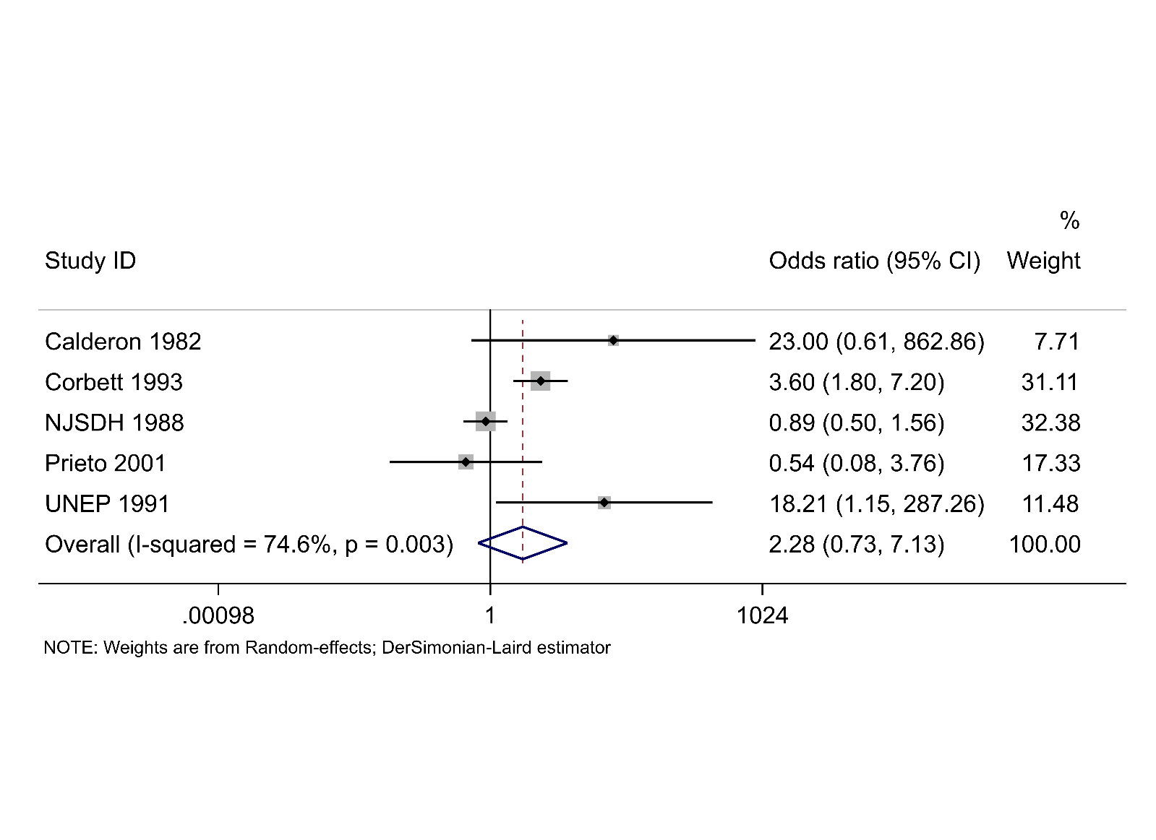Figure S5 Results of a random-effects meta-analysis to examine the risk of bathers reporting undefined cases of ear ailments compared to non-bathers.

#### **Gastrointestinal illnesses**

**E:\PhD\New folder\Systematic review\Publication\Int J Epi\Resubmission\High-resolution images\Figure 6 Gastrointestinal illness (sensitive case definition).tif**

Figure S6a Results of a random-effects meta-analysis to examine the risk of bathers reporting symptoms of gastrointestinal illness (sensitive case definitions) compared to non-bathers.

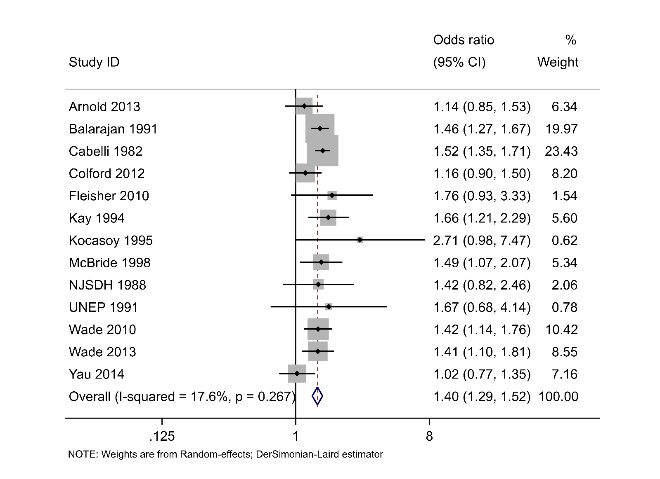

Figure S6b Results of a random-effects meta-analysis to examine the risk of bathers reporting symptoms of gastrointestinal illness (sensitive case definitions) compared to non-bathers. Results from studies in which the non-bathing control group included community (non-beach-going) controls have been excluded.

E:\PhD\New folder\Systematic review\Publication\Int J Epi\Resubmission\High-resolution images\Figure 7 Diarrhoea (Single symptom case definition).tif

Figure S7 Results of a random-effects meta-analysis to examine the risk of bathers reporting diarrhoea compared to non-bathers.

E:\PhD\New folder\Systematic review\Publication\Int J Epi\Resubmission\High-resolution images\Figure 8 Nausea (Single symptom case definition).tif

Figure S8 Results of a random-effects meta-analysis to examine the risk of bathers reporting nausea compared to non-bathers.

E:\PhD\New folder\Systematic review\Publication\Int J Epi\Resubmission\High-resolution images\Figure 9 Stomach ache (Single symptom case definition).tif

Figure S9 Results of a random-effects meta-analysis to examine the risk of bathers reporting stomach ache compared to non-bathers.

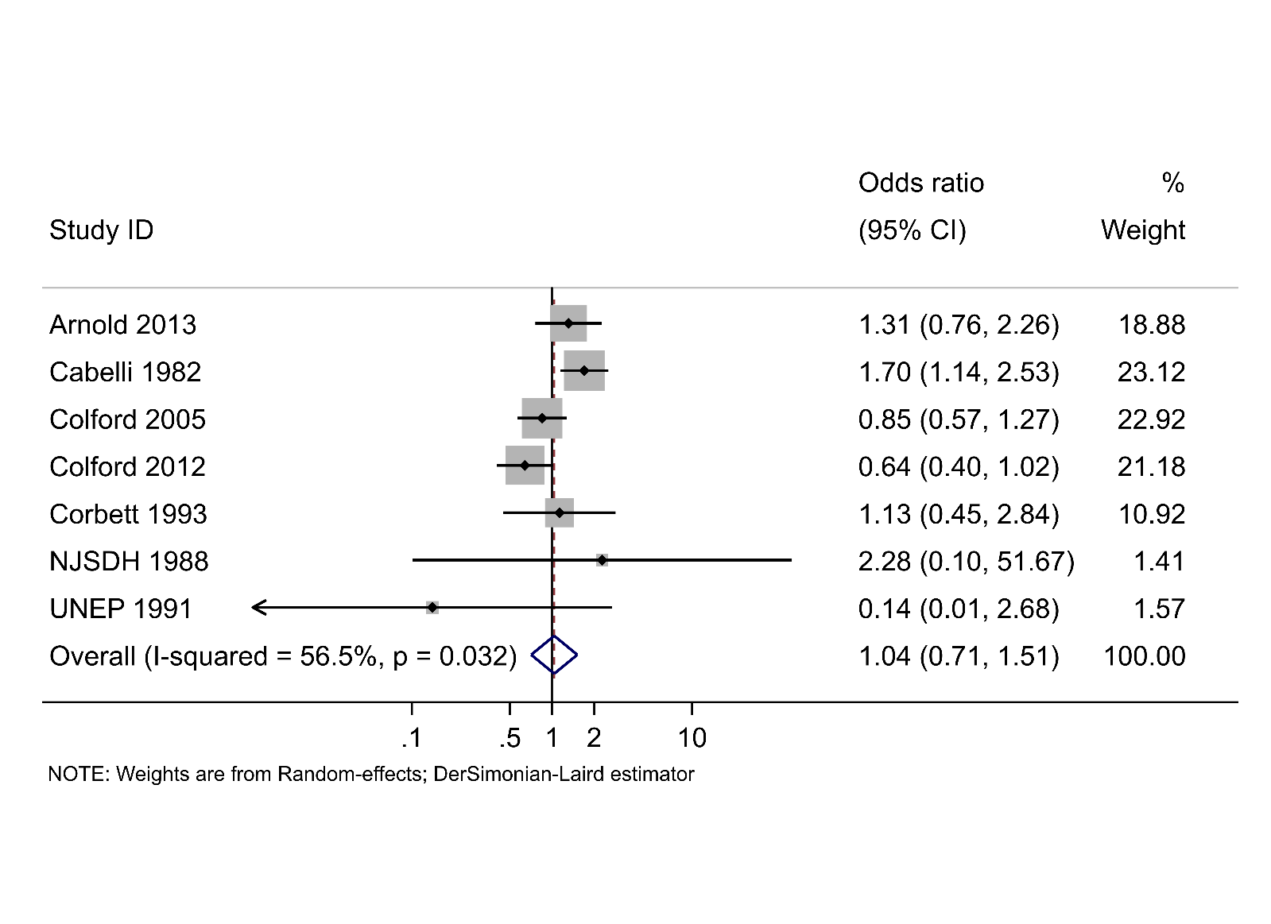

Figure S10 Results of a random-effects meta-analysis to examine the risk of bathers reporting vomiting compared to non-bathers.

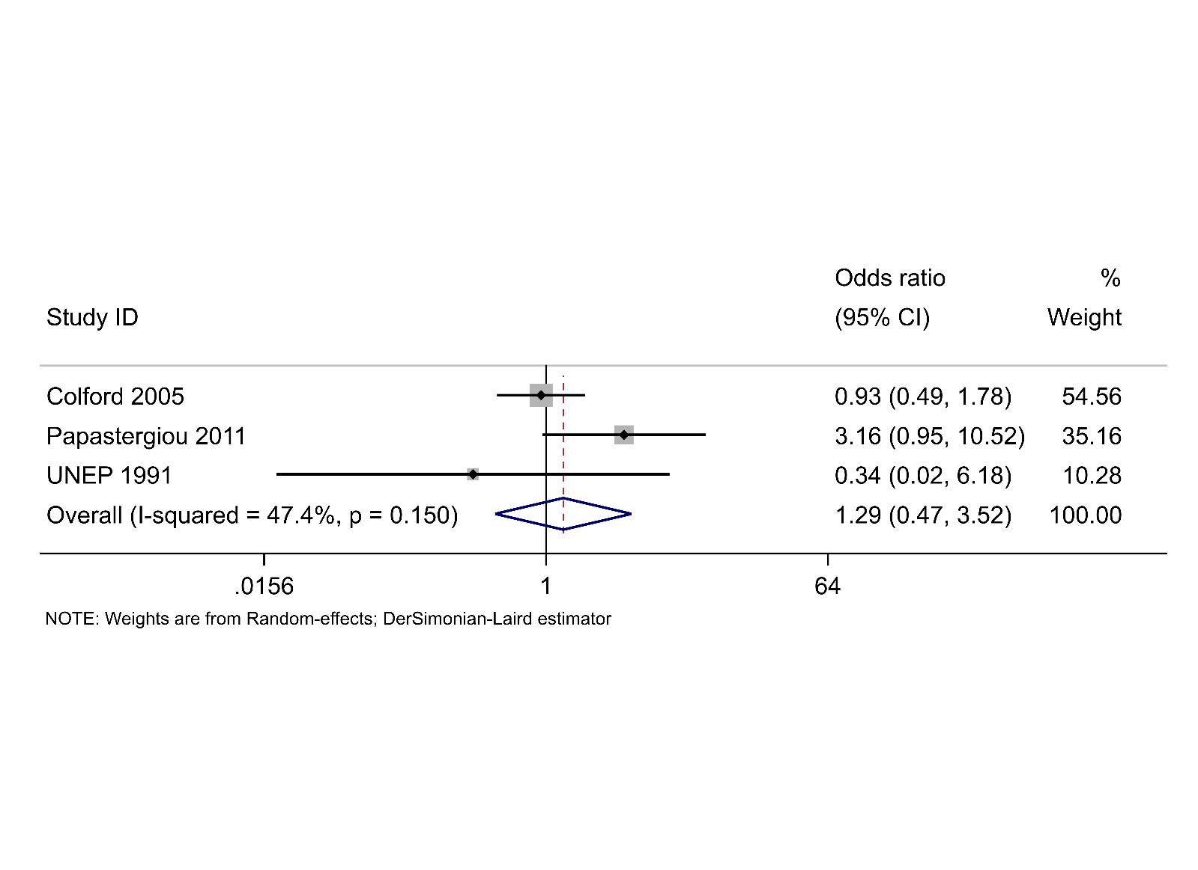

Figure S11 Results of a random-effects meta-analysis to examine the risk of bathers reporting gastrointestinal illness (specific case definitions) compared to non-bathers.

E:\PhD\New folder\Systematic review\Publication\Int J Epi\Resubmission\Resubmission2\analysese\SM\gicanttell.tifFigure S12 Results of a random-effects meta-analysis to examine the risk of bathers reporting undefined cases of gastrointestinal illness compared to non-bathers.

### 

### Bather head immersion analyses

#### **Any illness**

Four studies reported the risk of experiencing symptoms of any illness among only bathers who immersed their heads in seawater. Again, there is an increase in the risk of experiencing any symptoms of illness among these bathers compared to non-bathers (OR=1.91, 95% CI 1.40 to 2.60, p<0.001: Figure S13). Broadly, the odds ratio reported for bathers who immersed their heads compared to non-bathers was greater than the odds ratios reported for bathers reporting any kind of contact compared to non-bathers.



Figure S13 Results of a random-effects meta-analysis to examine the risk of reporting symptoms of any illness among bathers who immersed their heads in seawater compared to non-bathers.

#### **Ear ailments**

Sensitive case definitions: There is again an increase in the risk of experiencing this type of ear ailment among bathers reporting head immersion compared to non-bathers (OR=1.79, 95% CI 1.18 to 2.72, p=0.006: Figure S14). The point estimate is smaller than that reported for bathers with any kind of contact with water.

Earache (single symptom case definition): Bathers who reported head immersion are at greater risk of experiencing earache compared to non-bathers (OR=1.64, 95% CI 1.07 to 2.52, p=0.024: Figure S14). The point estimate is smaller than that reported for bathers with any kind of contact with water.

Ear discharge (single symptom case definition): Only one study (Colford 2005) reported this outcome in bathers who immersed their heads. As with bathers reporting any contact with seawater, there is little evidence of an association between bathing and experiencing ear discharge (OR=0.48, 95% CI 0.19 to 1.15, p=0.097).

Case definition not reported: Among bathers who immersed their heads, the risk of experiencing undefined cases of ear ailments is greater compared to non-bathers (OR=2.38, 95% CI 1.18 to 4.79, p=0.015: Figure S14). The point estimate is greater than that reported for the risk among bathers engaging in any kind of water activity.



Figure S14 Results of random-effects meta-analyses to examine the risk of reporting symptoms of ear ailments among bathers who immersed their heads in seawater compared to non-bathers.

#### **Gastrointestinal illnesses**

Sensitive: Bathers who immersed their heads in seawater are also at a higher risk of experiencing symptoms of gastrointestinal illness compared to non-bathers (odds ratio = 1.41, 95% CI 1.22 to 1.64, p<0.001: Figure S15). The OR reported for head immersion bathers compared to non-bathers is greater than the OR reported for bathers reporting any kind of contact compared to non-bathers. Heterogeneity was somewhat lower for this meta-analysis compared to that reported for bathers with any kind of exposure to seawater.



Figure S15 Results of a random-effects meta-analysis to examine the risk of reporting symptoms of gastrointestinal illness (sensitive case definitions) among bathers who immersed their heads in seawater compared to non-bathers.

Single: Bathers who immersed their heads in seawater are also at an increased risk of reporting diarrhoea and stomach ache compared to non-bathers: OR for diarrhoea=1.54, 95% CI 1.30 to 1.82, p<0.001; OR for stomach ache=1.31, 95% CI 1.14 to 1.50, p<0.001: Figure S16.

As with any exposure to seawater, there is no evidence of an increase in the risk of nausea or vomiting among bathers who immerse their heads compared to non-bathers: Or for nausea = 1.16, 95% CI 0.97 to 1.40, p=0.10; OR for vomiting = 1.07, 95% CI 0.74 to 1.53, p=0.72: Figure S16. The effect estimates for diarrhoea, nausea, stomach ache and vomiting are slightly larger compared those reported for bathers with any kind of contact with seawater.



Figure S16 Results of random-effects meta-analyses to examine the risk of reporting diarrhoea, nausea, stomach ache or vomiting among bathers who immersed their heads in seawater compared to non-bathers.

Specific: Among bathers who immerse their heads in water, there is an increase in the risk of reporting cases of gastrointestinal illness which require two or more symptoms to be reported together (OR 1.37, 95% CI 1.10 to 1.72, p=0.006: Figure S17).



Figure S17 Results of a random-effects meta-analysis to examine the risk of reporting symptoms of gastrointestinal illness (specific case definitions) among bathers who immersed their heads in seawater compared to non-bathers.

Case definition not reported: Bathers who immersed their heads in seawater are at an increased risk of experiencing these types of gastrointestinal illness compared to non-bathers (OR=1.30, 95% CI 1.05 to 1.60, p=0.016: Figure S18). The OR for experiencing gastrointestinal illness among head immersion bathers was smaller than the OR for bathers who reported any kind of contact with water.



Figure S18 Results of a random-effects meta-analysis to examine the risk of reporting symptoms of undefined cases of gastrointestinal illness among bathers who immersed their heads in seawater compared to non-bathers.

**Infections caused by specific microorganisms**

One study investigated the impact that immersing the head had upon the risk of acquiring an infection compared to non-bathers. Begier et al. (2008) reported that the risk of acquiring an echovirus infection among this group of bathers was OR=5.00, 95% CI 0.21 to 314 (not shown). This point estimate of 5.00 is somewhat lower than that reported in Figure 3 in the main text.

### Table S11 Summary of results of random-effects meta-analyses exploring the risk of illness in bathers with any kind of exposure to seawater compared to non-bathers, and bathers immersing their heads in seawater compared to non-bathers. * results from one study available.

|  |  |  |
| --- | --- | --- |
| **Health outcome** | **Any exposure**  **Odds ratio (95% confidence interval) [number of studies]** | **Head immersion**  **Odds ratio (95% confidence interval) [number of studies]** |
| **Any illness** | | |
| Any illness | 1.86 (1.31, 2.64) | 1.91 (1.40, 2.60) |
| **Ear ailments** | | |
| Sensitive case definitions | 2.05 (1.49, 2.82) | 1.79 (1.18, 2.72) |
| Ear ache (single symptom) | 1.77 (1.20, 2.63) | 1.64 (1.07, 2.52) |
| Ear discharge (single symptom) | 1.16 (0.08, 16.58) | 0.47 (0.19, 1.15)* |
| Specific case definitions | 8.56 (0.52, 140.5) | No studies |
| Case definitions not reported | 2.28 (0.73, 7.13) | 2.38 (1.18, 4.79) |
| **Gastrointestinal illnesses** | | |
| Sensitive case definitions | 1.29 (1.12, 1.49) | 1.35 (1.17, 1.55) |
| Sensitive case definitions (without studies including community subjects) | 1.40 (1.29, 1.52) | 1.37 (1.169, 1.58) |
| Diarrhoea (single symptom) | 1.44 (1.28, 1.63) | 1.54 (1.30, 1.82) |
| Nausea (single symptom) | 1.02 (0.84, 1.23) | 1.16 (0.97, 1.40) |
| Stomach ache (single symptom) | 1.27 (1.08, 1.49) | 1.31 (1.14, 1.50) |
| Vomiting (single symptom) | 1.04 (0.72, 1.51) | 1.07 (0.74, 1.54) |
| Specific case definitions | 1.29 (0.47, 3.52) | 1.37 (1.10, 1.72) |
| Case definitions not reported | 1.47 (0.96, 2.26) | 1.30 (1.05, 1.60) |

### Funnel plot

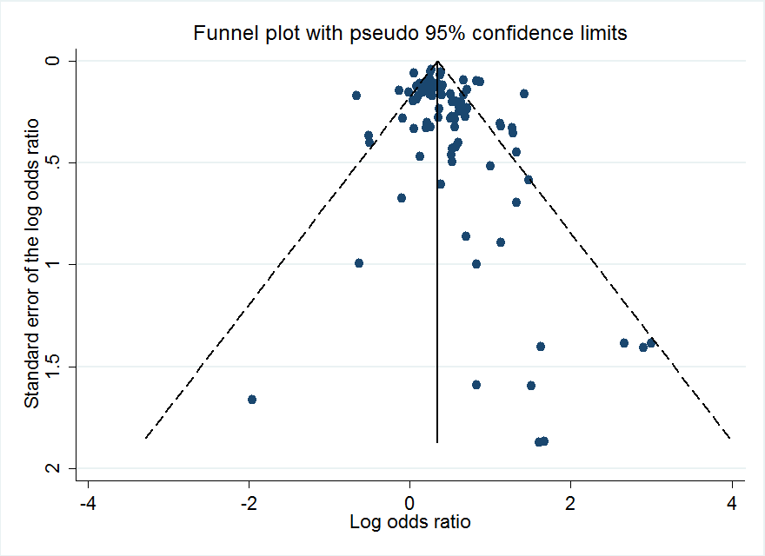

Figure S19. Funnel plot to assess publication bias in the systematic review

## **Results of sensitivity analyses**

### Table S12 Results of random-effects meta-analyses to estimate the risk of illness to bathers in studies conducted after 2006

|  |  |  |
| --- | --- | --- |
| **Health outcome** | **Results of any exposure meta-analysis**  **Odds ratio (95% confidence interval)** | **Post-2006 meta-analysis**  **Odds ratio (95% confidence interval) p-value** |
| **Any illness** | | |
| Any illness | 1.86 (1.31, 2.64) | No studies |
| **Ear ailments** | | |
| Sensitive case definitions | 2.05 (1.49, 2.82) | 1.97 (1.13, 3.43) p=0.017 |
| Ear ache (single symptom) | 1.77 (1.20, 2.63) | 2.07 (1.58, 2.70) p<0.001 |
| Ear discharge (single symptom) | 1.16 (0.08, 16.58) | 6.51 (0.39, 107.6) p=0.191* |
| Specific case definitions | 8.56 (0.52, 140.5) | No studies |
| Case definitions not reported | 2.28 (0.73, 7.13) | No studies |
| **Gastrointestinal illnesses** | | |
| Sensitive case definitions | 1.29 (1.12, 1.49) | 1.23 (1.06, 1.42) p=0.005 |
| Sensitive case definitions (without studies including community subjects) | 1.40 (1.29, 1.52) | 1.26 (1.11, 1.42) p<0.001 |
| Diarrhoea (single symptom) | 1.44 (1.28, 1.63) | 1.38 (1.19, 1.61) p<0.001 |
| Nausea (single symptom) | 1.02 (0.84, 1.23) | 0.99 (0.74, 1.34) p=0.963 |
| Stomach ache (single symptom) | 1.27 (1.08, 1.49) | 1.23 (0.97, 10.51) p=0.084 |
| Vomiting (single symptom) | 1.04 (0.72, 1.51) | 0.90 (0.45, 1.82) p=0.77 |
| Specific case definitions | 1.29 (0.47, 3.52) | 3.16 (0.95, 10.5) p=0.061 |
| Case definitions not reported | 1.47 (0.96, 2.26) | No studies |

Comparing effect sizes from studies conducted in different regions of the world

Regional differences in risk were explored by categorising studies into three geographic regions depending upon where they were conducted: Europe, North America and Oceania. Despite high levels of heterogeneity between the regional subgroups, meta-regression indicated little evidence to suggest that observed heterogeneity was due to region.

### Table S13 Results of sensitivity analyses to explore the impact of geographical region on the effect sizes of the different health outcomes

|  |  |  |  |  |
| --- | --- | --- | --- | --- |
| Health outcome | Risk of illness in European countries  [Number of studies] | Risk of illness in North American countries  [Number of studies] | Risk of illness in countries in Oceania  [Number of studies] | Effect of region risk of health outcome (results of meta-regression) |
| **ANY CONTACT WITH SEAWATER** | | | | |
| **Any illness** | | | | |
| Symptoms of any illness | 1.82 (0.93, 3.54), p=0.079 [4] | 1.95 (1.62, 2.34), p<0.001 [1] | 1.90 (1.30, 2.64), p<0.001 [1] | P=0.99 |
| **Ear ailments** | | | | |
| Sensitive case definitions | 5.58 (1.12, 28.0), p=0.036 [2] | 1.79 (1.42, 2.25), p<0.001 [4] | No studies | P=0.10 |
| Earache | 2.89 (1.55, 5.39), p=0.001 [1] | 1.59 (1.06, 2.38), p=0.024 [4] | No studies | P=0.31 |
| Ear discharge | 6.51 (0.39, 107.6), p=0.19 [1] | 0.40 (0.16, 1.01), p=0.051 [1] | No studies | Insufficient observations |
| Case definitions not reported | 2.71 (0.09, 85.0) p=0.57 [2] | 2.70 (0.13, 55.9) p=0.52 [2] | 3.60 (1.80, 7.20) p<0.001 [1] | P=0.99 |
| **Gastrointestinal illnesses** | | | | |
| Sensitive case definition | 1.58 (1.33, 1.88), p<0.001 [5] | 1.19 (0.97, 1.46), p=0.098 [9] | 1.21 (0.86, 1.69), p=0.271 [2] | P=0.19 |
| Diarrhoea | 1.44 (0.93, 2.23), p=0.12 [4] | 1.47 (1.27, 1.70), p<0.001 [7] | 1.69 (0.99, 2.89), p=0.056 [1] | P=0.75 |
| Nausea | 4.52 (0.20, 102.6), p=0.34 [1] | 1.01 (0.84, 1.23), p=0.89 [5] | No studies | P=0.41 |
| Stomach ache | 3.16 (0.95, 10.5), p=0.061 [1] | 1.25 (1.08, 1.49), p=0.001 [5] | No studies | P=0.21 |
| Vomiting | 0.14 (0.01, 3.67), p=0.24 [1] | 1.06 (0.70, 1.62), p=0.78 [5] | 1.13 (0.45, 2.85), p=0.80 [1] | P=0.55 |
| Specific case definitions | 1.56 (0.20, 11.9), p=0.670 [2] | 0.93 (0.49, 1.78) p=0.41 [1] | No studies | P=0.77 |
| Case definitions not reported | 2.24 (1.26, 400) p= 0.006 [3] | 1.04 (0.71, 1.52) p=0.85 [1] | 1.50 (0.82, 2.76) p=0.19 [1] | P=0.41 |
| **HEAD IMMERSION** | | | | |
| **Any illness** | | | | |
| Any illness | 1.60 (0.52, 4.98) p=0.41 [2] | 2.29 (1.89, 2.77) p<0.001 [1] | 1.90 (1.45, 2.79) p<0.001 [1] | 0.93 |
| **Ear ailments** | | | | |
| Sensitive case definitions | 1.60 (0.45, 5.61) p=0.47 [2] | 1.97 (1.52, 2.57) p<0.001 [3] | No studies | 0.69 |
| Ear ache | 0.89 (0.48, 1.66) p=0.71 [1] | 1.86 (1.20, 2.90) p=0.006 [4] | No studies | 0.27 |
| Ear discharge | 0.47 (0.19, 1.15) p=0.097 [1] | No studies | No studies | Insufficient observations |
| Specific case definitions | No studies | No studies | No studies | Insufficient observations |
| Case definitions not reported | No studies | 1.75 (1.14, 2.68) p=0.01 [1] | 3.60 (1.80, 7.20) p<0.001 [1] | Insufficient observations |
| **Gastrointestinal illnesses** | | | | |
| Sensitive case definitions | 1.35 (0.82, 2.22) p=0.24 [2] | 1.35 (1.14, 1.59) p=0.001 [7] | 1.21 (0.71, 2.07) p=0.49 [1] | 0.94 |
| Diarrhoea | 1.61 (0.97, 2.66) p=0.066 [3] | 1.50 (1.19, 1.89) p<0.001 [5] | 1.69 (0.99, 2.89) p=0.056 [1] | 0.94 |
| Nausea | 4.52 (0.20, 102.6) p=0.34 [1] | 1.16 (0.96, 1.39) p=0.12 [5] | No studies | 0.44 |
| Health outcome | Risk of illness in European countries  [Number of studies] | Risk of illness in North American countries  [Number of studies] | Risk of illness in countries in Oceania  [Number of studies] | Effect of region risk of health outcome (results of meta-regression) |
| Stomach ache | No studies | 1.31 (1.14, 1.50) p<0.001 [5] | No studies | Insufficient observations |
| Vomiting | No studies | 1.06 (0.70, 1.62) p=0.78 [5] | 1.13 (0.45, 2.85) p=0.80 [1] | 0.92 |
| Specific case definitions | 1.35 (0.64, 2.85) p=0.43 n=1 | 1.47 (1.12, 1.92) p=0.005 n=3 | No studies | 0.88 |
| Case definitions not reported | 1.96 (1.62, 2.38) p<0.001 [2] | 1.25 (0.92, 1.69) p=0.15 [2] | 1.50 (0.82, 2.76) p=0.19 [1] | 0.22 |

### Table S14 Effect size estimates pooled separately by observational studies and randomised controlled trials

|  |  |  |  |  |
| --- | --- | --- | --- | --- |
| **Health outcome** | **Results of meta-analysis**  **Odds ratio (95% CI)** | **Observational studies only**  **Odds ratio (95% CI)** | **Randomised controlled trials only**  **Odds ratio (95% CI)** | **Effect of study design on effect size (results of meta-regression)** |
| **Any illness** | | | |  |
| Any illness | 1.86 (1.31, 2.64) | 1.86 (1.31, 2.64) | No studies | Not applicable |
| **Ear ailments** | | | |  |
| Sensitive case definitions | 2.05 (1.49, 2.82) | 1.89 (1.30, 2.74) | 2.92 (1.65, 5.16) | P=0.31 |
| Ear ache (single symptom) | 1.77 (1.20, 2.63) | 1.77 (1.20, 2.63) | No studies | Not applicable |
| Ear discharge (single symptom) | 1.16 (0.08, 16.58) | 1.16 (0.08, 16.58) | No studies | Not applicable |
| Specific case definitions | 8.56 (0.52, 140.5) | 8.56 (0.52, 140.5) | No studies | Not applicable |
| Case definitions not reported | 2.28 (0.73, 7.13) | 2.28 (0.73, 7.13) | No studies | Not applicable |
| **Gastrointestinal illnesses** | | | |  |
| Sensitive case definitions | 1.29 (1.12, 1.49) | 1.26 (1.08, 1.46) | 1.68 (1.26, 2.24) | P=0.31 |
| Sensitive case definitions (without studies including community subjects) | 1.40 (1.29, 1.52) | 1.38 (1.26, 1.50) | 1.68 (1.26, 2.24) | P=0.24 |
| Diarrhoea (single symptom) | 1.44 (1.28, 1.63) | 1.42 (1.28, 1.58) | 3.20 (1.74, 8.04) | P=0.13 |
| Nausea (single symptom) | 1.02 (0.84, 1.23) | 1.01 (0.84, 1.23) | 4.52 (0.20, 102.61) | P=0.41 |
| Stomach ache (single symptom) | 1.27 (1.08, 1.49) | 1.27 (1.08, 1.49) | No studies | Not applicable |
| Vomiting (single symptom) | 1.04 (0.72, 1.51) | 1.04 (0.72, 1.51) | No studies | Not applicable |
| Specific case definitions | 1.29 (0.47, 3.52) | 1.29 (0.47, 3.52) | No studies | Not applicable |
| Case definitions not reported | 1.47 (0.96, 2.26) | 1.47 (0.96, 2.26) | No studies | Not applicable |

#### 

Table S15 Results of random-effects meta-analysis to explore the effect on the risk of illness in bathers if data on rates of illness 3 days after bathing were available.

|  |  |  |
| --- | --- | --- |
| **Health outcome** | **Results of Main meta-analysis (any exposure)**  **Odds ratio (95% confidence interval)** | **Risk of illness at 3 days (if available)**  **Odds ratio (95% confidence interval)** |
| **Any illness** | | |
| Any illness | 1.86 (1.31, 2.64) | Not applicable |
| **Ear ailments** | | |
| Sensitive case definitions | 2.05 (1.49, 2.82) | Not applicable |
| Ear ache (single symptom) | 1.77 (1.20, 2.63) | Not applicable |
| Ear discharge (single symptom) | 1.16 (0.08, 16.58) | Not applicable |
| Specific case definitions | 8.56 (0.52, 140.5) | Not applicable |
| Case definitions not reported | 2.28 (0.73, 7.13) | Not applicable |
| **Gastrointestinal illnesses** | | |
| Sensitive case definitions | 1.29 (1.12, 1.49) | 1.32 (1.13, 1.53) |
| Diarrhoea (single symptom) | 1.44 (1.28, 1.63) | 1.46 (1.32, 1.61) |
| Nausea (single symptom) | 1.02 (0.84, 1.23) | Not applicable |
| Stomach ache (single symptom) | 1.27 (1.08, 1.49) | Not applicable |
| Vomiting (single symptom) | 1.04 (0.72, 1.51) | Not applicable |
| Specific case definitions | 1.29 (0.47, 3.52) | Not applicable |
| Case definitions not reported | 1.47 (0.96, 2.26) | Not applicable |

### Table S16 Results of sensitivity analyses to explore the effects of excluding studies that were not peer-reviewed

|  |  |  |
| --- | --- | --- |
| **Health outcome** | **Results of Main meta-analysis (any exposure)** | **Peer-reviewed estimate** |
| **Any illness** | | |
| Symptoms of any illness (Figure 2) | 1.86 (1.31, 2.64) | 1.84 (1.15, 2.94) p=0.011  I2=92.3% |
| **Ear ailments** | | |
| Ear ailments (sensitive case definitions) (Figure 3) | 2.05 (1.49, 2.82) p<0.0001 | Not applicable |
| Earache (Figure 3) | 1.77 (1.20, 2.63) | Not applicable |
| Ear discharge (Figure 3) | 1.16 (0.08, 16.58) p=0.911 | Not applicable |
| **Gastrointestinal illnesses** | | |
| Gastrointestinal illness (sensitive case definition) (Figure 4) | 1.29 (1.12, 1.49) p=0.000 | 1.29 (1.11, 1.49) p=0.001  I2=78.8 |
| Diarrhoea (Figure 4) | 1.44 (1.28, 1.63) p=0.000 | 1.45 (1.28, 1.64) p=0.000  I2= 26.0% |
| Nausea (Figure 4) | 1.02 (0.84, 1.23) p=0.844 | 1.03 (0.87, 1.23) p=0.714  I2= 0% |
| Stomach ache (Figure 4) | 1.27 (1.08, 1.49) p=0.004 | 1.26 (1.06, 1.60) p = 0.008  I2=33.1% |
| Vomiting (Figure 4) | 1.04 (0.72, 1.51) p=0.85 | 1.03 (0.70, 1.52) p= 0.89 I2=62.4% |
| Gastrointestinal illness (specific case definitions) (Figure 5) | 1.29 (0.47, 3.52) | Not applicable |

# References of the included studies

Abdelzaher AM, Wright ME, Ortega C, Hasan AR, Shibata T, Solo-Gabriele HM, et al. 2011. Daily measures of microbes and human health at a non-point source marine beach. Journal of Water and Health 9:443-457.

Alexander LM, Heaven A, Tennant A, Morris R. 1992. Symptomatology of children in contact with sea water contaminated with sewage. Journal of Epidemiology and Community Health 46:340-344.

Arnold BF, Schiff KC, Griffith JF, Gruber JS, Yau V, Wright CC, et al. 2013. Swimmer illness associated with marine water exposure and water quality indicators: Impact of widely used assumptions. Epidemiology 24:845-853.

Balarajan R, Soni Raleigh V, Yuen P, Wheeler D, Machin D, Cartwright R. 1991. Health risks associated with bathing in sea water. BMJ 303:1444-1445.

Begier EM, Oberste MS, Landry ML, Brennan T, Mlynarski D, Mshar PA, et al. 2008. An outbreak of concurrent echovirus 30 and coxsackievirus a1 infections associated with sea swimming among a group of travelers to mexico. Clinical Infectious Diseases 47:616-623.

Bonilla TD, Nowosielski K, Cuvelier M, Hartz A, Green M, Esiobu N, et al. 2007. Prevalence and distribution of fecal indicator organisms in south florida beach sand and preliminary assessment of health effects associated with beach sand exposure. Marine Pollution Bulletin 54:1472-1482.

Brown JM, Campbell EA, Rickards AD, Wheeler D. 1987. Sewage pollution of bathing water. Lancet 2:1208-1209.

Cabelli V, Dufour A, Levin MA. 1975. The impact of pollution on marine bathing beaches: An epidemiological study. (Middle Atlantic continental shelf and the New York Bight Special Symposia). Lawrence, Kansas:American Society of Limnology and Oceanography.

Cabelli V. 1983. Health effects criteria for marine recreational waters.United States Environmental Protection Agency.

Cabelli VJ, Levin MA, Dufour A, McCabe LJ. 1975. The development of criteria for bathing waters. In: Discharge of sewage from sea outfalls: Proceedings of an international symposium held at church house, london, 27 august to 2 september 1974 (Gameson ALH, ed). London:Pergamon 63 - 73.

Cabelli VJ, Dufour AP, Levin MA, McCabe LJ, Haberman PW. 1979. Relationship of microbial indicators to health effects at marine bathing beaches. American Journal of Public Health 69:690-696.

Cabelli VJ, Dufour AP, McCabe LJ, Levin MA. 1982. Swimming-associated gastroenteritis and water quality. American Journal of Epidemiology 115:606-616.

Cabelli VJ, Dufour AP, McCabe LJ, Levin MA. 1983. A marine recreational water quality criterion consistent with indicator concepts and risk analysis. Journal of the Water Pollution Control Federation 55:1306-1314.

Calderon R, Mood EW. 1982. An epidemioloical assessment of water quality and "swimmer's ear". Archives of Environmental Health 37:300-305.

Charoenca N, Fujioka RS. 1995. Association of staphylococcal skin infections and swimming. Water Science and Technology 31:11-17.

Colford JM, Wade TJ, Schiff K, Wright C, Griffith JF, Sandhu SK, et al. 2005. Recreational water contact and illness in mission bay, california. Technical report.Southern California Coastal Water Research Project.

Colford JM, Wade TJ, Schiff KC, Wright CC, Griffith JF, Sandhu SK, et al. 2007. Water quality indicators and the risk of illness at beaches with nonpoint sources of fecal contamination. Epidemiology 18:27-35.

Colford JM, Schiff KC, Griffith JF, Yau V, Arnold BF, Wright CC, et al. 2012. Using rapid indicators for enterococcus to assess the risk of illness after exposure to urban runoff contaminated marine water. Water Research 46:2176-2186.

Corbett SJ, Rubin GL, Curry GK, Kleinbaum DG. 1993. The health effects of swimming at sydney beaches. The sydney beach users study advisory group. American Journal of Public Health 83:1701-1706.

Dale K, Wolfe R, Sinclair M, Hellard M, Leder K. 2009. Sporadic gastroenteritis and recreational swimming in a longitudinal community cohort study in melbourne, australia. American Journal of Epidemiology 170:1469-1477.

Dwight RH, Baker DB, Semenza JC, Olson BH. 2004. Health effects associated with recreational coastal water use: Urban versus rural california. American Journal of Public Health 94:565-567.

Esiobu N, Green M, Echeverry A, Bonilla TD, Stinson CM, Hartz A, et al. 2013. High numbers of staphylococcus aureus at three bathing beaches in south florida. International Journal of Environmental Health Research 23:46-57.

Fewtrell L, Kay D, Salmon RL, Wyer MD, Newman G, Bowering G. 1994. The health effects of low-contact water activities in fresh and estuarine waters. Journal of the Institution of Water and Environmental Management 8:97-101.

Fleisher JM, Jones F, Kay D, Stanwell-Smith R, Wyer M, Morano R. 1993. Water and non-water-related risk factors for gastroenteritis among bathers exposed to sewage-contaminated marine waters. International Journal of Epidemiology 22:698-708.

Fleisher JM, Kay D, Salmon RL, Jones F, Wyer MD, Godfree AF. 1996. Marine waters contaminated with domestic sewage: Nonenteric illnesses associated with bather exposure in the united kingdom. American Journal of Public Health 86:1228-1234.

Fleisher JM, Kay D, Wyer MD, Godfree AF. 1998. Estimates of the severity of illnesses associated with bathing in marine recreational waters contaminated with domestic sewage. International Journal of Epidemiology 27:722-726.

Fleisher JM, Kay D. 2006. Risk perception bias, self-reporting of illness, and the validity of reported results in an epidemiologic study of recreational water associated illnesses. Marine Pollution Bulletin 52:264-268.

Fleisher JM, Fleming LE, Solo-Gabriele HM, Kish JK, Sinigalliano CD, Plano L, et al. 2010. The beaches study: Health effects and exposures from non-point source microbial contaminants in subtropical recreational marine waters. International Journal of Epidemiology 39:1291-1298.

Fleming LE, Solo-Gabriele H, Elmir S, Shibata T, Squicciarini DJ, Quirino W, et al. 2004. A pilot study of microbial contamination of subtropical recreational waters. Fla J Environ Health 1:29.

Fleming LE, Solo-Gabriele H, Fleisher J, Elmir S, Sinigalliano C, Plano L, et al. 2008. Final report on the pilot epidemiologic assessment of microbial indicators for monitoring recreational water quality in marine subtropical environments.

Gammie A, Morris R, Wyn-Jones AP. 2002. Antibodies in crevicular fluid: An epidemiological tool for investigation of waterborne disease. Epidemiology and Infection 128:245-249.

Gammie AJ, Wyn-Jones AP. 1997. Does hepatitis a pose a significant health risk to recreational water users? Water Science and Technology 35:171-177.

Haile RW, Alamillo J, Barrett K, Cressey R, Dermond J, Ervin C, et al. 1996. An epidemiological study of possible adverse health effects of swimmin in santa monica bay.

Haile RW, Witte JS, Gold M, Cressey R, McGee C, Millikan RC, et al. 1999. The health effects of swimming in ocean water contaminated by storm drain runoff. Epidemiology 10:355-363.

Harder-Lauridsen NM, Kuhn KG, Erichsen AC, Molbak K, Ethelberg S. 2013. Gastrointestinal illness among triathletes swimming in non-polluted versus polluted seawater affected by heavy rainfall, denmark, 2010-2011. PLoS One 8:e78371.

Harding AK, Stone DL, Cardenas A, Lesser V. 2015. Risk behaviors and self-reported illnesses among pacific northwest surfers. Journal of Water & Health 13.

Harrington JF, Wilcox DN, Giles PS, Ashbolt NJ, Evans JC, Kirton HC. 1993. The health of sydney surfers - an epidemiologic study. Water Science and Technology 27:175-181.

Hoque ME, Hope VT, Kjellstrom T, Scragg R, Lay-Yee R. 2002. Risk of giardiasis in aucklanders: A case-control study. International Journal of Infectious Diseases 6:191-197.

Ihekweazu C, Barlow M, Roberts S, Christensen H, Guttridge B, Lewis D, et al. 2006. Outbreak of e. Coli o157 infection in the south west of the uk: Risks from streams crossing seaside beaches. Euro surveillance : bulletin europeen sur les maladies transmissibles = European communicable disease bulletin 11:128-130.

Jones F, Kay D, Stanwell-Smith R, Wyer M. 1991. Results of the first pilot-scale controlled cohort epidemiological investigation into the possible health effects of bathing in seawater at langland bay, swansea. Journal of the Institution of Water and Environmental Management 5:91-98.

Kay D, Fleisher JM, Salmon RL, Jones F, Wyer MD, Godfree AF, et al. 1994. Predicting likelihood of gastroenteritis from sea bathing: Results from randomised exposure. Lancet (North American Edition) 344:905-909.

Kocasoy G. 1989. The relationship between coastal tourism, sea pollution and public health: A case study from turkey. Environmentalist 9:245-251.

Kocasoy G. 1995. Waterborne disease incidences in the mediterranean region as a function of microbial pollution and t90. Water Science and Technology 32:257-266.

Ktsanes VK, Anderson A, Diem JE. 1981. Health effects of swimming in lake pontchartrain at new orleans.United States Environmental Protection Agency.

Lepesteur M, McComb AJ, Moore SA. 2006. Do we all face the same risk when bathing in the estuary? Water Research 40:2787-2795.

Marino FJ, Morinigo MA, Martinezmanzanares E, Borrego JJ. 1995. Microbiological-epidemiological study of selected marine beaches in malaga (spain) Water Science and Technology 31:5-9.

McBride GB, Salmond CE, Bandaranayake, Turner SJ, Lewis GD, Till DG. 1998. Health effects of marine bathing in new zealand. International Journal of Environmental Health Research 8:173-189.

Morens DM, Roll KK, Fujioka RS. 1994. A pilot epidemiological study of health risks associated with swimming at kuhio beach.State of Hawaii Department of Health.

Nelson C, Williams AT. 1997. Bathing water quality and health implications.

New Jersey State Department of Health. 1988. A study of the relationship between illnesses and ocean beach water quality: A progress report.Environmental Health Service Division of Occupational and Environmental Health.

OECD. 2016. List of oecd member countries - ratification of the convention on the oecd.

Papastergiou P, Mouchtouri VA, Rachiotis G, Pinaka O, Katsiaflaka A, Hadjichristodoulou C. 2011. Bather density as a predominant factor for health effects related to recreational bathing: Results from the greek bathers cohort study. Marine Pollution Bulletin 62:590-595.

Papastergiou P, Mouchtouri V, Pinaka O, Katsiaflaka A, Rachiotis G, Hadjichristodoulou C. 2012. Elevated bathing-associated disease risks despite certified water quality: A cohort study. International Journal of Environmental Research and Public Health 9:1548-1565.

Pike EB. 1990. Health effects of sea bathing (et 9511 slg) phase i – pilot studies at langland bay 1989. Water Research Centre plc, Medmenham.

Pike EB. 1992. Health effects of sea bathing (eh 9021). Phase iii studies in 1991. Interim report, april 1991 to march 1992. WRc plc, Medmenham

Pike EB. 1994. Health effects of sea bathing (wm1 9021) – phase iii (final report to the department of the environment).WRc Report, Water Research Centre plc.

Prieto MD, Lopez B, Juanes JA, Revilla JA, Llorca J, Delgado-Rodriguez M. 2001. Recreation in coastal waters: Health risks associated with bathing in sea water. Journal of Epidemiology and Community Health 55:442-447.

Reed C, Von Reyn CF, Chamblee S, Ellerbrock TV, Johnson JW, Marsh BJ, et al. 2006. Environmental risk factors for infection with mycobacterium avium complex. American Journal of Epidemiology 164:32-40.

Roy SL, DeLong SM, Stenzel SA, Shiferaw B, Roberts JM, Khalakdina A. 2004. Risk factors for sporadic cryptosporidiosis among immunocompetent persons in the united states from 1999 to 2001. Journal of Clinical Microbiology 42:2944-2951.

Sinigalliano CD, Fleisher JM, Gidley ML, Solo-Gabriele HM, Shibata T, Plano LRW, et al. 2010. Traditional and molecular analyses for fecal indicator bacteria in non-point source subtropical recreational marine waters. Water Research 44:3763-3772.

Soraas A, Sundsfjord A, Sandven I, Brunborg C, Jenum PA. 2013. Risk factors for community-acquired urinary tract infections caused by esbl-producing enterobacteriaceae -a case-control study in a low prevalence country. PLoS One 8:e69581.

UNEP, WHO. 1991. Epidemiological studies related to environmental quality criteria for bathing waters, shellfish growing waters and edible marine organisms (activity d). Final report on epidemiological study on bathers from selected beaches in malaga, spain (MAP Technical reports series no 53). Athens.

Wade TJ, Sams E, Brenner KP, Haugland R, Chern E, Beach M, et al. 2010a. Rapidly measured indicators of recreational water quality and swimming-associated illness at marine beaches: A prospective cohort study. Environmental health : a global access science source 9:66.

Wade TJ, Sams E, Haugland R, Brenner P, Li Q, Wymer L, et al. 2010b. Report on 2009 national epidemiological and environmental assessmen of recreational water epidemiology studies.United States Environmental Protection Agency.

Wade TJ, Converse RR, Sams E, Williams AH, Hudgens E, Dufour A. 2011. Gastrointestinal symptoms among swimmers following rain events at a beach impacted by urban runoff (poster). (Agency USEP, ed).

Wade TJ, Converse RR, Sams EA, Williams AH, Hudgens E, Dufour AP. 2013. Gastrointestinal symptoms among swimmers following rain events at a beach impacted by urban runoff. American Journal of Epidemiology 177:S157.

Yau VM, Schiff KC, Arnold BF, Griffith JF, Gruber JS, Wright CC, et al. 2014. Effect of submarine groundwater discharge on bacterial indicators and swimmer health at avalon beach, ca, USA. Water Research 59:23-36.