Supplementary material
Table 1. Age-standardized alcohol-attributable mortality rates (per 100,000) in European countries, 1990-2013, by sex
Men |  |  |  |  |  |  |  | Women
 | 1990 | 1995 | 2000 | 2005 | 2010 | 2013 |  | 1990 | 1995 | 2000 | 2005 | 2010 | 2013
Belarus | 139.4 | 218.6 | 220.1 | 231.0 | 240.2 | 238.0 |  | 85.0 | 120.2 | 120.7 | 119.4 | 124.6 | 127.1
Czech Republic | 88.0 | 87.3 | 87.5 | 85.0 | 70.9 | 59.4 |  | 27.4 | 27.9 | 26.3 | 25.6 | 20.3 | 16.1
Estonia | 114.8 | 141.1 | 130.9 | 147.0 | 110.0 | 98.5 |  | 67.8 | 28.4 | 28.4 | 29.4 | 20.5 | 17.1
Hungary | 216.0 | 228.7 | 188.4 | 170.0 | 133.8 | 114.8 |  | 66.1 | 63.1 | 52.0 | 46.4 | 35.2 | 29.4
Latvia | 137.5 | 184.2 | 152.4 | 153.4 | 115.5 | 99.0 |  | 78.3 | 41.7 | 34.7 | 38.0 | 28.2 | 20.8
Lithuania | 103.4 | 146.3 | 139.3 | 179.8 | 147.4 | 134.6 |  | 62.8 | 30.5 | 30.9 | 42.3 | 36.7 | 31.8
Poland | 98.4 | 96.8 | 96.4 | 102.7 | 100.1 | 93.4 |  | 26.3 | 24.3 | 23.5 | 22.6 | 22.3 | 20.6
Russia | 156.4 | 299.5 | 288.7 | 342.7 | 243.9 | 190.3 |  | 74.8 | 121.3 | 124.5 | 145.7 | 118.0 | 97.3
Ukraine | 124.4 | 151.7 | 172.3 | 255.5 | 193.0 | 159.3 |  | 82.5 | 97.2 | 97.6 | 131.2 | 112.2 | 98.4
Austria | 90.3 | 81.0 | 72.9 | 65.8 | 50.4 | 41.0 |  | 34.0 | 30.2 | 28.5 | 23.2 | 17.0 | 14.4
Belgium | 55.5 | 56.6 | 56.4 | 52.0 | 49.2 | 45.0 |  | 26.4 | 25.8 | 24.6 | 23.5 | 22.6 | 20.9
Denmark | 46.0 | 52.0 | 58.3 | 61.4 | 54.2 | 45.6 |  | 32.5 | 33.7 | 32.7 | 31.1 | 26.2 | 23.0
Finland | 60.5 | 52.0 | 56.6 | 64.0 | 57.2 | 50.8 |  | 24.1 | 19.3 | 20.5 | 22.8 | 19.9 | 17.2
France | 93.8 | 84.2 | 75.6 | 66.0 | 60.9 | 55.8 |  | 24.9 | 22.4 | 20.4 | 18.1 | 17.2 | 15.8
Germany | 58.1 | 57.1 | 53.9 | 48.7 | 47.4 | 43.1 |  | 21.1 | 19.8 | 20.3 | 18.5 | 18.1 | 16.2
Greece | 56.0 | 46.9 | 43.3 | 39.7 | 37.3 | 35.1 |  | 18.9 | 15.7 | 14.4 | 12.5 | 10.1 | 9.5
Ireland | 34.3 | 40.3 | 45.8 | 39.7 | 35.0 | 31.0 |  | 25.7 | 29.1 | 28.8 | 25.0 | 21.3 | 19.2
Italy | 62.9 | 51.0 | 42.1 | 34.0 | 27.2 | 23.6 |  | 25.0 | 20.7 | 16.6 | 13.3 | 11.0 | 10.2
Luxembourg | 66.8 | 64.9 | 64.7 | 59.6 | 44.7 | 38.4 |  | 28.0 | 24.7 | 26.2 | 23.3 | 20.1 | 17.8
Netherlands | 34.8 | 36.2 | 39.5 | 34.9 | 31.6 | 30.0 |  | 20.9 | 20.6 | 22.3 | 19.9 | 17.4 | 17.6
Portugal | 123.9 | 109.4 | 95.2 | 84.9 | 72.6 | 68.7 |  | 40.6 | 34.1 | 29.3 | 24.8 | 20.3 | 18.7
Spain | 86.2 | 72.3 | 65.1 | 58.5 | 46.7 | 43.8 |  | 30.4 | 24.7 | 21.3 | 19.0 | 16.7 | 15.6
Sweden | 25.3 | 22.1 | 22.3 | 24.2 | 23.1 | 21.2 |  | 19.0 | 16.1 | 15.6 | 15.7 | 14.3 | 13.6
UK | 26.2 | 26.6 | 31.8 | 35.5 | 32.7 | 27.2 |  | 26.4 | 23.1 | 24.0 | 24.4 | 21.3 | 18.5
Source: GBD Study 2013.
Figure 1. Life expectancy at birth (e0) in Western (EU-15) (blue) and Central and Eastern (red) European countries, over time, 1990-2012, by sex
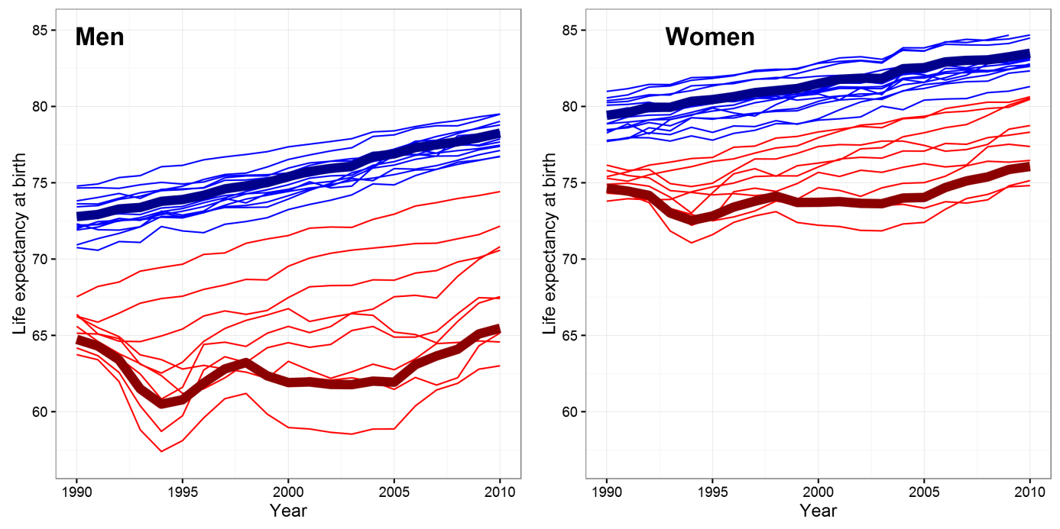
- Bold lines illustrate the weighted averages for the Western and the Central and Eastern regions.

Table 2. Potential gains in life expectancy by eliminating alcohol-attributable mortality in Western European countries, over time (1990-2012/13), by sex
 | Austria | Belgium | Denmark | Finland | France | Germany | Greece | Ireland | Italy | Luxembourg | Netherlands | Portugal | Spain | Sweden | United Kingdom | EU-15
Men
1990 | 1.68 | 1.07 | 0.96 | 1.20 | 1.82 | 1.15 | 1.07 | 0.60 | 1.16 | 1.21 | 0.59 | 2.13 | 1.60 | 0.58 | 0.53 | 1.18
1995 | 1.57 | 1.12 | 1.04 | 1.10 | 1.69 | 1.18 | 0.91 | 0.72 | 1.00 | 1.17 | 0.61 | 1.95 | 1.39 | 0.51 | 0.56 | 1.13
2000 | 1.47 | 1.14 | 1.17 | 1.22 | 1.58 | 1.13 | 0.83 | 0.87 | 0.88 | 1.21 | 0.68 | 1.75 | 1.30 | 0.52 | 0.68 | 1.09
2005 | 1.39 | 1.10 | 1.27 | 1.45 | 1.45 | 1.04 | 0.83 | 0.85 | 0.75 | 1.21 | 0.65 | 1.63 | 1.19 | 0.56 | 0.79 | 1.04
2010 | 1.11 | 1.08 | 1.15 | 1.33 | 1.41 | 1.03 | 0.83 | 0.80 | 0.63 | 0.95 | 0.63 | 1.47 | 1.02 | 0.55 | 0.76 | 0.97
2012/13 | 0.93 | 1.00 | 1.01 | 1.21 | 1.31 | 0.95 | 0.78 | 0.71 | 0.56 | 0.87 | 0.61 | 1.43 | 0.97 | 0.51 | 0.64 | 0.89
Women
1990 | 0.74 | 0.61 | 0.72 | 0.55 | 0.64 | 0.51 | 0.39 | 0.50 | 0.57 | 0.62 | 0.47 | 0.85 | 0.70 | 0.45 | 0.55 | 0.57
1995 | 0.70 | 0.61 | 0.72 | 0.47 | 0.60 | 0.50 | 0.33 | 0.57 | 0.50 | 0.58 | 0.46 | 0.76 | 0.60 | 0.39 | 0.50 | 0.53
2000 | 0.68 | 0.59 | 0.72 | 0.52 | 0.56 | 0.52 | 0.31 | 0.59 | 0.42 | 0.62 | 0.50 | 0.67 | 0.54 | 0.39 | 0.54 | 0.52
2005 | 0.58 | 0.58 | 0.72 | 0.62 | 0.51 | 0.48 | 0.29 | 0.59 | 0.35 | 0.58 | 0.47 | 0.59 | 0.49 | 0.40 | 0.58 | 0.49
2010 | 0.45 | 0.59 | 0.63 | 0.56 | 0.51 | 0.47 | 0.25 | 0.54 | 0.30 | 0.53 | 0.43 | 0.52 | 0.47 | 0.37 | 0.54 | 0.46
2012/13 | 0.38 | 0.54 | 0.57 | 0.48 | 0.47 | 0.43 | 0.24 | 0.49 | 0.28 | 0.47 | 0.44 | 0.48 | 0.44 | 0.35 | 0.47 | 0.42

Table 3. Potential gains in life expectancy by eliminating alcohol-attributable mortality in CEE countries over time (1990-2012/13), by sex
Men | Belarus | Czech Republic | Estonia | Hungary | Lithuania | Latvia | Poland | Russia | Ukraine | CEE
1990 | 2.28 | 1.17 | 1.87 | 2.74 | 1.94 | 2.02 | 1.37 | 2.28 | 2.10 | 2.09
1995 | 3.05 | 1.28 | 2.00 | 3.04 | 2.33 | 2.33 | 1.43 | 3.68 | 2.34 | 2.99
2000 | 3.10 | 1.39 | 2.10 | 2.65 | 2.42 | 2.24 | 1.55 | 3.65 | 2.60 | 3.02
2005 | 3.11 | 1.45 | 2.42 | 2.44 | 2.91 | 2.18 | 1.76 | 4.17 | 3.42 | 3.52
2010 | 3.28 | 1.31 | 1.95 | 2.05 | 2.50 | 1.79 | 1.81 | 3.43 | 2.91 | 2.95
2012/13 | 3.59 | 1.13 | 1.78 | 1.79 | 2.34 | 1.60 | 1.72 | 2.82 | 2.56 | 2.50
Women
1990 | 1.43 | 0.45 | 1.03 | 1.11 | 1.10 | 1.18 | 0.45 | 1.20 | 1.27 | 1.08
1995 | 1.85 | 0.50 | 0.59 | 1.13 | 0.66 | 0.79 | 0.44 | 1.87 | 1.38 | 1.47
2000 | 1.88 | 0.52 | 0.63 | 0.96 | 0.71 | 0.71 | 0.47 | 1.93 | 1.46 | 1.51
2005 | 1.95 | 0.54 | 0.71 | 0.88 | 0.96 | 0.79 | 0.50 | 2.39 | 2.07 | 1.90
2010 | 2.16 | 0.46 | 0.52 | 0.70 | 0.86 | 0.62 | 0.52 | 2.09 | 1.85 | 1.68
2012/13 | 2.38 | 0.38 | 0.45 | 0.59 | 0.76 | 0.48 | 0.49 | 1.79 | 1.69 | 1.46

Table 4. The contribution of alcohol to life expectancy differentials between Eastern European countries and Western Europe (in years), over time (1990-2012/13), by sex
 |  | Men |  |  |  | Women
Country | Year | e0 gap | Alcohol contr. |  |  | e0 gap | Alcohol contr.
Belarus | 1990 | 6.54 | 1.45 (0.25-2.50) | 22.1% |  | 3.61 | 0.98 (0.23-1.76) | 27.0%
 | 1995 | 11.11 | 2.72 (1.30-3.95) | 24.5% |  | 6.24 | 1.64 (0.65-2.64) | 26.3%
 | 2000 | 12.10 | 2.92 (1.29-4.36) | 24.1% |  | 6.83 | 1.75 (0.72-2.80) | 25.6%
 | 2005 | 14.14 | 3.21 (1.49-4.67) | 22.7% |  | 7.54 | 1.90 (0.85-2.97) | 25.2%
 | 2010 | 13.68 | 3.46 (1.78-4.92) | 25.3% |  | 7.02 | 2.14 (1.01-3.24) | 30.5%
 | 2012/13 | 12.09 | 3.70 (1.75-5.45) | 30.6% |  | 5.99 | 2.31 (0.99-3.66) | 38.6%
Czech Republic | 1990 | 5.26 | 0.30 (-0.25-0.79) | 5.7% |  | 4.02 | 0.00 (-0.38-0.34) | 0.1%
 | 1995 | 4.24 | 0.40 (-0.12-0.86) | 9.4% |  | 3.79 | 0.09 (-0.31-0.44) | 2.3%
 | 2000 | 3.86 | 0.52 (0.05-0.95) | 13.6% |  | 3.18 | 0.11 (-0.27-0.45) | 3.4%
 | 2005 | 3.95 | 0.64 (0.21-1.03) | 16.3% |  | 3.27 | 0.15 (-0.21-0.46) | 4.6%
 | 2010 | 3.84 | 0.55 (0.13-0.93) | 14.3% |  | 2.85 | 0.09 (-0.27-0.39) | 3.0%
 | 2012/13 | 3.72 | 0.42 (0.00-0.79) | 11.3% |  | 2.71 | 0.03 (-0.33-0.32) | 1.1%
Estonia | 1990 | 8.12 | 1.12 (0.07-2.15) | 13.8% |  | 4.52 | 0.63 (0.06-1.27) | 14.0%
 | 1995 | 12.30 | 1.56 (0.79-2.34) | 12.7% |  | 6.11 | 0.19 (-0.21-0.62) | 3.2%
 | 2000 | 9.81 | 1.57 (0.78-2.27) | 15.9% |  | 5.22 | 0.24 (-0.19-0.64) | 4.5%
 | 2005 | 9.36 | 1.97 (1.20-2.61) | 21.0% |  | 4.27 | 0.32 (-0.15-0.72) | 7.5%
 | 2010 | 7.45 | 1.39 (0.75-1.93) | 18.7% |  | 2.95 | 0.13 (-0.25-0.48) | 4.5%
 | 2012/13 | 7.36 | 1.26 (0.62-1.82) | 17.1% |  | 2.50 | 0.08 (-0.29-0.43) | 3.3%
Hungary | 1990 | 7.64 | 2.10 (1.63-2.52) | 27.4% |  | 5.62 | 0.75 (0.37-1.14) | 13.3%
 | 1995 | 8.48 | 2.54 (2.01-3.02) | 30.0% |  | 5.72 | 0.81 (0.41-1.21) | 14.1%
 | 2000 | 7.92 | 2.12 (1.64-2.57) | 26.8% |  | 5.47 | 0.63 (0.25-1.01) | 11.5%
 | 2005 | 8.28 | 2.00 (1.55-2.43) | 24.1% |  | 5.47 | 0.58 (0.23-0.94) | 10.6%
 | 2010 | 7.68 | 1.59 (1.15-2.01) | 20.7% |  | 5.17 | 0.40 (0.09-0.74) | 7.7%
 | 2012/13 | 7.16 | 1.34 (0.92-1.75) | 18.8% |  | 5.08 | 0.31 (0.00-0.61) | 6.1%
Lithuania | 1990 | 6.40 | 1.06 (0.04-2.04) | 16.6% |  | 3.26 | 0.62 (0.00-1.28) | 19.0%
 | 1995 | 10.66 | 1.81 (0.93-2.58) | 17.0% |  | 5.48 | 0.25 (-0.23-0.64) | 4.6%
 | 2000 | 8.65 | 1.80 (1.07-2.44) | 20.8% |  | 4.13 | 0.29 (-0.16-0.67) | 7.0%
 | 2005 | 11.68 | 2.63 (1.84-3.30) | 22.5% |  | 5.10 | 0.62 (0.11-1.08) | 12.1%
 | 2010 | 10.72 | 2.19 (1.51-2.78) | 20.4% |  | 4.74 | 0.53 (0.05-0.96) | 11.3%
 | 2012/13 | 10.31 | 2.04 (1.36-2.64) | 19.7% |  | 4.27 | 0.45 (-0.02-0.86) | 10.5%
Latvia | 1990 | 8.61 | 1.31 (0.27-2.32) | 15.3% |  | 4.89 | 0.81 (0.24-1.38) | 16.5%
 | 1995 | 14.17 | 2.11 (1.23-2.97) | 14.9% |  | 7.77 | 0.46 (-0.02-0.90) | 5.9%
 | 2000 | 10.88 | 1.80 (0.99-2.48) | 16.5% |  | 5.83 | 0.35 (-0.09-0.75) | 5.9%
 | 2005 | 12.01 | 1.91 (1.14-2.56) | 15.9% |  | 6.29 | 0.48 (0.02-0.89) | 7.6%
 | 2010 | 10.83 | 1.42 (0.77-1.97) | 13.1% |  | 6.11 | 0.3 (-0.11-0.67) | 4.9%
 | 2012/13 | 9.88 | 1.21 (0.59-1.77) | 12.3% |  | 5.01 | 0.16 (-0.21-0.49) | 3.2%
Poland | 1990 | 6.52 | 0.51 (-0.02-1.01) | 7.8% |  | 4.13 | -0.02 (-0.34-0.29) | -0.6%
 | 1995 | 6.33 | 0.63 (0.12-1.1) | 10.0% |  | 4.05 | 0.01 (-0.31-0.31) | 0.3%
 | 2000 | 5.87 | 0.77 (0.3-1.19) | 13.1% |  | 3.56 | 0.05 (-0.24-0.32) | 1.3%
 | 2005 | 6.04 | 1.04 (0.58-1.44) | 17.3% |  | 3.19 | 0.09 (-0.18-0.36) | 2.9%
 | 2010 | 6.10 | 1.16 (0.7-1.55) | 19.0% |  | 3.02 | 0.14 (-0.14-0.4) | 4.7%
 | 2012/13 | 6.06 | 1.13 (0.67-1.55) | 18.6% |  | 2.89 | 0.14 (-0.14-0.4) | 4.7%
Russia | 1990 | 9.05 | 1.62 (0.70-2.48) | 17.9% |  | 5.10 | 0.82 (0.36-1.38) | 16.0%
 | 1995 | 15.79 | 3.87 (2.46-5.08) | 24.5% |  | 8.85 | 1.77 (1.06-2.49) | 20.0%
 | 2000 | 16.44 | 3.92 (2.42-5.20) | 23.9% |  | 9.29 | 1.90 (1.14-2.66) | 20.5%
 | 2005 | 18.02 | 4.83 (3.24-6.27) | 26.8% |  | 10.14 | 2.50 (1.61-3.37) | 24.6%
 | 2010 | 15.25 | 3.67 (2.27-4.98) | 24.0% |  | 8.67 | 2.11 (1.27-2.93) | 24.3%
 | 2012/13 | 14.16 | 2.88 (1.57-4.06) | 20.3% |  | 7.83 | 1.74 (0.95-2.53) | 22.2%
Ukraine | 1990 | 7.19 | 1.31 (0.13-2.41) | 18.2% |  | 4.51 | 0.89 (0.27-1.59) | 19.7%
 | 1995 | 12.70 | 1.99 (0.63-3.26) | 15.7% |  | 7.94 | 1.22 (0.49-1.98) | 15.4%
 | 2000 | 13.33 | 2.38 (0.87-3.73) | 17.9% |  | 8.00 | 1.35 (0.56-2.14) | 16.8%
 | 2005 | 15.43 | 3.64 (1.98-5.11) | 23.6% |  | 9.21 | 2.13 (1.17-3.08) | 23.1%
 | 2010 | 13.10 | 2.88 (1.31-4.24) | 22.0% |  | 8.35 | 1.88 (0.94-2.77) | 22.5%
 | 2012/13 | 12.63 | 2.47 (0.90-3.88) | 19.5% |  | 7.70 | 1.67 (0.72-2.60) | 21.7%
CEE | 1990 | 8.04 | 1.37 | 17.0% |  | 4.78 | 0.70 | 14.7%
CEE | 1995 | 13.12 | 2.87 | 21.9% |  | 7.63 | 1.32 | 17.3%
CEE | 2000 | 13.49 | 2.98 | 22.1% |  | 7.79 | 1.42 | 18.2%
CEE | 2005 | 14.96 | 3.80 | 25.4% |  | 8.51 | 1.91 | 22.5%
CEE | 2010 | 12.79 | 2.96 | 23.1% |  | 7.42 | 1.64 | 22.2%
CEE | 2012/13 | 11.97 | 2.42 | 20.2% |  | 6.75 | 1.38 | 20.5%
Note: Life expectancy among men in Western Europe was 72.8, 73.9, 75.5, 76.9, and 78.3 in 1990, 1995, 2000, 2005, and 2010, respectively; while for the corresponding years life expectancy was 79.4, 80.5, 81.5, 82.5, 83.5 among women.
Abbreviations: Belarus (BLR), Czech Republic (CZE), Estonia (EST), Hungary (HUN), Lithuania (LTU), Latvia (LVA), Poland (POL), Russia (RUS), Ukraine (UKR), and the population-weighted average of the Central and Eastern European (CEE) countries.

Figure 2. Recorded per capita consumption in liters of pure alcohol per adult (aged 15+) and year in 24 European countries¹, 1985-2013
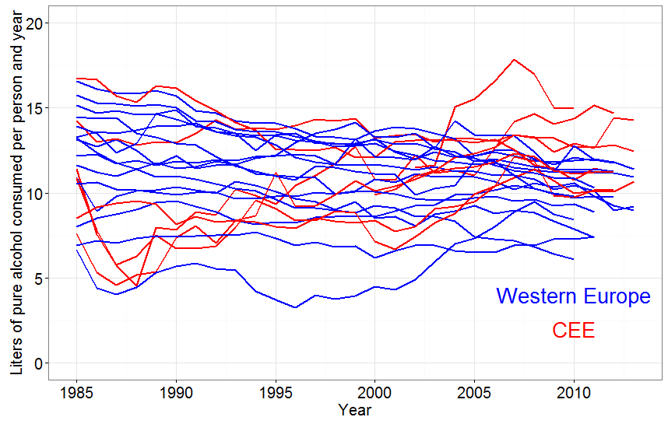
¹ We included the Western and the CEE countries analyzed in the paper. Western Europe: Austria, Belgium, Denmark, Finland, France, Germany, Greece, Ireland, Italy, Luxembourg, Netherlands, Portugal, Spain, Sweden and United Kingdom. CEE: Belarus, the Czech Republic, Estonia, Hungary, Lithuania, Latvia, Poland, Russia, and Ukraine.
Source: Own elaboration based on data from World Health Organization’s Global Information System on Alcohol and Health (GISAH) (http://www.who.int/gho/alcohol/en/).

