Supplemental Digital Content

Multiple Imputation
We performed Multiple Imputation through Chained Equations (MICE), using the R package MICE¹⁸, and assumed the missing data are Missing At Random, i.e. the probability of wave/item non-response only depends on other measured variables.
MICE requires that an appropriate model be specified for each variable with missing values. We used the following model specifications, with separate univariate imputation models for each wave of data collection of time-dependent variables (e.g. SF36 at wave t and wave t+1 are treated as distinct variables):
- Linear regression for continuous variables (time-dependent:- MH, K10, equivalised income)
- Logistic regression for binary variables (Indigenous status, time-dependent:- long term health condition)
- Polytomous regression for categorical variables (country of birth, time dependent:- household composition, employment, tenure)
- Proportional odds model for ordered variables (education (at baseline))
All variables were used as “predictors” in the imputation models. This includes observations that were collected at preceding and subsequent time points, e.g. imputation model for SF36 at wave 5 include as predictor variables, MH measured at wave 4 and waves 7 to 9. To account for potential non-linear associations with the imputed variables, we used cubic b-splines with five degrees of freedom for age and equivalised income (except the imputation model for imputing income).
All other predictors were included as linear terms or dummy coding where appropriate. Income was adjusted for inflation.
Initially, we intended to include education measured at multiple waves, however, upon visual inspection of the trace plots of the imputed variables, the chains did not seem to converge even after 50 cycles. In contrast, imputations for models that only included education at baseline, showed good mixture within 20 cycles for imputation of income.
We created 50 imputed datasets for each 5-year window, using 50 cycles for each chain. Fifty overall imputed datasets were created by sequentially stacking data from each five-year window for each imputation. To fit marginal structural models (MSMs) inverse probability of treatment weights (IPTWs) were estimated separately for each of the overall imputed datasets. Subsequently, we performed weighted and adjusted linear regression on each of the overall imputed datasets and combined the estimates using the Barnard-Rubin method²⁸.

Inverse probability of treatment weights (IPTWs)
Multiple options exist to estimate the treatment weights, including logistic regression and partition-based models. Initial attempts using logistic models and random forests did not provide satisfactory results (highly variable weights, zero weights, poor improvement of balance). Instead of manually specifying a more complex model for each wave, we adopted a stacking approach using the R package Superlearner. In this approach, multiple models are independently fitted to the same data and the produced estimates/predictions are combined into a weighted estimate/prediction. Hence, the stacking approach allows automatic combination of the best features (accuracy of classification) of multiple types of base models (base learners) into a supermodel (Superlearner).
We used three types of base learners: (1) a logistic regression model without interactions but including cubic b-splines of five degrees of freedom for the effect of age, MH and equivalised income, (2) a Gradient Boosting Machine and (3) a conditional inference forest. The relative contribution (weight) of each of the three base models to the final estimate of the probability of treatment was determined by maximising the Superlearner’s Area Under the Curve over 5-fold Cross-Validation.
We assessed the performance of the three base learners in two ways. First, we considered the range of the weights. Weights based on logistic regression tended to have much wider ranges than weights obtained by gradient boosting and by the Superlearner. This was observed both for the complete case analysis and the imputed datasets. Generally, a large range is undesirable as the MSM estimates may be dominated by a few or even a single observation. On the other hand, some variability is necessary unless the unweighted dataset is already balanced.
In a second step, we plotted the achieved balance on covariates between treated (social housing) and untreated participants: the aim of IPTW is to create a pseudo-population that is free of correlation between covariates and treatment. In essence, the (multivariate) distribution of the covariates should be identical in both the treated and the untreated group. A necessary condition for this is that the means of the (univariate) distributions are identical in the treated and the untreated group. To assess balance, we calculated the standardised mean differences between treated and untreated groups, as suggested by Austin and Stuart²¹. Their method is applicable for a single point-exposure: the standardised mean difference is calculated for A₀= 0 versus A₀ = 1. To apply this method to time-varying exposures we created two summary measures of treatment history (the number of transitions into/out of social housing, and the total number of years in social housing).
To assess balance between the multiple groups defined by the unique levels of these variables, we calculated the unweighted average of all pairwise comparisons of balance. That is we calculated the imbalance between 0 and 1 years of exposure to social housing, 0 and 2 years of exposure to social housing and so on.
eFigures 1 and 2 compare achieved balance (blue dots) for logistic regression and Superlearner, with balance in the unweighted sample (black dots) for cumulative exposure (left panel) and number of transitions (right panel).

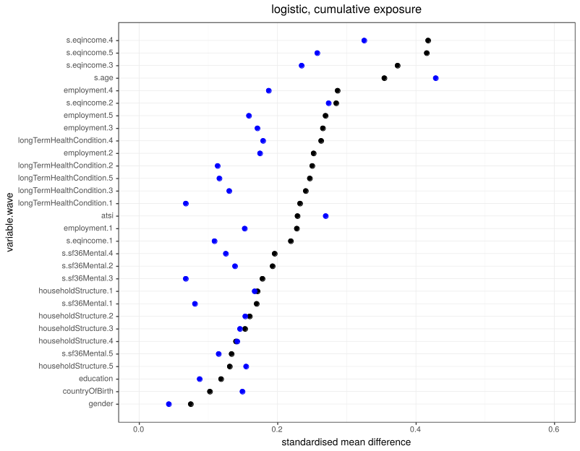
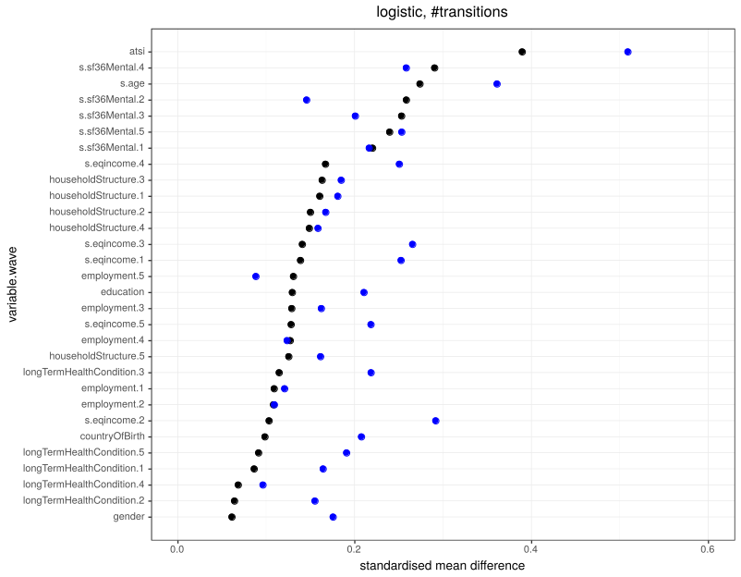

eFigure 1: Balance in the unweighted sample (black) and weighted sample with weights generated by the logistic regression model, imputed data (blue). Standardized mean difference per covariate, between people in social housing versus in other tenures. Cumulative exposure (left panel) and number of transitions (right panel).

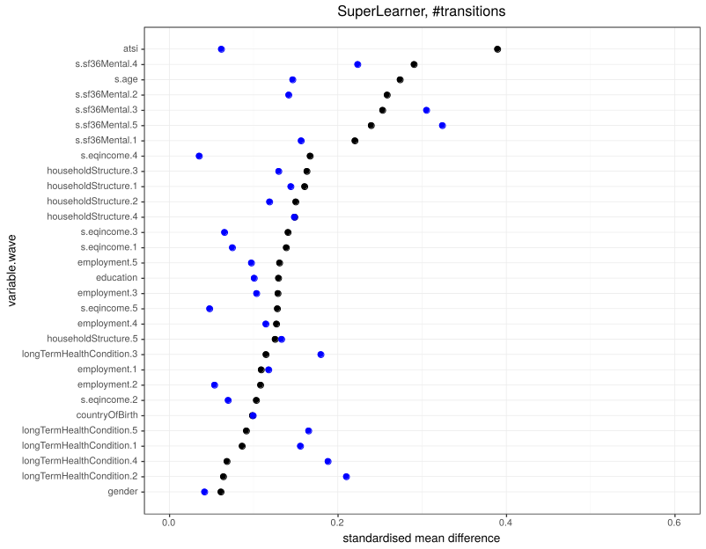
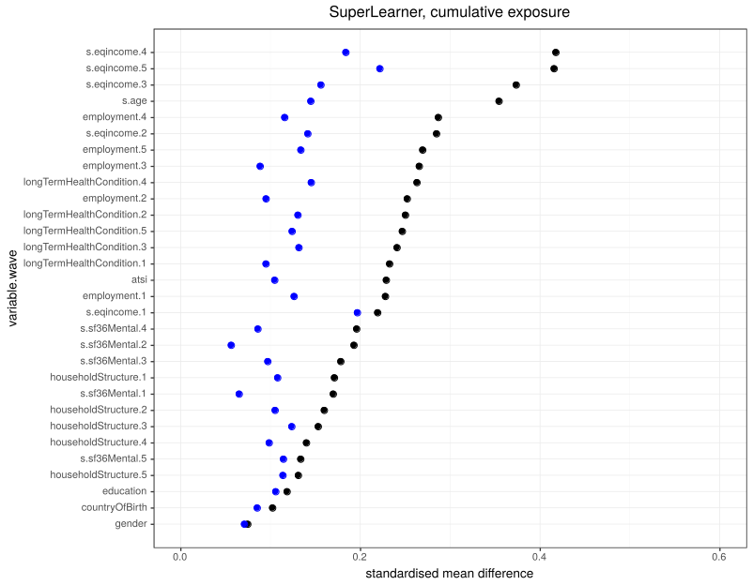

eFigure 2: Balance in the unweighted sample (black) and weighted sample with weights generated by the Superlearner, imputed data (blue). Standardized mean difference per covariate, between people in social housing versus in other tenures. . Cumulative exposure (left panel) and number of transitions (right panel).

The logistic model improves balance on some covariates, however, it simultaneously aggravates imbalance in other covariates (eFigure 1). For example, for gender the logistic regression worsens the balance (the blue dot is further to the right than the black dot) whereas the Superlearner improves the balance. Using weights generated by the Superlearner, the conditional inference forest or gradient boosting machines, similarly provides improvement on some covariates and aggravation for others (eFigure 2). Collectively over all covariates, the logistic model was the least favourable and the machine learning methods provided superior balance on average.
However, as the IPTW does not guarantee perfect balance on covariates in the generated pseudo-population, we fitted a ‘double robust’ linear model using both the IPTW and adjusting for baseline covariates age, gender, Indigeneity, employment status, presence of a long-term health condition and MH. Although double adjustment is often thought of as inefficient, the resulting estimates have a lower standard error than those obtained through an unadjusted, weighted linear regression model (eTable 1).
eTable 1. Cumulative exposure to social housing and social housing transitions in relation to measures of mental health and psychological distress estimated without double robust adjustment
Social Housing (years) |  |  | Without double robust adjustment |  | With double robust adjustment
 |  |  | MH  Estimate  [95% Confidence Interval] | K10  Estimate  [95% Confidence Interval] | MH  Estimate  [95% Confidence Interval] | K10  Estimate  [95% Confidence Interval]
Categorical exposure
Cumulative | 0 |  | Ref | Ref | Ref |  | Ref
 | 1 |  | -2.35 [-5.03; 0.32] | 1.05 [0.02; 2.07] | -0.37 [-2.70; 1.96] |  | 0.14 [-0.74; 1.01]
 | 2 |  | -3.18 [-7.18; 0.82] | 1.13 [-0.31; 2.56] | -2.54 [-61.6; 1.09] |  | 0.77 [-0.55; 2.08]
 | 3 |  | -4.38 [-9.07; 0.30] | 2.62 [0.63; 4.61] | -3.32 [-7.13; 0.50] |  | 2.20 [0.56; 3.84]
 | 4 |  | -2.96 [-7.65; 1.73] | 1.08 [-0.80; 2.95] | -2.76 [-6.48; 0.96] |  | 1.03 [-0.47; 2.53]
 | 5 |  | -2.99 [-4.77; -1.20] | 1.35 [0.66; 2.04] | -1.91 [-3.42; -0.39] |  | 0.94 [0.35; 1.54]
Transitions | 0 |  | Ref | Ref | Ref |  | Ref
 | 1 |  | -2.37 [-4.88; 0.13] | 0.89 [-0.15; 1.94] | -1.55 [-3.75; 0.65] |  | 0.50 [-0.43; 1.44]
 | 2 |  | -3.63 [-7.16; -0.11] | 1.70 [0.33; 3.08] | -2.19 [-5.27; 0.89] |  | 1.02 [-0.18; 2.21]
 | 3 |  | --4.09 [-11.50; 3.32] | 2.70 [-0.11; 5.52] | -2.03 [-7.90; 3.84] |  | 1.95 [-0.35; 4.26]
 | 4 |  | -5.32 [-28.45; 17.82] | 4.39 [-5.25; 14.03] | -5.85[-25.37;13.67] |  | 4.17[-4.12; 12.46]
Continuous exposure
Transitions |  |  | -1.74 [-3.03; -0.45] | 0.87 [0.38; 1.36] | -1.04 [-2.17; 0.09] |  | 0.56 [0.12; 1.00]
Sensitivity analyses
Results generated from the sensitivity analyses are presented below (eTable 2-4).
The estimates before adjusting for previous housing (eTable 3) differ somewhat (but not in terms of direction or conclusion) to findings presented in the main paper. However, the point of eTable 3 is to ‘test’ for possible confounding by previous housing, so comparing the unadjusted with adjusted columns within the table is more important (i.e. column 1 with 3, and column 2 with 4). The strength of association of cumulative housing increase modestly for K10 and MH (in the order of 10% to 20%), and the strength of association of transitions into and out of social housing with mental health decreased modestly (similar order of magnitude). Therefore, we conclude that there may be residual confounding by previous housing status over multiple waves, but it was modest – as best we could tell.
Exploration of residual time invariant confounding indicated by the addition of variables into regression models is presented in eTable 4. The sizeable reduction in association that arises with the addition of these covariates into the models suggests the possibility of residual confounding from unmeasured correlated variables and measurement error. That is, if there are other unmeasured and correlated time invariant confounders, and/or sizeable measurement error of the measured time invariant confounders, this may be enough to drive the findings to the null. Is this likely? We obviously cannot confidently say. However, we hypothesize that: education is likely measured well – but we do not have socioeconomic factors over the lifecourse; employment status earlier in life may be important; and the SF36 as a continuous covariate is less prone to remaining residual confounding than a dichotomous or categorical variable, and is capturing correlated earlier life mental health.

eTable 2. Cumulative exposure to social housing and social housing transitions in relation to measures of mental health and psychological distress for complete case and IPTW generated using logistic regression and superlearner
Social Housing (years) |  |  | Complete case |  | Logistic regression to generate IPTWs |  | Superlearner to generate IPTWs
 |  |  | MH Estimate  [95% Confidence Interval] | K10 Estimate  [95% Confidence Interval] | MH Estimate  [95% Confidence Interval] | K10 Estimate  [95% Confidence Interval] | MH Estimate  [95% Confidence Interval] | K10 Estimate  [95% Confidence Interval]
Categorical exposure
Cumulative | 0 |  | Ref | Ref | Ref | Ref | Ref | Ref
 | 1 |  | -2.73 [-7.01; 1.54] | 0.95 [-0.68; 2.57] | -0.78 [-3.13; 1.56] | 0.81 [-0.12; 1.73] | -0.37 [-2.70; 1.96] | 0.14 [-0.74; 1.01]
 | 2 |  | -4.68 [-9.58; 0.23] | 0.85 [-1.01; 2.71] | -1.66 [-7.28; 3.97] | 1.25 [-0.31; 2.80] | -2.54 [-61.6; 1.09] | 0.77 [-0.55; 2.08]
 | 3 |  | 5.45 [2.21; 8.69] | 0.38 [-0.85; 1.61] | -1.42 [-5.33; 2.49] | 1.54 [0.12; 2.96] | -3.32 [-7.13; 0.50] | 2.20 [0.56; 3.84]
 | 4 |  | -0.08 [-2.87; 2.72] | 0.11 [-0.95; 1.17] | -3.29 [-6.46; -0.13] | 1.37 [0.00; 2.73] | -2.76 [-6.48; 0.96] | 1.03 [-0.47; 2.53]
 | 5 |  | -2.58 [-4.46; -0.70] | 0.80 [0.09; 1.52] | -1.20 [-2.50; 0.10] | 0.74 [0.23; 1.25] | -1.91 [-3.42; -0.39] | 0.94 [0.35; 1.54]
Transitions | 0 |  | Ref | Ref | Ref | Ref | Ref | Ref
 | 1 |  | 0.75 [-1.35; 2.84] | 0.47 [-0.33; 1.26] | -1.26 [-3.44; 0.92] | 0.77 [0.00; 1.55] | -1.55 [-3.75; 0.65] | 0.50 [-0.43; 1.44]
 | 2 |  | -1.99 [-5.76; 1.78] | 0.08 [-1.35; 1.51] | -1.98 [-4.85; 0.90] | 1.48 [0.28; 2.68] | -2.19 [-5.27; 0.89] | 1.02 [-0.18; 2.21]
 | 3 |  | 10.19 [2.47; 17.92] | 0.82 [-2.12; 3.75] | -0.82[-11.87; 10.22] | 2.83 [0.00; 5.65] | -2.03 [-7.90; 3.84] | 1.95 [-0.35; 4.26]
 | 4 |  | -3.60 [-41.21; 34.01] | 0.27[-14.00;14.54] | -8.19[-26.92; 10.53] | 4.45 [-2.43; 11.32] | -5.85 [-25.37; 13.67] | 4.17 [-4.12; 12.46]
Continuous exposure
Transitions |  |  | 0.59 [-0.65; 1.82] | 0.24 [-0.23; 0.70] | -0.92 [-2.71; 0.86] | 0.78 [0.24; 1.33] | -1.04 [-2.16; 0.09] | 0.56 [0.12;1.00]

eTable 3. Cumulative exposure to social housing and social housing transitions in relation to measures of mental health and psychological distress for the sample restricted to respondents where their housing tenure in the three years prior to each window was known
Social Housing (years) |  |  | Data restricted to observations where prior social housing is known |  | Data restricted to observations where prior social housing is known, with adjustment for prior social housing
 |  |  | MH  Estimate  [95% Confidence Interval] | K10  Estimate  [95% Confidence Interval] | MH  Estimate  [95% Confidence Interval] | K10  Estimate  [95% Confidence Interval]
Categorical exposure
Cumulative | 0 |  | Ref | Ref | Ref | Ref
 | 1 |  | -0.41[-3.01; 2.18] | 0.06 [-0.94; 1.07] | -0.76 [-3.46; 1.93] | 0.04 [-0.99; 1.06]
 | 2 |  | -2.85 [-6.67; 0.97] | 1.20 [-0.29; 2.69] | -3.16 [-7.02; 0.70] | 1.17 [-0.34; 2.69]
 | 3 |  | -3.53 [-8.51; 1.46] | 1.80 [-0.29; 3.89] | -4.17 [-9.23; 0.90] | 1.80 [-0.18; 3.78]
 | 4 |  | -3.97; -8.81; 0.87] | 1.18 [-0.69; 3.05] | -4.98 [-9.58; -0.39] | 1.20 [-0.70; 3.10]
 | 5 |  | -1.28 [2.87; 0.31] | 0.79 [0.14; 1.43] | -2.92 [-6.38; 0.54] | 0.82 [-0.55; 2.19]
Transitions | 0 |  | Ref | Ref | Ref | Ref
 | 1 |  | -2.66 [-5.57; 0.25] | 0.86 [-0.19; 1.91] | -2.59 [-5.51; 0.33] | 0.71 [-0.34; 1.76]
 | 2 |  | -2.08 [-5.82; 1.66] | 0.74 [-0.64; 2.11] | -2.02 [-5.74; 1.70] | 0.59 [-0.75; 1.94]
 | 3 |  | -1.74 [-7.81; 4.32] | 2.61 [-0.50; 5.71] | -1.70 [-7.90; 4.51] | 2.29 [-0.84; 5.41]
 | 4 |  | -8.01 [-31.22; 15.19] | 5.91 [-3.57; 15.38] | -8.26 [-31.47; 14.95] | 5.78 [-3.66; 15.22]
Continuous exposure
Transitions |  |  | -1.33 [-2.71; 0.06] | 0.64 [0.07; 1.21] | -1.28 [-2.70; 0.13] | 0.54 [-0.02; 1.10]

eTable 4. Cumulative exposure to social housing and social housing transitions in relation to measures of mental health and psychological distress – attenuation of effect estimates with the introduction of covariate sets into each model
 | MH |  |  | K10
 | Estimate | Lower CI | Upper CI | Estimate | Lower CI | Upper CI
Cumulative (0 vs 5 years)
OLS with age, gender | -7.60 | -9.10 | -6.11 | 3.56 | 3.00 | 4.13
+Indigenous status, country of birth' | -7.31 | -8.81 | -5.80 | 3.39 | 2.82 | 3.96
+employment, education' | -5.77 | -7.27 | -4.27 | 2.75 | 2.18 | 3.31
+MH' | -3.43 | -4.74 | -2.11 | 1.92 | 1.41 | 2.42
IPTW(superlearner) with double robust | -1.91 | -3.42 | -0.39 | 0.94 | 0.35 | 1.54
Number of Transitions
OLS with age, gender | -2.92 | -3.96 | -1.88 | 1.48 | 1.08 | 1.88
+Indigenous status, country of birth' | -2.74 | -3.79 | -1.68 | 1.35 | 0.95 | 1.76
+employment, education' | -2.24 | -3.29 | -1.19 | 1.14 | 0.73 | 1.55
+MH' | -1.19 | -2.11 | -0.28 | 0.77 | 0.41 | 1.13
IPTW(Superlearner) with double robust | -1.04 | -2.17 | 0.09 | 0.56 | 0.12 | 1.00

