Supplemental materials

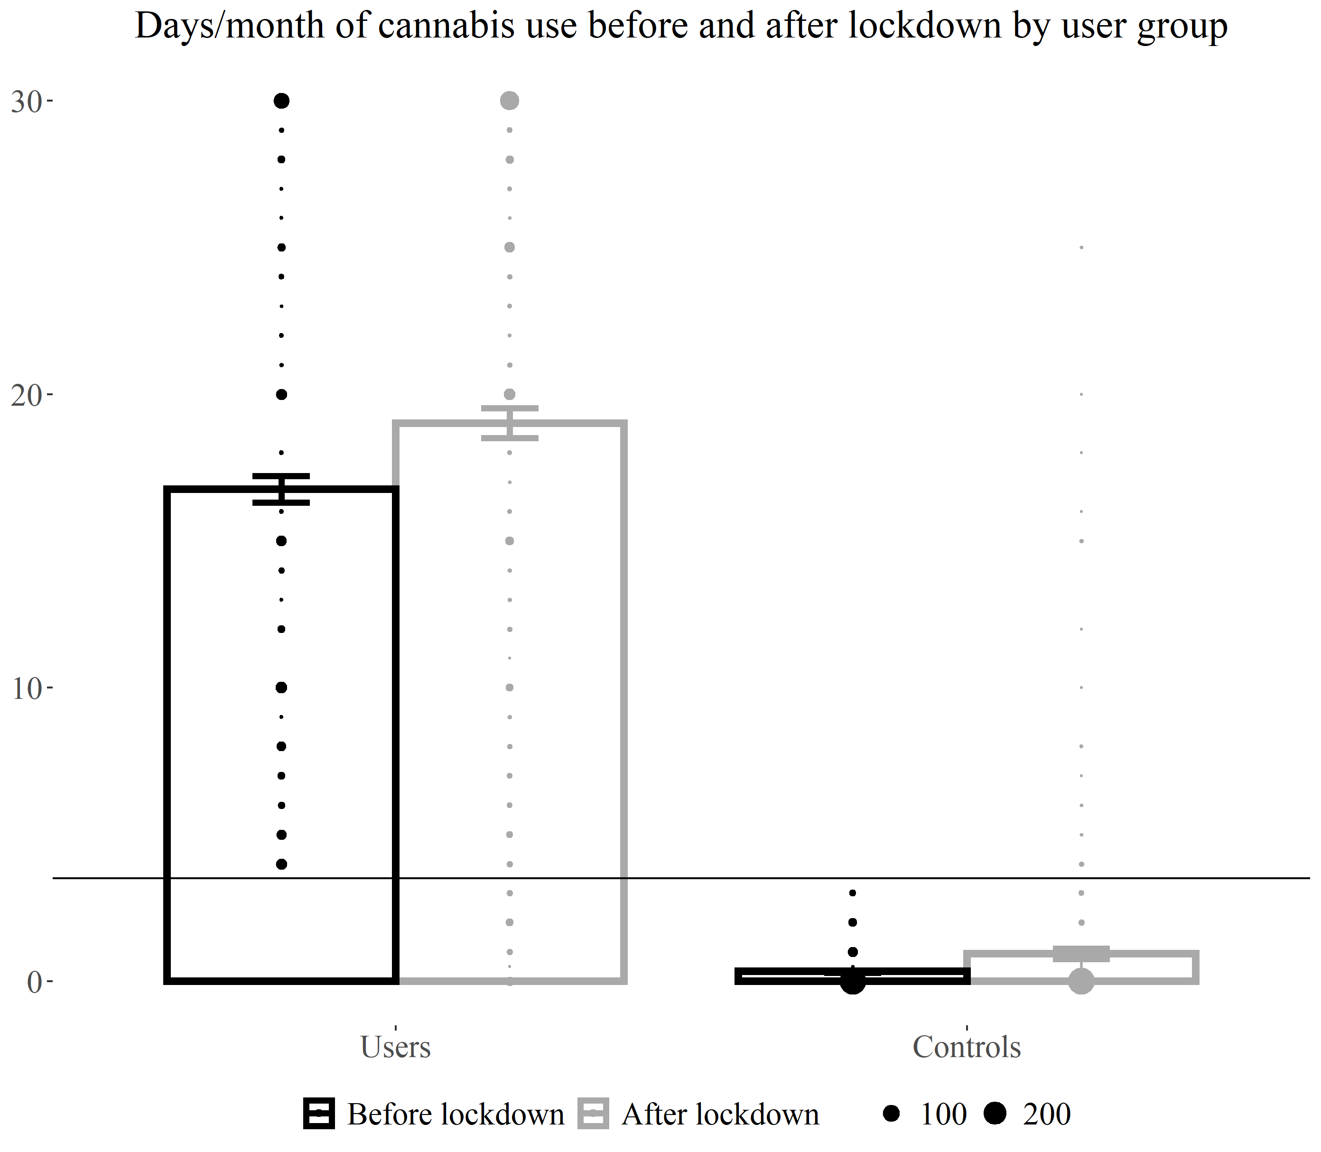
Figure S1. Means and standard errors of days per month of cannabis use by group before and after lockdown. Dots represent participants, with the diameter indicating the frequency of participants reporting the given value. The horizonal line at y = 3.5 shows the cut-off between users and controls.

Table S2. Bivariate Pearson correlations
Factor | AES  before lockdown | AES  after lockdown | SHAPS  before lockdown | SHAPS  after lockdown
Full sample
n = 798
Age | -.108** | -.172*** | -.132*** | -.107**
DPM alcohol use | -.020 | .004 | -.051 | -.029
DPM cigarette use | .089* | .093** | .080* | .072*
Illicit drug use | -.004 | -.020 | -.020 | -.035
Depression | .338*** | .311*** | .308*** | .303***
Anxiety | 234*** | .230*** | .223*** | 222***
Cannabis users
n = 456
Cannabis DPM before lockdown | .072 | .012 | .009 | .033
Cannabis DPM after lockdown | .054 | -.015 | .036 | -.039
Age of first use | -.039 | -.099* | -.086 | -.038
Age of regular use, n = 452 | -.120* | -.188*** | -.171*** | -.156**
SDS, n = 452 | .210*** | .258*** | .128** | .218***
*p < .05
**p < .01
***p < .001
Abbreviations. AES – Apathy Evaluation scale, DPM – days per month, SHAPS – Snaith-Hamilton Pleasure Scale, SDS – Severity of Dependence Scale

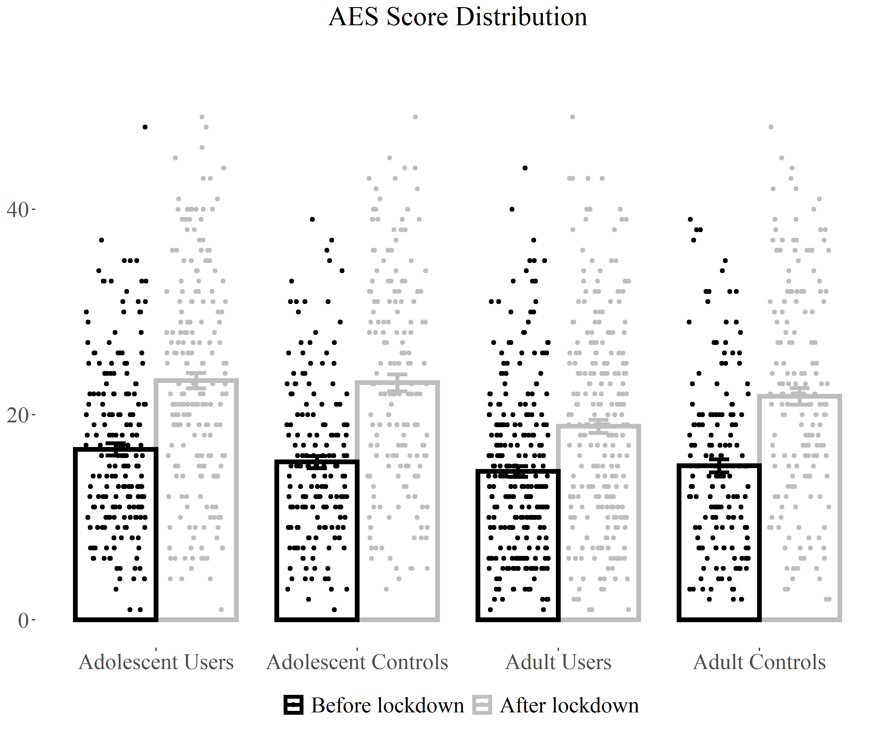
Figure S3. Means and standard errors for the Apathy Evaluation Scale by group before and after lockdown, with individual scores overlayed.

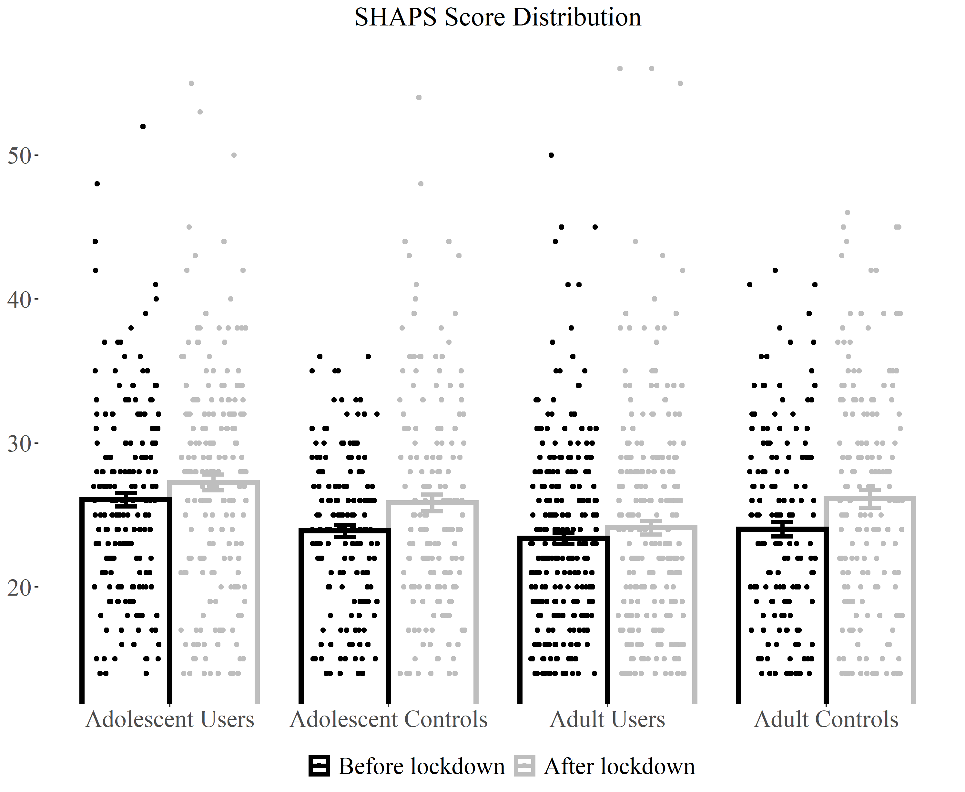
Figure S4. Means and standard errors for the Snaith-Hamilton Pleasure Scale by group before and after lockdown, with individual scores overlayed.

Table S5. AES complete results for full and partial sample

 | Full sample, n = 798 |  |  |  |  | Partial sample, n = 708
 | F | df | p | η_{p}² |  | F | df | p | η_{p}²
Time | 83.44 | 1, 789 | <.001 | .096 |  | 67.20 | 1, 699 | <.001 | .088
User-Group | 11.89 | 1, 789 | .001 | .015 |  | 14.77 | 1, 699 | <.001 | .021
Age-Group | 11.27 | 1, 789 | .001 | .014 |  | 11.45 | 1, 699 | .001 | .016
Alcohol | 0.14 | 1, 789 | .71 | <.001 |  | 0.08 | 1, 699 | .77 | <.001
Cigarettes | 3.83 | 1, 789 | .051 | .005 |  | 5.03 | 1, 699 | .03 | .007
Illicit drugs | 0.59 | 1, 789 | .44 | .001 |  | 0.27 | 1, 699 | .60 | <.001
Depression | 72.31 | 1, 789 | <.001 | .084 |  | 66.71 | 1, 699 | <.001 | .087
Anxiety | 11.88 | 1, 789 | .001 | .015 |  | 12.71 | 1, 699 | <.001 | .018
Time*User-Group | 11.22 | 1, 789 | .001 | .014 |  | 17.89 | 1, 699 | <.001 | .025
Time*Age-Group | 6.19 | 1, 789 | .01 | .008 |  | 4.12 | 1, 699 | .04 | .006
Time*Alcohol | 1.37 | 1,789 | .24 | .002 |  | 2.35 | 1, 699 | .13 | .003
Time*Cigarettes | 2.22 | 1, 789 | .14 | .003 |  | 3.52 | 1, 699 | .07 | .005
Time*Illicit drugs | 0.004 | 1, 789 | .95 | <.001 |  | 0.72 | 1, 699 | .40 | .001
Time*Depression | 1.17 | 1, 789 | .28 | .001 |  | 1.02 | 1, 699 | .31 | .001
Time*Anxiety | 1.38 | 1, 789 | .24 | .002 |  | 1.22 | 1, 699 | .27 | .002
User-Group*Age-Group | 4.19 | 1, 789 | .04 | .005 |  | 4.37 | 1, 699 | .04 | .006
Time*User-Group*Age-Group | 0.70 | 1, 789 | .40 | .001 |  | <0.001 | 1, 699 | .998 | <.001
Note. The partial sample excluded controls using cannabis more than three days per month after lockdown (n = 25) and users using cannabis less than four days per month after lockdown (n = 65).

Table S6. SHAPS complete results for full and partial sample

 | Full sample, n = 798 |  |  |  |  | Partial sample, n = 708
 | F | df | p | η_{p}² |  | F | df | p | η_{p}²
Time | 3.54 | 1, 789 | .06 | .004 |  | 0.55 | 1, 699 | .46 | .001
User-Group | 1.48 | 1, 789 | .23 | .002 |  | 3.80 | 1, 699 | .052 | .005
Age-Group | 7.86 | 1, 789 | .01 | .010 |  | 10.80 | 1, 699 | .001 | .015
Alcohol | 0.67 | 1, 789 | .41 | .001 |  | 0.03 | 1, 699 | .86 | <.001
Cigarettes | 0.84 | 1, 789 | .36 | .001 |  | 1.76 | 1, 699 | .19 | .003
Illicit drugs | 2.50 | 1, 789 | .11 | .003 |  | 2.23 | 1, 699 | .14 | .003
Depression | 63.32 | 1, 789 | <.001 | .074 |  | 61.16 | 1, 699 | <.001 | .020
Anxiety | 11.09 | 1, 789 | .001 | .014 |  | 14.31 | 1, 699 | <.001 | .026
Time*User-Group | 6.49 | 1, 789 | .01 | .008 |  | 16.17 | 1, 699 | <.001 | .023
Time*Age-Group | 0.07 | 1, 789 | .80 | <.001 |  | 0.13 | 1, 699 | .72 | <.001
Time*Alcohol | 0.42 | 1,789 | .52 | .001 |  | 0.76 | 1, 699 | .38 | .001
Time*Cigarettes | 0.64 | 1, 789 | .42 | .001 |  | 2.49 | 1, 699 | .12 | .004
Time*Illicit drugs | 0.04 | 1, 789 | .84 | <.001 |  | 1.26 | 1, 699 | .26 | .002
Time*Depression | 1.92 | 1, 789 | .17 | .002 |  | 1.86 | 1, 699 | .17 | .003
Time*Anxiety | 0.55 | 1, 789 | .46 | .001 |  | 0.26 | 1, 699 | .61 | <.001
User-Group*Age-Group | 14.53 | 1, 789 | <.001 | .018 |  | 19.03 | 1, 699 | <.001 | .026
Time*User-Group*Age-Group | 0.28 | 1, 789 | .60 | <.001 |  | 0.11 | 1, 699 | .74 | <.001
Note. The partial sample excluded controls using cannabis more than three days per month after lockdown (n = 25) and users using cannabis less than four days per month after lockdown (n = 65).

Table S7. Complete results of exploratory analyses of dependence in n = 452 cannabis users

 | AES |  |  |  |  | SHAPS
 | F | df | p | η_{p}² |  | F | df | p | η_{p}²
Time | 22.66 | 1, 443 | <.001 | .049 |  | 1.03 | 1, 443 | .31 | .002
Dependence | 17.05 | 1, 443 | <.001 | .037 |  | 13.07 | 1, 443 | <.001 | .029
Age-Group | 23.99 | 1, 443 | <.001 | .051 |  | 31.23 | 1, 443 | <.001 | .066
Alcohol | 0.13 | 1, 443 | .72 | <.001 |  | 0.19 | 1, 443 | .66 | <.001
Cigarettes | 0.52 | 1, 443 | .47 | .001 |  | 0.004 | 1, 443 | .95 | <.001
Illicit drugs | 3.59 | 1, 443 | .06 | .008 |  | 6.18 | 1, 443 | .01 | .014
Depression | 39.24 | 1, 443 | <.001 | .081 |  | 33.91 | 1, 443 | <.001 | .071
Anxiety | 1.61 | 1, 443 | .21 | .004 |  | 2.14 | 1, 443 | .15 | .005
Time*Dependence | 4.47 | 1, 443 | .04 | .010 |  | 4.25 | 1, 443 | .04 | .010
Time*Age-Group | 8.23 | 1, 443 | .004 | .018 |  | 1.04 | 1, 443 | .31 | .002
Time*Alcohol | 1.95 | 1, 443 | .16 | .004 |  | 0.74 | 1, 443 | .39 | .002
Time*Cigarettes | 0.57 | 1, 443 | .45 | .001 |  | 0.10 | 1, 443 | .76 | <.001
Time*Illicit drugs | 0.06 | 1, 443 | .81 | <.001 |  | 0.08 | 1, 443 | .78 | <.001
Time*Depression | 2.03 | 1, 443 | .16 | .005 |  | 1.78 | 1, 443 | .18 | .004
Time*Anxiety | 0.01 | 1, 443 | .93 | <.001 |  | 0.54 | 1, 443 | .46 | .001
Dependence*Age-Group | 0.85 | 1, 443 | .36 | .002 |  | 2.12 | 1, 443 | .15 | .005
Time*Dependence*Age-Group | 0.29 | 1, 443 | .59 | .001 |  | 0.002 | 1, 443 | .96 | <.001

