Fig. S1:
Lignocellulose degradation by consortia derived from cow rumen (RWS) and termite gut (TWS) microbiomes along the incubation time. Kinetics of dry matter degradation, volatile fatty acids (VFA), CMCase and xylanase activities for RWS and TWS are shown. Data of RWS are in blue and TWS in green color.
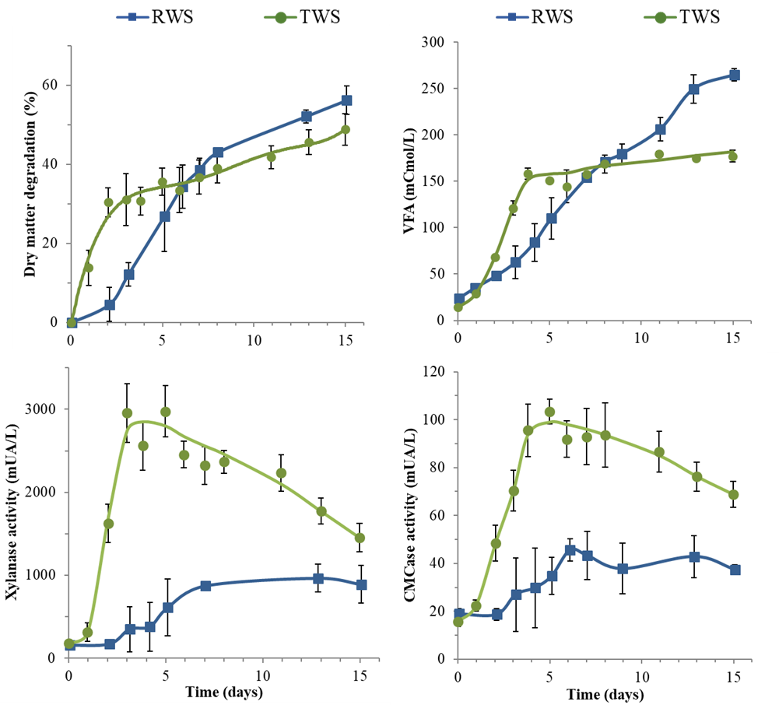
Fig. S2:
Rarefaction curves of 16S rRNA gene sequencing data (15,000 sequences) of each sampling time in RWS and TWS consortia replicates.
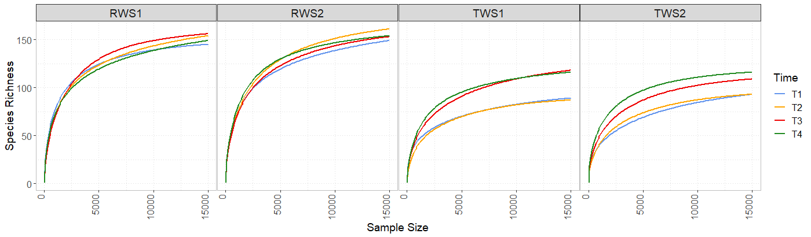

Fig. S3:
Hierarchical clustering of metaproteomics data (CLR transformed), based in Euclidean distance and Ward D2 clustering method, showing the trend exhibited by the protein profile of the different samples of RWS (blue) and TWS (green) microbial consortia.

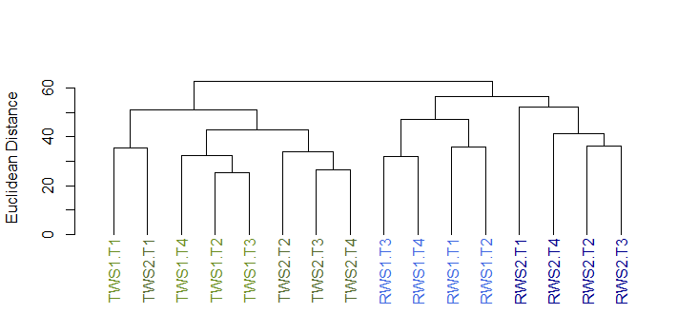

Fig. S4:
Relative abundance of bacterial phyla identified in metaproteomics (A) and 16S rRNA gene sequencing data (B). Relative abundance of proteins based on NSAFs (normalized spectral abundance factors) or OTUs was aggregated at the phylum level for stacked bar plot representation. The group “Others” gather phyla with relative abundance less than 1% in the dataset. Proteins belonging to the same bacterial phylum were represented with the same color palette: Bacteroidetes (blue), Firmicutes (red), Proteobacteria (green), Spirochaetes (purple), Fibrobacteres (orange).

A. B.
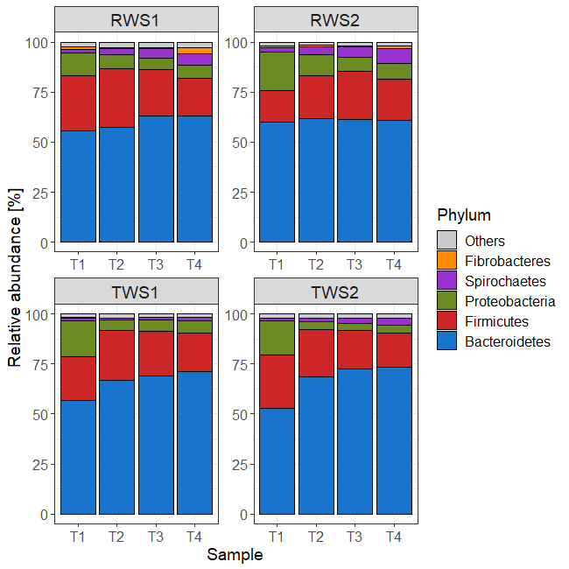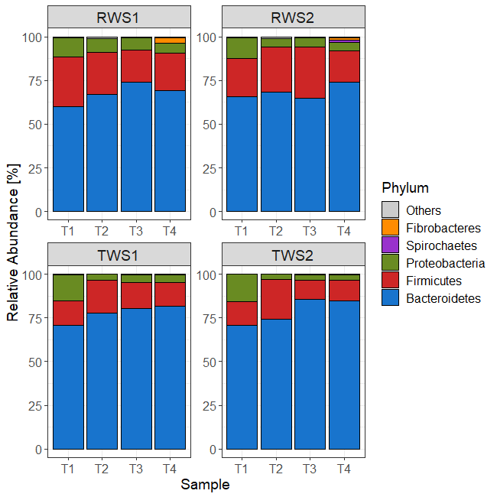

Fig. S5:
Comparison of the protein abundance (CLR-transformed data) affiliated to the major genera present in RWS and TWS metaproteomes.
For the boxplots, the bottom and top of the box are the first and third quartiles, respectively. The middle line represents the sample median. * P < 0.05, ** P < 0.01, *** P < 0.001 level of Wilcoxon rank sum test.

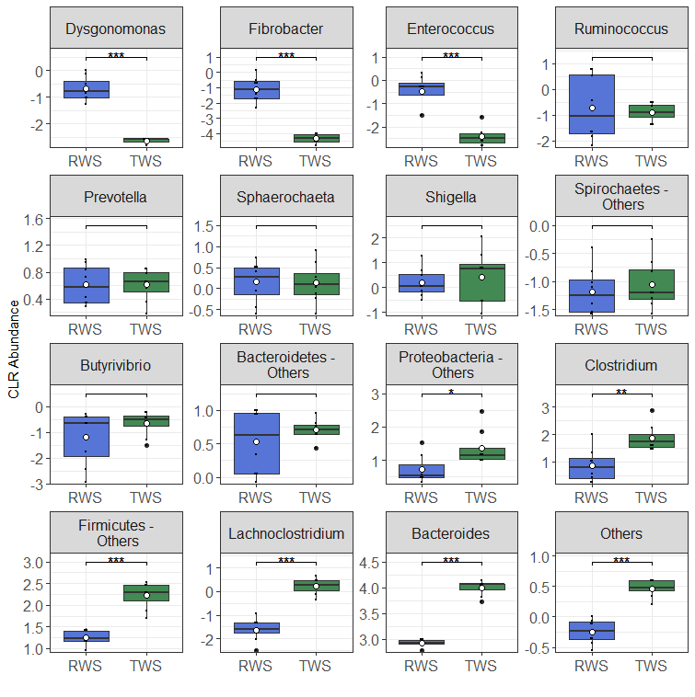

Fig. S6:
A. Clusters of orthologous groups (COGs) in the metaproteomes of RWS and TWS replicates (1 and 2 indicate the biological duplicates). The predicted proteins identified in the metaproteomes were mapped to different COGs using PROPHANE pipeline and RPS-BLAST program. Relative abundance of proteins based on NSAFs (normalized spectral abundance factors) was aggregated at the COG level for stacked bar plot representation for each time point. COGs affiliated to “Metabolism” functions: [C] Energy production and conversion, [E] Amino acid transport and metabolism, [F] Nucleotide transport and metabolism, [G] Carbohydrate transport and metabolism, [H] Coenzyme transport and metabolism, [I] Lipid transport and metabolism, [P] Inorganic ion transport and metabolism, [Q] Secondary metabolites biosynthesis, transport, and catabolism. COGs affiliated to “Information storage and processing” functions: [J] Translation, ribosomal structure and biogenesis, [K] Transcription, [L] Replication, recombination and repair. COGs affiliated to “Cellular processes and signaling” functions: [D] Cell cycle control, cell division, chromosome partitioning, [M] Cell wall/membrane/envelope biogenesis, [N] Cell motility, [O] Post-translational modification, protein turnover, and chaperones, [T] Signal transduction mechanisms, [U] Intracellular trafficking, secretion, and vesicular transport, [V] Defense mechanisms. COGs poorly described were: [R] General function prediction only, [S] Function unknown.

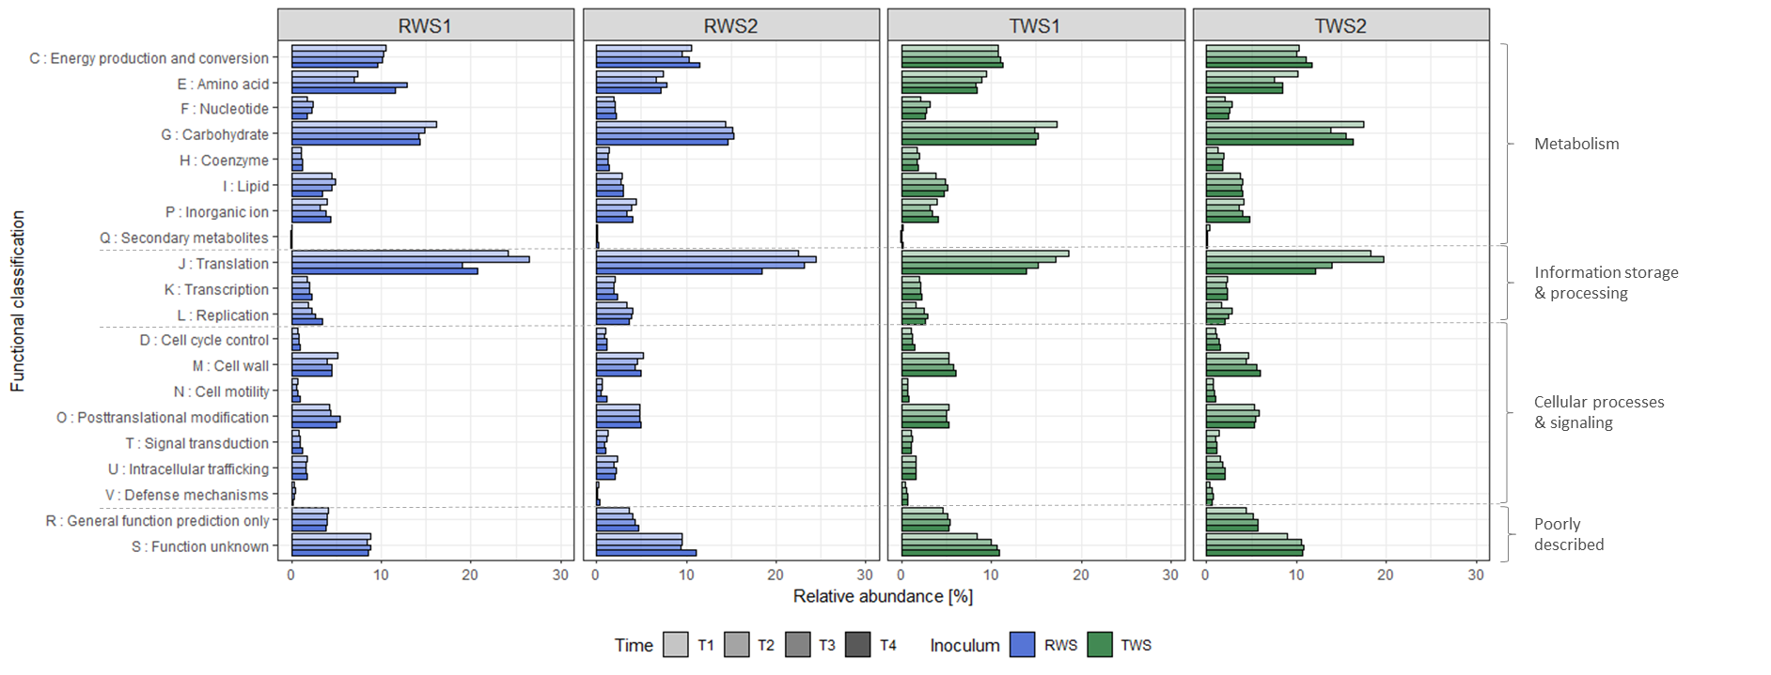

B. Comparison of the expression level of COGs linked to three major phyla Bacteroidetes, Firmicutes and Proteobacteria found in the metaproteomes of RWS and TWS consortia replicates at different sampling times. Relative abundance of proteins is based on NSAF (Normalized spectral abundance factors) values aggregated at the COG level. COGs categories are the same as in A.

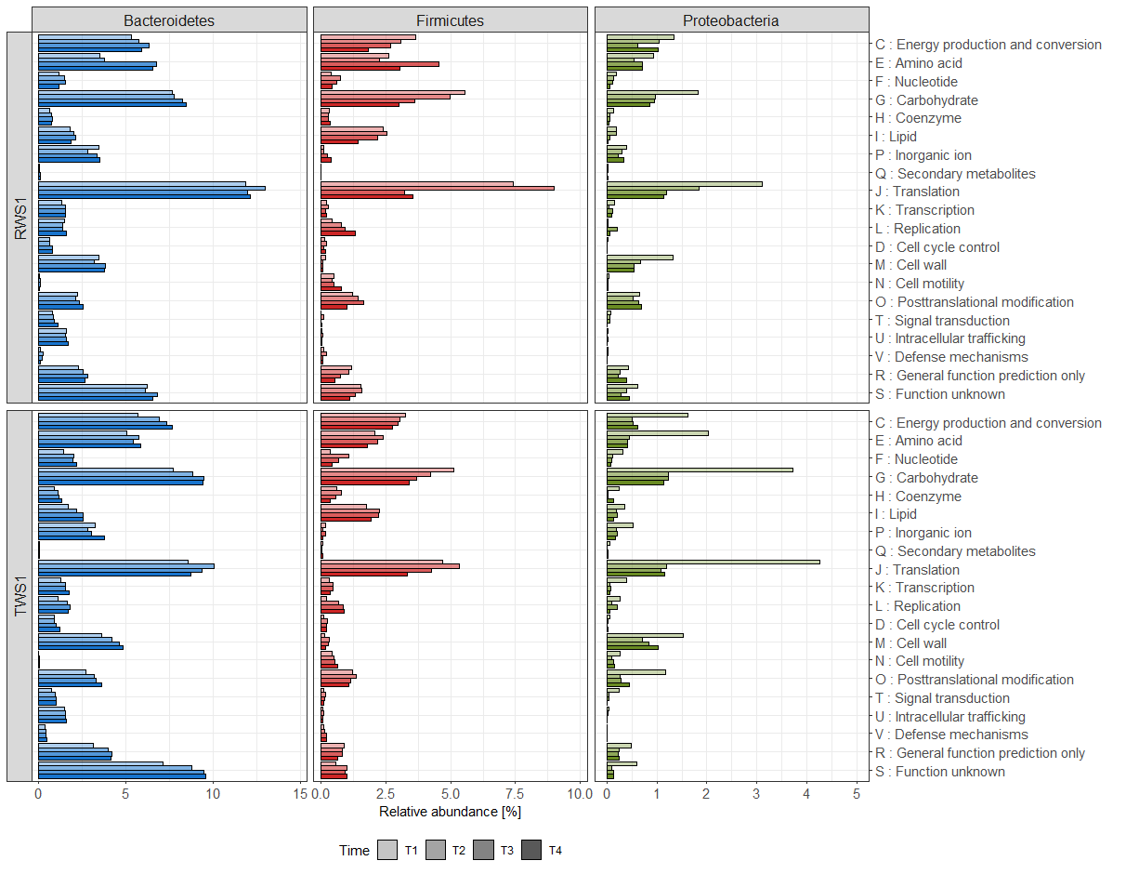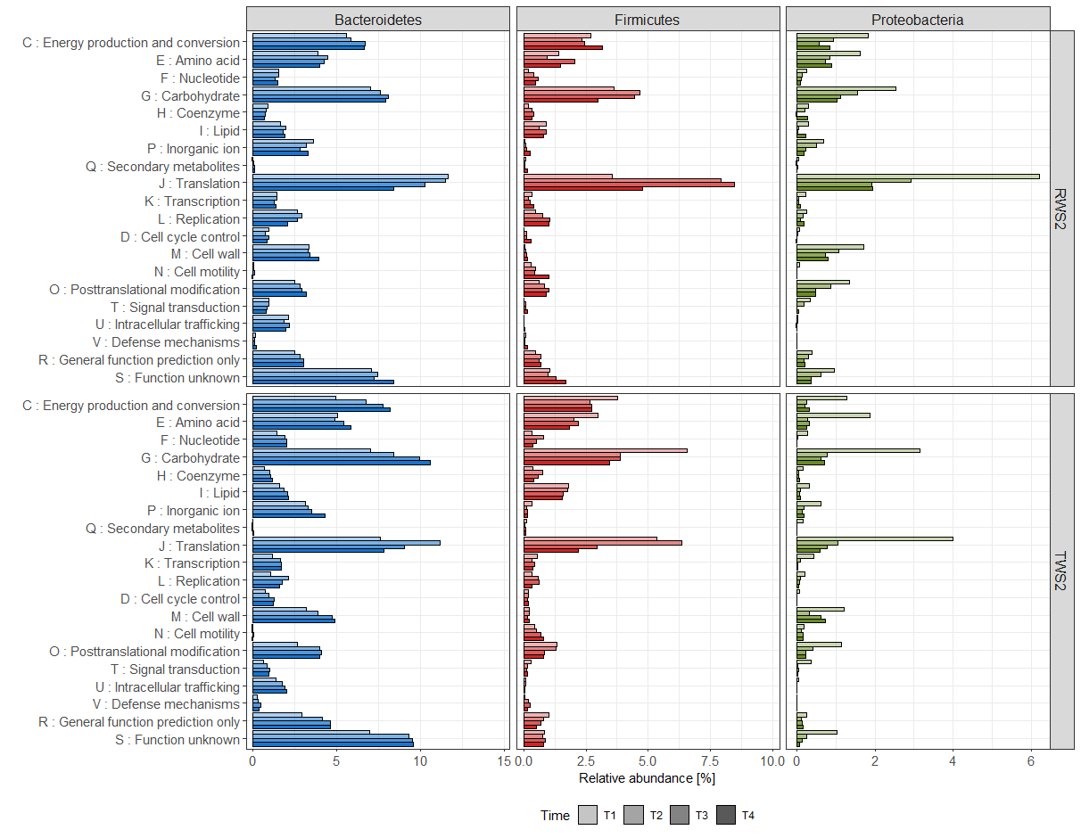

C. Comparison of the specific level of expression of clusters of orthologous groups (COGs) of three major phyla Bacteroidetes, Firmicutes and Proteobacteria found in the metaproteomes of RWS and TWS replicates at different sampling times. Relative abundance of proteins is based on phyla-normalized NSAF (Normalized spectral abundance factors) values. The predicted proteins identified were mapped to different COGs using PROPHANE pipeline and RPS-BLAST program. COGs categories are the same as in A.

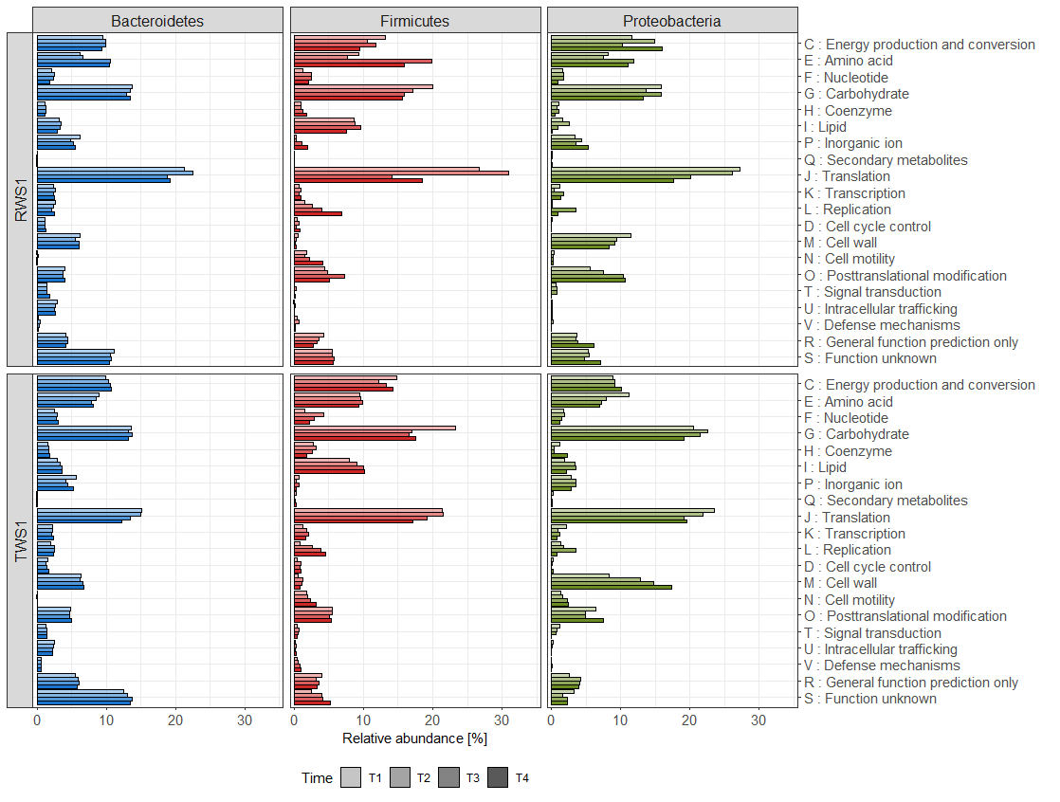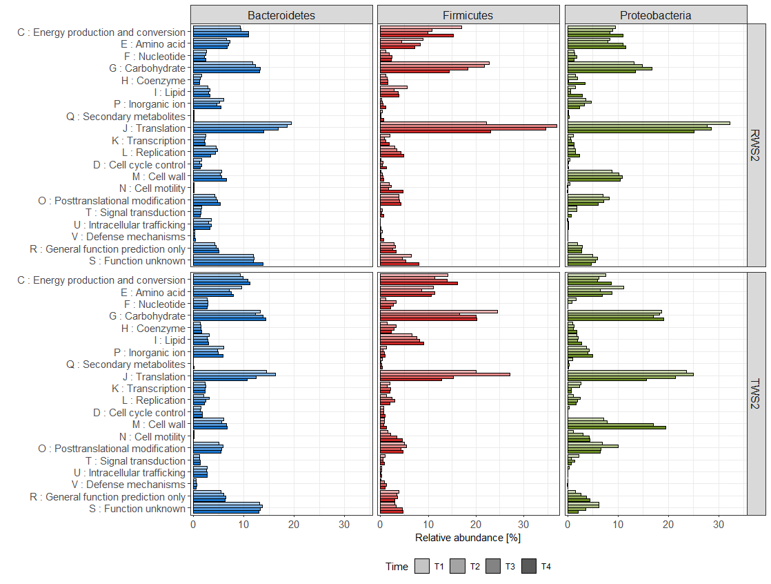

Fig. S7:
A. Venn diagram of shared CAZyme proteins (left) and families (right) between RWS and TWS metaproteomes.

B. Abundance of the CAZyme classes in RWS and TWS metaproteomes : glycoside hydrolases (GH), carbohydrate esterases (CE), carbohydrate binding modules (CBM), glycosyl tranferases (GT), polysaccharide lyases (PL), S-layer homology (SLH), dockerins (DOC), cohesins (COH). Relative abundance is based on average NSAF values. The total abundance of CAZymes category is less than the sum of total abundance of each enzyme class (CBMs + CEs + COHs + DOCs + GHs + GTs + PLs + SLHs) because some multimodular proteins were detected. For the boxplot, the bottom and top of the box are the first and third quartiles, respectively. The middle line represents the sample median. * P < 0.05, ** P < 0.01 level of Wilcoxon rank sum test.

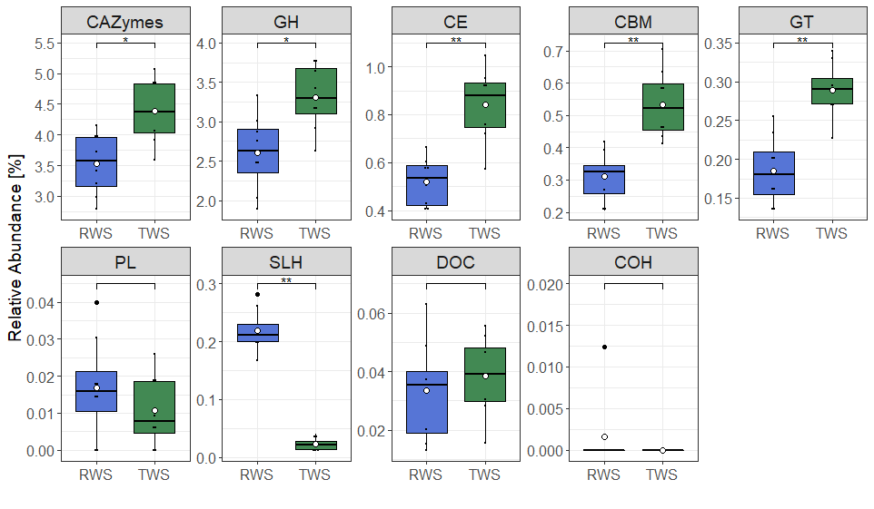

C. Phyla contribution to CAZyme domains (based on average NSAF values) in RWS and TWS. Proteins belonging to the same bacterial phylum are colored as follow: Bacteroidetes (blue), Firmicutes (red), Proteobacteria (green), Spirochaetes (purple), Fibrobacteres (orange), Actinobacteria (yellow), Others (gray).

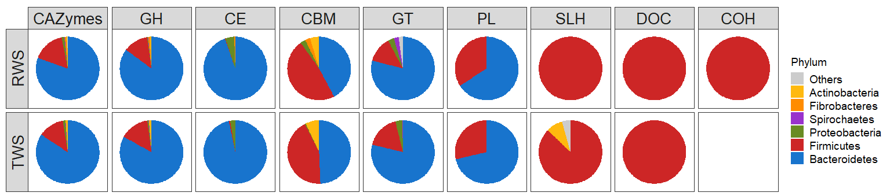

Fig. S8:
Principal component analysis (PCA) of CAZymes profile (CLR normalized data) in RWS and TWS consortia at the different sampling times with 95% confidence ellipses. A. Samples colored by inoculum source: RWS replicates are colored in blue, TWS replicates are colored in green; it reflects the differences in CAZymes profile expression between RWS and TWS. B. Samples colored by sampling points T1 red, T2 purple, T3 grey, T4, yellow.

A. | B.
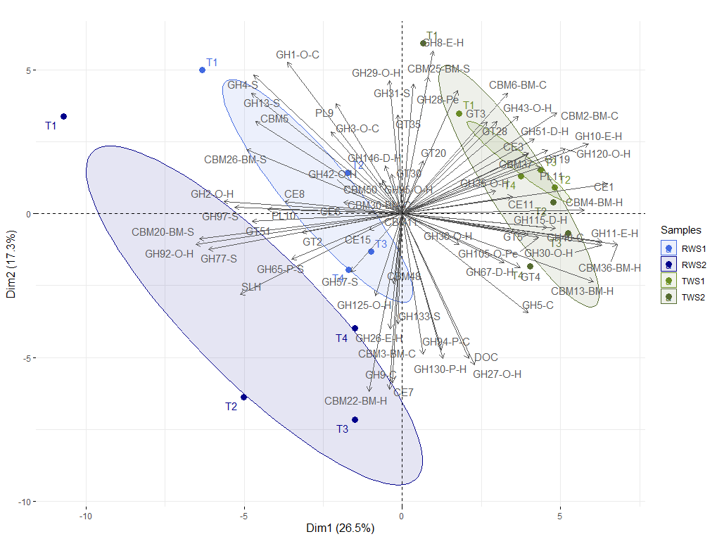 | 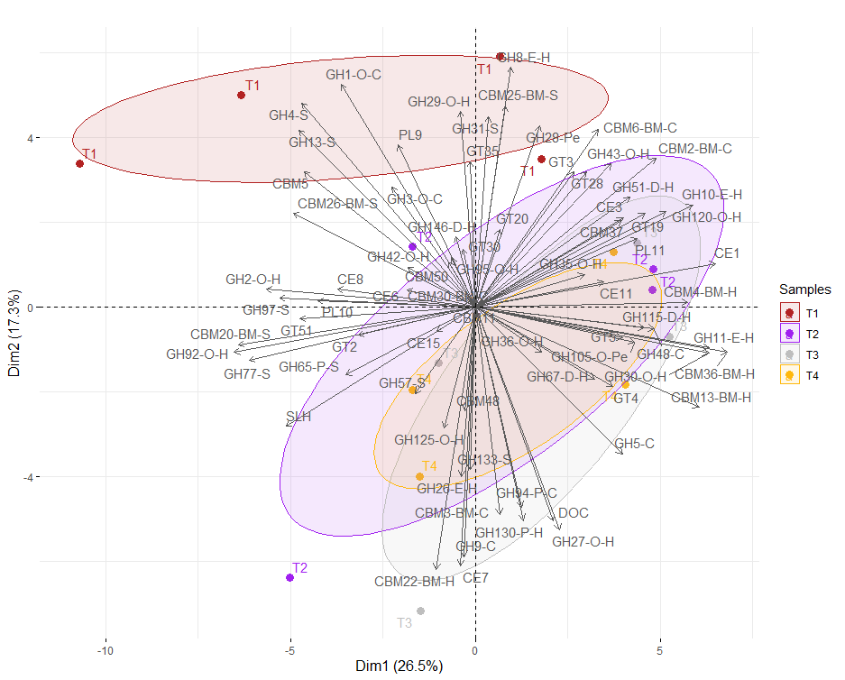

Fig. S9: Temporal dynamics of CAZymes with signal peptide in RWS and TWS metaproteomes. A. Impact of the incubation time in the dynamics of CAZyme with signal peptide of RWS and TWS metaproteomes, assessed by Multivariate Integrative Partial Least Square Discriminant Analysis (MINT-PLS-DA) based on the abundance of CAZymes with signal peptide (family level, CLR-transformed data). MINT-PLS-DA component 1 and 2 explained 31% and 18% of the total variance. Ellipses at 95% confidence. B. Clustered Image Map (CIM) represented the most discriminant CAZyme families of the different sampling times in RWS and TWS (only CAZymes with signal peptide). CIM was built using the main CAZyme families explaining the first two MINT-PLS-DA dimensions. Hierarchical clustering (Euclidean distance and Ward method) represents CAZymes in columns and samples (T1 to T4) in rows. The boxes on the left highlights the clusters discriminating the sampling points. The abundance of CAZy families is indicated by the white-to-red color gradient (increasing values).

A | B
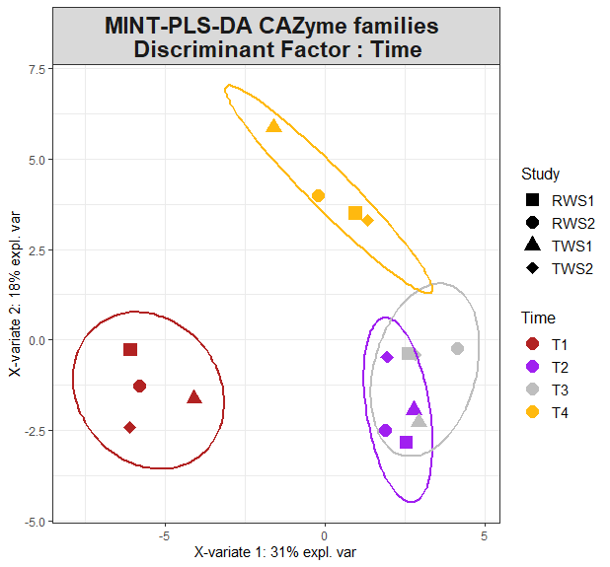 | 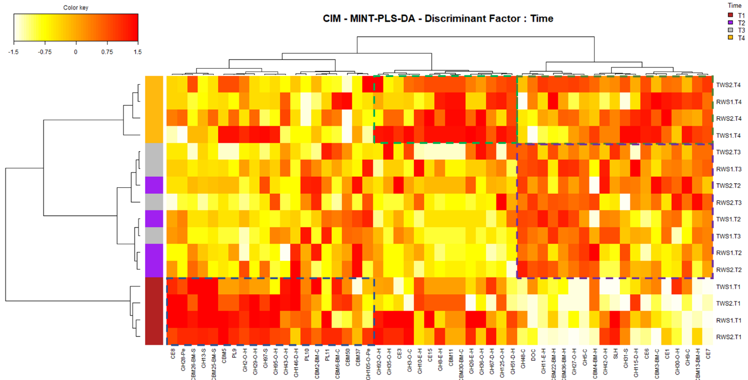

Fig. S10:
Boxplots representing the aggregated abundance of proteins involved in volatile fatty acids production (acetate, propionate, butyrate) in RWS and TWS consortia. For butyrate biosynthesis: COG4770 (acetyl/propionyl-CoA carboxylase), COG3426 (butyrate kinase), COG1250 (3-hydroxyacyl-CoA dehydrogenase), COG1024 (enoyl-CoA hydratase), COG0183 (acetyl/butyryl-CoA acetyltransferase), COG1979 (alcohol dehydrogenase YqhD), COG1454 (alcohol dehydrogenase, class IV), COG1028 (short-chain alcohol dehydrogenase), COG1064 (Zn-dependent alcohol dehydrogenase). For propionate biosynthesis: COG4799/0777 (acetyl/propionyl-CoA carboxylase), COG2185/COG1884 (methylmalonyl-CoA mutase), COG0346 (methylmalonyl-CoA epimerase). For acetate production: COG1012 (NAD-dependent aldehyde dehydrogenase), COG0282 (acetate kinase), COG0280 (phosphotransacetylase). For the box plot, the bottom and top of the box are the first and third quartiles, respectively. The middle line represents the sample median. * P < 0.05 level of Wilcoxon rank sum test.

