Ignoring the Messenger? Limits of Populist Rhetoric on Public Support for Foreign Development Aid

Supplementary Online Appendix

Table of Contents
1. Sample Characteristics................ p. 2-3
2. Experimental Conditions.............p. 2

3. Measurement................................pp. 3-4

3. Detailed Sub-Group Comparisons & Discussion of the Results from Model 3...... p. 4-7

4. Tables for Models Reported in The Main Text....... pp. 8-11

5. Additional Robustness Checks Using Ordinary Least Squares Estimations......p. 12-14

1. Sample Characteristics

 | UK Sample | U.S. Sample
 | Mean (St.d)/ Proportion | Mean (St.d)/ Proportion
Age | 50.3 (17.02)  (min 18, max 90) | 50 (17.15)  (min 19, max 89)
Gender | 54 % female, 46 % male | 54 % female, 46 % male
Less than High School | 31% | 4.5 %
High School | 16.5% | 63%
College or Higher | 53.6% | 32.5 %
Income | Mean £30,000 to £34,999 per year  (min under £5,000, max £150,000 and over) | Mean $50,000 - $59,999 per year  (min less than $10,000, max $5000,000 or more)
Tory | 32 % | NA
Labor | 26 % | NA
Liberal Democrat | 6 % | NA
SNP | 2.6 % | NA
UKIP | 7 % | NA
Green | 3.6 % | NA
BNP | 0.5 % | NA
Republican | NA | 26 %
Democrat | NA | 36 %
Independent | NA | 27 %
Other Party | NA | 5 %
No Party Affiliation | 15% | 5%
Race-White | NA | 70 %
Race-Black | NA | 11%
Race-Hispanic | NA | 10%

YouGov creates a representative sample using matching techniques. They draw a sub-sample of their online panel that is representative of American/ British adults in terms of gender, age, social class and type of newspaper they read. Data is statistically weighted to the national profile of all adults (including those without internet access). The data is weighed by age, gender, social class, region, level of education, how respondents voted at the previous election and their level of political interest. Targets for the weighted data are derived from four sources: (1) the census, (2) large-scale random probability surveys, (3) results of recent general elections, and (4) official office for national statistics population estimates. For example, in the U.S., respondents were matched to a sampling frame on gender, age, race, and education. The frame was constructed by stratified sampling from the full 2017 American Community Survey (ACS) 1-year sample with selection within strata by weighted sampling with replacements. Matched cases are weighted using propensity scores. Matched cases and the frame were combined, and a logistic regression was estimated for inclusion in the frame. Propensity score function include age, gender, race/ethnicity, years of education, and region, and are grouped into deciles of the estimated propensity score in the frame and post-stratified according to these deciles.

2. Experimental Conditions
Introduction script read by all participants: The United Nations International Children's Emergency Fund (UNICEF) has publicly denounced the British/American government. Mr. Jean Morton, the head of regional operations made the following statement on television: “The United Kingdom/ United States is not contributing enough funds to UNICEF, and what funds they provide are being earmarked for pet projects. We really need them to change course and increase Britain’s/America’s commitment of funds, so we can deliver help to children in need across the globe.

Conditions: After seeing the introduction script, participants were randomly assigned to the people, anti-elite, ingroup favoritism conditions that included populist rhetoric, and a control condition that did not include any populist rhetoric

People condition: The British (American) people, the men and women on the street, prefer to take care of British (American) children first.
Anti-elite condition: The media and these humanitarian aid groups are exaggerating the situation to manipulate the British (American) people.
Ingroup Favoritism condition: It is not our responsibility to help those people. Who should help these children are those countries that are more like them, not our people.
Non-populist rhetoric condition: We will assemble a Parliamentary (Congressional) committee to examine the issue and see whether they recommend giving more funding to UNICEF.

3. Measurement
Beliefs about populist politicians-Moderator Variable
Do you see populist leaders as the kind of leaders who...?
-Stand up for the little guy
-Scape-goat groups for our problems
-Neither
-Don’t know

Willingness to Fund UNICEF-Dependent Variable
In the situation you just read, would you prefer that the UK/US gives UNICEF the additional funds they are asking for?
-I would definitely want the UK/US to give UNICEF the funds
-I would probably want the UK/US to give UNICEF the funds
-I would probably not want the UK/US to give UNICEF the funds
-I would definitely not want the UK/US to give UNICEF the funds

4. Detailed Sub-Group Comparisons & Discussion of the Results from Model 3
To avoid presenting too many sub-group comparisons in the main text of the manuscript, we reported the results from a simplified model, which we called Model 3´ that regresses support for funding UNICEF onto a binary treatment variable and a binary prior beliefs variable. Here use all the categories of the experimental conditions and the prior belief variable and present all the sub-group comparison graphs (Model 3 in Table A1).

Figure A1 is based on the interaction effects between experimental conditions and beliefs about populist leaders, and compares the predicted probabilities for the definitely fund and definitely not fund UNICEF outcomes. The main finding is that individuals’ prior beliefs about populist politicians’ goals matter. These beliefs make them more or less susceptible to populist rhetoric, thus moderating of such discourse on preferences toward funding UNICEF.

Figure A1. Predicted Probabilities for Funding UNICEF By Experimental Conditions and Beliefs About Populist Leaders (Model 3)
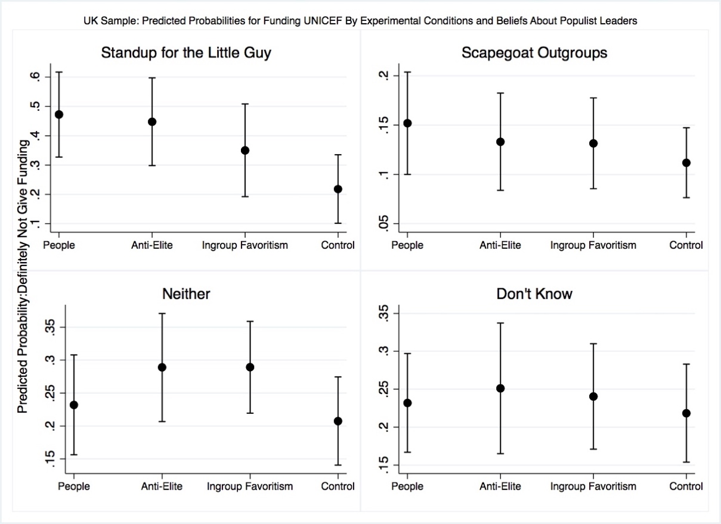
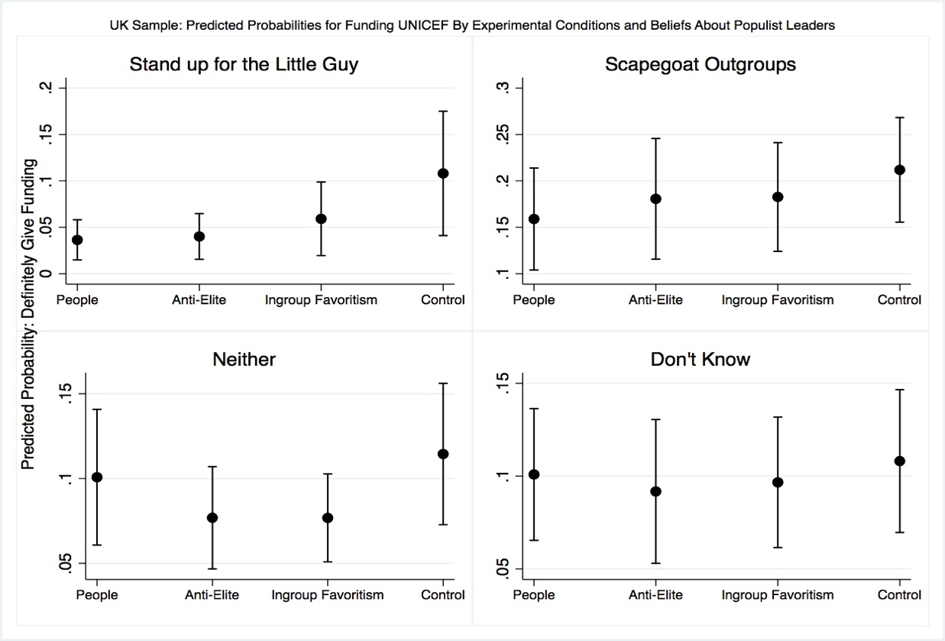
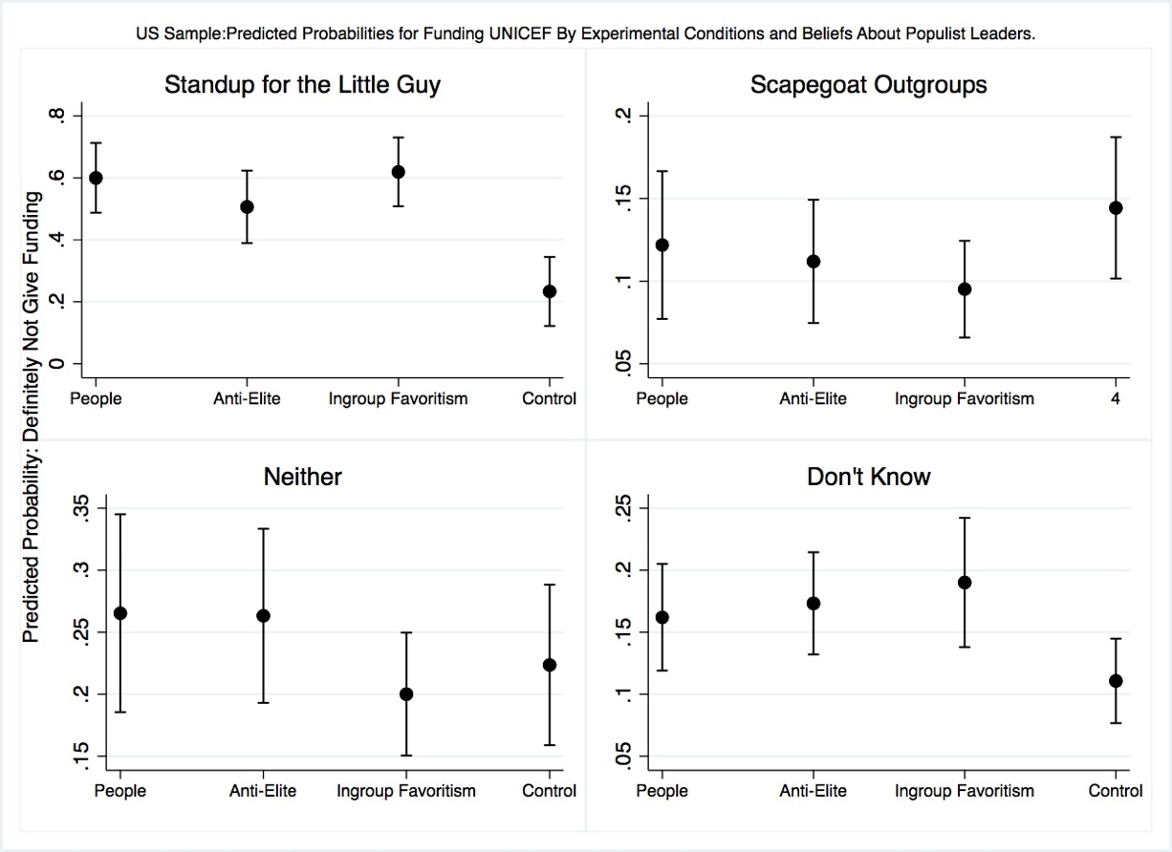
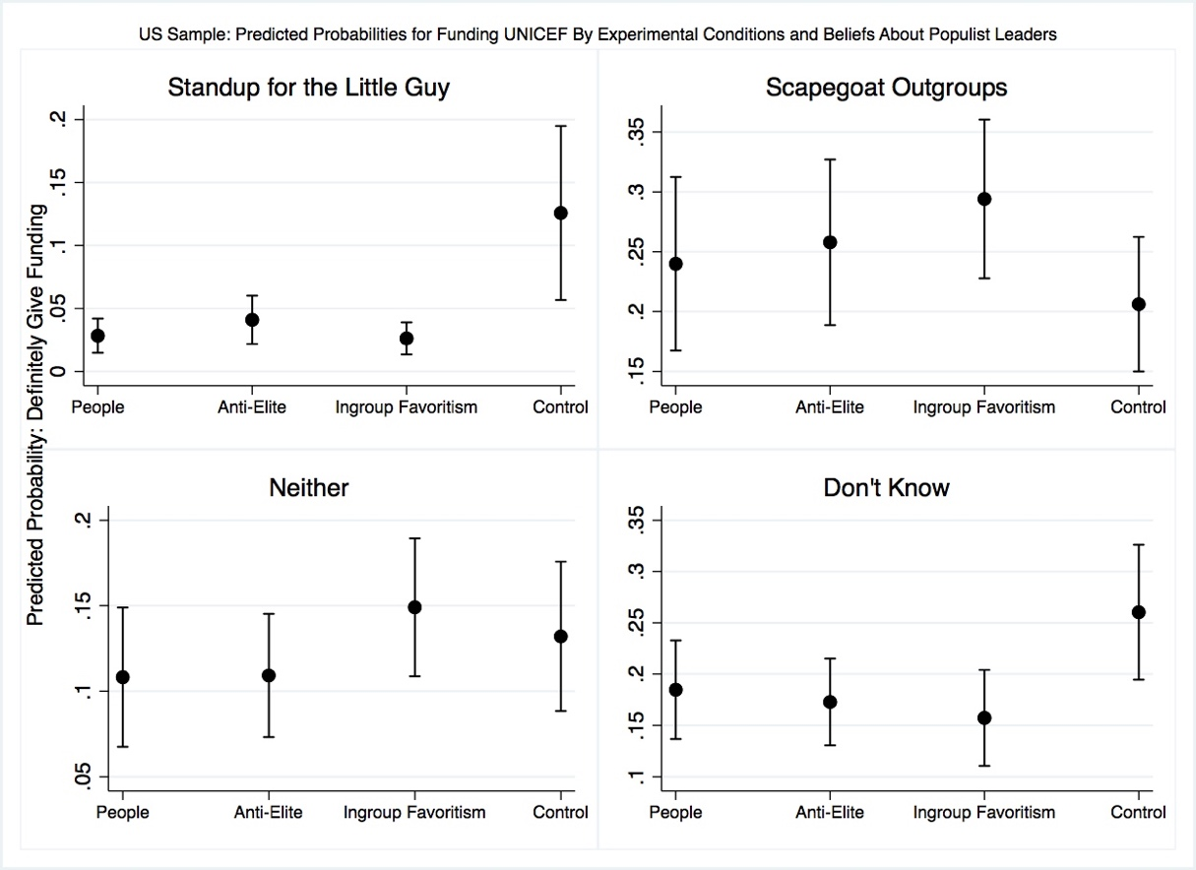
Note: Figure displays the predicted probabilities obtained from an ordered logistic regression model (Model 3 in Table A1) that regresses the dependent variable onto the populist rhetoric treatment, prior beliefs about populist politicians variable, and an interaction between prior beliefs and the treatment. The dependent variable measures participants’ willingness to contribute funds to UNICEF. It is ranges from 1 to 4, where 1 is coded as “definitely not give funds” and 4 is coded as “definite give funds.

In the UK sample, even though we do not observe any interaction between beliefs and the in-group favoritism condition, the interaction effects between beliefs about populist leaders and people and anti-elite conditions are statistically significant and substantively large. For example, among those who received the people treatment, the predicted probability of choosing definitely not give funding to UNICEF is 47 percentage points for those who think populist leaders stand up for the little guy, but it is only 13 percentage points for those who think populist leaders scapegoat outgroups. This is a difference of 34 percentage points. In the same way, while the predicted probability of saying definitely give additional funding to UNICEF is 0.3 for those who believe populist leaders stand up for the little guy, it is 0.16 among those who think populist politicians scapegoat outgroups (holding exposure to the people treatment constant).
A comparable trend can be observed in the anti-elite condition. Those who think populist leaders scapegoat outgroup are about 33 percentage points less likely to say definitely not give funds and 14 points more likely to say definitely give money relative to those who think populists stand up for the people. In the control condition, these differences are about 9 percentage points for the highest and lowest levels of the dependent variable.
Similar patterns exist in the U.S. sample. American respondents who believe that populist politicians scapegoat outgroups are 50 percentage points less likely to choose definitely not fund UNICEF compared to those who think populist politicians stand up for the little guy. Similarly, those who are uncertain about the intentions of populist politicians are about 35 percentage points less likely to choose the no funding option. For the definitely fund UNICEF outcome in the people condition, respondents who said they don’t know the intentions of populist leaders and respondents who say populist leaders scapegoat outgroups are 16 and 19 percentage points more likely to give funding than those who see populist politicians as standing up for the common people.
As was the case in the UK sample, we again observe that individuals respond to anti-aid populist discourse a function of what they think of populist politicians. While the predicted probability of choosing definitely fund UNICEF is 0.50 for respondents who think populist politicians stand up for the people, it declines to 0.11 for those who think populist politicians scapegoat outgroups, compared to 0.26 for those who think populist politicians do neither and to 0.17 for those who are not sure. Looking at the definitely fund UNICEF outcome, we again see that there is a 21-percentage points difference in likelihood between those who believe populist politicians are on the side of the common people and those who think populists are playing blame games.
One important difference between the U.S. and UK samples is that in the former, the interaction terms between beliefs about populist politicians and the ingroup favoritism condition are statistically significant and substantively large. Among Americans exposed to anti-aid rhetoric centered on favoring the ingroup, those who think populist politicians scapegoat outgroups are 50 percentage points less likely to choose the definitely not fund option relative to those who think populist politicians stand up for the common people. Similarly, respondents who said populist politicians do neither or provided don’t know answers are about 40 percentage points less likely to say do not fund UNICEF. For the definitely fund UNICEF options, compared to respondents who believe that populist leaders stand up for the little guy, others are significantly more likely to choose funding UNICEF (differences in predicted probabilities range from 28 to 13).
Our results also indicate that individuals who are uncertain or ambivalent about the intentions of populist leaders are not that easily swayed by populist rhetoric against aid. First, the statistically significant interaction terms between the experimental conditions and the “neither/don’t know” responses indicate that exposure to anti-aid populist rhetoric actually increases support for UNICEF among the uncertain respondents. To illustrate, the predicted probability of choosing definitely not give funds to UNICEF is 0.20 for uncertain British respondents assigned to the control condition, but 0.29 for uncertain those assigned to the anti-elite condition. In the same way, the predicted probability of choosing definitely give funding is 0.11 % if uncertain respondents have been assigned to the control condition, but 0.7 if they have been assigned to the anti-elite condition. These differences in probabilities are about 0.4 if we look at the people condition. If we look at “don’t know” responses, we see about 2 percentage points difference between those assigned to the control condition and the treatment conditions. In addition, in the people condition, British respondents who are uncertain about the intentions of populist politicians are about 24 percentage points less likely to choose definitely not give funds to UNICEF compared to those who think these politicians protect the interests of the people. In the same vein, uncertain respondents are about 7 points more likely to say definitely give funds to UNICEF than those who think populists have admirable intentions.
Similarly, in the ingroup favoritism condition, American respondents who said populist politicians neither stand up for the little guy nor scapegoat outgroups or provided don’t know answers are about 40 percentage points less likely to say do not fund UNICEF relative to those who think populist politicians stand up for the common people. In the people and anti-elite conditions, we observe a similar pattern for uncertain American respondents.

4. Tables for Models Reported in The Main Text
Table A1. Willingness to Provide Funds to UNICEF

 | Model UK 1 | Model UK 2 | Model UK 3 | Model UK 4 | Model US 1 | Model US 2 | Model US 3 | Model US 4
Experimental Conditions
People | -0.347 **  (0.147) | -0.328**  (0.148) | -1.165**  (0.457) | -1.447**  (0.43) | -0.369**  (0.133) | -0.346**  (0.137) | -1.604***  (0.406) | -1.854***  (0.408)
Ant-Elite | -0.356**  (0.153) | -0.356**  (0.154) | -1.065**  (0.464) | -1.480**  (0.46) | -0.318**  (0.125) | -0.287**  (0.132) | -1.214**  (0.405) | -1.403**  (0.417)
In-group Favoritism | -0.286**  (0.143) | -0.296**  (0.144) | -0.657  (0.500) | -1.041**  (0.47) | -0.263**  (0.127) | -0.243*  (0.131) | -1.675***  (0.406) | -1.735***  (0.404)
Beliefs about Populist Politicians

Scapegoat Others |  | 1.360***  (0.19) | 0.796**  (0.38) | 0.089  (0.35) |  | 2.00***  (0.162) | 0.600*  (0.357) | 0.234  (0.338)
Neither Standup for the little guy nor scapegoat |  | 0.560**  (0.19) | 0.064  (0.40) | -0.242  (0.36) |  | 1.146***  (0.157) | 0.055  (0.364) | 0.010  (0.340)
Don’t Know |  | 0.656***  (0.19) | 0.002  (0.40) | -0.219  (0.37) |  | 1.652***  (0.152) | -0.104**  (0.357) | 0.572*  (0.340)
Interactions
People X Scapegoat |  |  | 0.812*  (0.524) | 1.242**  (0.50) |  |  | 1.800***  (0.476) | 2.208***  (0.485)
People X Neither |  |  | 1.022**  (0.540) | 1.131**  (0.52) |  |  | 1.368**  (0.482) | 1.653**  (0.487)
People X Don’t Know |  |  | 1.087**  (0.53) | 1.182**  (0.53) |  |  | 1.154**  (0.467) | 1.490**  (0.473)
Anti-Elite X Scapegoat |  |  | 0.867*  (0.53) | 1.320**  (0.53) |  |  | 1.505**  (0.467) | 1.700***  (0.486)
Anti-Elite X Neither |  |  | 0.625  (0.54) | 1.027*  (0.53) |  |  | 1.00**  (0.472) | 1.047**  (0.487)
Anti-Elite X Don’t Know |  |  | 0.882*  (0.55) | 1.191**  (0.54) |  |  | 0.702*  (0.450) | 1.012**  (0.481)
In-group Favoritism X Scapegoat |  |  | 0.472  (0.55) | 1.031  (0.54) |  |  | 2.148***  (0.461) | 2.135***  (0.471)
In-group Favoritism X Neither |  |  | 0.216  (0.56) | 0.610  (0.53) |  |  | 1.816***  (0.463) | 2.01***  (0.466)
In-group Favoritism X Don’t Know |  |  | 0.532  (0.56) | 0.557  (0.55) |  |  | 1.041**  (0.462) | 1.170**  (0.470)
Income |  |  |  | 0.003*  (0.01) |  |  |  | -0.002  (0.001)
High School |  |  |  | 0.220  (0.175) |  |  |  | 0.127  (0.260)
College |  |  |  | 0.407**  (0.13) |  |  |  | 0.300  (0.270)
Lack of Generalized Trust |  |  |  | -0.756***  (0.13) |  |  |  | -0.404***  (0.102)
Labor |  |  |  | 0.848***  (0.13)
Liberal Democrat |  |  |  | 1.034***  (0.274)
SNP |  |  |  | 0.576*  (0.36)
UKIP |  |  |  | -0.344*  (0.21)
Green |  |  |  | 0.705**  (0.38)
BNP |  |  |  | -2.61**  (1.11)
Republican |  |  |  |  |  |  |  | -0.707***  (0.121)
Democrat |  |  |  |  |  |  |  | 1.074***  (0.118)
Age |  |  |  | -0.016***  (0.01) |  |  |  | -0.0101***  (0.002)
Female |  |  |  | 0.207*  (0.11) |  |  |  | 0.376***  (0.100)
Cutpoint 1 | -1.507  (0.11) | -0.760  (0.192) |  | -2.19  (0.417) | -1.480  (0.100) | -0.223  (0.162) | -1.210  (0.317) | -1.805  (0.417)
Cutpoint 2 | -0.029  (0.10) | 0.774  (0.194) |  | -0.477  (0.41) | -0.351  (0.100) | 1.031  (0.168) | 1.102  (0.314) | -0.363  (0.415)
Cutpoint 3 | 1.740  (0.11) | 2.61  (0.209) |  | 1.54  (0.41) | 1.37  (0.101) | 2.86  (0.181) | 2.03  (0.320) | 1.750  (0.421)
Wald χ² | 7.35** | 73.61*** | 80.70*** | 257.93*** | 9.61** | 184.82*** | 217.35** | 454.33***
Log likelihood | -1539.4238 | -1503.8492 | -1499.9515 | -1412.3443 | -2126.6433 | -2029.3211 | -2012.2535 | -1874.9933
Pseudo R² | 0.0024 | 0.0255 | 0.0281 | 0.0844 | 0.0022 | 0.0479 | 0.0559 | 0.1203
N | 1,167 | 1,167 | 1,167 | 1,167 | 1,581 | 1,581 | 1,581 | 1,581
*** p≤0.001 **p≤ 0.05 *p≤0.10
Note: Reported values are ordinal logistic regression coefficients with robust standard errors in parentheses. The dependent variable measures participants’ willingness to contribute funds to UNICEF. It is ranges from 1 to 4, where 1 indicates “Definitely not give funds” and 4 indicates “Definitely give funds”. The “control” group is the reference category for the experimental conditions that includes no populist rhetoric and “populist politicians stand up for the little guy” is the reference category for the beliefs about populist politicians’ variable. In the full mode, less than “high school” is the reference category for education, male is the reference category for gender and “Tory” is the reference category for party for the UK models and “Independent” is the reference category for party for the U. S. models.

5. Additional Robustness Checks: Ordinary least squares estimations yield similar results

 | Model 1 US OLS | Model 2 US OLS | Model 3 US OLS
Experimental Conditions
People | -0.211**  (0.073) | -0.200**  (0.071) | -0.788***  (0.181)
Ant-Elite | -0.1817**  (0.071) | -0.1624**  (0.070) | -0.616 ***  (0.186)
In-group Favoritism | -0.148**  (0.071) | -0.137**  (0.068) | -0.807 ***  (0.181)
Beliefs about Populist Politicians

Scapegoat Others |  | 1.011***  (0.0748) | 0.322*  (0.176)
Neither Standup for the little guy nor scapegoat |  | 0.566***  (0.076) | 0.0362  (0.180)
Don’t Know |  | 0.851***  (0.072) | 0.485 **  (0.174)
Interactions
People X Scapegoat |  |  | 0.846***  (0.227)
People X Neither |  |  | 0.672**  (0.231)
People X Don’t Know |  |  | 0.5542 **  (0.218)
Anti-Elite X Scapegoat |  |  | 0.753**  (0.227)
Anti-Elite X Neither |  |  | 0.497 *  (0.230)
Anti-Elite X Don’t Know |  |  | 0.349 *  (0.219)
In-group Favoritism X Scapegoat |  |  | 1.043***  (0.227)
In-group Favoritism X Neither |  |  | 0.892***  (0.223)
In-group Favoritism X Don’t Know |  |  | 0.471*  (0.219)
Constant | 2.606***  (.0510) | 1.917 ***  (0.078) | 2.370***  (0.151)
R² | 0.0062 | 0.1206 | 0.1388
N | 1,581 | 1,581 | 1,581
Note: *** p≤0.001 **p≤ 0.05 *p≤0.10
Table Entries are ordinary least squares regression coefficients with robust standard errors in parentheses

 | Model 1 UK OLS | Model 2 UK OLS | Model 3 UK OLS
Experimental Conditions
People | -0.172**  (0.077) | - 0.162**  (0.075) | -0.531**  (0.212)
Ant-Elite | -0.1764 **  (0.081) | -0.177**  (0.078) | -0.506**  (0.230)
In-group Favoritism | -0.146**  (0.077) | -0.156**  (0.075) | -0.3243  (0.244)
Beliefs about Populist Politicians

Scapegoat Others |  | 0.661***  (0.100) | 0.398**  (0.189)
Neither Standup for the little guy nor scapegoat |  | 0.247**  (0.100) | 0.0185  (0.200)
Don’t Know |  | 0.302**  (0.110) | 0.001  (0.20)
Interactions
People X Scapegoat |  |  | 0.357*  (0.230)
People X Neither |  |  | 0.471*  (0.260)
People X Don’t Know |  |  | 0.492**  (0.254)
Anti-Elite X Scapegoat |  |  | 0.420*  (0.267)
Anti-Elite X Neither |  |  | 0.281  (0.275)
Anti-Elite X Don’t Know |  |  | 0.402*  (0.270)
In-group Favoritism X Scapegoat |  |  | 0.222  (0.272)
In-group Favoritism X Neither |  |  | 0.177  (0.276)
In-group Favoritism X Don’t Know |  |  | 0.256  (0.279)
Constant | 2.468***  (.054) | 2.092***  (0.10) | 2.324***  (0.167)
R² | 0.0057 | 0.0634 | 0.0691
N | 1,167 | 1,167 | 1,167
Note: *** p≤0.001 **p≤ 0.05 *p≤0.10
Table Entries are ordinary least squares regression coefficients with robust standard errors in parentheses

