Supplementary data

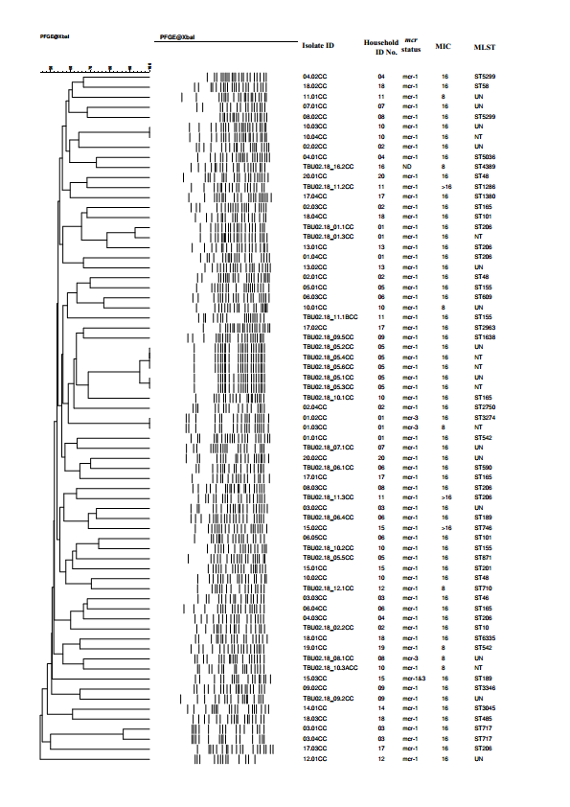
Figure S1. Dendrogram of PFGE patterns among colistin-resistant E. coli isolates
ND, not detected; MIC, mg/L; UN, unknown; NT, not tested.

Table S1. Percentages of colistin-resistant E. coli isolates that exhibited resistance to other antibiotics

Antimicrobial agent class |  |  | Antimicrobial agents | Resistance %
β-Lactams | Penicillins |  | AMP | 91.3
 | Cephalosporins | 2nd generation | FOX | 7.2
 |  | 3rd generation | CTX | 7.2
 |  |  | CAZ | 1.4
 | Carbapenem |  | MEM | 0
Aminoglycosides |  |  | STR | 65.2
 |  |  | KAN | 42.0
 |  |  | GEN | 33.3
Quinolones |  |  | CIP | 15.9
 |  |  | NAL | 33.3
Tetracycline |  |  | TET | 91.3
Phenicol |  |  | CHL | 85.5
Phosphomycin |  |  | FOF | 0
Folic acid inhibitors |  |  | SXT | 76.8
Sixty nine colistin-resistant E. coli isolates were tested.
AMP, ampicillin; FOX, cefoxitin; CTX. cefotaxime; CAZ, ceftazidime;
MEM, meropenem; STR, streptomycin; KAN, kanamycin; GEN, gentamicin;
CIP, ciprofloxacin; NAL, nardixic acid; TET, tetracycline; CHL, chloramphenicol;
FOF, fosfomycin; SXT, trimethoprim-sulfamethoxazole.

