Supplemental Table 1: Baseline characteristics without the one woman with a median pancreatic fat content of 23.7 percent | Total | control | pGDM/NGT | pGDM/PGT | p-value | post hoc test
clinical characteristics
n | 96 | 37 | 41 | 18
age (years) (mean ± SD) | 35.5±3.9 | 35.9±4.1 | 35.0±3.3 | 35.9±4.5 | 0.5094 | -
time since delivery (months) (mean ± SD) | 9.6±2.9 | 9.3±2.6 | 9.8±3.1 | 9.9±3.1 | 0.7760 | -
BMI (kg/m²) (mean ± SD) | 24.7±5.0 | 22.8±3.3 | 24.8±4.6 | 28.5±6.7 | 0.0032 | control vs. PGT
BMI <25 | 60 (62.5%) | 27 (73.0%) | 27 (65.9%) | 6 (33.3%) | 0.0123
BMI ≥25 - <30 | 19 (19.8%) | 8 (21.6%) | 6 (14.6%) | 5 (27.8%)
BMI ≥30 | 17 (17.7%) | 2 (5.4%) | 8 (19.5%) | 7 (38.9%)
waist circumference (cm)  (mean ± SD) | 79.9±10.9 | 76.3±9.0 | 80.0±11.2 | 87.4±10.7 | 0.0016 | control vs. PGT, NGT vs. PGT
systolic blood pressure (mmHg) (mean ± SD) | 115.6±10.3 | 111.5±10.0 | 117.4±9.3 | 119.8±10.8 | 0.0018 | control vs. PGT, NGT vs. control
diastolic blood pressure (mmHg) (mean ± SD) | 71.8±8.7 | 69.0±8.2 | 73.1±7.3 | 74.7±11.1 | 0.0209 | no
IFG (n, %) | 7 (7.3%) | 0 | - | 7 (38.9%) | -
IGT (n, %) | 7 (7.3%) | 0 | - | 7 (38.9%)
IFG+IGT (n, %) | 1 (1.0) | 0 | - | 1 (5.6)
Diabetes Type 2 (n, %) | 3 (3.1%) | 0 | - | 3 (16.7%)
MRI
pancreatic fat (%) (median (Q1–Q3)) | 2.7 (1.8-4.8) | 2.2 (1.9-3.4) | 3.2 (1.7-5.6) | 2.8 (1.9-5.1) | 0.1285 | -
liver fat (%) (median (Q1–Q3)) | 0.5 (0.0-1.2) | 0.2 (0.0-0.5) | 0.5 (0.1-1.3) | 1.5 (0.3-5.3) | 0.0020 | control vs. PGT
intraabdominal fat (l) (median (Q1–Q3)) | 1.6 (1.0-2.7) | 1.3 (0.8-1.9) | 1.7 (1.1-2.8) | 2.4 (1.3-3.2) | 0.0158 | control vs. PGT
clinical chemistry
triglycerides (mg/dl) (median (Q1–Q3)) | 64.0 (53.0-91.0) | 59.0 (52.0-75.0) | 66.0 (49.0-92.0) | 87.5 (64.0-130.0) | 0.0128 | control vs. PGT
LDL cholesterol (mg/dl) (median (Q1–Q3)) | 104.0 (87.5-118.5) | 104.0 (85.0-116.0) | 103.0 (89.0-120.0) | 108.0 (88.0-125.0) | 0.7618 | -
HDL cholesterol (mg/dl) (median (Q1–Q3)) | 61.5 (50.5-73.0) | 64.0 (58.0-75.0) | 64.0 (49.0-73.0) | 50.5 (42.0-59.0) | 0.0015 | control vs. PGT, NGT vs. PGT
hsCRP (median (Q1–Q3)) | 0.0 (0.0-0.1) | 0.0 (0.0-0.1) | 0.0 (0.0-0.1) | 0.1 (0.0-0.3) | 0.0032 | control vs. PGT
gamma-GT (U/l) (median (Q1–Q3)) | 14.0 (11.0-20.0) | 13.0 (10.0-17.0) | 14.0 (11.0-18.0) | 22.0 (15.0-29.0) | <0.0001 | control vs. PGT, NGT vs. PGT
OGTT
fasting plasma glucose (mg/dl) (median (Q1–Q3)) | 91.0 (87.0-96.0) | 90.0 (84.0-92.0) | 91.0 (88.0-94.0) | 102.5 (97.0-107.0) | <0.0001 | control vs. PGT, NGT vs. PGT
plasma glucose 2h (mg/dl) (median (Q1–Q3)) | 104.0 (87.0-120.5) | 87.0 (78.0-108.0) | 109.0 (100.0-121.0) | 150.0 (113.0-169.0) | <0.0001 | control vs. PGT, NGT vs. control
ISI (median (Q1–Q3)) | 5.5 (3.6-8.2) | 7.8 (5.5-9.5) | 5.4 (4.0-7.5) | 3.0 (2.3-4.0) | <0.0001 | all
IR30 (median (Q1–Q3)) | 40.5 (30.6-59.0) | 40.2 (31.7-61.8) | 41.1 (28.7-56.4) | 38.7 (33.4-60.0) | 0.8534 | -
DI (median (Q1–Q3)) | 232.8 (162.9-322.9) | 321.7 (250.6-392.0) | 194.4 (163.7-294.4) | 138.6 (100.5-173.4) | <0.0001 | all
IVGTT
FPIR (median (Q1–Q3)) (n=63) | 2.1 (1.3-3.2) | 2.1 (1.2-2.8) | 1.9 (1.3-2.9) | 2.2 (1.4-3.4) | 0.7590 | -
ivDI (median (Q1–Q3)) (n=63) | 11.1 (8.0-18.3) | 16.8 (11.1-22.9) | 9.9 (8.7-15.3) | 6.7 (5.8-10.2) | <0.0001 | all
Abbreviations: pGDM, post gestational diabetes mellitus; NGT, normal glucose tolerance; PGT, pathological glucose tolerance; BMI, body mass index; IFG, impaired fasting glucose; IGT, impaired glucose tolerance; LDL, low-density lipoprotein; HDL, high-density lipoprotein; hsCRP, high-sensitivity C-reactive protein; gamma-GT, gamma-glutamyl transferase; OGTT, oral glucose tolerance test; ISI, insulin sensitivity index; IR30, insulin increment within the first 30 minutes of the OGTT; DI, disposition index; IVGTT, intravenous glucose tolerance test; FPIR, first phase insulin response; ivDI, intravenous disposition index.

Supplemental Table 2: (Partial) spearman correlation coefficients

 | mean pancreatic fat content | minimum pancreatic fat content | median pancreatic fat content without the one woman with a pancreatic fat content of 23.7 percent
IR30 | 0.22 (0.027) | 0.16 (0.110) | 0.16 (0.116)
IR30 adjusted for ISI | 0.14 (0.278) | 0.12 (0.352) | 0.09 (0.471)
FPIR | 0.25 (0.049) | 0.15 (0.238) | 0.24 (0.052)
FPIR adjusted for ISI | 0.17 (0.182) | 0.11 (0.396) | 0.17 (0.172)
DI | -0.19 (0.060) | -0.08 (0.409) | -0.16 (0.125)
ivDI | 0.03 (0.798) | 0.02 (0.892) | 0.04 (0.728)
BMI | 0.43 (<0.001) | 0.25 (0.014) | 0.39 (<0.001)
waist circumference (cm) | 0.33 (0.001) | 0.19 (0.059) | 0.27 (0.008)
liver fat (%) | 0.32 (0.001) | 0.08 (0.408) | 0.26 (0.010)
intraabdominal fat (l) | 0.42 (<0.001) | 0.26 (0.012) | 0.36 (<0.001)
ISI | -0.32 (0.001) | -0.19 (0.056) | -0.25 (0.014)
ISI adjusted for BMI | -0.04 (0.724) | -0.03 (0.739) | 0.02 (0.862)
Abbreviations: IR30, insulin increment within the first 30 minutes of the OGTT; ISI, insulin sensitivity index; FPIR, first phase insulin response; DI, disposition index; ivDI, intravenous disposition index; BMI, body mass index. P-values are shown in parentheses, if <0.05 they were considered statistically significant and printed in bold.

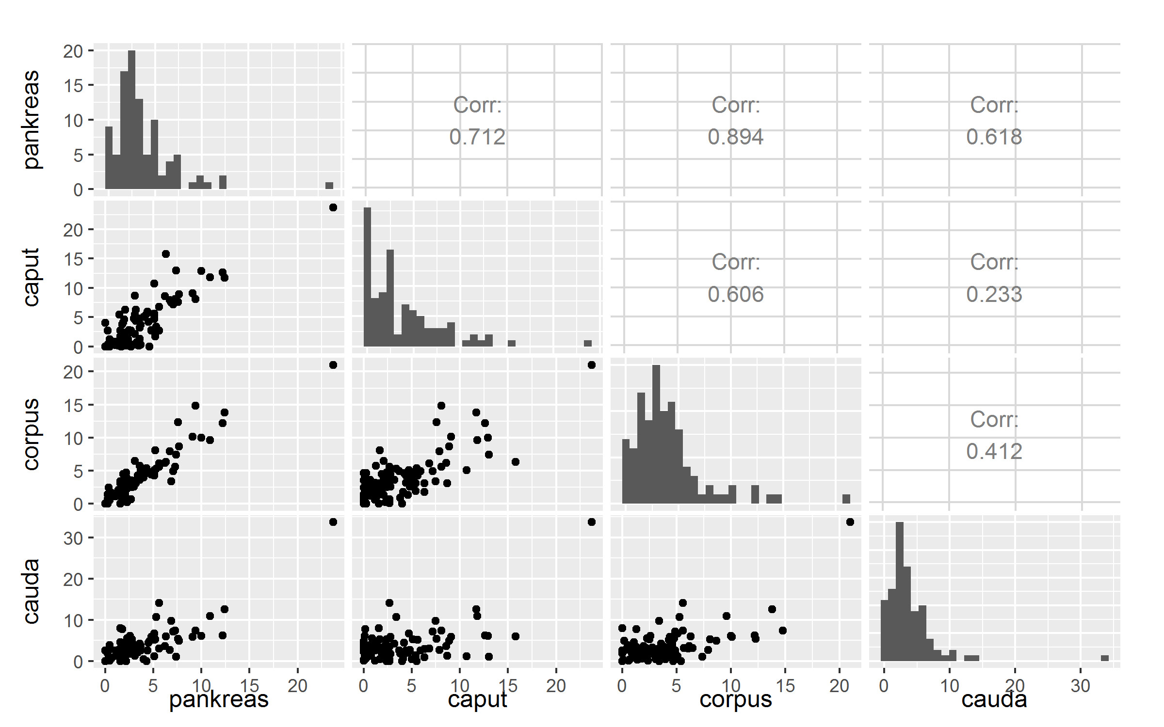

Supplemental Figure 1: Correlation matrix of median pancreatic fat in the different parts of the organ: Scatterplots (black), histograms (grey) and Spearman correlation coefficients for median fat content (in %) in caput, corpus, cauda, and the whole organ.
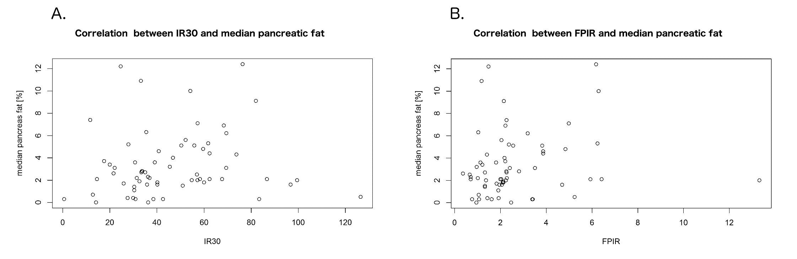
Supplemental Figure 2: Correlations of pancreatic fat with unadjusted measures of early insulin secretion: Correlation with IR30 from the OGTT (A.) and FPIR from the IVGTT (B.).

