SUPPLEMENTARY MATERIALS

Colorectal Cancer Incidence Patterns in the United States, 1974-2013

Rebecca L. Siegel, MPH;¹ Stacey A. Fedewa, MPH;¹ William F. Anderson, MD, MPH;² Kimberly D. Miller, MPH;¹ Jiemin Ma, PhD;¹ Philip S. Rosenberg, PhD;² Ahmedin Jemal, DVM, PhD¹

- Surveillance and Health Services Research, American Cancer Society, Atlanta, Georgia.
- Division of Cancer Epidemiology and Genetics, National Cancer Institute, Rockville, Maryland.

Corresponding author:

Rebecca L. Siegel
Surveillance and Health Services Research
American Cancer Society
250 Williams Street, NW
Atlanta, Georgia
404-329-7992
Rebecca.siegel@cancer.org

Supplementary Tables

Supplementary Table 1. Annual percent change (APC) in colorectal cancer incidence rates by age and tumor location, US, 1974-2013*

Supplementary Table 1 is available for separate download as an .xls file

* Trends were analyzed by Joinpoint Regression Program, Version 4.3.1.0, with a maximum of 4 joinpoints (i.e., 5 line segments). N=total number of cases diagnosed during 1974 to 2013. APC=Annual percent change; AAPC=Average annual percent change; both are based on incidence rates age-adjusted to the 2000 US standard population.
†Total colon includes unspecified/overlapping tumors.
‡The APC is statistically significantly different from zero (P < 0.05) using a two-sided test based on the permutation method.

Supplementary Table 2. Colorectal cancer screening trends by age, National Health Interview Survey, 2000-2013
Proportion of Respondents Indicating that they Received a Colonscopy in the Past 10 Years
Age | 2000  % (95% CI) | 2003  % (95% CI) | 2005  % (95% CI) | 2008  % (95% CI) | 2010  % (95% CI) | 2013  % (95% CI)
40-49 | 6.4 (5.7 to 7.2) | 9.8 (8.8 to 10.8) | 10.7 (9.9 to 11.6) | 12.8 (11.6 to 14.1) | 15.2 (14.0 to 16.4) | 13.6 (12.5 to 14.7)
50-54 | 13.7 (12.17 to 15.5) | 22.4 (20.3 to 24.6) | 26.5 (24.4 to 28.7) | 34.9 (32.3 to 37.6) | 39.7 (37.4 to 42.1) | 40.7 (38.2 to 43.2)
55-59 | 16.3 (14.37 to 18.5) | 29.6 (27.4 to 31.9) | 36.2 (34.0 to 38.4) | 48.1 (45.3 to 51.0) | 55.7 (53.0 to 58.5) | 52.3 (49.7 to 54.7)
60-64 | 21.5 (19.37 to 23.9) | 32.7 (30.2 to 35.4) | 42.2 (39.8 to 44.7) | 51.3 (48.2 to 54.4) | 62.2 (59.6 to 64.7) | 59.3 (56.9 to 61.7)
65+ | 25.1 (23.87 to 26.5) | 37.0 (35.5 to 38.6) | 45.4 (43.8 to 47.1) | 53.7 (51.9 to 55.5) | 61.3 (59.7 to 62.9) | 63.3 (61.9 to 64.8)
Total | 15.1 (14.47 to 15.7) | 23.6 (22.8 to 24.4) | 28.8 (28.0 to 29.7) | 36.4 (35.4 to 37.4) | 43.0 (42.0 to 44.0) | 43.6 (42.7 to 44.5)
Proportion of Respondents Indicating that they have Ever* Received a Colonscopy or Sigmoidoscopy
Age | 2000  % (95% CI) | 2003  % (95% CI) | 2005  % (95% CI) | 2008  % (95% CI) | 2010  % (95% CI) | 2013  % (95% CI)
40-49 | 13.4 (12.4 to 14.5) | 14.8 (13.6 to 16.0) | 15.2 (14.1 to16.2) | 16.2 (14.9 to 17.6) | 19.3 (18.0 to 20.7) | 16.8 (15.6 to 18.1)
50-54 | 27.2 (25.2 to 29.3) | 29.6 (27.4 to 32.0) | 33.7 (31.5 to 35.9) | 39.9 (37.1 to 42.8) | 43.1 (40.7 to 45.6) | 44.3 (41.9 to 46.8)
55-59 | 33.9 (31.3 to 36.6) | 40.0 (37.6 to 42.3) | 45.9 (43.6 to 48.2) | 54.0 (51.1 to 57.0) | 61.0 (58.4 to 63.6) | 56.9 (54.5 to 59.3)
60-64 | 40.6 (37.8 to 43.4) | 46.6 (43.8 to 49.5) | 55.0 (52.4 to 57.4) | 58.4 (55.2 to 61.5) | 68.4 (65.9 to 70.8) | 65.4 (63.0 to 67.7)
65+ | 46.2 (44.6 to 47.8) | 50.6 (48.9 to 52.3) | 57.3 (55.7 to 59.0) | 62.3 (60.6 to 64.0) | 69.8 (68.2 to 71.2) | 72.0 (70.6 to 73.4)
Total | 29.4 (28.6 to 30.2) | 32.9 (32.1 to 33.8) | 37.4 (36.5 to 38.3) | 42.3 (41.2 to 43.4) | 48.6 (47.6 to 49.6) | 49.1 (48.2 to 50.0)
*Due to differences in the survey questionnaire over time, trends in "ever receipt" cannot differentiate between sigmoidoscopy and colonscopy. CI=confidence interval.

Supplementary Figures
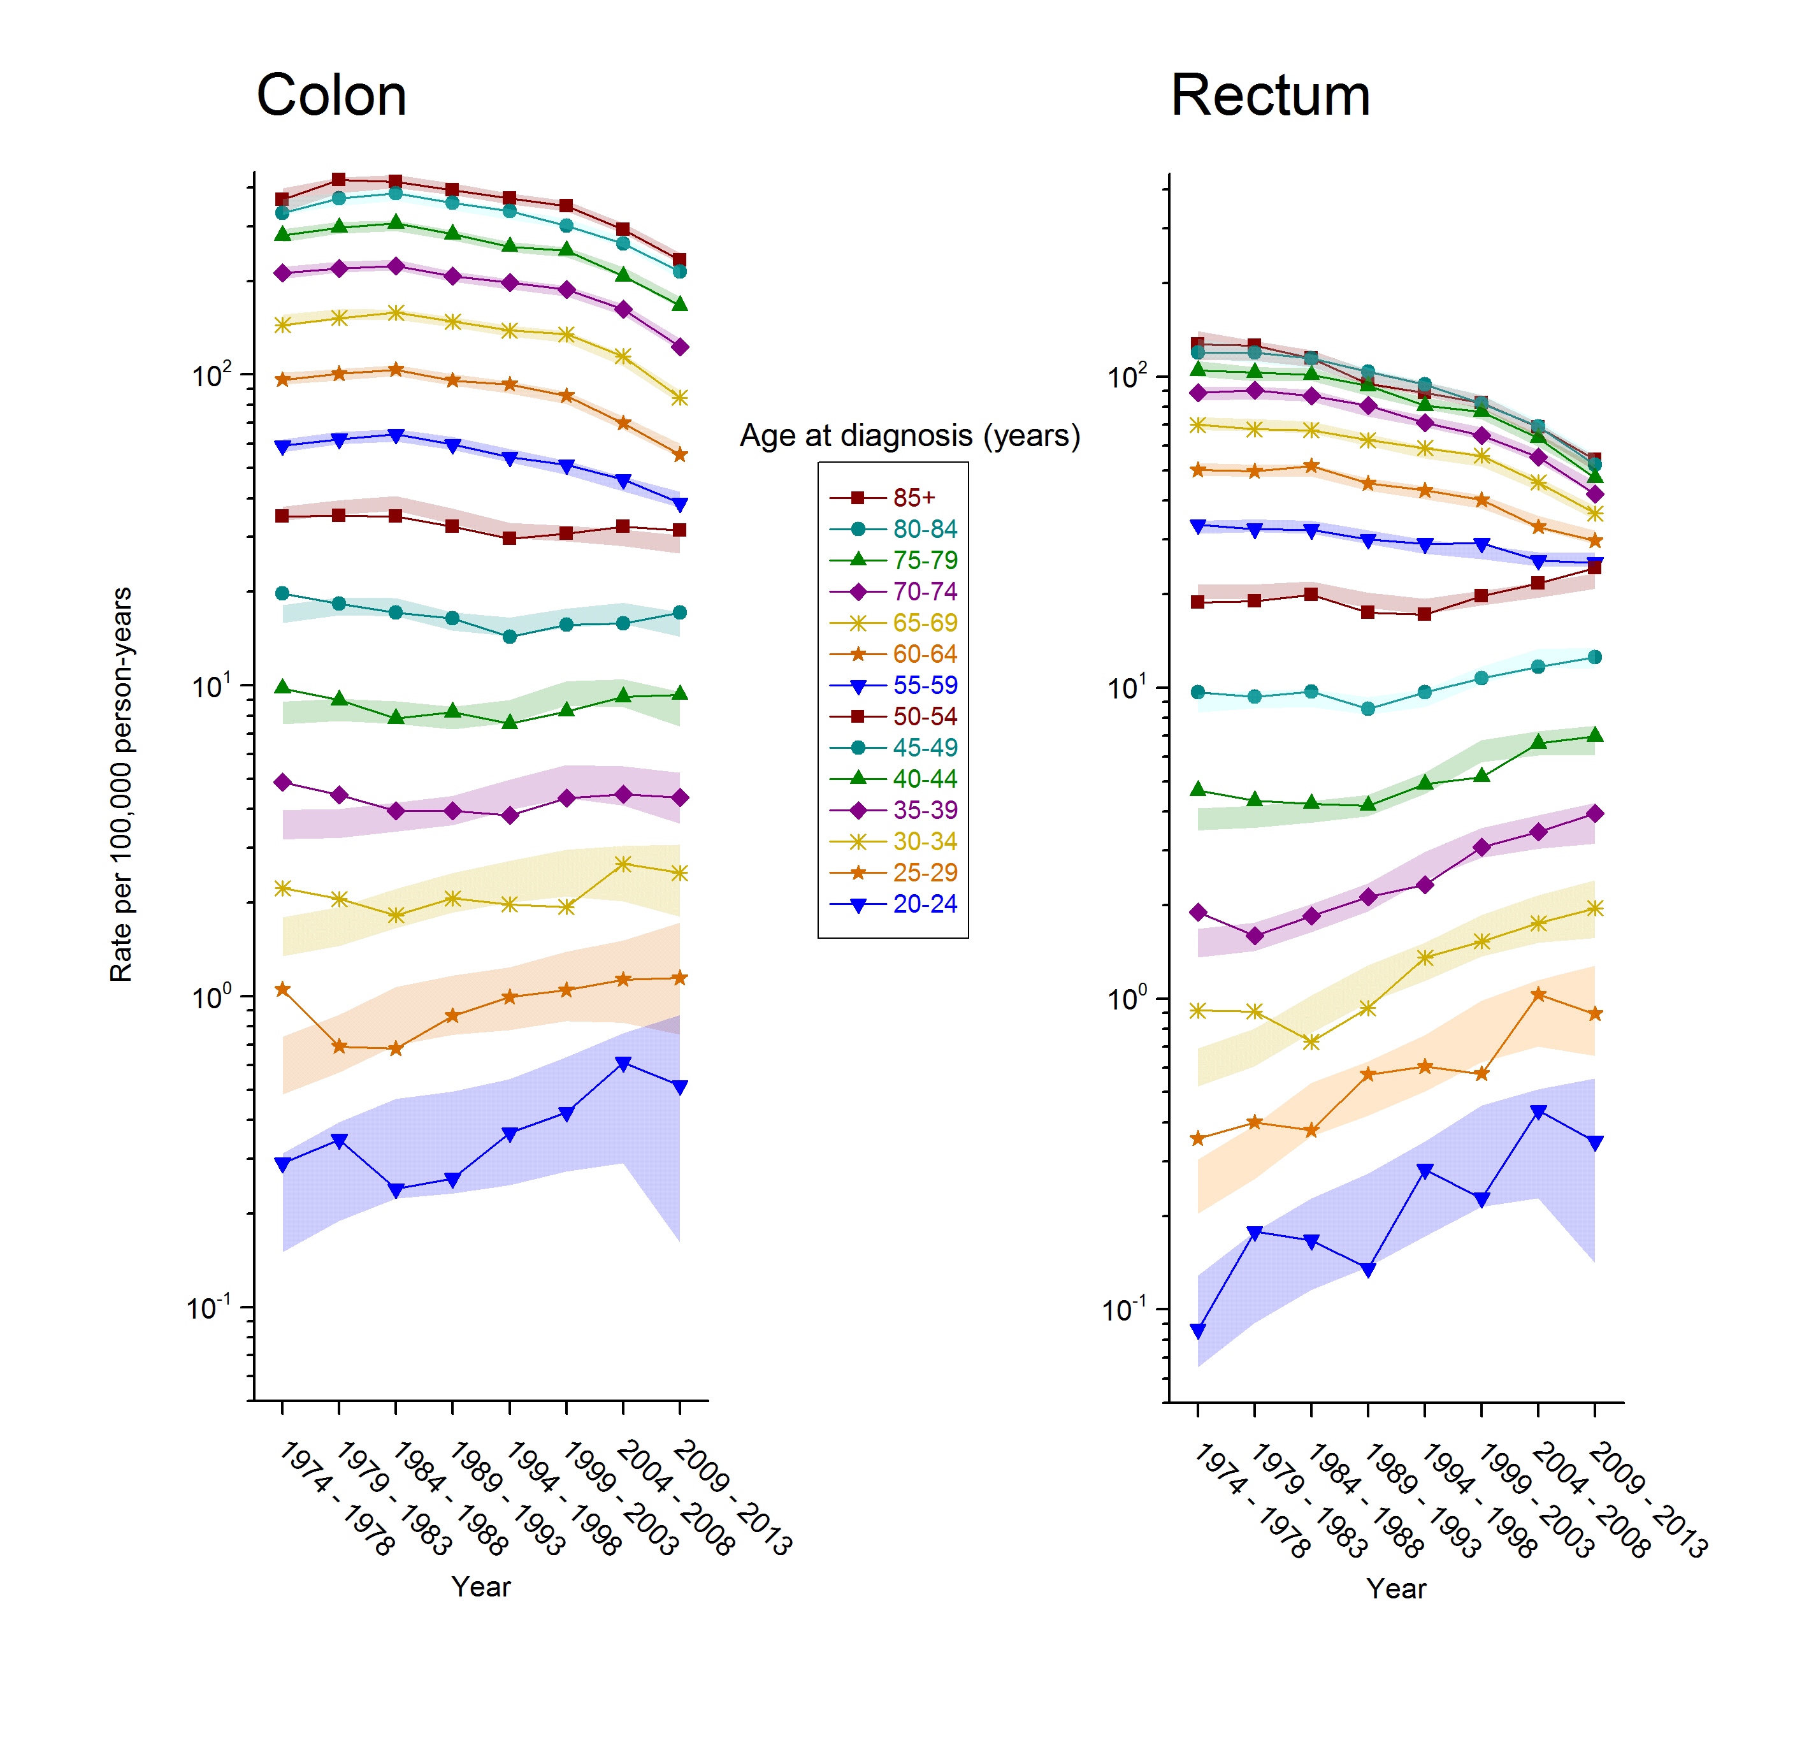
Supplementary Figure 1. Observed age-specific incidence rates for colon and rectal cancer with 95% confidence bands for APC-modeled values. Incidence rates and rate ratios for ages 50-54 versus 55-59: Colon, 1991-92 (30.7 vs 61.4: IRR=2.00; 95% CI, 1.82-2.20); 2012-2013 (31.9 vs 36.4: IRR=0.88; 95% CI, 0.81-0.94). Rectum, 1989-90 (15.9 vs 31.1: IRR=1.96; 95% CI, 1.71-2.25); 2012-2013 (24.7 vs 24.5: IRR=1.01; 95% CI, 0.92-1.10).

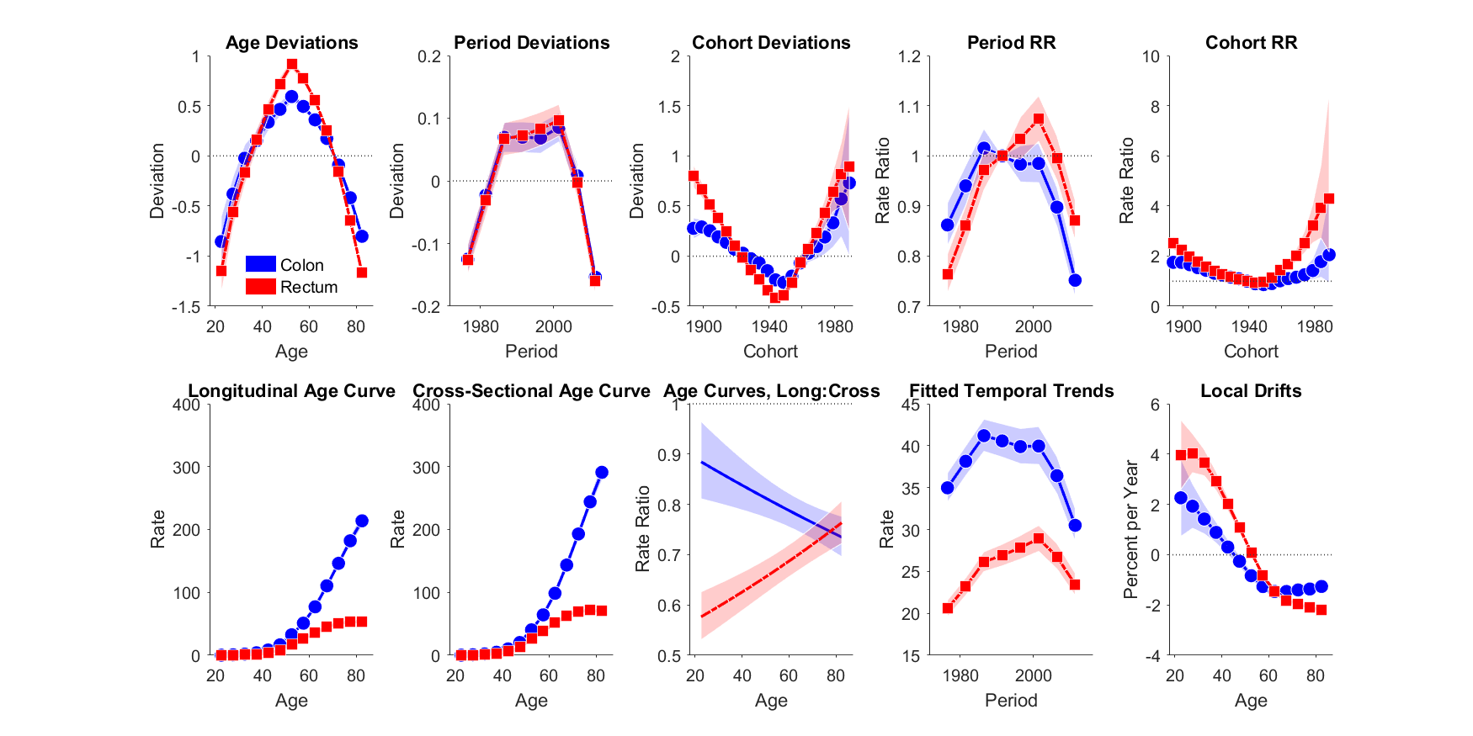
Supplementary Figure 2. Age-period-cohort model output metrics for colon and rectal cancer incidence in the United States, 1974-2013

Proximal colon Distal colon Rectum
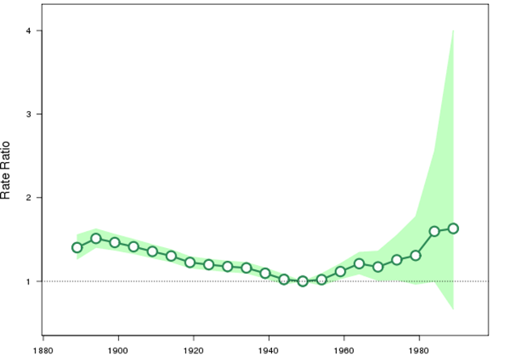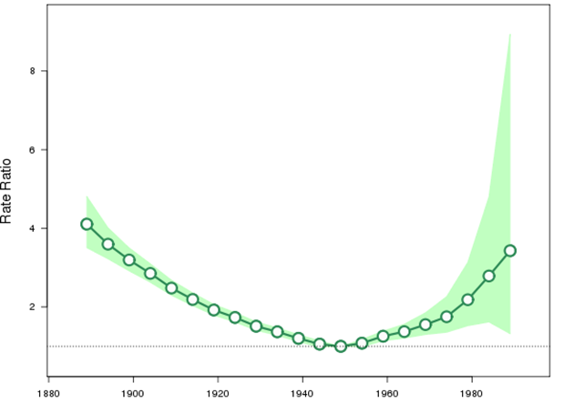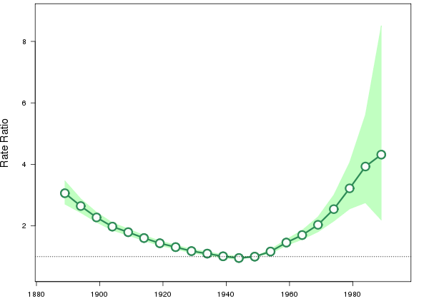
Birth cohort Birth cohort Birth cohort
Supplementary Figure 3. Incidence rate ratios by birth cohort for colorectal cancer by tumor subsite (referent cohort=1949). Shaded bands indicate 95% confidence intervals.

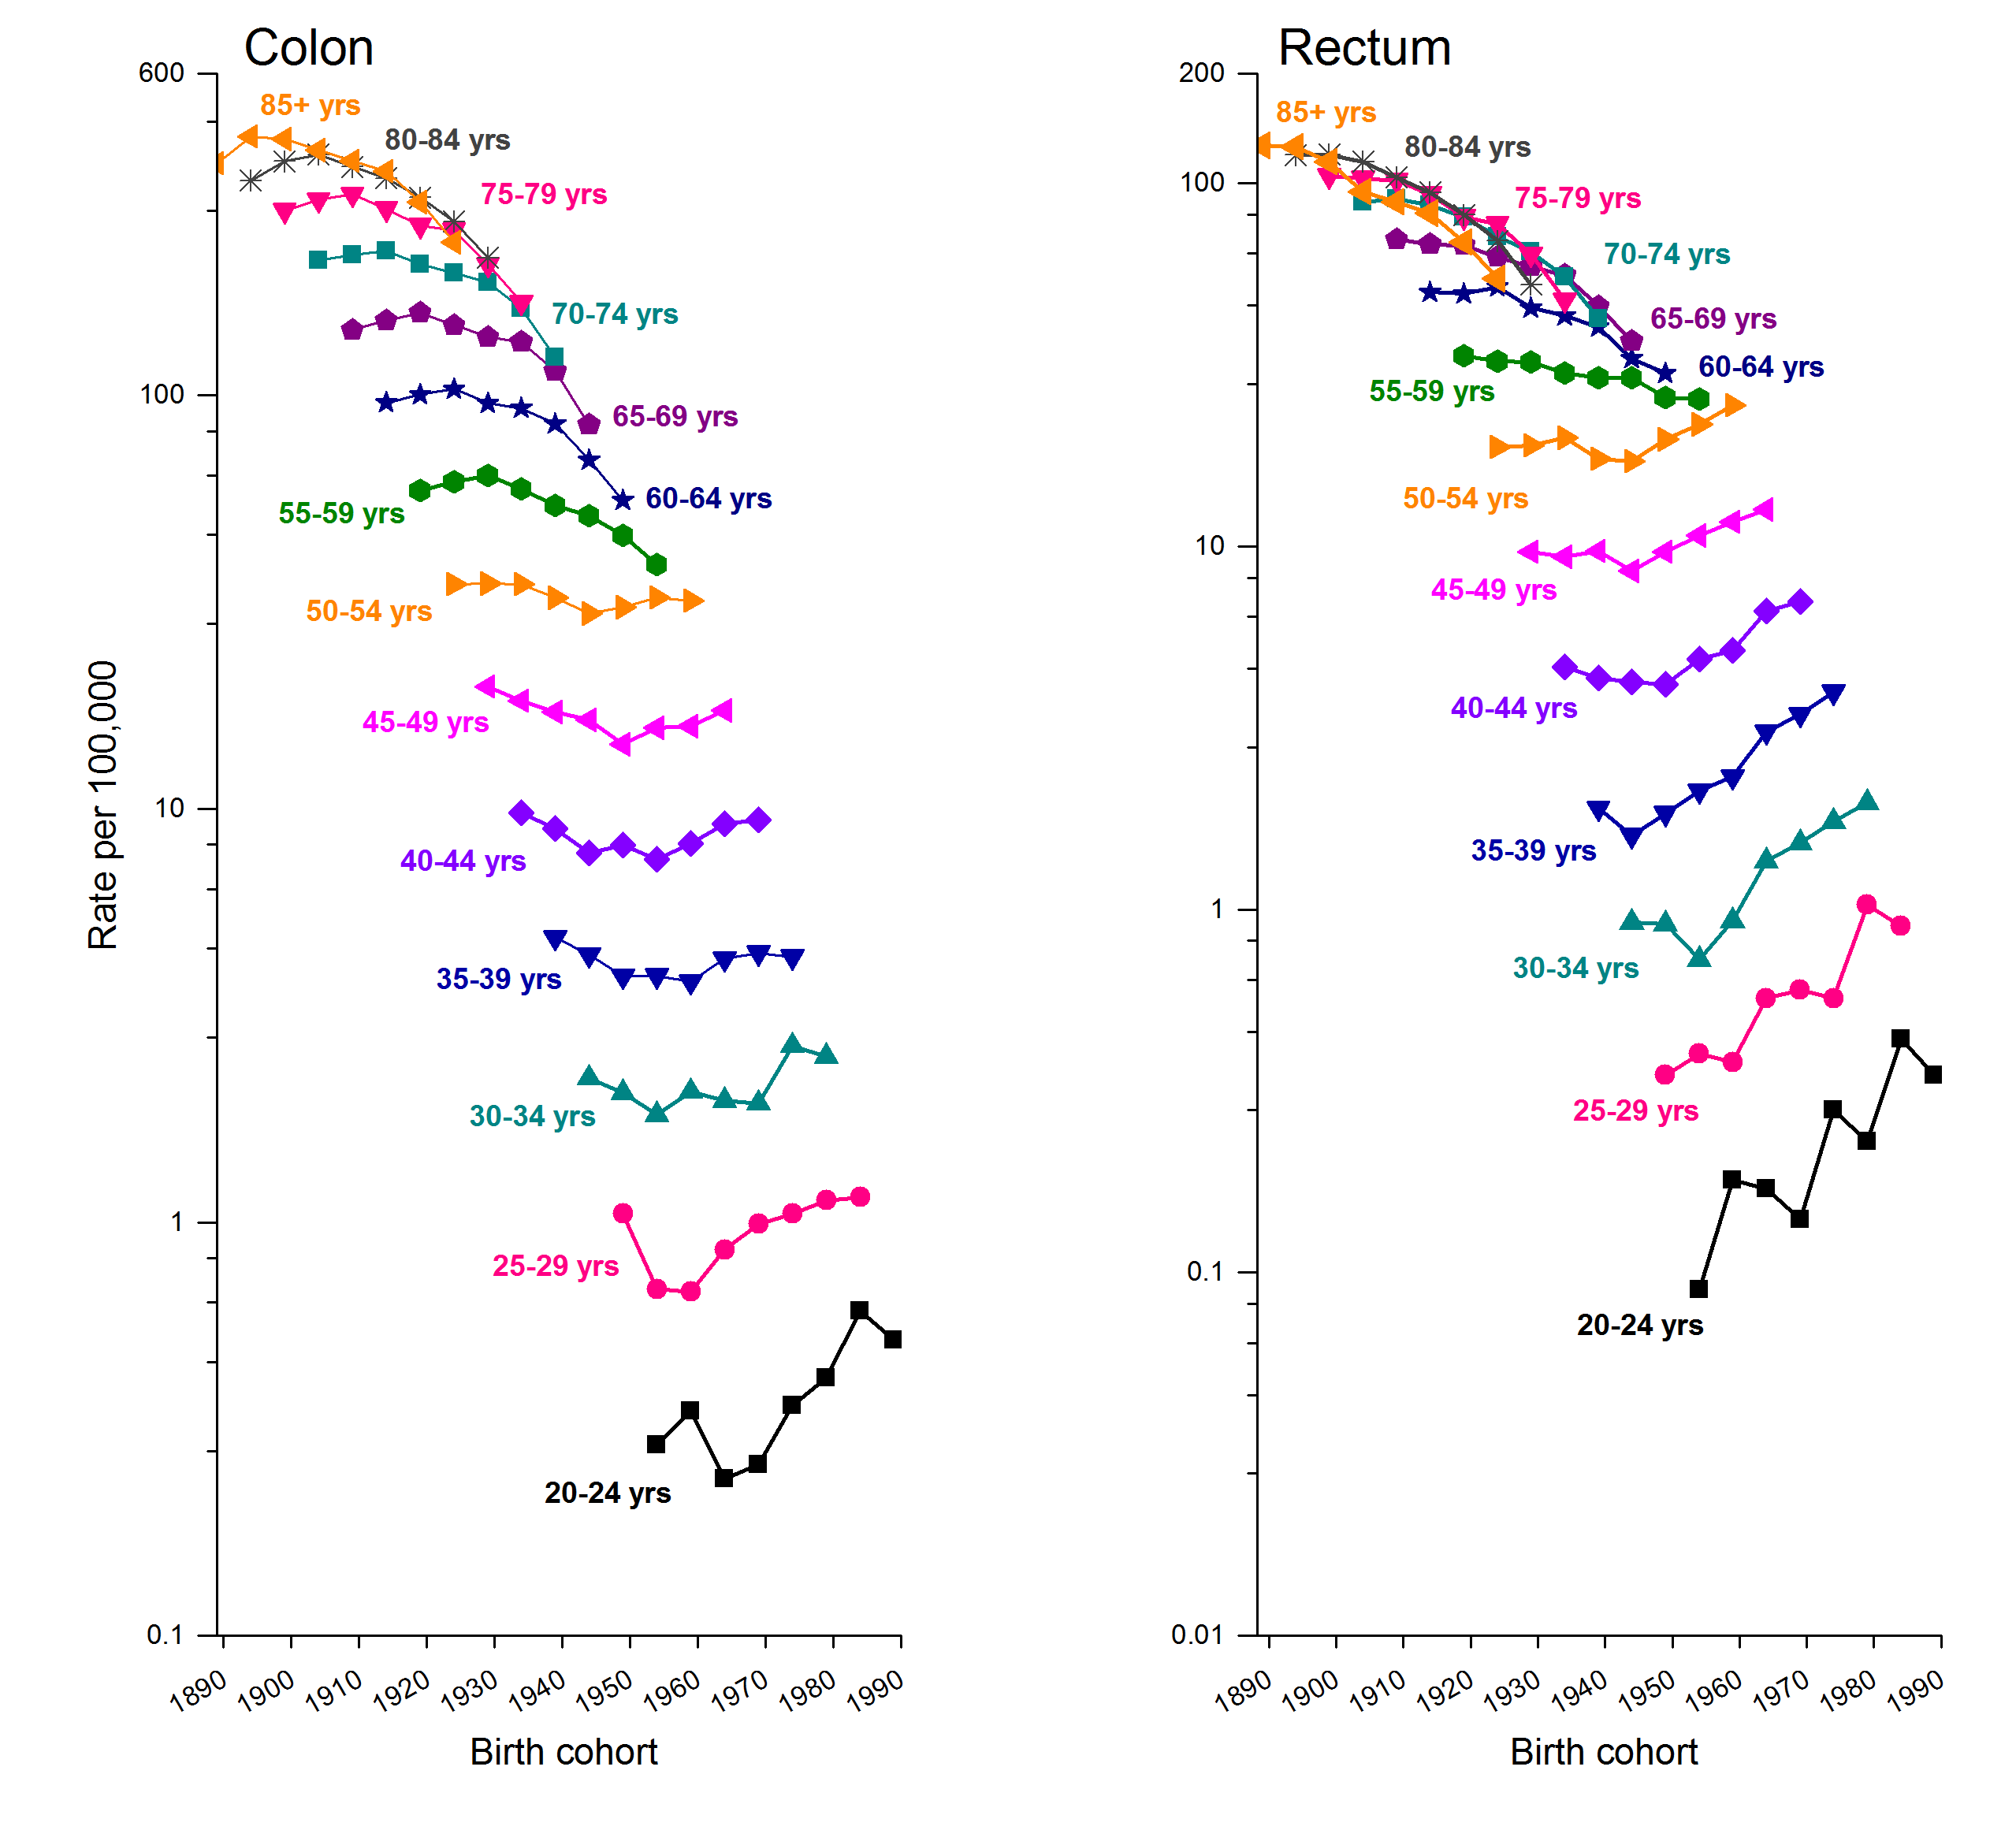
Supplementary Figure 4. Trends in age-specific colon and rectal cancer incidence rates by year of birth, United States, 1974-2013

