SUPPLEMENTARY MATERIAL

International patterns and trends in endometrial cancer incidence, 1978–2013
Joannie Lortet-Tieulent¹
Jacques Ferlay²
Freddie Bray²
Ahmedin Jemal¹

¹ Surveillance & Health Services Research, American Cancer Society, Atlanta, United States
² Cancer Surveillance Section, International Agency for Research on Cancer, Lyon, France

Supplementary Table 1. Selected countries and registries, and data sources
Region | Country | Study period | Annual female population, all ages (2006-2007) | Annual number of new cases, all ages (2006-2007) | National population coverage (%) | List of regional registries | Data sources
Africa
 | South Africa | 1998-2012 | 574,000 | 7 | 2 | PROMEC cancer registry (Eastern Cape Province) | CI5
 | Uganda | 1991-2012 | 1,035,000 | 16 | 3 | Kampala cancer registry | CI5
South America
 | Brazil | 1988-2007 | 645,000 | 40 | 1 | Goiania cancer registry | CI5plus
 | Colombia | 1983-2007 | 1,113,000 | 65 | 5 | Cali cancer registry | CI5plus
 | Costa Rica | 1980-2007 | 2,146,000 | 119 | 100 |  | CI5plus
 | Ecuador | 1985-2007 | 802,000 | 32 | 2 | Quito cancer registry | CI5plus
North America
 | Canada | 1983-2007 | 12,621,000 | 3,262 | 75 | All provinces but Quebec | CI5plus
 | USA Black | 1978-2012 | 1,863,000 | 303 | 9 | SEER: states of Connecticut, Hawaii, Iowa, New Mexico, and Utah and metropolitan areas of San Francisco-Oakland (California), Detroit (Michigan), Seattle-Puget Sound (Washington) and Atlanta (Georgia) | SEER
 | USA White | 1978-2012 | 10,562,000 | 3,139 | 9
Eastern Asia
 | China | 1988-2007 | 6,671,000 | 909 | 1 | Cancer registry of Hong-Kong and Shanghai | CI5plus
 | Japan | 1978-2007 | 6,598,000 | 752 | 8 | Cancer registry of Miyagi, Nagasaki and Osaka | CI5plus
Southern Asia
 | India | 1983-2007 | 8,169,000 | 236 | 2 | Cancer registry of Chennai and Mumbai | CI5plus
South-eastern Asia
 | Philippines | 1983-2007 | 3,075,000 | 232 | 7 | Manila cancer registry | CI5plus
 | Singapore | 1978-2007 | 1,792,000 | 291 | 100 | Resident population | CI5plus
 | Thailand | 1983-2007 | 779,000 | 41 | 3 | Chiang Mai cancer registry | CI5plus
Western Asia
 | Israel | 1983-2007 | 3,467,000 | 611 | 100 |  | CI5plus
Eastern Europe
 | Belarus | 1978-2007 | 5,181,000 | 1,436 | 100 |  | CI5plus
 | Bulgaria | 1993-2011 | 3,958,000 | 1,239 | 100 |  | National cancer registry (CI5plus and PDF reports)
 | Czech Republic | 1983-2010 | 5,264,000 | 1,797 | 100 |  | National cancer registry (CI5plus and PDF reports)
 | Poland | 1988-2008 | 2,562,000 | 672 | 13 | Cancer registry of Cracow city, Kielce and Lower Silesia | CI5plus+EUREG
 | Russian Federation | 1993-2013 | 76,406,000 | 18,094 | 100 |  | Moscow Research Oncological Institute (PDF reports)
 | Slovakia | 1978-2008 | 2,775,000 | 863 | 100 |  | National cancer registry (CI5plus and PDF report)
Northern Europe
 | Denmark | 1978-2012 | 2,751,000 | 667 | 100 |  | NORDCAN
 | Estonia | 1978-2007 | 724,000 | 200 | 100 |  | CI5plus
 | Finland | 1978-2012 | 2,693,000 | 797 | 100 |  | NORDCAN
 | Iceland | 1978-2012 | 151,000 | 24 | 100 |  | NORDCAN
 | Ireland | 1994-2011 | 2,142,000 | 305 | 100 |  | National cancer registry (public database)
 | Latvia | 1983-2007 | 1,230,000 | 389 | 100 |  | CI5plus
 | Lithuania | 1978-2007 | 1,808,000 | 532 | 100 |  | CI5plus
 | Norway | 1978-2012 | 2,355,000 | 665 | 100 |  | NORDCAN
 | Sweden | 1978-2012 | 4,590,000 | 1,335 | 100 |  | NORDCAN
 | United Kingdom | 1978-2012 | 28,560,000 | 6,344 | 92 | England and Scotland
Southern Europe
 | Croatia | 1988-2012 | 2,300,000 | 596 | 100 |  | National cancer registry (CI5plus and PDF reports)
 | Italy | 1988-2007 | 2,229,000 | 644 | 7 | Cancer registry of Turin, Modena, Parma, Romagna, Ragusa and Varese | CI5plus
 | Malta | 1992-2009 | 205,000 | 62 | 100 |  | National cancer registry (CI5plus and PDF reports)
 | Slovenia | 1978-2011 | 1,023,000 | 289 | 100 |  | National cancer registry (CI5plus and PDF reports)
 | Spain | 1988-2007 | 1,800,000 | 408 | 8 | Cancer registry of Granada, Murcia, Navarra and Tarragona | CI5plus
Western Europe
 | Austria | 1990-2009 | 4,253,000 | 974 | 100 |  | National cancer registry (CI5plus and PDF reports)
 | France | 1988-2009 | 3,150,000 | 714 | 10 | Cancer registry of Bas-Rhin, Calvados, Doubs, Isere, Haut-Rhin, Herault, Somme and Tarn | CI5plus+EUREG
 | Netherlands | 1989-2008 | 8,272,000 | 1,740 | 100 |  | CI5plus+EUREG
 | Switzerland | 1983-2008 | 494,000 | 112 | 13 | Cancer registry of Geneva and St. Gall-Appenzell | CI5plus+EUREG
Oceania
 | Australia | 1982-2009 | 10,506,000 | 1,819 | 100 |  | Australian Institute of Health and Welfare (AIHW)
 | New Zealand | 1983-2010 | 2,148,000 | 377 | 100 |  | National cancer registry (CI5plus and PDF reports)

SUPPLEMENTARY FIGURES
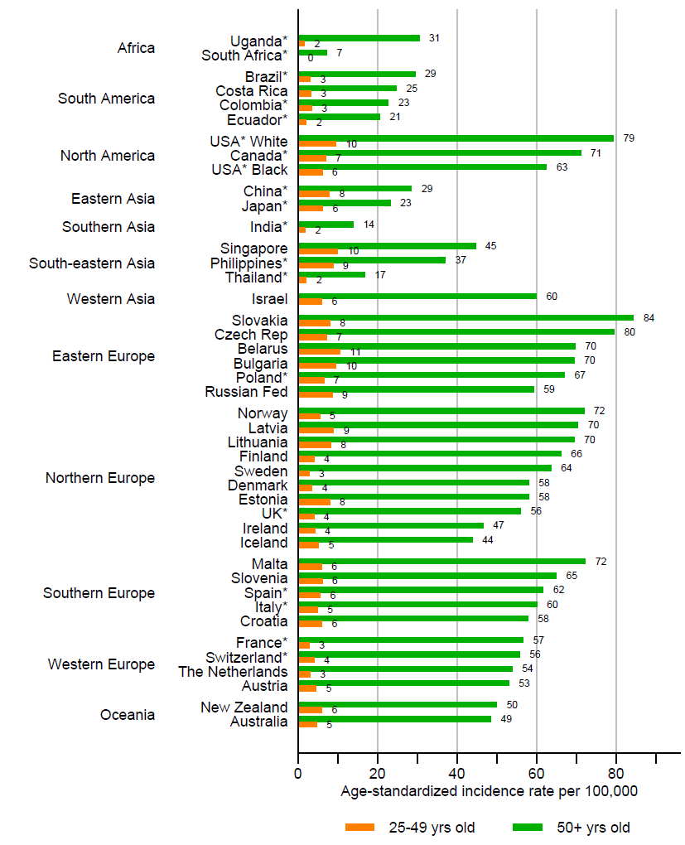
Supplementary Figure 1. Average annual age-standardized endometrial cancer incidence rate, in 2006–2007, for ages 25–49 and 50 years and older. * denotes regional registries.
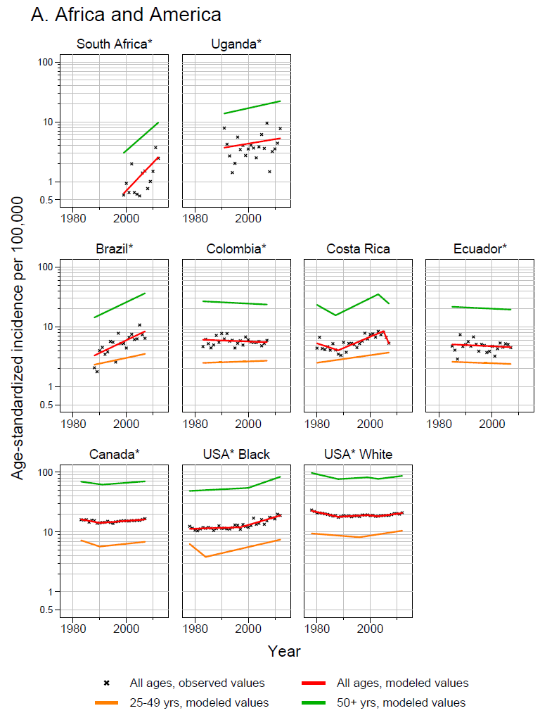
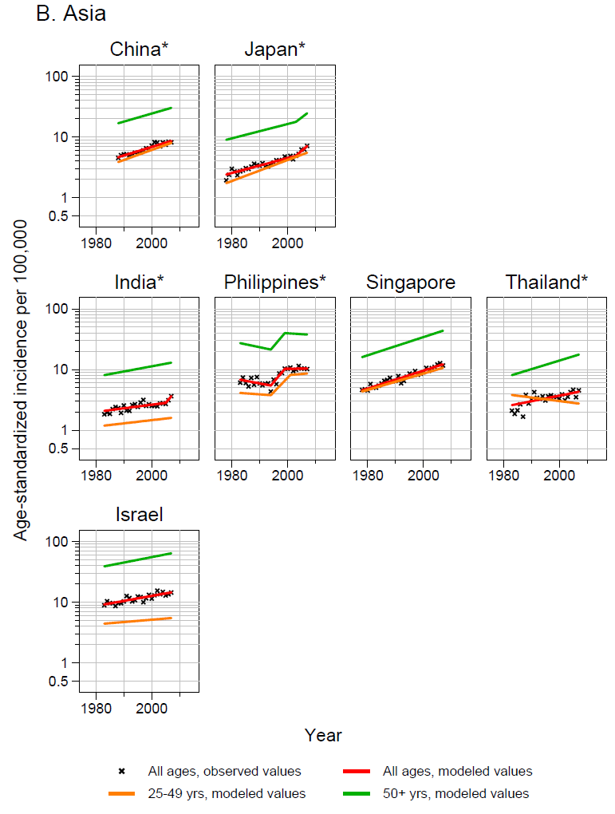
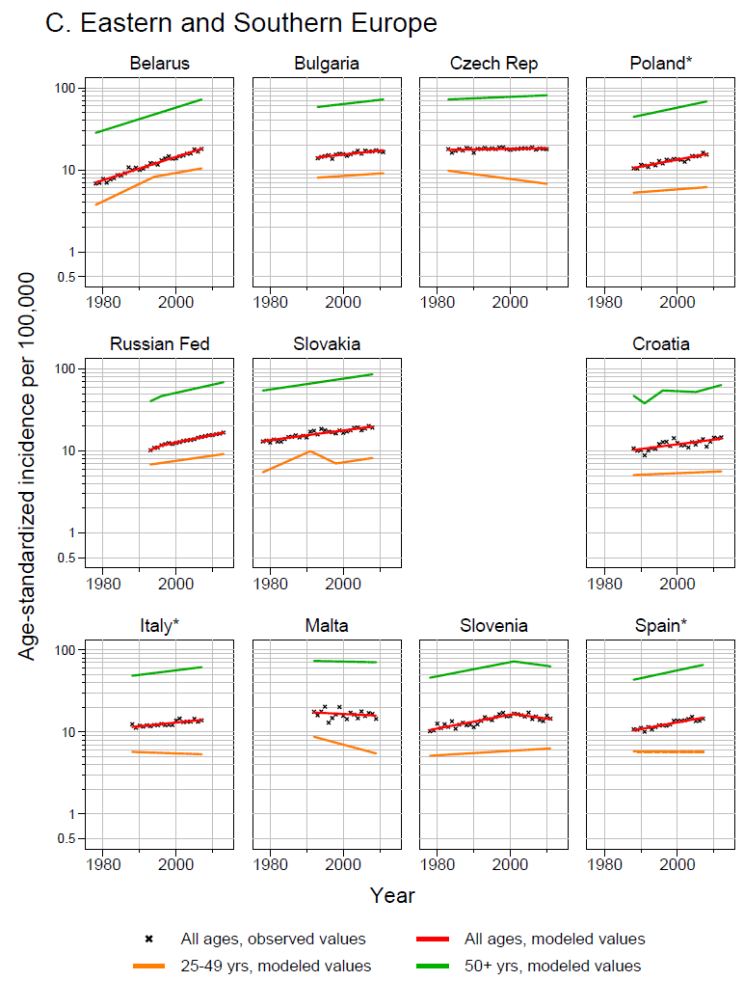
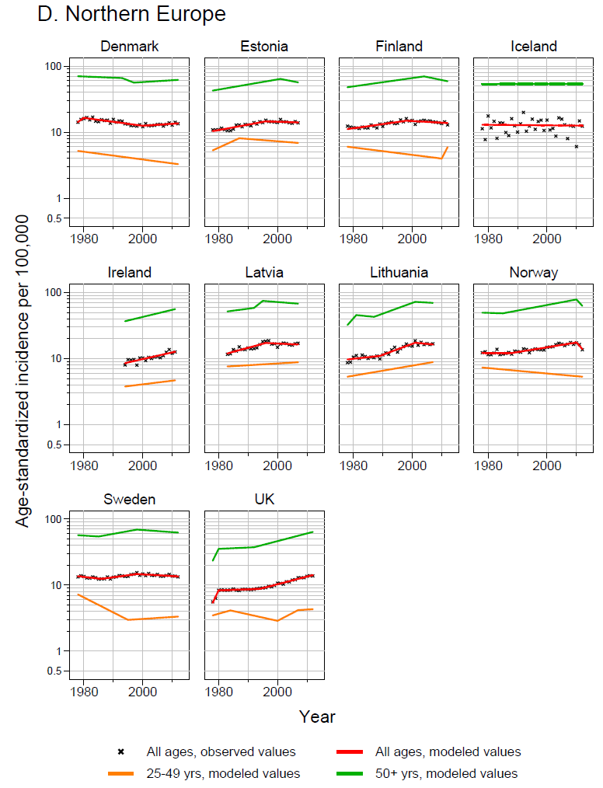
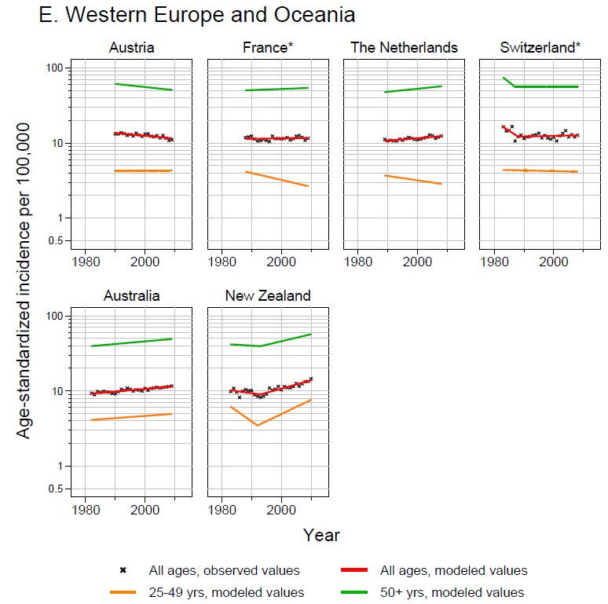Supplementary Figure 2. Trends in age-standardized endometrial cancer incidence rate by age group. (A) Africa and America; (B) Asia; (C) Eastern and Southern Europe; (D) Northern Europe; (E) Western Europe and Oceania. Observed data in black x and modeled values of Joinpoint analyses in lines. Observed rate ≤0.5 per 100,000 in South Africa (1 year) is not plotted. Joinpoint analysis was not possible for Iceland, South Africa, and Uganda for ages 25–49 due to the absence of cases for some years. * denotes regional registries.
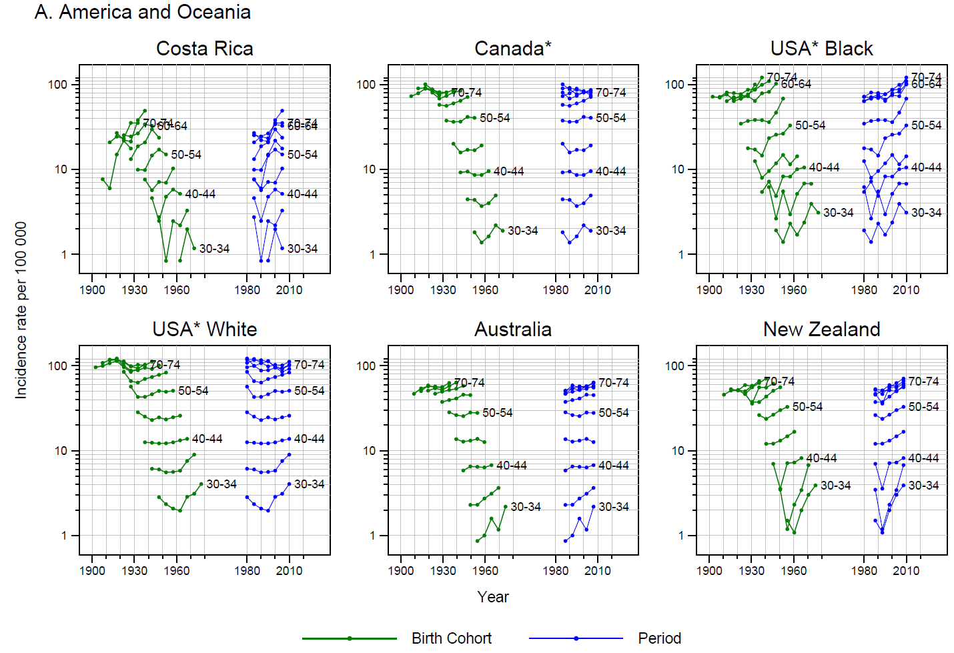
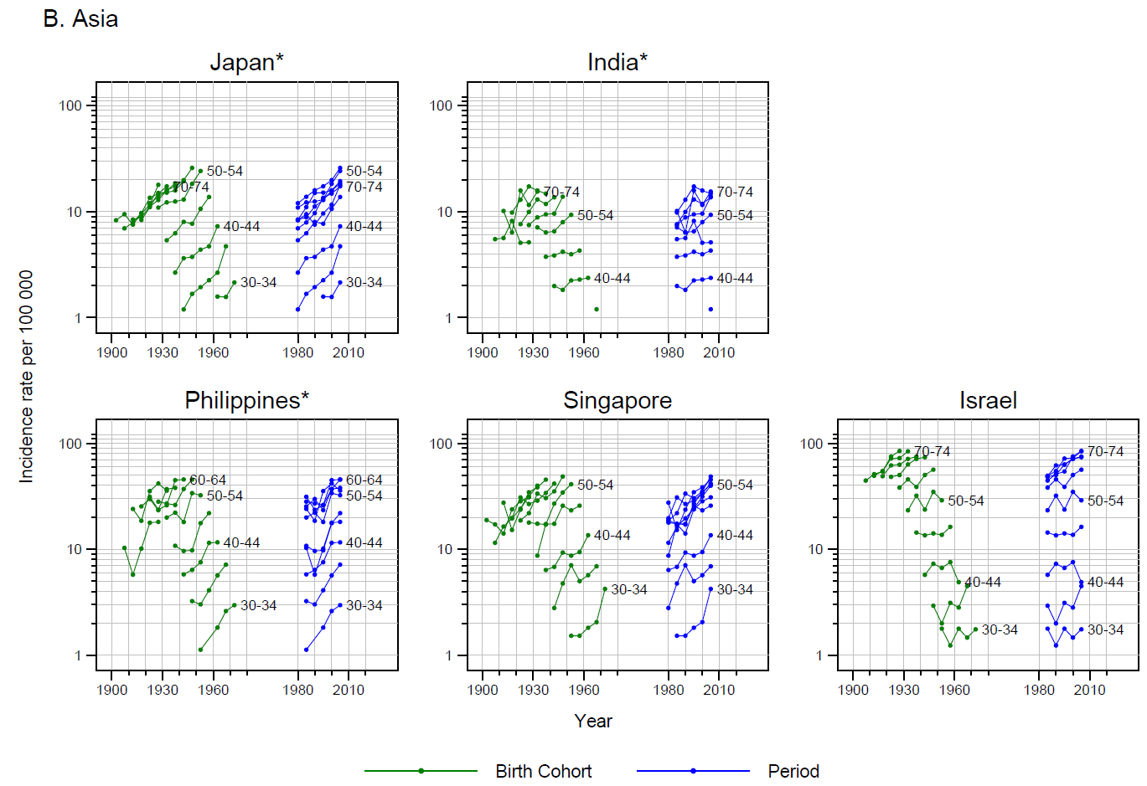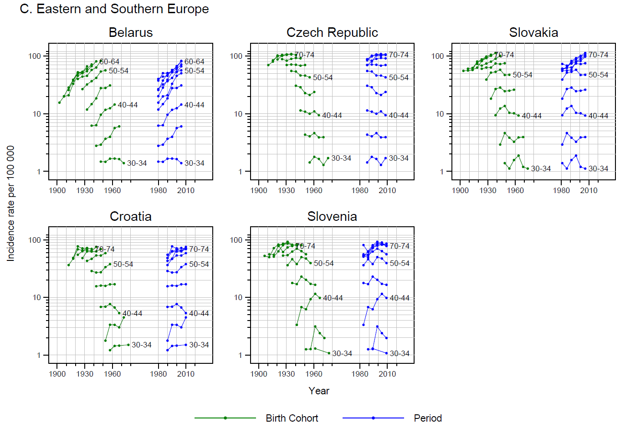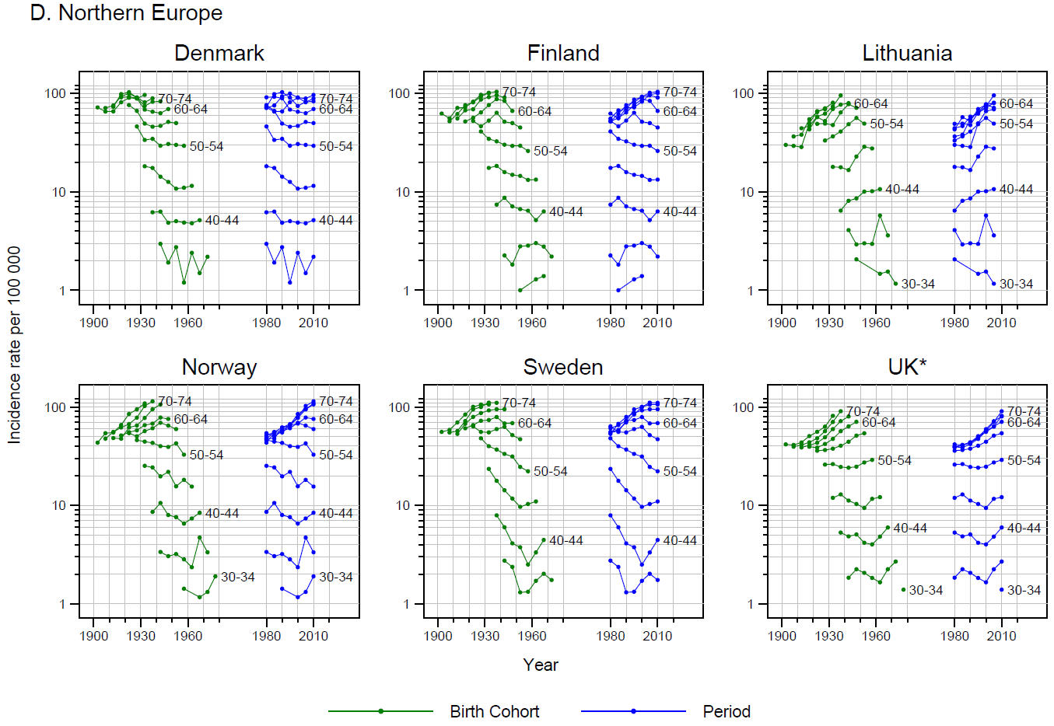
Supplementary Figure 3. Age-specific endometrial cancer incidence rates versus 5-year birth cohorts and 5-year periods, by 5-year age groups (ages 30–79), for select countries. (A) America and Oceania; (B) Asia; (C) Eastern and Southern Europe; (D) Northern Europe. * denotes regional registries. Rates<0.8 per 100 000 are not plotted.

