Appendix

Agency data included in the PAD 2.1 data

    - Federal

      - Bureau of Land Management (BLM)

      - U.S. Fish and Wildlife Service (FWS)

      - National Park Service (NPS)

      - U.S. Forest Service (USFS)

      - Department of Defense (DOD)

      - National Oceanic and Atmospheric Administration (NOAA)

      - Bureau of Ocean Energy Management (BOEM)

      - Natural Resources Conservation Service (NRCS)

      - U.S. Census Bureau (provided state boundaries)

      - Army Corps of Engineers (USACE)

      - Bureau of Reclamation (USBR)

      - Department of Energy (DOE)

      - Agricultural Research Service (ARS)

      - Tennessee Valley Authority (TVA)

      - U.S. Geological Survey (USGS)

      - Census American Indian/Alaskan Native Areas (AIA) Nonprofit partner data included in the PAD 2.1 data:
    - The Nature Conservancy’s (TNC) Secured Lands 2015 Public Database

    - The Nature Conservancy Lands database

    - Ducks Unlimited's (DU) Conservation and Recreation Lands (CARL)

    - The Trust for Public Lands' (TPL) Conservation Almanac and ParkServe data

    - National Conservation Easement Database (NCED), managed by Ducks Unlimited and the Trust for Public Land
Examples of Federal land types included in PAD 2.1 data:

    - Fee title

      - National Forest

      - National Park

      - National Wildlife Refuge

      - National Marine Protected Areas

    - Congressional designations

      - Wilderness Area

      - Wild and Scenic River

    - Presidential proclamation

      - National Monument

    - Administrative protected areas

      - Area of Critical Environmental Concern (BLM)

      - Research Natural Area (USFS)

      - Approved Acquisition Boundary (USFWS)

    - Conservation easements, leases, agreements

    - Military lands

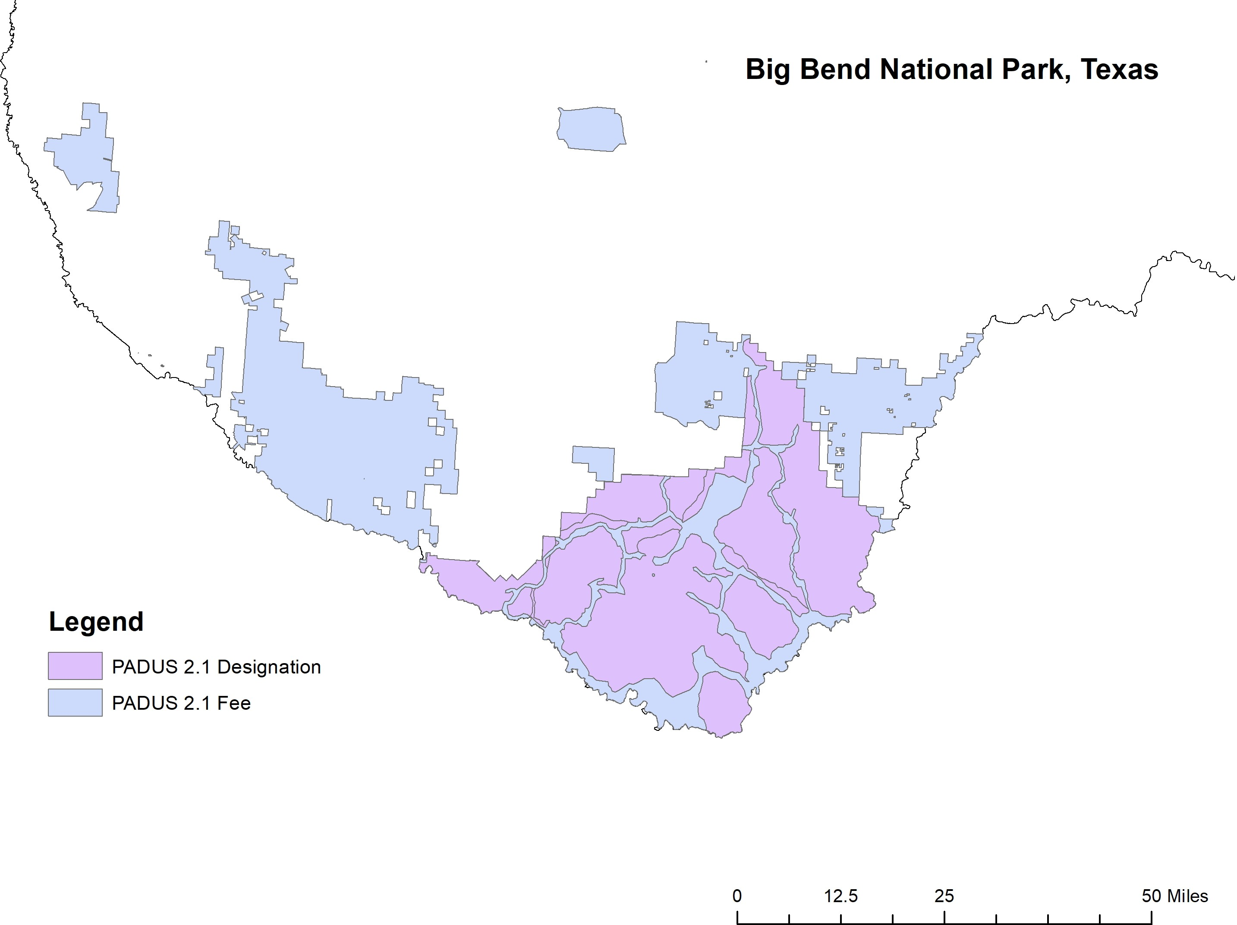

Figure 1: Example of Fee-Simple and Declaration Land Overlap

Table 1: Summary Statistics (Case 2)

 |  | Mean | Std. Dev. | Min | Max | Observations
Nonprofit Acres | overall | 4706.096 | 21891.350 | 0.000 | 611624.000 | N =1776
 | between |  | 8171.551 | 174.243 | 43927.920 | n =48
 | within |  | 20342.350 | -39213.820 | 572402.200 | t =37
% Govt Not Doing Enough | overall | 59.895 | 7.243 | 37.904 | 80.901 | N =1776
on Environment | between |  | 3.022 | 53.751 | 66.484 | n =48
 | within |  | 6.596 | 39.116 | 80.881 | t =37
Disposable Income | overall | 26.737 | 7.094 | 12.714 | 49.868 | N =1776
per Capita ($1000s) | between |  | 3.265 | 20.877 | 35.813 | n =48
 | within |  | 6.315 | 12.096 | 43.212 | t =37
Income Inequality | overall | 0.550 | 0.052 | 0.429 | 0.709 | N =1776
(Gini) | between |  | 0.021 | 0.518 | 0.591 | n =48
 | within |  | 0.048 | 0.434 | 0.693 | t =37
% Nonwhite | overall | 18.773 | 12.626 | 0.543 | 59.797 | N =1776
 | between |  | 11.410 | 2.307 | 45.798 | n =48
 | within |  | 5.646 | -17.698 | 39.409 | t =37
Special District Acres | overall | 77.447 | 768.477 | 0.000 | 21296.000 | N =1776
 | between |  | 210.139 | 0.000 | 1153.486 | n = 48
 | within |  | 739.793 | -1076.040 | 20797.880 | t =37
Local Acres | overall | 892.458 | 4207.739 | 0.000 | 81890.000 | N =1776
 | between |  | 2130.563 | 0.000 | 10622.920 | n =48
 | within |  | 3641.130 | -9060.596 | 78957.430 | t =37
State Acres | overall | 4100.707 | 32770.970 | 0.000 | 1268463.000 | N =1776
 | between |  | 6532.455 | 1.568 | 37008.190 | n =48
 | within |  | 32126.760 | -32907.480 | 1235556.000 | t =37
Federal Acres | overall | 9943.658 | 135359.100 | 0.000 | 5551735.000 | N =1776
 | between |  | 26652.370 | 111.595 | 158097.200 | n =48
 | within |  | 132763.500 | -148153.600 | 5403581.000 | t =37
Other Acres | overall | 269.368 | 2070.837 | 0.000 | 59853.000 | N =1776
 | between |  | 1157.198 | 0.000 | 7963.595 | n =48
 | within |  | 1725.230 | -7694.227 | 52158.770 | t =37
Farm Real Estate Value | overall | 2514.186 | 2412.916 | 211.564 | 17465.170 | N =1776
($/Acre) | between |  | 2123.477 | 338.640 | 9334.430 | n =48
 | within |  | 1185.099 | -1691.855 | 10835.880 | t =37
Population Density | overall | 0.276 | 0.381 | 0.006 | 1.874 | N =1776
(Acres) | between |  | 0.384 | 0.008 | 1.703 | n =48
 | within |  | 0.035 | 0.120 | 0.447 | t =37
Population | overall | 15.040 | 0.991 | 12.849 | 17.445 | N =1776
(logged) | between |  | 0.991 | 13.094 | 17.214 | n =48
 | within |  | 0.143 | 14.224 | 15.704 | t =37
Post-2000 | overall | 0.324 | 0.468 | 0.000 | 1.000 | N =1776
 | between |  | 0.000 | 0.324 | 0.324 | n=48
 | within |  | 0.468 | 0.000 | 1.000 | t=37

Table 2: Summary Statistics (Case 3)

 |  | Mean | Std. Dev. | Min | Max | Observations
Nonprofit Acres | overall | 2305.351 | 9866.095 | 0.000 | 243953.000 | N =1776
 | between |  | 3163.713 | 115.108 | 10820.300 | n=48
 | within |  | 9355.948 | -8514.947 | 239023.300 | t=37
% Govt Not Doing Enough | overall | 59.895 | 7.243 | 37.904 | 80.901 | N =1776
on Environment | between |  | 3.022 | 53.751 | 66.484 | n=48
 | within |  | 6.596 | 39.116 | 80.881 | t=37
Disposable Income | overall | 26.737 | 7.094 | 12.714 | 49.868 | N =1776
per Capita ($1000s) | between |  | 3.265 | 20.877 | 35.813 | n =48
 | within |  | 6.315 | 12.096 | 43.212 | t =37
Income Inequality | overall | 0.550 | 0.052 | 0.429 | 0.709 | N =1776
(Gini) | between |  | 0.021 | 0.518 | 0.591 | n=48
 | within |  | 0.048 | 0.434 | 0.693 | t=37
% Nonwhite | overall | 18.773 | 12.626 | 0.5432 | 59.797 | N =1776
 | between |  | 11.410 | 2.307 | 45.798 | n=48
 | within |  | 5.646 | -17.698 | 39.410 | t=37
Special District Acres | overall | 10.422 | 165.125 | 0.000 | 5740.000 | N =1776
 | between |  | 38.749 | 0.000 | 252.432 | n=48
 | within |  | 160.609 | -242.010 | 5497.990 | t=37
Local Acres | overall | 112.068 | 850.549 | 0.000 | 20688.000 | N =1776
 | between |  | 317.593 | 0.000 | 2002.270 | n=48
 | within |  | 790.326 | -1889.203 | 19358.660 | t=37
State Acres | overall | 1170.535 | 5755.490 | 0.000 | 114616.000 | N =1776
 | between |  | 1924.227 | 0.000 | 9125.757 | n=48
 | within |  | 5431.217 | -7955.221 | 106660.800 | t=37
Federal Acres | overall | 8931.520 | 134695.900 | 0.000 | 5551733.000 | N =1776
 | between |  | 25445.160 | 41.811 | 157027.100 | n=48
 | within |  | 132320.300 | -148095.600 | 5403637.000 | t=37
Other Acres | overall | 198.042 | 1974.352 | 0.000 | 59853.000 | N =1776
 | between |  | 1149.561 | 0.000 | 7945.135 | n=48
 | within |  | 1613.499 | -7747.093 | 52105.910 | t=37
Farm Real Estate Value | overall | 2514.186 | 2412.916 | 211.564 | 17465.170 | N =1776
($/Acre) | between |  | 2123.477 | 338.640 | 9334.430 | n =48
 | within |  | 1185.099 | -1691.855 | 10835.880 | t =37
Population Density | overall | 0.276 | 0.381 | 0.006 | 1.874 | N =1776
(Acres) | between |  | 0.384 | 0.008 | 1.703 | n=48
 | within |  | 0.035 | 0.120 | 0.447 | t=37
Population | overall | 15.040 | 0.991 | 12.849 | 17.445 | N =1776
(logged) | between |  | 0.991 | 13.094 | 17.214 | n=48
 | within |  | 0.143 | 14.224 | 15.704 | t=37
Post-2000 | overall | 0.324 | 0.468 | 0.000 | 1.000 | N =1776
 | between |  | 0.000 | 0.324 | 0.324 | n=48
 | within |  | 0.468 | 0.000 | 1.000 | t=37

Table 3: Problematic Proxies Illustration using Hypothesis 1 (All Cases)
42

Case 1 (Private) Case 2 (Club) Case 3 (Public)
(1) (2) (3) (4) (5) (6)
Nonprofit Acres Nonprofit Acres Nonprofit Acres Nonprofit Acres Nonprofit Acres Nonprofit Acres
% Nonwhite Population -171.789 -200.684 -136.657 -165.514 37.657 26.859
(0.102) (0.110) (0.170) (0.156) (0.678) (0.763)
Income Gini 41517.917 15974.267 35080.595 9202.259 14035.186 4540.074
(0.003) (0.409) (0.013) (0.629) (0.233) (0.718)
Disposable Income per capita 448.997 454.930 167.366
(0.093) (0.070) (0.043)
Special District Acres_{t−1} 0.120 0.128 0.686 0.687 0.916 0.810
(0.002) (0.004) (0.039) (0.040) (0.490) (0.547)
Local Acres_{t−1} 0.036 0.023 0.061 0.045 -0.028 -0.035
(0.578) (0.723) (0.450) (0.580) (0.914) (0.891)
State Acres_{t−1} 0.013 0.011 0.009 0.008 0.022 0.019
(0.135) (0.154) (0.158) (0.195) (0.365) (0.410)
Federal Acres_{t−1} -0.002 -0.002 -0.004 -0.004 -0.002 -0.002
(0.001) (0.001) (0.001) (0.002) (0.003) (0.003)
Federal Acres_{t−2} -0.002 -0.002 -0.004 -0.004 -0.002 -0.002
(0.001) (0.001) (0.001) (0.002) (0.002) (0.002)
Other Acres_{t−1} 0.227 0.243 0.220 0.233 0.071 0.074
(0.126) (0.096) (0.152) (0.122) (0.445) (0.426)
Farm Real Estate Value ($/Acre) -0.445 -0.531 -0.384 -0.475 -0.237 -0.269
(0.085) (0.083) (0.106) (0.081) (0.139) (0.127)
Population Density (Acres) -27484.334 -35170.078 -25163.279 -32855.412 -1369.444 -4326.388
(0.044) (0.039) (0.061) (0.047) (0.841) (0.550)
Population (logged) 8412.963 7520.741 7874.807 6972.530 5089.629 4769.091
(0.000) (0.000) (0.000) (0.000) (0.002) (0.007)
Post-2000 6764.760 4305.688 6246.263 3757.488 101.646 -822.883
(0.003) (0.010) (0.002) (0.011) (0.911) (0.363)
Constant -134512.231 -115397.897 -124699.274 -105382.718 -81742.811 -74787.465
(0.000) (0.000) (0.000) (0.000) (0.000) (0.003)
Observations 1680 1680 1680 1680 1680 1680
Rho 0.327 0.360 0.290 0.325 0.268 0.244
Note: p-values in parentheses. Disposable income per capita measured in $1000s.

Figure 2: Marginal Effect of Demand Heterogeneity on Nonprofit Land Conservation, Conditioned by Resources (Case 2)
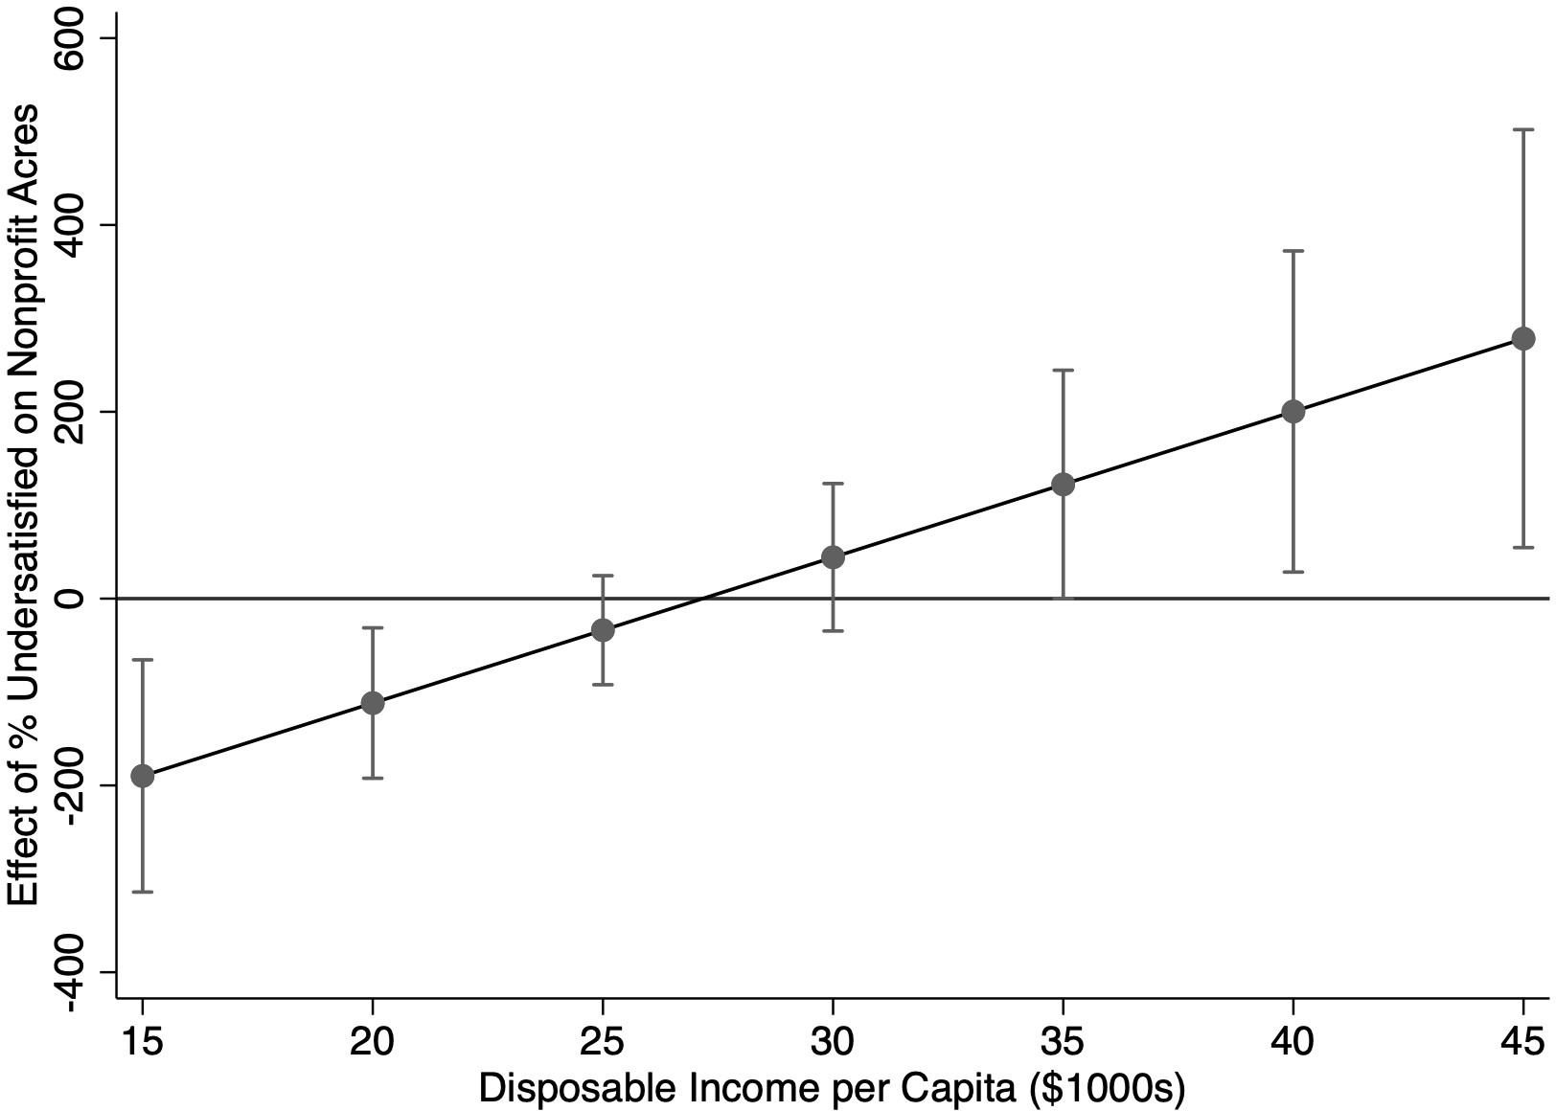

Note: Thin bars represent 90% confidence intervals.

Figure 3: Marginal Effect of Demand Heterogeneity on Nonprofit Land Conservation, Conditioned by Resources (Case 3)
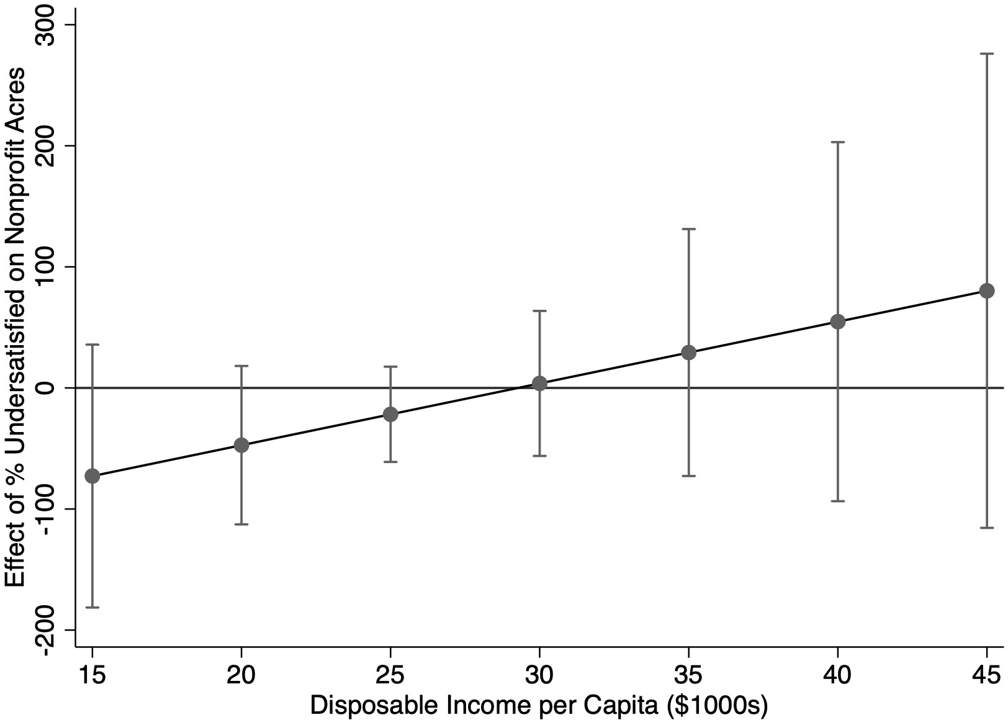

Note: Thin bars represent 90% confidence intervals.

Figure 4: Predicted Nonprofit Land Conservation (Case 2)
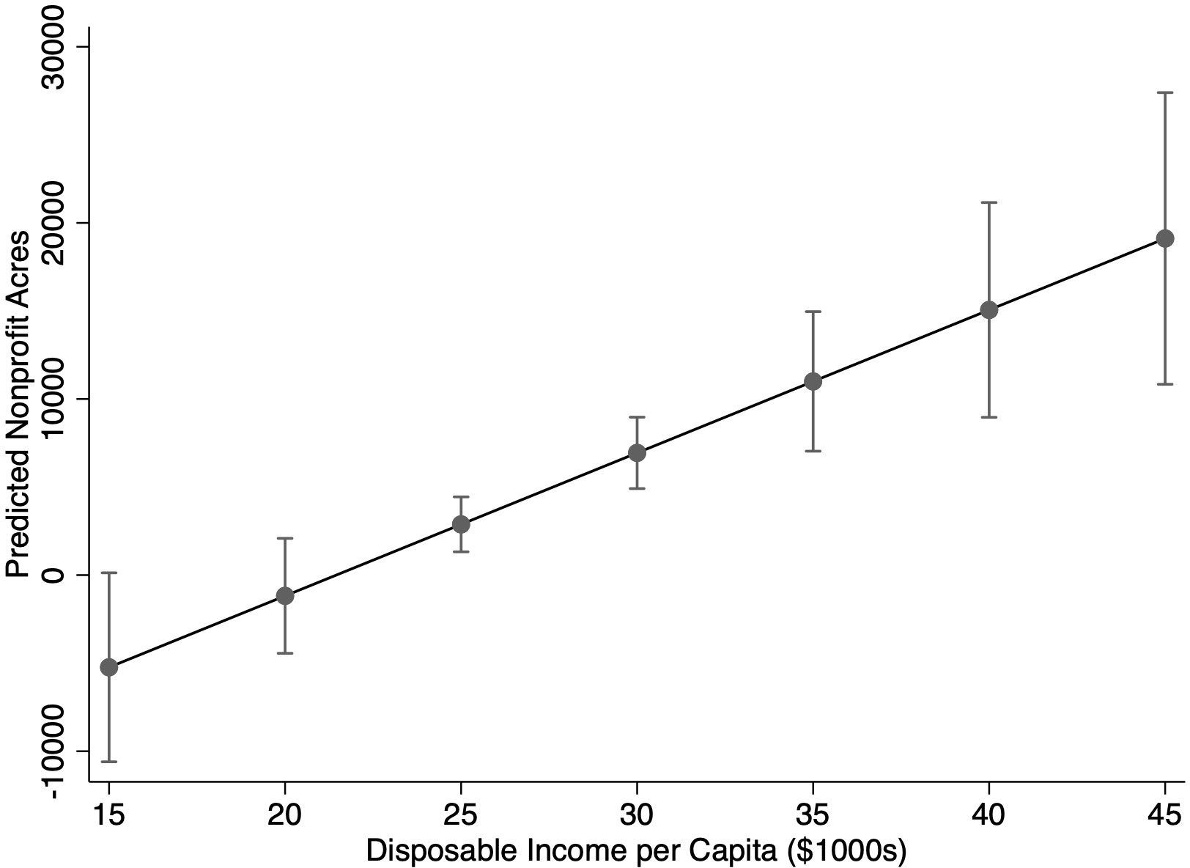

Note: Calculated when 80% of the state population is undersatisfied with government. Thin bars represent 90% confidence intervals.

Figure 5: Predicted Nonprofit Land Conservation (Case 3)
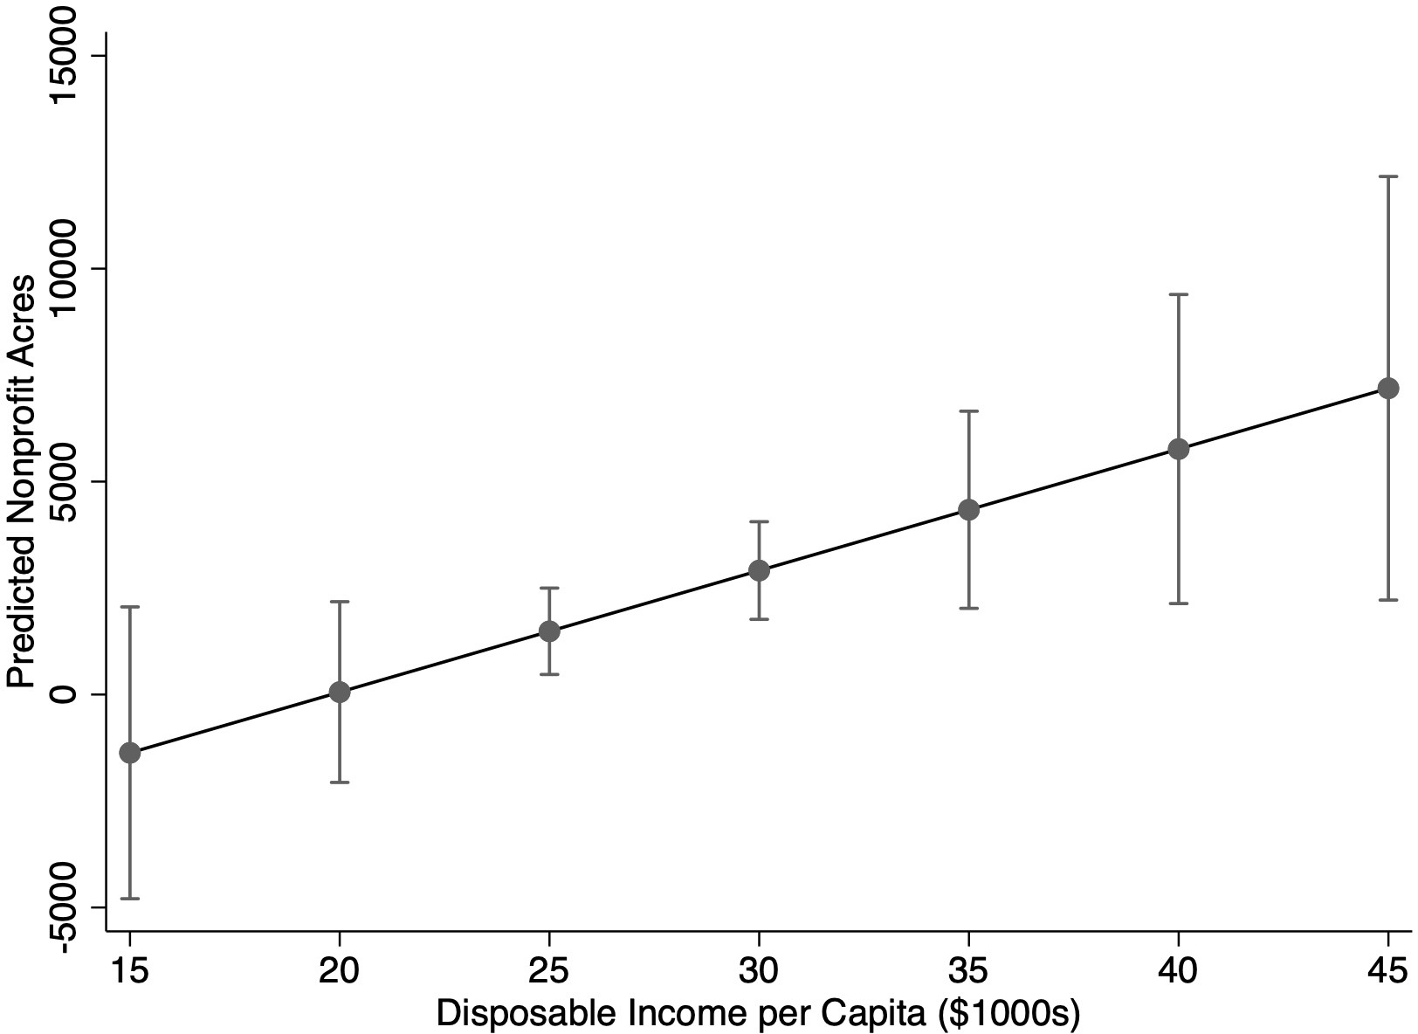

Note: Calculated when 80% of the state population is undersatisfied with government. Thin bars represent 90% confidence intervals.

