SUPPLEMENTAL INFORMATION
Let denote sensitivity as x (0<x<1), specificity as y (0<y<1), prevalence as p (0<p<1), positive predictive value (PPV) as f, and negative predictive value (NPV) as g, we have:
- $f=f\left(x, y, p\right)= \frac{xp}{xp+(1-y)(1-p)}$ (1)
- $g=g\left(x, y, p\right)= \frac{y(1-p)}{y\left(1-p\right)+p(1-x)}$ (2)
1) Relationship between PPV and prevalence:
To investigate the relationship between PPV (f) and prevalence (p), we consider the following:
- $\frac{∂f}{∂p}=\frac{-x(y-1)}{{\left(px-y-p+py+1\right)}^{2}}$ (3)
- $\frac{∂^{2}f}{∂p^{2}}=\frac{2x(y-1)(x+y-1)}{{\left(px-y-p+py+1\right)}^{3}}$ (4)
Given x, y, and p are between 0 and 1, (y-1) must be ≤0 and thus, -x(y-1) is ≥0. Furthermore, (px-y-p+py+1)² is always non-negative and thus, $\frac{∂f}{∂p}$ is ≥0.
We examine the denominator of equation (4). We have:
- $px-y-p+py+1=p\left(x+y-1\right)-(y-1)$
This suggests that $\frac{∂^{2}f}{∂p^{2}}$ depends on (x+y-1). If x+y-1≥0 and y-1≤0 (based on the boundary of y), then p(x+y-1)-(y-1)≥0. Hence, $\frac{∂^{2}f}{∂p^{2}}$≤0 and thus, f is a concave function with respect to p (when x+y-1≥0).
On the other hand, if x+y-1<0 and p is between 0 and 1, we have:
- $x+y-1≥\frac{x+y-1}{p}=\frac{x}{p}+\frac{y-1}{p}≥\frac{y-1}{p}$
- $p\left(x+y-1\right)≥y-1$
- $p\left(x+y-1\right)-(y-1)≥0$
Hence, when x+y-1<0, $\frac{∂^{2}f}{∂p^{2}}$≥0 and thus, PPV (f) is a convex function with respect to prevalence (p, Supplemental Figure 1).
2) Relationship between PPV and sensitivity:
To investigate the relationship between PPV (f) and sensitivity (x), we consider the following:
- $\frac{∂f}{∂x}=\frac{p(p-1)(y-1)}{{\left(px-y-p+py+1\right)}^{2}}$ (5)
- $\frac{∂^{2}f}{∂x^{2}}=\frac{-2p^{2}(p-1)(y-1)}{{\left(px-y-p+py+1\right)}^{3}}$ (6)
Given x, y, and p are non-negative, (p-1) and (y-1) must be ≤0. Furthermore, (px-y-p+py+1)² is always non-negative and thus, $\frac{∂f}{∂x}$≥0.
As suggested in section 1 above (equation 4), px-y-p+py+1≥0. Hence, $\frac{∂^{2}f}{∂x^{2}}≤$0 and thus, PPV (f) is a concave function with respect to sensitivity (x, Supplemental Figure 2)
3) Relationship between PPV and specificity:
To investigate the relationship between PPV (f) and specificity (y), we consider the following:
- $\frac{∂f}{∂y}=\frac{-px(p-1)}{{\left(\left(p-1\right)\left(y-1\right)+px\right)}^{2}}$ (7)
- $\frac{∂^{2}f}{∂y^{2}}=\frac{2px{\left(p-1\right)}^{2}}{{\left(\left(p-1\right)\left(y-1\right)+px\right)}^{3}}$ (8)
Given x, y, and p are non-negative, (p-1) must be ≤0 and thus, -px(p-1) must be ≥0. Furthermore, ((p-1)(y-1)+px)² is always non-negative and thus, $\frac{∂f}{∂y}$≥0.
Similarly, 2px(p-1)² is always non-negative. Moreover, (p-1)(y-1) is ≥0 and therefore, (p-1)(y-1)+px is always non-negative and thus, $\frac{∂^{2}f}{∂y^{2}}$ ≥0. Hence, PPV (f) is a convex function with respect to sensitivity (y, Supplemental Figure 3).
4) Relationship between NPV and prevalence:
To investigate the relationship between NPV (g) and prevalence (p), we consider the following:
- $\frac{∂g}{∂p}=\frac{y(x-1)}{{\left(p+y-px-py\right)}^{2}}$ (9)
- $\frac{∂^{2}g}{∂p^{2}}=\frac{2y(x-1)(x+y-1)}{{\left(p+y-px-py\right)}^{3}}$ (10)
Given x, y, and p are non-negative, (x-1) must be ≤0 and thus, y(x-1) is always ≤0. Furthermore, (p+y-px-py)² is always ≥0 and thus, $\frac{∂g}{∂p}$≤0.
We examine equation (10) by evaluating its denominator:
- $p+y-px-py=p\left(1-x\right)-y(p-1)$
Given the boundary conditions of x, y, and p between 0 and 1, (1-x) is ≥0 and (p-1) is ≤0. Hence, p(1-x)-y(p-1) (or p+y-px-py) is always ≥0. Therefore, the value of $\frac{∂^{2}g}{∂p^{2}}$ depends on x+y-1. If x+y-1≥0, then $\frac{∂^{2}g}{∂p^{2}}$≤0 (and thus, NPV (g) is a concave function with respect to prevalence [p]), and vice versa, if x+y-1<0, then $\frac{∂^{2}g}{∂p^{2}}$>0 (and thus, NPV (g) is a convex function with respect to prevalence [p], Supplemental Figure 1).
5) Relationship between NPV and sensitivity:
To investigate the relationship between NPV (g) and sensitivity (x), we consider the following:
- $\frac{∂g}{∂x}=\frac{py(1-p)}{{\left(p\left((1-x)\right)+y(1-p)\right)}^{2}}$ (11)
- $\frac{∂^{2}g}{∂x^{2}}=\frac{2p^{2}y(1-p)}{{\left(p\left(1-x\right)+y(1-p)\right)}^{3}}$ (12)
Given x, y, and p are non-negative values, (1-p) must be ≥0 and thus, py(1-p) must be ≥0. Furthermore, (p(1-x)+y(1-p))² is always non-negative and thus, $\frac{∂g}{∂x}$ is ≥0.
Similarly, 2p²y(1-p) is always ≥0. Moreover, (1-x) and (1-p) are ≥0 and thus, p(1-x)+y(1-p) is non-negative. Hence, p(x-1)+y(p-1) is always non-negative and thus, $\frac{∂^{2}g}{∂x^{2}}$ ≥0. Hence, NPV (g) is a convex function with respect to sensitivity (x, Supplemental Figure 2).
6) Relationship between NPV and specificity:
To investigate the relationship between NPV (g) and specificity (y), we consider the following:
- $\frac{∂g}{∂y}=\frac{p(p-1)(x-1)}{{\left(p+y-px-py\right)}^{2}}$ (13)
- $\frac{∂^{2}g}{∂y^{2}}=\frac{2p{\left(p-1\right)}^{2}(x-1)}{{\left(p+y-px-py\right)}^{3}}$ (14)
Given x, y, and p are non-negative values, (x-1) and (p-1) must be ≤0 and thus, p(p-1)(x-1) is ≥0. Furthermore, (p+y-px-py)² is always non-negative and thus, $\frac{∂g}{∂y}$≥0.
As shown in section (4) above (equation 10), p+y-px-py is always ≥0. Furthermore, x-1 must be ≤0 and hence, 2p(p-1)²(x-1)≤0. Thus, $\frac{∂^{2}g}{∂y^{2}}$≤0 and NPV (g) is a concave function with respect to specificity (y, Supplemental Figure 3).

Supplemental Figure S1: PPV and NPV as a function of prevalence (while keeping sensitivity and specificity constant). PPV (solid red line) and NPV (blue line with stars) were constructed using a sensitivity of 95% and a specificity of 90%. Similarly, a second PPV (green line with circles) and NPV (black line with triangles) were constructed using a sensitivity of 75% and a specificity of 70%. As seen, the prevalence drives significant rate of increase in PPV at the low end (of prevalence) and significant rate of decrease in NPV at the high end (of prevalence).
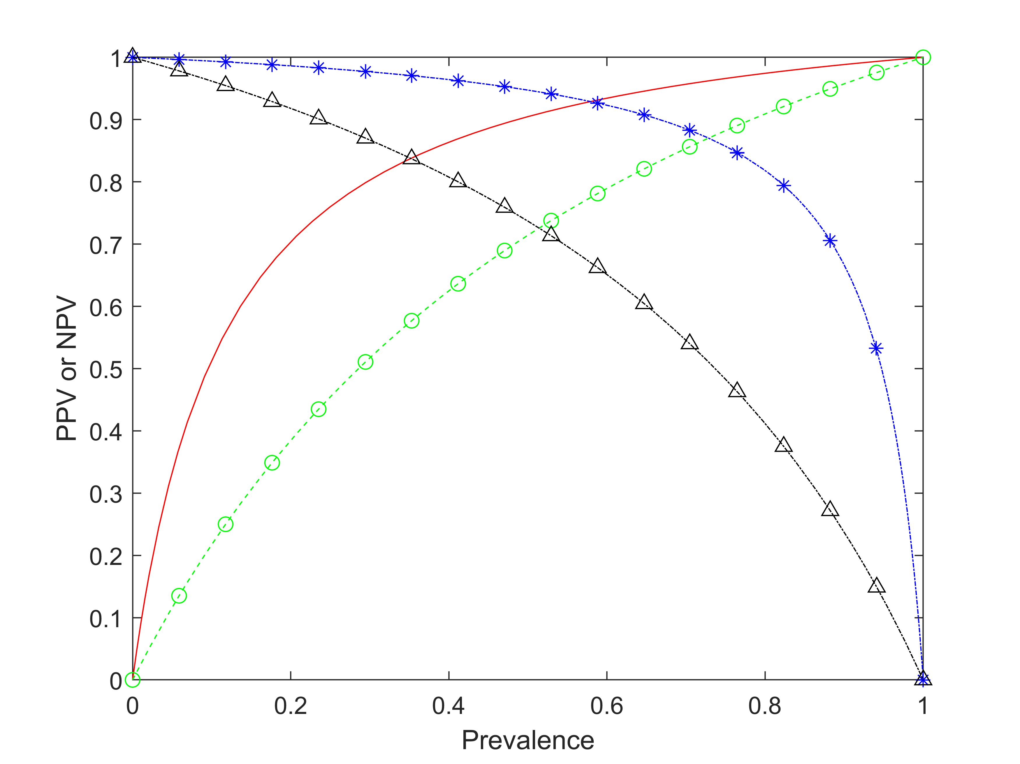

Supplemental Figure S2: PPV and NPV as a function of sensitivity (while keeping the prevalence and specificity constant). PPV (solid red line) and NPV (blue line with stars) were constructed using a prevalence of 10% and a specificity of 90%. Similarly, a second PPV (green line with circles) and NPV (black line with triangles) were constructed using a prevalence of 40% and a specificity of 90%. As seen, at a prevalence of 10%, the effect of sensitivity on PPV diminishes as the sensitivity increased beyond ~60% (solid red line) while the NPV increased at a higher rate (blue line with stars). These effects are more dramatically observed with a higher prevalence of 40% (black line with triangles).
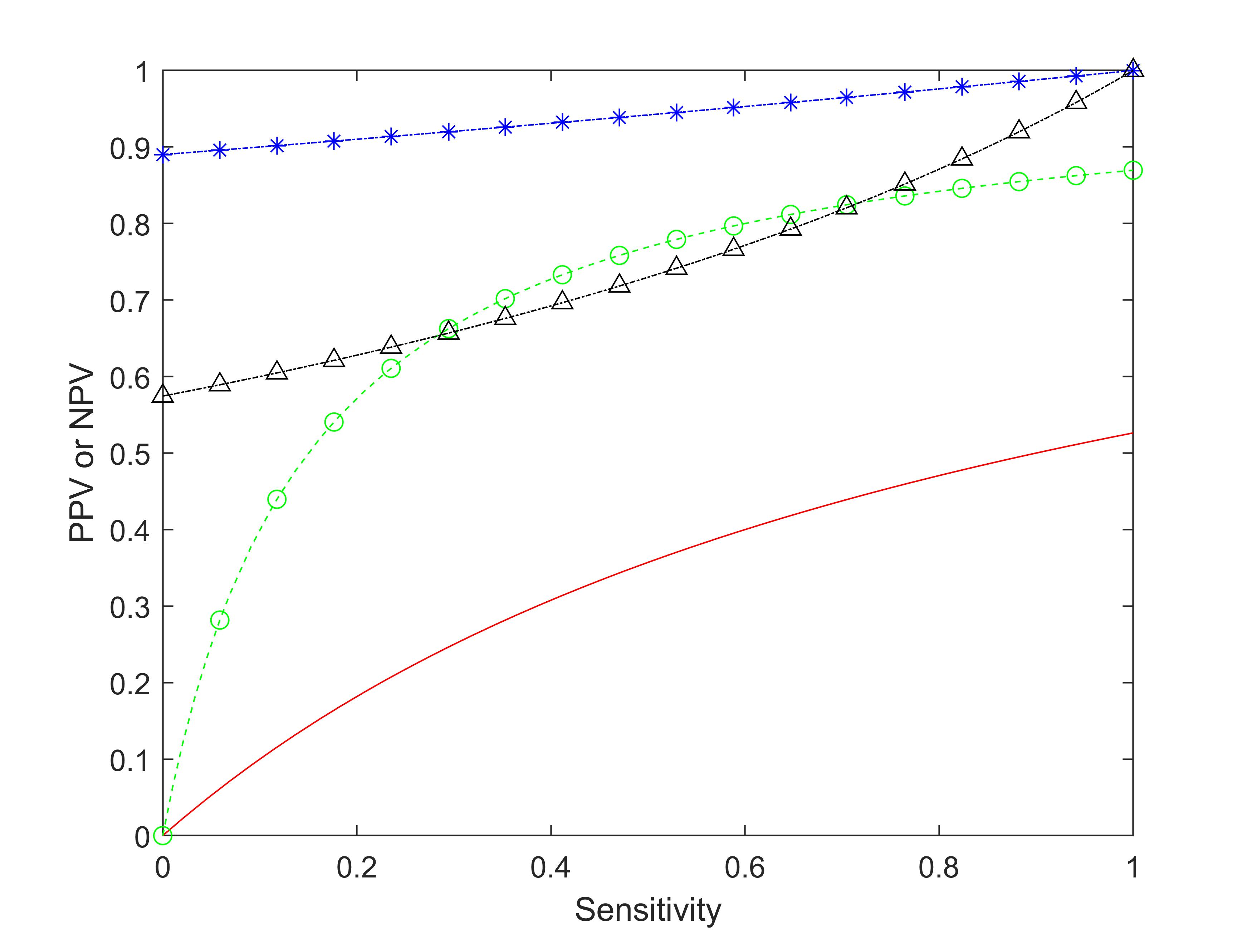

Supplemental Figure S3: PPV and NPV as a function of specificity (while keeping the prevalence and sensitivity constant). PPV (solid red line) and NPV (blue line with stars) were constructed using a prevalence of 10% and a sensitivity of 95%. Similarly, a second PPV (green line with circles) and NPV (black line with triangles) were constructed using a prevalence of 40% and a sensitivity of 95%. As seen, at a prevalence of 10%, the effect of sensitivity on PPV increased dramatically after the specificity >~80% (solid red line). However, the specificity virtually has no impact on the NPV when the specificity >~20% (blue line with stars). These effects are also seen when the prevalence is higher (at 40%) but less dramatic.
