Supplementary Material to
Dietary and homeostatic controls of Zn isotopes in rats: A controlled-feeding experiment study
Nicolas Bourgon, Théo Tacail, Klervia Jaouen, Jennifer N. Leichliter, Jeremy McCormack, Daniela E. Winkler, Marcus Clauss, Thomas Tütken

This file contains:
Supplementary Material-1: Tables and Figures
Supplementary Material-2: Sweep CI fits
Supplementary Material-3: Dietary switch figures

Supplementary Material-1: Tables and Figures

S-EVA # | Individual | Diet | Sample type | δ⁶⁶Zn  (‰) | δ⁶⁷Zn  (‰) | δ⁶⁸Zn  (‰) | [Zn]  (µg/g) | Zn cont.  (µg)
37603 | 1ARA4B1 | Insect Meal | Cementum/Dentine | -0.3 | -0.29 | -0.43 | 120 | 793
35761 | 1ARA4B1 | Insect Meal | Enamel | -0.15 | 0.11 | -0.1 | 127 | 610
35106 | 1ARA4B2 | Insect Meal | Bone | 0.26 | 0.3 | 0.55 | 101 | 3332
37604 | 1ARA4B2 | Insect Meal | Cementum/Dentine | -0.32 | -0.36 | -0.49 | 120 | 729
37623 | 1ARA4B2 | Insect Meal | Enamel | -0.35 |  |  | 58 | 292
35225 | 1ARA4B2 | Insect Meal | Feces | -0.5 | -0.77 | -0.96 | 229 | 11508
35229 | 1ARA4B2 | Insect Meal | Hair | -0.02 | 0.01 | -0.03 | 163 | 8135
35233 | 1ARA4B2 | Insect Meal | Kidney | -0.91 | -1.34 | -1.63 | 100 | 5047
35237 | 1ARA4B2 | Insect Meal | Liver | -1.21 | -1.75 | -2.3 | 92 | 4631
35241 | 1ARA4B2 | Insect Meal | Muscle | -0.77 | -1.1 | -1.48 | 33 | 1663
35253 | 1ARA4B2 | Insect Meal | Plasma | -0.28 | -0.05 | -0.32 | 1 | 523
35259 | 1ARA4B2 | Insect Meal | Red Blood Cells | -0.13 | -0.18 | -0.25 | 3 | 3485
35338 | 1ARA4B2 | Insect Meal | Red Blood Cells | -0.15 | -0.07 | -0.22 | 0 | 175
37608 | 1ARA4G1 | Insect Meal | Cementum/Dentine | -0.33 | -0.32 | -0.48 | 118 | 611
37624 | 1ARA4G1 | Insect Meal | Enamel | -0.34 |  |  | 69 | 282
35107 | 1ARA5B1 | Animal Meal | Bone | 0.22 | 0.37 | 0.48 | 81 | 2625
35226 | 1ARA5B1 | Animal Meal | Feces | -0.12 | -0.16 | -0.22 | 265 | 13276
35230 | 1ARA5B1 | Animal Meal | Hair | 0.1 | 0.17 | 0.18 | 161 | 8040
35234 | 1ARA5B1 | Animal Meal | Kidney | -0.91 | -1.33 | -1.54 | 86 | 4361
35238 | 1ARA5B1 | Animal Meal | Liver | -1.15 | -1.64 | -2.19 | 90 | 4572
35242 | 1ARA5B1 | Animal Meal | Muscle | -0.94 | -1.29 | -1.77 | 30 | 1510
35254 | 1ARA5B1 | Animal Meal | Plasma | -0.26 | -0.21 | -0.4 | 1 | 745
35258 | 1ARA5B1 | Animal Meal | Red Blood Cells | -0.18 | -0.24 | -0.32 | 6 | 5409
35337 | 1ARA5B1 | Animal Meal | Red Blood Cells | -0.2 | -0.13 | -0.36 | 0 | 307
37605 | 1ARA5B2 | Animal Meal | Cementum/Dentine | -0.39 | -0.35 | -0.59 | 152 | 773
35763 | 1ARA5B2 | Animal Meal | Enamel | -0.27 | -0.19 | -0.33 | 142 | 680
37609 | 1ARA5G1 | Animal Meal | Cementum/Dentine | -0.35 | -0.42 | -0.61 | 125 | 737
35765 | 1ARA5G1 | Animal Meal | Enamel | -0.25 | -0.2 | -0.32 | 127 | 751
37610 | 1ARA5G2 | Animal Meal | Cementum/Dentine | -0.37 | -0.45 | -0.62 | 123 | 700
37625 | 1ARA5G2 | Animal Meal | Enamel | -0.47 |  |  | 89 | 514
37613 | 1ARA5R1 | Animal Meal | Cementum/Dentine | -0.3 | -0.24 | -0.41 | 110 | 583
37626 | 1ARA5R1 | Animal Meal | Enamel | -0.34 |  |  | 76 | 350
37614 | 1ARA5R2 | Animal Meal | Cementum/Dentine | -0.29 | -0.22 | -0.49 | 137 | 806
37627 | 1ARA5R2 | Animal Meal | Enamel | -0.38 |  |  | 82 | 495
35105 | 1ARB1B1 | Lucerne | Bone | 0.23 | 0.52 | 0.48 | 125 | 2518
37606 | 1ARB1B1 | Lucerne | Cementum/Dentine | -0.42 | -0.51 | -0.66 | 131 | 692
37620 | 1ARB1B1 | Lucerne | Enamel | -0.43 |  |  | 141 | 663
35119 | 1ARB1B1 | Lucerne | Feces | -0.27 | -0.36 | -0.47 | 143 | 4346
35249 | 1ARB1B1 | Lucerne | Hair | -0.01 | 0.02 | 0.01 | 185 | 5055
35113 | 1ARB1B1 | Lucerne | Kidney | -0.92 | -1.31 | -1.74 | 36 | 3111
35110 | 1ARB1B1 | Lucerne | Liver | -1.3 | -1.88 | -2.53 | 53 | 4965
35116 | 1ARB1B1 | Lucerne | Muscle | -1.04 | -1.6 | -1.97 | 21 | 1568
35133 | 1ARB1B1 | Lucerne | Plasma | -0.36 | -0.19 | -0.59
35132 | 1ARB1B1 | Lucerne | Red Blood Cells | -0.29 | -0.51 | -0.56
36027 | 1ARB1B2 | Lucerne | Bone | 0.23 | 0.47 | 0.53 | 153 | 1625
37602 | 1ARB1B2 | Lucerne | Cementum/Dentine | -0.47 | -0.61 | -0.81 | 238 | 1263
37619 | 1ARB1B2 | Lucerne | Enamel | -0.37 |  |  | 1497 | 5690
36034 | 1ARB1B2 | Lucerne | Feces | -0.31 | -0.39 | -0.51 | 201 | 1119
36044 | 1ARB1B2 | Lucerne | Hair | 0.13 | 0.34 | 0.36 | 181 | 1083
36737 | 1ARB1B2 | Lucerne | Kidney | -0.85 | -1.11 | -1.45 | 82 | 1234
36744 | 1ARB1B2 | Lucerne | Liver | -1.18 | -1.7 | -2.21 | 89 | 1329
36750 | 1ARB1B2 | Lucerne | Muscle | -0.89 | -1.2 | -1.55 | 31 | 785
36028 | 1ARB1G1 | Lucerne | Bone | 0.28 | 0.47 | 0.61 | 155 | 2637
37607 | 1ARB1G1 | Lucerne | Cementum/Dentine | -0.48 | -0.47 | -0.76 | 123 | 639
37621 | 1ARB1G1 | Lucerne | Enamel | -0.48 |  |  | 115 | 577
36035 | 1ARB1G1 | Lucerne | Feces | -0.21 | -0.22 | -0.33 | 193 | 970
36045 | 1ARB1G1 | Lucerne | Hair | 0.1 | 0.32 | 0.37 | 188 | 1198
36738 | 1ARB1G1 | Lucerne | Kidney | -0.92 | -1.28 | -1.53 | 64 | 954
36745 | 1ARB1G1 | Lucerne | Liver | -1.28 | -1.81 | -2.39 | 85 | 1275
36751 | 1ARB1G1 | Lucerne | Muscle | -1.01 | -1.44 | -1.76 | 25 | 614
36029 | 1ARB1G2 | Lucerne | Bone | 0.3 | 0.44 | 0.65 | 158 | 1678
37611 | 1ARB1G2 | Lucerne | Cementum/Dentine | -0.48 | -0.5 | -0.81 | 110 | 629
37622 | 1ARB1G2 | Lucerne | Enamel | -0.5 |  |  | 94 | 556
36036 | 1ARB1G2 | Lucerne | Feces | -0.32 | -0.4 | -0.54 | 234 | 1219
36046 | 1ARB1G2 | Lucerne | Hair | 0.08 | 0.27 | 0.32 | 187 | 1186
36739 | 1ARB1G2 | Lucerne | Kidney | -0.91 | -1.33 | -1.62 | 76 | 1145
36746 | 1ARB1G2 | Lucerne | Liver | -1.24 | -1.75 | -2.33 | 84 | 1264
36752 | 1ARB1G2 | Lucerne | Muscle | -0.89 | -1.2 | -1.56 | 33 | 837
36030 | 1ARB1R1 | Lucerne | Bone | 0.25 | 0.43 | 0.56 | 158 | 1675
36042 | 1ARB1R1 | Lucerne | Feces | -0.34 | -0.47 | -0.57 | 197 | 1217
36047 | 1ARB1R1 | Lucerne | Hair | 0.13 | 0.35 | 0.39 | 183 | 1188
36740 | 1ARB1R1 | Lucerne | Kidney | -0.85 | -1.2 | -1.55 | 80 | 1195
36747 | 1ARB1R1 | Lucerne | Liver | -1.29 | -1.82 | -2.44 | 92 | 1384
36753 | 1ARB1R1 | Lucerne | Muscle | -0.95 | -1.32 | -1.65 | 27 | 679
36031 | 1ARB1R2 | Lucerne | Bone | 0.2 | 0.34 | 0.47 | 159 | 2227
37612 | 1ARB1R2 | Lucerne | Cementum/Dentine | -0.46 | -0.52 | -0.75 | 128 | 716
36043 | 1ARB1R2 | Lucerne | Feces | -0.26 | -0.28 | -0.42 | 280 | 1368
36048 | 1ARB1R2 | Lucerne | Hair | 0.17 | 0.42 | 0.5 | 157 | 813
36741 | 1ARB1R2 | Lucerne | Kidney | -0.89 | -1.27 | -1.46 | 59 | 886
36748 | 1ARB1R2 | Lucerne | Liver | -1.26 | -1.8 | -2.37 | 85 | 1281
36754 | 1ARB1R2 | Lucerne | Muscle | -0.8 | -1.08 | -1.36 | 31 | 768
36026 | 1BRA1B1 | Supplier | Bone | 0.46 | 0.74 | 0.96 | 139 | 1416
37616 | 1BRA1B1 | Supplier | Cementum/Dentine | 0.24 |  |  | 117 | 584
37615 | 1BRA1B1 | Supplier | Enamel | 0.29 |  |  | 80 | 488
36033 | 1BRA1B1 | Supplier | Feces | 0.52 | 0.93 | 1.14 | 121 | 758
36736 | 1BRA1B1 | Supplier | Kidney | -0.01 | 0.06 | 0.15 | 63 | 948
36743 | 1BRA1B1 | Supplier | Liver | -0.36 | -0.46 | -0.57 | 64 | 956
36749 | 1BRA1B1 | Supplier | Muscle | -0.1 | -0.01 | 0.15 | 31 | 781
36025 | 1BRC1B1 | Supplier | Bone | 0.39 | 0.64 | 0.83 | 135 | 1409
37618 | 1BRC1B1 | Supplier | Cementum/Dentine | 0.3 |  |  | 158 | 837
37617 | 1BRC1B1 | Supplier | Enamel | 0.27 |  |  | 157 | 847
36032 | 1BRC1B1 | Supplier | Feces | 0.3 | 0.52 | 0.65 | 208 | 1137
36735 | 1BRC1B1 | Supplier | Kidney | -0.16 | -0.13 | -0.14 | 68 | 1021
36742 | 1BRC1B1 | Supplier | Liver | -0.51 | -0.7 | -0.82 | 73 | 1097
35223 | 1BRC4B1 | Supplier | Bone | 0.27 | 0.47 | 0.52 | 140 | 2818
35227 | 1BRC4B1 | Supplier | Feces | 0.5 | 0.77 | 0.97 | 151 | 7490
35231 | 1BRC4B1 | Supplier | Hair | 0.08 | 0.12 | 0.2 | 208 | 9616
35235 | 1BRC4B1 | Supplier | Kidney | -0.19 | -0.2 | -0.28 | 97 | 4921
35239 | 1BRC4B1 | Supplier | Liver | -0.56 | -0.78 | -1.08 | 87 | 4414
35243 | 1BRC4B1 | Supplier | Muscle | -0.31 | -0.42 | -0.54 | 64 | 3224
35255 | 1BRC4B1 | Supplier | Plasma | 0.36 | 0.96 | 0.93 | 1 | 305
35257 | 1BRC4B1 | Supplier | Red Blood Cells | 0.46 | 0.69 | 0.92 | 4 | 3161
35336 | 1BRC4B1 | Supplier | Red Blood Cells | 0.44 | 0.8 | 0.88 | 0 | 133
35340 | 1BRC4B1 | Supplier | Red Blood Cells | 0.5 | 0.74 | 1.02 | 5 | 1351
35108 | 1ERB6B2 | 14% Bone | Bone | 0.32 | 0.57 | 0.69 | 73 | 2183
35120 | 1ERB6B2 | 14% Bone | Feces | 0.09 | 0.12 | 0.23 | 157 | 4730
35131 | 1ERB6B2 | 14% Bone | Hair | 0.07 | -0.01 | 0.16 | 85 | 9105
35114 | 1ERB6B2 | 14% Bone | Kidney | -0.73 | -1.09 | -1.37 | 60 | 5256
35111 | 1ERB6B2 | 14% Bone | Liver | -1.03 | -1.6 | -1.99 | 38 | 3555
35117 | 1ERB6B2 | 14% Bone | Muscle | -0.88 | -1.27 | -1.66 | 23 | 1826
35136 | 1ERB6B2 | 14% Bone | Plasma | -0.16 | 0.41 | -0.14 | 2
35135 | 1ERB6B2 | 14% Bone | Red Blood Cells | -0.08 | -0.15 | -0.11 | 8
35224 | 2AA1G1 | Vegetable Mix | Bone | 0.37 | 0.58 | 0.72 | 139 | 2820
35228 | 2AA1G1 | Vegetable Mix | Feces | 0.25 | 0.45 | 0.55 | 129 | 6530
35232 | 2AA1G1 | Vegetable Mix | Hair | 0.23 | 0.32 | 0.46 | 191 | 9563
35250 | 2AA1G1 | Vegetable Mix | Hair | 0.18 | 0.27 | 0.37 | 164 | 8254
35236 | 2AA1G1 | Vegetable Mix | Kidney | -0.26 | -0.36 | -0.47 | 91 | 4591
35240 | 2AA1G1 | Vegetable Mix | Liver | -0.62 | -0.9 | -1.2 | 91 | 4619
35244 | 2AA1G1 | Vegetable Mix | Muscle | -0.43 | -0.49 | -0.68 | 38 | 1923
35256 | 2AA1G1 | Vegetable Mix | Plasma | 0.33 | 0.76 | 0.71 | 1 | 764
35260 | 2AA1G1 | Vegetable Mix | Red Blood Cells | 0.36 | 0.56 | 0.71 | 7 | 6032
35339 | 2AA1G1 | Vegetable Mix | Red Blood Cells | 0.33 | 0.7 | 0.69 | 0 | 126
35341 | 2AA1G1 | Vegetable Mix | Red Blood Cells | 0.36 | 0.54 | 0.73 | 6 | 1543
35109 | 2AA6B1 | Day-old-chicks | Bone | 0.33 | 0.54 | 0.71 | 115 | 2692
35141 | 2AA6B1 | Day-old-chicks | Bone | 0.28 | 0.46 | 0.58 | 92
35121 | 2AA6B1 | Day-old-chicks | Feces | 0.34 | 0.42 | 0.73 | 312 | 9972
35122 | 2AA6B1 | Day-old-chicks | Hair | 0.19 | 0.13 | 0.42 | 78 | 7815
35115 | 2AA6B1 | Day-old-chicks | Kidney | -0.51 | -0.72 | -0.97 | 55 | 4642
35143 | 2AA6B1 | Day-old-chicks | Kidney | -0.53 | -0.82 | -1.03 | 75
35112 | 2AA6B1 | Day-old-chicks | Liver | -0.72 | -1.1 | -1.37 | 121 | 4139
35142 | 2AA6B1 | Day-old-chicks | Liver | -0.71 | -1.09 | -1.38 | 54
35118 | 2AA6B1 | Day-old-chicks | Muscle | -0.45 | -0.58 | -0.86 | 21 | 1569
35140 | 2AA6B1 | Day-old-chicks | Plasma | 0.27 | 0.73 | 0.63 | 5
35139 | 2AA6B1 | Day-old-chicks | Red Blood Cells | 0.23 | 0.29 | 0.49 | 9
35129 |  | 14% Bone | Feed | 0 | 0.09 | 0.15 | 88 | 2658
35127 |  | Animal Meal | Feed | -0.09 | -0.1 | -0.12 | 67 | 2189
35130 |  | Bone meal | Ingredient | 0.96 | 1.33 | 1.92 | 78 | 3834
35125 |  | Day-old-chicks | Feed | 0.31 | 0.58 | 0.73 | 32 | 977
35128 |  | Insect Meal | Feed | -0.04 | -0.07 | -0.01 | 69 | 2144
35124 |  | Lucerne | Feed | -0.25 | -0.35 | -0.45 | 48 | 1484
36040 |  | Lucerne | Feed | -0.32 | -0.41 | -0.53 | 106 | 2168
36041 |  | Lucerne | Feed | -0.33 | -0.42 | -0.53 | 101 | 2044
35126 |  | Supplier | Feed | 0.27 | 0.44 | 0.53 | 37 | 1219
35248 |  | Supplier | Feed | 0.43 | 0.65 | 0.9 | 70 | 3493
36037 |  | Supplier | Feed | 0.5 | 0.81 | 1.11 | 79 | 2029
36038 |  | Supplier | Feed | 0.48 | 0.78 | 1.14 | 67 | 1354
36039 |  | Supplier | Feed | 0.42 | 0.84 | 0.99 | 70 | 1484
35245 |  | Vegetable Mix | Feed | 0.45 | 0.84 | 0.92 | 24 | 1192

Table S1. Full list of samples analyzed for δ⁶⁶Zn, with corresponding laboratory internal S-EVA number, original sample number (i.e., rat specimens’ ID), dietary group, and sample type (mostly tissues, excreta, and biofluids, but also the feed and the calcium-rich supplement used in the Bone Addition experiment, listed as "Ingredient"). Abbreviations: S-EVA = Stable isotope-Evolutionary Anthropology (the numbering system used in the Human Evolution department of the Max Planck Institute for Evolution Anthropology, Leipzig, for every sample analyzed for isotopic analysis).
Individual | Age  (weeks) | Diet | Initial weight  (g) | Final weight  (g) | Max. weight  (g)
1ARA4B1 | 20 | Insect Meal | 217 | 266 | 269
1ARA4B2 | 20 | Insect Meal | 198 | 261 | 261
1ARA4G1 | 20 | Insect Meal | 204 | 252 | 256
1ARA5B1 | 20 | Animal Meal | 209 | 274 | 274
1ARA5B2 | 20 | Animal Meal | 185 | 236 | 236
1ARA5G1 | 20 | Animal Meal | 193 | 232 | 239
1ARA5G2 | 20 | Animal Meal | 198 | 251 | 264
1ARA5R1 | 20 | Animal Meal | 170 | 228 | 229
1ARA5R2 | 20 | Animal Meal | 205 | 267 | 268
1ARB1B1 | 20 | Lucerne | 190 | 234 | 246
1ARB1B2 | 20 | Lucerne | 181 | 211 | 211
1ARB1G1 | 20 | Lucerne | 205 | 243 | 249
1ARB1G2 | 20 | Lucerne | 210 | 246 | 249
1ARB1R1 | 20 | Lucerne | 192 | 225 | 226
1ARB1R2 | 20 | Lucerne | 192 | 234 | 235
1BRA1B1 | 12 | Supplier | 195 | 220 | 220
1BRC1B1 | 12 | Supplier | 218 | 229 | 229
1BRC4B1 | 12 | Supplier | 193 | 201 | 201
1ERB6B2 | 20 | 14% Bone | 199 | 233 | 234
2AA1G1 | 16 | Vegetable Mix | 226 | 251 | 251
2AA6B1 | 16 | Day-old-chicks | 202 | 230 | 236

Table S2. Full list of weight (in g) for each specimen at the start of the experiments and at termination, with maximal weight as some body mass peaked and then decreased slightly.

Proportion
(%)
Ingredient | Lucerne | Animal-meal | Insect-meal | 14% Bone
Main ingredient (lucerne flour (1), lamb meat (2), and protix insect meal (3)) | 56⁽¹⁾ | 25⁽²⁾ | 26⁽³⁾ | 21.5⁽²⁾
Potato protein | 13.5 | 0 | 0 | 0
Ground wheat | 10.23 | 17.68 | 15.95 | 15.21
Ground oat | 7 | 15.5 | 18 | 13.33
Apple pomace | 4.5 | 15 | 14 | 12.9
Beet molasses | 3 | 3 | 3 | 2.58
Soy hulls | 0 | 13 | 10 | 11.18
Straw flour | 0 | 9 | 10 | 7.74
Soy oil | 2.8 | 0 | 0 | 0
Monosodium phosphate | 0.95 | 0 | 0.3 | 0
Carbonate lime | 0 | 0 | 0.8 | 0
Vitamin/Mineral/Amino acid premix | 1.52 | 1.52 | 1.60 | 1.31
Salt | 0.5 | 0.3 | 0.35 | 0.26
Bone meal supplement | 0 | 0 | 0 | 14

Table S3. Full list of ingredients for Experiment 1 (Basic Diet) and 3 (Bone Addition) with their relative proportion (%) of the composition of the whole feed.
 | Vegetable mix | Day-old-chicks
Ingredient | (%) | (%)
Celery Root | 28.97 | 0
Carrot | 19.04 | 0
Stalk celery | 9.82 | 0
Kohlrabi | 9.65 | 0
Parsley | 9.11 | 0
Spinach | 8.11 | 0
Whole frozen day-old chicks | 0 | 100
Quark | 7.3 | 8.3
Sunflower oil | 1.2 | 0
Supplement powder | 0.8 | 3.0

Table S4. Relative proportion (weight %) of the composition of (including supplementations: quark, sunflower oil, and supplement powders) experimental diets for Experiment 3 (natural diets).

S-EVA # | Individual | Diet | Sample type | Δ⁶⁶Zn_{diet} | Δ⁶⁶Zn_{plasma}
35108 | 1ERB6B2 | 14% Bone | Bone | 0.32 | 0.48
35120 | 1ERB6B2 | 14% Bone | Feces | 0.09 | 0.25
35131 | 1ERB6B2 | 14% Bone | Hair | 0.07 | 0.23
35114 | 1ERB6B2 | 14% Bone | Kidney | -0.73 | -0.57
35111 | 1ERB6B2 | 14% Bone | Liver | -1.03 | -0.87
35117 | 1ERB6B2 | 14% Bone | Muscle | -0.88 | -0.72
35136 | 1ERB6B2 | 14% Bone | Plasma | -0.16 | 0.00
35135 | 1ERB6B2 | 14% Bone | RBC | -0.08 | 0.08
35129 |  | 14% Bone | Feed | 0.00 | 0.16
35107 | 1ARA5B1 | Animal Meal | Bone | 0.31 | 0.48
35226 | 1ARA5B1 | Animal Meal | Feces | -0.03 | 0.14
35230 | 1ARA5B1 | Animal Meal | Hair | 0.19 | 0.36
35234 | 1ARA5B1 | Animal Meal | Kidney | -0.82 | -0.65
35238 | 1ARA5B1 | Animal Meal | Liver | -1.06 | -0.89
35242 | 1ARA5B1 | Animal Meal | Muscle | -0.85 | -0.68
35254 | 1ARA5B1 | Animal Meal | Plasma | -0.17 | 0.00
35258 | 1ARA5B1 | Animal Meal | Cem./Den. | -0.09 | 0.08
35337 | 1ARA5B1 | Animal Meal | Cem./Den. | -0.11 | 0.06
37605 | 1ARA5B2 | Animal Meal | Cem./Den. | -0.30 | -0.13
35763 | 1ARA5B2 | Animal Meal | Enamel | -0.18 | -0.01
37609 | 1ARA5G1 | Animal Meal | Cem./Den. | -0.26 | -0.09
35765 | 1ARA5G1 | Animal Meal | Enamel | -0.16 | 0.01
37610 | 1ARA5G2 | Animal Meal | Cem./Den. | -0.28 | -0.11
37625 | 1ARA5G2 | Animal Meal | Enamel | -0.38 | -0.21
37613 | 1ARA5R1 | Animal Meal | Cem./Den. | -0.21 | -0.04
37626 | 1ARA5R1 | Animal Meal | Enamel | -0.25 | -0.08
37614 | 1ARA5R2 | Animal Meal | Cem./Den. | -0.20 | -0.03
37627 | 1ARA5R2 | Animal Meal | Enamel | -0.29 | -0.12
35127 |  | Animal Meal | Feed | 0.00 | 0.17
35109 | 2AA6B1 | Day-old-chicks | Bone | 0.02 | 0.06
35141 | 2AA6B1 | Day-old-chicks | Bone | -0.03 | 0.01
35121 | 2AA6B1 | Day-old-chicks | Feces | 0.03 | 0.07
35122 | 2AA6B1 | Day-old-chicks | Hair | -0.12 | -0.08
35115 | 2AA6B1 | Day-old-chicks | Kidney | -0.82 | -0.78
35143 | 2AA6B1 | Day-old-chicks | Kidney | -0.84 | -0.80
35112 | 2AA6B1 | Day-old-chicks | Liver | -1.03 | -0.99
35142 | 2AA6B1 | Day-old-chicks | Liver | -1.02 | -0.98
35118 | 2AA6B1 | Day-old-chicks | Muscle | -0.76 | -0.72
35140 | 2AA6B1 | Day-old-chicks | Plasma | -0.04 | 0.00
35139 | 2AA6B1 | Day-old-chicks | RBC | -0.08 | -0.04
35125 |  | Day-old-chicks | Feed | 0.00 | 0.04
37603 | 1ARA4B1 | Insect Meal | Cem./Den. | -0.26 | -0.02
35761 | 1ARA4B1 | Insect Meal | Enamel | -0.11 | 0.13
35106 | 1ARA4B2 | Insect Meal | Bone | 0.30 | 0.54
37604 | 1ARA4B2 | Insect Meal | Cem./Den. | -0.28 | -0.04
37623 | 1ARA4B2 | Insect Meal | Enamel | -0.31 | -0.07
35225 | 1ARA4B2 | Insect Meal | Feces | -0.46 | -0.22
35229 | 1ARA4B2 | Insect Meal | Hair | 0.02 | 0.26
35233 | 1ARA4B2 | Insect Meal | Kidney | -0.87 | -0.63
35237 | 1ARA4B2 | Insect Meal | Liver | -1.17 | -0.93
35241 | 1ARA4B2 | Insect Meal | Muscle | -0.73 | -0.49
35253 | 1ARA4B2 | Insect Meal | Plasma | -0.24 | 0.00
35259 | 1ARA4B2 | Insect Meal | RBC | -0.09 | 0.15
35338 | 1ARA4B2 | Insect Meal | RBC | -0.11 | 0.13
37608 | 1ARA4G1 | Insect Meal | Cem./Den. | -0.29 | -0.05
37624 | 1ARA4G1 | Insect Meal | Enamel | -0.30 | -0.06
35128 |  | Insect Meal | Feed | 0.00 | 0.24
35105 | 1ARB1B1 | Lucerne | Bone | 0.53 | 0.59
37606 | 1ARB1B1 | Lucerne | Cem./Den. | -0.12 | -0.06
37620 | 1ARB1B1 | Lucerne | Enamel | -0.13 | -0.07
35119 | 1ARB1B1 | Lucerne | Feces | 0.03 | 0.09
35249 | 1ARB1B1 | Lucerne | Hair | 0.29 | 0.35
35113 | 1ARB1B1 | Lucerne | Kidney | -0.62 | -0.56
35110 | 1ARB1B1 | Lucerne | Liver | -1.00 | -0.94
35116 | 1ARB1B1 | Lucerne | Muscle | -0.74 | -0.68
35133 | 1ARB1B1 | Lucerne | Plasma | -0.06 | 0.00
35132 | 1ARB1B1 | Lucerne | RBC | 0.01 | 0.07
36027 | 1ARB1B2 | Lucerne | Bone | 0.53 | 0.59
37602 | 1ARB1B2 | Lucerne | Cem./Den. | -0.17 | -0.11
37619 | 1ARB1B2 | Lucerne | Enamel | -0.07 | -0.01
36034 | 1ARB1B2 | Lucerne | Feces | -0.01 | 0.05
36044 | 1ARB1B2 | Lucerne | Hair | 0.43 | 0.49
36737 | 1ARB1B2 | Lucerne | Kidney | -0.55 | -0.49
36744 | 1ARB1B2 | Lucerne | Liver | -0.88 | -0.82
36750 | 1ARB1B2 | Lucerne | Muscle | -0.59 | -0.53
36028 | 1ARB1G1 | Lucerne | Bone | 0.58 | 0.64
37607 | 1ARB1G1 | Lucerne | Cem./Den. | -0.18 | -0.12
37621 | 1ARB1G1 | Lucerne | Enamel | -0.18 | -0.12
36035 | 1ARB1G1 | Lucerne | Feces | 0.09 | 0.15
36045 | 1ARB1G1 | Lucerne | Hair | 0.40 | 0.46
36738 | 1ARB1G1 | Lucerne | Kidney | -0.62 | -0.56
36745 | 1ARB1G1 | Lucerne | Liver | -0.98 | -0.92
36751 | 1ARB1G1 | Lucerne | Muscle | -0.71 | -0.65
36029 | 1ARB1G2 | Lucerne | Bone | 0.60 | 0.66
37611 | 1ARB1G2 | Lucerne | Cem./Den. | -0.18 | -0.12
37622 | 1ARB1G2 | Lucerne | Enamel | -0.20 | -0.14
36036 | 1ARB1G2 | Lucerne | Feces | -0.02 | 0.04
36046 | 1ARB1G2 | Lucerne | Hair | 0.38 | 0.44
36739 | 1ARB1G2 | Lucerne | Kidney | -0.61 | -0.55
36746 | 1ARB1G2 | Lucerne | Liver | -0.94 | -0.88
36752 | 1ARB1G2 | Lucerne | Muscle | -0.59 | -0.53
36030 | 1ARB1R1 | Lucerne | Bone | 0.55 | 0.61
36042 | 1ARB1R1 | Lucerne | Feces | -0.04 | 0.02
36047 | 1ARB1R1 | Lucerne | Hair | 0.43 | 0.49
36740 | 1ARB1R1 | Lucerne | Kidney | -0.55 | -0.49
36747 | 1ARB1R1 | Lucerne | Liver | -0.99 | -0.93
36753 | 1ARB1R1 | Lucerne | Muscle | -0.65 | -0.59
36031 | 1ARB1R2 | Lucerne | Bone | 0.50 | 0.56
37612 | 1ARB1R2 | Lucerne | Cem./Den. | -0.16 | -0.10
36043 | 1ARB1R2 | Lucerne | Feces | 0.04 | 0.10
36048 | 1ARB1R2 | Lucerne | Hair | 0.47 | 0.53
36741 | 1ARB1R2 | Lucerne | Kidney | -0.59 | -0.53
36748 | 1ARB1R2 | Lucerne | Liver | -0.96 | -0.90
36754 | 1ARB1R2 | Lucerne | Muscle | -0.50 | -0.44
35124 |  | Lucerne | Feed | 0.05 | 0.11
36040 |  | Lucerne | Feed | -0.02 | 0.04
36041 |  | Lucerne | Feed | -0.03 | 0.03
36026 | 1BRA1B1 | Supplier | Bone | 0.04 | 0.10
37616 | 1BRA1B1 | Supplier |  | -0.18 | -0.12
37615 | 1BRA1B1 | Supplier | Enamel | -0.13 | -0.07
36033 | 1BRA1B1 | Supplier | Feces | 0.10 | 0.16
36736 | 1BRA1B1 | Supplier | Kidney | -0.43 | -0.37
36743 | 1BRA1B1 | Supplier | Liver | -0.78 | -0.72
36749 | 1BRA1B1 | Supplier | Muscle | -0.52 | -0.46
36025 | 1BRC1B1 | Supplier | Bone | -0.03 | 0.03
37618 | 1BRC1B1 | Supplier | Cem./Den. | -0.12 | -0.06
37617 | 1BRC1B1 | Supplier | Enamel | -0.15 | -0.09
36032 | 1BRC1B1 | Supplier | Feces | -0.12 | -0.06
36735 | 1BRC1B1 | Supplier | Kidney | -0.58 | -0.52
36742 | 1BRC1B1 | Supplier | Liver | -0.93 | -0.87
35223 | 1BRC4B1 | Supplier | Bone | -0.15 | -0.09
35227 | 1BRC4B1 | Supplier | Feces | 0.08 | 0.14
35231 | 1BRC4B1 | Supplier | Hair | -0.34 | -0.28
35235 | 1BRC4B1 | Supplier | Kidney | -0.61 | -0.55
35239 | 1BRC4B1 | Supplier | Liver | -0.98 | -0.92
35243 | 1BRC4B1 | Supplier | Muscle | -0.73 | -0.67
35255 | 1BRC4B1 | Supplier | Plasma | -0.06 | 0.00
35257 | 1BRC4B1 | Supplier | RBC | 0.04 | 0.10
35336 | 1BRC4B1 | Supplier | RBC | 0.02 | 0.08
35340 | 1BRC4B1 | Supplier | RBC | 0.08 | 0.14
35126 |  | Supplier | Feed | -0.15 | -0.09
35248 |  | Supplier | Feed | 0.01 | 0.07
36037 |  | Supplier | Feed | 0.08 | 0.14
36038 |  | Supplier | Feed | 0.06 | 0.12
36039 |  | Supplier | Feed | 0.00 | 0.06
35224 | 2AA1G1 | Vegetable Mix | Bone | -0.08 | 0.04
35228 | 2AA1G1 | Vegetable Mix | Feces | -0.20 | -0.08
35232 | 2AA1G1 | Vegetable Mix | Hair | -0.22 | -0.10
35250 | 2AA1G1 | Vegetable Mix | Hair | -0.27 | -0.15
35236 | 2AA1G1 | Vegetable Mix | Kidney | -0.71 | -0.59
35240 | 2AA1G1 | Vegetable Mix | Liver | -1.07 | -0.95
35244 | 2AA1G1 | Vegetable Mix | Muscle | -0.88 | -0.76
35256 | 2AA1G1 | Vegetable Mix | Plasma | -0.12 | 0.00
35260 | 2AA1G1 | Vegetable Mix | RBC | -0.09 | 0.03
35339 | 2AA1G1 | Vegetable Mix | RBC | -0.12 | 0.00
35341 | 2AA1G1 | Vegetable Mix | RBC | -0.09 | 0.03
35245 |  | Vegetable Mix | Feed | 0.00 | 0.12

Table S5. The Δ⁶⁶Zn values relatives to the mean of the feed (Δ⁶⁶Zn_{diet}), and plasma (Δ⁶⁶Zn_{plasma}), with corresponding laboratory internal S-EVA number, original sample number (i.e., rat specimens’ ID), dietary group, and sample type (organ, biofluids, excreta, and feed). Red blood cells and cementum/dentine are respectively denoted by abbreviation RBC and Cem./Den. Abbreviations: S-EVA = Stable isotope-Evolutionary Anthropology (the numbering system used in the Human Evolution department of the Max Planck Institute for Evolution Anthropology, Leipzig, for every sample analyzed for isotopic analysis).

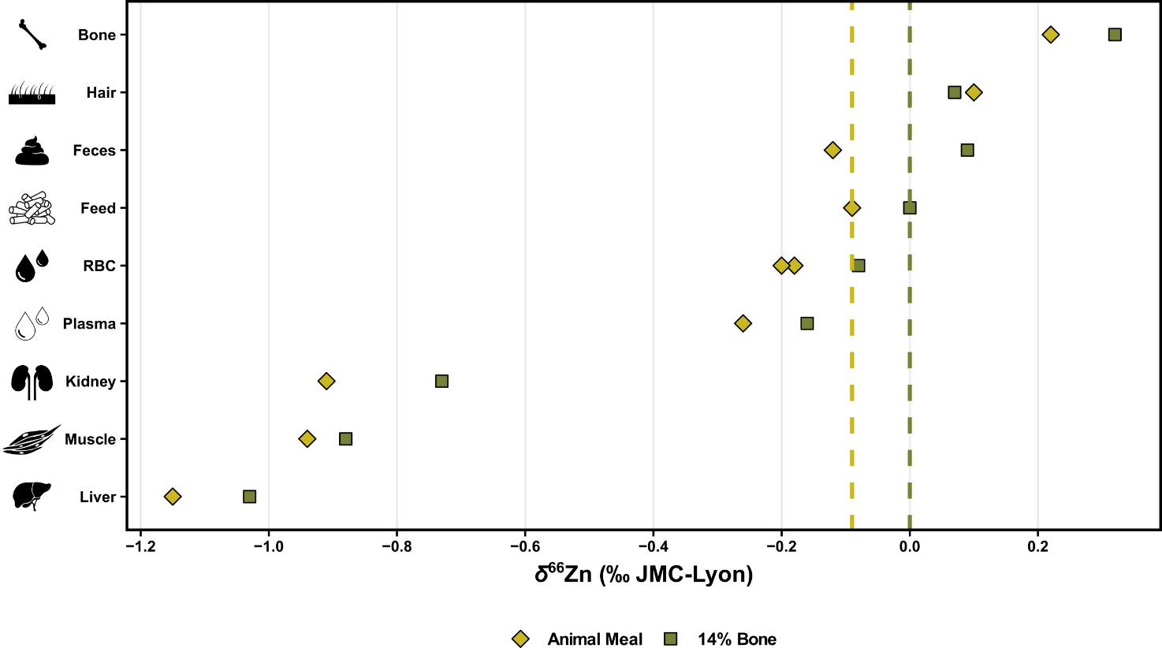
Figure S1. The zinc isotope compositions (‰, relative to the JMC-Lyon zinc isotope standard) of the liver, muscle, kidney, plasma, red blood cells (RBC), feces, hair, and bone, and respective feeds for the animal meal pelleted diet (light green-yellow diamond) and the 14% Bone pelleted diet (green square). Note that all tissue and excreta δ⁶⁶Zn values associated with the 14% Bone pelleted diet are reflecting the ⁶⁶Zn-enrichment of this feed compared to the animal meal pellet and thus are all accordingly exhibiting higher δ⁶⁶Zn values. This demonstrates that even small zinc isotope differences of 0.1 ‰ in the diet are reflected in consumer tissues. The dashed lines correspond to the δ⁶⁶Zn values of the diet supplied to the animals for each diet.

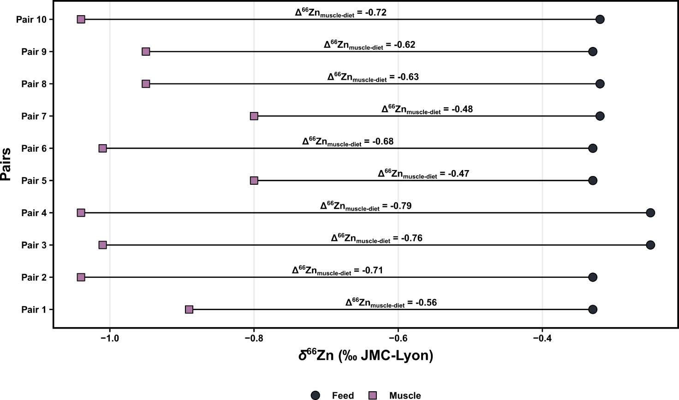
Figure S2. The zinc isotope compositions (‰, relative to the JMC-Lyon zinc isotope standard) of randomly-selected pairs of δ⁶⁶Zn values of feed (n = 3) and muscle tissues from the pelleted lucerne diet (n = 6), and the respective Δ⁶⁶Zn_{muscle-diet} value of each pairing, here ranging from -0.79 to -0.47 ‰.
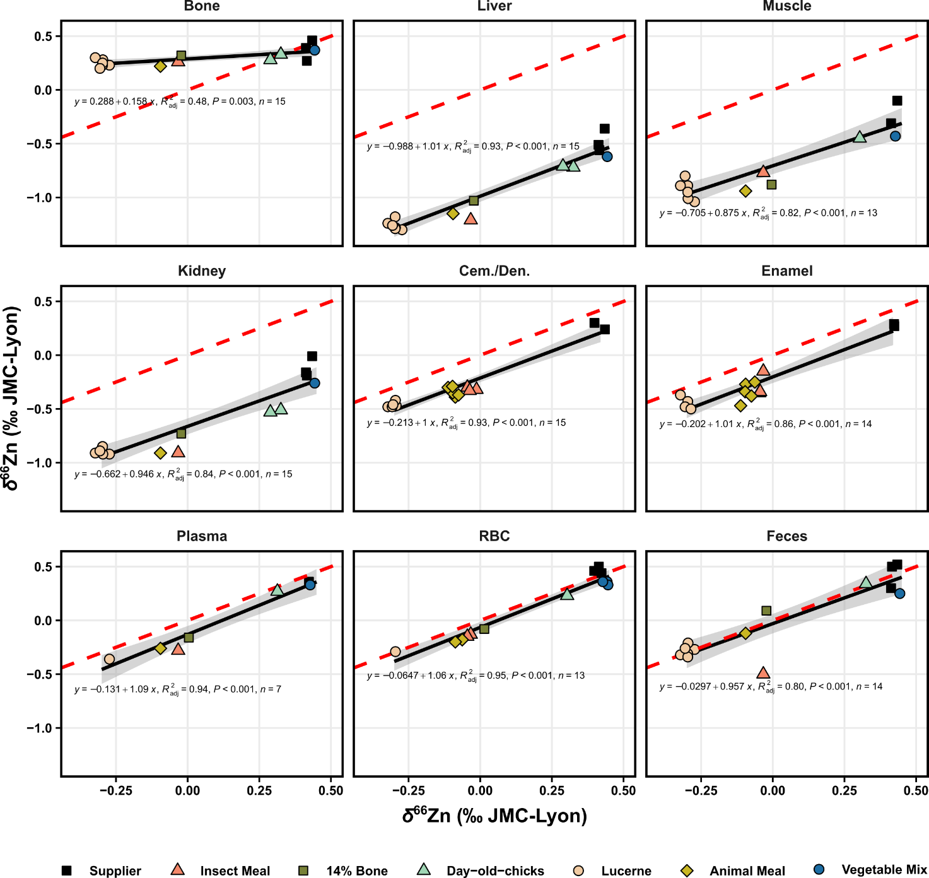
Figure S3. The zinc isotope compositions (‰, relative to the JMC-Lyon zinc isotope standard) of the liver, muscle, kidney, plasma, red blood cells (RBC), feces, bone, enamel, cementum/dentine (Cem./Den.) relative to the zinc isotope compositions of their respective feeds (pelleted supplier’s diet, pelleted animal meal diet, pelleted insect meal diet, pelleted lucerne meal, pelleted animal meal diet with a 14% bone-meal supplement, vegetable mix diet, and a day-old-chick diet). The dashed red line correspond to a theoretical 1:1, while the black line represent the actual relationship between the zinc isotope compositions of the tissues and the diet, which are systematically in agreement with the slope of theoretical one, except for bone. The shaded area corresponds to 95% confidence intervals of the observed compositions.

Supplementary Material-2: Sweep CI fits

Defining Zn cycle series
Because the nominal values of some Zn fluxes and Zn isotope fractionations in rats remain unknown or poorly constrained, we simulated the evolutions of Zn isotope distributions in rats by sweeping these parameters over wide ranges of values prior to running either Model 1 or 2. For this purpose, we used the sweep.final_nD and fit.final_space functions of the isobxr R package to estimate the best parameter values allowing to reproduce the steady-state Zn isotope compositions (within confidence intervals) reported for the key reservoirs of the organism [1].
The Zn isotope compositions (used to calculate α_{i-j}; see Table 3) and associated data (e.g., feed's zinc concentration) measured for the supplier rats were used as the reference steady-state status of the system, as supplier rats are assumed to be at isotopic equilibrium with their diets since their last dietary switch occurred at weaning from breastmilk. Box sizes (i.e., mass of Zn in each box, Table 1) and initial Zn fluxes (Figure 1) were taken from House and Wastney (1997), and the net absorption was set to 305 µg/d based on House and Wastney (1997) and Høyer and Weismann (1979) [2,3]. Lastly, the intake was set to 1000 µg/d, calculated from the average zinc concentration (rounded to 100 µg/g) in the supplier's diet and the daily food (15 g per day); the fractional absorption thus corresponds to around ca. 30% of the daily intake.
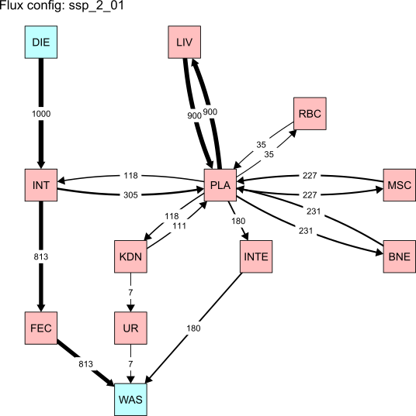
Figure 1. Initial flux structure (in µg/d) of the Zn cycle prior to the sweep space parameters, between compartments: diet (DIE), intestine (INT), plasma (PLA), erythrocytes (i.e., red blood cells; RBC), liver (LIV), muscles (MSC), bones (BNE), kidneys (KDN), hair (considered here as integument; INTE), urine (UR), feces (FEC), and waste (WAS).

Compartment | Zinc content in compartment (μg)
Diet | Infinite
Intestine | 1000
Plasma | 32
Liver | 378
Red Blood Cells | 320
Muscle | 1960
Bone | 3212
Kidney | 63
Integument | 2787
Feces | 813
Urine | 7
Waste | Infinite
Table 1. List of masses (μg) of each compartment used in the current study for a rat of 370 g, taken from House & Wastney (1997) [2].

Space of parameters

Sweeping of the endogenous vs. integument balance
Varying flux configurations were swept to encompass the various Zn cycles in mammals, as reported in humans and rats. The fluxes that are the most critical in determining the steady-state isotope compositions of an organism are those responsible for the exchange of the element with the environment. In the case of Zn in mammals, the environment-organism exchanges occur upon (1) intestinal absorption (INT->PLA), (2) endogenous losses (PLA->INT), (3) urinary losses (KDN->UR), and (4) integumentary losses (PLA->INTEG). The urinary losses are well constrained and limited in rats of 7 µg/d Zn, accounting for about 2% of intestinally absorbed Zn [2,3]. As detailed above, intestinal absorption is estimated to lie around 300 µg/d.
However, the relative importance of integumentary and endogenous losses is somewhat uncertain, as there is limited yet contrasting data in rats. In rats, some studies suggest a strong loss of Zn in the integument of the order of 180 µg/d, corresponding to ca. 59% of absorbed Zn [2]. In contrast, the rate of zinc loss through the skin in humans is about 250 to 300 µg/d for an absorption of ca. 4000 µg/d, thus representing a relative integumentary Zn loss of only 6.5-7.5% of absorbed Zn [4,5].
Sets of sweep space parameters (ssp; Table 2) were thus established to evaluate varying degrees of integumentary Zn loss, whereby ssp_2_01 corresponds to the highest integument flux (as suggested by House and Wastney, 1997) and ssp_2_11 to low integument one (as suggested for humans by Jaouen et al., 2019) [2,5]. The relative proportion of endogenous losses was accordingly adjusted to ensure a Zn balance in line with a fractional absorption of around 30% of dietary intake, as discussed above. The maximal relaxation times (t_{relax}) were estimated for these Zn cycles to assess the minimum duration required to reach the steady-state. These maximum t_{relax} values range from 33 to 696 days between ssp_2_01 and ssp_2_11. We usually consider that the steady-state is reached after more than 5*t_{relax}. Therefore, we set the total run durations to 10,000 days for all simulations aiming at relaxing the system to steady-state.

flux list name | Absorption |  | Endogenous losses |  | Integumentary losses |  | Urinary losses
 | Apparent frac. abs. | True frac. abs. | Relative loss | Flux PLA-INT | Relative loss | Flux PLA-INTEG | Relative loss | Flux KDN-UR
 | % | % | % | µg/d | % | µg/d | % | µg/d
ssp_2_01 | 19% | 31% | 39% | 118 | 59% | 180 | 2% | 7
ssp_2_02 | 15% | 31% | 52% | 132 | 46% | 166 | 2% | 7
ssp_2_03 | 11% | 31% | 65% | 146 | 33% | 152 | 2% | 7
ssp_2_04 | 7% | 31% | 78% | 160 | 20% | 138 | 2% | 7
ssp_2_05 | 5% | 31% | 85% | 174 | 13% | 124 | 2% | 7
ssp_2_06 | 4% | 31% | 88% | 188 | 10% | 110 | 2% | 7
ssp_2_07 | 3% | 31% | 91% | 202 | 7% | 96 | 2% | 7
ssp_2_08 | 2% | 31% | 93% | 216 | 5% | 82 | 2% | 7
ssp_2_09 | 2% | 31% | 94% | 230 | 3% | 68 | 2% | 7
ssp_2_10 | 1% | 31% | 96% | 244 | 2% | 54 | 2% | 7
ssp_2_11 | 1% | 31% | 96% | 258 | 1% | 40 | 2% | 7
Table 2. Sets of sweep space parameters that were used to explore Zn losses in the environment-organism exchanges in a rat: (1) endogenous losses (PLA->INT), (2) integumentary losses (PLA->INTEG), and (3) urinary losses (KDN->UR). Each flux configuration (µg/d) is then associated with a relative loss (%) and the overall apparent absorption (%) of the organism. The apparent fractional absorption refers to the observed difference between dietary intake and fecal losses normalized to dietary intake: 100*(1-F_{(INT>FEC)}⁄F_{(DIET>INT)}) where F refers to the Zn flux in µg/d. The true fractional absorption refers to the ratio between effectively absorbed Zn and dietary intake: 100*(F_{(INT>PLA)}⁄F_{(DIET>INT)}).

Sweeping of isotope fractionation coefficients
In addition to the sweeping of fluxes relative to the endogenous vs. integument balance, sets of isotope fractionation coefficients were also explored. Notably, the fractionation upon intestinal absorption (α_{INT-PLA}) and endogenous losses (α_{PLA-INT}) were set to vary between 0.9997 and 1.0003 (corresponding to -0.3 and +0.3 ‰), owing to the lack of precise basal estimate measured yet. Similarly, no precise basal estimate for isotope fractionation upon urinary losses (α_{KDN-UR}) has been measured yet, and was thus here swept between 1.0000 and 1.0010 (0 and 1 ‰), in favor of heavy isotopes as seen in humans [6]. Lastly, fractionation upon integument transport (α_{PLA-INTEG}) was set to vary between 0.9995 and 1.0000 (-0.50 and 0 ‰), as integument values found in supplier rat (hair) are around -0.30 ‰ lower than plasma, but the fractionation is otherwise undescribed yet.

FROM ( i ) | TO  ( j ) | Coefficient  α_{i-j} |  |  |  | Corresponding  Δ_{i-j} (‰) |  |  | Parameter sweeping
DIET | INT | 1.00000 |  |  |  | 0.00 |  |  | constant
INT | FEC | 1.00000 |  |  |  | 0.00 |  |  | constant
PLA | LIV | 0.99958 |  |  |  | -0.42 |  |  | constant
PLA | RBC | 1.00005 |  |  |  | 0.05 |  |  | constant
PLA | MSC | 0.99972 |  |  |  | -0.28 |  |  | constant
PLA | BNE | 1.00001 |  |  |  | 0.01 |  |  | constant
PLA | KDN | 1.00000 |  |  |  | 0.00 |  |  | constant
LIV | PLA | 1.00042 |  |  |  | 0.42 |  |  | constant
RBC | PLA | 0.99995 |  |  |  | -0.05 |  |  | constant
MSC | PLA | 1.00028 |  |  |  | 0.28 |  |  | constant
BNE | PLA | 0.99999 |  |  |  | -0.01 |  |  | constant
KDN | PLA | 1.00000 |  |  |  | 0.00 |  |  | constant
INT | PLA | 0.99970 | to | 1.00030 |  | -0.30 | to | 0.30 | swept over 10 values
PLA | INT | 0.99970 | to | 1.00030 |  | -0.30 | to | 0.30 | swept over 10 values
KDN | UR | 1.00000 | to | 1.00100 |  | 0.00 | to | 1.00 | swept over 10 values
PLA | INTEG | 0.99950 | to | 1.00000 |  | -0.50 | to | 0.00 | swept over 10 values
Table 3. List of fractionation coefficients between compartments used in the current study. Fractionation coefficient are calculated from δ⁶⁶Zn values from the current study or deduced.

CI-fit

Principle of the CI-fit approach
The sweeping of the space of parameters was performed using the sweep.final_nD function of isobxr R package [1]. The space of parameters entails 11 distinct flux configurations (Figure 1 and Table 2) as well as 4 isotope fractionation coefficients (Table 3), with each 10 values evenly distributed across the targeted ranges. The exhaustive sweeping produced as a result 110,000 simulations, corresponding to all combinations of parameter values. For a set of key reservoirs, this method allows to find all the combinations of parameter values allowing to produce steady-state isotope compositions falling within the observed confidence intervals of all reservoirs of interest. To this end, we use the fit.final_space function of isobxr R package.
As mentioned before, the Zn isotope compositions measured in the supplier rats were used as references to compare the swept space of parameters with observed compositions of rats assumed to be at equilibrium with their diets, given that their last dietary switch occurred at weaning from breast milk. The observed confidence intervals (obs.CI) were defined as 2SE and, in the case of boxes with a single observation (PLA and INTEG), the obs.CI were conservatively set to 0.2 ‰, corresponding to 4*maximized external reproducibility (roughly 0.05 ‰ on repeated measurement of standards) and also to the maximum of estimated 2SE on other boxes with n ≥ 2 individuals (Table 4).

Organ | Observations |  |  |  | Defining obs.CI
 | Mean δ⁶⁶Zn | ∆⁶⁶Zn_{diet} | SD | n | CI.T | 2SE 2SD/sqrt(n) | obs.CI
Bone | 0.37 | -0.05 | 0.1 | 3 | 0.25 | 0.12 | 0.12
Feces | 0.44 | 0.02 | 0.12 | 3 | 0.30 | 0.14 | 0.14
Feed* | 0.42 | 0.00 | 0.09 | 5 | 0.11 | 0.08 | 0.08
Hair | 0.08 | -0.34 | - | 1 | - | - | 0.20
Kidney* | -0.12 | -0.54 | 0.1 | 3 | 0.25 | 0.12 | 0.12
Liver | -0.48 | -0.90 | 0.1 | 3 | 0.25 | 0.12 | 0.12
Muscle | -0.21 | -0.62 | 0.15 | 2 | 1.35 | 0.21 | 0.21
Plasma | 0.36 | -0.06 | - | 1 | - | - | 0.20
RBC | 0.47 | 0.05 | 0.03 | 3 | 0.07 | 0.03 | 0.03
Table 4. List of δ⁶⁶Zn values per tissue, biofluid, and excreta, from the rat specimens fed only their supplier's feed, used to establish confidence interval (CI) used for the sweeping of the space of parameters. *Refers to boxes that were excluded from the CI-fits.
Lastly, it is important to mention that the kidney was excluded from simulation vs. observation fitting; the current design treats it as an interface and thus does not aim to reproduce its true isotopic composition. Moreover, it represents a too complex organ to be modelled effectively in the model's current form and thus is beyond the scope of this study.

Results of the confidence-interval fittings

Fit_0: Fitting over all parameter values
Overall, this CI-fit shows a very good agreement between observed and predicted steady-state (Figure 2A). The density distributions of the fitted fractionation coefficients are not markedly constraining with the exception of the PLA-INTEG fractionation coefficient, with a best fit value of -0.28 ± 0.12 ‰ (expressed as a Δ_{PLA-INTEG}). Finally, all flux configurations (ssp_2_01 to ssp_2_11) are equally represented in the CI-fits.

Effect of renal isotope fractionation / fit_1 to fit_3
We assume here two extreme hypotheses with (1) an absence of renal fractionation (Δ_{PLA-INTEG} = 0 ‰, fit_1) and (2) a constant and strong renal fractionation inducing a preferential loss of urinary Zn enriched by 1 ‰ (fit _2). Both corresponding CI-fits show that all the fitted simulations predict compositions comparable in both hypotheses (with differences lower than 0.01 ‰), irrespective of the extant of renal fractionation, being of 0 or 1 ‰ (Figure 2A). This is true for all reservoirs other than kidney and urine, which are directly affected, as expected. The density distributions of the corresponding fitted values of all parameters other than the renal fractionation coefficient also remain unchanged (Figure 2B).
In other words, the extent of the renal isotope fractionation has no importance in determining the steady-state isotope compositions of the organism itself. We thus set thereafter the renal isotope fractionation at 0.44 ‰ (α_{KDN-UR} = 1.00044). This amplitude is comparable to the average offset in δ⁶⁶Zn between urine and plasma previously reported in humans [6].
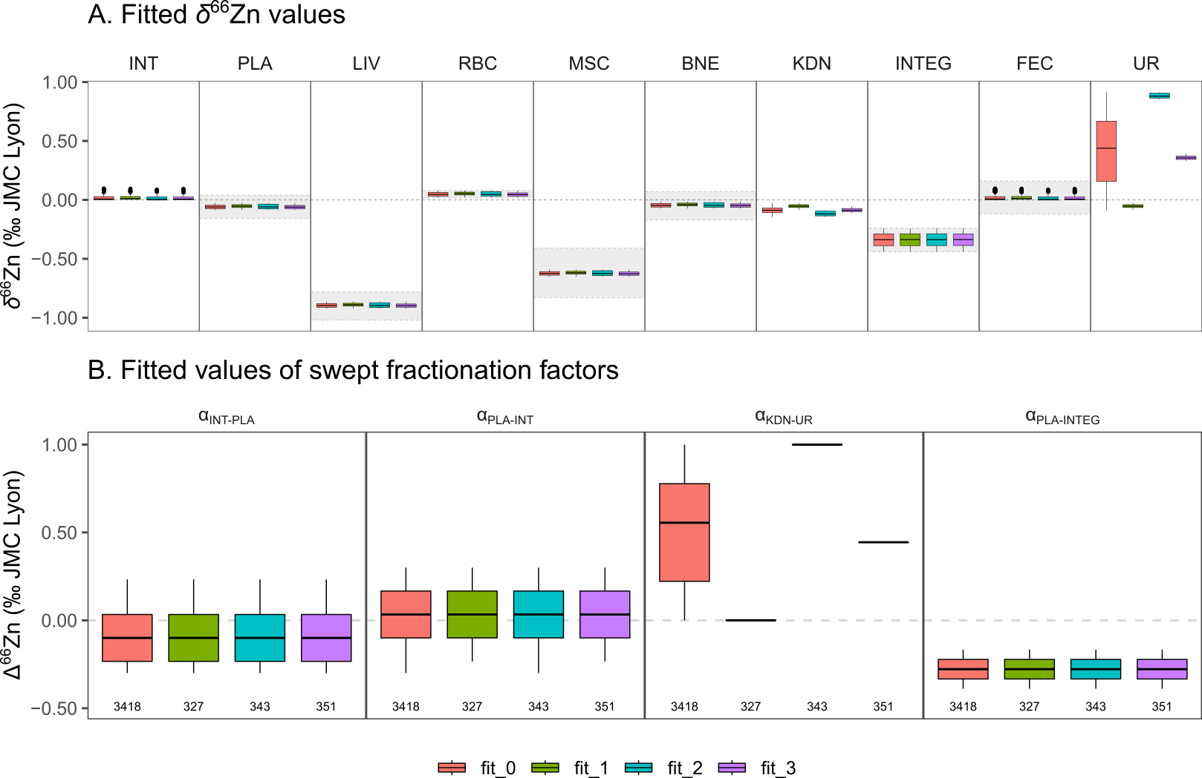
Figure 2. A. Distributions of fitted δ⁶⁶Zn values in all boxes: intestine (INT), plasma (PLA), liver (LIV), red blood cells (RBC), muscle (MSC), bone (BNE), kidney (KDN), integument (INTEG; i.e., in this case, hair), feces (FEC), and urine (UR). Shaded area corresponds to confidence intervals of the observed compositions used for the CI-fits. B. Distributions of fitted swept fractionation coefficients, plotted as ∆ values expressed in ‰. The number of fitted simulations (out of 110 000 simulations) is shown at the bottom.

Fit_4: Effect of fractionation upon intestinal absorption, endogenous losses, and integument transport
We then determine the sets of CI-fitted values of the other swept fractionation coefficients (α_{INT-PLA}, α_{PLA-INT}, α_{PLA-INTEG}) for each flux configuration (from ssp_2_01 to ssp_2_11). As a result, each flux configuration is associated with a combination of fractionation coefficient values allowing the simulation of isotope compositions falling within the confidence intervals of the key reservoirs. The distributions of the predicted isotope compositions and the CI-fitted fractionation coefficients are shown in Figure 3.
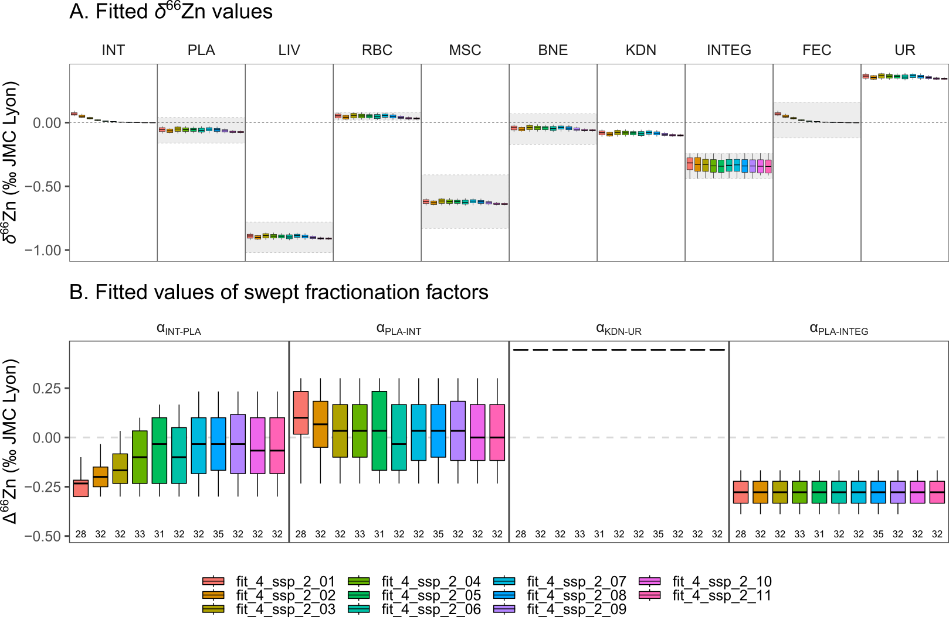
Figure 3. A. Distributions of fitted δ⁶⁶Zn values in all boxes: intestine (INT), plasma (PLA), liver (LIV), red blood cells (RBC), muscle (MSC), bone (BNE), kidney (KDN), integument (INTEG; i.e., in this case, hair), feces (FEC), and urine (UR). Shaded area corresponds to confidence intervals of the observed compositions. B. Distributions of fitted swept fractionation coefficients, plotted as ∆ values expressed in ‰. The number of fitted simulations is shown at the bottom (out of 110 000 simulations).

The CI-fitting of each flux configuration successfully identifies a set of parameter values that produce δ⁶⁶Zn predictions falling within the observed confidence intervals. Within those confidence intervals, the δ⁶⁶Zn predictions are poorly sensitive to the considered flux configuration. The only obvious trend is observed in feces, which are ⁶⁶Zn enriched for high integument/low endogenous loss ratios. This is explained by the fact that the endogenous losses are hence representing a higher proportion of the Zn fecal losses.

Supplier – lucerne diet change with varying integument t_{1/2}
We use here all the fitted sets of parameter values for each flux configuration (ssp_2_01 to ssp_2_11 with varying integumentary/endogenous loss balance) to assess the effects of the residence time of Zn in integument on the isotope compositions of the key reservoirs of the rats after a diet switch to the lucerne diet. These individuals, fed for 59 days on the lucerne pellets are expected to display varying extents of diet-body isotope equilibration depending on the box considered.
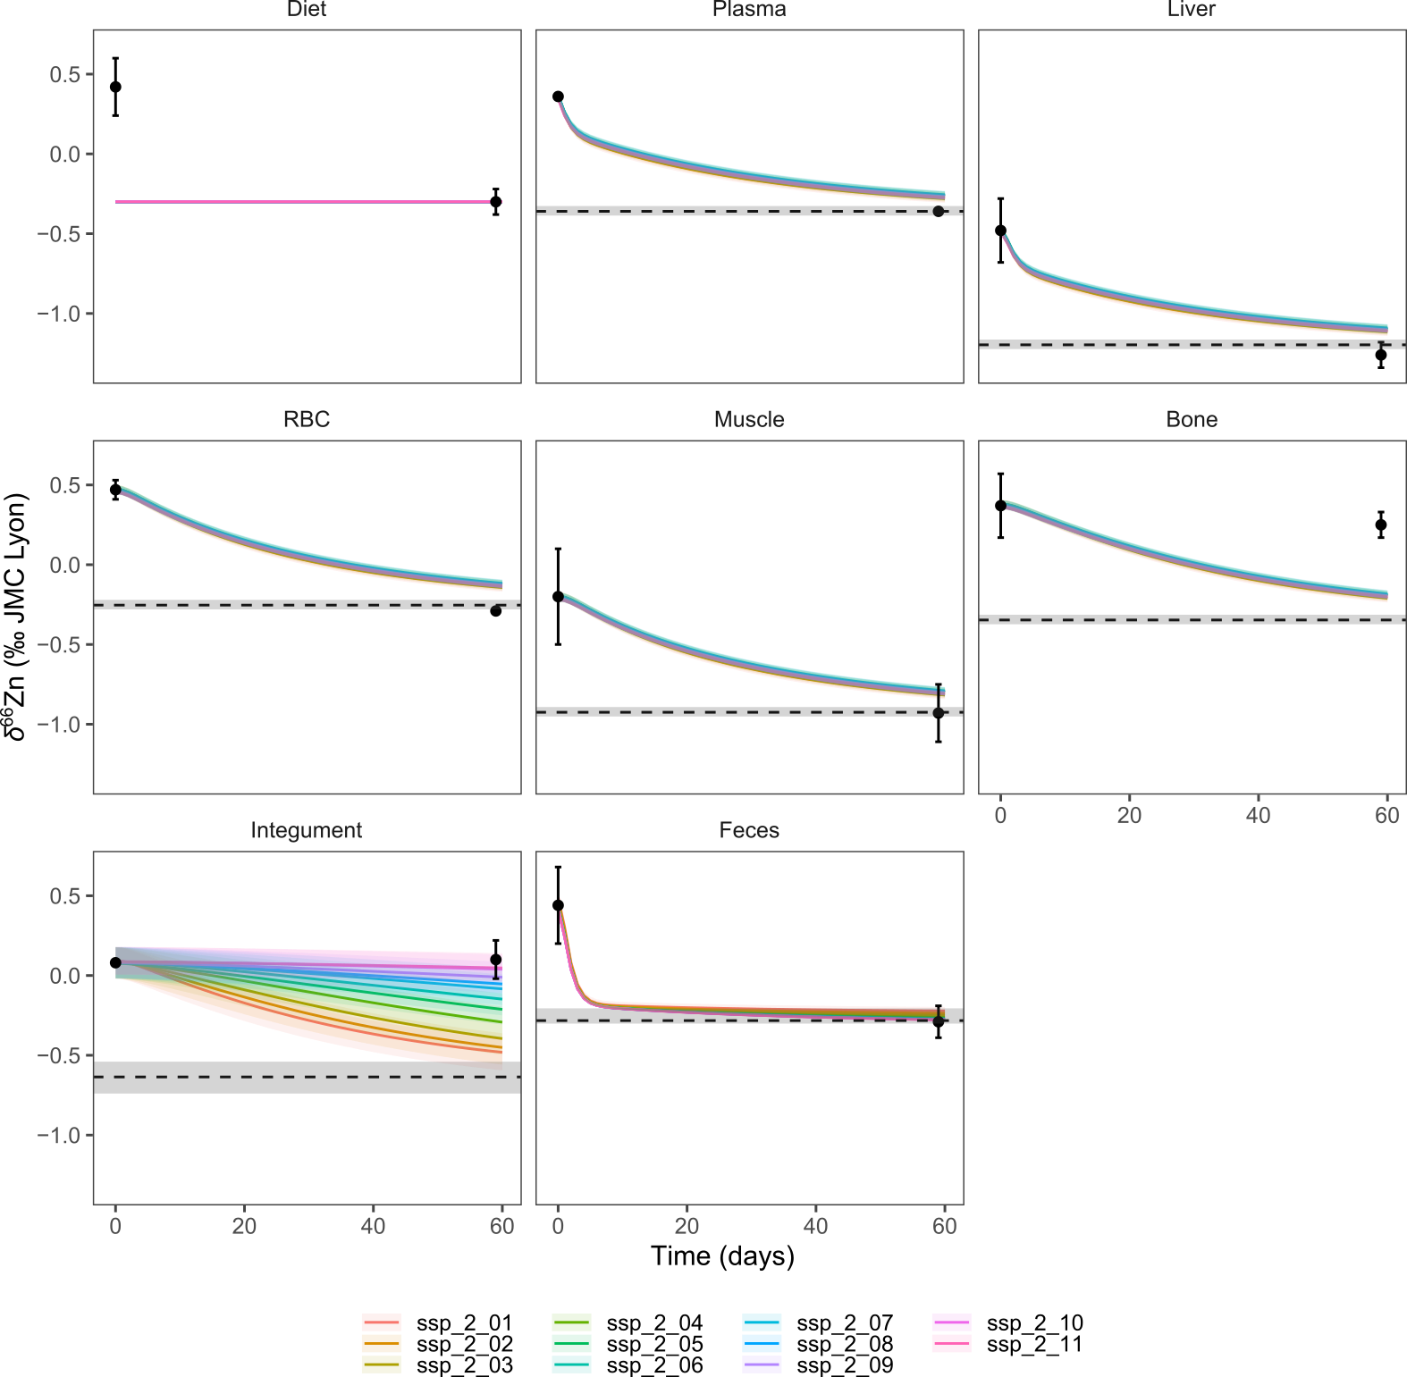
Figure 4. Predicted evolution of δ⁶⁶Zn (‰ JMC-Lyon) in each box following a dietary transition from a steady-state organism at equilibrium with the supplier diet to a lucerne pellet diet. The dashed lines with a shaded area correspond to the predicted steady-state isotope composition when the organism is fully equilibrated with the second diet (lucerne pellets here). The black circles correspond to the average values of the observed δ⁶⁶Zn values (error bars are 2SD). The time axis corresponds to the time (in days) that elapsed since the start of the experiment (i.e., the introduction of the second diet). Each curve and shaded area represent the average and full extent of compositions predicted by the sets of fitted parameter values determined for each flux configuration (see fit_4 described above and illustrated in Figure 3).

Figure 4 shows the prediction of the evolution of the organism isotope compositions following a diet switch from the supplier diet to the lucerne diet, using the fitted parameters determined using the rats at equilibrium with the supplier diet only. We observe that irrespective of the assumed flux configuration, the isotope compositions of plasma, liver, red blood cells, muscle, and feces predicted after 59 days are in very good agreement with the δ⁶⁶Zn values measured in the rats fed on the lucerne pellets for the same amount of time. Overall, the isotope compositions in those reservoirs have reached full isotopic equilibrium with the new diet. However, the bone appears to remain out of equilibrium in all cases and in poor agreement with the predicted evolution.
The predicted evolution of the zinc isotope composition of the integument is strongly related to the flux configuration, which are characterized by varying PLA-INTEG fluxes and hence varying Zn residence time in integument.
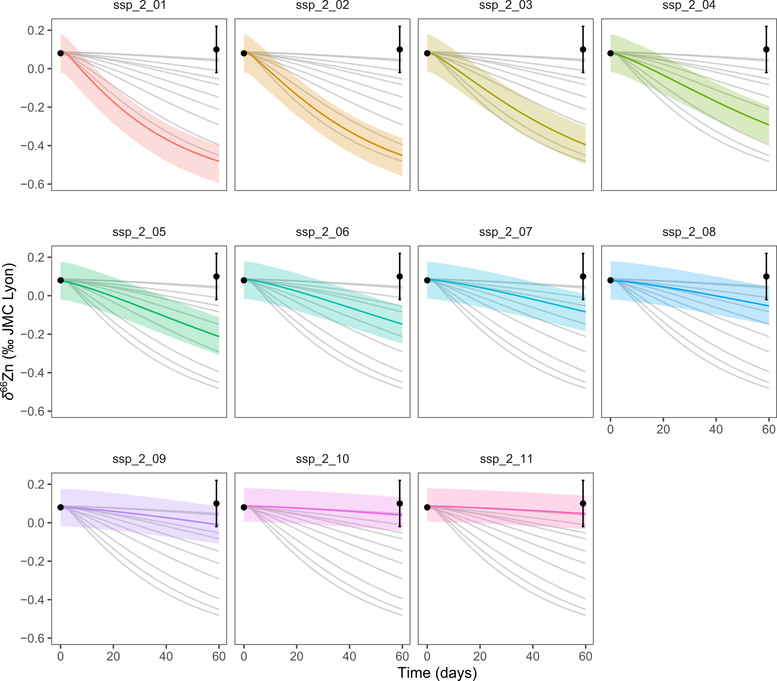
Figure 5. Predicted evolution of δ⁶⁶Zn (‰ JMC-Lyon) in hair following a dietary transition from a steady-state organism at equilibrium with the supplier diet to a lucerne pellet diet, whereby different PLA-INTEG fluxes (from 4 to 180 μg/day) are modeled. The colored lines shown with the shaded area correspond to the predicted steady-state isotope composition when the organism is fully equilibrated with the second diet (lucerne pellets here), whereby the grey lines correspond to the prediction using the other fluxes. The black circles correspond to the average values of the observed δ⁶⁶Zn values (error bars are 2SD). The time axis corresponds to the time (in days) that elapsed since the start of the experiment (i.e., the introduction of the second diet). Each curve and shaded area represent the average and full extent of compositions predicted by the sets of fitted parameter values determined for each flux configuration (see fit_4 described above and illustrated in Figure 3).

The best integument fit is found in flux configuration ssp_2_11, corresponding to a low integument loss/high endogenous loss comparable to what was described in humans. The t_{1/2} in integument (hair in the current case) is thus rather in the order of 700 days, not 70 days, as initially assumed in House and Wastney (1997) [2]. We thereafter use the ssp_2_11 flux configuration, shown below, for subsequent modeling.
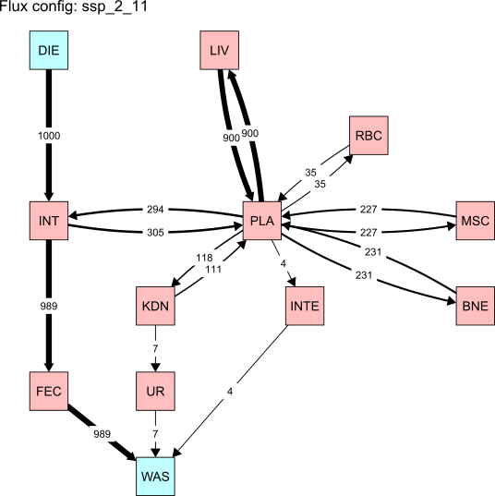
Figure 6. Updated flux configuration (in µg/d) for all compartments (diet (DIE), intestine (INT), plasma (PLA), erythrocytes (i.e., red blood cells; RBC), liver (LIV), muscles (MSC), bones (BNE), kidneys (KDN), hair (considered here as integument; INTE), urine (UR), feces (FEC), and waste (WAS)) from ssp_2_11, corresponding to a 700 days residence time of Zn in integument.

Supplier – lucerne diet change with varying bone t_{1/2}
Following the same approach as in section 3, we estimate the best residence time of Zn in the bone that could explain why it appears out of isotopic equilibrium in the rats fed for ca. 60 days on the lucerne pellets. By modulating the flux of Zn from plasma to bone and from bone to plasma, we let the residence time of Zn in bone vary between 14 d (as suggested previously in House and Wastney, 1997) up to roughly 3000 d, as assumed if Zn has the same residence time as Ca (e.g., 2000 days if 1kg Ca in bone and 500 mg/d exchanged; Del Valle et al., 2011) [2,7].
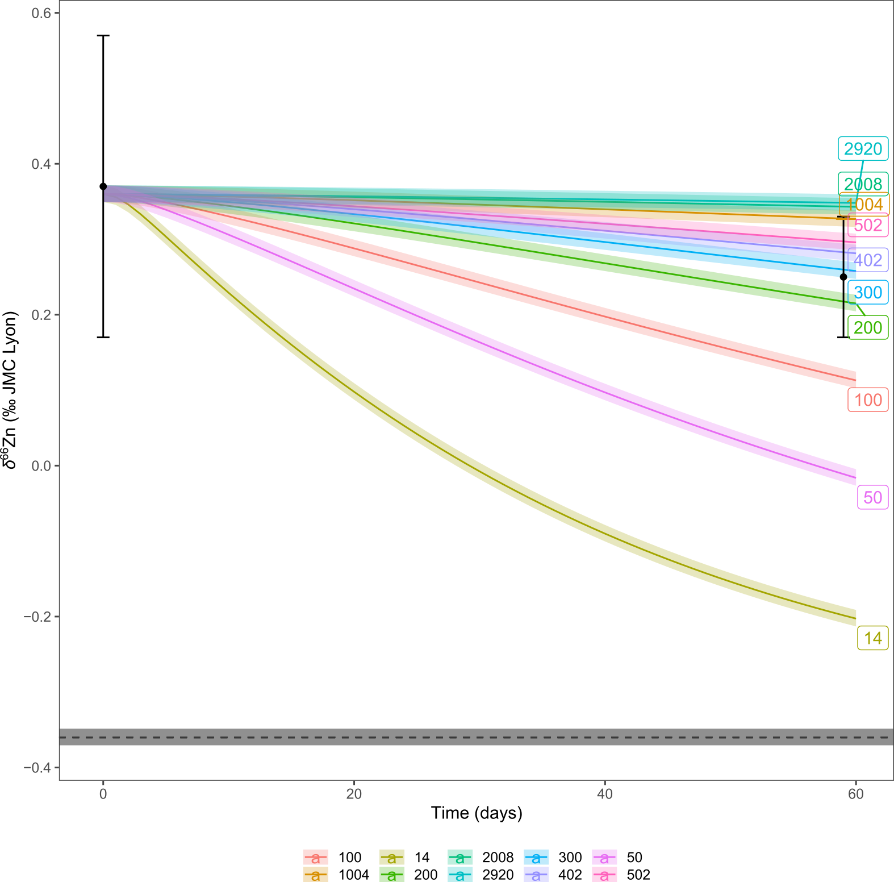
Figure 7. Predicted evolution of δ⁶⁶Zn (‰ JMC-Lyon) in bone following a dietary transition from a steady-state organism at equilibrium with the supplier diet to a lucerne pellet diet, whereby different PLA-BNE fluxes (from 1.1 to 231.1 μg/day) are modeled and correspond to varying residence time (14 to 2920 days as shown in legend and on labels). The colored lines shown with the shaded area correspond to the predicted steady-state isotope composition when the organism is fully equilibrated with the second diet (lucerne pellets here) based on varying residence time. The black circles correspond to the average values of the observed δ⁶⁶Zn values (error bars are 2SD). The dashed lines with a shaded area correspond to the predicted steady-state isotope composition when the organism is fully equilibrated with the second diet. The time axis corresponds to the time (in days) that elapsed since the start of the experiment (i.e., the introduction of the second diet). Each curve and shaded area represent the average and full extent of compositions predicted by a set of fitted parameter values but with different bone t_{1/2}.
The resulting simulations suggest the best fit for bone t_{1/2} at around 300 days, which is much higher and hardly compatible with the 14 days estimate by House and Wastney 1997 [2]. While the uncertainties on t₀ and t₆₀ bone δ⁶⁶Zn values might allow for higher t_{1/2} values of up to 3000 days, our 300 days estimate seems to be lower than the residence time of Ca (2000–3000 days). We thus thereafter assume a t_{1/2} of 300 days in bone, corresponding to a PLA-BNE and BNE-PLA fluxes of 10.7 µg/d (Figure 8), and used for subsequent modelling.
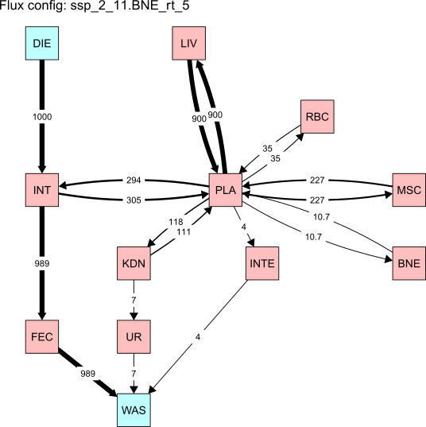
Figure 8. Updated flux configuration (in µg/d) for all compartments (diet (DIE), intestine (INT), plasma (PLA), erythrocytes (i.e., red blood cells; RBC), liver (LIV), muscles (MSC), bones (BNE), kidneys (KDN), hair (considered here as integument; INTE), urine (UR), feces (FEC), and waste (WAS)) taking in account a 300 days residence time of Zn in bone.

References
1. Tacail T. (2023) isobxr: Stable isotope box modelling in R, version 2.0. https://cran.r-project.org/web/packages/isobxr/index.html.
2. House WA, Wastney ME. Compartmental analysis of zinc kinetics in mature male rats. Am J Physiol-Regul Integr Comp Physiol 1997;273:R1117–25.
3. Høyer H, Weismann K. The effect of oral zinc loading on the absorption of ⁶⁵zinc in the rat. Arch Dermatol Res 1979;264:327–30.
4. Milne DB, Canfield WK, Mahalko JR, Sandstead HH. Effect of dietary zinc on whole body surface loss of zinc: Impact on estimation of zinc retention by balance method. Am J Clin Nutr 1983;38:181–6.
5. Jaouen K, Pouilloux L, Balter V, Pons M-L, Hublin J-J, Albarède F. Dynamic homeostasis modeling of Zn isotope ratios in the human body. Metallomics 2019;11:1049–59.
6. Moore RET, Rehkämper M, Maret W, Larner F. Assessment of coupled Zn concentration and natural stable isotope analyses of urine as a novel probe of Zn status†. Metallomics 2019;11:1506–17.
7. Del Valle HB, Taylor CL, Yaktine AL, Ross AC eds. Dietary Reference Intakes for Calcium and Vitamin D. National Academies Press, 2011.

Supplementary Material-3: Dietary switch
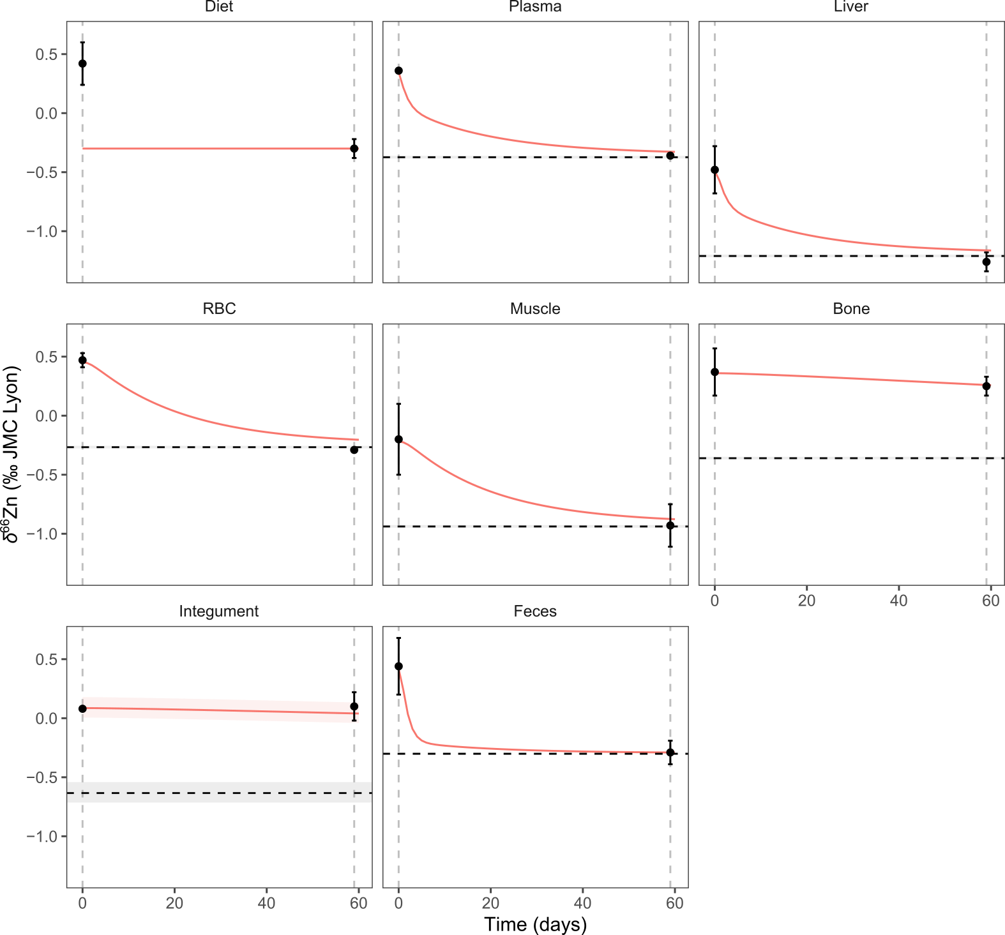
Figure S1. Predicted evolution of δ⁶⁶Zn (‰ JMC-Lyon) in each box following a dietary transition from a steady-state organism at equilibrium with the supplier diet to a pelleted lucerne diet. The dashed lines with a shaded area correspond to the predicted steady-state isotope composition when the organism is fully equilibrated with the second diet (lucerne pellets here). The black circles correspond to the average values of the observed δ⁶⁶Zn values (error bars are 2SD). The time axis corresponds to the time (in days) that elapsed since the start of the experiment (i.e., the introduction of the second diet). Each curve and shaded area represent the average and full extent of compositions predicted by the sets of fitted parameter values determined for each flux configuration (see fit_4 described in Supplementary Material-2 and Figure 8 of Supplementary Material-2).
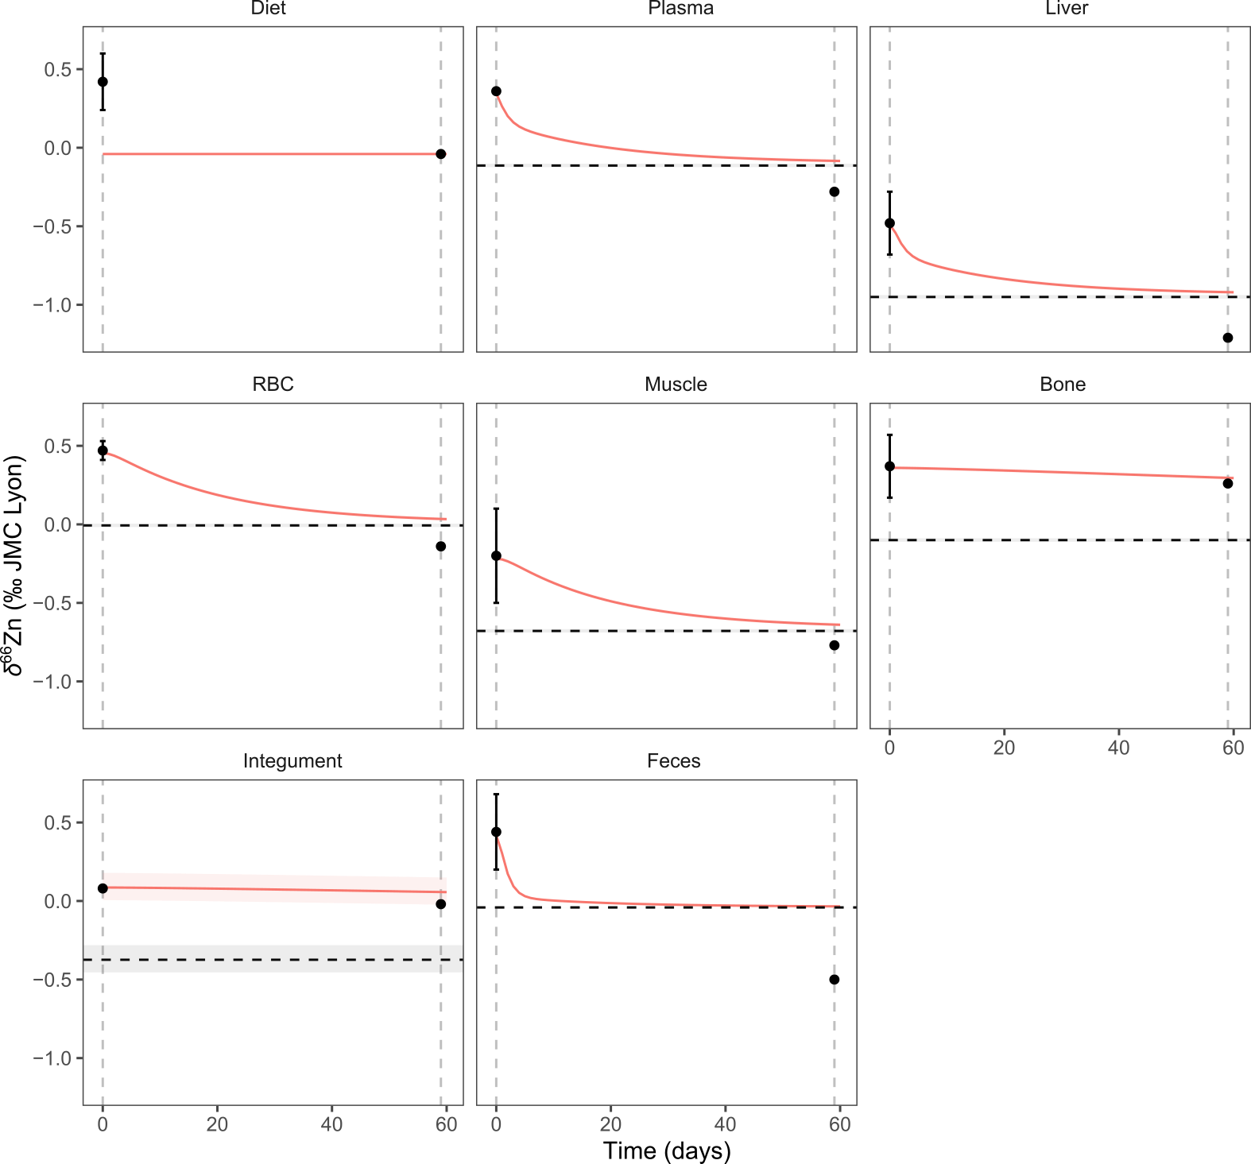
Figure S2. Predicted evolution of δ⁶⁶Zn (‰ JMC-Lyon) in each box following a dietary transition from a steady-state organism at equilibrium with the supplier diet to a pelleted insect meal diet. The dashed lines with a shaded area correspond to the predicted steady-state isotope composition when the organism is fully equilibrated with the second diet (pelleted insect meal here). The black circles correspond to the average values of the observed δ⁶⁶Zn values (error bars are 2SD). The time axis corresponds to the time (in days) that elapsed since the start of the experiment (i.e., the introduction of the second diet). Each curve and shaded area represent the average and full extent of compositions predicted by the sets of fitted parameter values determined for each flux configuration (see fit_4 described in Supplementary Material-2 and Figure 8 of Supplementary Material-2).

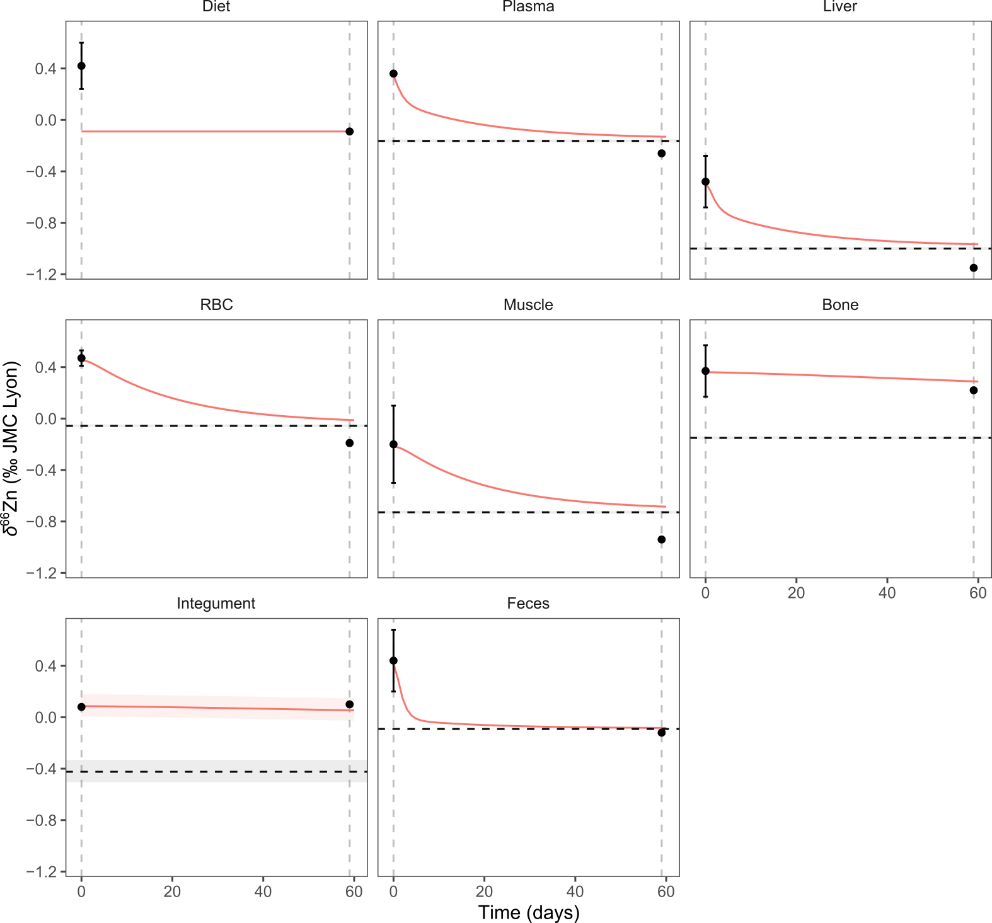
Figure S3. Predicted evolution of δ⁶⁶Zn (‰ JMC-Lyon) in each box following a dietary transition from a steady-state organism at equilibrium with the supplier diet to a pelleted animal meal diet. The dashed lines with a shaded area correspond to the predicted steady-state isotope composition when the organism is fully equilibrated with the second diet (pelleted animal meal here). The black circles correspond to the average values of the observed δ⁶⁶Zn values (error bars are 2SD). The time axis corresponds to the time (in days) that elapsed since the start of the experiment (i.e., the introduction of the second diet). Each curve and shaded area represent the average and full extent of compositions predicted by the sets of fitted parameter values determined for each flux configuration (see fit_4 described in Supplementary Material-2 and Figure 8 of Supplementary Material-2).

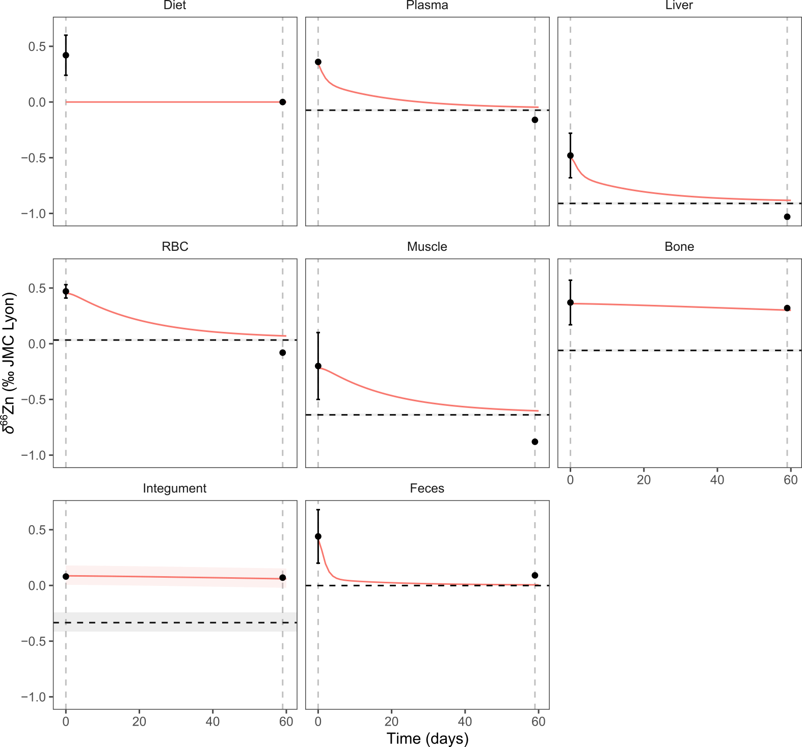
Figure S4. Predicted evolution of δ⁶⁶Zn (‰ JMC-Lyon) in each box following a dietary transition from a steady-state organism at equilibrium with the supplier diet to a pelleted animal meal diet with a bone-meal supplement totaling 14% of the feed’s weight. The dashed lines with a shaded area correspond to the predicted steady-state isotope composition when the organism is fully equilibrated with the second diet (pelleted 14% “bone” meal here). The black circles correspond to the average values of the observed δ⁶⁶Zn values (error bars are 2SD). The time axis corresponds to the time (in days) that elapsed since the start of the experiment (i.e., the introduction of the second diet). Each curve and shaded area represent the average and full extent of compositions predicted by the sets of fitted parameter values determined for each flux configuration (see fit_4 described in Supplementary Material-2 and Figure 8 of Supplementary Material-2).

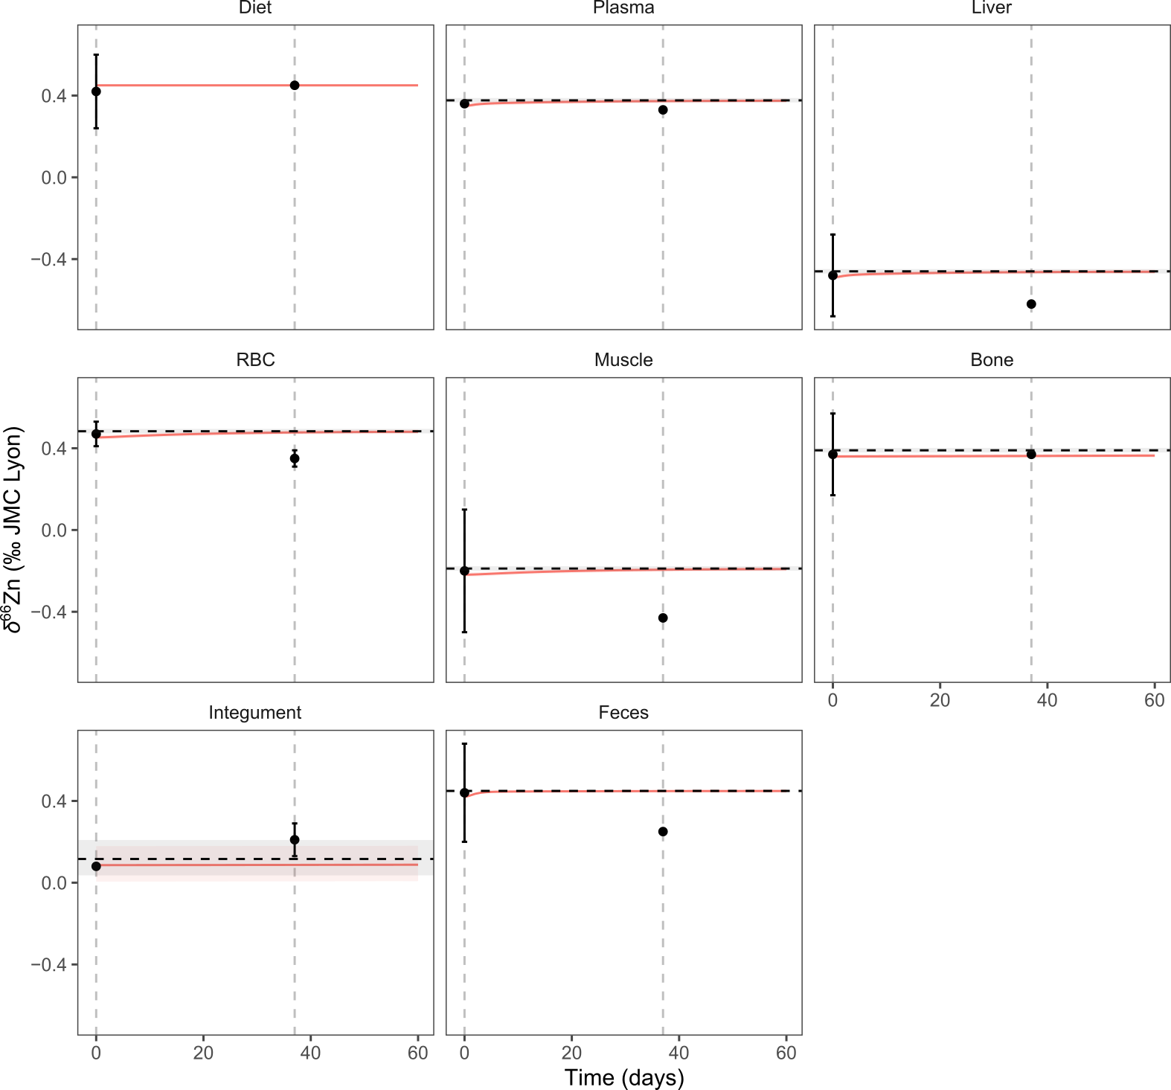
Figure S5. Predicted evolution of δ⁶⁶Zn (‰ JMC-Lyon) in each box following a dietary transition from a steady-state organism at equilibrium with the supplier diet to a vegetable mix diet. The dashed lines with a shaded area correspond to the predicted steady-state isotope composition when the organism is fully equilibrated with the second diet (vegetable mix diet here). The black circles correspond to the average values of the observed δ⁶⁶Zn values (error bars are 2SD). The time axis corresponds to the time (in days) that elapsed since the start of the experiment (i.e., the introduction of the second diet). Each curve and shaded area represent the average and full extent of compositions predicted by the sets of fitted parameter values determined for each flux configuration (see fit_4 described in Supplementary Material-2 and Figure 8 of Supplementary Material-2).

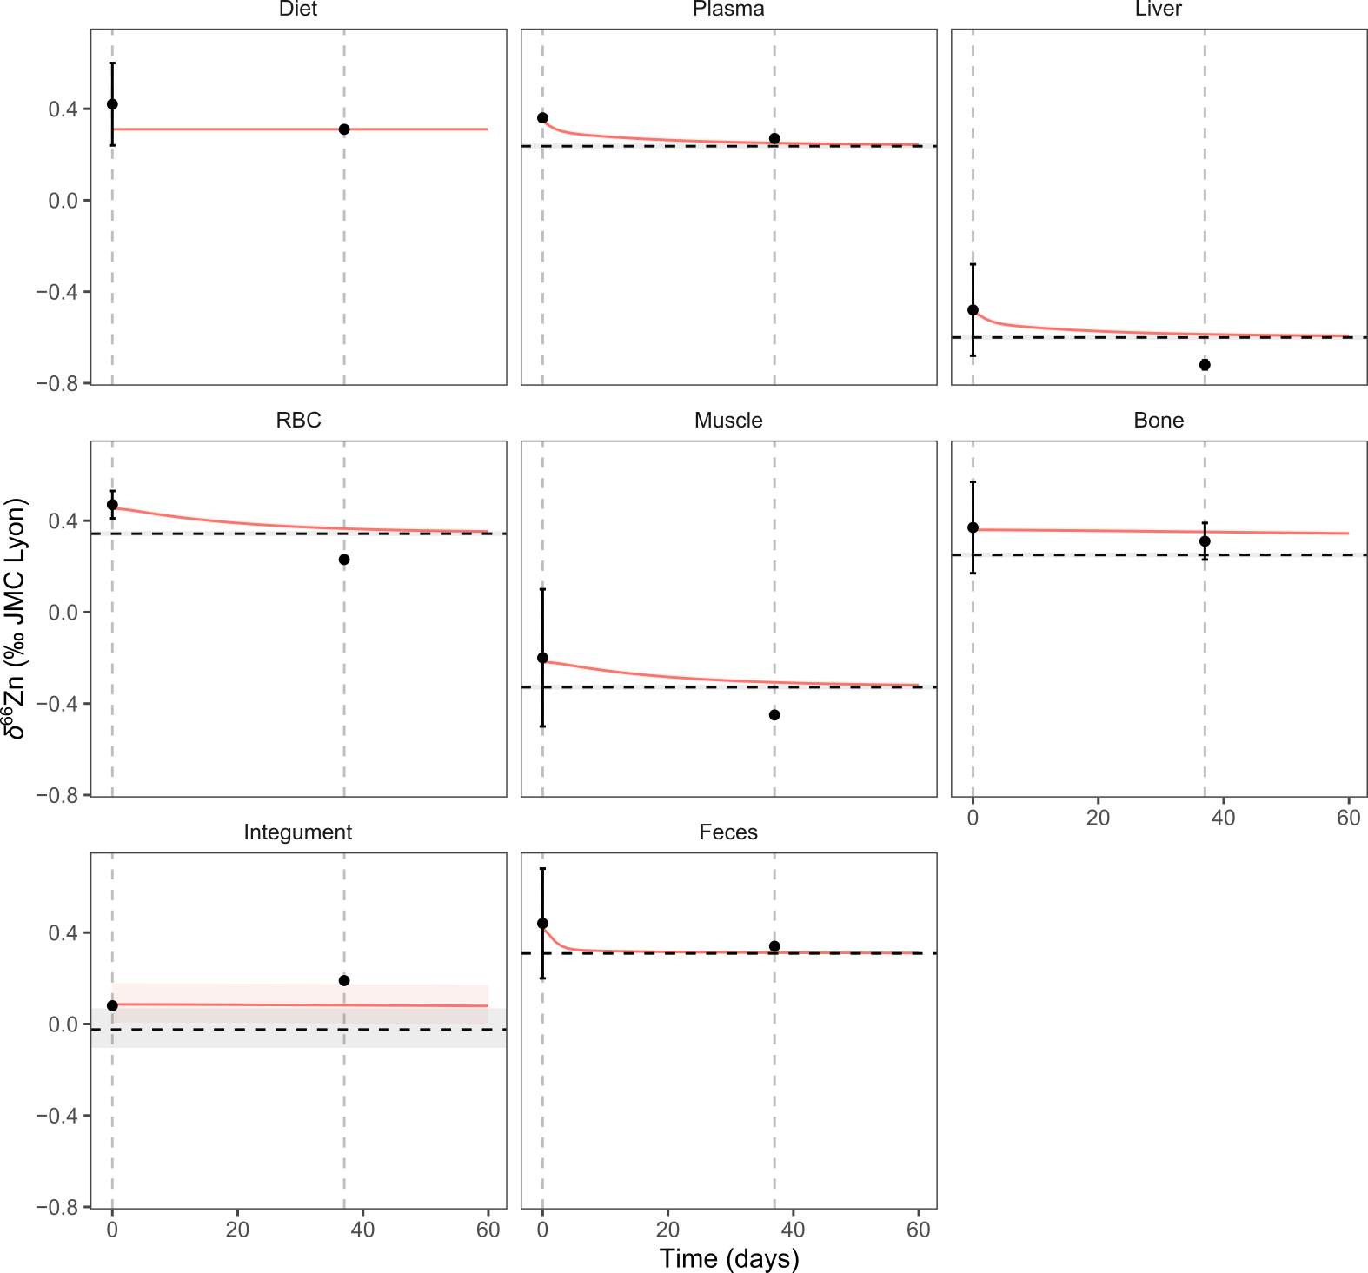
Figure S6. Predicted evolution of δ⁶⁶Zn (‰ JMC-Lyon) in each box following a dietary transition from a steady-state organism at equilibrium with the supplier diet to a day-old-chicks diet. The dashed lines with a shaded area correspond to the predicted steady-state isotope composition when the organism is fully equilibrated with the second diet (day-old-chicks diet here). The black circles correspond to the average values of the observed δ⁶⁶Zn values (error bars are 2SD). The time axis corresponds to the time (in days) that elapsed since the start of the experiment (i.e., the introduction of the second diet). Each curve and shaded area represent the average and full extent of compositions predicted by the sets of fitted parameter values determined for each flux configuration (see fit_4 described in Supplementary Material-2 and Figure 8 of Supplementary Material-2).

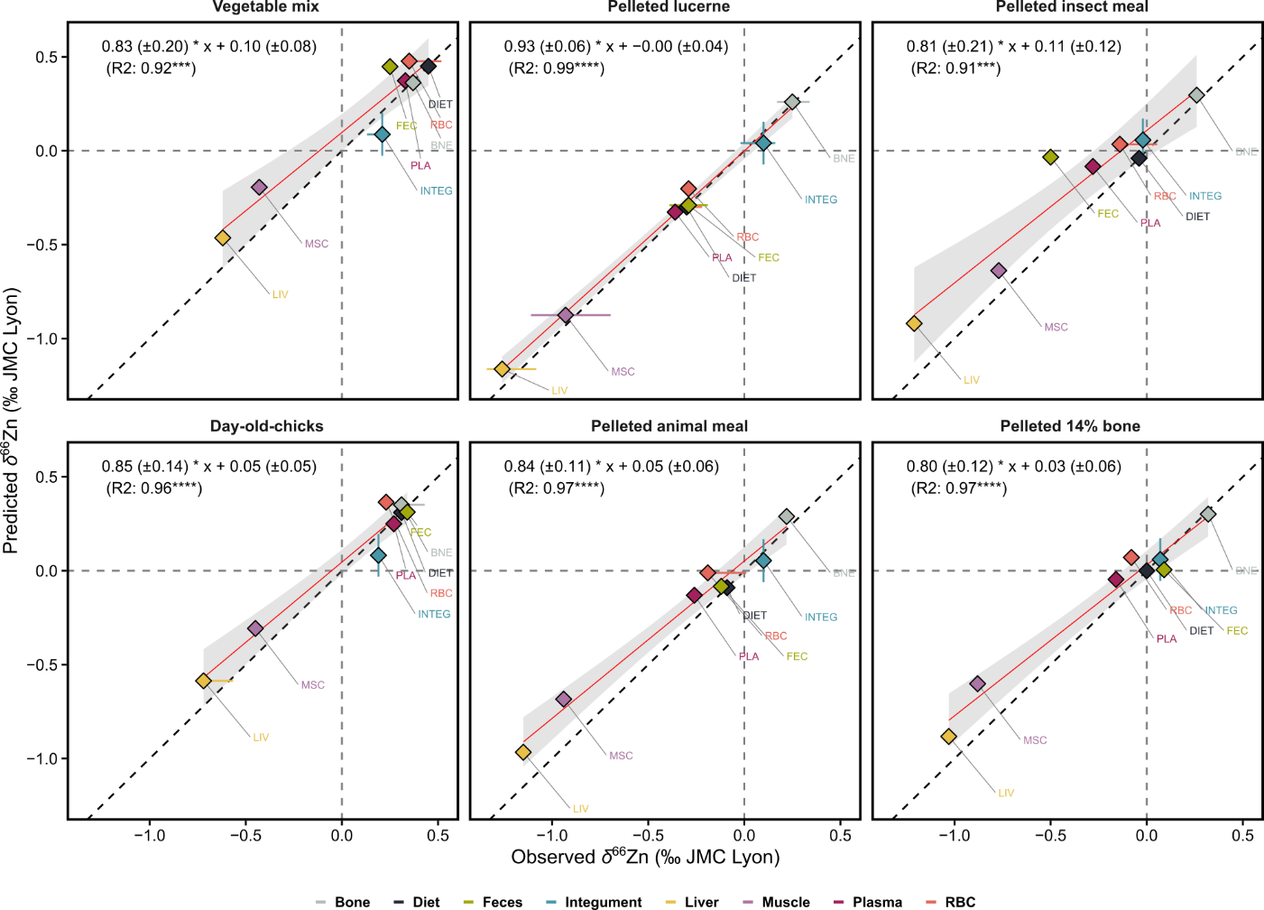
Figure S7. Fitness of predictions between predicted and observed δ⁶⁶Zn (‰ JMC-Lyon) for each diet and according tissue and excreta samples for the respective feeding experiments, whereby the dashed lines represent a 1:1 regression between the two while the blue lines represent the actual regression. The shaded areas correspond to the 95% confidence interval of their respective regression line.

