Renal Replacement Therapy Intensity for Acute Kidney Injury and Recovery to Dialysis Independence: a systematic review and individual patient data meta-analysis
Supplementary Figure 1 All-cause mortality at 28, 60, 90 days and within ICU admission by randomized treatment group
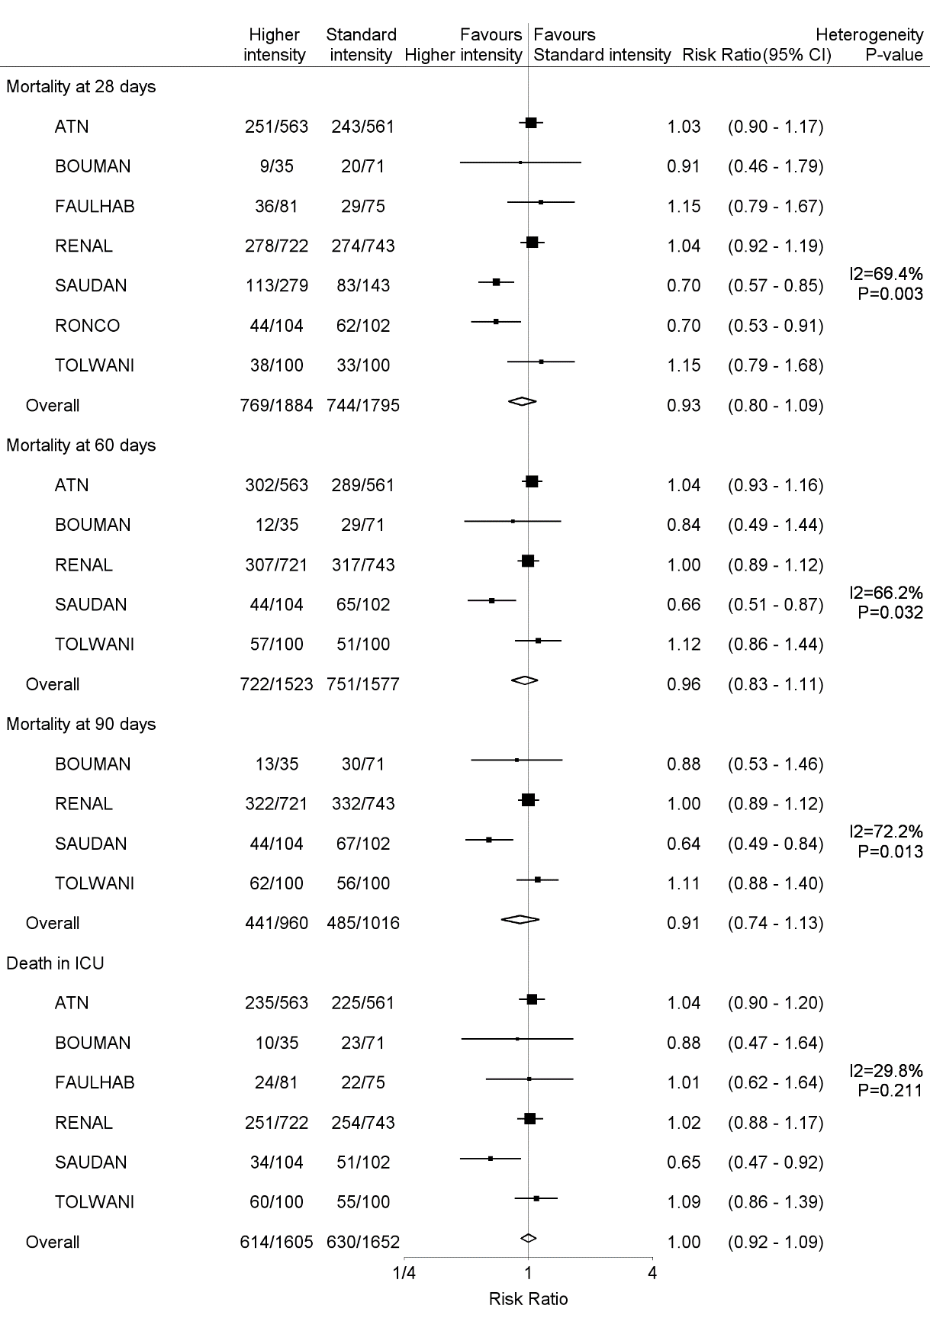

Supplementary Figure 2: Subgroup analysis of mortality at different time points for different subgroups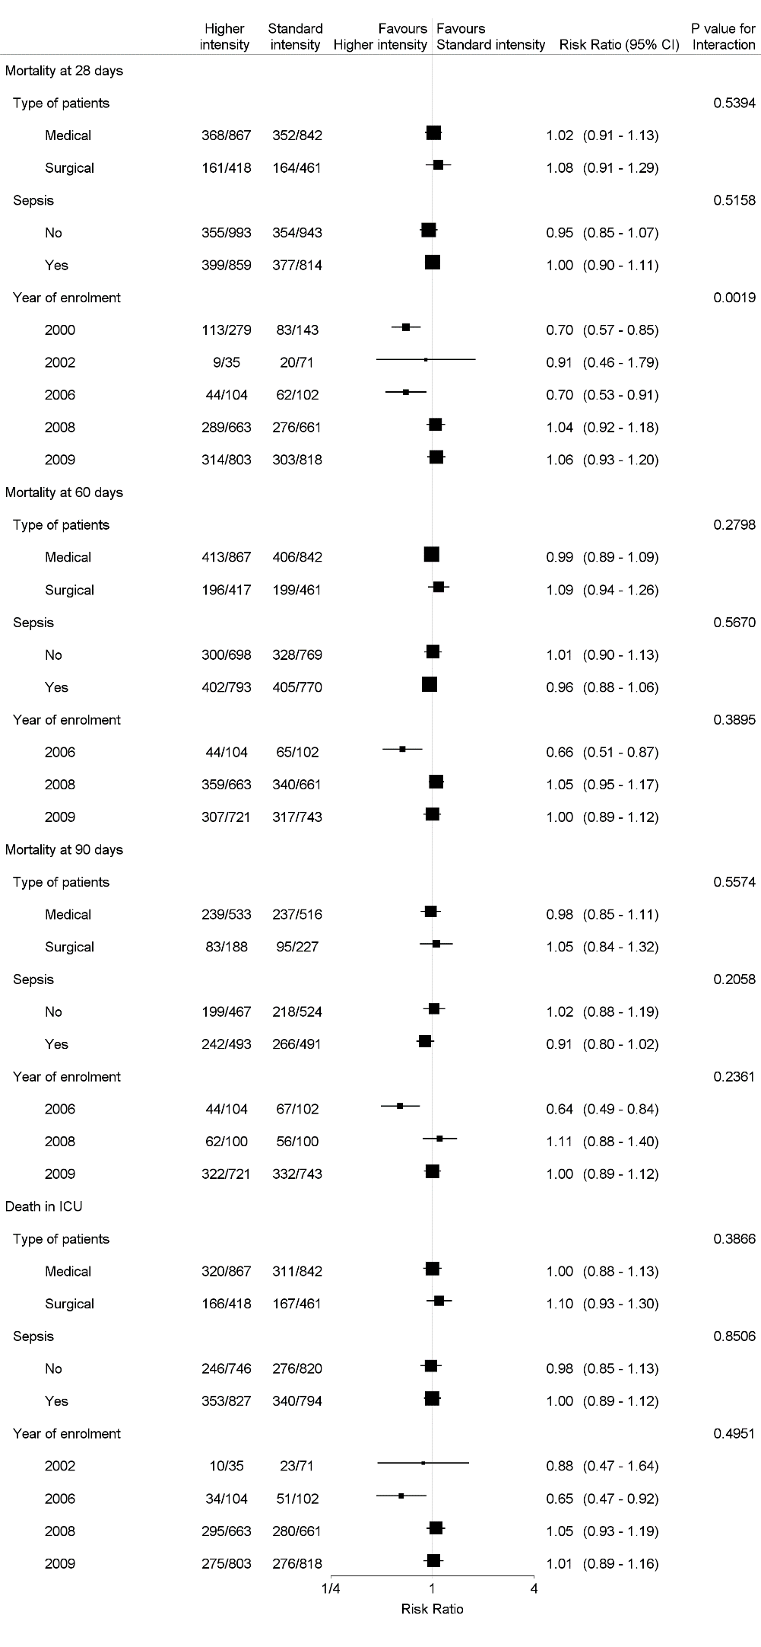
Supplementary Figure 3: Subgroup analysis of Death at 28, 60, 90 days and in ICU adjusted by continuous baseline characteristics (weight and APACHEIII scores)
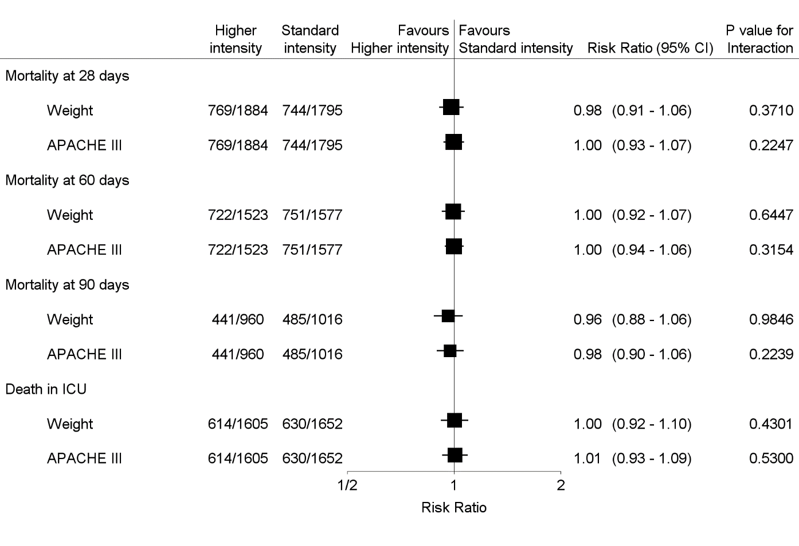

 |  | Supplementary Table 1: Characteristics of design and interventions in included trials
Studies | Summary of trials |  | Number of participants | Primary cause of AKI | Outcome measures
Ronco  et al  2000(1) | Randomised single center study comparing CVVH at 45, 35 and 20ml/kg.hr |  | 425 | Surgery (89%) | Primary outcome: survival at 15 days after discontinuation of treatment. Secondary outcome: the recovery of renal function 15 days after continuous renal replacement therapy had been stopped.
Bouman et al  2002(2) | Randomised 2 centre study comparing CVVH at 48 and 25ml/kg.hr |  | 106 | Cardio-surgery (58%) | Primary outcome: survival at day 28 after inclusion and recovery of renal function. Secondary outcome: ICU survival, hospital survival, duration of mechanical ventilation, length of ICU stay, and length of hospitalization.
Saudan  et al  2006(3) | Randomised single centre study comparing CVVH at 42 and 25ml/kg.hr |  | 206 | Sepsis (60%) | Primary outcome: survival at 28 and 90 days. Secondary outcome: renal recovery (mean duration of ARF) and length of ICU stay.
ATN study  2008(4) | Randomised multi- centre study comparing CVVHDF/IHD/SLED at 36.2 and 21.5ml/kg.hr |  | 1124 | Ischemia (81%) | Primary outcome: death from any cause by day 60. Secondary outcome: in-hospital death and recovery of kidney function (defined as lack of need for continuing dialysis support, with a minimum creatinine clearance of 20 ml per minute).
Tolwani et al 2008(5) | Randomised single centre study comparing CVVHDF at 35 and 20 ml/kg.hr |  | 200 | Sepsis (54%) | Primary outcome: survival to the earlier of either intensive care unit discharge or 30 day. Secondary outcome: renal recovery at ICU discharge, renal recovery at hospital discharge, ICU survival, hospital survival, ICU length of stay, and hospital length of stay.
Faulhaber-Walter  et al  2009(6) | Randomised single centre study comparing IHD at dose to maintain urea levels of 120-150mg/dl and <90mg/dl |  | 156 | SIRS/sepsis (72%) | Primary outcome: survival at day 14 after initiation of renal replacement therapy.  Secondary outcome: survival and renal recovery at day 28 after initiation of renal replacement therapy.
RENAL study  2009(7) | Randomised multi-centre study comparing CVVHDF at 40 and 25ml/kg.hr |  | 1464 | Sepsis (48%) | Primary outcome: death within 90 days after randomization. Secondary outcome: death within 28 days after randomization, death in the ICU, in-hospital death, cessation of renal replacement therapy, duration of ICU and hospital stays, duration of mechanical ventilation and renal replacement therapy, dialysis status at day 90, and any new organ failures.

Supplementary Table 2: Hazard of RRT independence at different time points comparing higher intensity to standard intensity RRT groups, stratified by treatment group (a trial level analysis)

Outcomes | Trial numbers | Pooled estimate
 |  | HR (95% CI) | P value
All trials
Time to end of RRT dependence at day 28 | 4 | 0.91 (0.82 - 1.01) | 0.09
Time to end of RRT dependence at day 60 | 3 | 0.93 (0.84 - 1.03) | 0.18
Time to end of RRT dependence at day 90 | 2 | 0.97 (0.86 – 1.10) | 0.61
IRRT trials*
Time to end of RRT dependence at day 28 | 2 | 0.78 (0.65-0.94) | 0.009
Time to end of RRT dependence at day 60 | 1 | 0.90 (0.75-1.08) | 0.30
CRRT trials#
Time to end of RRT dependence at day 28 | 2 | 0.99 (0.87-1.12) | 0.80
Time to end of RRT dependence at day 60 | 2 | 0.96 (0.85-1.09) | 0.50
Time to end of RRT dependence at day 90 | 2 | 0.97 (0.86-1.10) | 0.60

Supplementary Table 3: Hazard of RRT independence at different time points comparing higher intensity to standard intensity RRT groups, stratified by treatment group (a patient level analysis)

Outcomes | Trial numbers | Pooled estimate
 |  | HR (95% CI) | P value
All trials
Time to end of RRT dependence at day 28 | 4 | 0.91 (0.82 - 1.01) | 0.09
Time to end of RRT dependence at day 60 | 3 | 0.93 (0.84 - 1.03) | 0.18
Time to end of RRT dependence at day 90 | 2 | 0.97 (0.86 – 1.10) | 0.61
IRRT trials*
Time to end of RRT dependence at day 28 | 2 | 0.78 (0.64-0.95) | 0.01
Time to end of RRT dependence at day 60 | 1 | 0.90 (0.75-1.09) | 0.29
CRRT trials#
Time to end of RRT dependence at day 28 | 2 | 0.98 (0.86-1.11) | 0.71
Time to end of RRT dependence at day 60 | 2 | 0.96 (0.85-1.08) | 0.52
Time to end of RRT dependence at day 90 | 2 | 0.97 (0.86-1.10) | 0.61

IRRT = intermittent renal replacement therapy; CRRT = continuous renal replacement therapy; RR = risk ratio; RRT dependence refers to number of patients who were still RRT dependent at the different study point. *Two trials allowed IRRT as part of the protocol including ATN (4) and Faulhaber-Walter trial (6); #Five trials employed CRRT only including Ronco (1), Bouman (2), Saudan (3), Tolwani (5), RENAL (7).
Denominator was all patients alive at each fixed study point.

List of studies used for individual patient data meta-analysis
1. Ronco C, Bellomo R, Homel P, Brendolan A, Dan M, Piccinni P, et al. Effects of different doses in continuous veno-venous haemofiltration on outcomes of acute renal failure: a prospective randomised trial. Lancet. 2000;356(9223):26-30.
2. Bouman CS, Oudemans-Van Straaten HM, Tijssen JG, Zandstra DF, Kesecioglu J. Effects of early high-volume continuous venovenous hemofiltration on survival and recovery of renal function in intensive care patients with acute renal failure: a prospective, randomized trial. Critical care medicine. 2002;30(10):2205-11.
3. Saudan P, Niederberger M, De Seigneux S, Romand J, Pugin J, Perneger T, et al. Adding a dialysis dose to continuous hemofiltration increases survival in patients with acute renal failure. Kidney Int. 2006;70(7):1312-7.
4. VA/NIH Acute Renal Failure Trial Network. Palevsky PM ZJ, O'Connor TZ, Chertow GM, Crowley ST, et al. Intensity of renal support in critically ill patients with acute kidney injury. The New England journal of medicine. 2008;359(1):7-20.
5. Tolwani AJ, Campbell RC, Stofan BS, Lai KR, Oster RA, Wille KM. Standard versus high-dose CVVHDF for ICU-related acute renal failure. Journal of the American Society of Nephrology : JASN. 2008;19(6):1233-8.
6. Faulhaber-Walter R, Hafer C, Jahr N, Vahlbruch J, Hoy L, Haller H, et al. The Hannover Dialysis Outcome study: comparison of standard versus intensified extended dialysis for treatment of patients with acute kidney injury in the intensive care unit. Nephrol Dial Transplant. 2009;24(7):2179-86.
7. RENAL Replacement Therapy Study Investigators. Bellomo R CA, Cole L, Finfer S, Gallagher M, et al. Intensity of continuous renal-replacement therapy in critically ill patients. The New England journal of medicine. 2009;361(17):1627-38.

Supplementary Table 4: All-cause mortality between higher intensity and standard intensity RRT group - time to event analysis
Outcomes | Trial numbers | Higher intensity RRT group | Standard intensity RRT group | Pooled estimate
 |  |  |  | RR (95% CI) | P value
All trials
Mortality at 28 days | 7 | 760/1849 (41.1%) | 724/1724 (42.0%) | 0.95 (0.85 - 1.05) | 0.30
Mortality at 60 days | 5 | 710/1488 (47.7%) | 722/1506 (47.9%) | 0.99 (0.89 - 1.09) | 0.80
Mortality at 90 days | 4 | 428/925 (46.3%) | 455/945 (48.1%) | 0.94 (0.83 - 1.08) | 0.39
Death in ICU | 6 | 580/1489 (39.0%) | 585/1506 (38.8%) | 0.96 (0.83 - 1.12) | 0.63
IRRT trials*
Mortality at 28 days | 2 | 287/644 (44.6%) | 272/636 (42.8%) | 1.04 (0.88 - 1.23) | 0.62
Mortality at 60 days | 1 | 302/563 (53.6%) | 289/561 (51.5%) | 1.05 (0.89 - 1.24) | 0.54
Mortality at 90 days | 0
Death in ICU | 2 | 235/563 (41.7%) | 225/561 (40.1%) | 0.97 (0.84 - 1.12) | 0.68
CRRT trials#
Mortality at 28 days | 5 | 473/1025 (39.3%) | 452/1088 (41.5%) | 0.89 (0.78 - 1.02) | 0.08
Mortality at 60 days | 4 | 408/925 (44.1%) | 433/945 (45.8%) | 0.95 (0.83 - 1.08) | 0.42
Mortality at 90 days | 4 | 428/925 (46.3%) | 455/945 (48.1 %) | 0.94 (0.83 - 1.08) | 0.39
Death in ICU | 4 | 345/926 (37.3%) | 360/945 (38.1%) | 0.96 (0.83 - 1.12) | 0.63
IRRT = intermittent renal replacement therapy; CRRT = continuous renal replacement therapy; RR = risk ratio; RRT dependence refers to number of patients who were still RRT dependent at the different study point. *Two trials allowed IRRT as part of the protocol including ATN (1)and Faulhaber-Walter trial; #Five trials employed CRRT only including Ronco, Bouman, Saudan, Tolwani, RENAL.
1. VA/NIH Acute Renal Failure Trial Network. Palevsky PM ZJ, O'Connor TZ, Chertow GM, Crowley ST, et al. Intensity of renal support in critically ill patients with acute kidney injury. The New England journal of medicine. 2008 Jul 3;359(1):7-20. Pubmed Central PMCID: 2574780.
2. Faulhaber-Walter R, Hafer C, Jahr N, Vahlbruch J, Hoy L, Haller H, et al. The Hannover Dialysis Outcome study: comparison of standard versus intensified extended dialysis for treatment of patients with acute kidney injury in the intensive care unit. Nephrol Dial Transplant. 2009 Jul;24(7):2179-86. PubMed PMID: 19218540.
3. Ronco C, Bellomo R, Homel P, Brendolan A, Dan M, Piccinni P, et al. Effects of different doses in continuous veno-venous haemofiltration on outcomes of acute renal failure: a prospective randomised trial. Lancet. 2000 Jul 1;356(9223):26-30. PubMed PMID: 10892761.
4. Bouman CS, Oudemans-Van Straaten HM, Tijssen JG, Zandstra DF, Kesecioglu J. Effects of early high-volume continuous venovenous hemofiltration on survival and recovery of renal function in intensive care patients with acute renal failure: a prospective, randomized trial. Critical care medicine. 2002 Oct;30(10):2205-11. PubMed PMID: 12394945.
5. Saudan P, Niederberger M, De Seigneux S, Romand J, Pugin J, Perneger T, et al. Adding a dialysis dose to continuous hemofiltration increases survival in patients with acute renal failure. Kidney Int. 2006 Oct;70(7):1312-7. PubMed PMID: 16850022.
6. Tolwani AJ, Campbell RC, Stofan BS, Lai KR, Oster RA, Wille KM. Standard versus high-dose CVVHDF for ICU-related acute renal failure. Journal of the American Society of Nephrology : JASN. 2008 Jun;19(6):1233-8. PubMed PMID: 18337480. Pubmed Central PMCID: 2396940.
7. RENAL Replacement Therapy Study Investigators. Bellomo R CA, Cole L, Finfer S, Gallagher M, et al. Intensity of continuous renal-replacement therapy in critically ill patients. The New England journal of medicine. 2009 Oct 22;361(17):1627-38.

Supplementary Table 5: Time of the end of RRT dependence among the survivors between higher intensity and standard intensity RRT group stratified by treatment group (time to event analysis)
Outcomes | Trial numbers | Higher intensity RRT | Standard intensity RRT | Pooled estimate
 |  |  |  | RR (95% CI) | P value
All trials
RRT independence by day 28 | 6 | 687/977 (70.3%) | 706/938 (75.3%) | 0.89 (0.80 – 0.99) | 0.03
RRT independence by day 60 | 4 | 625/734 (85.1%) | 647/744 (87.0%) | 0.96 (0.86 - 1.07) | 0.49
RRT independence by day 90 | 2 | 416/459 (90.6%) | 417/446 (93.5%) | 0.94 (0.82 – 1.07) | 0.34
IRRT trials*
RRT independence by day 28 | 2 | 197/346 (56.9%) | 227/357 (63.6%) | 0.87 (0.72-1.05) | 0.15
RRT independence by day 60 | 1 | 188/244 (77.0%) | 202/260 (77.7%) | 0.97 (0.79-1.18) | 0.75
CRRT trials#
RRT independence by day 28 | 4 | 490/631 (77.7%) | 479/581 (82.4%) | 0.87 (0.77-0.99) | 0.04
RRT independence by day 60 | 3 | 437/490(89.2%) | 445/484(91.9%) | 0.94 (0.83 -1.08) | 0.40
RRT independence by day 90 | 2 | 416/459 (90.6%) | 417/446 (93.5%) | 0.94 (0.82 – 1.07) | 0.34

IRRT = intermittent renal replacement therapy; CRRT = continuous renal replacement therapy; RR = risk ratio; RRT dependence refers to number of patients who were still RRT dependent at the different study point. *Two trials allowed IRRT as part of the protocol including ATN (1) and Faulhaber-Walter trial (2); #Five trials employed CRRT only including Ronco (3), Bouman (4), Saudan (5), Tolwani (6), RENAL (7).
Denominator included all patients who were alive at that fixed study point.
List of studies used for individual patient data meta-analysis
1. VA/NIH Acute Renal Failure Trial Network. Palevsky PM ZJ, O'Connor TZ, Chertow GM, Crowley ST, et al. Intensity of renal support in critically ill patients with acute kidney injury. The New England journal of medicine. 2008;359(1):7-20.
2. Faulhaber-Walter R, Hafer C, Jahr N, Vahlbruch J, Hoy L, Haller H, et al. The Hannover Dialysis Outcome study: comparison of standard versus intensified extended dialysis for treatment of patients with acute kidney injury in the intensive care unit. Nephrol Dial Transplant. 2009;24(7):2179-86.
3. Ronco C, Bellomo R, Homel P, Brendolan A, Dan M, Piccinni P, et al. Effects of different doses in continuous veno-venous haemofiltration on outcomes of acute renal failure: a prospective randomised trial. Lancet. 2000;356(9223):26-30.
4. Bouman CS, Oudemans-Van Straaten HM, Tijssen JG, Zandstra DF, Kesecioglu J. Effects of early high-volume continuous venovenous hemofiltration on survival and recovery of renal function in intensive care patients with acute renal failure: a prospective, randomized trial. Critical care medicine. 2002;30(10):2205-11.
5. Saudan P, Niederberger M, De Seigneux S, Romand J, Pugin J, Perneger T, et al. Adding a dialysis dose to continuous hemofiltration increases survival in patients with acute renal failure. Kidney Int. 2006;70(7):1312-7.
6. Tolwani AJ, Campbell RC, Stofan BS, Lai KR, Oster RA, Wille KM. Standard versus high-dose CVVHDF for ICU-related acute renal failure. Journal of the American Society of Nephrology : JASN. 2008;19(6):1233-8.
7. RENAL Replacement Therapy Study Investigators. Bellomo R CA, Cole L, Finfer S, Gallagher M, et al. Intensity of continuous renal-replacement therapy in critically ill patients. The New England journal of medicine. 2009;361(17):1627-38.

Supplementary Table 6: All-cause mortality between higher intensity and standard intensity IRRT group
Outcomes | Trial numbers | Higher intensity RRT group | Standard intensity RRT group | Pooled estimate
 |  |  |  | RR (95% CI) | P value
ATN trial
Mortality at 28 days | 1 | 251/563 (44.6%) | 243/561 (43.3%) | 1.03 (0.90 - 1.17) | 0.41
Mortality at 60 days | 1 | 302/563 (53.6%) | 289/561 (51.5%) | 1.04 (0.93 - 1.16) | 0.48
Mortality at 90 days | 0
Death in ICU | 1 | 235/563 (41.7%) | 247/636 (38.8%) | 1.04 (0.90 - 1.20) | 0.58
HANNOVER trial
Mortality at 28 days | 1 | 36/81 (44.4%) | 29/75 (38.7%) | 1.15 (0.79 - 1.67) | 0.47
Mortality at 60 days | 0
Mortality at 90 days | 0
Death in ICU | 1 | 24/81 (29.6%) | 22/75 (29.3%) | 1.01 (0.62 - 1.64) | 0.97

Supplementary Table 7: Proportion of RRT dependence among survivals between higher intensity and standard intensity IRRT group (Fixed effect model)
Outcomes | Trial numbers | Higher intensity RRT | Standard intensity RRT | Pooled estimate
 |  |  |  | RR (95% CI) | P value
ATN trial
RRT dependence at day 28 | 1 | 132/305 (43.3%) | 116/316 (36.7%) | 1.18 (0.97-1.43) | 0.10
RRT dependence at day 60 | 1 | 56/245 (22.9%) | 60/263 (22.8%) | 1.00 (0.73-1.38) | 0.99
HANNOVER trial
RRT dependence at day 28 | 1 | 19/45 (42.2%) | 17/46 (37.0%) | 1.14 (0.69-1.90) | 0.61

Supplementary Figure 4: Violin plot for RRT independence
Violin plot for RRT independence at day 28:

Violin Plot of time to stop RRT by treatment
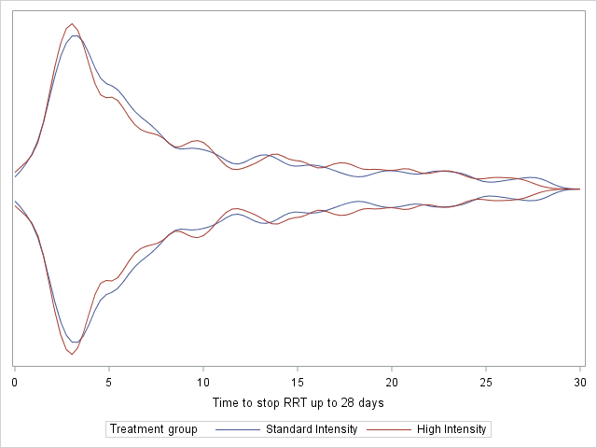

Violin plot for RRT independence at day 60:
Violin Plot of time to stop RRT by treatment
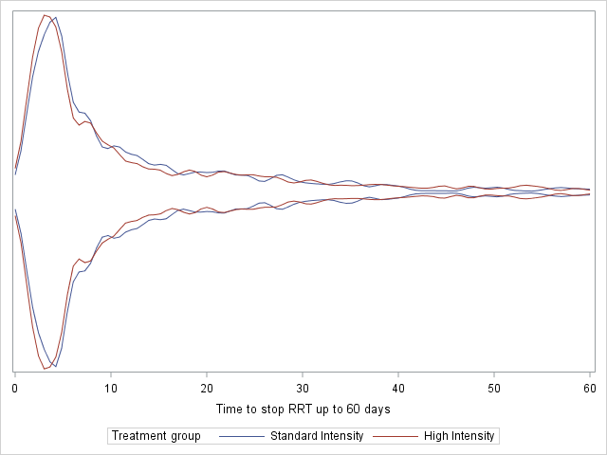

Violin plot for RRT independence at day 90:
Violin Plot of time to stop RRT by treatment
