SUPPLEMENTARY FILE
Urine TNF-α and IL-9 for Prognosis of Human Acute Interstitial Nephritis
Moledina et. al.
Contents
Supplementary Table 1. Association of biomarkers with 6-month estimated glomerular filtration rate after AIN 2
Supplementary Table 2. Association of corticosteroid use with 6-month estimated glomerular filtration rate in various subgroups 3
Supplementary Table 3. Association of baseline characteristics with change in eGFR from diagnosis to 6-month follow-up 4
Supplementary Figure 1. STARD flow diagram 6

Supplementary Table 1. Association of biomarkers with 6-month estimated glomerular filtration rate after AIN
Biomarker |  | 6m-eGFR
 |  | Model1 | Model2 | Model3
Interleukin-9 | Overall | -2.7 (-16.9, 11.5) | 0.6 (-11.1, 12.2) | -2.1 (-13.4, 9.1)
 | No steroids | -27.9 (-37.7, -18.2) | -25.3 (-37.6, -13.1) | -25.9 (-51.3, -0.4)
 | Steroids | 2.8 (-13.6, 19.1) | 6.0 (-7.0, 19.0) | 2.4 (-9.7, 14.5)
TNF-a | Overall | -7.6 (-21.6, 6.5) | -2.0 (-13.9, 9.8) | -2.0 (-13.3, 9.4)
 | No steroids | -20.7 (-40.5, -1.0) | -17.7 (-48.7, 13.3) | -23.4 (-78.3, 31.5)
 | Steroids | -5.1 (-21.3, 11.2) | -0.1 (-13.4, 13.2) | -1.4 (-13.4, 10.7)

Model 1: Univariable. Model 2: Controls for baseline estimated glomerular filtration rate and albuminuria. Model 3: Model 2+ interstitial fibrosis and interstitial infiltrate.

Supplementary Table 2. Association of corticosteroid use with 6-month estimated glomerular filtration rate in various subgroups
Characteristic | Cut-off | 6m-eGFR (95% CI) | P value | Interaction  P value
Urine biomarkers
IL-9, urine |  |  |  | 0.07
 | ≤0.66 | -6.7 (-31.2, 17.8) | 0.58
 | >0.66 | 20.9 (0.2, 41.6) | 0.05
TNF-α, urine |  |  |  | 0.50
 | ≤1.82 | 6.6 (-18.8, 32.0) | 0.59
 | >1.82 | 13.1 (-8.1, 34.3) | 0.21
Histology features
Infiltrate |  |  |  | 0.18
 | <25% | -1.3 (-36.2, 33.7) | 0.94 | .
 | >25% | 17.3 (-0.6, 35.1) | 0.06
IFTA |  |  | . | 0.06
 | <25% | 28.6 (-15.5, 72.6) | 0.18 | .
 | >25% | 2.6 (-12.5, 17.8) | 0.73
ATI |  |  |  | 0.68
 | <25% | 15.8 (4.3, 27.2) | 0.01 | .
 | >25% | 4.5 (-16.3, 25.2) | 0.66
Eosinophils |  |  |  | 0.93
 | <5/HPF | 10.9 (-5.0, 26.9) | 0.17 | .
 | >5/HPF | 7.7 (-31.3, 46.7) | 0.68
Tubulitis |  |  |  | 0.87
 | <5/tubule | 10.7 (-8.8, 30.2) | 0.28 | .
 | >5/tubule | 4.3 (-20.9, 29.6) | 0.66
Other markers
Eosinophil, Blood |  |  |  | 0.61
 | <224.0 | 8.4 (-8.9, 25.8) | 0.32 | .
 | >228.0 | 16.5 (-14.4, 47.4) | 0.28
Creatinine, serum |  |  |  | 0.84
 | <3.8 | 13.1 (-14.1, 40.4) | 0.33 | .
 | >3.8 | 10.8 (-6.4, 28.1) | 0.21
GFR, pre-biopsy |  |  |  | 0.10
 | <45 | 0.1 (-17.9, 18.0) | 0.99 | .
 | >45 | 30.3 (-1.4, 62.0) | 0.06
Albuminuria |  |  |  | 0.79
 | <0.2 | 7.5 (-16.4, 31.3) | 0.52 | .
 | >0.2 | 9.5 (-12.1, 31.1) | 0.37

Linear regression analysis for outcome of 6-month eGFR and predictor as corticosteroid use in various subgroups. Controls for baseline eGFR and albuminuria. eGFR, estimated glomerular filtration rate; IFTA, interstitial fibrosis and tubular atrophy.

Supplementary Table 3. Association of baseline characteristics with change in eGFR from diagnosis to 6-month follow-up
Characteristic | Model 1 | Model 2
Demographics and comorbidities
Age, per year | 2.2 (-2.1, 6.5) | 0.9 (-3.5, 5.3)
Female | -2.4 (-15.3, 10.6) | 2.5 (-9.3, 14.3)
Black race | -7.8 (-22.9, 7.3) | -1.1 (-15.1, 12.9)
Diabetes | -13.5 (-27.2, 0.1) | -10.0 (-22.5, 2.5)
Hypertension | -18.2 (-32.6, -3.9) | -17.3 (-31.9, -2.8)
CKD | -11.7 (-27.1, 3.7) | 11.5 (-10.5, 33.4)
Inpatient | 17.0 (2.9, 31.0) | 15.5 (3.0, 27.9)
AKI Stage | 10.8 (1.5, 20.1) | 8.4 (-0.1, 17.0)
Dialysis | 25.2 (-1.6, 52.0) | 23.9 (0.3, 47.5)
Baseline Features
Serum creatinine, per mg/dl change | -2.1 (-6.1, 1.8) | 2.2 (-2.3, 6.7)
Estimated GFR, per ml/min change | 0.3 (0.1, 0.6) | 0.3 (0.1, 0.5)
Albuminuria, per mg/mg change | -5.7 (-9.8, -1.6) | -4.3 (-8.3, -0.2)
Features at Biopsy
Serum creatinine, per mg/dl change | 0.2 (-2.1, 2.6) | 2.1 (0.0, 4.3)
Estimated GFR, per ml/min change | 0.0 (-0.5, 0.5) | -0.5 (-0.9, 0.0)
Blood urea nitrogen, per mg/dl | -0.1 (-0.3, 0.1) | 0.0 (-0.2, 0.2)
Hemoglobin, per g/dl | -2.4 (-5.8, 1.0) | -1.6 (-4.6, 1.5)
Platelet count, per 1000/mm³ | 0.0 (-0.1, 0.1) | 0.0 (-0.1, 0.1)
Eosinophil count, per 100/mm³ | 1.1 (0.0, 2.1) | 1.0 (0.0, 1.9)
AIN management
Drug-induced AIN | 17.6 (5.6, 29.6) | 14.1 (2.3, 25.9)
Days of drug exposure* | -8.3 (-14.5, -2.2) | -7.9 (-13.7, -2.0)
Days from AKI to drug withdrawal* | -5.8 (-12.3, 0.6) | -7.9 (-13.5, -2.2)
Days from biopsy to drug withdrawal* | -3.5 (-12.1, 5.1) | -1.1 (-10.2, 8.0)
Corticosteroid therapy | 16.4 (-0.7, 33.6) | 16.2 (1.0, 31.4)
Days from loss of kidney function to steroid therapy# | -5.5 (-10.6, -0.5) | -5.2 (-9.3, -1.1)
Days from biopsy to steroid therapy, per doubling# | -5.7 (-12.6, 1.2) | -5.6 (-11.0, -0.2)
Number of days of steroid therapy, per doubling# | 2.8 (-3.0, 8.6) | 3.8 (-1.2, 8.8)
Route of first steroid dose (IV vs. PO)# | 19.3 (2.9, 35.7) | 15.8 (1.1, 30.5)
Corticosteroid dose, per doubling | 0.1 (-0.2, 0.4) | 0.1 (-0.1, 0.4)
Days from AKI to biopsy | -4.7 (-9.3, -0.2) | -5.1 (-9.4, -0.9)
Histological Features
Infiltrate
<25% | Ref. | Ref.
26-50% | 14.5 (-1.3, 30.3) | 15.2 (1.3, 29.1)
>50% | 17.4 (1.8, 33.0) | 15.5 (1.6, 29.4)
Eosinophils
None | Ref. | Ref.
1-5/HPF | -4.6 (-23.6, 14.3) | -1.0 (-18.1, 16.1)
>5/HPF | 1.3 (-16.8, 19.5) | 3.4 (-12.7, 19.6)
IFTA | -4.4 (-7.1, -1.6) | -2.6 (-5.7, 0.5)
Interstitial fibrosis
<25% | Ref. | Ref.
26-50% | -23.4 (-37.5, -9.3) | -17.1 (-32.5, -1.6)
>50% | -30.1 (-44.5, -15.6) | -21.2 (-38.3, -4.2)
Tubulitis, >5 cells/HPF (vs. 0-5 cells/HPF) | 0.0 (-17.8, 17.8) | -5.2 (-21.1, 10.7)
ATI
<25% | Ref. | Ref.
26-50% | 8.3 (-9.2, 25.9) | 9.0 (-6.3, 24.3)
>50% | 11.8 (-5.1, 28.7) | 16.3 (1.2, 31.3)
Glomerulosclerosis, per 10% increase | -3.6 (-5.5, -1.7) | -2.0 (-4.4, 0.5)
Biomarkers
IL-9
Per doubling | 0.9 (-2.0, 3.9) | 2.1 (-0.7, 4.8)
T2 vs. T1 | 6.9 (-6.1, 20.0) | 9.1 (-2.9, 21.1)
TNF-α
Per doubling | 0.5 (-1.6, 2.6) | 1.3 (-0.7, 3.3)
T2 vs. T1 | 3.2 (-10.0, 16.4) | 7.6 (-4.8, 20.0)
Biomarkers by steroid use
IL-9 (T2 vs. T1)
No steroids | 0.16 (-16.0, 16.3) | 2.2 (-19.3, 23.7)
Steroids | 9.7 (-5.2, 24.6) | 11.8 (-1.6, 25.3)
TNF-α (T2 vs. T1)
No steroids | 5.5 (-9.2, 20.2) | 8.1 (-12.0, 28.2)
Steroids | 2.9 (-12.3, 18.0) | 7.0 (-6.9, 21.0)
Change in eGFR calculated as difference in eGFR from diagnosis of AIN to 6m after AIN.
Model 1: Univariable. Model 2: Controls for baseline eGFR and albuminuria.
Beta-coefficient indicates 6-month eGFR per doubling (per log2 change) or presence of predictor (present vs. absent). eGFR, estimated glomerular filtration rate; AKI, acute kidney injury; CKD, chronic kidney disease

Supplementary Figure 1. STARD flow diagram
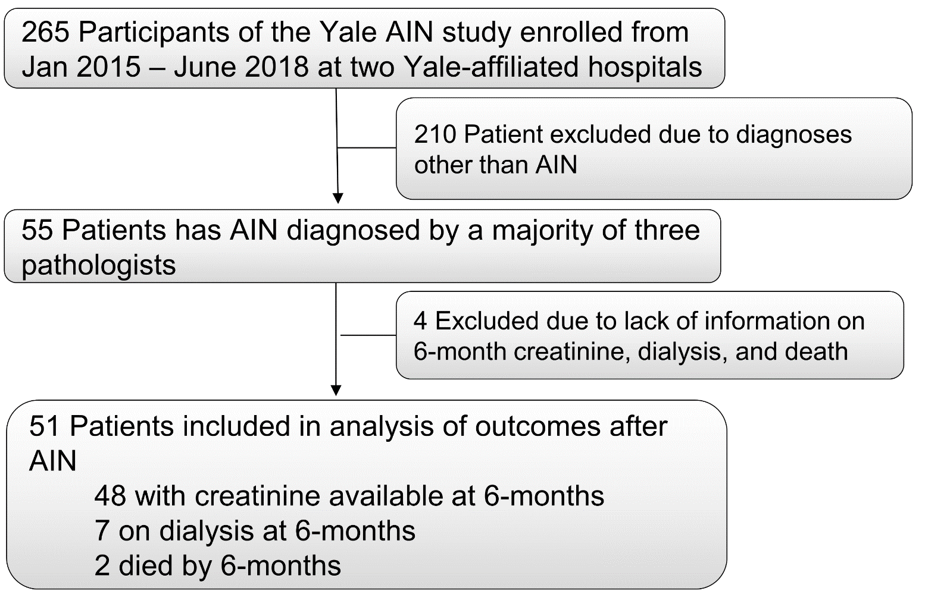
3-9 month window for creatinine. eGFR imputed as 5 ml/min for those on dialysis. For deaths, last creatinine/eGFR carried forward.

Supplementary Figure 2. Predicted change in estimated glomerular filtration rate in groups with or without corticosteroid use stratified by urine biomarker level

