Supplementary Data
Technological Innovations at the Onset of the Mid-Pleistocene Climate Transition in High-Latitude East Asia
Shi-Xia Yang^{1,2,3*}, Fa-Gang Wang⁴, Fei Xie⁴, Jian-Ping Yue⁵, Cheng-Long Deng^{6,7}, Ri-Xiang Zhu^{6,7}, Michael D. Petraglia^{3,8,9*}
1. Key Laboratory of Vertebrate Evolution and Human Origins of Chinese Academy of Sciences, Institute of Vertebrate Paleontology and Paleoanthropology, Chinese Academy of Sciences, Beijing 100044, China
2. Center for Excellence in Life and Paleoenvironment, Chinese Academy of Sciences, Beijing 100044, China
3. Department of Archaeology, Max Planck Institute for the Science of Human History, Jena 07745, Germany
4. Hebei Provincial Institute of Cultural Relics, Shijiazhuang 050031, China
5. Department of History, Anhui University, Hefei 230039, China
6. State Key Laboratory of Lithospheric Evolution, Institute of Geology and Geophysics, Chinese Academy of Sciences, Beijing 100029, China
7. College of Earth and Planetary Sciences, University of Chinese Academy of Sciences, Beijing 100049, China
8. Human Origins Program, National Museum of Natural History, Smithsonian Institution, Washington, D.C. 20560, USA
9. School of Social Science, The University of Queensland, Brisbane, Queensland 4072, Australia

Contents
Supplementary Notes 3
Supplementary Note 1. The Nihewan Basin and surrounding area 3
Supplementary Note 2. Samples and data collection 4
Supplementary Note 3. Refitting analysis 5
Supplementary Note 4. Dating results of Xiaochangliang and Donggutuo 6
Supplementary Note 5. Timing of the Mid-Pleistocene transition (MPT) 7

Supplementary Tables 9
Supplementary Table 1. Lithic assemblage components and refitting information from Cenjiawan 9
Supplementary Table 2. Overall count of refitting groups from Cenjiawan 9
Supplementary Table 3. Flaking direction among the refitted groups from Cenjiawan 10
Supplementary Table 4. Lithic assemblage components from Xiaochangliang (XCL), Donggutuo (DGT) and Cenjiawan (CJW) 10
Supplementary Table 5. The dimensions of cores (mm) of the Xiaochangliang (XCL), Donggutuo (DGT) and Cenjiawan (CJW) 11
Supplementary Table 6 Statistical tests results of the cores’ maximum length from Xiaochangliang (XCL), Cenjiawan(CJW) and Donggutuo(DGT) 11
Supplementary Table 7. Tool types from Xiaochangliang (XCL), Donggutuo (DGT) and Cenjiawan (CJW) 11
Supplementary Table 8. Dating estimates and endocranial capacity of fossil hominins from China 12
Supplementary Figures 13
Supplementary Figure 1. The lacustrine deposits in the Nihewan Basin of North China 13
Supplementary Figure 2. Conjoined pieces at Cenjiawan 13
Supplementary Figure 3. Examples of simple refitting groups among flakes at Cenjiawan. 14
Supplementary Figure 4. A well-defined refitting group including a finely retouched tool from Cenjiawan 14
Supplementary Figure 5. Cores sizes from Xiaochangliang(XCL), Donggutuo (DGT) and Cenjiawan(CJW) (in mm) 15
Supplementary Figure 6. Tool types with diagnostic characteristics 15
Supplementary Figure 7. Representative tool types from Xiaochangliang (XCL), Donggutuo (DGT) and Cenjiawan (CJW). 16
Supplementary Figure 8. The plan and profile of some refitting groups at Cenjiawan 16
Supplementary References 17

Supplementary Notes

Note 1. The Nihewan Basin and surrounding area
The Nihewan Basin is located at the northeastern edge of the Loess Plateau and at the transition zone between the North China Plain and the Inner Mongolia Plateau (Figure 1). The basin contains up to 150 m of exposed deposits that accumulated in and around a weak to semi-saline palaeolake (Figure 1 and Supplementary Figure 1) [1], dating from the Late Pliocene [2-4] to the Middle Pleistocene, at ca. 420−260 ka [5-6], when the water body finally dried up.
There is no long, high-resolution record concerning changes in flora and fauna of the basin. In order to understand the ecological background of the Nihewan Basin over the long term, it is necessary to consult the geological and paleoenvironmental record of the surrounding region. A key, recent study of a drill core placed in the North China Plain revealed a long sequence of changes in paleovegetation patterns, which was compared against changes in large mammal communities [7]. This study illustrated climatic fluctuations during the Mid-Pleistocene climate transition (MPT) and linkages with ecosystems. Before 1.2 Ma, vegetation was mainly composed of alternating warm temperate forests and temperate forests; after 1.2 Ma, vegetation was mainly characterized by alternations in forests and grasslands [7]. The Mu Us Desert to the west of the Nihewan Basin also shows an episode of the expansion at about 1.2 Ma, and intensified aridification after 0.7 Ma [8-9]. Up to the onset of the Late Pleistocene, the region is characterized by a warm coniferous-broadleaved mixed forest with woody-grassland, as well as an increase in the extent of wetlands [7]. Pollen studies of the Nihewan Basin from key sections indicate that a relatively dry and cold desert grassland environment was present early on, as shown in the Nangou section from 2.5 to 2.0 Ma [10]. A well-developed forest was present until the transition to the MPT, with pollen evidence indicating the existence of subtropical plants, such as Sapindaceae, Hymenophyllum sm., and Lyodium sw. [11]. During the MPT, at ca. 1.2-1.0 Ma, a stepwise intensification of aridification is recorded by the presence of grasses and herbs at Donggutuo [11-13]. The limited information available from the Nihewan Basin is generally consistent with the sequences established in the North China Plain.
For Figure 4, we gathered paleoclimatic and ecological information in and around the Nihewan Basin, including the benthic isotope data from ODP Site 1143 of the South China Sea and the pollen data of the drilling core from the North China Plain. Figure 4 illustrates the environmental background, assisting in interpretations about the context of changes in stone tool knapping through time.

Note 2. Samples and data collection
Xiaochangliang, Donggutuo and Cenjiawan are key Early Pleistocene sites in the Nihewan Basin, and include ca. 5,000 lithic artefacts (Supplementary Table 4). Xiaochangliang (40º13'10"N, 114º39'44"E) was discovered in 1978 and later dated to ca. 1.36 Ma by magnetostratigraphy. In the current study, a total of 1184 lithic artefacts were included in the analyses. Donggutuo (40º13'22"N, 114º40'11"E) is situated in the eastern margin of the Nihewan Basin and was identified in 1981. The Donggutuo cultural layers date to ca. 1.1 Ma by magnetostratigraphy. In the current study, 2315 pieces artefacts were included in the analyses. Cenjiawan (40º13'21"N, 114º40'17"E) was identified in 1984, and dated to ca. 1.1 Ma by magnetostratigraphy. In the current study, 1383 artefacts were analyzed. The lithic artefacts from the three sites have been systematically studied and compared using the same methods, making it possible to have a comprehensive understanding of inter-assemblage lithic variability through the creation of a single comparative database.
The key attributes of the main classes of artefacts, i.e., cores, flakes, and shaped tools, have been compared in each of the Nihewan lithic assemblages. The classification systems used in East African Oldowan assemblages has been followed [14-18], while taking the characteristics of the Nihewan lithic assemblages and raw materials into account. The Xiaochangliang, Donggutuo and Cenjiawan sites contain retouched tools which are significance for learning about tool use and the skills of early hominins. Several attributes (e.g., size charateristics of retouched pieces; blank retouch types; tool types; the average maximum retouch extent and the average maximum retouch depth) were taken into account for inter-site comparison.

Note 3. Refitting study
The Cenjiawan site, with a relative high refitting rate of stone artefacts (33.4 %, or 462 pieces of 1383 artefacts), was selected in order to conduct a study of stone tool knapping skills and to assess the cognitive ability of early humans. Previous refitting studies [19-22] provided important background information on knapping sequences. Most of the refitting groups are from an area of 5m², including the excavation of units M, N, O, P and Q (each unit is 1mx1m). The maximum distance in vertical depth of refits is ca. 16 cm (Supplementary Figure 5).
In describing the refitting artefact sets, we follow Cziesla [23] in distinguishing between refits and conjoins. Refits are sets of artefacts split from each other by controlled fracture (e.g., a flake whose ventral side joins to the surface of a core or the dorsal surface of another flake). Conjoins are fragments of formerly whole artefacts broken by forces other than conchoidal fracture (i.e., natural flaws, bending fractures). The most common form of conjoins are distal and proximal fragments of the same flake, or the left and the right fragments of the same flake. In our study, we checked the previously refit artefacts and obtained 105 refitted groups and 41 conjoined groups. To reconstruct knapping sequences, we used the refitted group data, examining the type of the exploitation methods that the prehistoric knappers employed.

Note 4. Dating results of Xiaochangliang and Donggutuo
Magnetostratigraphic dating of the fluvio-lacustrine sequence in the Nihewan Basin has been a significant undertaking, permitting evaluation of the timing of basin infilling and dating of associated mammalian faunas and archaeological sites [2,24-25]. Magnetostratigraphic dating of long stratigraphic sequences requires assumptions about sedimentation rates, hence anchoring of age estimates are always best achieved through the application of multiple chronometric methods. Though debated and subject to change, overall, magnetochronological findings indicate that the earliest archeological sites of the fluvio-lacustrine Nihewan Beds date from the post-Olduvai Matuyama chron (~1.66 Ma for MJG-III) to the middle Brunhes chron (ca. 395 ka for Hougou) [26].
The site of Xiaochangliang has four estimated ages. In the current study, we cited the result of 1.36 Ma by Zhu et al. (2001) [25]. Here we summarise other age estimates and their potential problems:
- The age of 1.48 Ma is from Ao et al. (2010) [27] was obtained through stratigraphic correlation between the Dachangliang (also named Xiantai) section and the Xiaochangliang section. Thus, the age estimate of 1.48 Ma for the Xiaochangliang section is obtained indirectly.
- The age estimate of 1.26 Ma was obtained on the basis of sedimentological comparisons and sediment grain size distributions from the Xiaodukou and Xiaochangliang sections [28]. In Li et al.’s paper [28], magnetostratigraphic studies were carried out on the Xiaodukou and Donggutuo sections, not on the Xiaochangliang section. Therefore, the age of 1.26 Ma is an indirect age estimate.
- The age of 1.67 Ma was obtained based on the presence of certain types of mammalian fauna, as well as unpublished information about the magnetostratigraphy, informally provided by other scientists [29]. According to palaeomagnetic results obtained using cryogenic magnetometers, e.g., Zhu et al. (2001) [25] and Li et al. (2008) [28], the Xiaochangliang cultural layer is not located just above the Olduvai normal subchron. Thus, its age should be significantly younger than the age of the upper boundary of Olduvai (1.77 Ma).

Taking into account the above-mentioned age estimates for the Xiaochangliang site, a range from 1.67 Ma to 1.26 Ma has been suggested [28-29]. However, we maintain that the age of 1.36 Ma obtained by Zhu et al. (2001) is the best age estimate for the Xiaochangliang site, and fits well in the synthetic diagram from well-dated sections in the Nihewan Basin [25].

Magnetostratigraphic dating of the Donggutuo cultural layers has been conducted by several scholars since 1980s’ [30-32], and these dating projects have obtained similar results. According to the latest dating work [28,32], the age of the Donggutuo cultural layer is prior to the onset of Jaramillo normal subchron, which has been dated at 1.053±0.006 Ma [33] or 1.072 Ma [34]. The detailed magnetostratigraphic work by Wang et al. (2005) described the short interval with a possible geomagnetic excursion (E3) within the pre-Jaramillo Matuyama reverse chron (and also within the Donggutuo artifact layer) [32]; this may be correlated to the Punaruu normal geomagnetic excursion, which has an ⁴⁰Ar/³⁹Ar age determination of 1.105 ± 0.005 Ma [33]. This lends further support to the contention that the Donggutuo Palaeolithic site has an age of about 1.1 Ma [32].

Note 5. Timing of the Mid-Pleistocene climate transition (MPT)
Milanković’s theory suggested that orbitally induced summer insolation change at high-latitude region of the Northern Hemisphere played a key role in driving the ice cycles during the Pleistocene [35]. A significant shift occurred around the end of Early Pleistocene, and afterward into the Middle Pleistocene, with the length and intensity of the glacial-interglacial cycles significantly increasing, and with the dominant periodicity of high-latitude climate oscillations changing from 41 kye to 100 kyr. These significant changes in climate is named the mid-Pleistocene climate transition (MPT). Since its first recognition by Pisias and Moore (1981) [36], there have been extensive discussions about timing, duration, and mechanisms [37-43].
The timing of MPT is of importance when discussing the topic on human evolution. The MPT began at about 1.25 Ma [39] or about 1−0.8 Ma [44-47] and terminated at about 0.7–0.6 Ma [46-47]. Correlation between the grain size records of Chinese loess-paleosol sequence and the marine oxygen isotope records revealed a change in the dominant climatic periodicity from 41 kyr to 100 kyr at about 1–0.8 Ma [44].

Supplementary Tables
Supplementary Table 1. Lithic assemblage components and refitting information from Cenjiawan
Category | Current study | % | refitted | % refitted
Core (Freehand) | 61 | 3.78 | 25 | 40.98
Flake (Freehand) | 282 | 17.45 | 119 | 42.20
Flake fragment | 324 | 20.05 | 73 | 22.53
Bipolar Core and splinter | 18 | 1.11 | 2 | 11.11
Retouched pieces | 54 | 3.34 | 16 | 29.63
Shatter | 681 | 42.14 | 81 | 13.11
Angular fragment | 173 | 10.71 | 95 | 54.91
Pebble/unmodified pieces | 23 | 1.42 | - | -
TOTAL | 1616 | 100 | 411 | 25.43

Supplementary Table 2. Overall count of refitting groups from Cenjiawan
No. of pieces per refitting group | No. of refitting groups | Total
2 | 42 | 84
3 | 21 | 63
4 | 13 | 52
5 | 9 | 45
6 | 8 | 48
7 | 4 | 28
8 | 1 | 8
9 | 3 | 27
10 | 2 | 20
11 | 1 | 11
25 | 1 | 25
-- | 105 | 411

Supplementary Table 3. Flaking direction among the refitted groups from Cenjiawan
The direction no. | No. of groups | % of the refitted group
One direction | 66 | 62.86
Two directions | 25 | 23.81
Three directions | 11 | 10.48
Four directions | 3 | 2.86
TOTAL | 105 | 100

Supplementary Table 4. Lithic assemblage components from Xiaochangliang (XCL), Donggutuo (DGT) and Cenjiawan (CJW)
Lithic class | XCL | % | DGT | % | CJW | %
Core (Freehand) | 43 | 3.63 | 245 | 10.58 | 61 | 3.78
Flake (Freehand) | 160 | 13.51 | 380 | 16.41 | 282 | 17.45
Flake fragment | 129 | 10.90 | 300 | 12.96 | 324 | 20.05
Bipolar Core and splinter | 439 | 37.08 | 269 | 11.62 | 18 | 1.11
Retouched pieces | 45 | 3.80 | 228 | 9.85 | 54 | 3.34
Shatter | 292 | 24.66 | 558 | 24.11 | 681 | 42.14
Angular fragment | 76 | 6.42 | 335 | 14.47 | 173 | 10.71
Pebble/ unmodified pieces | -- | -- | -- | -- | 23 | 1.42
TOTAL | 1184 | 100 | 2315 | 100 | 1616 | 100

Supplementary Table 5. Cores from Xiaochangliang (XCL), Donggutuo (DGT) and Cenjiawan (CJW) (in mm).
 | Length |  | Width |  | Thickness
 | Mean | Std.D | Mean | Std.D | Mean | Std.D
XCL | 52.7 | 28.8 | 47.7 | 23.9 | 35.2 | 19.2
DGT | 37.80 | 16.43 | 49.53 | 20.29 | 36.18 | 19.97
CJW | 33.07 | 13.9 | 40.44 | 23.04 | 29.74 | 33.1

Supplementary Table 6. Statistical tests results of the cores’ maximum length from Xiaochangliang (XCL), Cenjiawan(CJW) and Donggutuo(DGT)

The compared pair | Student's t test results (P value) | Mann-Whitney U test (P value)
CJW-DGT | 0.1038 | 0.0678
CJW-XCL | <0.01 | <0.01
DGT-XCL | <0.05 | <0.05

Supplementary Table 7. Tool types from Xiaochangliang (XCL), Donggutuo (DGT) and Cenjiawan (CJW)
Tool type | XCL | % | DGT | % | CJW | %
Scraper | 32 | 71.11 | 176 | 77.19 | 38 | 70.37
Borer | 3 | 6.67 | 10 | 4.38 | 4 | 7.41
Notch | 4 | 8.88 | 17 | 7.46 | 4 | 7.41
Denticulate | 3 | 6.67 | 5 | 2.19 | 2 | 3.7
Pointed tool | -- | -- | 3 | 1.32 | -- | --
Unidentified | 3 | 6.67 | 17 | 7.46 | 6 | 11.11
Total | 45 | 100 | 228 | 100 | 54 | 100

Supplementary Table 8. Dating estimates and endocranial capacity of fossil hominins from China
No. | Hominid cranial | Age (Ma) | Brain size (cc) | Dating ref. | Brain size ref.
1 | Gongwangling | 1.61 | 780 | [48] | [49]
2 | Zhoukoudian II | 0.77±0.08 | 1030 | [50] | [49]
3 | Zhoukoudian VI | 0.77±0.08 | 850 | [50] | [49]
4 | Zhoukoudian X | 0.77±0.08 | 1225 | [50] | [49]
5 | Zhoukoudian XI | 0.77±0.08 | 1015 | [50] | [49]
6 | Zhoukoudian XII | 0.77±0.08 | 1030 | [50] | [49]
7 | Zhoukoudian III | 0.77±0.08 | 937.5 | [50] | [49]
8 | Hexian | 0.41 | 1305 | [51] | [49]
9 | Hualongdong | 0.30 | 1150 | [52] | [49]
10 | Dali | 0.281+0.046/-0.041 | 1160 | [53] | [49]
11 | Xuchang | 0.125-0.105 | 1800 | [54] | [54]
12 | Upper Cave 101 | 0.035-0.033 | 1500 | [55] | [49]
13 | Upper Cave 102 | 0.035-0.033 | 1380 | [55] | [49]
14 | Upper Cave 103 | 0.035-0.033 | 1290 | [55] | [49]

Supplementary Figures
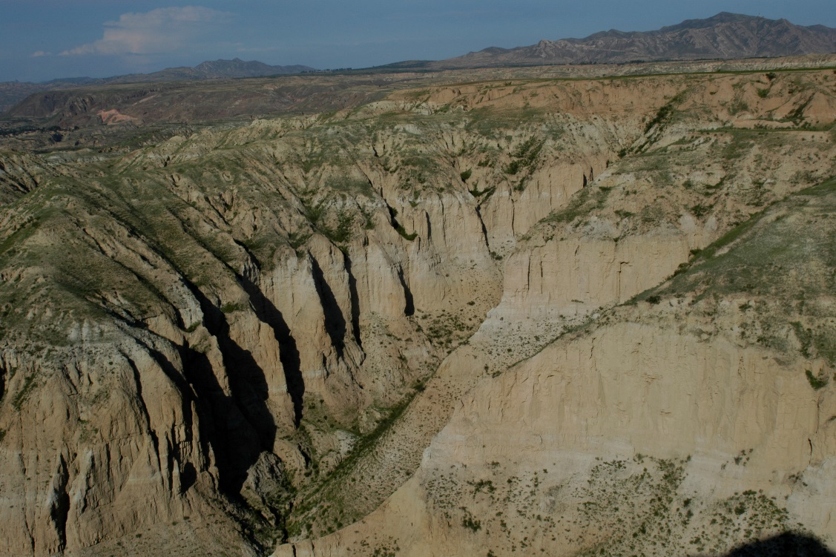
Supplementary Figure 1. Fluvio-lacustrine deposits in Nihewan Basin of North China
Supplementary Figure 2. Conjoined pieces from Cenjiawan

Supplementary Figure 3. Examples of simple refitting groups among flakes at Cenjiawan. Flake refits in these groups provide information about reduction sequences and core exploitation methods.

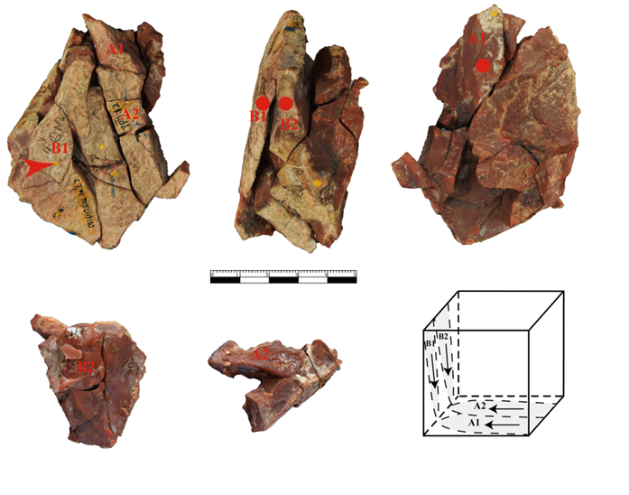
Supplementary Figure 4. A well-defined refitting group including a finely retouched tool from Cenjiawan. This refitting group consists of 35 pieces, including a retouched piece, broken flakes and broken flake fragments. This refitting group is a two directional reduction sequence. No whole flakes were produced. A long flake was used to produce a borer. The tip of the borer was made at the middle portion of the flake, along a single lateral edge.

Supplementary Figure 5. Cores sizes from Xiaochangliang (XCL), Donggutuo (DGT) and Cenjiawan (CJW)

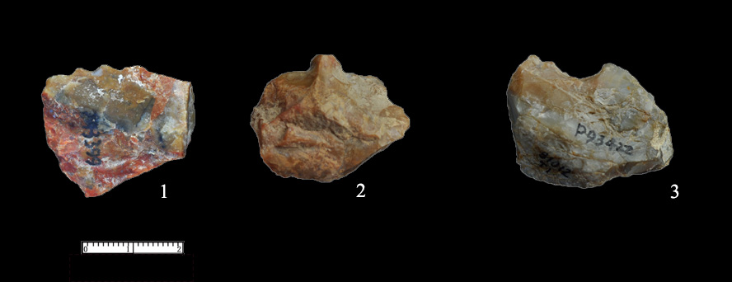
Supplementary Figure 6. Tool types with diagnostic characteristics (1. Denticulate; 2. Borer; 3. Notch)
Supplementary Figure 7. Representative tool types from Xiaochangliang (XCL), Donggutuo (DGT) and Cenjiawan (CJW). Nos. 1, 2 from DGT and No. 1 from CJW are intentionally retouched borer tips. Scrapers with long and strait retouched ends were identified in the three assemblages (XCL-2, 3; DGT-3, 4; CJW-2, 3, 4); in the latter two the retouch scars were more invasive and regular.
Supplementary Figure 8. The plan and profile of refitting groups at Cenjiawan. Most of the refitting groups are from an area of 5 m², including excavation units M, N, O, P and Q (each unit is 1x1 m). The maximum distance in vertical depth of refits is ca. 16 cm [21].
Supplementary References
- Li RQ, Qiao JG and Qiu WL et al. Soluble salt deposit in the Nihewan beds and its environmental significance. Sci China Earth Sci 2000; 43: 464–79.
- Deng CL, Zhu RX and Zhang R et al. Timing of the Nihewan formation and faunas. Quat Res 2008; 69: 77–90.
- Deng CL, Hao QZ and Guo ZT et al. Quaternary integrative stratigraphy and timescale of China. Sci China Earth Sci 2019; 62: 324–48.
- Liu P, Yue F and Liu JQ et al. Magnetostratigraphic dating of the Shixia red sediments and implications for formation of Nihewan paleo-lake, North China. Quat Sci Rev 2018; 193: 118–28.
- Zhao H, Lu Y and Wang C et al. ReOSL dating of aeolian and fluvial sediments from Nihewan Basin, northern China and its environmental application. Quat Geochronol 2010; 5: 159–63.
- Nian XM, Zhou LP and Yuan BY. Optically stimulated luminescence dating of terrestrial sediments in the Nihewan Basin and its implication for the evolution of ancient Nihewan Lake. Quat Sci 2013; 31: 404–13.
- Zhou XY, Yang JL and Wang SQ et al. Vegetation change and evolutionary response of large mammal fauna during the Mid-Pleistocene transition in temperate northern East Asia. Palaeogeogr Palaeoclimatol Palaeoecol 2018; 505: 287–94.
- Ding ZL, Derbyshire E and Yang SL et al. Stepwise expansion of desert environment across northern China in the past 3.5 Ma and implications for monsoon evolution. Earth Planet Sci Lett 2005; 237: 45–55.
- Yang SL, Ding F and Ding ZL. Pleistocene chemical weathering history of Asian arid and semi-arid regions recorded in loess deposits of China and Tajikistan. Geochim Cosmochim Acta 2006; 70: 1695–709.
- Zhou KS, Liang XL and Yan FH et al. Some remarks on the Nangou cold period based on the analysis of the pollen from the Nihewan stratum. Chin J Geol 1983; 18: 82–92.
- Yuan BY, Zhu RX and Tian WL et al. The age, subdivision and correlation of Nihewan Group. Sci China Ser D 1996; 26: 67–76.
- Pei SW, Li XL and Liu DC et al. Preliminary study on the living environment of hominids at the Donggutuo site, Nihewan Basin. Chin Sci Bull 2009; 54: 3896–904.
- Li XL, Pei SW and Jia ZX et al. Paleoenvironmental conditions at Madigou (MDG), a newly discovered early Paleolithic site in the Nihewan Basin, North China. Quat Int 2016; 400: 100–10.
- Toth N. The Oldowan reassessed: a close look at early stone artefacts. J Archaeol Sci 1985; 12: 101–20.
- Clark JD. Kalambo Falls Prehistoric Site, I: The Geology, Palaeoecology and Detailed Stratigraphy of the Excavations. Cambridge: Cambridge University Press, 1969.
- Leakey MD. Olduvai Gorge, Vol. 3: Excavations in Beds I and II, 1960-63. Cambridge: Cambridge University Press, 1971.
- Isaac GL, Harris JWK and Kroll E. The stone artefact assemblages: a comparative study. In: Isaac G and Isaac B (eds.). Koobi Fora Research Project, Volume 5: Plio-Pleistocene Archaeology. Oxford: Clarendon Press, 1997, 262–99.
- de la Torre I. The Early Stone Age lithic assemblages of Gadeb (Ethiopia) and the Developed Oldowan/early Acheulean in East Africa. J Hum Evol 2011; 60: 768–812.
- Xie F and Cheng SQ. Palaeoliths excavation in Cenjiawan Village, Yangyuan County, Hebei Province. Acta Anthropol Sin 1990; 9: 265–72.
- Xie F, Toth N and Schick K et al. The refitting study of Cenjiawan lithic artefacts unearthed in 1986. Journal of Chinese Antiquity 1994; 6: 86–102.
- Xie F, Li J and Liu LQ. Palaeolithic Archeology in the Nihewan Basin. Shijiazhuang: Huashan Literature & Arts Press, 2006.
- Xie F and Li J. The application of lithic refitting method in the research of Cenjiawan site. Journal of Chinese Antiquity 1995; 7: 25–38.
- Cziesla E. On refitting of stone artefacts. In: Cziesla E, Eichoff S and Arts N et al. (eds.). The Big Puzzle: International Symposium on Refitting Stone Artefacts, Studies in Modern Archaeology 1. Bonn: Holos, 1990, 9–44.
- Zhu RX, Potts R and Xie F et al. New evidence on the earliest human presence at high northern latitudes in northeast Asia. Nature 2004; 431: 559–62.
- Zhu RX, Hoffman KA and Potts R et al. Earliest presence of humans in northeast Asia. Nature 2001; 413: 413–17.
- Zuo TW, Cheng HJ and Liu P et al. Magnetostratigraphic dating of the Hougou Paleolithic site in the Nihewan Basin, North China. Sci China Ser D 2011; 54: 1643–50.
- Ao H, Deng CL and Dekkers MJ et al. Astronomical dating of the Xiantai, Donggutuo and Maliang Paleolithic sites in the Nihewan Basin (North China) and implications for early human evolution in East Asia. Palaeogeogr Palaeoclimatol Palaeoecol 2010; 297: 129–37.
- Li H, Yang X and Heller F et al. High resolution magnetostratigraphy and deposition cycles in the Nihewan Basin (North China) and their significance for stone artifact dating. Quat Res 2008; 69: 250–62.
- Tang YJ, Li Y and Chen WY. Mammalian fossils and the age of Xiaochangliang Paleolithic site of Yangyuan, Hebei. Vertebrata Palasiatica 1995; 33: 74–83.
- Li HM and Wang JD. Magnetostratigraphic study of several typical geologic sections in North China. In: Liu TS (ed.). Quaternary Geology and Environment of China. Beijing: Ocean Press, 1982, 33–8.
- Schick KD and Zhuan D. Early Paleolithic of China and eastern Asia. Evol Anthropol 1993; 2: 22–35.
- Wang HQ, Deng CL and Zhu RX et al. Magnetostratigraphic dating of the Donggutuo and Maliang Paleolithic sites in the Nihewan Basin, North China. Quat Res 2005; 64: 1–11.
- Singer BS, Hoffman KA and Chauvin A et al. Dating transitionally magnetized lavas of the late Matuyama Chron: toward a new ⁴⁰Ar/³⁹Ar timescale of reversals and events. J Geophys Res 1999; 104: 679–93.
- Hilgen FJ, Lourens LJ and van Dam JA. The Neogene period. In: Gradstein FM, Ogg JG and Schmitz MD et al. (eds.). The Geologic Time Scale 2012. Amsterdam: Elsevier BV, 2012, 923–78.
- Milankovitch M. Canon of Insolation and the Ice Age Problem (in Yugoslavian). Belgrade: Serb. Acad. Beorg. Special Publication, 1941. (translated by the Israel Program for Scientific Translations, Jerusalem, 1969).
- Pisias NG and Moore TC. The evolution of Pleistocene climate: A time series approach. Earth Planet Sci Lett 1981; 52: 450–8.
- Maasch KA. Statistical detection of the mid-Pleistocene transition. Clim Dynam 1988; 2: 133–43.
- Short DA, Mengel JG and Crowley TJ et al. Filtering of Milankovitch cycles by Earth’s geography. Quat Res 1991; 35: 157–73.
- Clark PU, Archer D and Pollard D et al. The middle Pleistocene transition: Characteristics, mechanisms, and implications for long-term changes in atmospheric pCO₂. Quat Sci Rev 2006; 25: 3150–84.
- Elderfield H, Ferretti P and Greaves M et al. Evolution of ocean temperature and ice volume through the mid-Pleistocene climate transition. Science 2012; 337: 704–9.
- Markova AK. Eastern European rodent (Rodentia, mammalia) faunas from the Early-Middle Pleistocene transition. Quat Int 2005; 131: 71–7.
- Head MJ and Gibbard PL. Early-Middle Pleistocene transitions: Linking terrestrial and marine realms. Quat Int 2015; 389: 7–46.
- Kitamura A. Constraints on eustatic sea-level changes during the Mid-Pleistocene Climate Transition: Evidence from the Japanese shallow-marine sediment record. Quat Int 2016; 397: 417–21.
- Ding ZL, Derbyshire E and Yang SL et al. Stacked 2.6-Ma grain size record from the Chinese loess based on five sections and correlation with the deep-sea δ¹⁸O record. Palaeoceanography 2002; 17: 5-1–21.
- Wang T, Sun YB and Liu XX. Mid-Pleistocene climate transition: Characteristic, mechanism and perspective. Chin Sci Bull 2017; 62: 3861–72.
- Mudelsee M and Schulz M. The Mid-Pleistocene climate transition: Onset of 100 ka cycle lags ice volume build-up by 280 ka. Earth Planet Sci Lett 1997; 151: 117–23.
- Medina-Elizalde M and Lea DW. The mid-Pleistocene transition in the tropical Pacific. Science 2005; 310: 1009–12.
- Zhu ZY, Dennell R and Huang WW et al. New dating of the Homo erectus cranium from Lantian (Gongwangling), China. J Hum Evol 2015; 78: 111–57.
- Shultz S, Nelson E and Dunbar RIM. Hominin cognitive evolution: Identifying patterns and processes in the fossil and archaeological record. Philos T R Soc B 2012; 367: 2130–40.
- Shen GJ, Gao X and Gao B et al. Age of Zhoukoudian Homo erectus determined with ²⁶Al/¹⁰Be burial dating. Nature 2009; 458: 198–200.
- Grün R, Huang PH and Huang WP et al. ESR and U-series analyses of teeth from the palaeoanthropological site of Hexian, Anhui Province, China. J Hum Evol 1998; 34: 555–64.
- Wu XJ, Pei SW and Cai YJ et al. Archaic human remains from Hualongdong, China, and Middle Pleistocene human continuity and variation. Proc Natl Acad Sci USA 2019; 116: 9820–4.
- Yin GM, Bahain JJ and Shen GJ et al. ESR/U-series study of teeth recovered from the palaeoanthropological stratum of the Dali Man site (Shaanxi Province, China). Quat Geochronol 2011; 6: 98–105.
- Li ZY, Wu XJ and Zhou LP et al. Late Pleistocene archaic human crania from Xuchang, China. Science 2017; 355: 969–72.
- Li F, Bae CJ and Ramsey CB et al. Re-dating Zhoukoudian Upper Cave, northern China and its regional significance. J Hum Evol 2018; 121: 170–7.

