**Supporting Info: Optimal Cutoff Concentration of Urinary Cyanoethyl Mercapturic Acid for Differentiating Cigarette Smokers from Nonsmokers**

Deepak Bhandari*, Luyu Zhang, Wanzhe Zhu, Víctor R. De Jesús, and Benjamin C. Blount

*Centers for Disease Control and Prevention*

*Division of Laboratory Sciences, Tobacco and Volatiles Branch*

*Atlanta, GA 30341*

Submitted for consideration for publication in ***Nicotine & Tobacco Research***

Running Title: 2CyEMA cutoff for smoking status classification

*Corresponding Author:

Deepak Bhandari, PhD

Centers for Disease Control and Prevention

Division of Laboratory Sciences, Tobacco and Volatiles Branch

Email: xwo1@cdc.gov

Phone: 770-488-0939

Disclaimer: The views and opinions expressed in this report are those of the authors and do not necessarily represent the views, official policy or position of the U.S. Department of Health and Human Services or any of its affiliated institutions or agencies. The use of trade names is for identification purposes and does not imply endorsement by the Centers for Disease Control and Prevention, the Public Health Service, or the U.S. Department of Health and Human Services.



***Figure S1***: Flow chart showing the classification of smokers, nonsmokers, and tobacco nonusers in the study

|  |  |  |  |  |  |  |  |
| --- | --- | --- | --- | --- | --- | --- | --- |
| **Characteristic** | **Level** | **Nonsmokers N** | **Smokers N** | **Nonsmokers Median [25th %ile, 75th %ile]** | **Smokers Median [25th %ile, 75th %ile]** | **Nonsmokers GM [95%CI]** | **Smokers GM [95%CI]** |
|  | All | 3613 | 2090 | 1.37 [0.884, 2.26] | 145 [69.0, 240] | 1.70 [1.58, 1.83] | 107 [94.2, 122] |
| Sex | Male | 1716 | 1181 | 1.25 [0.813, 2.06] | 125 [54.0, 204] | 1.63 [1.49, 1.78] | 89.1 [76.2, 104] |
| Female | 1897 | 909 | 1.46 [0.956, 2.43] | 170 [86.6, 275] | 1.76 [1.61, 1.93] | 131 [113, 153] |
| Age | 21 – 39 | 1115 | 751 | 1.31 [0.826, 2.24] | 102 [34.9, 174] | 1.69 [1.51, 1.90] | 67.3 [54.3, 83.5] |
| 40 – 59 | 1149 | 846 | 1.42 [0.914, 2.39] | 181 [105, 278] | 1.81 [1.60, 2.05] | 148 [127, 173] |
| ≥60 | 1349 | 493 | 1.39 [0.899, 2.16] | 175 [101, 265] | 1.59 [1.46, 1.72] | 144 [126, 164] |
| Race/ Ethnicity | Non-Hispanic White | 1346 | 942 | 1.39 [0.894, 2.27] | 166 [85.5, 256] | 1.73 [1.58, 1.90] | 120 [101, 142] |
| Non-Hispanic Black | 717 | 577 | 1.36 [0.843, 2.53] | 133 [75.9, 216] | 1.86 [1.68, 2.05] | 118 [106, 131] |
| Hispanic | 968 | 358 | 1.28 [0.845, 1.95] | 71.3 [22.5, 148] | 1.51 [1.38, 1.65] | 53.3 [42.5, 66.7] |
| Other Race/Multi-Racial | 582 | 213 | 1.47 [0.916, 2.50] | 132 [73.2, 230] | 1.61 [1.46, 1.78] | 110 [85.3, 141] |

***Table S1***. Weighted geometric mean (95% CI) and median (IQR) urinary 2CyEMA [μg/g creatinine] in adult U.S. population by sex, age, race or ethnicity, and smoking status, based on NHANES 2011-2016 (N = 5,703).

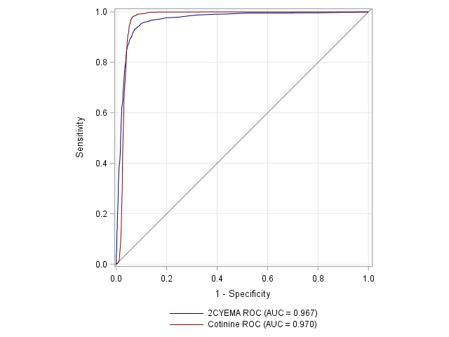

Urinary 2CyEMA (ng/mL)

Serum Cotinine (ng/mL)

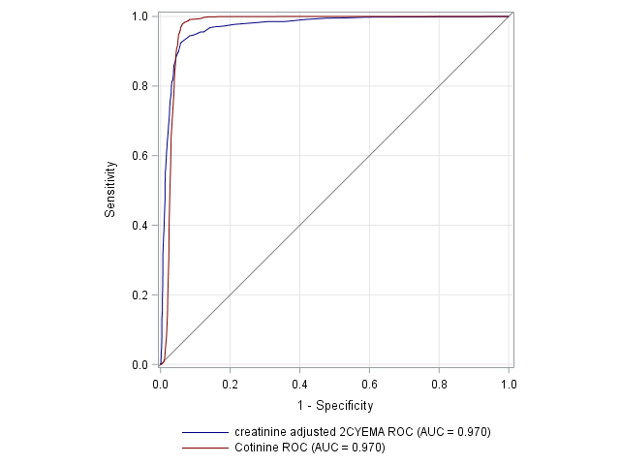

Creatine adj 2CyEMA

Serum Cotinine (ng/mL)

***Figure S2***. Weighted ROC curves for urinary 2CyEMA concentration and serum cotinine (left), and creatine adjusted 2CyEMA and serum cotinine (right) for exclusive cigarette smoker versus nonsmokers. The 2CyEMA cutoff levels were 7.32 ng/ml (sensitivity 0.933; specificity 0.926) and 11.4 µg/g creatinine (sensitivity 0.924; specificity 0.943)

***Table S2***. Weighted urinary 2CyEMA (µg/g creatinine) cutoff values to distinguish between smoker and nonsmoker by demographic subgroup for adult U.S. population based on NHANES 2011-2016.

|  |  |  |  |  |
| --- | --- | --- | --- | --- |
| **Variables** | **Cutoff (95%CI)** | **Sensitivity** | **Specificity** | **Youden's J Statistic** |
| Age 21 – 39 | 7.69 (3.51, 8.80) | 0.891 | 0.921 | 0.812 |
| Age 40 – 59 | 11.4 (9.37, 17.0) | 0.968 | 0.935 | 0.902 |
| Age ≥60 | 6.30 (6.30, 34.04) | 0.977 | 0.946 | 0.923 |
| Male | 9.37 (3.48, 13,94) | 0.916 | 0.928 | 0.845 |
| Female | 11.4 (6.30, 12.62) | 0.940 | 0.953 | 0.893 |
| Non-Hispanic White | 11.4 (6.30, 13.94) | 0.930 | 0.939 | 0.869 |
| Non-Hispanic Black | 11.4 (9.37, 27.91) | 0.976 | 0.917 | 0.893 |
| Hispanic | 6.30 (3.48, 8.49) | 0.879 | 0.940 | 0.820 |
| Other Race/Multi-Racial | 12.6 (6.30, 18.77) | 0.955 | 0.980 | 0.935 |