Supplemental materials

Appendix S1: Search algorithm

EMBASE search (35 articles)
('ascorbic acid'/exp OR 'ascorbic acid') AND ('periodontal disease'/exp OR 'periodontal disease') AND ([cochrane review]/lim OR [systematic review]/lim OR [meta analysis]/lim OR [controlled clinical trial]/lim OR [randomized controlled trial]/lim)

PubMed Search (32 articles)
("periodontal diseases"[MeSH Terms] OR "gingivitis"[tiab]) AND ("ascorbic acid"[MeSH Terms] OR "ascorbic acid"[tiab] OR "AA"[tiab]) AND ("Clinical Trial" [PT:NoExp] OR "clinical trial, phase i"[pt] OR "clinical trial, phase ii"[pt] OR "clinical trial, phase iii"[pt] OR "clinical trial, phase iv"[pt] OR "controlled clinical trial"[pt] OR "multicenter study"[pt] OR "randomized controlled trial"[pt] OR "Clinical Trials as Topic"[mesh:noexp] OR "clinical trials, phase i as topic"[MeSH Terms:noexp] OR "clinical trials, phase ii as topic"[MeSH Terms:noexp] OR "clinical trials, phase iii as topic"[MeSH Terms:noexp] OR "clinical trials, phase iv as topic"[MeSH Terms:noexp] OR "controlled clinical trials as topic"[MeSH Terms:noexp] OR "randomized controlled trials as topic"[MeSH Terms:noexp] OR "early termination of clinical trials"[MeSH Terms:noexp] OR "multicenter studies as topic"[MeSH Terms:noexp] OR “Double-Blind Method”[Mesh] OR ((randomised[TIAB] OR randomized[TIAB]) AND (trial[TIAB] OR trials[tiab])) OR ((single[TIAB] OR double[TIAB] OR doubled[TIAB] OR triple[TIAB] OR tripled[TIAB] OR treble[TIAB] OR treble[TIAB]) AND (blind*[TIAB] OR mask*[TIAB])) OR ("4 arm"[tiab] OR "four arm"[tiab]))”)

Cochrane (20 articles)
Mesh descriptor:[Periodontal diseases] explode all trees AND MeSH descriptor [Ascorbic acid] explode all trees]

Appendix S2 -Statistical details

- Calculation of standard errors for the average treatment effect in trials with multiple AA treatment arms: Correlated effect sizes can result because of multiple treatment arms ($x_{1},x_{2},…,x_{n}$), or because of the split-mouth design (where an AA effect size, x₁, is estimated for the split-mouth which was scaled, and an AA effect size, x₂, is estimated for the split-mouth which was not scaled.) Effect sizes ($x_{1},x_{2},…,x_{n}$) which were correlated were combined with the inverse-variance weighted mean. The point estimate for a study which had 2 or more comparisons utilizing a shared group was:
$$x=\frac{\sum_{i}{x_{i}/σ_{i}^{2}}}{\sum_{i}{1/σ_{i}^{2}}}.$$The variance of this weighted mean was:
$σ^{2}=\frac{1}{\sum_{i}{1/σ_{i}^{2}}}\left\{1+2ρ\frac{\sum_{i}{\sum_{j>i}{\frac{1}{σ_{i}σ_{j}}}}}{\sum_{i}{1/σ_{i}^{2}}}\right\}$,
where $ρ$ is the correlation between the effect sizes (assumed to be the same for all effect sizes). In the analyses, ρ is set equal to 0.5.

- Estimation of correlation between baseline and final exam measurements of gingival health endpoints: An estimate of ρ was derived from included CCTs reporting 3 standard deviations (SD): SD_{baseline}, SD_{final}, and SD_{change}.¹ Seventeen point-estimates of the correlation coefficient between baseline and final gingival health scores were calculated based on SD_{baseline}, SD_{final}, and SD_{change} by six authors of AA supplementation trials. ²⁻⁶ A mean correlation coefficient was calculated for each of the six studies. This mean was 0.65 and ranged between 0.22 (minimum) and 0.87 (maximum). The summary estimates of 0.65 were consistent with magnitude of the correlation coefficient reported in oral hygiene trials. ⁷

Appendix S3 - Some notes on data abstraction of individual studies

Trials on gingival bleeding tendency

Endpoint choice:
Roff and Glazebrook⁸: Roff and Glazebrook distinguish between two types gingivitis: gingivo-stomatitis which is hypothesized to be caused by vitamin C deficiency, and marginal gingivitis which is hypothesized to be caused by local factors. In the meta-analysis, “gingivitis” (both gingiva-stomatitis and marginal gingivitis) at the last examination was regarded as the primary outcome because: (i) Roff and Glazebrook do not report the number of cases of gingivo-stomatitis among controls in the first trial, and (ii) the “a priori” hypothesis of Roff and Glazebrook regarding gingivo-stomatitis may have biased the diagnosis given it was a non-blinded study, and (iii) overall gingivitis is more reliable than vitamin C specific-gingivitis for the same reason that overall mortality is more reliable than disease-specific mortality. This decision to choose gingivitis over gingivo-stomatitis led to extremely conservative results. In other words, the beneficial impact of vitamin C supplementation was severely underestimated.

Baseline vitamin C intake:
Roff and Glazebrook⁸: The report by Roff and Glazebrook is unclear whether the new recruits (the second trial) also had a typical AA intake of 25 mg per day or 11 µmol/L (see Table S1). Our primary results presented assume that the new recruits also had a typical intake of 25 mg. This assumption is supported by the data to the extent that the prevalence of gingiva-stomatitis in this second trial was higher than in the first trial – suggesting that if anything these recruits had a lower vitamin C intake.
Deleting the Roff & Glazebrook trial from the meta-analysis did not impact the conclusions of the effectiveness estimates.

Amaliya et al. ⁹: The baseline plasma level in all groups was controlled by asking participants to consume as little fruit and vegetables as possible. It was estimated that the three groups had on average a 6 mg AA intake per day corresponding to 7 µmol/L (average intake of 3 groups in table 2 is 5.65 or 6 mg/day).

Lingström et al. ¹⁰: Treatment effects in this study were estimated in the setting of a cross-over trial. The standardized mean differences were calculated based on the Cochrane handbook (16.4.6.2). The investigators of this study report that all subjects had their vitamin C depots filled prior to the study (500 mg from day 1 to day 8 prior to study) and due to the cross-over design all but 5 subjects in series I had 300 mg of AA per day and all subjects in series II had either an eight day period of 500 mg or a 3 month period of 300 mg per day. Based on this information it was assumed that subjects had typically 300 mg intake and a mean AA plasma level of 70 µmol/L. A table suggested both series had a sample size of 30 which was the sample size reported here. One sentence suggested series 2 had 29 subjects (18 men/11 women) which was assumed to be a typographical error. The small between-study correlation caused by having 5 trial participants who participated in both series was ignored.

Raghavendra et al. ¹¹: Baseline gingival bleeding tendency was significantly different in this study. This significant baseline inequality was not taken into account by the authors when they reported a highly significant benefit from vitamin C supplementation. The significant baseline inequality was taken into account by our approach of taking differences from baseline and led to non-significant effect of vitamin C supplementation.

Trials on gingival health endpoints other gingival bleeding tendency:

Fox: 25 mg day or 11 µmol/L; Fox reported that the AA intake varied within the limits of 12 or 15 to about 25 mg a day –the maximum of 25 mg was taken (p. 4152). ¹² There was no report of scurvy at baseline and the reported plasma levels are inconsistent with a diagnosis of scurvy.
Stamm: first experiment 26 mg per day or 11 µmol/L ¹³
Stamm: second experiment 17 mg per day or 9 µmol/L ¹³
Hanke: 82 mg or 44 µmol/L ¹⁴ - this is the average of 89.22 mg intake for boys and 75.18 mg intake for girls AA concentration in AA food/fruit juices were for this study obtained from sources such as the National Nutrient Database for Standard Reference by United States Department of Agriculture.¹⁵

Table S1 -Depletion studies with confined subjects relating AA intake to AA plasma levels
 |  |  | Supplementation regimen and corresponding steady-state AA plasma levels in confined subjects
Author | Year | n | 5mg | 30 mg | 60 mg | 90 mg³ | 100 mg | 200mg | 400gm | 1000 mg | 2500 mg
Leggott | 1986 | 11 | 7.54± 3.32¹
Leggott | 1991 | 12 | 6.02±2.31
Sauberlich† | 1989 | 6 | - | 10.8± 2.8 | 13.1±4.0 | 29.0±8.0
Sauberlich | 1989 | 5 | - | 15.3±3.4 | 20.4±5.7 | 42.6±15.3
Levine | 1996 | 7 | - | 8.7±1.7 | 24.8±15.3 | - | 56.0±4.9 | 65.8±7.9 | 70.0±7.4 | 76.9±5.8 | 85.0±6.6
Levine | 2001 | 15 | - | 12.7±2.6 | 46.6±6.7 | - | 61.9±5.6 | 67.7±5.6 | 73.2±5.4 | 75.1±4.5 | 77.8±6.2
 |  | 33 | 6.6±0.72² | 11.9±1.5 | 26.3±9.6 | 34.5±6.7 | 59.0±3.0 | 67.3±1.3 | 72.4±1.3 | 75.5±1.1 | 80.7±3.5
† HPLC method
- ± Standard deviation
- ± standard error estimates using DerSimonian Laird random effects models
- AA plasma levels for AA doses ranging from 5 to 2500 mg were estimated based on linear interpolation and without the 90 mg dose.

Table S2. Robustness of AA effectiveness estimates in individuals with high or unknown baseline AA plasma levels.
Method | High (> µmol/L) baseline AA plasma |  |  | Baseline AA plasma unknown
 |  | p-value |  |  | p-value
 | Estimate | Without KH¹ | With KH | Estimate | Without KH | With KH
DL² | -0.2299 | 0.0449 | 0.0346 | -0.5645 | 0.0773 | 0.3071
HE³ | -0.2299 | 0.0449 | 0.0346 | -0.7758 | 0.2278 | 0.2626
HS⁴ | -0.2299 | 0.0449 | 0.0346 | -0.5151 | 0.0641 | 0.3160
SJ⁵ | -0.2317 | 0.0518 | 0.0348 | -0.7573 | 0.2012 | 0.2666
ML⁶ | -0.2299 | 0.0449 | 0.0346 | -0.6049 | 0.0911 | 0.2991
REML⁷ | -0.2299 | 0.0449 | 0.0346 | -0.7096 | 0.1511 | 0.2770
- KH= Knapp-Hartung,2. DL= DerSimonian-Laird estimator. 3. HE= Hedges estimator 4. HS= Hunter-Schmidt estimator, 5. SJ= Sidik-Jonkman estimator, 6. ML=Maximum-likelihood estimator, and 7. REML= Restricted maximum-likelihood estimator.

Appendix S4. Sensitivity analysis of meta-analysis results for studies based on gingival bleeding tendency: A meta-regression using robumeta was conducted which included an intercept and two categorical variables for baseline AA plasma > 28 µmol/L and unknown. All regression coefficients from this model had sufficiently large degrees of freedom. A significant intercept reflecting a significant AA effect was found when AA plasma < 28 µmol/L (SMD: -0.852; p-value 0.00164); that the AA effect when AA plasma > 28 µmol/L was significantly different from the AA effect when AA plasma < 28 µmol/L (SMD: -0.246; p-value for the difference 0.00661), and that the AA effect when AA plasma is unknown was not significantly different from the AA effect when AA plasma < 28 µmol/L (SMD: -0.416; p-value for the difference 0.13288).

Table S3 - Risk factors for gingival bleeding tendency and retinal hemorrhaging in National Health Examination Survey III in participants above the age of 40*.
 |  | Gingival Bleeding Tendency |  |  |  | Retinal  Hemorrhaging
Covariate | Level | PR | 5% | 95% | p-value | PR | 5% | 95% | p-value
Ascorbic Acid (serum) | > 28 mmol/l | 1.00 | - | - | - | 1.00 | - | - | .
 | 11-28 mmol/l | 1.59 | 1.28 | 1.98 | <.01 | 1.24 | 1.03 | 1.48 | 0.02
 | < 11 mmol/l | 1.90 | 1.50 | 2.41 | <.01 | 1.16 | 0.93 | 1.44 | 0.19
Hemoglobin A1C | <= 6.5 | 1.00 | - | - | - | 1.00 | - | - | -
 | 6.5-7.5 | 1.48 | 1.05 | 2.07 | 0.02 | 3.61 | 2.85 | 4.58 | <.01
 | > 7.5 | 1.96 | 1.53 | 2.52 | <.01 | 5.80 | 4.92 | 6.84 | <.01
Cotinine (serum) | nonsmokers (< 10 ng/mL) | 1.00 | - | - | - | 1.00 | - | - | -
 | light smokers (10-300 ng/mL) | 0.84 | 0.65 | 1.07 | 0.16 | 1.00 | 0.82 | 1.22 | 0.99
 | heavy smokers (>300 ng/mL) | 0.88 | 0.63 | 1.22 | 0.44 | 0.71 | 0.51 | 0.98 | 0.04
Age | 40-49 | 1.00 | - | - | - | 1.00 | - | - | -
 | 50-59 | 1.92 | 1.45 | 2.53 | <.01 | 1.13 | 0.89 | 1.45 | 0.32
 | 60-69 | 2.10 | 1.61 | 2.74 | <.01 | 1.36 | 1.09 | 1.69 | <.01
 | 70-79 | 2.50 | 1.87 | 3.33 | <.01 | 1.52 | 1.20 | 1.94 | <.01
 | 80+ | 2.70 | 1.93 | 3.78 | <.01 | 1.61 | 1.21 | 2.14 | <.01
Sex | male | 1.00 | - | - | - | 1.00 | - | - | -
 | female | 0.81 | 0.68 | 0.97 | 0.02 | 1.01 | 0.87 | 1.17 | 0.93
* No retinal bleeding assessments were performed in survey participants < 40 years old.

Table S4: Risk of bias in 21 controlled trials evaluating the impact of AA supplementation on gingival health endpoints other than gingival bleeding tendency. ^{4,8,12-14,16-31}

 | Random sequence generation | Allocation concealment | Selective reporting | Blinding of participants and personnel | Blinding of outcome assessment | Incomplete outcome data | Baseline plasma AA comparability | Complinace
Fox |  |  |  |  | 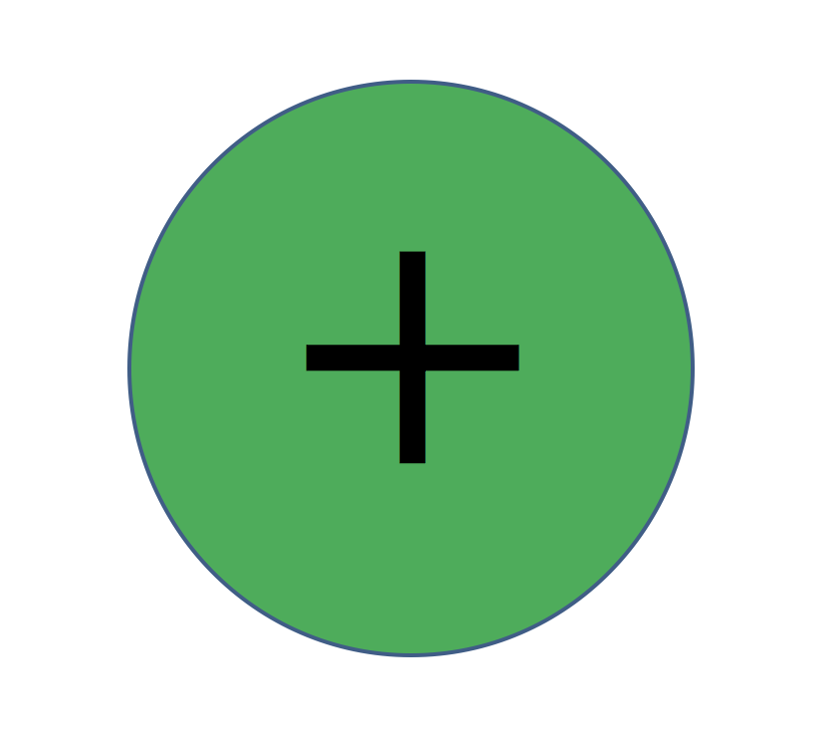
Ockerse
Linghorne
Mead
Stamm
Stamm
El-Ashiri
Keller
Parfitt
Buzina
Ogilvie
Hanke
Dilley
Pierce
Coven
Prentice
Fawzi
Roth
Carvel
Kolbus
Kutscher
- Legend: Cochrane risk of bias was judged to be low risk of bias, high risk of bias, or unclear risk of bias.
Figure S1: Forest plot displaying the effect of Ascorbic Acid (AA) supplementation on gingival health endpoints in 36 controlled clinical trials (49 treatment arms).
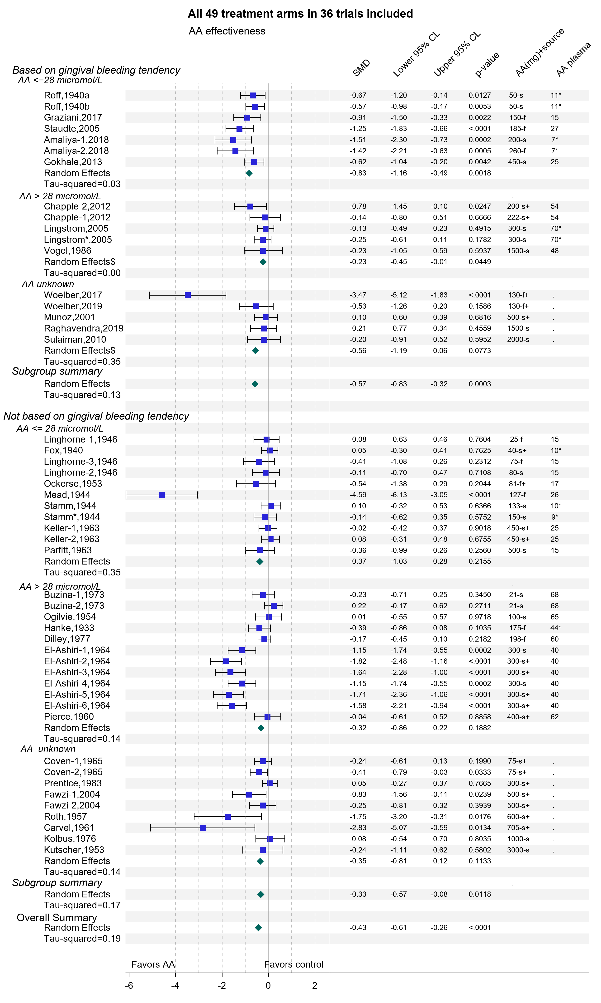
Legend: A star symbol after an author’s name refers to the second trial published in the same year. Number symbols after an author’s name refer to correlated AA treatment effects with number 1 referring to the least confounded AA effect. The $ symbol after the “random effects” label indicates that the summary effect was based on calculating average AA treatment effects for trials with multiple treatment arms and proceeding with a Der-Simonian Laird estimator. The absence of the $ symbol indicates that the results from robust variance estimation are presented. Legend: For AA plasma a "*” indicates an imputed AA plasma level. For AA(mg)+ source a “s” stands for AA as a single active systemic ingredient, a “s+” stands for a supplement with AA and other active ingredients, a “f” stands for a fruit rich in AA, and “f+” stands for a fruit rich in vitamin C and other dietary interventions.
Detailed legend: Amaliya-1 and -2 refer to pure AA supplement and guava, respectively. Chapple-1 and -2 refer to a fruit/vegetable product without and with berry concentrate, respectively. Linghorne-1, -2, and -3 refer to three different AA doses. El-Ashiri-1 and -2 refer to natural AA suppl., El-Ashiri-3 and -4 refer to AA suppl. + bioflavonoids, and El-Ashiri-5 and -6 refer to synthetic AA+ bioflavonoids. Odd- and even- numbered El-Ashiri arms are without and with scaling, respectively. Keller-1 and -2 refer to the AA effect without and with scaling. Buzina-1 and -2 refer to long- and short follow-up, respectively. Coven-1 and -2 refer to a pure AA effect versus an AA effect combined with vitamins. And, Fawzi -1 and 2 refer to a multivitamin with and without vitamin A.

Figure S2: Forest plot displaying the impact of Ascorbic Acid supplementation on gingival health endpoints in the 36 least confounded treatments of 36 controlled clinical trials.
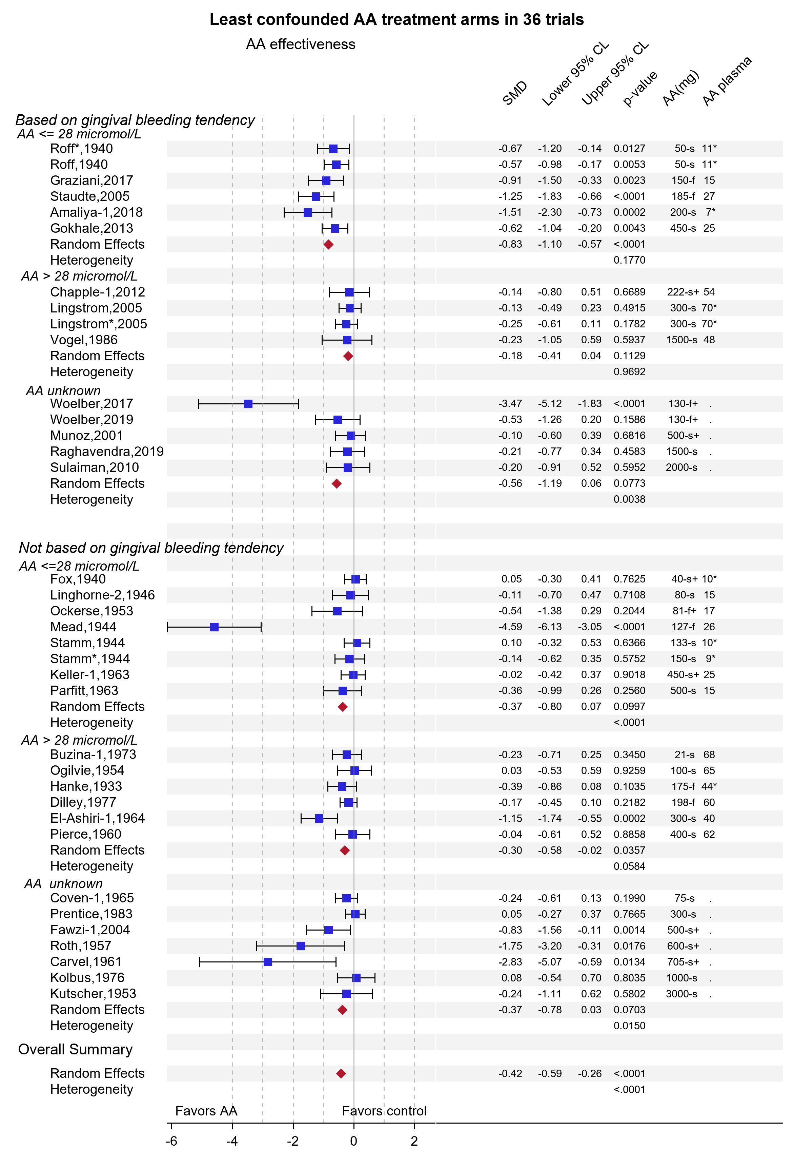
Legend: The star symbol after an author’s name refers to the second trial published in the same publication. Legend: For AA plasma a "*” indicates an imputed AA plasma level. For AA(mg)+ source a “s” stands for AA as single active systemic ingredient, a “s+” stands for a supplement with AA and other active ingredients, a “f” stands for a fruit rich in AA, and “f+” stands for a fruit rich in vitamin C and other dietary interventions.
Figure S3: Forest plot displaying the impact of Ascorbic Acid supplementation on gingival health endpoints in the 36 average AA treatment effects in 36 controlled clinical trials.
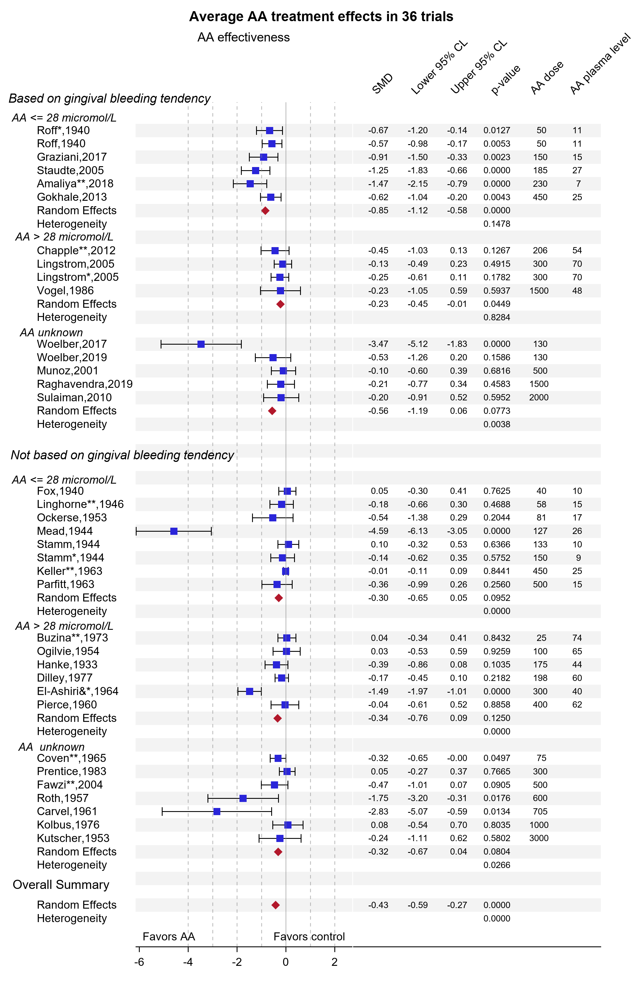
Legend: The star symbol after an author’s name refers to the second trial published in the same publication

References
S1. Higgins J, Green S. 16.4.6.2 Standardized mean difference. In: The Cochrane Collaboration, ed. Cochrane Handbook for Systematic Reviews of Interventions. Version 5.12011.
S2. Munoz CA, Kiger RD, Stephens JA, Kim J, Wilson AC. Effects of a nutritional supplement on periodontal status. Compend Contin Educ Dent. 2001;22(5):425-428, 430, 432 passim; quiz 440.
S3. Graziani F, Gabriele M, D'Aiuto F, Suvan J, Tonelli M, Cei S. Dental plaque, gingival inflammation and tooth -discolouration with different commercial -formulations of 0.2% chlorhexidine rinse: a double-blind randomised controlled clinical trial. Oral health & preventive dentistry. 2015;13(2):101-111.
S4. Kolbus I, Senge K. Controlled clinical study on the effect of oral and topical administration of a vitamin C preparation on periodontitis. Deutsche zahnärztliche Zeitschrift. 1976;31(5):456-457.
S5. Gokhale NH, Acharya AB, Patil VS, Trivedi DJ, Thakur SL. A short-term evaluation of the relationship between plasma ascorbic acid levels and periodontal disease in systemically healthy and type 2 diabetes mellitus subjects. Journal of Dietary Supplements. 2013;10(2):93-104.
S6. Woelber JP, Gartner M, Breuninger L, et al. The influence of an anti-inflammatory diet on gingivitis. A randomized controlled trial. J Clin Periodontol. 2019;46(4):481-490.
S7. Gordon JM, Frascella JA, Reardon RC. A clinical study of the safety and efficacy of a novel electric interdental cleaning device. J Clin Dent. 1996;7(3 Spec No):70-73.
S8. Roff FS, Glazebrook AJ. The therapeutic use of vitamin C in gingivitis and adolescents. British Dental Journal. 1940;68:135-141.
S9. Amaliya A, Risdiana AS, Van der Velden U. Effect of guava and vitamin C supplementation on experimental gingivitis: A randomized clinical trial. J Clin Periodontol. 2018.
S10. Lingström P, Fure S, Dinitzen B, Fritzne C, Klefbom C, Birkhed D. The release of vitamin C from chewing gum and its effects on supragingival calculus formation. European Journal of Oral Sciences. 2005;113(1):20-27.
S11. Raghavendra U, Rao A, Kashyap AR, et al. Vitamin C supplementation as an adjunct to non-surgical therapy in the treatment of chronic periodontitis: a clinical and biochemical study. J Int Oral Health. 2019;10:256-261.
S12. Fox FW, Dangerfield LF, Gottlich SF, Jokl E. VITAMIN C REQUIREMENTS OF NATIVE MINE LABOURERS * AN EXPERIMENTAL STUDY. British Medical Journal. 1940(4152):143-147.
S13. Stamm WP, Macrae TF, Yudkin S. Bleeding Gums in R.A.F. Personnel: Value of Ascorbic Acid. Br Med J. 1944;2(4363):239-241.
S14. Hanke MT. Diet and dental health. Chicago, Ill.,: The University of Chicago press; 1933.
S15. United States Department of Agriculture USDA National Nutrient Database for Standard Reference Legacy Release. 2018; https://ndb.nal.usda.gov/ndb/. Accessed September 7, 2020.
S16. Buzina R, Brodarec A, Jusic M, Milanovic N, Kolombo V. Epidemiology of angular stomatitis and bleeding gums. Internat J Vit Nutr Res. 1973;43:401-415.
S17. Prentice AM, Lamb WH, Bates CJ. A trial of ascorbic acid and of multivitamin supplementation on the oral health of West African children. Transactions of the royal society of tropical medicine and hygiene. 1983;77(6):792‐795.
S18. Kutscher AH. Massive vitamin C therapy of chronic marginal gingivitis. The New York State Dental Journal. 1953;19:422-424.
S19. Carvel RI, Halperin V. Therapeutic effect of water-soluble bioflavonoids in gingival inflammatory conditions. Oral Surgery, Oral Medicine, & Oral Pathology. 1961;14(7):847-855.
S20. Ogilvie GF, Pett LB. A long term study on ascorbic acid supplementation. Can Serv Med J. 1954;10(3):191-197.
S21. Coven EM. Effect of prophylaxis and vitamin supplementation upon periodontal index in children. J Periodontol. 1965;36(6):494-500.
S22. Fawzi WW, Msamanga GI, Spiegelman D, et al. A randomized trial of multivitamin supplements and HIV disease progression and mortality. New England Journal of Medicine. 2004;351(1):23-32.
S23. Ockerse T, LeRiche H, Kinnear AA, Draper WL. A nutrition and health study on Bantu boys. The New York State Dental Journal. 1953;19(5):213-219.
S24. Roth H, Greene H, Kirsch S. Preliminary progress report of a clinical study of the effect of C.V.P. on gingival hemorrhage. Oral Surg Oral Med Oral Pathol. 1957;10(6):590-600.
S25. Linghorne WJ, Mc IW, et al. The relation of ascorbic acid intake to gingivitis. Can Med Assoc J. 1946;54:106-119.
S26. Mead S. Studies of the effect of the ingestion of citrus fruit upon gingival hemorrhage. Journal of Dental Research. 1944;23(1):73-79.
S27. Parfitt GJ, Hand CD. Reduced plasma ascorbic acid levels and gingival health. Journal of Periodontology. 1963:47-51.
S28. El-Ashiry GM, Ringsdorf WM, Jr., Cheraskin E. Local and Systemic Influences in Periodontal Disease. Iv. Effect of Prophylaxis and Natural Versus Synthetic Vitamin C Upon Clinical Tooth Mobility. Int Z Vitaminforsch. 1964;34:202-218.
S29. Dilley GJ, Koerber LG, Roche JR. The effects of a dietary supplement of fresh oranges on the oral health of children. ASDC J Dent Child. 1977;44(1):35-41.
S30. Pierce HB, Newhall CA, Merrow SB, Lamden MP, Schweiker C, Laughlin A. Ascorbic acid supplementation. I. Response of gum tissue. Am J Clin Nutr. 1960;8:353-362.
S31. Keller SE, Ringsdorf Jr WM, Cheraskin E. Interplay of local and systemic influences in the periodontal disease. Journal of Periodontology. 1963;34(3 ):259-280.

