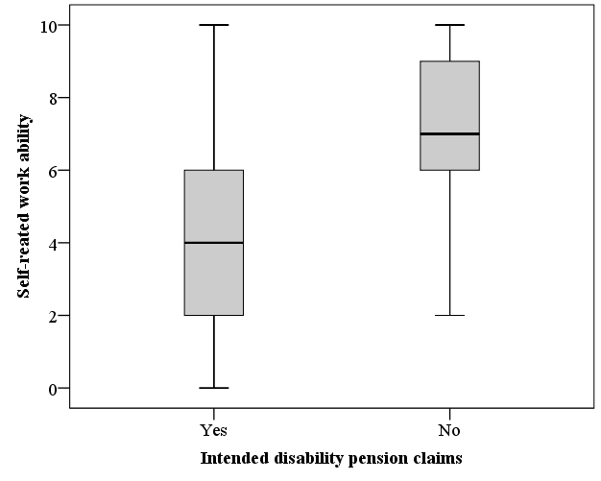 | 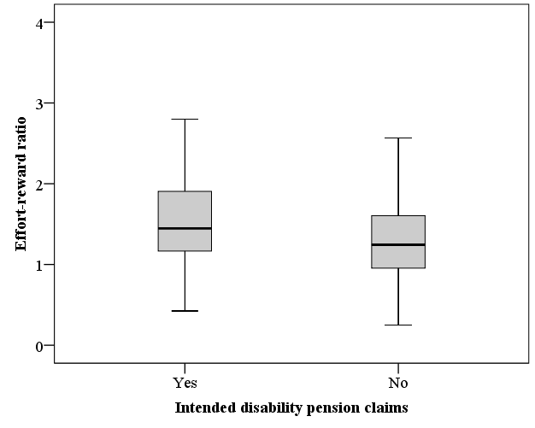
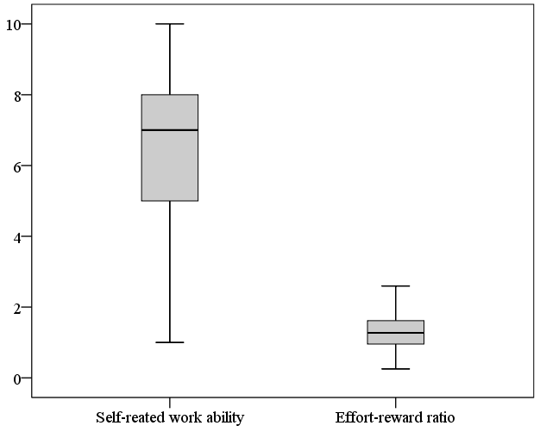

Figure S1. Box plots depicting upper and lower quartiles for self-rated work ability and effort-reward ratio in relation to intended disability pension claims and self-rated work ability vs. effort reward ratio.

