SUPPLEMENT

Advancing patient-centered care in tuberculosis management: a mixed methods appraisal of video directly observed therapy (vDOT)

Samuel B Holzman,¹ Avi Zenilman¹ and Maunank Shah^{1,2}

¹ Division of Infectious Diseases, Johns Hopkins School of Medicine, Baltimore, MD
² Baltimore City Health Department, Baltimore, MD

Description of miDOT platform
Upon opening the app, patients were automatically navigated through a series of windows which screened for side-effects, reviewed treatment regimen, and ultimately a video-capture interface where they recorded pill ingestion (Supplementary Fig 1). Any noted side-effects were automatically routed to the miDOT provider portal for follow-up. Twice daily text-message reminders were automatically sent in the absence of expected submissions by the software. Recorded videos were encrypted and stored within internal phone memory only until successful upload, after which they were automatically deleted . An encrypted transmission tunnel was used to access patient data from provider desktops (Figure 1). Given the asynchronous nature of miDOT, clinic staff were able to review submitted videos at any point following digital capture and transmission.

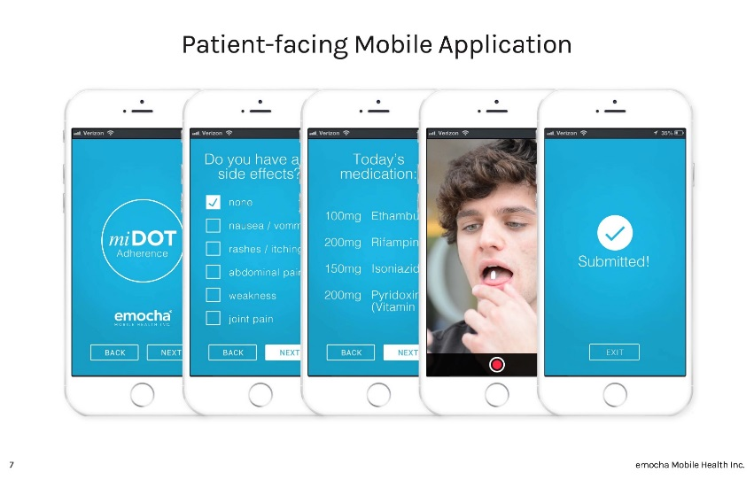
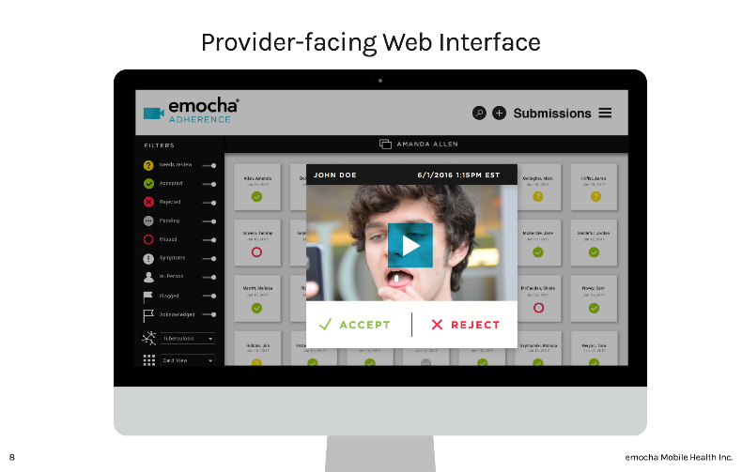
Supplementary Figure 1. miDOT platform
Patient facing
Provider facing

Supplemental Methods
Outcomes of interest
We considered two primary outcomes (Supplement Figure 2). Adherence was measured as the proportion of expected DOT ultimately completed, whether verified by in-person or video observation. Observable fraction considered the proportion total planned treatment doses (including weekend/holiday self-administered doses) observed (in-person or by video). For the latter measurement, ‘observation’ was defined loosely on vDOT to include accepted, rejected and unexpected videos.

Outcome ascertainment
For in-person DOT, dose administration was retrospectively abstracted from paper charts. During the miDOT phase, patient dosing was prospectively monitored via the miDOT system (provider web interface). All decisions regarding video classification (i.e. reject vs accept), were made by unbiased clinic providers. While the miDOT platform automatically tallies doses and calculates adherence, for accuracy (and as a check on the system) all miDOT dosing was abstracted to paper calendars and then tallied by hand.

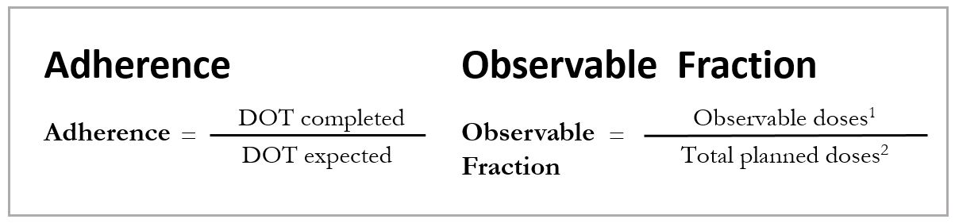
Supplementary Figure 2. Treatment metrics

¹ Inclusive of all observed doses, either by video or in-person. Includes rejected and unexpected videos, the latter representing those submitted on days patient was not planned for observation, most often weekend videos submitted by those on M-F vDOT.
² Total number of planned doses, inclusive for weekend/holiday self-administered.

Supplemental Results
Quantitative results
One MDR patient was included in our study cohort. This patient transferred into our jurisdiction mid- continuation phase (no injectable) and, given patient-specific needs, was started directly on vDOT 7x per week. She successfully completed therapy after 36 weeks of vDOT.

Qualitative results
Surveys and in-depth interviews were conducted with patients and staff, both before and after vDOT implementation. Interviews were transcribed verbatim and an open-coding strategy was utilized to identify salient themes. An inclusive list of themes is reported below (Supplement Table 3 and Table 4), with a subset, representing the most significant themes, presented in the primary manuscript.

Supplementary Table 1. Staff opinions pre/post vDOT

Survey Question | Pre-vDOT  (n=20) |  | Post-vDOT  (n=16) |  | p
 | Agree  n (%) | Disagree  n (%) | Agree  n (%) | Disagree  n (%)
Patients can successfully complete TB treatment with self-administered therapy ONLY (i.e. DOT unnecessary) | 2 (10) | 18 (90) | 0 (0) | 16 (100) | 0.16
DOT provides beneficial social support | 19 (95) | 1 (5) | 16 (100) | 0 (0) | .
vDOT is effective for monitoring patient adherence | 17 (85) | 3 (15) | 15 (94) | 1 (6) | 0.16
sDOT provides improved adherence over self-administered | 20 (100) | 0 (0) | 16 (100) | 0 (0) | .
vDOT provides improved adherence over self-administration | 14 (70) | 6 (30) | 16 (100) | 0 (0) | 0.03
sDOT is burdensome for patients | 14 (70) | 6 (30) | 12 (75) | 4 (25) | 0.65
vDOT is burdensome for patients | 0 (0) | 20 (0) | 1 (6) | 15 (94) | .
vDOT is more convenient for patients than sDOT | 15 (75) | 5 (25) | 14 (88) | 2 (13) | 0.56
sDOT can compromise patient privacy | 8 (40) | 12 (60) | 10 (63) | 6 (38) | 0.16
vDOT can compromise patient privacy | 2 (10) | 18 (90) | 2 (13) | 14 (88) | 0.32
Comfortable using computers for patient care | 19 (95) | 1 (5)¹ | 15 (94) | 1 (6) | 1.00
Comfortable using smartphones for patient care | 19 (95) | 1 (5)¹ | 15 (94) | 1 (6) | .

sDOT=standard DOT (in-person), vDOT=video DOT
⁺ A five point Likert scale was used. Agree/strongly agree and neutral/disagree/strongly disagree were grouped for the above reporting.
⁺⁺ Provider sample size varied pre/post vDOT implementation due to staffing turnover, with several staff members coming and going over the course of the study. Provider cohort included all those involved with DOT-related activities, including DOT-workers, nurse case managers and TB clinicians.
¹ Represents two separate staff members, though recorded response was “neutral” in both cases.

Supplement Table 2. Patient opinions pre/post vDOT

Survey Questions | Pre-vDOT  (n=25) |  | Post-vDOT  (n=9) |  | p
 | Agree  n (%) | Disagree  n (%) | Agree  n (%) | Disagree  n (%)
DOT is helpful | 15 (60) | 10 (40) | 6 (67) | 3 (33) | 0.10
Self-administration would be preferred | 21 (84) | 4 (16) | 8 (89) | 1 (11) | 0.56
sDOT is inconvenient | 15 (60) | 10 (40) | 7 (78) | 2 (22) | 0.32
Comfortable using a smartphone | 23 (92) | 2 (8) | 8 (89) | 1 (11) | .
Comfortable using a computer | 18 (72) | 7 (28) | 6 (67) | 3 (33) | 0.32
Comfortable using video for DOT | 23 (92) | 2 (8) | 7 (78) | 2 (22) | 0.32
vDOT is convenient¹ |  |  | 8 (89) | 1 (11)
vDOT provides for autonomy¹ |  |  | 7 (79) | 2 (22)
miDOT was easy to use |  |  | 8 (100) | 0 (0)

sDOT=standard DOT (in-person), vDOT=video DOT
⁺ A five point Likert scale was used. Agree/strongly agree and neutral/disagree/strongly disagree were grouped for the above reporting.
⁺⁺ The patient response rate declined post-vDOT due to frequent loss-to-follow-up beyond treatment completion. Notably, vDOT adherence did not differ between those completing and those not completing post-intervention qualitative assessment (adherence 89% vs 90%, p=0.92)
¹ All patients grouped under “disagree” responded “neutral” on the Likert scale

Supplementary Table 3. Full list of staff themes from qualitative analysis

STAFF Themes
Theme | Subtheme | Illustrative quote
DOT efficacy | DOT is a necessary component of TB therapy | “DOT is absolutely necessary. I think without it, we'd have relapses right and left.”
Impact of DOT on patients | sDOT can be burdensome for patients | “…some people have to go to school and waiting for the DOT provider … can be a problem. Sometimes they miss the bus.”
 | sDOT can cause emotional stress | “It's invasive. It's inconvenient. For some people, it's embarrassing or humiliating.”
 | Daily home visits with sDOT help some | “There are some people who like having that nurse come to their home … sometimes we’re the only person they see throughout the course of the day.”
 | vDOT can be more convenient for patients | “[vDOT] frees the patient out to live a normal life. They don't feel like they are a prisoner in their home for nine months or a year.”
DOT logistics | sDOT efficacy is limited by environmental factors | “…when there's power failure, or a weather state of emergency, or a traffic issue … we can’t get to the patient … the medicine has to be self-administered … and we have to extend the length of patient's treatment.”
 | sDOT efficacy is limited by patient factors | “We’ve had several clients who do seasonal work … they leave at dawn and they don't get back home until dusk. My staff routinely works anywhere from 7:30-4:30, and so trying to do DOT is impossible.”
 | vDOT increases access to transient patients | “[vDOT] works very well with immigrant populations ... when they go back [to their home country], they can still do videos with us ... for countries in Africa like Liberia and Gambia it’s very difficult to find a partner TB clinic ... but now we get to count those days because we see them.”
 | With sDOT travel can result in longer treatment courses | “A three day vacation. It's hard because you needs to have packs, and the packs are not counted. So the more days off, the more packs you have, the longer is your therapy.”
Confidentiality | sDOT can violate patient privacy | “I've had people not want to meet at their house … because they don't want their neighbors or their families to know that they're being treated for TB.”
 | vDOT is more private than sDOT | “You can do [vDOT] in your car on the way to work. You can sit out in your driveway and do it. I think it’s more private than having a nurse come to the house.”
Impact of DOT on staff | sDOT is inconvenient for staff | “The DOT worker has to adjust his schedule according to the patient's schedule. Sometimes they have to get up very early or drive far distances.”
 | vDOT convenient for staff | “Especially for people who have to get up very early in the morning to go to work. [vDOT] saves us from having to ... be at their house at 5:00am.”
 | vDOT may threaten livelihood | “...the only rumor that I'm hearing, is that some of the DOT workers are thinking that [vDOT] is going to take their jobs.”
Treatment effects of vDOT | vDOT able to shorten therapy | “...for patients who aren't [home] during our normal hours, video DOT ... is much more effective ... they can dose anytime during the daytime as long as they have their phone available ...and they're still getting a counted dose ... we can actually count that dose towards their end goal as an observed dose and their treatment is shortened by several days.”
 | vDOT allows for observed therapy 7x per week | “The ability to do seven days a week, rather than five, is really kind of uncharted territory ... we don't actually know whether people are taking their medicines over the weekends, and a lot of programs don't even prescribe weekend packs, which when you think about it is sort of odd.”
Decisions about DOT should be patient centered | vDOT good for those who travel | “I’ve had patients that have [traveled] to Vietnam, China, England, Holland, and Los Angeles in the past month. So if they have to travel, I think [vDOT] would be a good thing.”
 | vDOT may not work in those less tech savvy | “..for the folks ... still using ... older, outdated [phone] models, or that aren't familiar with how to use an app ... it may be a little foreboding.”
 | Some may prefer sDOT | “Some patients are lonely ... They won't want [vDOT]. They will say, ‘Oh you know, I love her to come into my house. Oh, it's nice to see her.’”
 | vDOT should not just be a reward for those with good adherence | “It's almost like [some view] video DOT [as] a prize for those that can show that they are going to be compliant. We nurses don't look at it that way ... If [it]feels like I can get better compliance from them by offering them the vDOT option, I would like to jump on board quicker.”
 | Some with poor adherence on sDOT may actually do better on vDOT | “We [had a] patient that was highly non-adherent in standard DOT. She was missing three or four doses a week ... we were going to quarantine this individual, but [we decided to] attempt video DOT, and ... for about a month or two [she] was nearly 100% adherent on a seven-day regimen of medicine on video DOT.”
vDOT on clinic operations | vDOT may increase clinic capacity | “I don't have to spend two hours, three hours in the morning driving all over and around the county. It frees me up time-wise enormously. I can see more patients in my office.”
 | vDOT costs not as high as feared | “Phones may not be as big of a cost as I thought it would be ... Most of our patients had a cell phone or an iPad … we've loaned out like two phones.”
Technology | High community level access to smartphones | “We have a fair amount of foreign-born people from all walks of life, and I am always amazed at how far advanced everyone is with smartphones ... almost everybody has them, almost everybody uses them.”
 | vDOT platform easy to use | “I'm so surprised at how user-friendly the software is and how few technical issues we've had.”
Concerns about vDOT | Patients taking different medications than prescribed | “When I’m there I’m putting the meds in the packet and I’m putting the contents of the packet into your hands but now I’m watching you. I don’t have any control ... so many drugs that look similar”
 | Patients gaming the system | “There is the possibility that the patient may be deceptive ... They may pretend to take it. And you have no assurance that they really took it or dropped it on their lap.”

sDOT=standard DOT (i.e. in-person), vDOT=video DOT
Supplementary Table 4. Full list of patient themes from qualitative analysis
PATIENT Themes
Theme | Subtheme | Illustrative quote
DOT efficacy | DOT is a necessary component of TB therapy | “…when you start [treatment] … you're sick … but if you're talking nine months medication, by month three [or] four you feel great and you figure, "Oh, I don't need [medicine] anymore." But you do. So it's important that [treatment] be monitored.”
 | DOT is unnecessary | “… [the nurses] are making sure that I'm taking my medicines on time, but as a responsible adult, I can take it myself.”
 | Reminders could replace DOT | “I think if they just sent reminders, that would be fine … I would take the medicines.”
Impact of DOT on patients | DOT can engender perceived stigma | “I feel a stigma for having tuberculosis …this [in-person] DOT arrangement, it … emphasizes that I have something that not so many people have … we tried first to have a person to come during my lunch break and it was just terrible.”
 | sDOT can be burdensome for patients | “I'm about to start a class, and the class … doesn't really match the time that I have to be here to take the pill … I won't be able to do the class, and I need the class more than I need [DOT].”
 | sDOT can cause emotional stress | “In-person DOT had an emotional impact on me, it was stressful. It made me resent [the treatment team].”
 | vDOT can allay DOT-related stress | “When someone was next to me [for in-person DOT], I felt awkward … they were asking me a lot of things, it was stressful. When I got to use the app, it was way better. ”
 | sDOT acts as a treatment reminder | “[sDOT] is good, because sometimes I forget about my medication, but when someone comes to observe you, no problem.”
 | sDOT daily visits are appreciated by some | “I built a relationship with my duty officer. She's a very caring nice person, and I look forward to seeing her every day.”
 | vDOT can be more convenient for patients | “I prefer taking the medication during the night time. So [vDOT is] convenient because you can take it on your own time.”
 | vDOT preferred over sDOT | “I think [vDOT] is 100% better than the standard [DOT] … definitely better.”
DOT logistics | sDOT efficacy is limited by patient factors | “[sDOT] just doesn’t work. Like tonight, I work, I don’t get off until 7:30am and then I go to school … there is no time.”
 | vDOT increases access to transient patients | “When I was in Peru for two months the system worked perfectly. Sometimes I even used it outside of the city or at the beach.”
 | vDOT increases access to those with complicated work schedules | “I have very long working hours … it's not possible for me to meet with a DOT nurse … with video DOT I could continue with my work and still take the medicine.”
Confidentiality | sDOT can violate patient privacy | “When somebody has to come to your house driving that [DOH] car, coming in … the whole neighborhood's going to look and start asking questions.”
 | vDOT is more private than sDOT | “With [vDOT] we can control [the] setting we are in … it's in your hand … just avoid taking videos in places where you can be viewed by others … we have control.”
Treatment effects of vDOT | vDOT provided treatment support | “I liked that the application asked me about side-effects. I sometimes selected “nausea,” and then someone would call …we would try different strategies, like trying to eat before taking the pills.”

 | vDOT able to shorten therapy | “[With vDOT] I was able to take meds in the Dominican Republic. Before I would have had to take [self-administered medication] packets, which are not observed and don’t count … my treatment would have been three weeks longer.”
 | vDOT can improve treatment self-efficacy | “My ability to continue life in a very normal way [by using vDOT] made it easier to carry on with the treatment … the medication was hard … but because I was able to travel as I wished it was easier for me to follow the regimen.”
Technology | High community level access to smartphones | “A smartphone is what everybody keeps in their hand all the time … no problem.”
 | Many patients are tech savvy | “Well, I use the internet … Facebook … and things like that … doesn’t everyone?”
 | The miDOT platform was easy to use | “You don’t even have to be able to read English. Once they show you [how to use miDOT], its fine. You just follow the pictures.”

sDOT=standard DOT (i.e. in-person), vDOT=video DOT
Cost Analysis
Time motion studies
DOT workers were found to travel an average of 5.4 miles per day, though differences in population density and county size led to marked variability, with sites reporting daily travel anywhere between three and thirteen miles. Time per patient per day (inclusive of travel) also varied, ranging from 23 to 89 minutes, with 47 minutes used in our base-case.

Time spent, per patient, on DOT was much shorter during the miDOT period. Time motion studies showed a range of two to eight minutes per patient, with three minutes ultimately used in our base case.

Supplement Table 5. Key parameters from cost analysis.
 | Base-case | Low | High
Equipment¹
Economy car (DOH vehicle) | $16,400 | $13,000 | $35,000
Computer | $1,000 | $600 | $1,500
Smartphone | $250 | $120 | $770
Consumables¹
Mileage reimbursement (per mile) | $0.54 | - | -
Gasoline (per gallon) | $2.20 | $1.69 | $2.35
Mobile data plan (per month)² | $32.50 | $30.00 | $50
Software (per patient month)³ | $50 | $0 | $100
Labor (per hour)⁴
Registered nurse (RN) | $38.13 | $31.40 | $44.85
Licensed practical nurse (LPN) | $30.21 | $28.14 | $39.06
DOT worker | $28.65 | $18.23 | $31.25
¹ Equipment and consumable costs were estimated through time-motion studies and publically available commercial pricing.
² Reflects cost of data plans able to accommodate the minimum needs of the miDOT platform (2-3 GB per month).
³ Estimates of miDOT platform costs were obtained through direct communication with emocha Mobile Health Inc.
⁴ Hourly wage estimates were obtained through direct communication with TB clinic administrators and from general estimates provided by the US Bureau of Labor Statistics (https://www.bls.gov).
Clinical variability
Significant heterogeneity was observed in the DOT delivery structure between health departments (see Supplement Figure 2). Each site had a nurse administrator overseeing one or more nurse case-managers, though the educational training/background of those conducting DOT ranged from that of a CHW, with no specific health training, to an LPN to an RN. CHWs were generally tasked only with DOT-related activities, while those with more robust clinical training (ex RNs) often had additional clinical roles such as latent tuberculosis (LTBI) screening, phlebotomy and vaccine administration (non-TB related). The average DOT caseload was 15, though ranged from as few as 3 to as many as 22. In terms of transportation, some sites utilized government-owned vehicles, while others reimbursed staff of the usage of their own vehicles.

Supplementary Figure 3. Site-specific variation in DOT implementation structure. All staff listed below the dashed line were directly involved in DOT implementation. The educational training/background of those conducting DOT ranged from that of a community health worker (CHW), with no specific health training (all high school graduates), to a licensed practical nurse (LPN) to a registered nurse (RN). Across sites, those conducting DOT also varied in their location within the organizational hierarchy.

