Appendix 1. Information on the baseline and follow-up of the China Kadoorie Biobank Study
The survey took place in 10 (5 urban and 5 rural) geographically unique localities across China between the years 2004 to 2008, with the response rate of around 30%. After excluding those who did not complete the survey, who attended the survey twice, who had major data errors, and those beyond the age range from 30 to 79 years, a total of 512,891 adults aged 30-79 years with valid data were included in CKB. The study was approved by the Oxford University Tropical Research Ethics Committee, the Ethical Review Committee of the Chinese Center for Disease Control and Prevention (Beijing, China), and the institutional research boards at the local Center for Disease Control and Prevention in each survey site. Written informed consent was obtained from all participants.

At baseline survey, information was obtained by face-to-face interviews through laptop-based questionnaires or measured by trained health workers. The questionnaire included sociodemographic factors (e.g. region, highest education, household income), lifestyle factors (e.g. smoking, alcohol consumption, and physical activity), medical history (self-reported diseases), and mental health status. Additionally, trained staff measured each participant’s height, weight, waist and hip circumference, lung function, blood pressure, and heart rate. All-cause mortality was monitored regularly from baseline until January 1, 2014, through China’s Center for Disease Control (CDC) Disease Surveillance Point system, supplemented by health insurance database and annual active validation of survival using local residential and administrative records. After 7-year following-up, 2411 (0.5%) respondents who were lost to follow-up were censored in analyses.

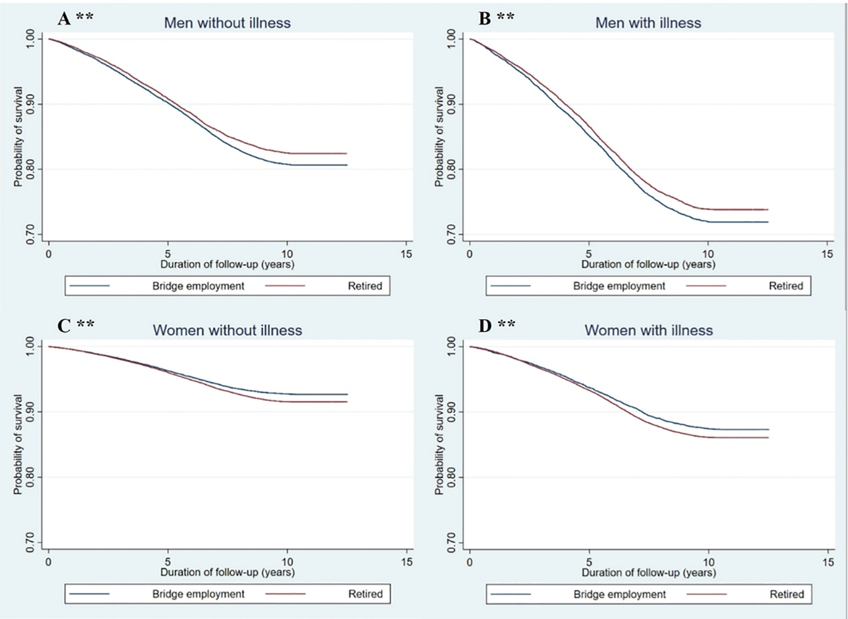
Supplementary Figure 1. Kaplan-Meier Estimates of survival by sex, illness conditions and bridge employment
** p for log rank test <0.01

Supplementary table 1. Characteristics of male participants by type of bridge employment
Characteristics | Agriculture & related workers | Factory worker | Administrator / manager | Professional / technical | Sales & service workers | Self-employed | Retired
 | N=24,211 | N=1,690 | N=205 | N=564 | N=1,382 | N=392 | N=28,659
Age (mean, SD) | 66.44 (4.27) | 64.26 (3.58) | 63.87 (4.06) | 65.22 (3.73) | 65.22 (3.84) | 64.45 (3.58) | 67.81 (4.43)
Socio-economic characteristics
Region (%)
Rural | 95.45 | 45.21 | 19.02 | 18.44 | 34.95 | 40.05 | 23.35
Urban | 4.55 | 54.79 | 80.98 | 81.56 | 65.05 | 59.95 | 76.65
Marital status (%)
Married | 84.26 | 92.43 | 95.61 | 95.39 | 89.80 | 93.62 | 89.80
Widowed/separated/divorced | 13.78 | 6.86 | 4.39 | 4.61 | 9.48 | 6.12 | 9.61
Never married | 1.97 | 0.71 | 0.00 | 0.00 | 0.72 | 0.26 | 0.59
Education (%)
Illiterate and primary school | 84.90 | 73.67 | 10.73 | 5.32 | 71.56 | 59.69 | 43.30
Middle school | 13.08 | 20.65 | 22.93 | 11.52 | 21.85 | 25.00 | 23.40
High school and above | 2.02 | 5.68 | 66.34 | 83.16 | 6.58 | 15.31 | 33.30
Household income, yuan (%)
<10,000 | 54.87 | 15.62 | 4.88 | 4.08 | 23.81 | 16.58 | 19.12
10,000~19,999 | 21.98 | 24.56 | 13.66 | 15.43 | 24.38 | 21.94 | 33.92
≥20,000 | 23.15 | 59.82 | 81.46 | 80.50 | 51.81 | 61.48 | 46.95
Lifestyle factors
Body Mass Index, kg/m²
<24 | 78.84 | 65.44 | 38.05 | 44.68 | 56.22 | 53.06 | 52.62
24-28 | 18.12 | 27.99 | 48.78 | 45.57 | 34.52 | 34.44 | 36.73
≥28 | 3.04 | 6.57 | 13.17 | 9.75 | 9.26 | 12.50 | 10.65
Metabolic Equivalent Tasks, hours/day
< Mean MET | 41.07 | 3.61 | 20.98 | 26.24 | 6.58 | 11.73 | 92.14
≥ Mean MET | 58.93 | 96.39 | 79.02 | 73.76 | 93.42 | 88.27 | 7.86
Smoking (%)
Never | 12.73 | 11.24 | 32.20 | 31.21 | 13.75 | 16.58 | 24.46
Occasional or ex-smoker | 25.18 | 30.06 | 28.29 | 34.40 | 28.22 | 31.38 | 36.45
Regular | 62.09 | 58.70 | 39.51 | 34.40 | 58.03 | 52.04 | 39.09
Alcohol consumption (%)
Never | 31.04 | 25.09 | 14.63 | 18.26 | 26.56 | 21.43 | 28.59
Occasional | 42.13 | 34.14 | 51.71 | 54.96 | 38.49 | 44.64 | 46.73
Regular | 26.83 | 40.77 | 33.66 | 26.77 | 34.95 | 33.93 | 24.68
Health status
With illness (%) | 25.69 | 29.53 | 34.63 | 39.18 | 31.26 | 35.71 | 44.97
Self-rated health level (%)
Excellent/ Good | 40.93 | 59.76 | 58.54 | 63.65 | 62.08 | 54.34 | 40.29
Fair | 46.95 | 36.33 | 39.02 | 32.80 | 32.34 | 36.73 | 47.92
Poor | 12.12 | 3.91 | 2.44 | 3.55 | 5.57 | 8.93 | 11.78

Supplementary table 2. Characteristics of female participants by type of bridge employment
Characteristics | Agriculture & related workers | Factory worker | Administrator / manager | Professional / technical | Sales & service workers | Self-employed | Retired
 | N=35,874 | N=1,498 | N=131 | N=382 | N=1,730 | N=537 | N=66,364
Age (mean, SD) | 61.45 (5.09) | 59.70 (3.89) | 58.18 (3.80) | 59.40 (4.22) | 59.78 (4.13) | 59.64 (4.21) | 64.18 (5.84)
Socio-economic characteristics
Region (%)
Rural | 92.09 | 61.68 | 9.92 | 9.42 | 23.87 | 32.40 | 30.70
Urban | 7.91 | 38.32 | 90.08 | 90.58 | 76.13 | 67.60 | 69.30
Marital status (%)
Married | 82.37 | 86.58 | 90.84 | 86.39 | 85.09 | 85.29 | 75.41
Widowed/separated/divorced | 17.59 | 13.28 | 8.40 | 11.78 | 14.80 | 14.53 | 24.47
Never married | 0.04 | 0.13 | 0.76 | 1.83 | 0.12 | 0.19 | 0.13
Education (%)
Illiterate and primary school | 94.07 | 91.99 | 4.58 | 1.57 | 76.07 | 68.53 | 67.12
Middle school | 5.41 | 5.61 | 15.27 | 8.90 | 15.20 | 23.84 | 18.86
High school and above | 0.52 | 2.40 | 80.15 | 89.53 | 8.73 | 7.64 | 14.02
Household income, yuan (%)
<10,000 | 52.71 | 14.55 | 1.53 | 1.31 | 17.17 | 16.76 | 26.76
10,000~19,999 | 23.40 | 19.63 | 9.92 | 10.99 | 27.28 | 31.66 | 31.56
≥20,000 | 23.88 | 65.82 | 88.55 | 87.70 | 55.55 | 51.58 | 41.69
Lifestyle factors
Body Mass Index, kg/m²
<24 | 62.81 | 59.21 | 46.56 | 45.03 | 46.82 | 41.15 | 47.84
24-28 | 28.03 | 31.11 | 46.56 | 43.72 | 40.00 | 39.11 | 35.57
≥28 | 9.17 | 9.68 | 6.87 | 11.26 | 13.18 | 19.74 | 16.59
Metabolic Equivalent Tasks, hours/day
< Mean MET | 31.95 | 2.74 | 12.21 | 22.25 | 4.51 | 10.06 | 89.16
≥ Mean MET | 68.05 | 97.26 | 87.79 | 77.75 | 95.49 | 89.94 | 10.84
Smoking (%)
Never | 87.34 | 97.86 | 97.71 | 97.64 | 96.18 | 94.23 | 93.40
Occasional or ex-smoker | 6.57 | 1.13 | 0.76 | 1.57 | 2.08 | 2.98 | 3.09
Regular | 6.09 | 1.00 | 1.53 | 0.79 | 1.73 | 2.79 | 3.50
Alcohol consumption (%)
Never | 65.45 | 88.52 | 42.75 | 42.41 | 76.47 | 74.49 | 71.05
Occasional | 30.89 | 10.01 | 51.91 | 54.45 | 21.97 | 23.65 | 27.20
Regular | 3.66 | 1.47 | 5.34 | 3.14 | 1.56 | 1.86 | 1.75
Health status
With illness (%) | 22.82 | 23.56 | 32.82 | 35.86 | 25.49 | 28.31 | 39.99
Self-rated health level (%)
Excellent/ Good | 38.38 | 53.60 | 56.49 | 51.31 | 57.80 | 42.27 | 34.07
Fair | 46.02 | 39.99 | 41.22 | 42.67 | 34.74 | 48.98 | 51.87
Poor | 15.60 | 6.41 | 2.29 | 6.02 | 7.46 | 8.75 | 14.06

