Supporting Information
pH-responsive superstructures prepared via the assembly of Fe₃O₄ amphipathic Janus nanoparticles
Cai Shuang, Luo Bin, Zhan Xiaohui, Zhou Xiaoxi, Lan Fang, Yi Qiangying*, Wu Yao*
National Engineering Research Center for Biomaterials, Sichuan University, Chengdu, Sichuan 610064, P.R. China

Figure S1. The hydrodynamic diameter of the self-assemblies.

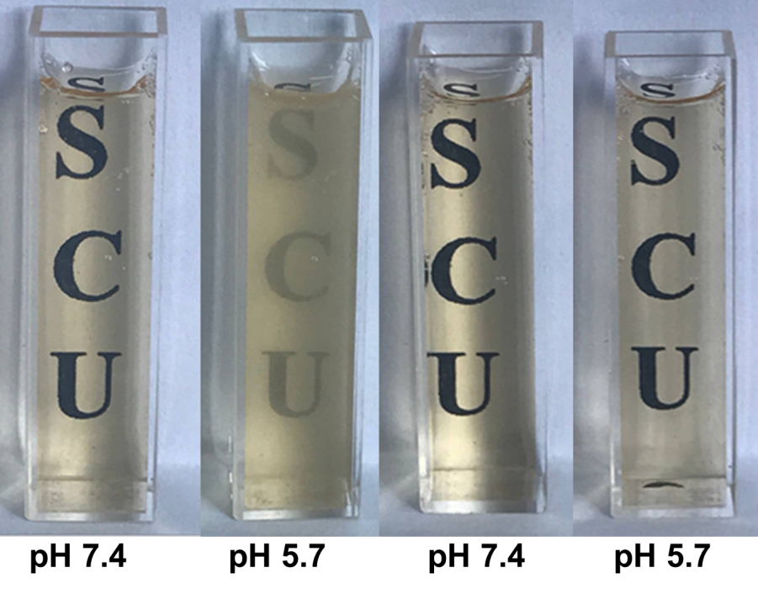
Figure S2 The visualized images of co-assemblies (A) and self-assemblies (B) suspensions at pH 7.4 and pH 5.7.
Figure S3 FTIR spectra of PGMA-PD and precipitate obtained from co-assemblies in acid circumstance.
Figure S4. The hydrodynamic diameter of the DOX-loaded co-assemblies.
Figure S5. Fluorescence spectra of DOX-loaded co-assemblies in pH 7.4 (A), pH 5.7 (B) and pH 4.5 (C) buffer solutions at room temperature.

