SUPPLEMENTARY DATA
Supplementary Table S1. Sex differences of patients who satisfied International Study Group for Behçet's Disease criteria
N=5565 |  | Men | Women | Comparison
N |  | 2138 | 3427
Oral ulceration | Yes  No  Unclear  Prevalence, % | 2138 (100.0)  0 (0.0)  0 (0.0)  NA | 3427 (100.0)  0 (0.0)  0 (0.0)  NA | NA
Skin lesions | Yes  No  Unclear  Prevalence, % | 2029 (94.9)  94 (4.4)  15 (0.7)  95.6 | 3270 (95.4)  138 (4.0)  19 (0.6)  96.0 | OR 0.91 (0.70-1.19)  P = 0.495
Ocular lesions | Yes  No  Unclear  Prevalence, % | 1145 (53.6)  924 (43.2)  69 (3.2)  55.3 | 1054 (30.8)  2242 (65.4)  131 (3.8)  32.0 | OR 2.64 (2.35-2.95)  P < 0.001
Genital ulceration | Yes  No  Unclear  Prevalence, % | 1370 (64.1)  699 (32.7)  69 (3.2)  66.2 | 2938 (85.7)  431 (12.6)  58 (1.7)  87.2 | OR 0.29 (0.25-0.33)  P < 0.001
Positive pathergy test | Yes  No  Unclear  Prevalence, % | 612 (28.6)  736 (34.4)  790 (37.0)  45.4 | 880 (25.7)  1350 (39.4)  1197 (34.9)  39.5 | OR 1.28 (1.11-1.46)  P < 0.001
Arthritis | Yes  No  Unclear  Prevalence, % | 981 (45.9)  1029 (48.1)  128 (6.0)  48.8 | 1877 (54.8)  1410 (41.1)  140 (4.1)  57.1 | OR 0.72 (0.64-0.80)  P < 0.001
Gastrointestinal symptoms | Yes  No  Unclear  Prevalence, % | 508 (23.8)  1524 (71.3)  106 (5.0)  25.0 | 906 (26.4)  2390 (69.7)  131 (3.8)  27.5 | OR 0.88 (0.78-0.998)  P = 0.046
Vascular lesions | Yes  No  Unclear  Prevalence, % | 219 (10.2)  1558 (72.9)  361 (16.9)  12.3 | 261 (7.6)  2588 (75.5)  578 (16.9)  9.2 | OR 1.39 (1.15-1.69)  P < 0.001
Neurological manifestations | Yes  No  Unclear  Prevalence, % | 401 (18.8)  1633 (76.4)  104 (4.9)  19.7 | 767 (22.4)  2540 (74.1)  120 (3.5)  23.2 | OR 0.81 (0.71-0.93)  P < 0.001
HLA-B51 positive | Yes  No  Unclear  Prevalence, % | 515 (24.1)  534 (25.0)  1089 (50.9)  49.1 | 604 (17.6)  846 (24.7)  1977 (57.7)  41.7 | OR 1.35 (1.15-1.58)  P < 0.001
All values listed as n (%) unless otherwise stated. Prevalence was judged from the Yes / (Yes + No) ignoring Unclear. Epididymitis was excluded from this table. OR: odds ratio evaluating females as reference; NA: Not applicable.

Supplementary Table s2. Age differences of patients who satisfied International Study Group for Behçet's Disease criteria
N = 5565 | Manifestation (+) |  | Manifestation (-)
 | N | Median age (IQR) | N | Median age (IQR) | P
Skin lesions | 5299 | 38 (30-48) | 232 | 39.5 (30-52) | 0.446
Ocular lesions | 2199 | 40 (32-51) | 3166 | 37 (29-47) | < 0.001
Genital ulceration | 4308 | 38 (30-47) | 1130 | 40 (31.25-51) | < 0.001
Positive pathergy test | 1492 | 38 (30-50) | 2086 | 37 (29-46) | 0.007
Arthritis | 2858 | 39 (31-50) | 2439 | 37 (29-47) | < 0.001
Epididymitis  (men only) | 213 | 37 (30-46) | 1714 | 39 (31-51) | 0.076
Gastrointestinal symptoms | 1414 | 39 (30-50) | 3914 | 38 (30-47) | 0.097
Vascular lesions | 480 | 42 (33-55) | 4146 | 38 (30-47) | < 0.001
Neurological manifestations | 1168 | 39 (31-49) | 4173 | 38 (30-48) | 0.098
HLA-B51 positive | 1119 | 37 (29-48) | 1380 | 37 (29-45.25) | 0.513
Top row manifestation includes HLA-B51. Oral ulcer was removed from this table. P: Mann Whitney test.
Supplementary Figure S1. Subgrouping by sex and age of patients who satisfied International Study Group for Behçet's Disease criteria
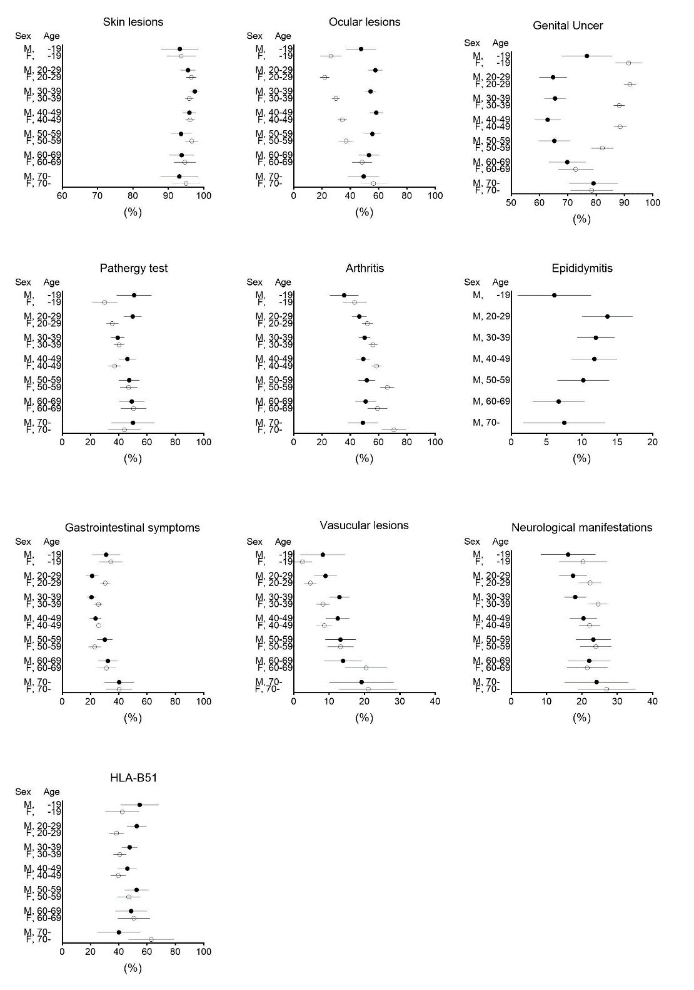

A filled/open circle indicates estimated prevalence. An error bar indicates 95% confidence interval. Note that x axes were modified for each figure. M: male; F: female.

